Jones Automation – Exercise
Submitted by: Noam Kadosh
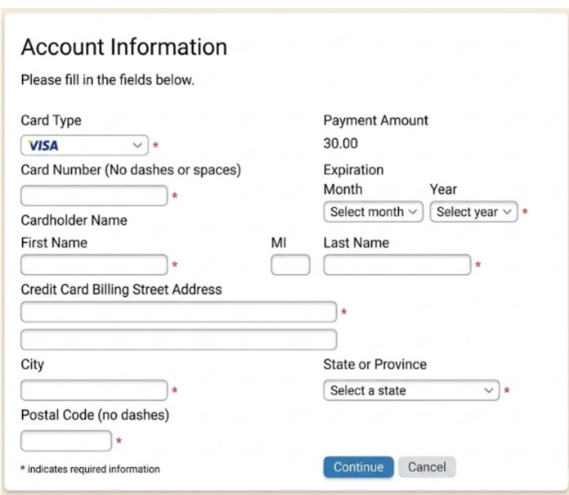
A global Saas Company is using:

The review is based on the screenshot provided only. I identified the following issues and potential risks:
Missing currency: The payment amount is displayed as “30.00” without a currency. For a global company, users should know which currency they will be charged in.
Small text and crowded layout: Some labels appear small, and the fields are closely spaced. This may make the form harder to read and complete. Increasing the text size and spacing between fields could improve usability.
International address support: There is no country selector, while State / Province is required Unless the country was selected earlier, the form may not support customers from different countries correctly.
Restrictive input instructions: Requiring card numbers without spaces and postal codes without dashes makes data entry less convenient. The form should accept common formats and handle formatting automatically.
Unclear button action: “Continue” does not clarify whether the user will review the payment or be charged immediately. The label should match the actual action.

In a working application, I would also check:
Security: Payment details are transmitted over HTTPS and are not exposed in URLs or logs.
Functionality: Missing or invalid details are rejected, and repeated clicks do not cause duplicate charges.
Performance and usability: A loading indicator appears during processing, with clear feedback if the payment is delayed or fails.
Accessibility: The form can be completed using a keyboard, and fields and error messages are understandable to screen readers.

Sample Test Cases:
Result | Steps | Test Case
The form accepts the details and proceeds to the next step without validation errors. | 1. Select the card type and enter a valid test card number.  2. Select a future expiration date.  3. Complete all required name and billing address fields.  4. Click Continue. | Test1 - payment details
The form prevents progression and displays a clear expiration-date error. Other entered details are preserved, and no payment is processed. | 1. Complete all required fields with otherwise valid test data.  2. Select an expiration date in the past.  3. Click Continue. | Test 2 – Expired card
Only one charge is created, and a processing indicator is displayed while the payment is being handled. | 1. Enter valid test payment details.  2. Proceed to the final payment step if Continue only opens a review page.  3. Double-click the final payment button quickly. | Test 3 - Duplicate Charges

Product Solution for the Most Severe Issue:
The most significant issue I identified in the mockup is the missing payment currency. For a global company, users should know exactly which currency they will be charged in before confirming payment.
I suggest displaying the amount with a clear currency code, such as 30.00 USD, and showing it again at the final confirmation step. If the button immediately processes the payment, its label should be “Pay 30.00 USD”. This would make the payment clearer and help prevent misunderstandings.

