Subclinical OCD and inference about absence in visual search

Noam Sarna1, Ruvi Dar1, & Matan Mazor2

1 School of Psychological Sciences, Tel Aviv University

2 Department of Psychological Sciences, Birkbeck, University of London, UK

Author note

Correspondence concerning this article should be addressed to Noam Sarna, Tel Aviv, Israel 69978. E-mail: [noamsarna@mail.tau.ac.il](mailto:noamsarna@mail.tau.ac.il)

Abstract

Inference about the absence of a target is qualitatively different than inference about the presence of one. While the latter is established from a signal evident in the external world, the former is based on the internal belief of not having missed the target. Obsessive-compulsive disorder (OCD) is characterized by inflated levels of doubt and difficulty accessing internal states. Previous research has shown that obsessive-compulsive participants indeed struggle when searching for an absent target; however, results were confounded by heightened uncertainty. In this study, we designed a paradigm intended to decouple absence from difficulty to probe the specific effects of obsessive-compulsive tendencies on visual processing and decision making in the absence of a target. High and low OC participants will be presented with 96 visual search displays and asked to decide whether a target is “absent” or “present.” In addition, participants will provide information about explicit metacognitive knowledge to probe for discrepancies between behavior and belief. By introducing an easy target-absent condition, we can dissociate specific difficulties with inference about absence from more general difficulties with uncertainty. This experiment will provide key information about interactions between obsessive-compulsive tendencies and inference about absence, which are an essential window into OCD and metacognitive impairments.

Subclinical OCD and inference about absence in visual search

Previous work by (Toffolo, Hout, Hooge, Engelhard, & Cath, 2013) , using a visual search paradigm in high (OC+) and low (OC-) OC individuals, provided evidence that OC+ participants search longer in target-absent trials. This robust finding has been replicated (Toffolo, Hout, Engelhard, Hooge, & Cath, 2014) and extended to a clinical sample of OCD patients (Toffolo, Van Den Hout, Engelhard, Hooge, & Cath, 2016). In these experiments, checking behavior was operationalized by search time and high and low uncertainty were operationalized by means of contrasting target-present and target-absent trials. Therefore, the longer search times for the OC+ group in target-absent trials were interpreted as perseverative checking for mild uncertainty. However, the paradigm structure used in Toffolo’s experiments has conflated uncertainty with target absence. Decisions about target absence are indeed qualitatively different from target-present trials since the evidence for lack of stimuli is less salient and based on the metacognitive belief of not having missed the target (Mazor & Fleming, 2022).

Nevertheless, some decisions about absence can be accompanied by low subjective uncertainty, for instance, perceiving the absence of a red dot among blue dots. Distinguishing features of inference about absence from uncertainty will be achieved by introducing such a search where absence can be more directly inferred and will allow us to probe for distinct behavior of OC+ in absent trials.

##   
## 1 2 3 4   
## 240 253 261 253

# Methods

We report how we determined our sample size, all data exclusions (if any), all manipulations, and all measures in the study.

## Participants

The research complied with all relevant ethical regulations and was approved by the Research Ethics Committee of Tel-Aviv University (study ID number 0004169-1). Participants will be recruited via Prolific and selected based on their acceptance rate (>95%) and for being native English speakers, located in the UK, and not having participated in former study pilots. We encountered graphical problems with Safari browser during the pilot study, so we will ask participants to use only other browsers. The entire experiment will take 14 minutes to complete (the median completion time in a pilot study). Participants will be paid £2 for their participation, equivalent to an hourly wage of £8.57.

## Material

The experiment described in this study was adapted from Mazor and Fleming (2022), with stimuli created to replicate the ones used in the Toffolo et al. (2013). All elements (distractors and target) and their placement on the search grid were made to replicate as closely as possible the paradigm used in Toffolo et al. (2013).

## Procedure

The visual search task will consist of 4 blocks, each containing 24 trials of searching for either a closed or an open square. To make sure participants understand the task, a practice phase will be given first. The practice phase will consist of one block with six trials of visual search. Elements in both practice and main part will be white on dark grey background. Each trial will last for a maximum of 10 seconds or until a response is received. If no response is given within 10 seconds, the next trial will immediately appear. Feedback about the response (wrong/right) will be given only in the practice phase, to help participants learn the task efficiently. In the main part of the experiment, no feedback will be given, as was the case in the original paradigm (Toffolo et al., 2013).

Participants will first be instructed about the experiment’s structure, which comprises three parts: A visual search part, questions about the visual search part, and some more general questions. Then, they will be informed about the main part of the experiment – the visual search part. Specifically, their task is to report, as accurately and quickly as possible, whether a target stimulus was present (press ‘J’) or absent (press ‘F’). Then, practice trials will be delivered, in which the target stimulus is a rotated T, and distractors are rotated Ls. The purpose of the practice trials is to familiarize participants with the task structure. For these practice trials, the number of items will always be 4. In the practice trials, participants will be given feedback about the accuracy of their responses. The feedback will appear right after a response is given. If the response is correct, then the word “Correct!” will immediately pop on the screen, for 1 second. If the response is wrong, the word “Wrong!” will immediately pop on the screen for 5 seconds. The extended duration of the word “wrong” is intended to feel aversive and to make sure participants are paying full attention and giving accurate responses (a pilot study showed higher accuracy rates when using this method). Practice trials will be delivered in one block of 6 trials, and the main part of the experiment will start only once participants respond correctly on at least five trials.

In the main part of the experiment, participants will look for an O (a square with rounded corners. Figure 1, right panel) or a rotated C (a square with rounded corners with a gap in one of its edges. Figure 1, left panel). The distractors in each trial will be either O’s when searching for a C or C’s when searching for an O. Due to a search asymmetry for open edges, searching of O among C’s is qualitatively harder than the searching for a C among O’s (Treisman & Gormican, 1988). In each trial the target can be present or absent. Set sizes will be 9 or 25, resulting in a 2X2X2 design (search type: ‘C in O’ or ‘O in C’; Target: present/absent; set size: 9 or 25). Block order will be counterbalanced between participants: for about half of the participants, it will be: ‘C in O’, ‘C in O’, ‘O in C’, ’ O in C ‘. For the other half, it would be:’ O in C ‘,’ O in C ‘, ’C in O’, ‘C in O’. For all participants, target change will be emphasized between the second and third blocks. Trial order will be fully randomized within individual blocks.

After completing the first two blocks, participants will be given a short break encouraging them to let their eyes rest before continuing – “Before you continue, we suggest that you take a short break. You can let your eyes rest for a moment and take a few breaths. When you are ready click on next/spacebar to move to the next block.” Critically and unknown to subjects, the first two trials of the first and third blocks will always be target-absent trials (one of each set-size), presented in randomized order. Upon finishing the main part of the experiment, participants will move to the second part of the experiment, the difficulty estimation part, and will be informed:

“In the next part you will answer questions regarding the first part you have just completed. Some searches are easier than others. This means that participants find the target faster in some searches, compared to others. In the following part you will be asked to rate the difficulty level of deciding that a target was present or absent among different distractors.”

Before evaluating the perceived difficulty of the trials, we added an explanation, telling participants that each question would contain a picture of the trial with a red square around the target if it were present or no marking at all if the target was absent. Doing that helps us to assure participants are not actively searching for the target in the difficulty estimation part.

Participants will then be requested to rate the perceived difficulty of four different trial types: “To the best of your ability, try to rate how hard it is to find a target among distractors from very easy (fastest) to very hard (slowest). Drag the slider into position and click”continue” when you have finished rating.” The four questions will be (each question will be accompanied by a picture depicting the trial):

1. How difficult is detecting the presence closed square among many open squares
2. How difficult is detecting the presence of one closed square among few open squares
3. How difficult is detecting the absence of one open square among many closed squares
4. How difficult is detecting the absence of one open square few closed squares

#need to add the figures.

We focused on these four trials as this was our most intriguing hypothesis, comparing easy target-absent trials to more challenging target-present trials. After finishing this part, participants will be informed they have reached the final part of the experiment. In the last part, they will fill out the OCI-R (Foa et al., 2002) and DASS-21 (Lovibond & Lovibond, 1995) questionnaires. We inserted two attention checks questions between the regular OCI items, asking participants to select a certain answer (‘If you read this question, check the option ‘Not at all’). As part of an exploratory analysis, we added another item to the OCI asking specifically about problems with inference about absence (‘I sometimes go back and check that I didn’t do something bad unintentionally’). Upon completion, participants they will receive a message thanking them for participation and then will be redirected back to prolific with a completion code.

###Randomization The order and timing of experimental events will be determined pseudo-randomly by the Mersenne Twister pseudorandom number generator, initialized to ensure registration time-locking (Mazor, Mazor, & Mukamel, 2019).

###Rejection criteria Participants will be excluded for making more than 15% errors in the main part of the experiment or for having extremely fast (below 100 milliseconds) in more than 25% of the trials. Error trials and trials with response times below 100 milliseconds will be excluded from the response-time analysis. Participants will also be excluded from the analysis if they are wrong in one or more of the attention checks questions (asking them to mark a specific answer in the questionnaire).

## Data analysis

We used R (Version 4.2.2; R Core Team, 2021) and the R-packages *}lvmisc* [@}R-lvmisc], *broom* (Version 1.0.1; Robinson, Hayes, & Couch, 2021), *caret* (Version 6.0.93; Kuhn, 2021), *citr* (Aust, 2019), *cowplot* (Version 1.1.1; Wilke, 2020), *devtools* (Version 2.4.5; Wickham, Hester, Chang, & Bryan, 2022), *dplyr* (Version 1.0.10; Wickham, Fran?ois, Henry, & M?ller, 2021), *forcats* (Version 0.5.2; Wickham, 2021a), *GGally* (Version 2.1.2; Schloerke et al., 2021), *ggplot2* (Version 3.4.0; Wickham, 2016), *ggpubr* (Version 0.5.0; Kassambara, 2020), *lattice* (Version 0.20.45; Sarkar, 2008), *lme4* (Version 1.1.31; Bates, Mächler, Bolker, & Walker, 2015), *lmerTest* (Version 3.1.3; Kuznetsova, Brockhoff, & Christensen, 2017), *Matrix* (Version 1.5.3; Bates & Maechler, 2021), *nlme* (Version 3.1.160; Pinheiro & Bates, 2000), *papaja* (Version 0.1.1; Aust & Barth, 2022), *piggyback* (Boettiger & Ho, 2022), *purrr* (Version 0.3.5; Henry & Wickham, 2020), *readr* (Version 2.1.3; Wickham & Hester, 2021), *shiny* (Version 1.7.3; Chang, Cheng, Allaire, Xie, & McPherson, 2020), *stringr* (Version 1.4.1; Wickham, 2019), *tibble* (Version 3.1.8; M<U+00FC>ller & Wickham, 2021), *tidyr* (Version 1.2.1; Wickham, 2021b), *tidyverse* (Version 1.3.2; Wickham et al., 2019), *tinylabels* (Version 0.2.3; Barth, 2022), and *usethis* (Version 2.1.6; Wickham, Bryan, & Barrett, 2022) for all our analyses.

##Hypotheses and analysis plan This experiment is designed to test several hypotheses about the behavior of individuals high on obsessive-compulsive tendencies (OC+) in a visual search paradigm. We will focus on search slopes during target-absent trials and the perceived difficulty of target-absent vs. target-present trials. Participants will be divided to OC+/OC- groups based on OCI scores (1st/4th quartiles). Subject-wise search slopes will be extracted for each combination of search type (C in O; O in C) and presence of the target (present/absent) by fitting a linear regression model to predict reaction time as a function of set size, with one intercept and one set-size term. We will use search slope as a dependent measure for all of our hypotheses concerning search times. We will use the full sample for the first two hypotheses validating our paradigm.

# Results

*Hypothesis 1* - To validate our methods and the quality of our data, we will test for a difference in slopes between the two search types (C in O; O in C) beyond the presence of the target (present/absent). We expect to find an overall steeper slopes for O in C search compared to C in O search. To compare these slopes, we will use a one-tailed paired t-test.

In line with our hypothesis and paradign structure, search slopes between the two search type, followed the expected pattern with a steeper slope for the hard search (O in C; $M_{D}=−1,049.01$, 95% CI $\left[−1,080.05,−1,017.98\right]$, $t\left(1,795\right)=−66.30$, $p<.001$).

*Hypothesis 2* We will test the difference of slopes between O in C in target presence and C in O in target absence. Based on our pilot and paradigm design, we expect to find a steeper slope for O in C in target presence than C in O in target absence. To compare these slopes, we will use a one-tailed paired t-test.

In contrast with our hypothesis [MM: isn’t this in line with our hypothesis?], search slopes for the easy absent search were shallower, rather than steeper, than search slopes in the hard present condition ($M_{D}=−273.48$, 95% CI $\left[−316.25,−230.71\right]$, $t\left(897\right)=−12.55$, $p<.001$).

*Hypothesis 3* Replication of previous findings by Toffolo et al. (2013). In order to directly replicate Toffolo’s findings, we will focus on the hard search type (O in C) with the larger set size (set size =25), the same as was used in both studies (Toffolo et al., 2013, 2014). We will compare the mean RT between the two groups (OC+/OC-) in both target-present and target-absent trials. For this hypothesis, we will conduct a mixed-effects ANOVA, with mean RT as a dependent variable, group (OC+/OC-) as a between-subject variable and target presence (present/absent) as within-subject variable. We expect to find an interaction between group and target present, in which mean search times difference between OC+ and OC- will be significantly stronger in target-absent trials.

#NS:how can I open the replication plot here? #MM: I fixed it now, but why don’t you generate the plot directly from here? 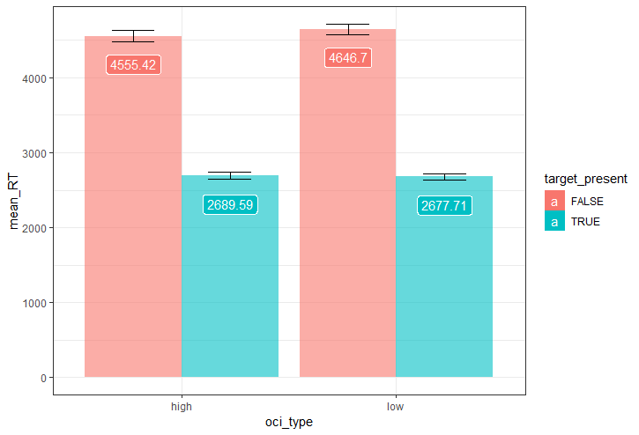 toffolo_data %>% filter(OCI_quantile==1| OCI_quantile==4) %>% aov(RT~OCI_quantile * target_present, data = .) %>% summary(.) [MM: things that don’t appear within back ticks (either as part of a chunk or with the backtick-r-backtick notation) are not evaluated as R code.]

In contrast to our hypothesis, we didn’t find an interaction between group and target present in the direction we expected. There is a marginaly significant interaction ([MM: why is this not generated by R?] p=0.7) to the opposite direction, in which OC- are having longer search time in target absent trials, but not in target present trials.

*Hypothesis 5* Difficulty of OC+ participants with inference about absence in the easy search type. We will check for the interaction between group and target presence and focus on the easy search type (C in O). We will test the hypothesis that the search slope differences between OC+ and OC- will be significantly stronger in target-absent trials. Obtaining this interaction pattern would strengthen the hypothesis that decisions about absence contribute to OC+ search times irrespective of task uncertainty (figure 4 top panel). On the other hand, an interaction between group and target presence with the same pairwise comparison pattern that is specific to the hard search (Hypothesis 4, above) will strengthen the competing hypothesis that heightened uncertainty contributes to OC+ search times (figure 4 bottom panel).

[MM: this should be in a chunk, and stats should appear in the next paragraph.] search_slopes_df %>% filter(OCI_quantile==1| OCI_quantile==4) %>% filter(search_type==‘CinO’) %>% aov(estimate ~ OCI_quantile*target_present, data=.) %>% summary(.)

Hypothesis 5 isn’t met. There isn’t a significant interaction between group and target present in the easy search.

*Hypothesis 6* Model comparison - search type or target-presence contribute to OC+ search time. In order to directly test the hypothesis that target-presence affects OC+ search time to a greater extent than search type we will conduct a model comparison between two multiple regression models. The first model will predict search slopes using the following predictors: search type; group; the interaction between search type and target presence; the interaction between search type and group. The first model will use the following formula:

slope_estimate~ 1+group+search_type X target_presence+ search_type X group

The second model will predict search slopes using the following predictors: search type; group; the interaction between search type and target presence and the interaction between target presence and group. The second model will use the following formula:

slope_estimate~ 1+group+ search_type X target_present+target_present X group

These two models differ only in their last interaction effect. Thus, their complexity level (that is, the number of fitted coefficients) will be the same, which will allow us to compare these models directly. We will compare model performance using leave-one-out cross validation.

## Linear Regression   
##   
## 1732 samples  
## 3 predictor  
##   
## No pre-processing  
## Resampling: Leave-One-Out Cross-Validation   
## Summary of sample sizes: 1731, 1731, 1731, 1731, 1731, 1731, ...   
## Resampling results:  
##   
## RMSE Rsquared MAE   
## 555.6586 0.5779829 419.285  
##   
## Tuning parameter 'intercept' was held constant at a value of TRUE

## Linear Regression   
##   
## 1732 samples  
## 3 predictor  
##   
## No pre-processing  
## Resampling: Leave-One-Out Cross-Validation   
## Summary of sample sizes: 1731, 1731, 1731, 1731, 1731, 1731, ...   
## Resampling results:  
##   
## RMSE Rsquared MAE   
## 555.4654 0.5782763 418.7286  
##   
## Tuning parameter 'intercept' was held constant at a value of TRUE

Model comparison shows that both models have the same R-sqaured value [MM: was this statistically quantified?], therefore we can reject the hypothesis that target-presence affects OC+ search time to a greater extent than search type on OC+ [MM: can we reject an hypothesis because we don’t find a significant difference?].

*Hypothesis 7*: First trials analysis. Prior to the analysis, we will correct for trial and block order effects by using the following formula:

#NS:(need to add the formula) #NS: Here I need your help. I went back to your code for the termination experiment but couldn’t figure out how to perform this correction for trial and block order effects.

Where RTs,b,t corresponds to the reaction time of subject s in block b and trial t, and RTs to the mean RT for subject s in trials 1 and 2 of blocks 1 and 3. Then, at the whole group level we will compare the slopes of the two types of searches (O in C and C in O) to see if they are different already in the first trials, using a two-tailed paired t-test. Finding a difference between them will serve as a sign for metacognitive knowledge about the asymmetry between the two types of searches, that was in place before experiencing target-present trials.

## Warning: Using `size` aesthetic for lines was deprecated in ggplot2 3.4.0.  
## ℹ Please use `linewidth` instead.

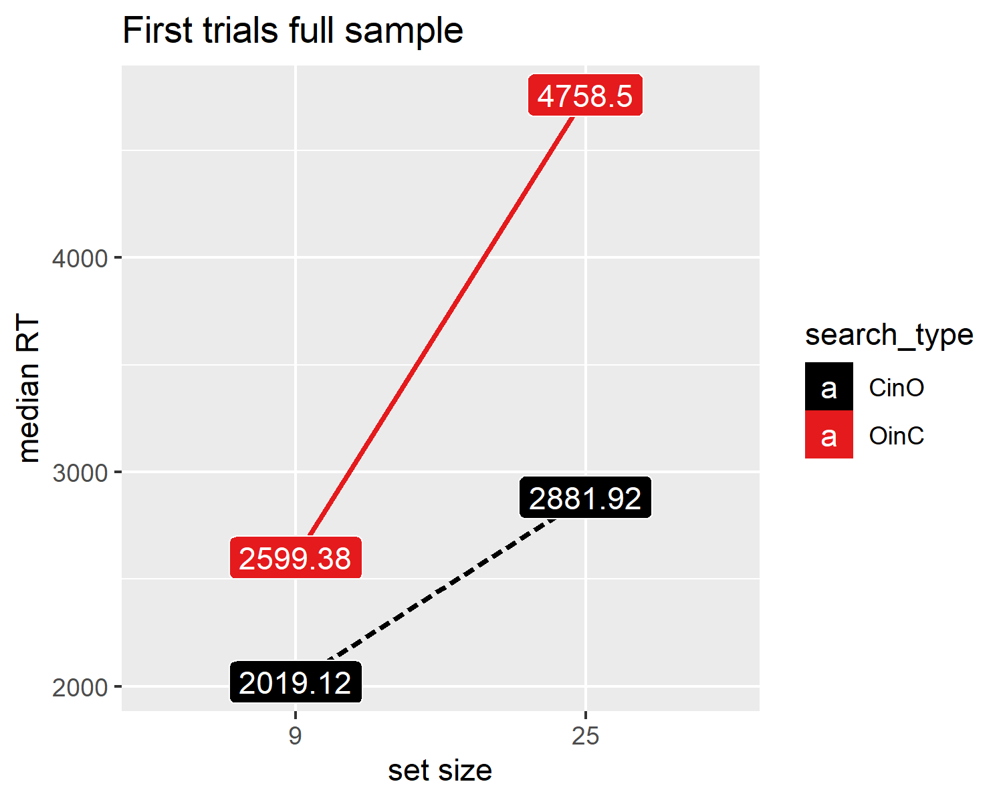

[MM: how do we know the t test function knows to match the two slopes by subj_id? I don’t see a grouping variable in the formula]

Consistent with our hypothesis [MM: here and in other places you say “consistent with our hypothesis”, but I’m not sure we actually pre-registered a directional hypothesis, just a null hypothesis that we are planning to test], we found a significance difference between the slope of the easy search (C in O) and the slope of the hard search (C in O) in the first trials of each block type ($M_{D}=−1,122.53$, 95% CI $\left[−1,286.88,−958.18\right]$, $t\left(361\right)=−13.43$, $p<.001$). This significant difference between the search slopes indicate that subjects had some sort of metacognitive knowledge (valid expectations about search difficulty), allowing them to terminate the easy search faster than the hard search.

*Hypothesis 8*: Interaction between group and search time on first-trials slopes. Using a mixed-effects ANOVA, with slope as a dependent variable and group and search type as the two between- and within-subject independent variables, we will test for an interaction of group (OC+/OC-) with search type.

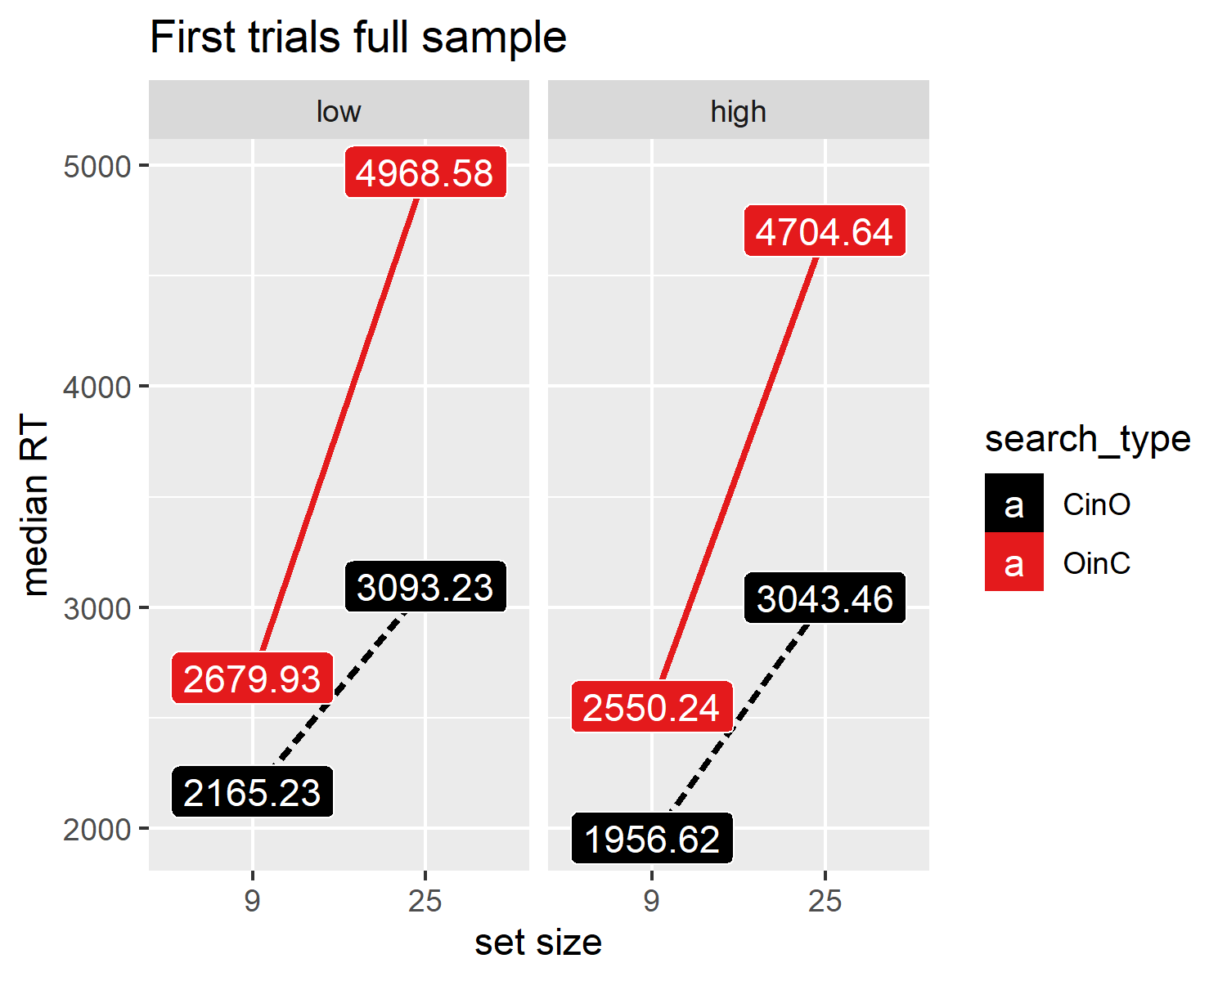

## Df Sum Sq Mean Sq F value Pr(>F)   
## OCI_quantile 1 9.357e+05 935702 0.670 0.413   
## search_type 1 2.281e+08 228072913 163.386 <2e-16 ***  
## OCI_quantile:search_type 1 1.245e+06 1245171 0.892 0.345   
## Residuals 720 1.005e+09 1395914   
## ---  
## Signif. codes: 0 '***' 0.001 '**' 0.01 '*' 0.05 '.' 0.1 ' ' 1

We didn’t find an interaction between search type and group on first trials slopes.

*Hypothesis 9*: Correlations between OC tendencies and search slopes. In order to strengthen the validity of our results, we will reanalyze our main hypothesis using the entire range of OC scores. That way, we will be able to investigate whether search times in absent trials varies as a function of OC tendencies. We will do so by correlating OC tendencies with search slopes in target-absent and target presence conditions.

## Linear mixed model fit by REML. t-tests use Satterthwaite's method [  
## lmerModLmerTest]  
## Formula: estimate ~ 1 + OCI_quantile + search_type * target_present +   
## target_present * OCI_quantile + (1 | subj_id)  
## Data: search_slopes_df  
##   
## REML criterion at convergence: 55203.1  
##   
## Scaled residuals:   
## Min 1Q Median 3Q Max   
## -3.7958 -0.5514 -0.0472 0.5154 3.7513   
##   
## Random effects:  
## Groups Name Variance Std.Dev.  
## subj_id (Intercept) 83401 288.8   
## Residual 223222 472.5   
## Number of obs: 3592, groups: subj_id, 898  
##   
## Fixed effects:  
## Estimate Std. Error df t value Pr(>|t|)  
## (Intercept) 976.37 38.02 1923.03 25.681 <2e-16  
## OCI_quantile -15.36 13.37 1669.03 -1.148 0.251  
## search_typeOinC 1202.30 22.30 2690.00 53.922 <2e-16  
## target_presentTRUE -660.18 41.96 2690.00 -15.733 <2e-16  
## search_typeOinC:target_presentTRUE -306.58 31.53 2690.00 -9.723 <2e-16  
## OCI_quantile:target_presentTRUE 15.27 14.31 2690.00 1.067 0.286  
##   
## (Intercept) ***  
## OCI_quantile   
## search_typeOinC ***  
## target_presentTRUE ***  
## search_typeOinC:target_presentTRUE ***  
## OCI_quantile:target_presentTRUE   
## ---  
## Signif. codes: 0 '***' 0.001 '**' 0.01 '*' 0.05 '.' 0.1 ' ' 1  
##   
## Correlation of Fixed Effects:  
## (Intr) OCI_qn src_OC t_TRUE s_OC:_  
## OCI_quantil -0.874   
## srch_typOnC -0.293 0.000   
## trgt_prTRUE -0.552 0.453 0.266   
## sr_OC:_TRUE 0.207 0.000 -0.707 -0.376   
## OCI_q:_TRUE 0.468 -0.535 0.000 -0.847 0.000

The interaction between OC and target presence remain not significant when analyzing the results using all four quartiles.

*Hypothesis 10*: Finally, in order to test the robustness of our results, we will add depression and anxiety scores as covariates into our model, for possible mediating effects. We will use the DASS questionnaire to measure anxiety and depression (Lovibond & Lovibond, 1995).

## Linear mixed model fit by REML. t-tests use Satterthwaite's method [  
## lmerModLmerTest]  
## Formula: estimate ~ 1 + OCI_quantile + search_type * target_present +   
## target_present * OCI_quantile + DASS_anxiety + DASS_depression +   
## (1 | subj_id)  
## Data: search_slopes_df  
##   
## REML criterion at convergence: 55190.8  
##   
## Scaled residuals:   
## Min 1Q Median 3Q Max   
## -3.8091 -0.5539 -0.0479 0.5154 3.7278   
##   
## Random effects:  
## Groups Name Variance Std.Dev.  
## subj_id (Intercept) 83196 288.4   
## Residual 223222 472.5   
## Number of obs: 3592, groups: subj_id, 898  
##   
## Fixed effects:  
## Estimate Std. Error df t value  
## (Intercept) 968.239 38.302 1896.590 25.279  
## OCI_quantile -4.300 15.366 1421.154 -0.280  
## search_typeOinC 1202.305 22.297 2690.000 53.922  
## target_presentTRUE -660.179 41.963 2690.000 -15.733  
## DASS_anxiety -8.917 5.177 894.000 -1.723  
## DASS_depression 1.607 3.328 894.000 0.483  
## search_typeOinC:target_presentTRUE -306.579 31.533 2690.000 -9.723  
## OCI_quantile:target_presentTRUE 15.270 14.309 2690.000 1.067  
## Pr(>|t|)   
## (Intercept) <2e-16 ***  
## OCI_quantile 0.7797   
## search_typeOinC <2e-16 ***  
## target_presentTRUE <2e-16 ***  
## DASS_anxiety 0.0853 .   
## DASS_depression 0.6292   
## search_typeOinC:target_presentTRUE <2e-16 ***  
## OCI_quantile:target_presentTRUE 0.2860   
## ---  
## Signif. codes: 0 '***' 0.001 '**' 0.01 '*' 0.05 '.' 0.1 ' ' 1  
##   
## Correlation of Fixed Effects:  
## (Intr) OCI_qn src_OC t_TRUE DASS_n DASS_d s_OC:_  
## OCI_quantil -0.787   
## srch_typOnC -0.291 0.000   
## trgt_prTRUE -0.548 0.394 0.266   
## DASS_anxity 0.125 -0.277 0.000 0.000   
## DASS_dprssn -0.075 -0.180 0.000 0.000 -0.565   
## sr_OC:_TRUE 0.206 0.000 -0.707 -0.376 0.000 0.000   
## OCI_q:_TRUE 0.464 -0.466 0.000 -0.847 0.000 0.000 0.000

*Exploratory analysis* Measuring the perceived difficulty of participants will serve us to compare between participants’ explicit metacognitive knowledge and their behavior. Findings a discrepancy between the perceived difficulty and task performance in the OC+ group, will indicate a dissociation and disruption between action and knowledge. On the other hand, finding a correspondence between the perceived difficulty and task performance in the OC+ group, will indicate an intact behavior monitoring and good insight. Results in the OC- group will serve as a control group.

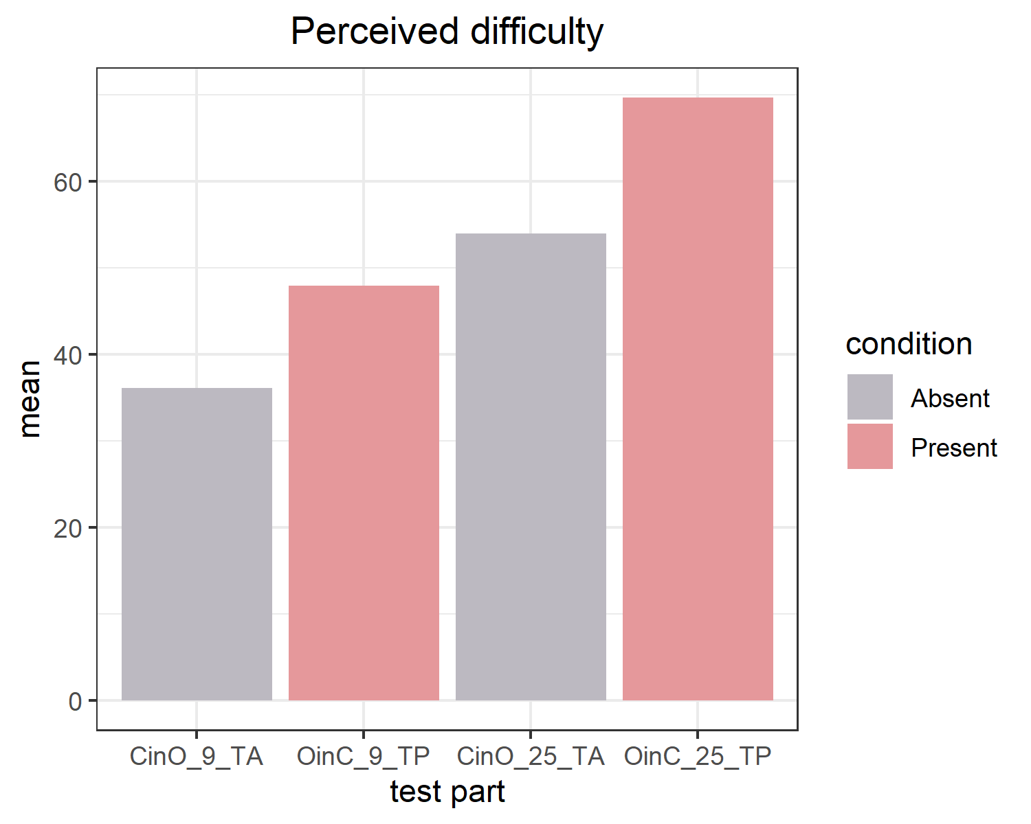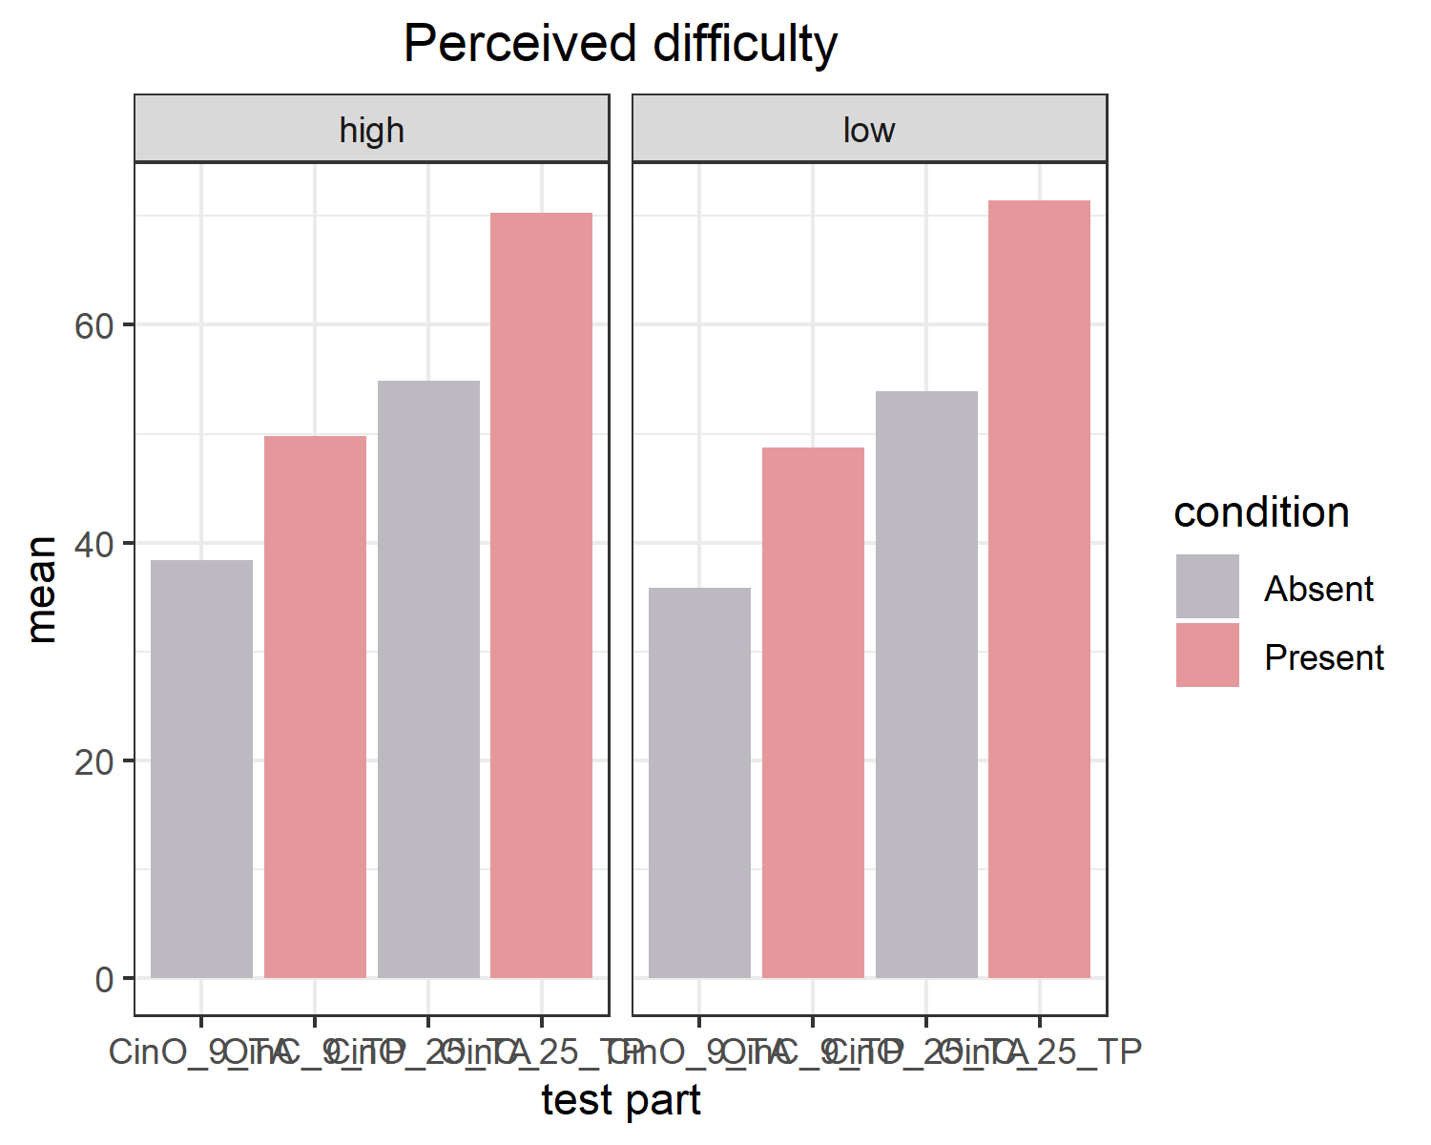

# Discussion

# References

Aust, F. (2019). *Citr: ’RStudio’ add-in to insert markdown citations*. Retrieved from <https://github.com/crsh/citr>

Aust, F., & Barth, M. (2022). *papaja: Prepare reproducible APA journal articles with R Markdown*. Retrieved from <https://github.com/crsh/papaja>

Barth, M. (2022). *tinylabels: Lightweight variable labels*. Retrieved from <https://cran.r-project.org/package=tinylabels>

Bates, D., Mächler, M., Bolker, B., & Walker, S. (2015). Fitting linear mixed-effects models using lme4. *Journal of Statistical Software*, *67*(1), 1–48. <https://doi.org/10.18637/jss.v067.i01>

Bates, D., & Maechler, M. (2021). *Matrix: Sparse and dense matrix classes and methods*. Retrieved from <https://CRAN.R-project.org/package=Matrix>

Boettiger, C., & Ho, T. (2022). *Piggyback: Managing larger data on a GitHub repository*. Retrieved from <https://CRAN.R-project.org/package=piggyback>

Chang, W., Cheng, J., Allaire, J., Xie, Y., & McPherson, J. (2020). *Shiny: Web application framework for r*. Retrieved from <https://CRAN.R-project.org/package=shiny>

Foa, E. B., Huppert, J. D., Leiberg, S., Langner, R., Kichic, R., Hajcak, G., & Salkovskis, P. M. (2002). The obsessive-compulsive inventory: Development and validation of a short version. *Psychological Assessment*, *14*(4), 485.

Henry, L., & Wickham, H. (2020). *Purrr: Functional programming tools*. Retrieved from <https://CRAN.R-project.org/package=purrr>

Kassambara, A. (2020). *Ggpubr: ’ggplot2’ based publication ready plots*. Retrieved from <https://CRAN.R-project.org/package=ggpubr>

Kuhn, M. (2021). *Caret: Classification and regression training*. Retrieved from <https://CRAN.R-project.org/package=caret>

Kuznetsova, A., Brockhoff, P. B., & Christensen, R. H. B. (2017). lmerTest package: Tests in linear mixed effects models. *Journal of Statistical Software*, *82*(13), 1–26. <https://doi.org/10.18637/jss.v082.i13>

Lovibond, P. F., & Lovibond, S. H. (1995). The structure of negative emotional states: Comparison of the depression anxiety stress scales (DASS) with the beck depression and anxiety inventories. *Behaviour Research and Therapy*, *33*(3), 335–343.

Mazor, M., & Fleming, S. M. (2022). Efficient search termination without task experience. *Journal of Experimental Psychology: General*.

Mazor, M., Mazor, N., & Mukamel, R. (2019). A novel tool for time-locking study plans to results. *European Journal of Neuroscience*, *49*(9), 1149–1156.

M<U+00FC>ller, K., & Wickham, H. (2021). *Tibble: Simple data frames*. Retrieved from <https://CRAN.R-project.org/package=tibble>

Pinheiro, J. C., & Bates, D. M. (2000). *Mixed-effects models in s and s-PLUS*. New York: Springer. <https://doi.org/10.1007/b98882>

R Core Team. (2021). *R: A language and environment for statistical computing*. Vienna, Austria: R Foundation for Statistical Computing. Retrieved from <https://www.R-project.org/>

Robinson, D., Hayes, A., & Couch, S. (2021). *Broom: Convert statistical objects into tidy tibbles*.

Sarkar, D. (2008). *Lattice: Multivariate data visualization with r*. New York: Springer. Retrieved from <http://lmdvr.r-forge.r-project.org>

Schloerke, B., Cook, D., Larmarange, J., Briatte, F., Marbach, M., Thoen, E., … Crowley, J. (2021). *GGally: Extension to ’ggplot2’*. Retrieved from <https://CRAN.R-project.org/package=GGally>

Toffolo, M. B., Hout, M. A. van den, Engelhard, I. M., Hooge, I. T., & Cath, D. C. (2014). Uncertainty, checking, and intolerance of uncertainty in subclinical obsessive compulsive disorder: An extended replication. *Journal of Obsessive-Compulsive and Related Disorders*, *3*(4), 338–344.

Toffolo, M. B., Hout, M. A. van den, Hooge, I. T., Engelhard, I. M., & Cath, D. C. (2013). Mild uncertainty promotes checking behavior in subclinical obsessive-compulsive disorder. *Clinical Psychological Science*, *1*(2), 103–109.

Toffolo, M. B., Van Den Hout, M. A., Engelhard, I. M., Hooge, I. T., & Cath, D. C. (2016). Patients with obsessive-compulsive disorder check excessively in response to mild uncertainty. *Behavior Therapy*, *47*(4), 550–559.

Wickham, H. (2016). *ggplot2: Elegant graphics for data analysis*. Springer-Verlag New York. Retrieved from <https://ggplot2.tidyverse.org>

Wickham, H. (2019). *Stringr: Simple, consistent wrappers for common string operations*. Retrieved from <https://CRAN.R-project.org/package=stringr>

Wickham, H. (2021a). *Forcats: Tools for working with categorical variables (factors)*. Retrieved from <https://CRAN.R-project.org/package=forcats>

Wickham, H. (2021b). *Tidyr: Tidy messy data*. Retrieved from <https://CRAN.R-project.org/package=tidyr>

Wickham, H., Averick, M., Bryan, J., Chang, W., McGowan, L. D., Fran<U+00E7>ois, R., … Yutani, H. (2019). Welcome to the tidyverse. *Journal of Open Source Software*, *4*(43), 1686. <https://doi.org/10.21105/joss.01686>

Wickham, H., Bryan, J., & Barrett, M. (2022). *Usethis: Automate package and project setup*. Retrieved from <https://CRAN.R-project.org/package=usethis>

Wickham, H., Fran?ois, R., Henry, L., & M?ller, K. (2021). *Dplyr: A grammar of data manipulation*. Retrieved from <https://CRAN.R-project.org/package=dplyr>

Wickham, H., & Hester, J. (2021). *Readr: Read rectangular text data*. Retrieved from <https://CRAN.R-project.org/package=readr>

Wickham, H., Hester, J., Chang, W., & Bryan, J. (2022). *Devtools: Tools to make developing r packages easier*. Retrieved from <https://CRAN.R-project.org/package=devtools>

Wilke, C. O. (2020). *Cowplot: Streamlined plot theme and plot annotations for ’ggplot2’*. Retrieved from <https://CRAN.R-project.org/package=cowplot>