Subclinical OCD and inference about absence in visual search

Noam Sarna1, Ruvi Dar1, & Matan Mazor2

1 School of Psychological Sciences, Tel Aviv University

2 Department of Psychological Sciences, Birkbeck, University of London, UK

Author note

Correspondence concerning this article should be addressed to Noam Sarna, Tel Aviv, Israel 69978. E-mail: [noamsarna@mail.tau.ac.il](mailto:noamsarna@mail.tau.ac.il)

Abstract

In previous research, obsessive-compulsive (OC) tendencies were associated with longer search times in a visual search setting. These findings, which were replicated and extended to a clinical sample, were specific to target-absent trials, with no effect on search times when a target was present in the display. Initially, this selectivity was interpreted as indicative of checking behavior in response to mild uncertainty. However, an alternative interpretation is that individuals with high OC tendencies (OC+) suffer from a more specific difficulty with inferences about absence. In two large-scale pre-registered online experiments (conceptual replication N = 1004, direct replication N = 226), we sought to replicate the original finding and shed further light on its underlying cause: an increased sensitivity to mild uncertainty, or a selective deficiency in inference about absence. In both experiments, we find no evidence of prolonged search times in target-absent trials for OC+ individuals. Taken together, our findings provide no support for the previously observed higher search times of OC+ participants in target-absent trials. We discuss potential differences relative to previous findings and implications for cognitive and metacognitive theories of OCD.

Subclinical OCD and inference about absence in visual search

In Experiment 1, target-absent search times were not significantly slower in OC+ compared to OC- individuals. While this stands in contrast to previous reports Toffolo, Van Den Hout, Engelhard, Hooge, & Cath (2016), our experiment differed from the original study in several respects. Most notably, search times in this study (~4.5s for target-absent and ~2.6s for target-present) were shorter compared to those in Toffolo et al. (2013) (~5.5 for target-absent and ~3.5s for target-present). Accordingly, we considered the possibility that the task used in experiment 1 may have been less challenging and potentially insufficient to elicit doubt and trigger repetitive checking behavior. In order to directly investigate this hypothesis, experiment 2 employed the original stimuli from Toffolo et al. (2013) within an online sample to ascertain whether the failure to reproduce the effect resulted from an excessively easy task.

## # A tibble: 3 x 2  
## # Groups: OCI_quantile [3]  
## OCI_quantile n  
## <chr> <int>  
## 1 else 48  
## 2 high 110  
## 3 low 68

## Warning: NAs introduced by coercion

## # A tibble: 3 x 2  
## OCI_quantile mean_acc  
## <chr> <dbl>  
## 1 else 0.833  
## 2 high 0.821  
## 3 low 0.829

## [1] 0

## [1] 1

# Methods

We report how we determined our sample size, all data exclusions (if any), all manipulations, and all measures in the study.

## Participants

The research complied with all relevant ethical regulations and was approved by the Research Ethics Committee of Tel-Aviv University (study ID number 0004169-1). Two hundred twenty-six participants were recruited via Prolific. We invited former participants whose OCI scores were in the top or bottom OCI quantile in Exp. 1. In line with our preregistered stopping rule, we kept data collection until we had invited all participants in the first and fourth quartiles from our previous experiment (n=250; n=239, respectively). Participants completed the OCI questionnaire in this second session to. We then split the sample into OC+/OC- groups based on cut-off scores from Toffolo et al. (2013) (OCI-R total score ≥ 17 for the OC+ group; OCI-R total score ≤ 5 for the OC- group). Our final sample consisted of 110 OC+ participants and 68 OC- participants. The entire experiment took 12 minutes to complete, and participants were paid £1.8 for their participation, equivalent to an hourly wage of £9.

## Material

We used the original stimuli used in Toffolo et al. (2013), as provided by the authors. The visual search task consisted of one block of 50 individual search displays, each containing 25 elements. Half of the search displays were target-absent trials, in which 25 squares with a gap in one of the four edges were presented, and the other half were target-present trials, in which 24 open squares were presented and one closed square, the target. To make sure participants understood the task, a practice phase was given first. The practice phase consisted of 4 search displays, (2 target-absent and 2 target-present). In the practice phase, participants got feedback on their response accuracy. Participants were able to move to the next part of the experiment only after getting all questions right (4/4). The practice phase repeated until the performance was perfect, or until it has repeated more than three times, at which point the experiment terminated. Each trial lasted for a maximum of 10 seconds or until a response was received. If no response was given within 10 seconds, the next trial immediately appeared. Feedback about the response was given only in the practice phase, to help participants learn the task efficiently. In the main part of the experiment, no feedback was given.

## Procedure

A static version of experiment 2 can be accessed here: jatos.mindprobe.eu/publix/Qkm6hi2c3vS. Experiment 2 was similar to experiment 1 with the following exceptions. First, the search task was more challenging due to an enlarged search grid, which led to larger gaps between stimuli, as well as reduced stimulus size and narrower sides of the squares. Second, experiment 2 did not had a perceived difficulty estimation part and was comprised of two parts: a visual search part and study questionnaires. Third, to make it identical to Toffolo et al. (2013), the practice trials in experiment 2 involved the same stimuli as the main blocks. Forth, participants were instructed to press the spacebar key to move to the search display screen. Once they pressed the space bar, the search display appeared immediately . Finally, the main part of the experiment included only the hard search type: looking for a closed square among open squares.

The preregistered analysis plan can be accessed at the following link: <https://osf.io/8a5mr>. As in Experiment 1, we employed the Mersenne Twister pseudorandom number generator to ensure that our preregistration preceded data collection Mazor, Mazor, and Mukamel (2019). Since Experiment 2 served as a direct replication, we adopted the same rejection criteria as Toffolo et al. (2013), in which participants were excluded if their error count exceeded 2.5 standard deviations from the mean error rate of the entire sample. In line with Experiment 1, participants were also excluded from the analysis if they incorrectly answered one or more attention-check questions.

###Randomization The order and timing of experimental events will be determined pseudo-randomly by the Mersenne Twister pseudorandom number generator, initialized to ensure registration time-locking (Mazor et al., 2019).

## Data analysis

We used R (Version 4.1.2; R Core Team, 2021) and the R-packages *}lvmisc* [@}R-lvmisc], *broom* (Version 1.0.5; Robinson, Hayes, & Couch, 2021), *caret* (Version 6.0.94; Kuhn, 2021), *citr* (Aust, 2019), *cowplot* (Version 1.1.1; Wilke, 2020), *devtools* (Version 2.4.5; Wickham, Hester, Chang, & Bryan, 2022), *dplyr* (Version 1.1.2; Wickham, Fran?ois, Henry, & M?ller, 2021), *forcats* (Version 1.0.0; Wickham, 2021a), *GGally* (Version 2.1.2; Schloerke et al., 2021), *ggplot2* (Version 3.4.2; Wickham, 2016), *ggpubr* (Version 0.6.0; Kassambara, 2020), *lattice* (Version 0.20.45; Sarkar, 2008), *lme4* (Version 1.1.32; Bates, Mächler, Bolker, & Walker, 2015), *lmerTest* (Version 3.1.3; Kuznetsova, Brockhoff, & Christensen, 2017), *Matrix* (Version 1.5.4; Bates & Maechler, 2021), *nlme* (Version 3.1.162; Pinheiro & Bates, 2000), *papaja* (Version 0.1.1; Aust & Barth, 2022), *piggyback* (Version 0.1.4; Boettiger & Ho, 2022), *purrr* (Version 1.0.1; Henry & Wickham, 2020), *readr* (Version 2.1.4; Wickham & Hester, 2021), *shiny* (Version 1.7.4; Chang, Cheng, Allaire, Xie, & McPherson, 2020), *stringr* (Version 1.5.0; Wickham, 2019), *tibble* (Version 3.2.1; M<U+00FC>ller & Wickham, 2021), *tidyr* (Version 1.3.0; Wickham, 2021b), *tidyverse* (Version 2.0.0; Wickham et al., 2019), *tinylabels* (Version 0.2.3; Barth, 2022), and *usethis* (Version 2.2.0; Wickham, Bryan, & Barrett, 2022) for all our analyses.

# Results

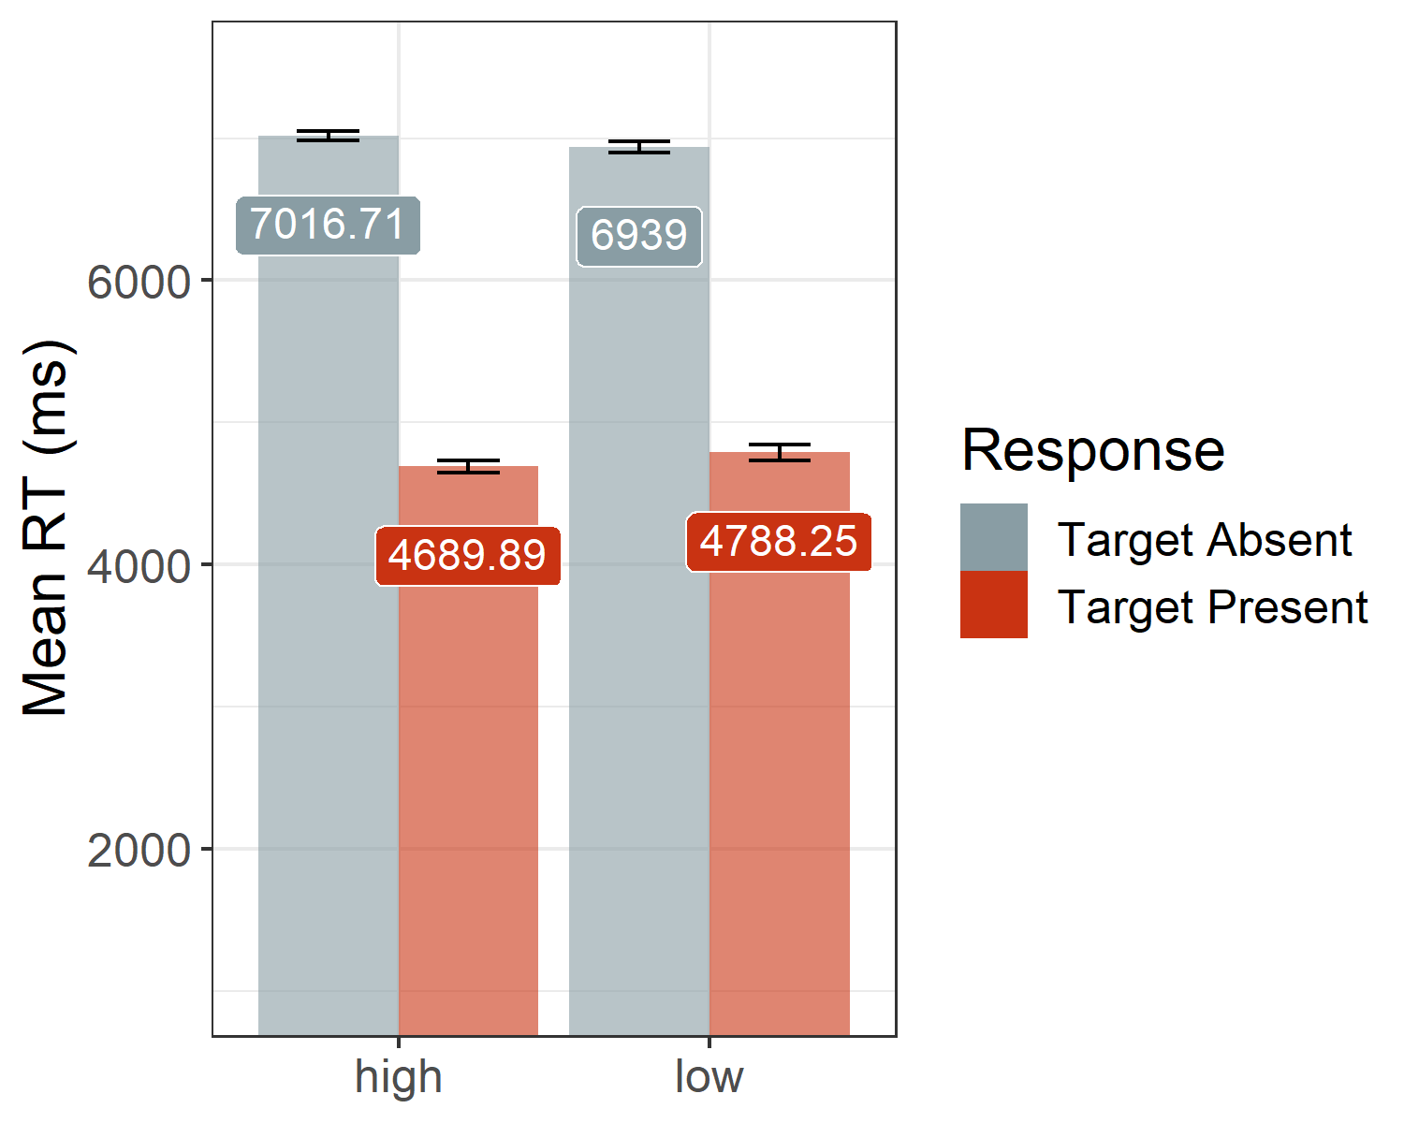

## [1] 4732.69

## [1] 7022.51

##   
## Paired t-test  
##   
## data: mean_RT by condition  
## t = 37.534, df = 174, p-value < 2.2e-16  
## alternative hypothesis: true difference in means is greater than 0  
## 95 percent confidence interval:  
## 2188.93 Inf  
## sample estimates:  
## mean of the differences   
## 2289.813

*Hypothesis 1 - Task validation*  
To validate our paradigm and demonstrate that target-absent searches are more difficult, we tested for an effect of condition (target-absent vs. target-present) on mean search times, collapsed across both groups. Our results revealed the expected difference $M_{D}=2,289.81$, 95% CI $\left[2,188.93,∞\right]$, $t\left(174\right)=37.53$, $p<.001$, $M_{D}=2,289.81$, 95% CI $\left[2,188.93,∞\right]$, $t\left(174\right)=37.53$, $p<.001$, list(estimate = “2,289.81”, conf.int = “[2,188.93, $\\infty$]”, statistic = “37.53”, df = “174”, p.value = “< .001”) with 4,732.69 ms for target-present responses and 7,022.51 ms for target-absent responses.

*Hypothesis 2 - Direct replication* The primary aim of experiment 2 was to examine the interaction between group (OC+ vs. OC-) and condition (target-absent vs. target-present). We conducted a one-tailed t-test using the difference in search times (mean RT absent - mean RT present) as the dependent variable and group (OC+ vs. OC-) as the independent variable, expecting a greater difference score for the OC+ group. The one-tailed t-test revealed no significant differences between the groups, $ΔM=174.09$, 95% CI $\left[−30.92,∞\right]$, $t\left(144.88\right)=1.41$, $p=.081$, $ΔM=174.09$, 95% CI $\left[−30.92,∞\right]$, $t\left(144.88\right)=1.41$, $p=.081$, list(estimate = “174.09”, conf.int = “[-30.92, $\\infty$]”, statistic = “1.41”, df = “144.88”, p.value = “.081”), providing no evidence for the expected interaction.

# Discussion

# References

Aust, F. (2019). *Citr: ’RStudio’ add-in to insert markdown citations*. Retrieved from <https://github.com/crsh/citr>

Aust, F., & Barth, M. (2022). *papaja: Prepare reproducible APA journal articles with R Markdown*. Retrieved from <https://github.com/crsh/papaja>

Barth, M. (2022). *tinylabels: Lightweight variable labels*. Retrieved from <https://cran.r-project.org/package=tinylabels>

Bates, D., Mächler, M., Bolker, B., & Walker, S. (2015). Fitting linear mixed-effects models using lme4. *Journal of Statistical Software*, *67*(1), 1–48. <https://doi.org/10.18637/jss.v067.i01>

Bates, D., & Maechler, M. (2021). *Matrix: Sparse and dense matrix classes and methods*. Retrieved from <https://CRAN.R-project.org/package=Matrix>

Boettiger, C., & Ho, T. (2022). *Piggyback: Managing larger data on a GitHub repository*. Retrieved from <https://CRAN.R-project.org/package=piggyback>

Chang, W., Cheng, J., Allaire, J., Xie, Y., & McPherson, J. (2020). *Shiny: Web application framework for r*. Retrieved from <https://CRAN.R-project.org/package=shiny>

Henry, L., & Wickham, H. (2020). *Purrr: Functional programming tools*. Retrieved from <https://CRAN.R-project.org/package=purrr>

Kassambara, A. (2020). *Ggpubr: ’ggplot2’ based publication ready plots*. Retrieved from <https://CRAN.R-project.org/package=ggpubr>

Kuhn, M. (2021). *Caret: Classification and regression training*. Retrieved from <https://CRAN.R-project.org/package=caret>

Kuznetsova, A., Brockhoff, P. B., & Christensen, R. H. B. (2017). lmerTest package: Tests in linear mixed effects models. *Journal of Statistical Software*, *82*(13), 1–26. <https://doi.org/10.18637/jss.v082.i13>

Mazor, M., Mazor, N., & Mukamel, R. (2019). A novel tool for time-locking study plans to results. *European Journal of Neuroscience*, *49*(9), 1149–1156.

M<U+00FC>ller, K., & Wickham, H. (2021). *Tibble: Simple data frames*. Retrieved from <https://CRAN.R-project.org/package=tibble>

Pinheiro, J. C., & Bates, D. M. (2000). *Mixed-effects models in s and s-PLUS*. New York: Springer. <https://doi.org/10.1007/b98882>

R Core Team. (2021). *R: A language and environment for statistical computing*. Vienna, Austria: R Foundation for Statistical Computing. Retrieved from <https://www.R-project.org/>

Robinson, D., Hayes, A., & Couch, S. (2021). *Broom: Convert statistical objects into tidy tibbles*.

Sarkar, D. (2008). *Lattice: Multivariate data visualization with r*. New York: Springer. Retrieved from <http://lmdvr.r-forge.r-project.org>

Schloerke, B., Cook, D., Larmarange, J., Briatte, F., Marbach, M., Thoen, E., … Crowley, J. (2021). *GGally: Extension to ’ggplot2’*. Retrieved from <https://CRAN.R-project.org/package=GGally>

Toffolo, M. B., Hout, M. A. van den, Engelhard, I. M., Hooge, I. T., & Cath, D. C. (2014). Uncertainty, checking, and intolerance of uncertainty in subclinical obsessive compulsive disorder: An extended replication. *Journal of Obsessive-Compulsive and Related Disorders*, *3*(4), 338–344.

Toffolo, M. B., Hout, M. A. van den, Hooge, I. T., Engelhard, I. M., & Cath, D. C. (2013). Mild uncertainty promotes checking behavior in subclinical obsessive-compulsive disorder. *Clinical Psychological Science*, *1*(2), 103–109.

Toffolo, M. B., Van Den Hout, M. A., Engelhard, I. M., Hooge, I. T., & Cath, D. C. (2016). Patients with obsessive-compulsive disorder check excessively in response to mild uncertainty. *Behavior Therapy*, *47*(4), 550–559.

Wickham, H. (2016). *ggplot2: Elegant graphics for data analysis*. Springer-Verlag New York. Retrieved from <https://ggplot2.tidyverse.org>

Wickham, H. (2019). *Stringr: Simple, consistent wrappers for common string operations*. Retrieved from <https://CRAN.R-project.org/package=stringr>

Wickham, H. (2021a). *Forcats: Tools for working with categorical variables (factors)*. Retrieved from <https://CRAN.R-project.org/package=forcats>

Wickham, H. (2021b). *Tidyr: Tidy messy data*. Retrieved from <https://CRAN.R-project.org/package=tidyr>

Wickham, H., Averick, M., Bryan, J., Chang, W., McGowan, L. D., Fran<U+00E7>ois, R., … Yutani, H. (2019). Welcome to the tidyverse. *Journal of Open Source Software*, *4*(43), 1686. <https://doi.org/10.21105/joss.01686>

Wickham, H., Bryan, J., & Barrett, M. (2022). *Usethis: Automate package and project setup*. Retrieved from <https://CRAN.R-project.org/package=usethis>

Wickham, H., Fran?ois, R., Henry, L., & M?ller, K. (2021). *Dplyr: A grammar of data manipulation*. Retrieved from <https://CRAN.R-project.org/package=dplyr>

Wickham, H., & Hester, J. (2021). *Readr: Read rectangular text data*. Retrieved from <https://CRAN.R-project.org/package=readr>

Wickham, H., Hester, J., Chang, W., & Bryan, J. (2022). *Devtools: Tools to make developing r packages easier*. Retrieved from <https://CRAN.R-project.org/package=devtools>

Wilke, C. O. (2020). *Cowplot: Streamlined plot theme and plot annotations for ’ggplot2’*. Retrieved from <https://CRAN.R-project.org/package=cowplot>