Subclinical OCD and inference about absence in visual search: pre-registration document

Noam Sarna1, Matan Mazor2 & Ruvi Dar1

1School of Psychological Sciences, Tel Aviv University

2 Department of Psychological Sciences, Birkbeck, University of London, UK

Author note

Address all correspondence to Noam Sarna, School of Psychological Sciences, Tel Aviv University, Tel Aviv, Israel 69978.

Email Address: [Noamsarna@mail.tau.ac.il](mailto:Noamsarna@mail.tau.ac.il)

Abstract

Inference about the absence of a target is qualitatively different than inference about the presence of one. While the latter is established from a signal evident in the external world, the former is based on the internal belief of not having missed the target. Obsessive-compulsive disorder (OCD) is characterized by inflated levels of doubt and difficulty accessing internal states. Previous research has shown that obsessive-compulsive participants indeed struggle when searching for an absent target; however, results were confounded by heightened uncertainty. In this study, we designed a paradigm intended to decouple absence from difficulty to probe the specific effects of obsessive-compulsive tendencies on visual processing and decision making in the absence of a target. High and low OC participants will be presented with 96 visual search displays and asked to decide whether a target is "absent" or "present." In addition, participants will provide information about explicit metacognitive knowledge to probe for discrepancies between behavior and belief. By introducing an easy target-absent condition, we can dissociate specific difficulties with inference about absence from more general difficulties with uncertainty. This experiment will provide key information about interactions between obsessive-compulsive tendencies and inference about absence, which are an essential window into OCD and metacognitive impairments.

# Introduction

Previous work by Toffolo et al., (2013), using a visual search paradigm in high (OC+) and low (OC-) OC individuals, provided evidence that OC+ participants search longer in target-absent trials. This robust finding has been replicated (Toffolo et al., 2014) and extended to a clinical sample of OCD patients (Toffolo et al., 2016). In these experiments, checking behavior was operationalized by search time and high and low uncertainty were operationalized by means of contrasting target-present and target-absent trials. Therefore, the longer search times for the OC+ group in target-absent trials were interpreted as perseverative checking for mild uncertainty. However, the paradigm structure used in Toffolo's experiments has conflated uncertainty with target absence. Decisions about target absence are indeed qualitatively different from target-present trials since the evidence for lack of stimuli is less salient and based on the metacognitive belief of not having missed the target (Mazor, 2021).

Nevertheless, some decisions about absence can be accompanied by low subjective uncertainty, for instance, perceiving the absence of a red dot among blue dots. Distinguishing features of inference about absence from uncertainty will be achieved by introducing such a search where absence can be more directly inferred and will allow us to probe for distinct behavior of OC+ in absent trials.

# Methods

We report how we determined our sample size, all data exclusions (if any), all manipulations, and all measures in the study.

## Participants

The research complied with all relevant ethical regulations and was approved by the Research Ethics Committee of Tel-Aviv University (study ID number 0004169-1). Participants will be recruited via Prolific and selected based on their acceptance rate (>95%) and for being native English speakers, located in the UK, and not participating in former study pilots. We encountered graphical problems with Safari browser during the pilot study, so we will ask participants to use only other browsers.

The entire experiment will take 14 minutes to complete (the median completion time in a pilot study). Participants will be paid £2 for their participation, equivalent to an hourly wage of £8.57.

**Material**

Visual search task

The experiment described in this study was adapted from Mazor & Fleming (2022), with stimuli created to replicate the ones used in the Toffolo et al. (2013) experiment. All elements (distractors and target) and their placement on the search grid were made to replicate as closely as possible the paradigm used in Toffolo et al. (2013).

The visual search task will consist of 4 blocks, each containing 24 trials of searching for either a closed or an open square. To make sure participants understand the task, a practice phase will be given first. The practice phase will consist of one block with six trials of visual search. Elements in both practice and main part will be white on dark grey background. Each trial will last for a maximum of 10 seconds or until a response is received. If no response is given within 10 seconds, the next trial will immediately appear. Feedback about the response (wrong/right) will be given only in the practice phase, to help participants learn the task efficiently. In the main part of the experiment, no feedback will be given, as was the case in the original paradigm (Toffolo et al. 2013).

## Procedure

Participants will first be instructed about the experiment's structure, which comprises three parts: A visual search part, questions about the visual search part, and some more general questions. Then, they will be informed about the main part of the experiment – the visual search part. Specifically, their task is to report, as accurately and quickly as possible, whether a target stimulus was present (press 'J') or absent (press 'F'). Then, practice trials will be delivered, in which the target stimulus is a rotated T, and distractors are rotated Ls. The purpose of the practice trials is to familiarize participants with the task structure. For these practice trials, the number of items will always be 4. In the practice trials, participants will be given feedback about the accuracy of their responses. The feedback will appear right after a response is given. If the response is correct, then the word “Correct!” will immediately pop on the screen, for 1 second. If the response is wrong, the word “wrong!” will immediately pop on the screen for 5 seconds. The extended duration of the word “wrong” is intended to feel aversive and to make sure participants are paying full attention and giving accurate responses (a pilot study showed higher accuracy rates when using the penalty method). Practice trials will be delivered in one block of 6 trials, and the main part of the experiment will start only once participants respond correctly on at least five trials.

In the main part of the experiment, participants will look for an *O* (a square with rounded corners. Figure 1, right panel) or a rotated *C* (a square with rounded corners with a gap in one of its edges. Figure 1, left panel). The distractors in each trial will be either *O*'s when searching for *C* or *C*'s when searching for an *O*. Due to a search asymmetry for open edges, searching of *O* among *C*’s is qualitatively harder than the searching for a *C* among *O*’s (Treisman & Gormican, 1988). In each trial the target can be present or absent. Set sizes will be 9 or 25, resulting in a 2X2X2 design (search type: '*C* in *O*' or '*O* in *C*'; Target: present/absent; set size: 9 or 25). Block order will be counterbalanced between participants: for about half of the participants, it will be: '*C* in *O*', '*C* in *O*', '*O* in *C*', ' *O* in *C* '. For the other half, it would be: ' *O* in *C* ', ' *O* in *C* ', '*C* in *O*', '*C* in *O*'. For all participants, target change will be emphasized between the second and third blocks. Trial order will be fully randomized within individual blocks.

Figure - The visual search task: the main part of the experiment. Left panel: easy search, searching for a C (open square) among O’s (closed squares). Right panel: hard search, searching for an O (closed square) among C’s (open squares).

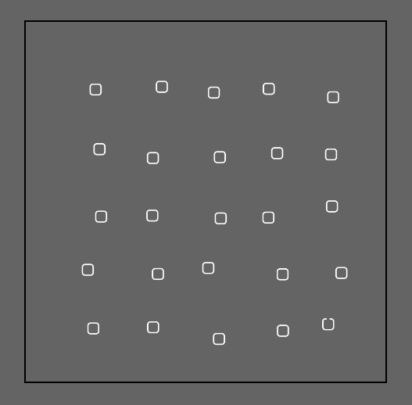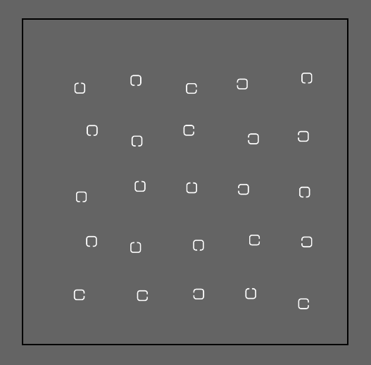

After completing the first two blocks, participants will be given a short break encouraging them to let their eyes rest before continuing – "Before you continue, we suggest that you take a short break. You can let your eyes rest for a moment and take a few breaths. When you are ready click on next/spacebar to move to the next block."

Critically and unknown to subjects, the first two trials of the first and third blocks will always be target-absent trials (one of each set-size), presented in randomized order. Upon finishing the main part of the experiment, participants will move to the second part of the experiment, the difficulty estimation part, and will be informed:

"In the next part you will answer questions regarding the first part you have just completed. Some searches are easier than others. This means that participants find the target faster in some searches, compared to others. In the following part you will be asked to rate the difficulty level of finding a certain target among different distractors."

Before evaluating the perceived difficulty of the trials, we added an explanation, telling participants that each question would contain a picture of the trial with a red square around the target if it were present or no marking at all if the target was absent. Doing that helps us to assure participants are not actively searching for the target in the difficulty estimation part.

Participants will then be requested to rate the perceived difficulty of four different trial types:

"To the best of your ability, try to rate how hard it is to find a target among distractors from very easy (fastest) to very hard (slowest). Drag the slider into position and click "continue" when you have finished rating."

The four questions will be (each question will be accompanied by a picture depicting the trial):

1. How difficult is detecting the presence closed square among many open squares
2. How difficult is detecting the presence of one closed square among few open squares
3. How difficult is detecting the absence of one open square among many closed squares
4. How difficult is detecting the absence of one open square few closed squares

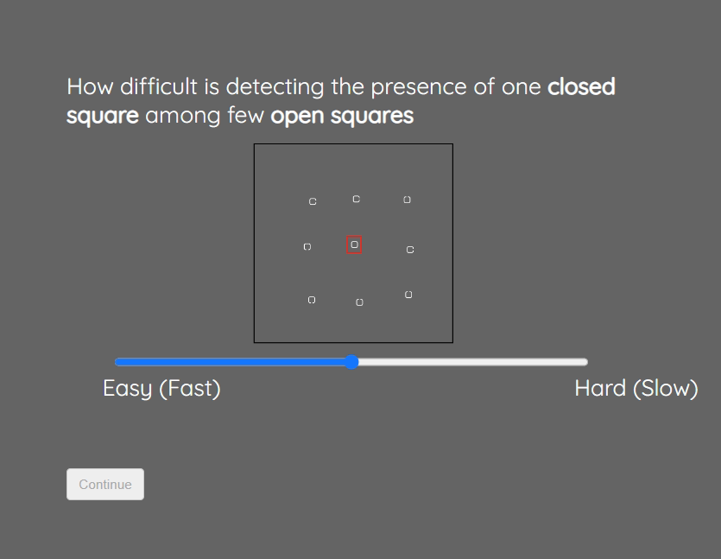

*Figure 2: Perceived difficulty rating. Participants will drag the slider into position and click 'Continue' when they finish rating. The continue button will stay disabled unless the slider has moved.*

We focused on these four trials as this was our most intriguing hypothesis, comparing easy target-absent trials to more challenging target-present trials. After finishing this part, participants will be informed they have reached the final part of the experiment. In the last part, they will fill out the OCI-R (Foa et al., 2002) and DASS-21 (Lovibond & Lovibond, 1995) questionnaires. We inserted two attention checks questions between the regular OCI items, asking participants to select a certain answer (‘If you read this question, check the option ‘Not at all’). As part of an exploratory analysis, we added another item to the OCI asking specifically about problems with inference about absence (‘I sometimes go back and check that I didn’t do something bad unintentionally’).

Upon completion, participants they will receive a message thanking them for participation and then will be redirected back to prolific with a completion code.

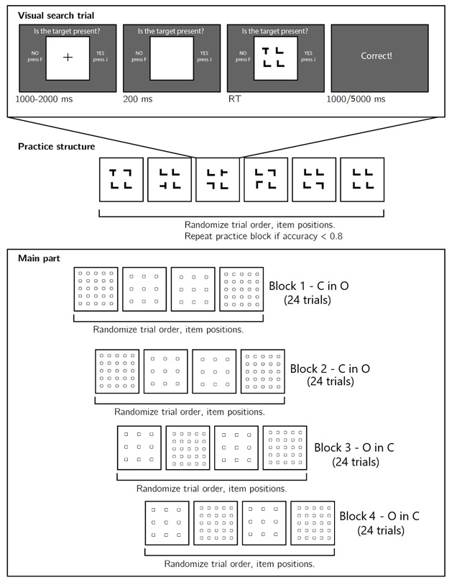

Figure 3: Experimental design. Top panel: each visual search trial will start with a fixation cross. The search display will remain visible until a response will be recorded. Middle panel: after reading the instructions, participants will practice the visual search task in blocks of 6 trials until they reach an accuracy level of 83% correct or higher (at most one error per block of 6 trials). Bottom panel: the main part of the experiment comprised 96 trials in 4 blocks.

At the beginning of the task, a sequence will be randomly chosen. Each sequence comprised four blocks, two of the same type in succession, and 24 trials each. Sequence A consists two blocks of searching for *C* in *O*'s, then searching for *O* in *C*'s. Sequence B is the opposite, searching for *O* in *C*'s first followed by *C* in *O*'s search. The block search type will change only once to prevent confusion in the first trials. Randomizing the orders of blocks will assure there is no order effect influencing the results. Unknown to the subjects, the first two trials of the first and third blocks will always be target-absent trials, one small set size (9) and one with a big set size (25), appearing in random order. Throughout the experiment, an incorrect answer will result in a 5-second screen freeze to minimize mistakes and achieve high accuracy scores.

## Randomization

The order and timing of experimental events will be determined pseudo-randomly by the Mersenne Twister pseudorandom number generator, initialized to ensure registration time-locking (Mazor, Mazor, & Mukamel, 2019).

# Data analysis

## Rejection criteria

Participants will be excluded for making more than 15% errors in the main part of the experiment or for having extremely fast or slow reaction times (below 100 milliseconds or above 5 seconds) in more than 25% of the trials. Error trials and trials with response time below 100 milliseconds or above 5 seconds will be excluded from the response-time analysis. Participants will also be excluded from the analysis if they are wrong in one or more of the attention checks questions (asking them to mark a specific answer in the questionnaire).

## Hypotheses and analysis plan

This experiment is designed to test several hypotheses about the behavior of individuals high on obsessive-compulsive tendencies (OC+) in a visual search paradigm. We will focus on search slopes during target-absent trials and the perceived difficulty of target-absent vs. target-present trials. Participants will be divided to OC+/OC- groups based on OCI scores (1st/4th quartiles).

Subject-wise search slopes will be extracted for each combination of search type (*C* in *O*; *O* in *C*) and presence of the target (present/absent) by fitting a linear regression model to predict reaction time as a function of set size, with one intercept and one set-size term. We will use search slope as a dependent measure for all of our hypotheses concerning search times. We will use the full sample for the first two hypotheses validating our paradigm.

*Hypothesis 1* - To validate our methods and the quality of our data, we will test for a difference in slopes between the two search types (*C* in *O*; *O* in *C*) beyond the presence of the target (present/absent). We expect to find an overall steeper slopes for *O* in *C* search compared to *C* in *O* search.To compare these slopes, we will use a one-tailed paired t-test.

*Hypothesis 2-* We will test the difference of slopes between *O* in *C* in target presence and *C* in *O* in target absence. Based on our pilot and paradigm design, we expect to find a steeper slope for *O* in *C* in target presence than *C* in *O* in target absence. To compare these slopes, we will use a one-tailed paired t-test.

These first two control comparisons will serve to confirm that we successfully created a target-absence trial that is easier than a target-present trial. This will allow us to explore unique properties of inference about absence controlling for search difficulty.

*Hypothesis 3*: Replication of previous findings by Toffolo et al., (2013).  In order to directly replicate Toffolo’s findings, we will focus on the hard search type (*O* in *C*) with the larger set size (set size =25), the same as was used in both studies (Toffolo et al., 2013, 2014). We will compare the mean RT between the two groups (OC+/OC-) in both target-present and target-absent trials. For this hypothesis, we will conduct a mixed-effects ANOVA, with mean RT as a dependent variable, group (OC+/OC-) as a between-subject variable and target presence (present/absent) as within-subject variable. We expect to find an interaction between group and target present, in which mean search times difference between OC+ and OC- will be significantly stronger in target-absent trials.

*Hypothesis 4:* Extension of the replication mentioned above of findings by Toffolo et al., (2013). Following the previous hypothesis, we will conduct the same mixed-effects ANOVA, with group (OC+/OC-) as between-subject variable and target presence (present/absent) as within-subject variables, only this time we will focus on the search slopes (reaction time as a function of set size) as a dependent variable. We will test for an interaction between group and target presence, in which the search slope differences between OC+ and OC- is significantly stronger in target-absent trials. In conjunction with Hypothesis 3, Hypothesis 4 will arbitrate between a constant time cost to decisions about absence in OC+ individuals, versus a time cost that is sensitive to set size.

*Hypothesis 5:* Difficulty of OC+ participants with inference about absence in the easy search type. We will check for the interaction between group and target presence and focus on the easy search type (*C* *in O*). We will test the hypothesis that the search slope differences between OC+ and OC- will be significantly stronger in target-absent trials. Obtaining this interaction pattern would strengthen the hypothesis that decisions about absence contribute to OC+ search times irrespective of task uncertainty (figure 4 top panel). On the other hand, finding the interaction between group and target presence with the same pairwise comparison pattern, only in the hard search (Hypothesis 4, above), and not in the easy search, will strengthen the competing hypothesis that heightened uncertainty contributes to OC+ search times (figure 4 bottom panel).

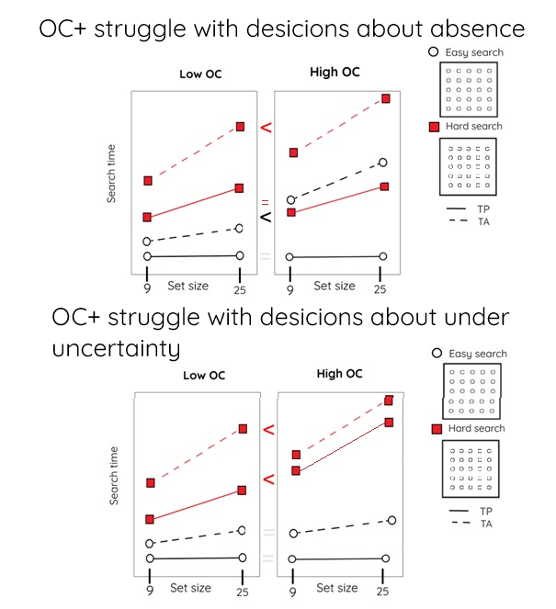

Figure 4: Two possible search time patterns and their interpretation.

*Hypothesis 6:* Model comparison – search type or target-presence contribute to OC+ search time. In order to directly test the hypothesis that target-presence affects OC+ search time to a greater extent than search type we will conduct a model comparison between two multiple regression models. The first model will predict search slopes using the following predictors: search type; group; the interaction between search type and target presence; the interaction between search type and group. The first model will use the following formula:

*slope\_estimate~ 1+group+search\_type\*target\_presence+ search\_type \*group*

The second model will predict search slopes using the following predictors: search type; group; the interaction between search type and target presence and the interaction between target presence and group. The second model will use the following formula:

*slope\_estimate~ 1+group+ search\_type \*target\_present+target\_present\*group*

These two models differ only in their last interaction effect. Thus, their complexity level (that is, the number of fitted coefficients) will be the same, which will allow us to compare these models directly. We will compare model performance using leave-one-out cross validation.

C:\Users\User\Downloads\lagrida_latex_editor.png*Hypothesis 7*: First trials analysis. Prior to the analysis, we will correct for trial and block order effects by using the following formula:

Where RTs,b,t corresponds to the reaction time of subject s in block b and trial t, and RTs to the mean RT for subject s in trials 1 and 2 of blocks 1 and 3. Then, at the whole group level we will compare the slopes of the two types of searches (*O* in *C* and *C* in *O)* to see if they are different already in the first trials, using a two-tailed paired t-test. Finding a difference between them will serve as a sign for metacognitive knowledge about the asymmetry between the two types of searches, that was in place before experiencing target-present trials.

*Hypothesis 8*: Interaction between group and search time on first-trials slopes. Using a mixed-effects ANOVA, with slope as a dependent variable and group and search type as the two between- and within-subject independent variables, we will test for an interaction of group (OC+/OC-) with search type.

*Hypothesis 9:* Correlations between OC tendencies and search slopes. In order to strengthen the validity of our results, we will reanalyze our main hypothesis using the entire range of OC scores. That way, we will be able to investigate whether search times in absent trials varies as a function of OC tendencies. We will do so by correlating OC tendencies with search slopes in target-absent and target presence conditions. Following Toffolo et al. (2014) findings, we expect to find positive correlations between OC tendencies and search slopes in absent trials but not in search slopes for present trials.

Finally, in order to test the robustness of our results, we will add depression and anxiety scores as covariates into our model, for possible mediating effects. We will use the DASS questionnaire to measure anxiety and depression (Lovibond & Lovibond, 1995).

**Exploratory analysis**

Measuring the perceived difficulty of participants will serve us to compare between participants’ explicit metacognitive knowledge and their behavior. Findings a discrepancy between the perceived difficulty and task performance in the OC+ group, will indicate a dissociation and disruption between action and knowledge. On the other hand, finding a correspondence between the perceived difficulty and task performance in the OC+ group, will indicate an intact behavior monitoring and good insight. Results in the OC- group will serve as a control group.

## Statistical power

In order to run a statistical power analysis, we extracted effect sizes from Toffolo and colleagues work (2013, 2014). We focused on the comparison between the two groups (OC+/OC-) in target-absent trials. We used the means and SD specified in both studies (Toffolo et al., 2013, 2014) and converted these means and SD into Cohen’ d values using the following formula:

*Cohen's d = (M2 - M1) ⁄ SDpooled*

*SDpooled = √ ((SD12 + SD22) ⁄ 2)*

We computed the following Cohen’s Ds for Toffolo et al., 2013 and 2014 papers: 0.48 and 0.29 respectively. Since Toffolo et al. (2014) used a larger sample (2014: n=109; 2013: n=68) we considered the effect they found as more statistical sound. Hence, we conducted statistical power calculations using the R-pwr package (Champely, 2020), and report that with a minimum of 250 participants in each group, we will have a statistical power of 90% to detect effects of size 0.30 in a one-tailed t-tests (Hypothesis 3, direct replication).

# References

Champely, S. (2020). *Pwr: Basic functions for power analysis*. Retrieved from <https://CRAN.R-project.org/package=pwr>

Mazor, M., Mazor, N., & Mukamel, R. (2019). A novel tool for time-locking study plans to results. *European Journal of Neuroscience*, *49*(9), 1149–1156.

Foa, E. B., Huppert, J. D., Leiberg, S., Langner, R., Kichic, R., Hajcak, G., & Salkovskis, P. M. (2002). The Obsessive-Compulsive Inventory: Development and validation of a short version. *Psychological Assessment*, *14*(4), 485.

Lovibond, P. F., & Lovibond, S. H. (1995). The structure of negative emotional states: Comparison of the Depression Anxiety Stress Scales (DASS) with the Beck Depression and Anxiety Inventories. *Behaviour Research and Therapy*, *33*(3), 335–343.

Mazor, M. (2021). *Inference about absence as a window into the mental self-model*.

Mazor, M., & Fleming, S. M. (2022). Efficient search termination without task experience. *Journal of Experimental Psychology: General*.

Toffolo, M. B., van den Hout, M. A., Engelhard, I. M., Hooge, I. T., & Cath, D. C. (2014). Uncertainty, checking, and intolerance of uncertainty in subclinical obsessive compulsive disorder: An extended replication. *Journal of Obsessive-Compulsive and Related Disorders*, *3*(4), 338–344.

Toffolo, M. B., Van Den Hout, M. A., Engelhard, I. M., Hooge, I. T., & Cath, D. C. (2016). Patients with obsessive-compulsive disorder check excessively in response to mild uncertainty. *Behavior Therapy*, *47*(4), 550–559.

Toffolo, M. B., van den Hout, M. A., Hooge, I. T., Engelhard, I. M., & Cath, D. C. (2013). Mild uncertainty promotes checking behavior in subclinical obsessive-compulsive disorder. *Clinical Psychological Science*, *1*(2), 103–109.

Treisman, A., & Gormican, S. (1988). Feature analysis in early vision: Evidence from search asymmetries. *Psychological Review*, *95*(1), 15.