Metacognitive contributions to search termination: pre-registration document

Matan Mazor1 & Stephen M. Fleming1,2,3

1 Wellcome Centre for Human Neuroimaging, UCL

2 Max Planck UCL Centre for Computational Psychiatry and Ageing Research

3 Department of Experimental Psychology, UCL

Author note

Correspondence concerning this article should be addressed to Matan Mazor, 12 Queen Square, London WC1N 3BG. E-mail: [mtnmzor@gmail.com](mailto:mtnmzor@gmail.com)

Abstract

When searching for a target object among distractors, a robust finding in cognitive science is that search time varies as a function of the number of distractors and their similarity to the target object. This is true not only for the time taken to say a target is present, but also for the time taken to terminate a search and conclude that a target object is absent. However, while models of visual search have successfully characterized perceptual and cognitive contributions to target detection, the mechanisms underpinning when to terminate a search and conclude that a target is absent are poorly understood. In other words, when do people decide to give up and conclude that nothing is there? One hypothesis is that efficient search termination involves metacognitive knowledge such as the expected difficulty of the search, target salience, or fluctuations in one’s attentional state. By focusing on the first few trials in a visual search task, here we control participants’ ability to base their search termination on metacognitive knowledge before engaging with the task, and the effect of experience on the shaping of this knowledge. The results of this experiment will provide foundational information about the latent metacognitive variables contributing to search termination, and refine our understanding of how people judge the absence of stimuli.

Metacognitive contributions to search termination: pre-registration document

# Methods

We report how we determined our sample size, all data exclusions (if any), all manipulations, and all measures in the study.

## Participants

The research complied with all relevant ethical regulations, and was approved by the Research Ethics Committee of University College London (study ID number 1260/003). 886 Participants were recruited via Prolific, and gave their informed consent prior to their participation. They were selected based on their acceptance rate (>95%) and for being native English speakers. We collected data until we reached 320 included participants for each of our hypotheses (after applying our pre-registered exclusion criteria). The entire experiment took around 3 minutes to complete (median completion time in our pilot data: 3:06 minutes). Participants were paid £0.38 for their participation, equivalent to an hourly wage of £7.60.

## Procedure

Participants were first instructed about the visual search task. Specifically, that their task is to report, as accurately and quickly as possible, whether a target stimulus was present (press ‘J’) or absent (press ‘F’). Then, practice trials were delivered, in which the target stimulus was a rotated *T*, and distractors are rotated *L*s. The purpose of the practice trials was to familiarize participants with the structure of the task. For these practice trials the number of items was always 3. Practice trials were delivered in small blocks of 6 trials each, and the main part of the experiment started only once participants responded correctly on at least five trials in a block (see Figure 1).

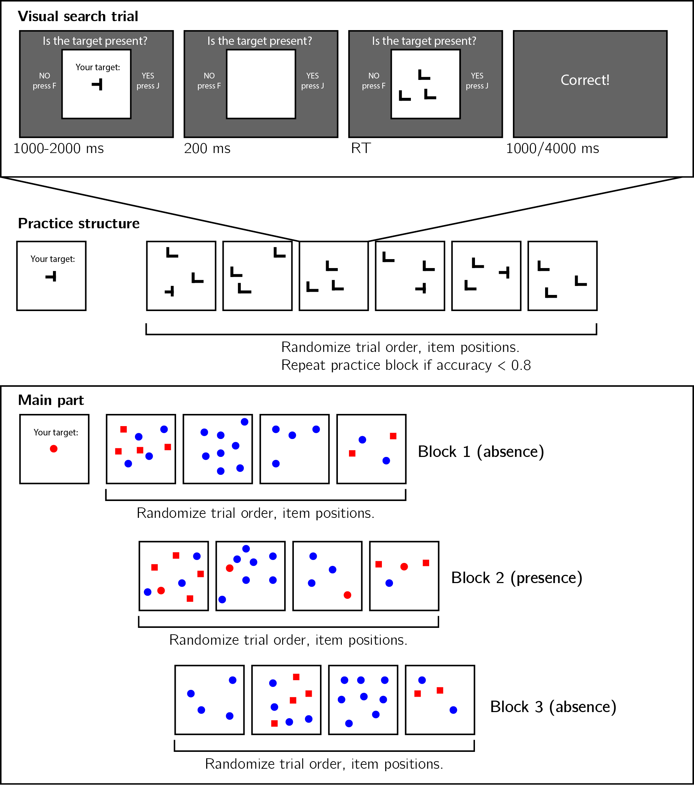

*Figure* *1:*. Experimental design. Top panel: each visual search trial started with a screen indicating the target stimulus. The search display remained visible until a response is recorded. To motivate accurate responses, the feedback screen remained visible for one second following correct responses and for four seconds following errors. Middle panel: after reading the instructions, participants practiced the visual search task in blocks of 6 trials, until they had reached an accuracy level of 83% correct or higher (at most one error per block of 6 trials). Bottom panel: the main part of the experiment comprised 12 trials only, in which the target was a red circle. Unbeknown the subjects, only trials 5-8 (Block 2) were target-present trials, and the remaining trials were target-absent trials. Each 4-trial block followed a 2 by 2 design, with factors being set size (4 or 8) and distractor type (color or conjunction; blue circles only or blue circles and red squares, respectively).

In the main part of the experiment, participants searched for a red circle among blue circles or a mixed array of blue circles and red squares. Set sizes was 4 or 12, resulting in a 2-by-2 design (search type: color or color $×$ shape, by set size: 4 or 12). Critically, and unknown to subjects, the first four trials were always target-absent trials (one of each set-size $×$ search-type combination), presented in randomized order. These trials were followed by the four corresponding target-present trials, presented in randomized order. The final four trials were again target-absent trials, presented in randomized order.

### Randomization.

The order and timing of experimental events was determined pseudo-randomly by the Mersenne Twister pseudorandom number generator, initialized in a way that ensures registration time-locking (Mazor, Mazor, & Mukamel, 2019).

## Data analysis

### Rejection criteria.

Participants were excluded for making more than one error in the main part of the experiment, or for having extremely fast or slow reaction times in one or more of the tasks (below 250 milliseconds or above 5 seconds in more than 25% of the trials).

Error trials, and trials with response time below 250 milliseconds or above 1 second were excluded from the response-time analysis.

### Data preprocessing.

To control for within-block trial order effects, a separate linear regression model was fitted to the data of each block, predicting search time as a function of trial serial order ($RT∼β_{0}+β_{1}i$, with $i$ denoting the mean-centered serial position within a block). Search times were corrected by subtracting the product of the slope and the mean-centered serial position, in a block-wise manner.

### Hypotheses and analysis plan.

This study is designed to test several hypotheses about the contribution of metacognitive knowledge to search termination, the state of this knowledge prior to engaging with the task, and the effect of experience trials on this metacognitive knowledge. We outline some possible search time patterns and their interpretation in Fig. 2. In the next section we demonstrate our hypotheses and analyses on pilot data.

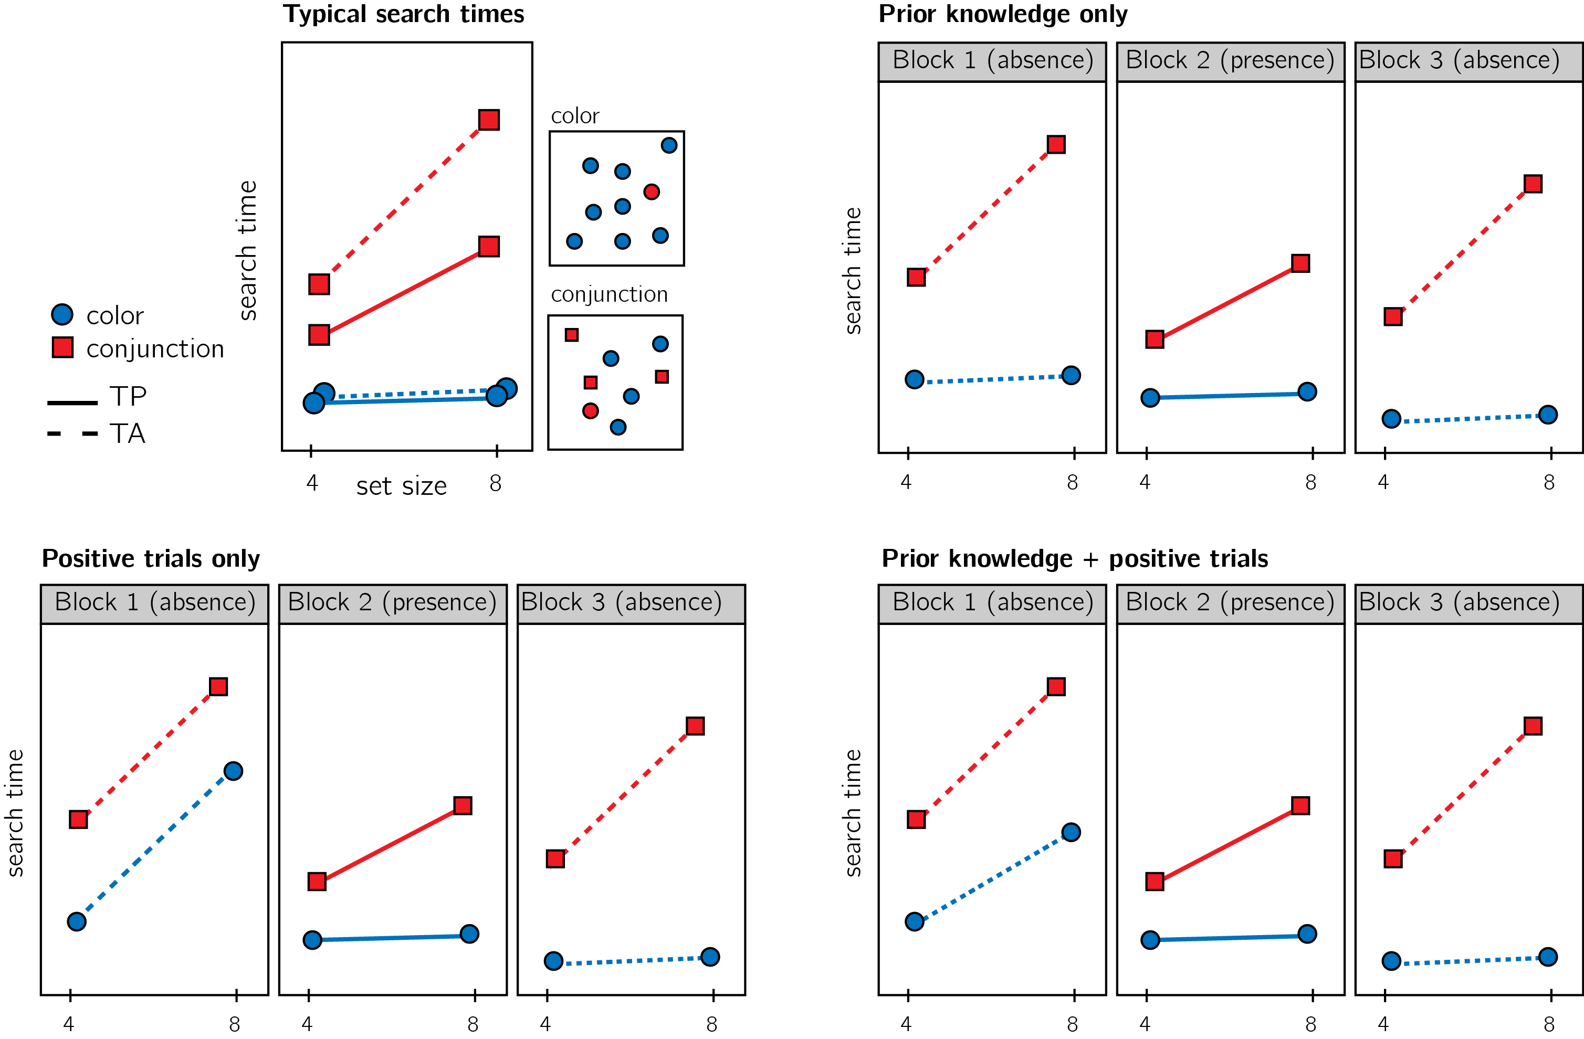

*Figure* *2:*. Top left: typical search time results in visual search experiments with many trials. Set size (x axis) affects search time in conjunction search, but much less so in color search. However, it is unclear whether this pattern is also true for the first trials in an experiment. Top right: one possible pattern is that the same qualitative pattern will be observed in our design, with an overall decrease in response time as a function of trial number. This will suggest that the metacognitive knowledge necessary to support efficient inference about absence was already in place before engaging with the task. Bottom left: an alternative pattern is that the same qualitative pattern will be observed for blocks 2 and 3, but not in block 1. This will suggest that for inference about absence to be efficient, participants had to experience some target-present trials. Bottom right: alternatively, some of the metacognitive knowledge is available prior to engaging with the task, and some is acquired by exposure to target-present trials. This will manifest as different slopes for conjunction and color searches in blocks 1 and a learning effect for color search between blocks 1 and 3.

Subject-wise search slopes were extracted for each combination of search type (color or conjunction) and block number by fitting a linear regression model to the reaction time data with one intercept and one set-size term.

Analysis comprised a positive control based on target-present trials, a test of the presence of a pop-out effect for color search in block 1, and a test for the change in slope for color search between blocks 1 and 3. All hypotheses were tested using a within-subject t-test, with a significance level of 0.05. Given the fact that we only have one trial per cell, one excluded trial is sufficient to make some hypotheses impossible to test on a given participant. For this reason, for each hypothesis separately, participants were included only if all necessary trials met our inclusion criteria. This means that some hypotheses were tested on different subsets of participants.

## Results

We used R (Version 3.6.0; R Core Team, 2019) and the R-packages *}base* [@}R-base], *}PowerTOST* [@}R-PowerTOST], *}psycho* [@}R-psycho], *}reticulate* [@}R-reticulate], *base* (Version 3.6.0; @}R-base; R Core Team, 2019), *BayesFactor* (Version 0.9.12.4.2; Morey & Rouder, 2018), *brms* (Version 2.13.0; Bürkner, 2017, 2018), *broom* (Version 0.5.6; Robinson & Hayes, 2020), *coda* (Version 0.19.3; Plummer, Best, Cowles, & Vines, 2006), *cowplot* (Version 1.0.0; Wilke, 2019), *dplyr* (Version 1.0.0; Wickham et al., 2020), *forcats* (Version 0.5.0; Wickham, 2020), *ggplot2* (Version 3.3.1; Wickham, 2016), *lsr* (Version 0.5; Navarro, 2015), *Matrix* (Version 1.2.17; Bates & Maechler, 2019), *MESS* (Version 0.5.6; Ekstrøm, 2019), *papaja* (Version 0.1.0.9942; Aust & Barth, 2020, 2020, 2020), *purrr* (Version 0.3.4; Henry & Wickham, 2020), *pwr* (Version 1.3.0; Champely, 2020), *Rcpp* (Version 1.0.4.6; Eddelbuettel & François, 2011; Eddelbuettel & Balamuta, 2017), *readr* (Version 1.3.1; Wickham, Hester, & Francois, 2018), *remotes* (Version 2.2.0; Hester et al., 2020), *stringr* (Version 1.4.0; Wickham, 2019), *tibble* (Version 3.0.1; Müller & Wickham, 2020), *tidyr* (Version 1.1.0; Wickham & Henry, 2020), *tidyverse* (Version 1.3.0; Wickham, Averick, et al., 2019), *TOSTER* (Version 0.3.4; Lakens, 2017), and *tostpower* (Version 0.1.3; Malandro, 2016) for all our analyses.

Overall mean accuracy was 0.96 (standard deviation =0.06). The median reaction time was 644.10 ms (median absolute deviation = 124.50). In all further analyses, only correct trials with response time between 250 and 1000 ms are included.

*Hypothesis 1 (positive control)*: Search times in block 2 (target-present) followed the expected pattern, with a steep slope for conjunction search ($M=15.07$, 95% CI $[12.32$, $17.82]$) and a shallow slope for conjunction search ($M=5.85$, 95% CI $[3.92$, $7.79]$; see Fig. 3). The slope for shape search was significantly lower than 10 ms/item and thus met our criterion for being considered ‘pop-out’ ($t(753)=−4.21$, $p<.001$). Furthermore, the difference between the slopes was significant ($t(583)=4.97$, $p<.001$). This positive control served to validate our method.

*Hypothesis 2*: Our central focus was on results from block 1 (target-absent). Here participants didn’t yet have experience with searching for the red circle. Similar to the second block, the slope for the conjunction search was steep ($M=19.78$, 95% CI $[16.33$, $23.24]$). A clear ‘pop-out’ effect for shape search was also evident ($M=8.03$, 95% CI $[−∞$, $10.47]$, $t(608)=−1.33$, $p=.092$). Furthermore, the average search slope for shape search in this first block was significantly different from that of the conjunction search ($t(326)=3.05$, $p=.002$), indicating that a shape-absence pop-out does not depend on task experience.

*Hypothesis 3*: Like in the first block, in the third block shape search complied with our criterion for ‘pop-out’ ($M=9.02$, 95% CI $[−∞$, $10.84]$, $t(722)=−0.89$, $p=.187$), and was significantly different from the search for conjunction search ($t(564)=5.92$, $p<.001$). This result is not surprising, given that a pop-out effect was already observed in block 1.

*Hypothesis 4*: To quantify the learning effect for shape search, we directly contrasted the search slope for shape search in blocks 1 and 3. We find no evidence for a learning effect ($t(542)=−0.04$, $p=.968$). Furthermore, a Bayesian t-test with a scaled Cauchy prior for effect sizes (r=0.707) provided strong evidence in favour of the absence of a learning effect (${BF}_{\text{01}}=20.71$).

*Hypothesis 5*: In case of a learning effect for pop-out search, Hypothesis 5 was designed to test the specificity of this effect to shape pop-out by computing an interaction of block number and search type. Given that no learning effect has been observed, this test makes little sense. For completeness, we report that the change in slope between blocks 1 and 3 was similar for shape and conjunction search ($M=4.09$, 95% CI $[−3.42$, $11.61]$, $t(274)=1.07$, $p=.285$).

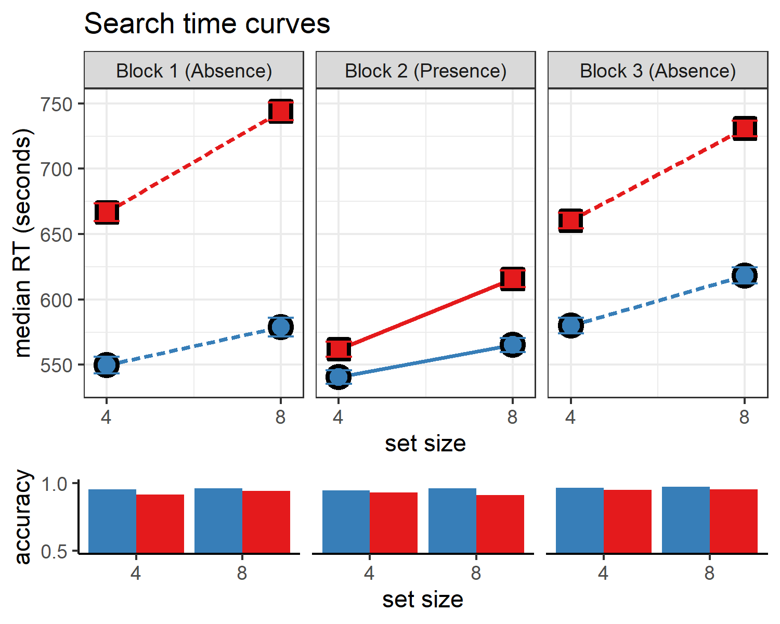

*Figure* *3:*. Upper panel: median search time by distractor set size for the two search tasks across the three blocks. Correct responses only. Lower panel: accuracy as a function of block, set size and search type. Error bars represent the standard error of the median.

# References

Aust, F., & Barth, M. (2020). *papaja: Create APA manuscripts with R Markdown*. Retrieved from <https://github.com/crsh/papaja>

Bates, D., & Maechler, M. (2019). *Matrix: Sparse and dense matrix classes and methods*. Retrieved from <https://CRAN.R-project.org/package=Matrix>

Bürkner, P.-C. (2017). brms: An R package for Bayesian multilevel models using Stan. *Journal of Statistical Software*, *80*(1), 1–28. <https://doi.org/10.18637/jss.v080.i01>

Bürkner, P.-C. (2018). Advanced Bayesian multilevel modeling with the R package brms. *The R Journal*, *10*(1), 395–411. <https://doi.org/10.32614/RJ-2018-017>

Champely, S. (2020). *Pwr: Basic functions for power analysis*. Retrieved from <https://CRAN.R-project.org/package=pwr>

Eddelbuettel, D., & Balamuta, J. J. (2017). Extending extitR with extitC++: A Brief Introduction to extitRcpp. *PeerJ Preprints*, *5*, e3188v1. <https://doi.org/10.7287/peerj.preprints.3188v1>

Eddelbuettel, D., & François, R. (2011). Rcpp: Seamless R and C++ integration. *Journal of Statistical Software*, *40*(8), 1–18. <https://doi.org/10.18637/jss.v040.i08>

Ekstrøm, C. T. (2019). *MESS: Miscellaneous esoteric statistical scripts*. Retrieved from <https://CRAN.R-project.org/package=MESS>

Henry, L., & Wickham, H. (2020). *Purrr: Functional programming tools*. Retrieved from <https://CRAN.R-project.org/package=purrr>

Hester, J., Csárdi, G., Wickham, H., Chang, W., Morgan, M., & Tenenbaum, D. (2020). *Remotes: R package installation from remote repositories, including ’github’*. Retrieved from <https://CRAN.R-project.org/package=remotes>

Lakens, D. (2017). Equivalence tests: A practical primer for t-tests, correlations, and meta-analyses. *Social Psychological and Personality Science*, *1*, 1–8. <https://doi.org/10.1177/1948550617697177>

Malandro, D. (2016). *Tostpower: TOST equivalence/noninferiority power calculation*.

Mazor, M., Mazor, N., & Mukamel, R. (2019). A novel tool for time-locking study plans to results. *European Journal of Neuroscience*, *49*(9), 1149–1156.

Morey, R. D., & Rouder, J. N. (2018). *BayesFactor: Computation of bayes factors for common designs*. Retrieved from <https://CRAN.R-project.org/package=BayesFactor>

Müller, K., & Wickham, H. (2020). *Tibble: Simple data frames*. Retrieved from <https://CRAN.R-project.org/package=tibble>

Navarro, D. (2015). *Learning statistics with r: A tutorial for psychology students and other beginners. (Version 0.5)*. Adelaide, Australia: University of Adelaide. Retrieved from <http://ua.edu.au/ccs/teaching/lsr>

Plummer, M., Best, N., Cowles, K., & Vines, K. (2006). CODA: Convergence diagnosis and output analysis for mcmc. *R News*, *6*(1), 7–11. Retrieved from <https://journal.r-project.org/archive/>

R Core Team. (2019). *R: A language and environment for statistical computing*. Vienna, Austria: R Foundation for Statistical Computing. Retrieved from <https://www.R-project.org/>

Robinson, D., & Hayes, A. (2020). *Broom: Convert statistical analysis objects into tidy tibbles*. Retrieved from <https://CRAN.R-project.org/package=broom>

Wickham, H. (2016). *Ggplot2: Elegant graphics for data analysis*. Springer-Verlag New York. Retrieved from <https://ggplot2.tidyverse.org>

Wickham, H. (2019). *Stringr: Simple, consistent wrappers for common string operations*. Retrieved from <https://CRAN.R-project.org/package=stringr>

Wickham, H. (2020). *Forcats: Tools for working with categorical variables (factors)*. Retrieved from <https://CRAN.R-project.org/package=forcats>

Wickham, H., Averick, M., Bryan, J., Chang, W., McGowan, L. D., François, R., … Yutani, H. (2019). Welcome to the tidyverse. *Journal of Open Source Software*, *4*(43), 1686. <https://doi.org/10.21105/joss.01686>

Wickham, H., François, R., Henry, L., & Müller, K. (2020). *Dplyr: A grammar of data manipulation*. Retrieved from <https://CRAN.R-project.org/package=dplyr>

Wickham, H., & Henry, L. (2020). *Tidyr: Tidy messy data*. Retrieved from <https://CRAN.R-project.org/package=tidyr>

Wickham, H., Hester, J., & Francois, R. (2018). *Readr: Read rectangular text data*. Retrieved from <https://CRAN.R-project.org/package=readr>

Wilke, C. O. (2019). *Cowplot: Streamlined plot theme and plot annotations for ’ggplot2’*. Retrieved from <https://CRAN.R-project.org/package=cowplot>