Metacognitive contributions to search termination, Experiment 2: pre-registration document

Matan Mazor1 & Stephen M. Fleming1,2,3

1 Wellcome Centre for Human Neuroimaging, UCL

2 Max Planck UCL Centre for Computational Psychiatry and Ageing Research

3 Department of Experimental Psychology, UCL

Author note

Correspondence concerning this article should be addressed to Matan Mazor, 12 Queen Square, London WC1N 3BG. E-mail: [mtnmzor@gmail.com](mailto:mtnmzor@gmail.com)

Abstract

When searching for a target object among distractors, a robust finding in cognitive science is that search time varies as a function of the number of distractors and their similarity to the target object. This is true not only for the time taken to say a target is present, but also for the time taken to terminate a search and conclude that a target object is absent. However, while models of visual search have successfully characterized perceptual and cognitive contributions to target detection, the mechanisms underpinning when to terminate a search and conclude that a target is absent are poorly understood. In other words, when do people decide to give up and conclude that nothing is there? By focusing on the first few trials in a visual search task, in Experiment 1 we found that participants had prior expectations about the pop-out of color, prior to engaging with the task. In Experiment 2, we ask if the same is true for another visual dimension, shape. In this second Experiment we also include a debriefing questionnatire, designed to rule out prior experience with similar visual search experiments in the past, and to measure explicit metacognitive access to attention-guiding knowledge.

Metacognitive contributions to search termination, Experiment 2: pre-registration document

## Experiment 1: summary and results.

In Experiment 1, participants searched for a red dot among 4 or 8 distractors that differed from the target by color alone (all blue dots) or by color and shape (blue dots and red squares). We found that search was parallel in target-absent trials when all distractors were blue. Critically, this was true even in the first four trials of the experiment, before participants were exposed to target-present trials (see Fig. 1, left panel). We took this as evidence that participants had prior knowledge about the pop-out effect for color, and that this knowledge was not dependent on experience from previous trials.

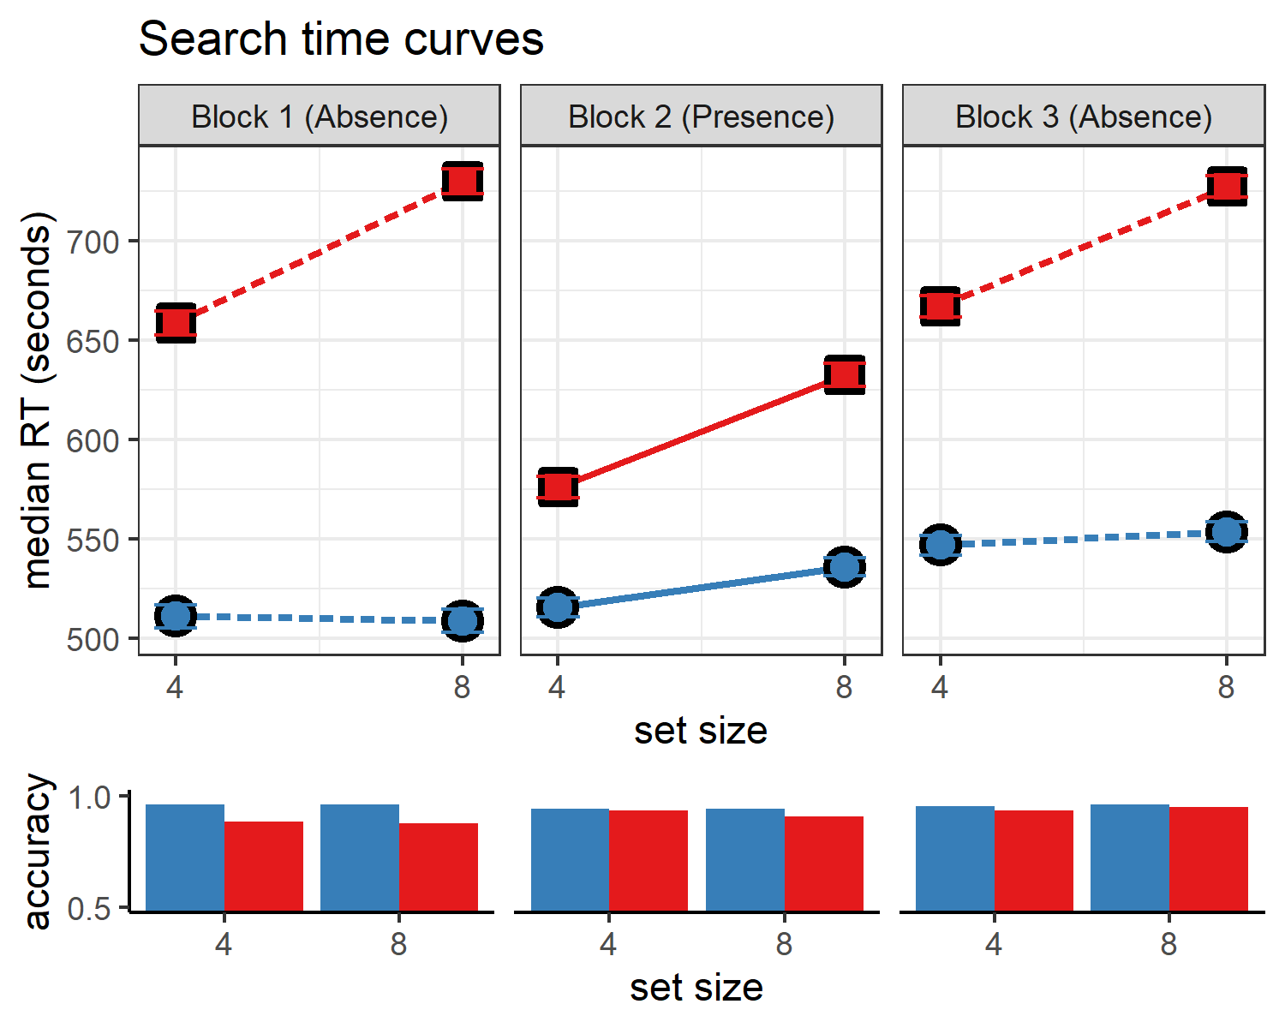

*Figure* *1:*. Results for Experiment 1. Upper panel: median search time by distractor set size for the two search tasks across the three blocks. Correct responses only. Lower panel: accuracy as a function of block, set size and search type.

# Experiment 2

Experiment 1 provided unequivocal evidence for color-absence pop-out prior to experiencing color pop-out in the context of the task. We interpret this as indicating that task-naive adults had valid implicit or explicit metacognitive expectations about color pop-out. This metacognitive knowledge may be innate (acquired in the course of evolution, for example driven by the utility of color search for foraging), learned from previous visual experience (for example, first-person experience of attention being immediately drawn to distinct colors), or culturally acquired (for example, through language). Experiment 2 is designed to extend these findings to another stimulus feature that is found to efficiently guide attention: shape. The time cost of additional distractors in shape search is under 10 ms ( ms/item, 95% CI , and ms/item, 95% CI , for target-absent and target-present responses in our pilot data), rendering it a case of parallel, efficient search. It is possible however that unlike in the case of color, the metacognitive knowledge that gives rise to the pop-out effect for shape-absence is acquired through experience with the task. In this experiment we also include an additional control for prior experience with visual search tasks, and a measure of metacognitive access to this attention-guiding knowledge.

# Methods

We report how we determined our sample size, all data exclusions (if any), all manipulations, and all measures in the study.

## Participants

The research complies with all relevant ethical regulations, and was approved by the Research Ethics Committee of University College London (study ID number 1260/003). Participants will be recruited via Prolific, and will give informed consent prior to their participation. They will be selected based on their acceptance rate (>95%) and for being native English speakers, and for not participating in Experiment 1. We will collect data until we reach 320 included participants for each of our hypotheses (after applying our pre-registered exclusion criteria). The entire experiment will take 4 minutes to complete. Participants will be paid £0.51 for their participation, equivalent to an hourly wage of £7.60.

## Procedure

Experiment 2 will be similar to Experiment 1 with two changes. First, the distractors will be red triangles and blue dots for conjunction trials, and red squares for shape trials (see Fig. 2.) Second, participants will be asked to complete a short debriefing questionnaire upon finishing the study.

Participants will first be instructed about the visual search task. Specifically, that their task is to report, as accurately and quickly as possible, whether a target stimulus was present (press ‘J’) or absent (press ‘F’). Then, practice trials will be delivered, in which the target stimulus is a rotated *T*, and distractors are rotated *L*s. The purpose of the practice trials is to familiarize participants with the structure of the task. For these practice trials the number of items will always be 3. Practice trials will be delivered in small blocks of 6 trials each, and the main part of the experiment will start only once participants respond correctly on at least five trials in a block (see Figure 2).

In the main part of the experiment, participants will look for a red dot among red squares or a mixed array of blue dots and red triangles. Set sizes will be 4 or 8, resulting in a 2-by-2 design (search type: shape or colorshape, by set size: 4 or 8). Critically, and unknown to subjects, the first four trials will always be target-absent trials (one of each set-size search-type combination), presented in randomized order. These trials will be followed by the four corresponding target-present trials, presented in randomized order. The final four trials will again be target-absent trials, presented in randomized order.

Upon finishing the main part of the experiment, participants will answer to debriefing questions. The first question (Q1) will be:

Some searches are easier than others. This means that participants find the red dot faster when hidden among some sets of distractors, compared to others. To the best of your ability, order the following distractor sets from easiest (fastest) to hardest (slowest).

Participants will then be requested to drag the four distractor sets (4 red squares, 2 red triangles and 2 blue dots, 8 red squares, 4 red triangles and 4 blue dots) into position to reflect their perceived difficulty (see Fig. 3). The second question (Q2) will be:

Have you ever participated in a similar experiment before, where you were asked to search for a target item?

In case they answer ‘yes’, they will be further asked to report when they took part in the experiment, and provide as many details as they can remember about the experiment itself.

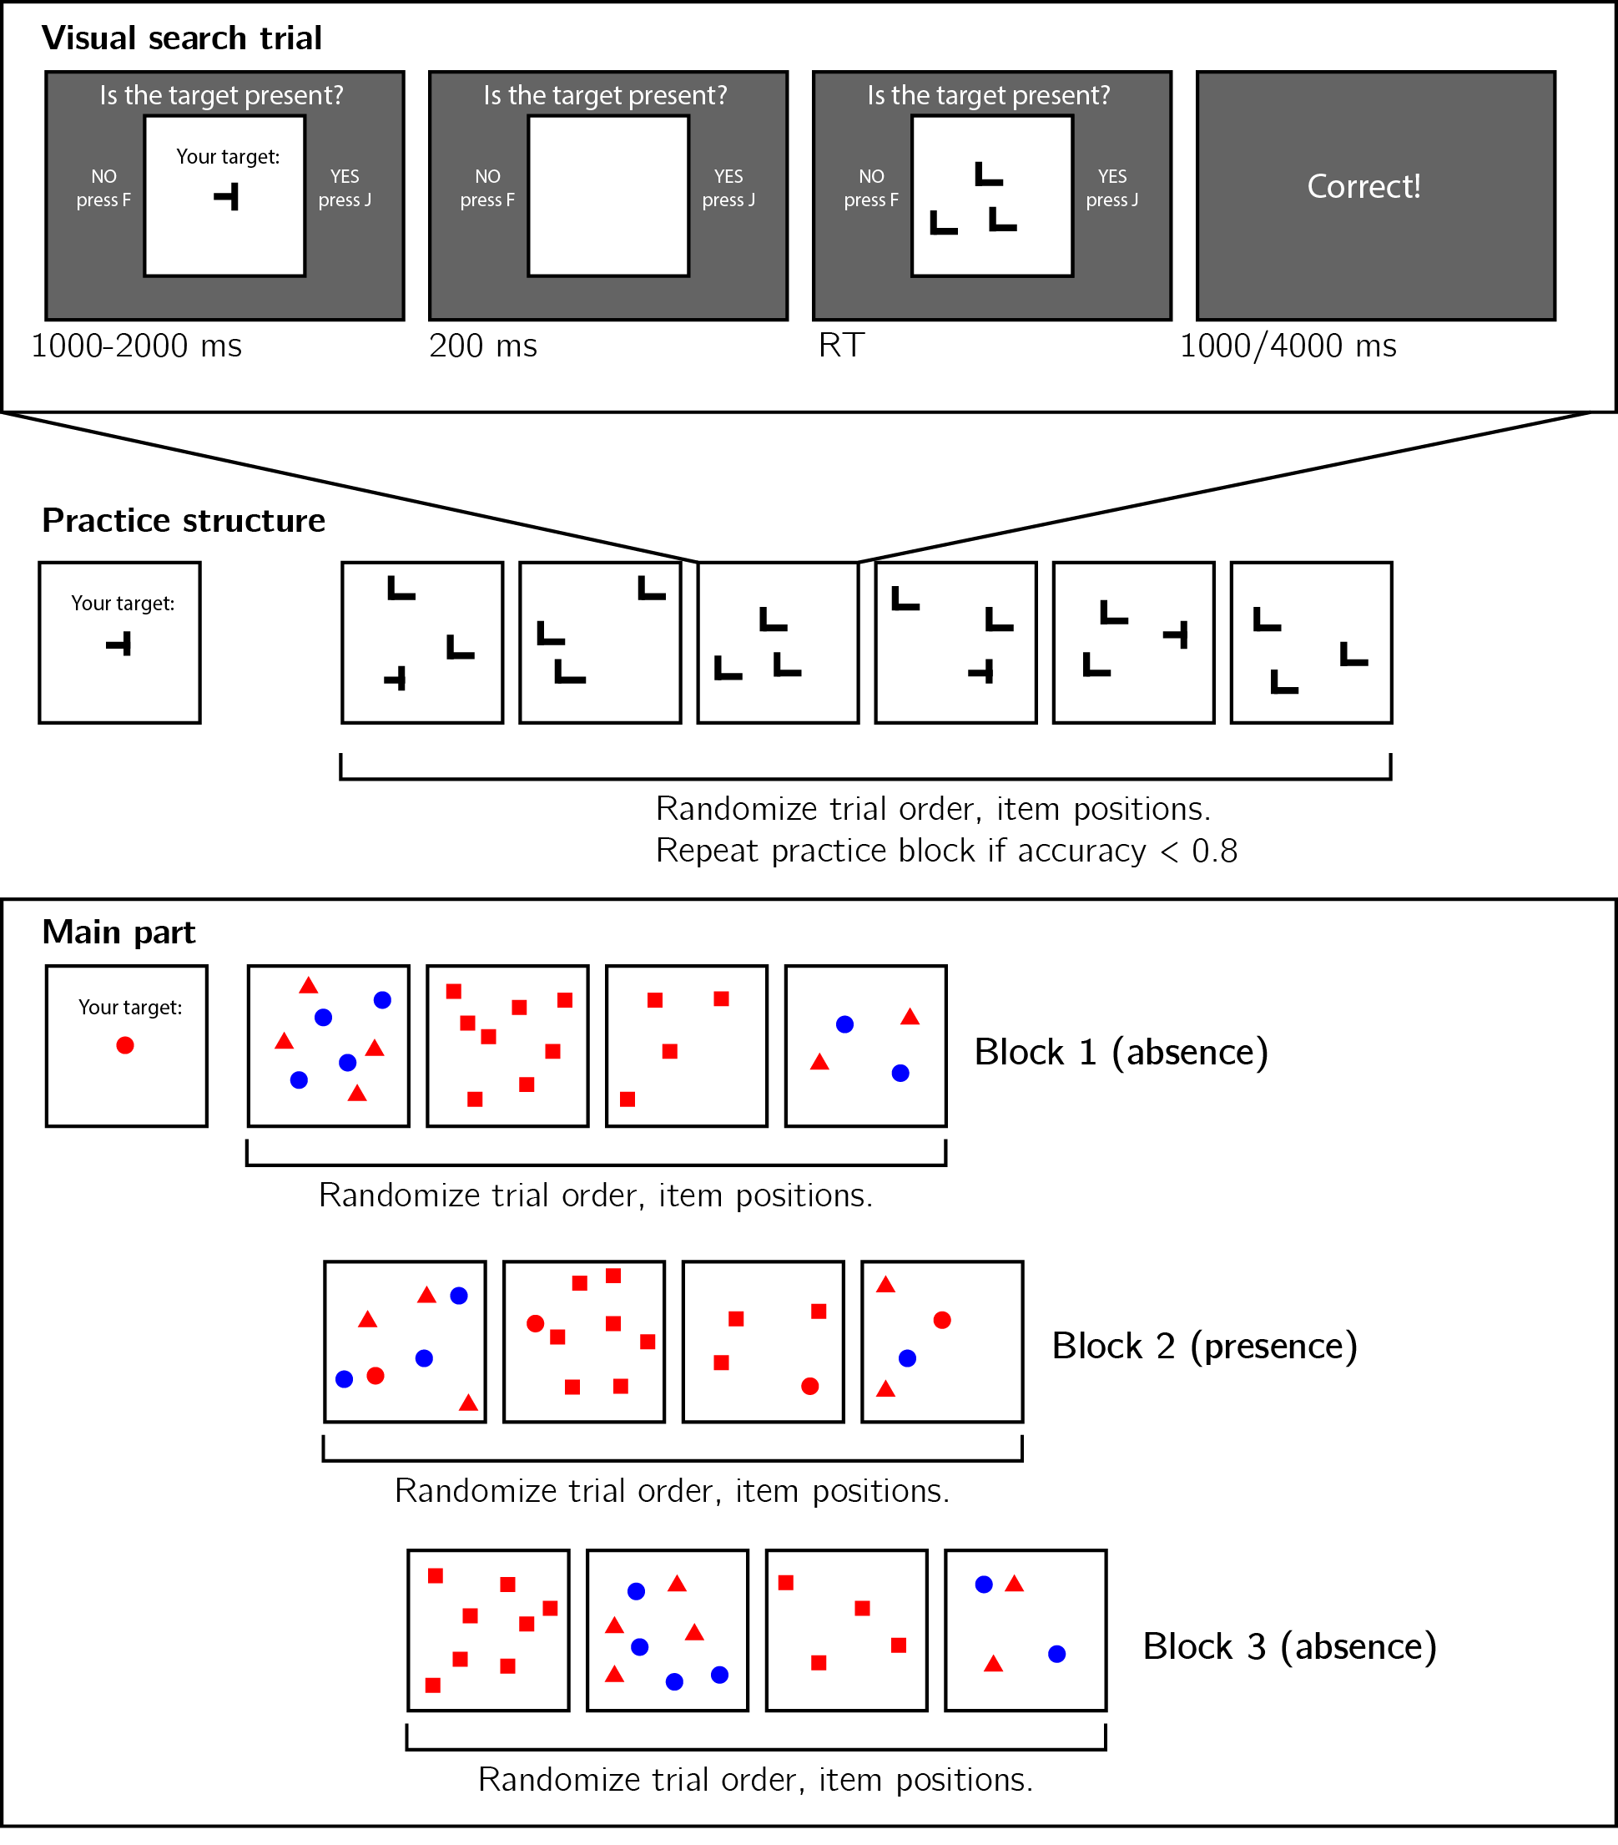

*Figure* *2:*. Experimental design. Top panel: each visual search trial will start with a screen indicating the target stimulus. The search display will remain visible until a response is recorded. To motivate accurate responses, the feedback screen will remain visible for one second following correct responses and for four seconds following errors. Middle panel: after reading the instructions, participants will practice the visual search task in blocks of 6 trials, until they reach an accuracy level of 83% correct or higher (at most one error per block of 6 trials). Bottom panel: the main part of the experiment will comprise 12 trials only, in which the target is a red dot. Unbeknown the subjects, only trials 5-8 (Block 2) will be target-present trials, and the remaining trials target-absent trials. Each 4-trial block will follow a 2 by 2 design, with factors being set size (4 or 8) and distractor type (shape or conjunction; red squares only or blue dots and red triangles, respectively).

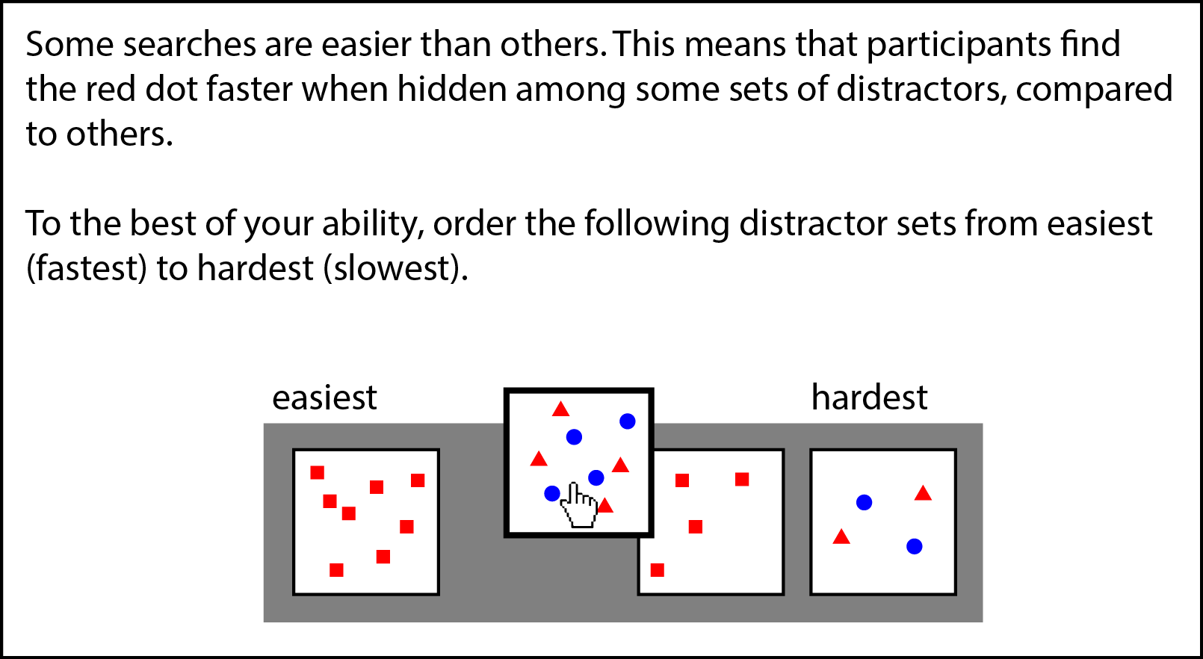

*Figure* *3:*. Debrief question Q1. Participatns will be asked to drag the four search arrays into position, to match their perceived difficulty.

## Randomization

The order and timing of experimental events will be determined pseudo-randomly by the Mersenne Twister pseudorandom number generator, initialized in a way that ensures registration time-locking (Mazor, Mazor, & Mukamel, 2019).

# Data analysis

## Rejection criteria

Participants will be excluded for making more than one error in the main part of the experiment, or for having extremely fast or slow reaction times (below 250 milliseconds or above 5 seconds) in more than 25% of the trials.

Error trials, and trials with response time below 250 milliseconds or above 1 second will be excluded from the response-time analysis.

## Data preprocessing

To control for within-block trial order effects, a separate linear regression model will be fit to the data of each block, predicting search time as a function of trial serial order (, with denoting the mean-centered serial position within a block). Search times will be corrected by subtracting the product of the slope and the mean-centered serial position, in a block-wise manner.

## Hypotheses and analysis plan

Experiment 2 is designed to test several hypotheses about the contribution of metacognitive knowledge to search termination in the case of shape search, the state of this knowledge prior to engaging with the task, and the effect of experience trials on this metacognitive knowledge. We outline some possible search time patterns and their interpretation in Fig. 4.

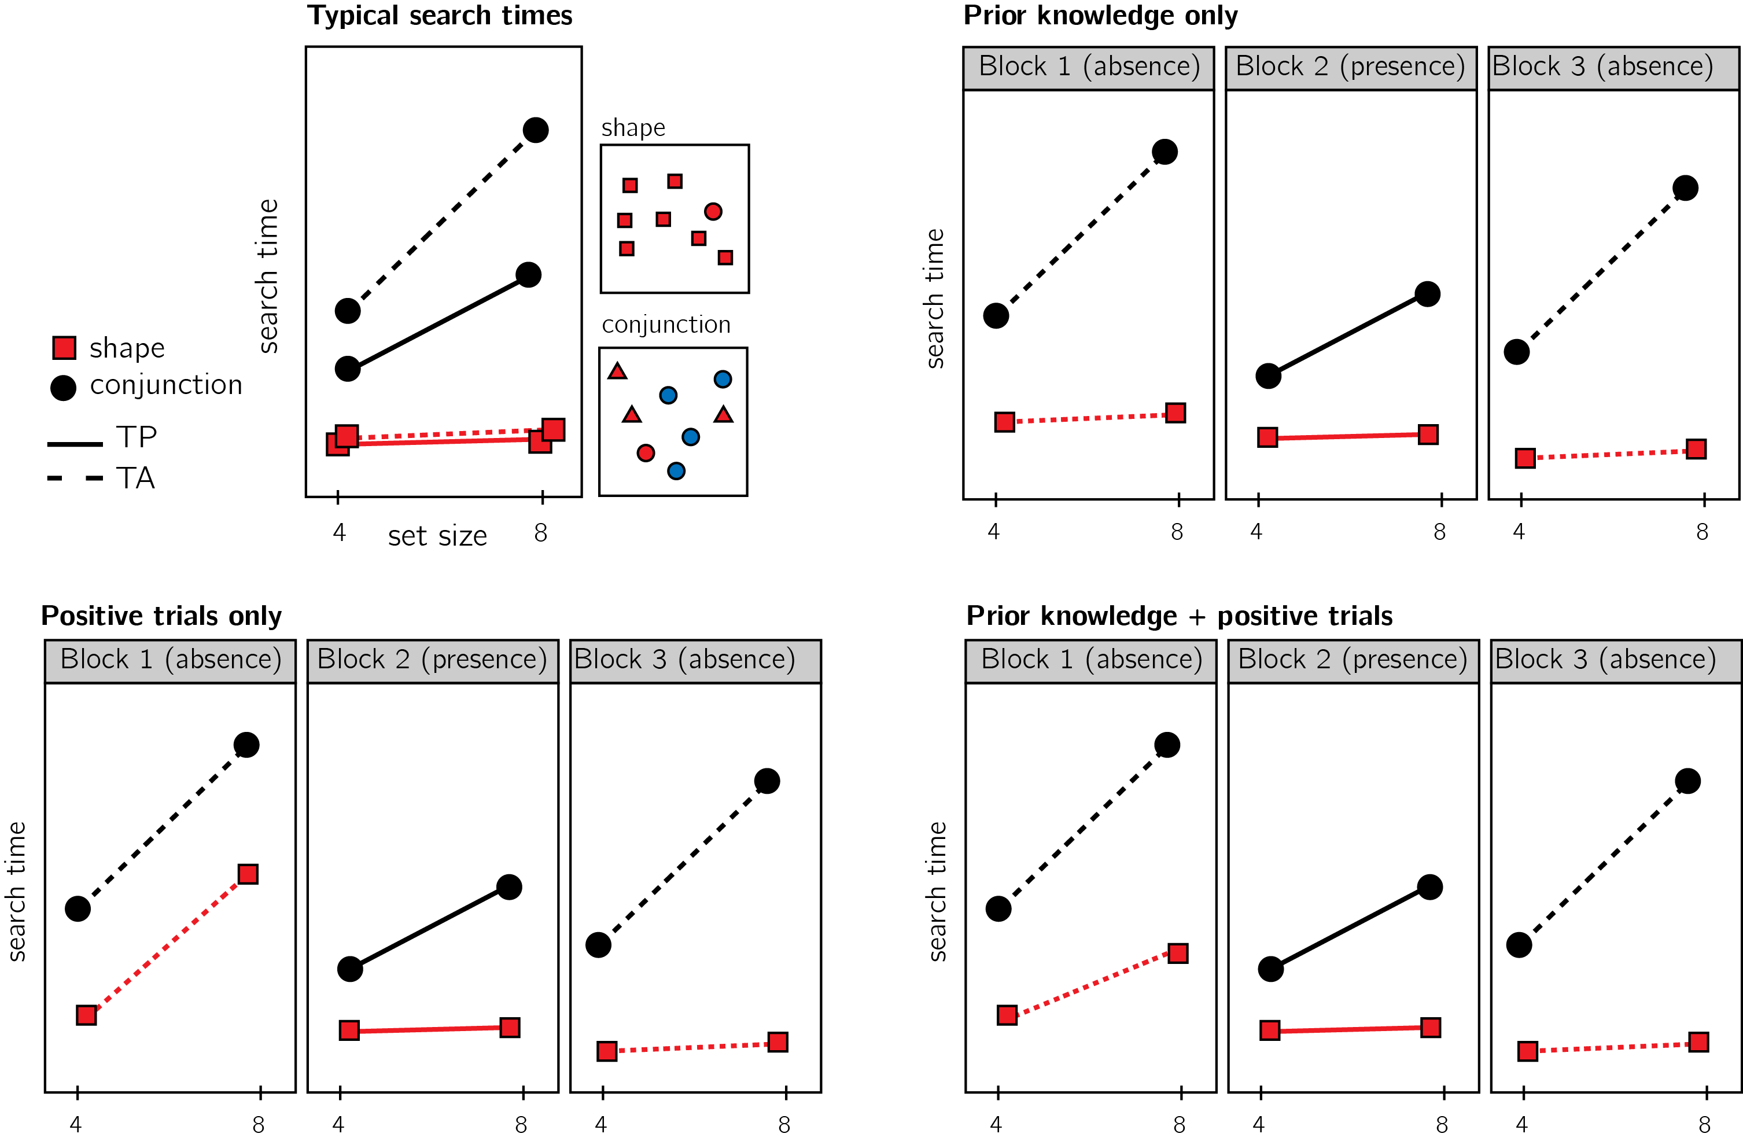

*Figure* *4:*. Top left: typical search time results in visual search experiments with many trials. Set size (x axis) affects search time in conjunction search, but much less so in shape search. However, it is unclear whether this pattern is also true for the first trials in an experiment. Top right: one possible pattern is that the same qualitative pattern will be observed in our design, with an overall decrease in response time as a function of trial number. This will suggest that the metacognitive knowledge necessary to support efficient inference about absence was already in place before engaging with the task. Bottom left: an alternative pattern is that the same qualitative pattern will be observed for blocks 2 and 3, but not in block 1. This will suggest that for inference about absence to be efficient, participants had to experience some target-present trials. Bottom right: alternatively, some of the metacognitive knowledge is available prior to engaging with the task, and some is acquired by exposure to target-present trials. This will manifest as different slopes for conjunction and shape searches in blocks 1 and a learning effect for shape search between blocks 1 and 3.

Subject-wise search slopes will be extracted for each combination of search type (shape or conjunction) and block number by fitting a linear regression model to the reaction time data with one intercept and one set-size term.

Analysis will comprise a positive control based on target-present trials, a test of the presence of a pop-out effect for shape search in block 1, and a test for the change in slope for shape search between blocks 1 and 3. All hypotheses will be tested using a within-subject t-test, with a significance level of 0.05.

Given the fact that we only have one trial per cell, one excluded trial is sufficient to make some hypotheses impossible to test on a given participant. For this reason, for each hypothesis separately, participants will be included only if all necessary trials meet our inclusion criteria. This means that some hypotheses may be tested on different subsets of participants.

*Hypothesis 1 (Positive control)*: To validate our methods and the quality of our data, we will test for a difference between search slopes for shape and conjunction search in block 2 (target-present). Based on previous work we expect a steeper slope for conjunction than for shape search (Treisman and Gelade, 1980). This positive control will serve to confirm that these effects are detectable in a large sample, even with only one trial per cell.

*Hypothesis 2*: Pop-out for shape absence in block 1. Throughout our analysis, we will define pop-out as a search slope significantly lower than 10 ms/item. This cutoff was chosen based on empirical distributions of search slopes in feature search (Wolfe, 1998). We will test the null hypothesis that the search slope in the shape search, block 1 (target-absent) equals to or is higher than 10ms/item, using a t-test. We will further test the null hypothesis that search slopes for shape and conjunction searches in blocks 1 are equal.

*Hypothesis 3*: Pop-out for shape absence in block 3. We will test the null hypothesis that the search slope in the shape search, block 3 (target-absent) equals to or is higher than 10ms/item, using a t-test. We will further test the null hypothesis that search slopes for shape and conjunction searches in blocks 3 are equal.

*Hypothesis 4*: Search slope for shape search changes between blocks 1 and 3. We will test the null hypothesis that the search slope in the shape search, block 1 (target-absent) equals to search slope in the shape search, block 1 (target-absent).

*Hypothesis 5*: The change in search slopes between blocks 1 and 3 is different for shape and for conjunction searches. To rule out a nonspecific change in search slope between blocks 1 and 3, We will compare the difference in search slopes for shape search between block 1 and 3 with the difference in search slopes for conjunction search for the same blocks.

In case we find a pop out effect for shape absence in block 1, we will make sure that it was not driven by experienced participants that have taken part in similar visual-search tasks in the past. this will be done by repeating our analysis on the subset of participants that reported not participating in a similar experiment before.

Responses to Q1 (perceived difficulty) will be used for post-hoc exploratory analysis, looking into explicit metacognitive insight into search-guiding metacognitive knowledge.

## Statistical power

Statistical power calculations were performed using the R-pwr package (Champely, 2020).

With a minimum of 320 participants for each hypothesis, we will have statistical power of 95% to detect effects of size 0.20

# References

Champely, S. (2020). *Pwr: Basic functions for power analysis*. Retrieved from <https://CRAN.R-project.org/package=pwr>

Mazor, M., Mazor, N., & Mukamel, R. (2019). A novel tool for time-locking study plans to results. *European Journal of Neuroscience*, *49*(9), 1149–1156.

Treisman, A. M., & Gelade, G. (1980). A feature-integration theory of attention. *Cognitive Psychology*, *12*(1), 97–136.

Wolfe, J. M. (1998). What can 1 million trials tell us about visual search? *Psychological Science*, *9*(1), 33–39.