Metacognitive contributions to search termination: pre-registration document

Matan Mazor1 & Stephen M. Fleming1,2,3

1 Wellcome Centre for Human Neuroimaging, UCL

2 Max Planck UCL Centre for Computational Psychiatry and Ageing Research

3 Department of Experimental Psychology, UCL

Author note

Correspondence concerning this article should be addressed to Matan Mazor, 12 Queen Square, London WC1N 3BG. E-mail: [mtnmzor@gmail.com](mailto:mtnmzor@gmail.com)

Motivation

When searching for a target object among distractors, a robust finding in cognitive science is that search time varies as a function of the number of distractors and their similarity to the target object. This is true not only for the time taken to say a target is present, but also for the time taken to terminate a search and conclude that a target object is absent. However, while models of visual search have successfully characterized perceptual and cognitive contributions to target detection, the mechanisms underpinning when to terminate a search and conclude that a target is absent are poorly understood. In other words, when do people decide to give up and conclude that nothing is there? One hypothesis is that efficient search termination involves metacognitive knowledge such as the expected difficulty of the search, target salience, or fluctuations in one’s attentional state. By focusing on the first few trials in a visual search task, here we control participants’ ability to base their search termination on metacognitive knowledge before engaging with the task, and the effect of experience on the shaping of this knowledge. The results of this experiment will provide foundational information about the latent metacognitive variables contributing to search termination, and refine our understanding of how people judge the absence of stimuli.

Metacognitive contributions to search termination: pre-registration document

# Methods

We report how we determined our sample size, all data exclusions (if any), all manipulations, and all measures in the study.

## Participants

The research complies with all relevant ethical regulations, and was approved by the Research Ethics Committee of University College London (study ID number 1260/003). Participants will be recruited via Prolific, and will give informed consent prior to their participation. They will be selected based on their acceptance rate (>95%) and for being native English speakers. We will collect data until we reach 320 included participants for each of our hypotheses (after applying our pre-registered exclusion criteria). The entire experiment will take 3 minutes to complete (median completion time in our pilot data: 3:06 minutes). Participants will be paid £0.38 for their participation, equivalent to an hourly wage of £7.60.

## Procedure

Participants will first be instructed about the visual search task. Specifically, that their task is to report, as accurately and quickly as possible, whether a target stimulus was present (press ‘J’) or absent (press ‘F’). Then, practice trials will be delivered, in which the target stimulus is a rotated *T*, and distractors are rotated *L*s. The purpose of the practice trials is to familiarize participants with the structure of the task. For these practice trials the number of items will always be 3. Practice trials will be delivered in small blocks of 6 trials each, and the main part of the experiment will start only once participants respond correctly on at least five trials in a block (see Figure 1).

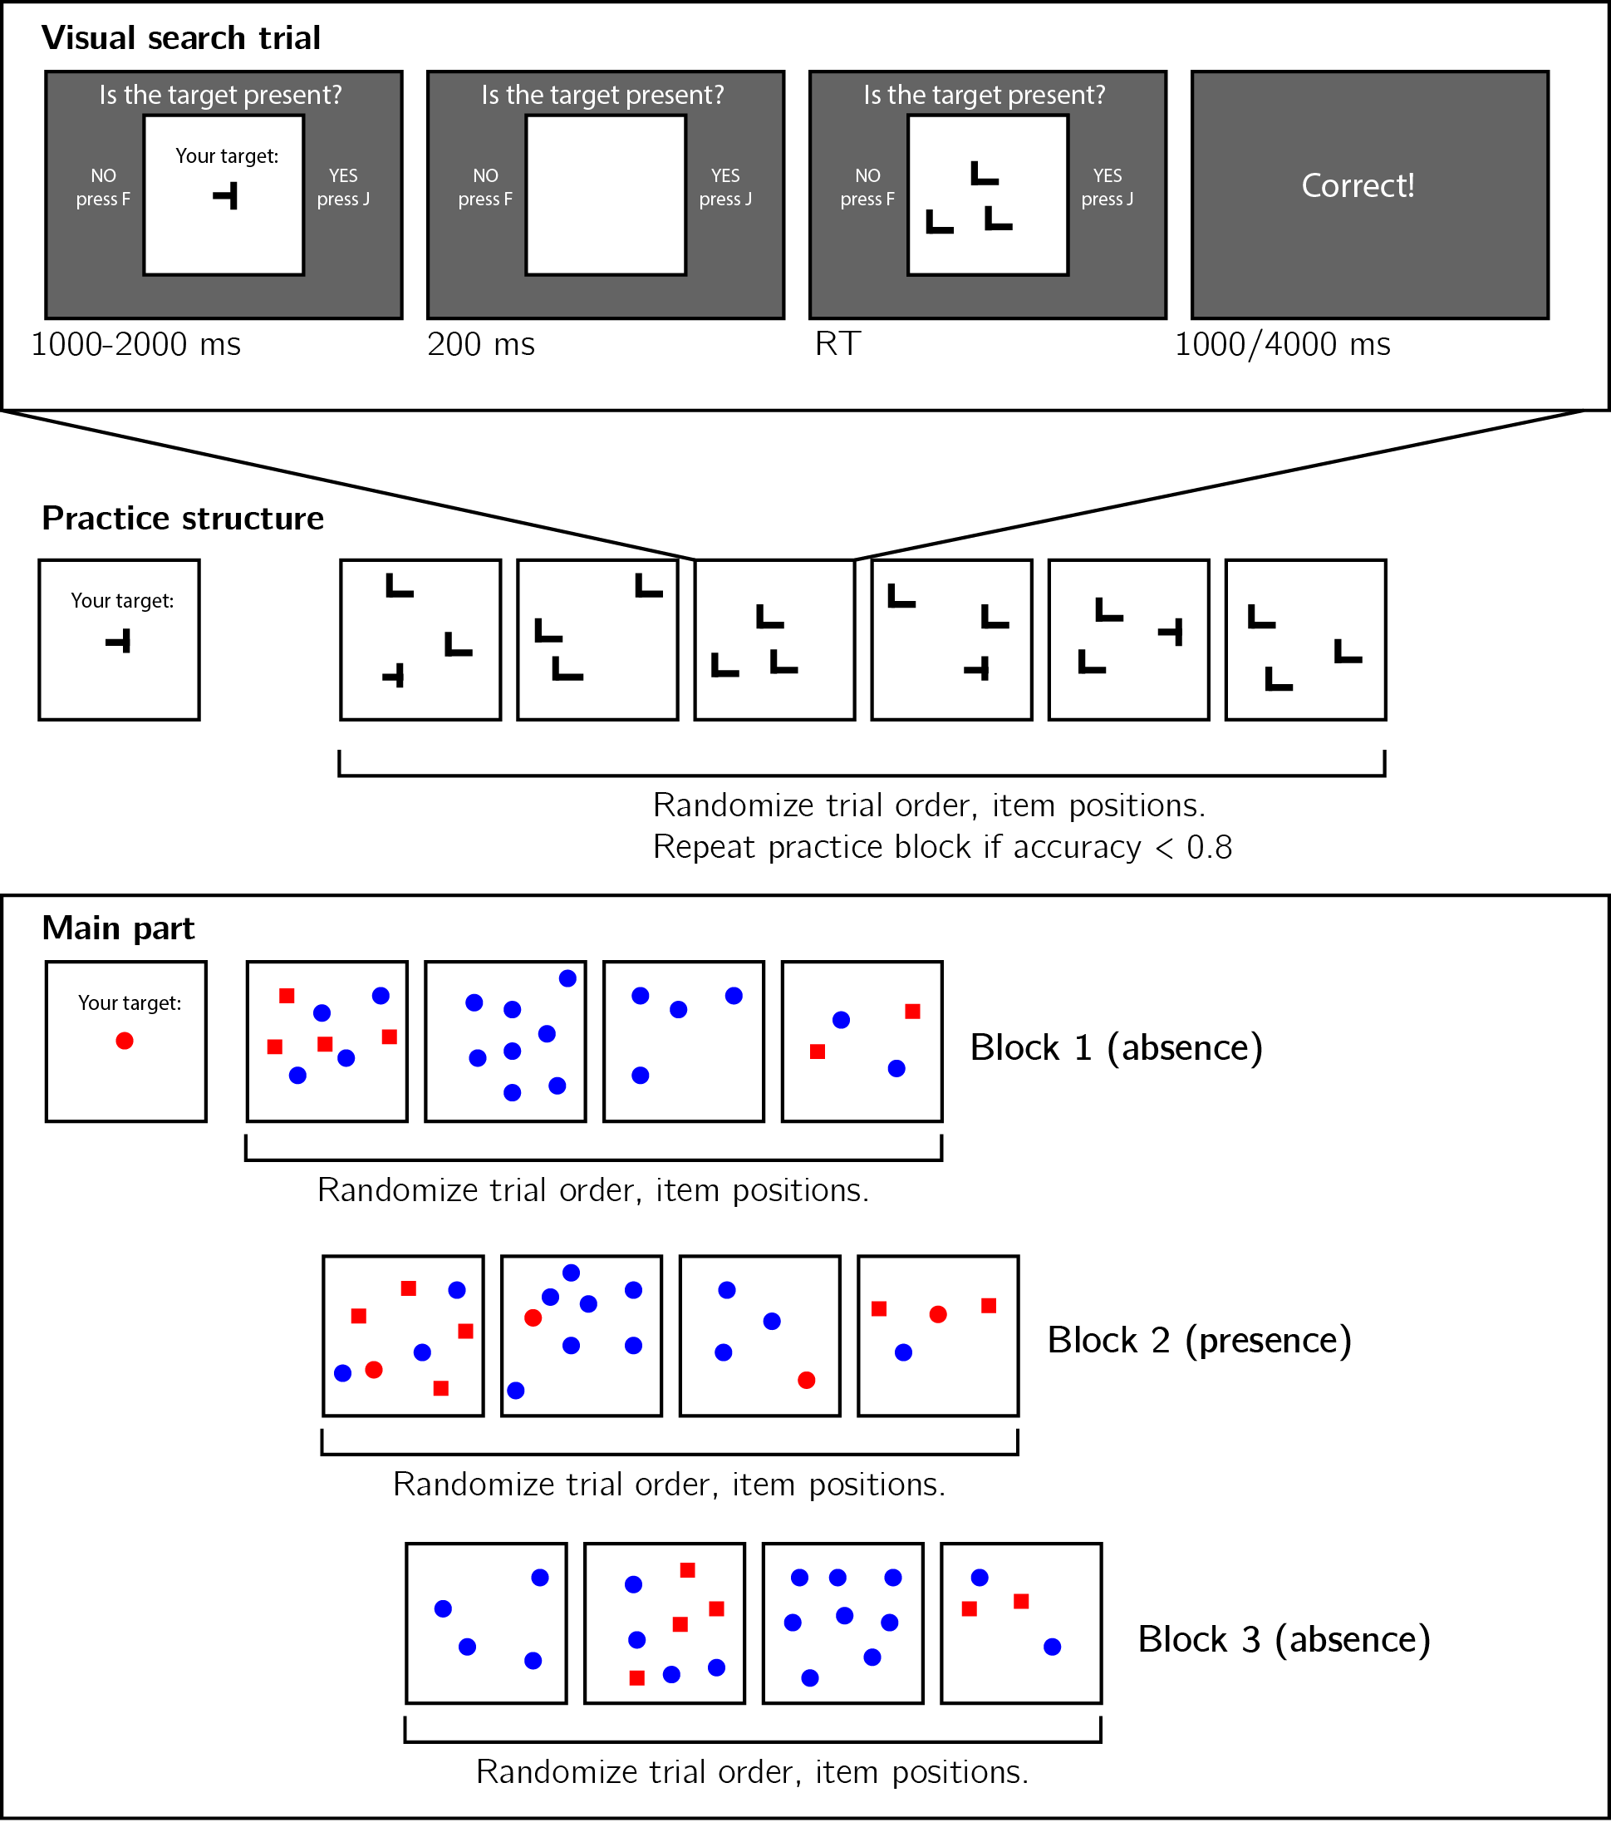

*Figure* *1:*. Experimental design. Top panel: each visual search trial will start with a screen indicating the target stimulus. The search display will remain visible until a response is recorded. To motivate accurate responses, the feedback screen will remain visible for one second following correct responses and for four seconds following errors. Middle panel: after reading the instructions, participants will practice the visual search task in blocks of 6 trials, until they reach an accuracy level of 83% correct or higher (at most one error per block of 6 trials). Bottom panel: the main part of the experiment will comprise 12 trials only, in which the target will be a red circle. Unbeknown the subjects, only trials 5-8 (Block 2) will be target-present trials, and the remaining trials will be target-absent trials. Each 4-trial block will follow a 2 by 2 design, with factors being set size (4 or 8) and distractor type (color or conjunction; blue circles only or blue circles and red squares, respectively).

In the main part of the experiment, participants will look for a red circle among blue circles or a mixed array of blue circles and red squares. Set sizes will be 4 or 12, resulting in a 2-by-2 design (search type: color or color $×$ shape, by set size: 4 or 12). Critically, and unknown to subjects, the first four trials will always be target-absent trials (one of each set-size $×$ search-type combination), presented in randomized order. These trials will be followed by the four corresponding target-present trials, presented in randomized order. The final four trials will again be target-absent trials, presented in randomized order.

### Randomization.

The order and timing of experimental events will be determined pseudo-randomly by the Mersenne Twister pseudorandom number generator, initialized in a way that ensures registration time-locking (Mazor, Mazor, & Mukamel, 2019).

## Data analysis

### Rejection criteria.

Participants will be excluded for making more than one error in the main part of the experiment, or for having extremely fast or slow reaction times in one or more of the tasks (below 250 milliseconds or above 5 seconds in more than 25% of the trials).

Error trials, and trials with response time below 250 milliseconds or above 1 second will be excluded from the response-time analysis.

### Data preprocessing.

To control for within-block trial order effects, a separate linear regression model will be fit to the data of each block, predicting search time as a function of trial serial order ($RT∼β_{0}+β_{1}i$, with $i$ denoting the mean-centered serial position within a block). Search times will be corrected by subtracting the product of the slope and the mean-centered serial position, in a block-wise manner.

### Hypotheses and analysis plan.

This study is designed to test several hypotheses about the contribution of metacognitive knowledge to search termination, the state of this knowledge prior to engaging with the task, and the effect of experience trials on this metacognitive knowledge. We outline some possible search time patterns and their interpretation in Fig. 2. In the next section we demonstrate our hypotheses and analyses on pilot data.

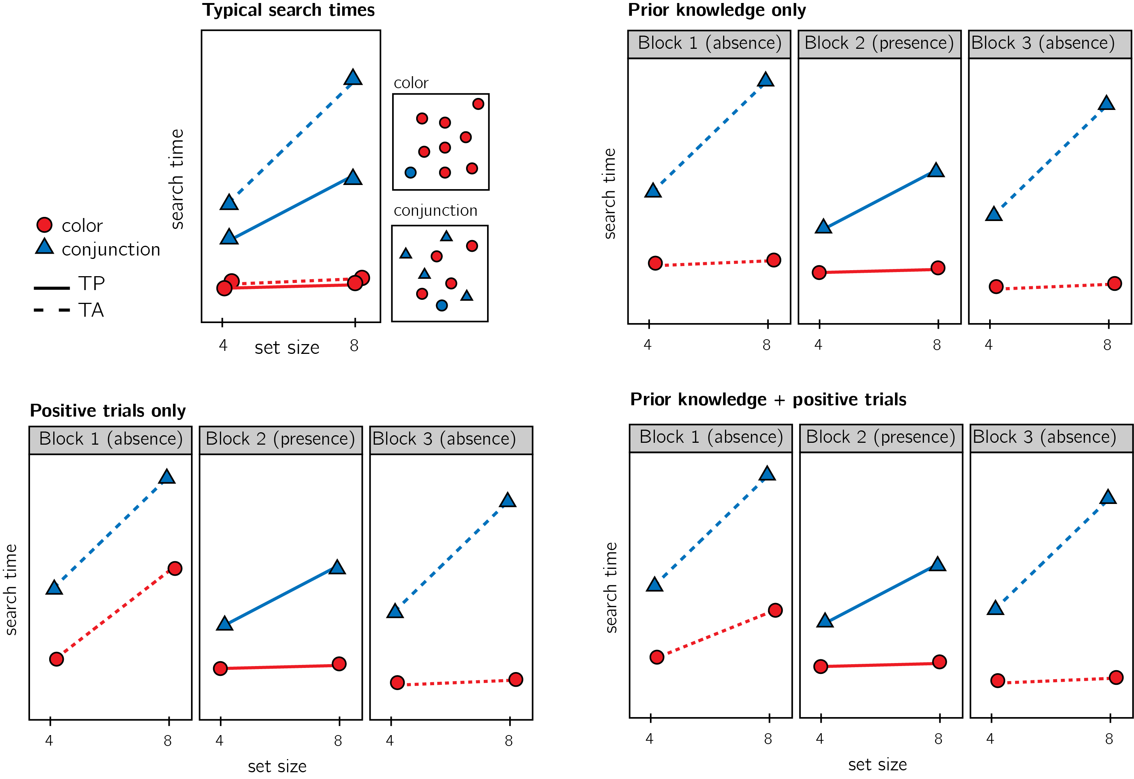

*Figure* *2:*. Top left: typical search time results in visual search experiments with many trials. Set size (x axis) affects search time in conjunction search, but much less so in color search. However, it is unclear whether this pattern is also true for the first trials in an experiment. Top right: one possible pattern is that the same qualitative pattern will be observed in our design, with an overall decrease in response time as a function of trial number. This will suggest that the metacognitive knowledge necessary to support efficient inference about absence was already in place before engaging with the task. Bottom left: an alternative pattern is that the same qualitative pattern will be observed for blocks 2 and 3, but not in block 1. This will suggest that for inference about absence to be efficient, participants had to experience some target-present trials. Bottom right: alternatively, some of the metacognitive knowledge is available prior to engaging with the task, and some is acquired by exposure to target-present trials. This will manifest as different slopes for conjunction and color searches in blocks 1 and a learning effect for color search between blocks 1 and 3.

Subject-wise search slopes will be extracted for each combination of search type (color or conjunction) and block number by fitting a linear regression model to the reaction time data with one intercept and one set-size term.

Analysis will comprise a positive control based on target-present trials, a test of the presence of a pop-out effect for color search in block 1, and a test for the change in slope for color search between blocks 1 and 3. All hypotheses will be tested using a within-subject t-test, with a significance level of 0.05. Given the fact that we only have one trial per cell, one excluded trial is sufficient to make some hypotheses impossible to test on a given participant. For this reason, for each hypothesis separately, participants will be included only if all necessary trials meet our inclusion criteria. This means that some hypotheses may be tested on different subsets of participants.

*Hypothesis 1 (Positive control)*: To validate our methods and the quality of our data, we will test for a difference between search slopes for color and conjunction search in block 2 (target-present). Based on previous work we expect a steeper slope for conjunction than for color search (Treisman & Gelade, 1980; Wolfe, 1998). This positive control will serve to confirm that these effects are detectable in a large sample, even with only one trial per cell.

*Hypothesis 2*: Pop-out for color absence in block 1. Throughout our analysis, we will define pop-out as a search slope significantly lower than 10 ms/item. This cutoff was chosen based on empirical distributions of search slopes in feature search (Wolfe, 1998). We will test the null hypothesis that the search slope in the color search, block 1 (target-absent) equals to or is higher than 10ms/item, using a t-test. We will further test the null hypothesis that search slopes for color and conjunction searches in blocks 1 are equal.

*Hypothesis 3*: Pop-out for color absence in block 3. We will test the null hypothesis that the search slope in the color search, block 3 (target-absent) equals to or is higher than 10ms/item, using a t-test. We will further test the null hypothesis that search slopes for color and conjunction searches in blocks 3 are equal.

*Hypothesis 4*: Search slope for color search changes between blocks 1 and 3. We will test the null hypothesis that the search slope in the color search, block 1 (target-absent) equals to search slope in the color search, block 1 (target-absent).

*Hypothesis 5*: The change in search slopes between blocks 1 and 3 is different for color and for conjunction searches. To rule out a nonspecific change in search slope between blocks 1 and 3, We will compare the difference in search slopes for color search between block 1 and 3 with the difference in search slopes for conjunction search for the same blocks.

## Statistical power

Statistical power calculations were performed using the R-pwr package (Champely, 2020).

With a minimum of 320 participants for each hypothesis, we will have statistical power of 95% to detect effects of size 0.20

# Pilot data and analysis

## Pilot Experiment

We used R (Version 3.6.0; R Core Team, 2019) and the R-packages *}base* [@}R-base], *}reticulate* [@}R-reticulate], *base* (Version 3.6.0; @}R-base; R Core Team, 2019), *BayesFactor* (Version 0.9.12.4.2; Morey & Rouder, 2018), *brms* (Version 2.13.0; Bürkner, 2017, 2018), *broom* (Version 0.5.6; Robinson & Hayes, 2020), *coda* (Version 0.19.3; Plummer, Best, Cowles, & Vines, 2006), *cowplot* (Version 1.0.0; Wilke, 2019), *dplyr* (Version 1.0.0; Wickham et al., 2020), *forcats* (Version 0.5.0; Wickham, 2020), *ggplot2* (Version 3.3.1; Wickham, 2016), *lsr* (Version 0.5; Navarro, 2015), *Matrix* (Version 1.2.17; Bates & Maechler, 2019), *MESS* (Version 0.5.6; Ekstrøm, 2019), *papaja* (Version 0.1.0.9942; Aust & Barth, 2020, 2020, 2020), *purrr* (Version 0.3.4; Henry & Wickham, 2020), *pwr* (Version 1.3.0; Champely, 2020), *Rcpp* (Version 1.0.4.6; Eddelbuettel & François, 2011; Eddelbuettel & Balamuta, 2017), *readr* (Version 1.3.1; Wickham, Hester, & Francois, 2018), *stringr* (Version 1.4.0; Wickham, 2019), *tibble* (Version 3.0.1; Müller & Wickham, 2020), *tidyr* (Version 1.1.0; Wickham & Henry, 2020), and *tidyverse* (Version 1.3.0; Wickham, Averick, et al., 2019) for all our analyses.

## Participants

We collected data from a total of 181 participants, recruited on Prolific. The entire experiment took 3 minutes to complete (median completion time: 3:06 minutes). Participants were paid £0.38 for their participation, equivalent to an hourly wage of £7.60. The data of 163 participants met our inclusion criteria and were used for the main analysis.

## Material

## Procedure

The pilot task, as delivered to participants, can be accessed [in the following link](http://167.99.93.4/publix/30/start?batchId=51&generalMultiple). The pilot task followed the procedure for Experiment 1, described in the Methods section above.

## Results

Overall mean accuracy was 0.95 (standard deviation =0.06). The median reaction time was 626.56 ms (median שbsolute deviation = 129.59). In all further analyses, only correct trials with response time between 250 and 1000 ms are included.

*Hypothesis 1 (positive control)*: Search times in block 2 (target-present) followed the expected pattern, with a steep slope for conjunction search ($M=14.97$, 95% CI $[8.61$, $21.34]$) and a shallow slope for conjunction search ($M=5.26$, 95% CI $[1.19$, $9.33]$; see Fig. 3). The slope for color search was significantly lower than 10 ms/item and thus met our criterion for being considered ‘pop-out’ ($t(138)=-2.30$, $p=.011$). Furthermore, the difference between the slopes was significant ($t(105)=2.90$, $p=.005$). This positive control served to validate our method.

*Hypothesis 2*: Our central focus was on results from block 1 (target-absent). Here participants didn’t yet have experience with searching for the red circle. Similar to the second block, the slope for the conjunction search was steep ($M=15.39$, 95% CI $[5.99$, $24.79]$). However, in this first block the slope of the color search did not meet our criterion for being considered a ‘pop-out’ effect ($M=9.56$, 95% CI $[-∞$, $16.12]$, $t(116)=-0.11$, $p=.456$). Furthermore, the average search slope for color search in this first block was indistinguishable from that of the conjunction search ($t(61)=0.64$, $p=.526$), suggesting that some experience was needed in order for the color pop-out effect to manifest in target-absence searches.

*Hypothesis 3*: Next, we tested the effect of experience on search slope. In the third block participants made ‘target-absent’ judgments, but in contrast to the first block here they already had experience with ‘target-present’ trials. In this third block, color search complied with our criterion for ‘pop-out’ ($M=-2.95$, 95% CI $[-∞$, $1.51]$, $t(136)=-4.81$, $p<.001$), and was significantly different from the search for conjunction search ($t(106)=7.28$, $p<.001$). In other words, after target-present experience, participants show a classical pop-out effect for color search when inferrring target absence.

*Hypothesis 4*: To quantify the learning effect for color search, we directly contrasted the search slope for color search in blocks 1 and 3. by contrasting the color slopes for the target-absence blocks 1 and 3. By the third block (or 9th trial), the slope for color search was already significantly different from the slope in block 1 ($t(101)=2.48$, $p=.015$), indicating a learning effect.

*Hypothesis 5*: Finally, to make sure that this learning effect is not generic (for example, participants generally become more efficient in their searches), we quantified the interaction effect of search type (color, conjunction), and block number (1 and 3). This effect was only marginally significant in our sample ($M=18.48$, 95% CI $[-1.76$, $38.72]$, $t(49)=1.83$, $p=.073$).

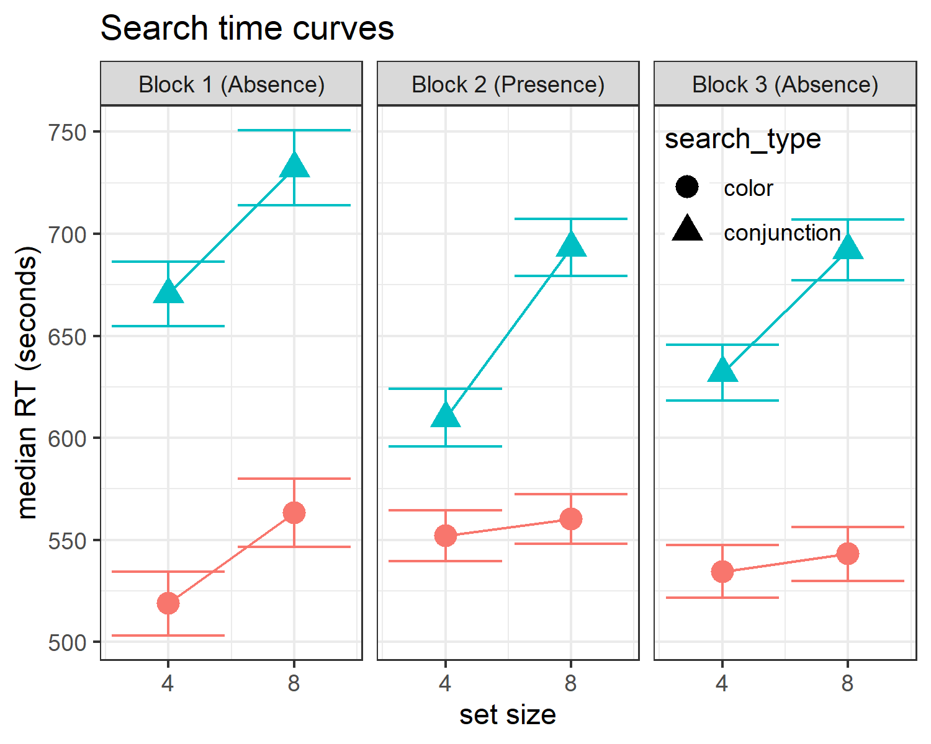

*Figure* *3:*. Median search time by distractor set size for the two search tasks across the three blocks. Correct responses only. Error bars represent the standard error of the median.

# References

Aust, F., & Barth, M. (2020). *papaja: Create APA manuscripts with R Markdown*. Retrieved from <https://github.com/crsh/papaja>

Bates, D., & Maechler, M. (2019). *Matrix: Sparse and dense matrix classes and methods*. Retrieved from <https://CRAN.R-project.org/package=Matrix>

Bürkner, P.-C. (2017). brms: An R package for Bayesian multilevel models using Stan. *Journal of Statistical Software*, *80*(1), 1–28. <https://doi.org/10.18637/jss.v080.i01>

Bürkner, P.-C. (2018). Advanced Bayesian multilevel modeling with the R package brms. *The R Journal*, *10*(1), 395–411. <https://doi.org/10.32614/RJ-2018-017>

Champely, S. (2020). *Pwr: Basic functions for power analysis*. Retrieved from <https://CRAN.R-project.org/package=pwr>

Eddelbuettel, D., & Balamuta, J. J. (2017). Extending extitR with extitC++: A Brief Introduction to extitRcpp. *PeerJ Preprints*, *5*, e3188v1. <https://doi.org/10.7287/peerj.preprints.3188v1>

Eddelbuettel, D., & François, R. (2011). Rcpp: Seamless R and C++ integration. *Journal of Statistical Software*, *40*(8), 1–18. <https://doi.org/10.18637/jss.v040.i08>

Ekstrøm, C. T. (2019). *MESS: Miscellaneous esoteric statistical scripts*. Retrieved from <https://CRAN.R-project.org/package=MESS>

Henry, L., & Wickham, H. (2020). *Purrr: Functional programming tools*. Retrieved from <https://CRAN.R-project.org/package=purrr>

Mazor, M., Mazor, N., & Mukamel, R. (2019). A novel tool for time-locking study plans to results. *European Journal of Neuroscience*, *49*(9), 1149–1156.

Morey, R. D., & Rouder, J. N. (2018). *BayesFactor: Computation of bayes factors for common designs*. Retrieved from <https://CRAN.R-project.org/package=BayesFactor>

Müller, K., & Wickham, H. (2020). *Tibble: Simple data frames*. Retrieved from <https://CRAN.R-project.org/package=tibble>

Navarro, D. (2015). *Learning statistics with r: A tutorial for psychology students and other beginners. (Version 0.5)*. Adelaide, Australia: University of Adelaide. Retrieved from <http://ua.edu.au/ccs/teaching/lsr>

Plummer, M., Best, N., Cowles, K., & Vines, K. (2006). CODA: Convergence diagnosis and output analysis for mcmc. *R News*, *6*(1), 7–11. Retrieved from <https://journal.r-project.org/archive/>

R Core Team. (2019). *R: A language and environment for statistical computing*. Vienna, Austria: R Foundation for Statistical Computing. Retrieved from <https://www.R-project.org/>

Robinson, D., & Hayes, A. (2020). *Broom: Convert statistical analysis objects into tidy tibbles*. Retrieved from <https://CRAN.R-project.org/package=broom>

Treisman, A. M., & Gelade, G. (1980). A feature-integration theory of attention. *Cognitive Psychology*, *12*(1), 97–136.

Wickham, H. (2016). *Ggplot2: Elegant graphics for data analysis*. Springer-Verlag New York. Retrieved from <https://ggplot2.tidyverse.org>

Wickham, H. (2019). *Stringr: Simple, consistent wrappers for common string operations*. Retrieved from <https://CRAN.R-project.org/package=stringr>

Wickham, H. (2020). *Forcats: Tools for working with categorical variables (factors)*. Retrieved from <https://CRAN.R-project.org/package=forcats>

Wickham, H., Averick, M., Bryan, J., Chang, W., McGowan, L. D., François, R., … Yutani, H. (2019). Welcome to the tidyverse. *Journal of Open Source Software*, *4*(43), 1686. <https://doi.org/10.21105/joss.01686>

Wickham, H., François, R., Henry, L., & Müller, K. (2020). *Dplyr: A grammar of data manipulation*. Retrieved from <https://CRAN.R-project.org/package=dplyr>

Wickham, H., & Henry, L. (2020). *Tidyr: Tidy messy data*. Retrieved from <https://CRAN.R-project.org/package=tidyr>

Wickham, H., Hester, J., & Francois, R. (2018). *Readr: Read rectangular text data*. Retrieved from <https://CRAN.R-project.org/package=readr>

Wilke, C. O. (2019). *Cowplot: Streamlined plot theme and plot annotations for ’ggplot2’*. Retrieved from <https://CRAN.R-project.org/package=cowplot>

Wolfe, J. M. (1998). What can 1 million trials tell us about visual search? *Psychological Science*, *9*(1), 33–39.