An important note before beginning, depending on your processor you may have to go in to your bios and change setting to allow for Virtualization. Refrain to your motherboard documentation.

Intalling CentOS 7

1. <https://www.centos.org/download/>

When downloading Linux distros it is best to get them from the developers website.

1. Scroll down to the bottom of the page and select legacy versions

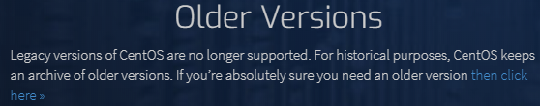

1. 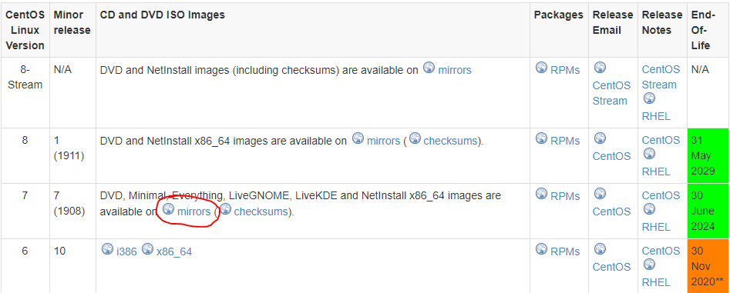Select CentOS 7

1. Select the closest mirror and download the DVD version
2. Open VMware
3. Crtl+N to create a new virtual machine

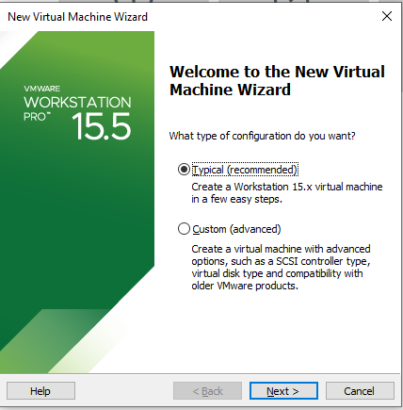

1. Select the iso file

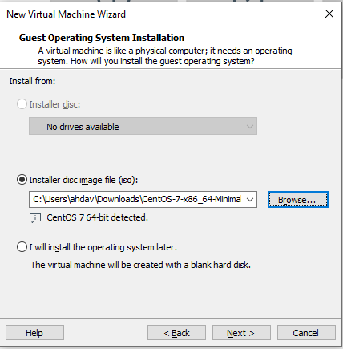

1. Name your VM accordingly and select 20 GB of storage and an appropriate amount of RAM. I used 4gb due to having 32gb of ram in my workstation.
2. Store the Virtual disk as a single file
3. Make sure you turn on your NIC

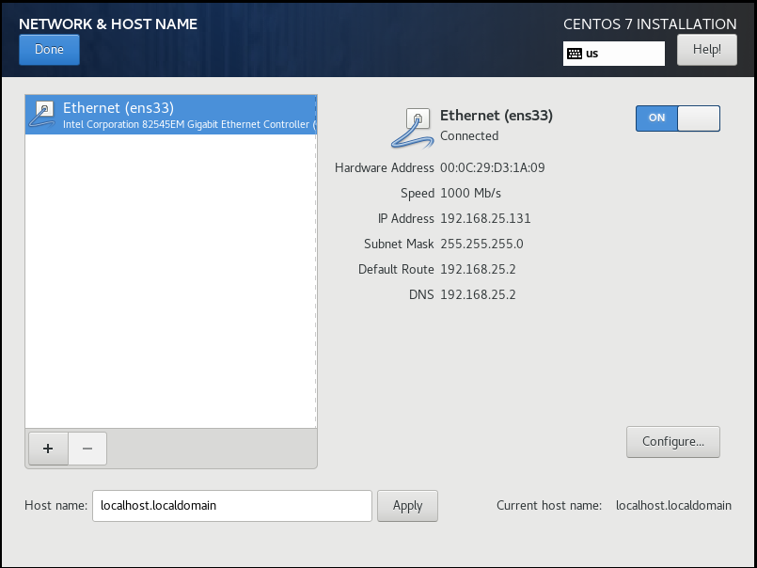

1. 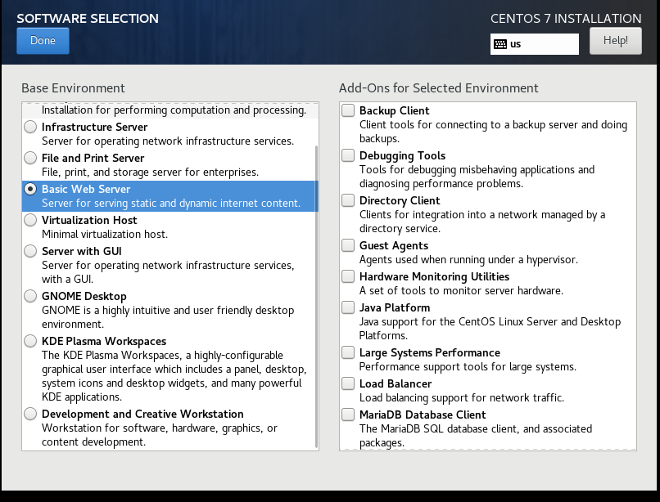Select basic web server
2. Your disk partition should be automatically the 20gb you selecting in VMware
3. Create an admin user and select a safe and secure root password

Installing Ubuntu server

1. Go to <https://ubuntu.com/download/server>
2. 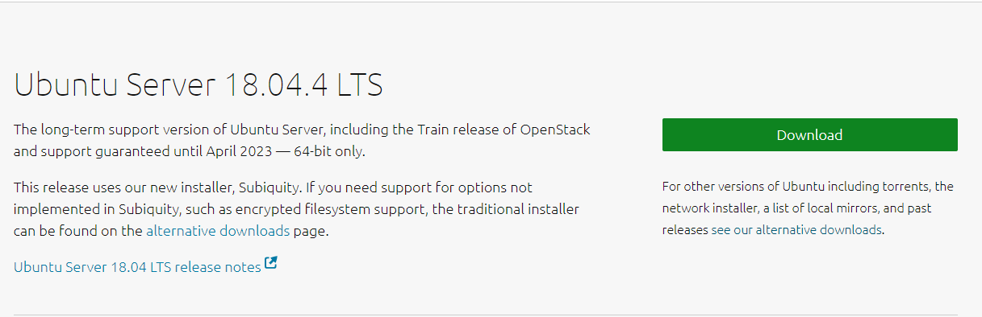Select
3. After downloading open VMware press Ctrl+N
4. 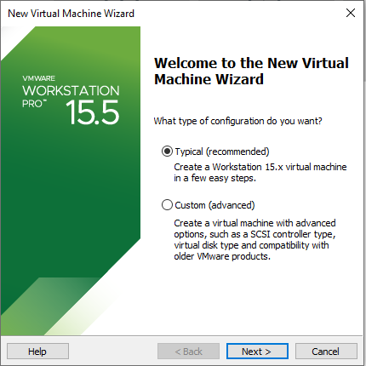Select Typical
5. Select the ISO

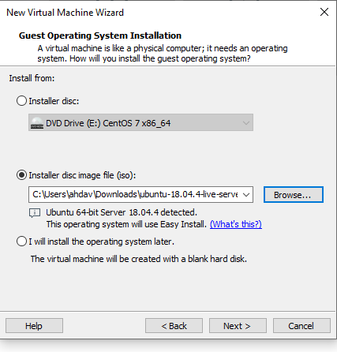

1. Depending on your systems RAM and hard drive space select an adequate amount for your machine. Having a 32gb machine I selected 4gb and also used 30gb of hard drive space to store/run my machine.
2. Install and boot the machine
3. Configure the proper setting to adhere to your environment
4. Forgot to screen shot during install but you should download wormhole for fileshareing
5. When selecting a password for your account on your server make sure you follow the guideline to making a secure password. Ex G1sfm2!@aoi
6. The first thing I do on my server is test the connection to the server and the internet
7. Enter ping google.com to confirm you are connected to the internet

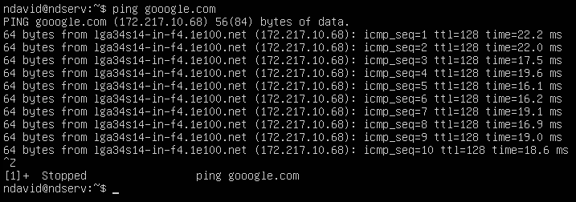

You have now set up and installed Ubuntu server and And CentOS7