Abstract—In every aspect of modern technology, such as pattern recognition and artificial intelligence, the impact of time signal classification either theoretically or functionally is huge. Our novel approach within this paper, is to differentiate among three separate objects where the time-frequency dependency of their reflected acoustic wave signal readings has been analysed. Initially, the respective time-frequency representation (TFR) of each echoed signal was computed using Gabor transformation to the specified time-series data. The spatial relation was considered for characteristic features extraction of the spectrogram in the subsequent steps. Classification of those TFRs which treated as images, was achieved via usage of a Convolutional Neural Network (CNN). In the end, the designed system can accomplish with great consistency in classifying three objects’ reflected signals within the MATLAB environment.
Keywords—Time signal, Gabor transformation, Time-frequency representation (TFR), Spectrogram, Convolutional Neural Networks (CNN) , MATLAB

Experiment

Experiment’s result

Following the performance analysis, further statistics such as the confusion matrix, Positive Predictive Value (PPV), False Discovery Rate (FDR), Negative Predictive Value (NPV), False Omission Rate (FOR), True Positive Rate (TPR), True Negative Rate (TNR), F-score (F1), False Positive Rate (FPR) and accuracy are provided for each resolution mentioned above in the following figures.

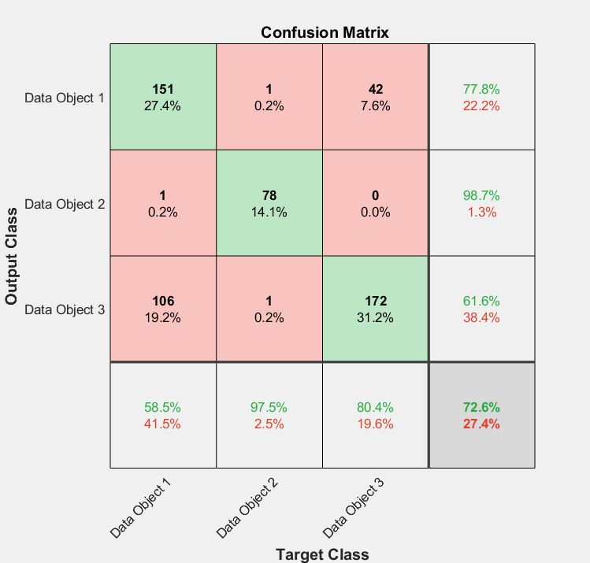

Fig. 1. Confusion Matrix of 1st experiment.
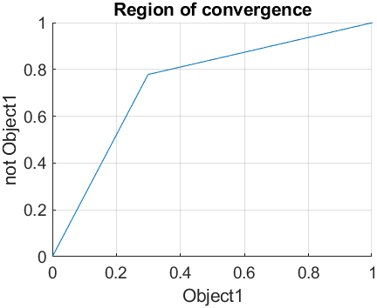
Fig. 2. Receiver Operating Characteristics(ROC) of 1st experiment.
- First Experiment Further Statistics
Accuracy | 72.65%
PPV | 0.59
FDR | 0.414
NPV | 0.85
FOR | 0.15
TPR | 0.78
TNR | 0.7
F1 | 0.67
FPR | 0.3

For the second experiment, the confusion matrix and other statistical results are shown.
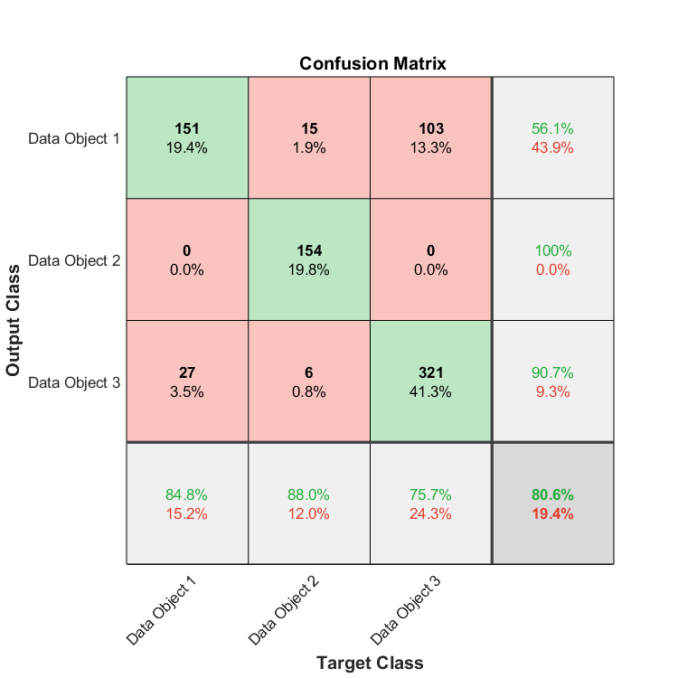
Fig. 3. Confusion Matrix of 2nd experiment.

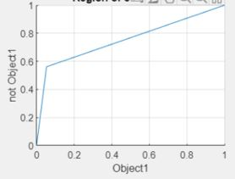

Fig. 4. Receiver Operating Characteristics(ROC) of 2nd experiment.
- Second Experiment Further Statistics

Accuracy | 80.56%
PPV | 0.85
FDR | 0.152
NPV | 0.8
FOR | 0.2
TPR | 0.56
TNR | 0.95
F1 | 0.68
FPR | 0.05

The given Data is for the third training experiment done with a sampling of 80.

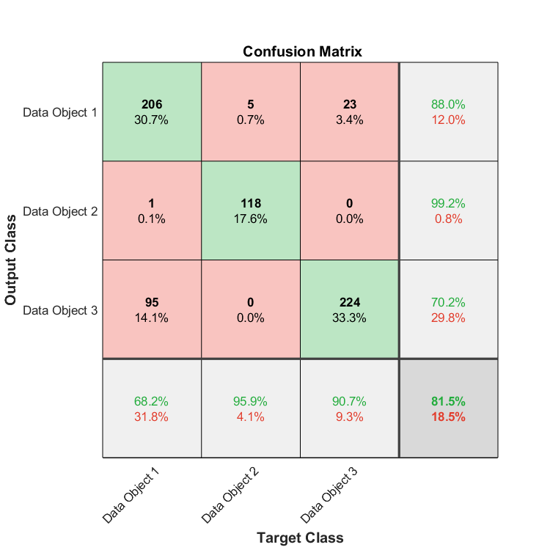
Fig. 5. Confusion Matrix of 3rd experiment..

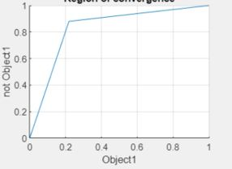

Fig. 6. Receiver Operating Characteristics(ROC) of 2nd experiment.
- Third Experiment Further Statistics
Accuracy | 81.58%
PPV | 0.68
FDR | 0.32
NPV | 0.92
FOR | 0.08
TPR | 0.88
TNR | 0.78
F1 | 0.77
FPR | 0.21

Overall, the network accomplished near perfect performance. Better resolution is preferable for accuracy but slow down the training and validation time, and depending on the running hardware, the computational requirement may be too much for it to handle.

Result on Given Test data
After applying the given test data on the trained network, the classifier predicts 3 data objects as follows:

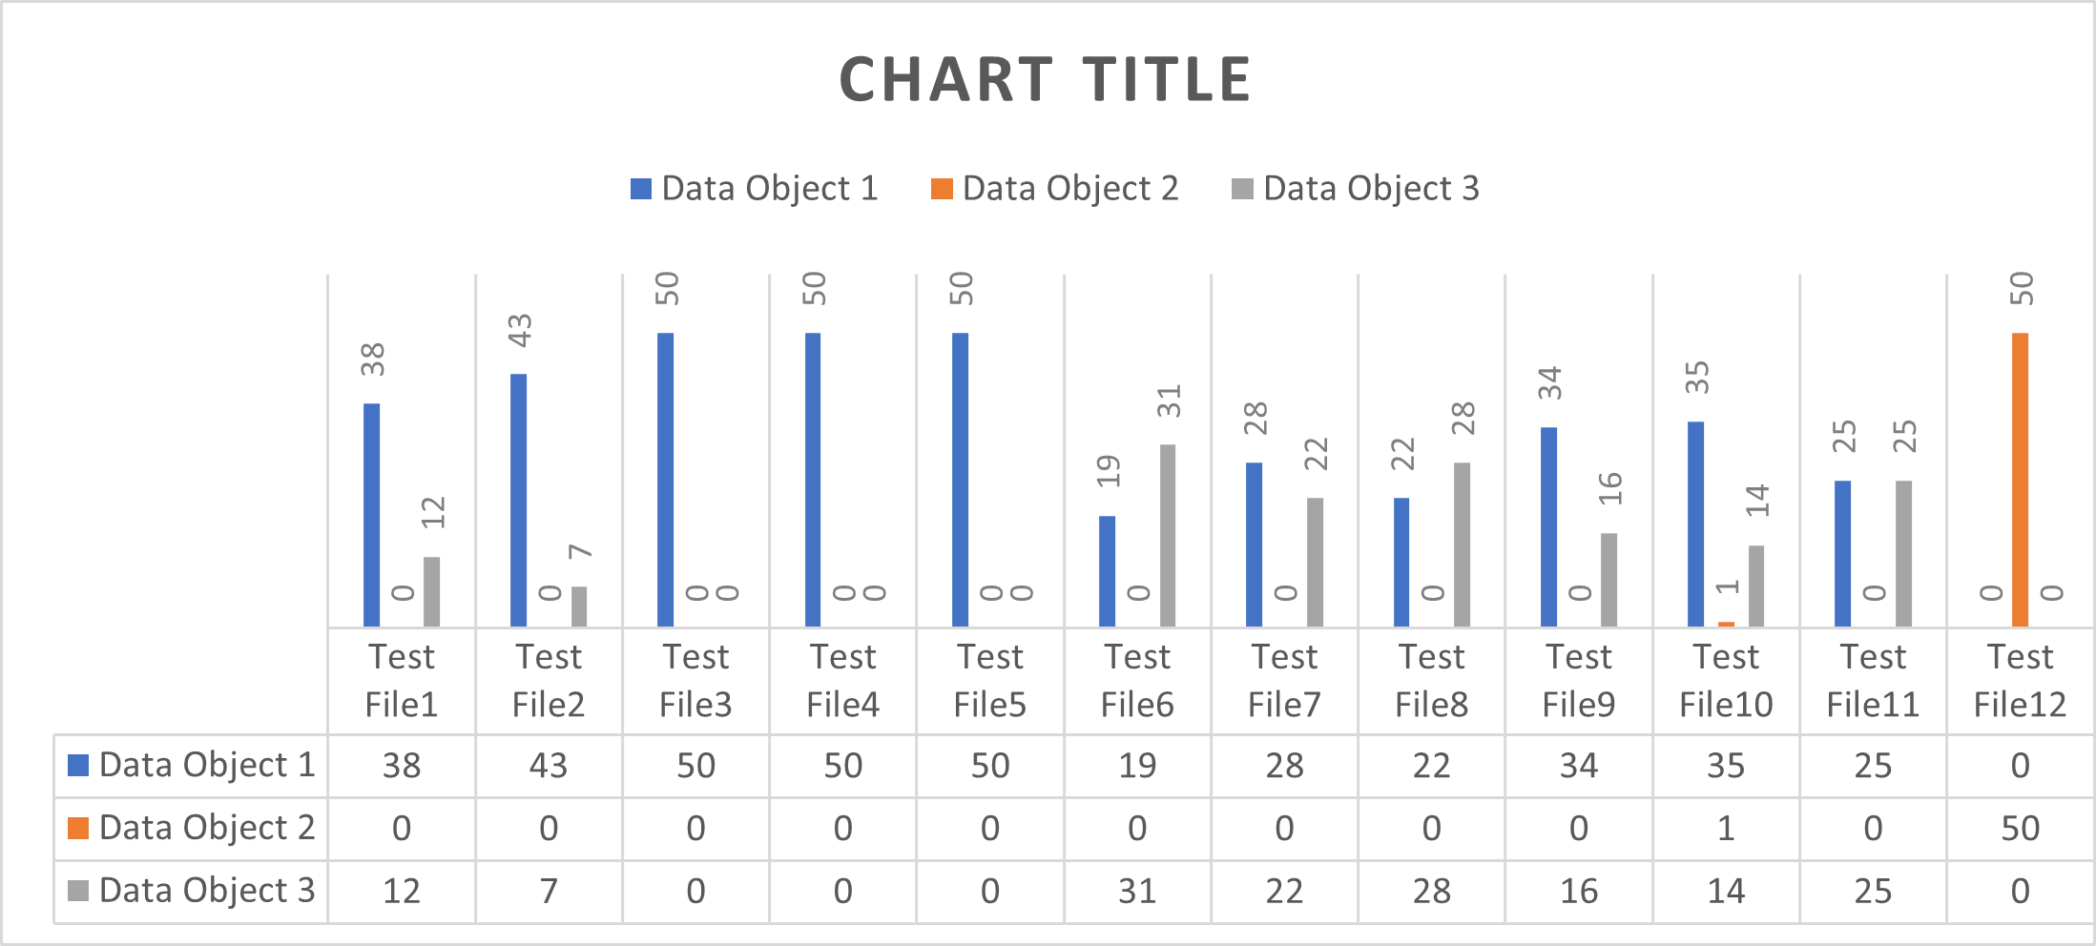

Fig. 7. Data Object prediction from testing data for 1st experiment.

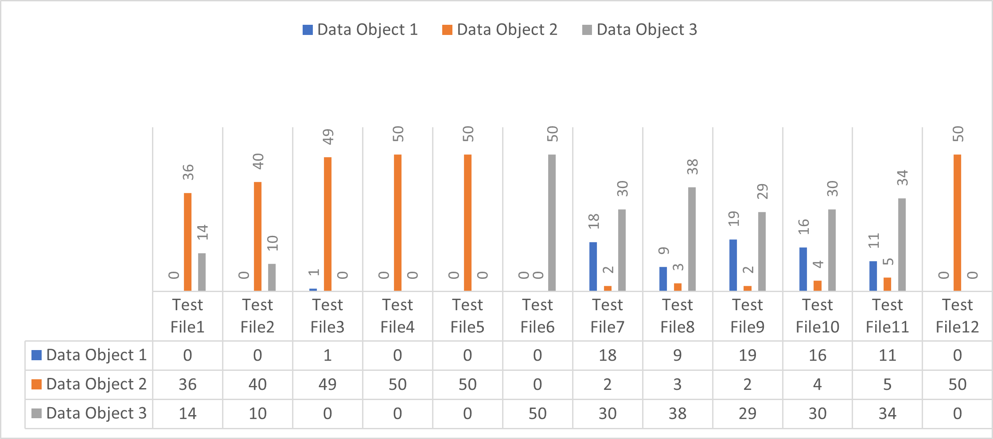

Fig. 8. Data Object prediction from testing data for 2nd experiment.
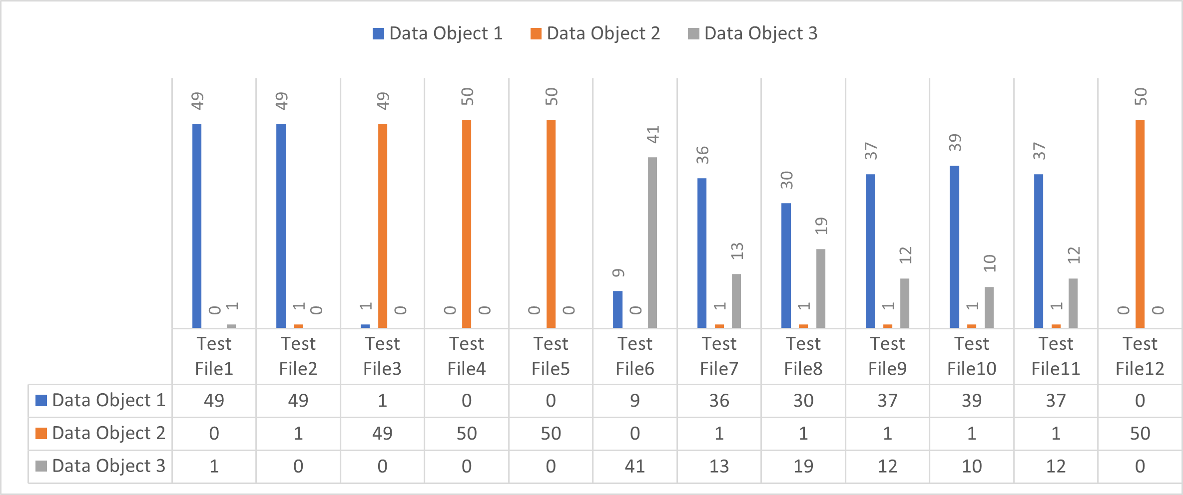

Fig. 9. Data Object prediction from testing data for 3rd experiment.

.

