There are the circuit diagrams below.

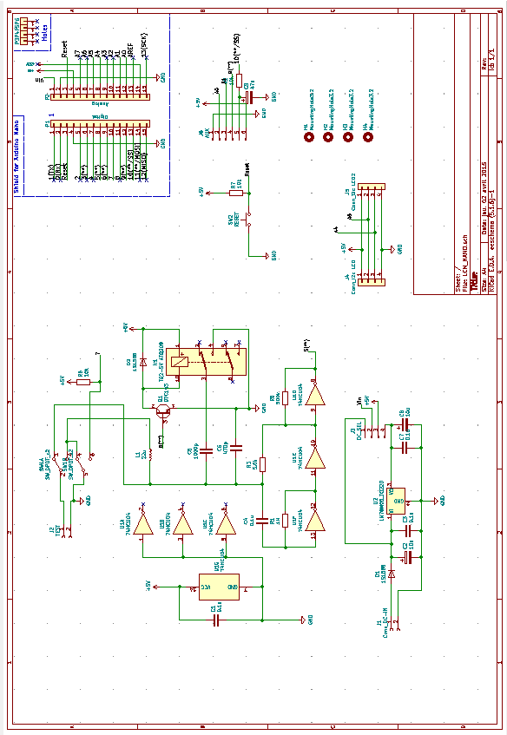

Parts list



　By　nobcha48　AT　gmail.com