**Nobel Shan Setiono – 2602080762**

**Computer Vision Assignment 2**

1. **What are the differences found in your experiment between 2 algorithm and based on across the variety images?**

For my experiment the 2 algorithms I used are ORB and SIFT and then for the matchers I used BF (Brute Force) and FLANN. From my observation ORB tends to have way more matches than SIFT but is only the case when using BF as a matcher. When I use FLANN matcher ORB tends to have very little matches while SIFT now have more matches than ORB. Also when using ORB or BF as matcher the output tends to have way more mismatches than when using SIFT or FLANN as matcher.

1. **Based on your observation, do these 2-algorithm failed in certain cases in your samples?**

Yes, when I try to match flags, it fails to do so here is the result when it tries to match American flags between all the algorithms and matchers

The combination of ORB_BF just points to other flags that has some kind of 90-degree angle of edges, ORB_FLANN just fails to have any matches altogether, SIFT_BF still able to connect the stripes of the American flag but for the stars it connects to the edges of Canada’s maple leaf, and the last SIFT_FLANN connects all the American flag with Canada’s maple leaf edges. These results are probably affected by the different in size between the scene image and the object/target image. Since here the American flag is so big while in the scene it is so small it results in different calculation on the algorithm making the parts not match.

1. **Which one is the robust feature extractor for the keypoint matching task? Explain!**

The more robust feature extractor from what I observe is SIFT as it is way more accurate than ORB. This is the result of ORB not requiring to take the most maximum key-point hence in most prediction ORB has more matches. This is also the reason why when using ORB with FLANN the output tends to be way less matches since FLANN is more selective

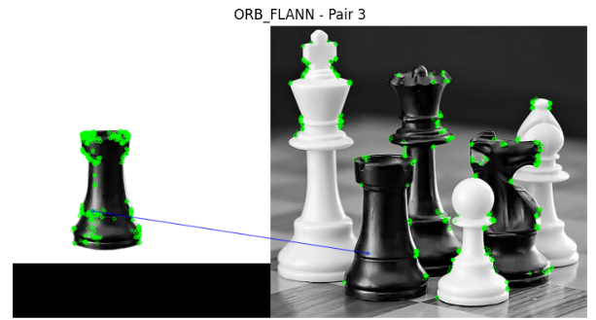

Since SIFT looks for the maximum key-points it tends to be more selective on the key points resulting in a lesser match but also more controlled especially when paired with FLANN making an almost perfect match and even when I use SIFT with BF it still has some mismatch but not as much as ORB in general.

**Reference:**

<https://mikhail-kennerley.medium.com/a-comparison-of-sift-surf-and-orb-on-opencv-59119b9ec3d0>