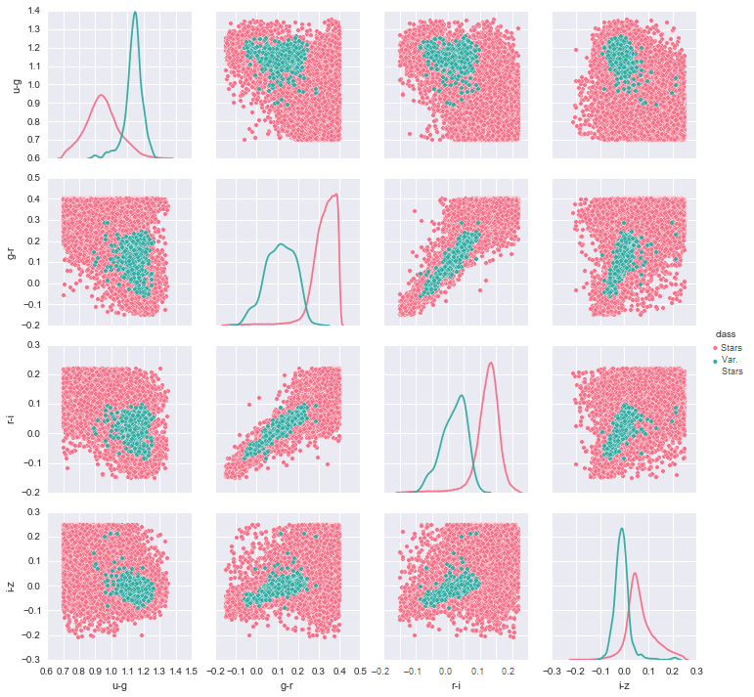

 | precision | recall | F1 | ROC_AUC | Accuracy
KNN | 0.657407 | 0.572581 | 0.612069 | 0.785492 | 0.996135
D Tree | 0.514286 | 0.145161 | 0.226415 | 0.572214 | 0.994718
Log Reg | 0.13986 | 0.967742 | 0.244399 | 0.96794 | 0.968135
Naive Bayes | 0.027459 | 0.983871 | 0.053427 | 0.898658 | 0.814352
Random Forest | 0.604651 | 0.419355 | 0.495238 | 0.708943 | 0.995448
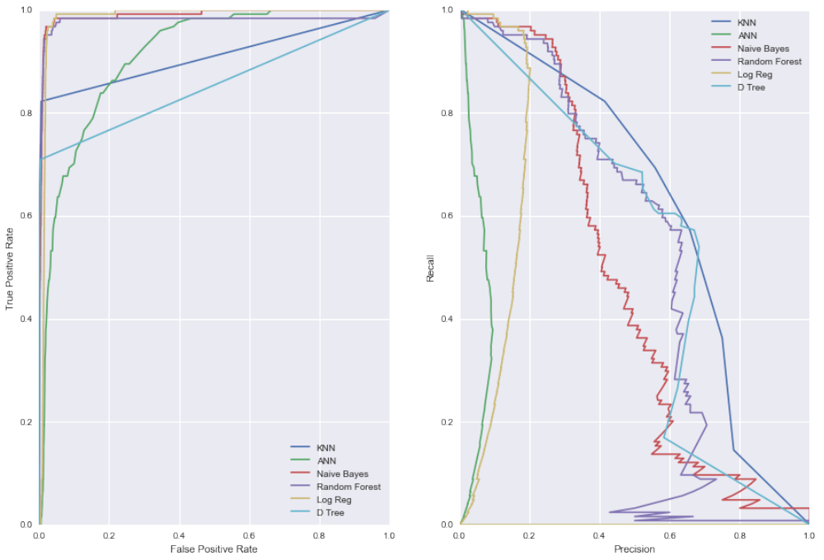
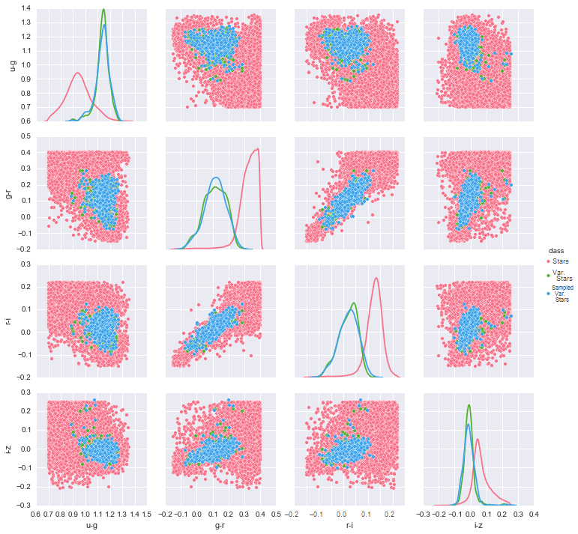
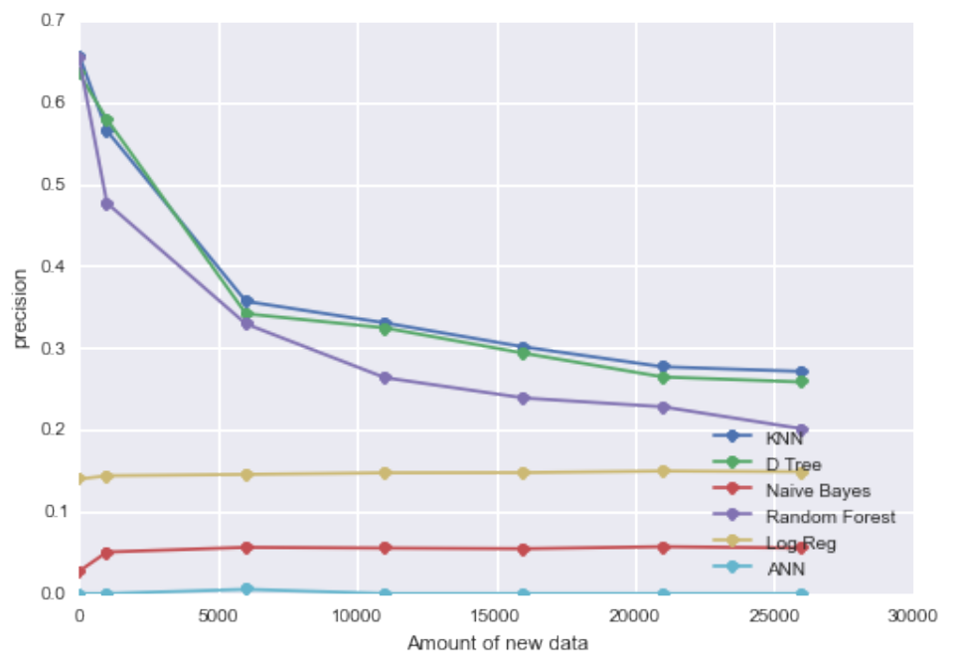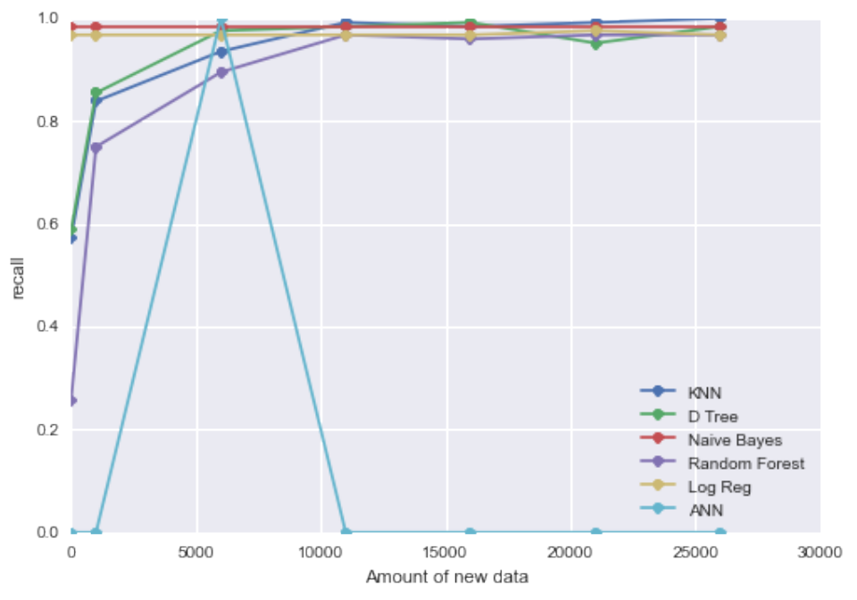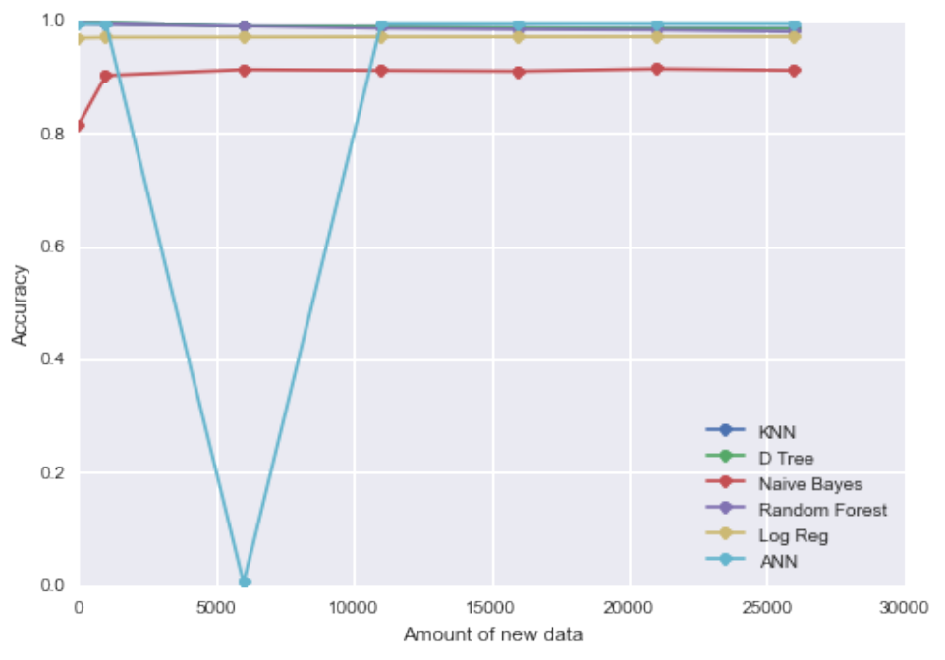

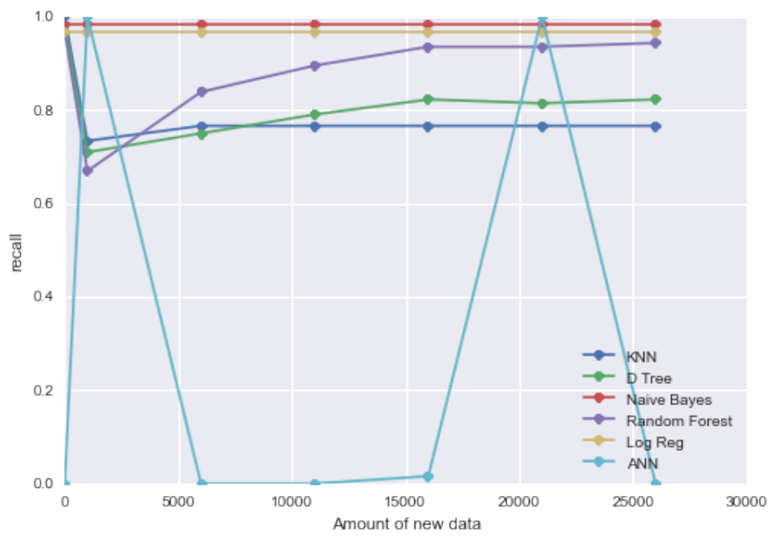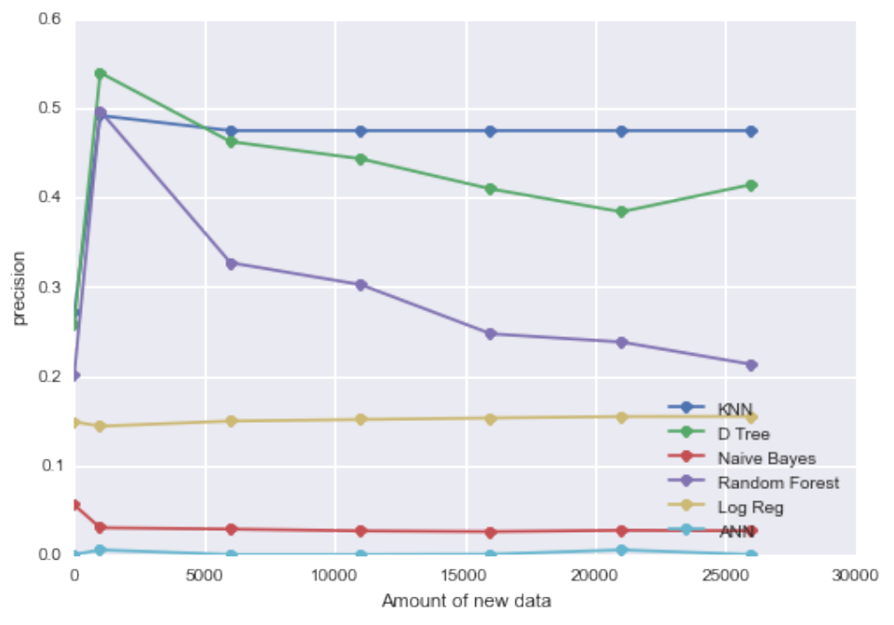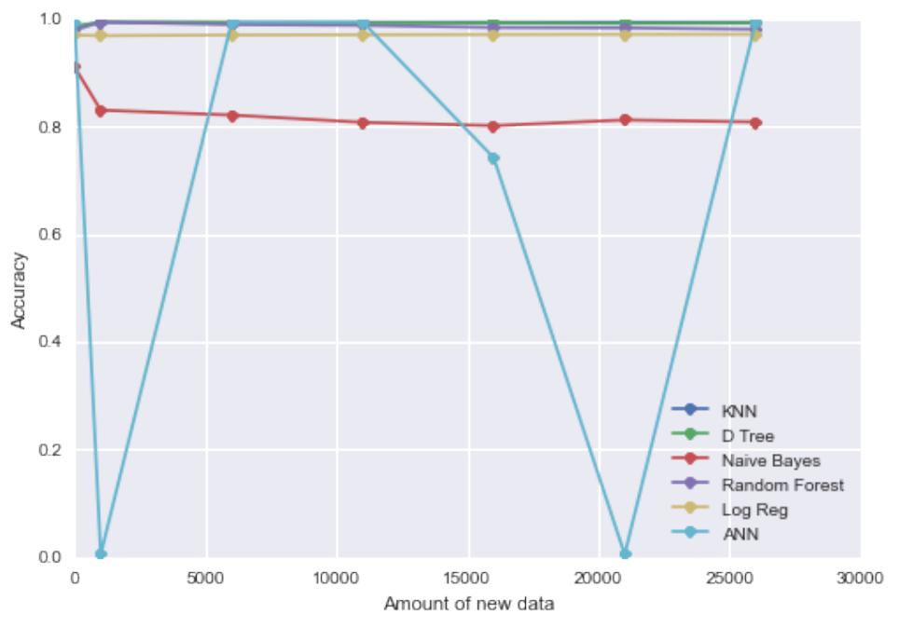

 | Explained Variance | Mean Absolute Error | R2 Error | Mean Squared Error
KNN | 0.800698 | 0.01768 | 0.800697 | 0.00058
Boosted DT | 0.802678 | 0.017692 | 0.802643 | 0.000575
D Tree | 0.701174 | 0.022393 | 0.701132 | 0.00087
RF | 0.70223 | 0.022371 | 0.702187 | 0.000867
Ridge Reg | 0.615556 | 0.022984 | 0.615466 | 0.00112
LR | 0.365826 | 0.033775 | 0.365035 | 0.001849

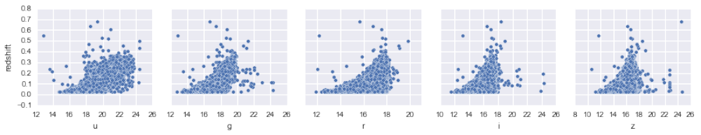

RR LYRAE CLASSIFICATION

REDSHIFT PROBLEM

ORIGINAL DATA KDE SAMPLED DATA

COMBINED DATA
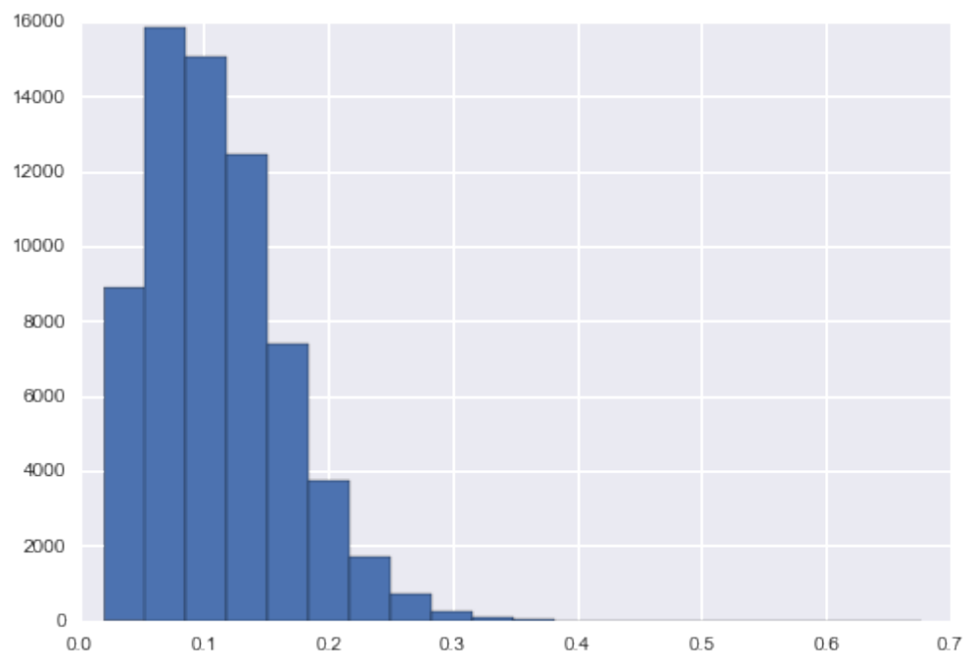

RESULTS HISTOGRAM

RESULTS PROBLEM DATA

A SURVEY OF CLASSIFICATION ANALYSIS TECHNIQUES FOR ASTROPHYSICS PROBLEMS

INTRODUCTION

CONCLUSION
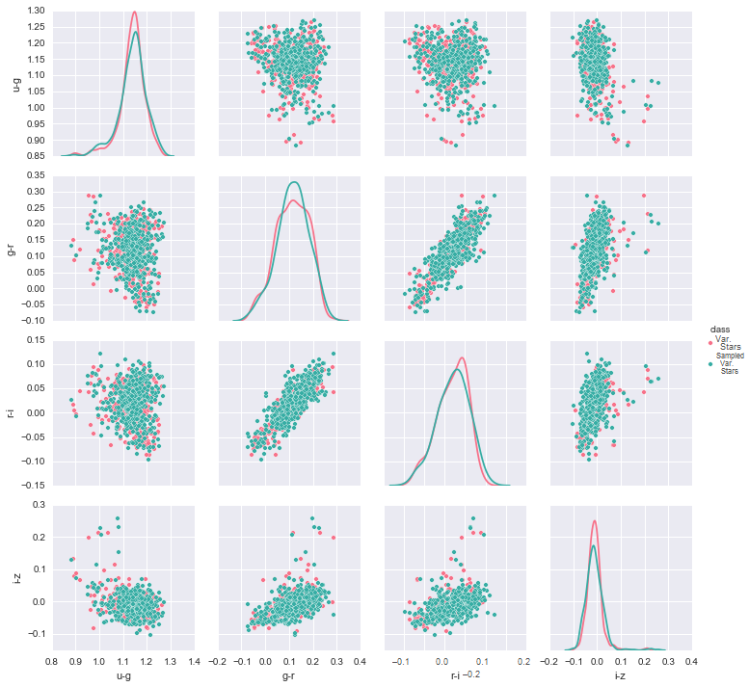
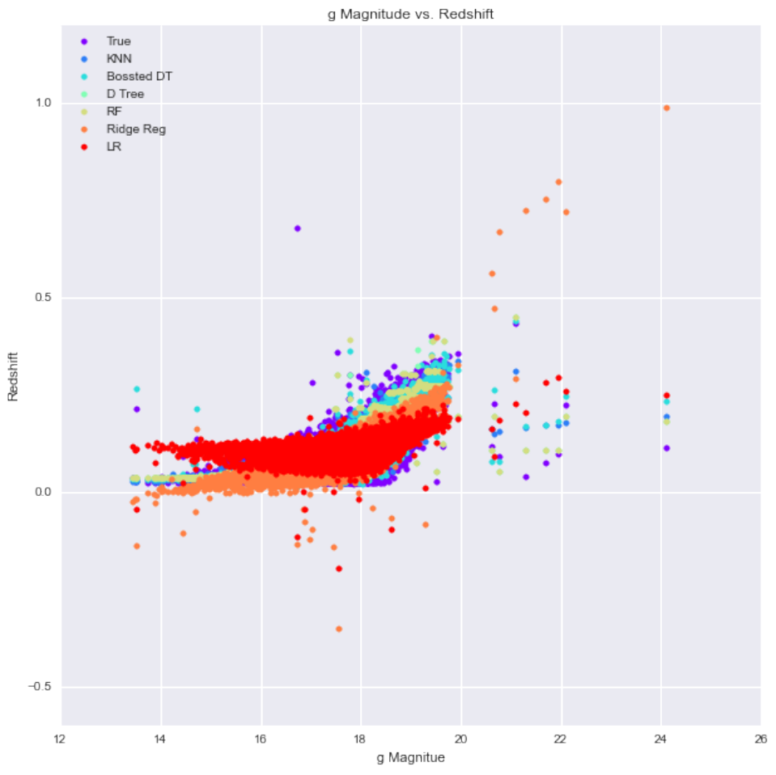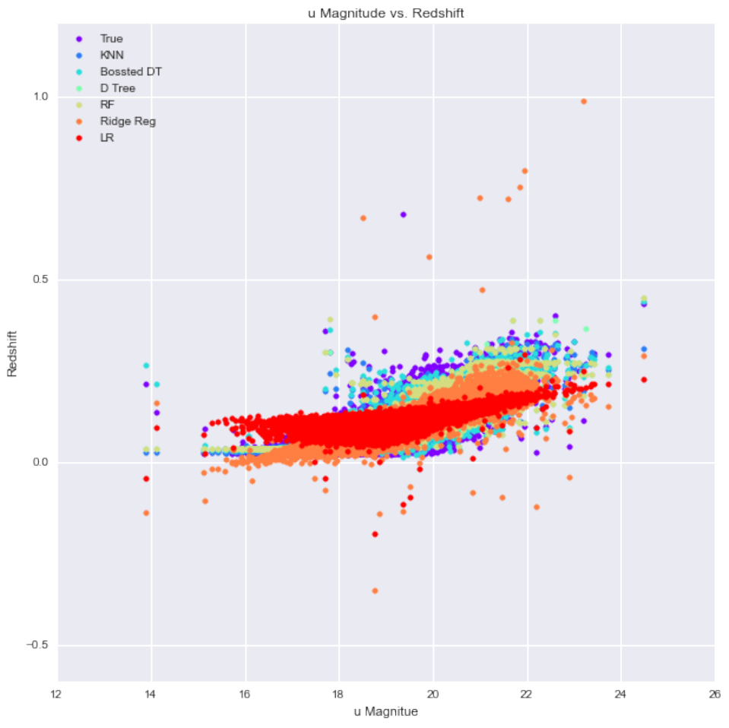
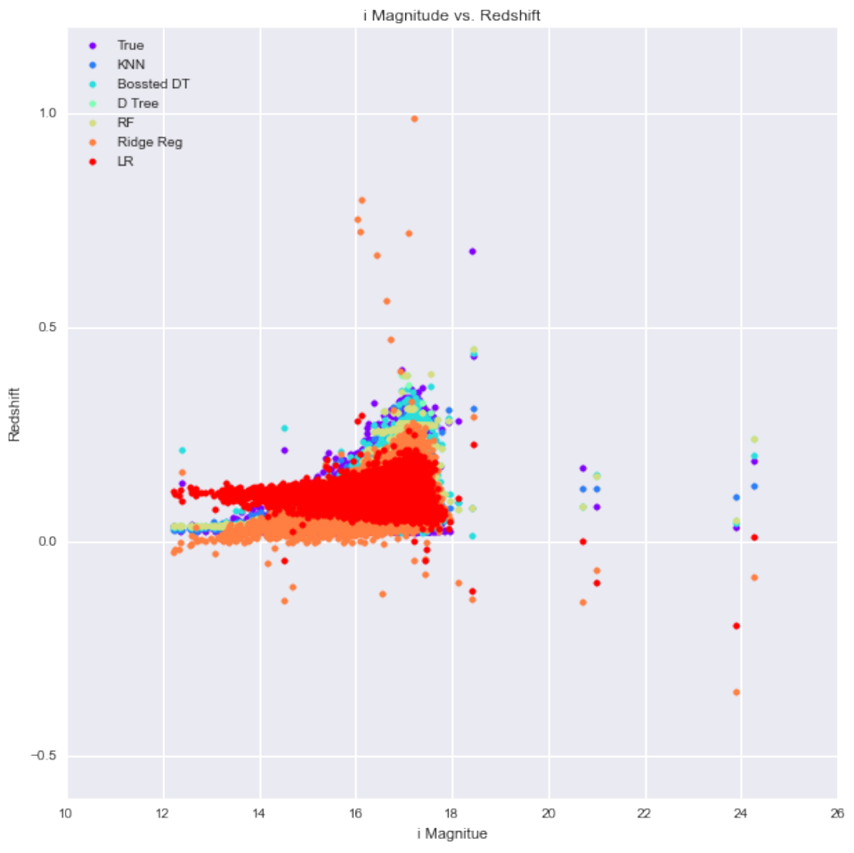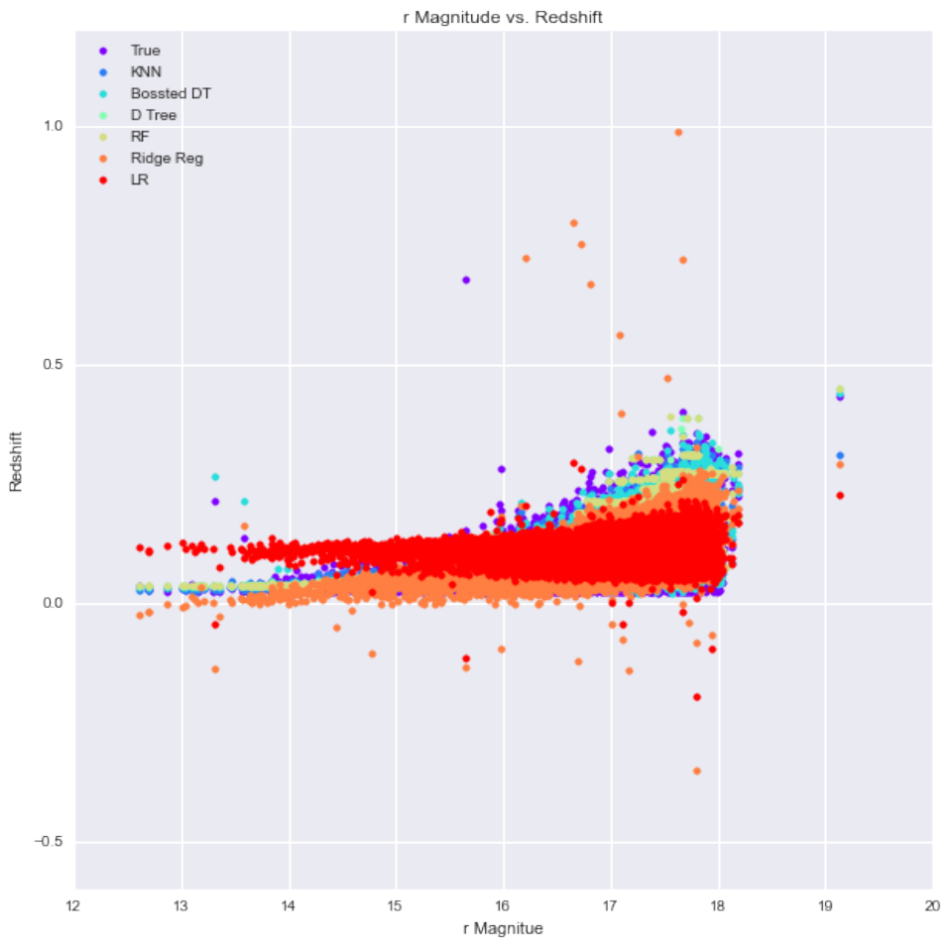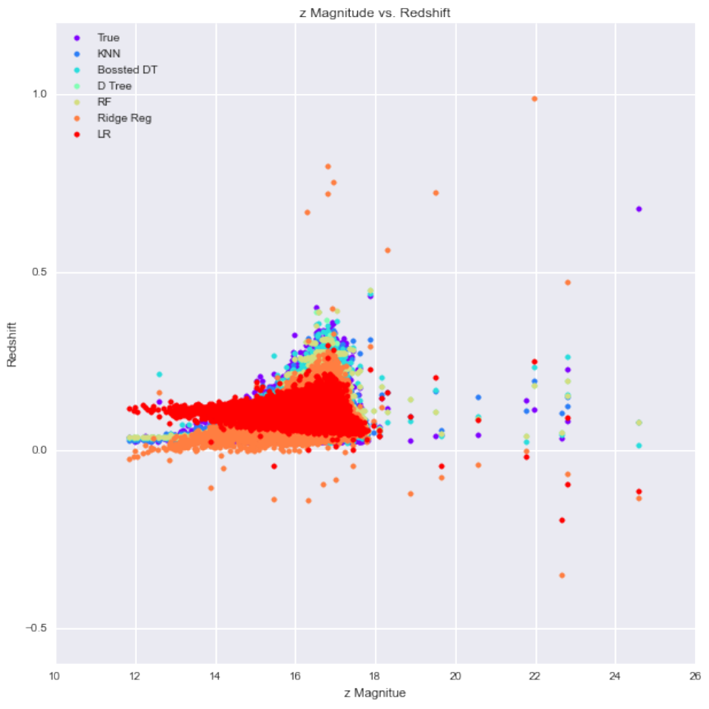

This project served as an introduction to applying machine learning to astronomy. We worked on two different problems a classification problem where we tried to classify RR Lyrae variable stars from standard stars and a regression problem where tried to determine the redshift of galaxies. Both project used photometric data from the Sloan Digital Sky Survey and had their separate challenges. In particular the classification problem had the difficult property where there was much more of one class (Standard stars) than the other. Building a classifier to detect these rare events was a difficult challenge. For both problems we compared a variety of models.
From this report we can see that the nearest neighbor and tree (random , boosted) approaches did very well for both problems. Even though both problems are very different physically and in regards to what they are trying to pick both used photometric data. As stated previously photometry gives you a very coarse representation of the object so perhaps the success of these methods speaks to their ability to work with a feature space where you do not have fine details about the objects (the representation contains little information compared to a spectrum representation).
The linear models also did not do well for either problem indicating that there is quite a bit of complexity in the actual physical relationships that we are observing. And there needs to be more investigation into the neural networks. If more time were permitted a more systematic study would be done of training a variety of network models with different hyper-parameters.
The KDE and random sample approach for adding more example of the RR class did not do as well as we expected and analysis was given for why this might be the case. Adding in more data has shown to be a successful approach for a variety of problems especially with images. Thus we think more investigation needs to be done to conclude whether this approach is viable for this problem. Perhaps it is necessary to incorporate domain expertise about the physical objects and use this build a generative model. It is entirely possible that more clever approach such as this might achieve even better performance that was presented.
We would also like to add that this is only the tip of the iceberg for applying machine learning methods to astronomy. As stated in the introduction the amount of data is growing both in size and complexity and it important to develop models that can process and analyze it. This is very exciting and active area of research for both physicist and data science experts.
For our project we worked on two different problems. Both focused on applying and comparing different machine learning methods on astrophysical data.
One of the projects we worked was to classify RR Lyrae variable stars versus standard stars. This is a very important problem in astrophysics because RR Lyrae variable stars are used as standard to candles to measure distances. Thus if we can develop reliable methods for discriminating between RR Lyrae stars from standard stars just using photometric data than observational astronomers can use this to select which stars to collect finer data on to determine distances.
The data, shown on the left under Original Data, comes from the Sloan Digital Sky Survey and consists of four features called colors. These colors are u-g, g-r, r-i, and i-z and they are the difference of magnitudes between two different bands. For example the u-g colors is the magnitude from the g band subtracted from the u band. The dataset consists of about 93 thousand objects and only about 500 of which are RR Lyrae variable stars. This huge difference between the number of positive example (RR Lyrae stars) and negative examples makes this a very challenging problem. Furthermore the detection of rare events is pervasive throughout observational astronomy so by identifying and developing methods that are good at addressing this issue might generalize to other problems. The detection of exoplanets, strong lensing, collisions, supernova, MACHOS and many more are all examples in astrophysics where detecting rare events is important.
The other problem we worked on was a regression problem where we would like to assign a redshift to a galaxy using only photometric data. This dataset consists of over 60 thousand objects where the features are the magnitudes of the 5 bands. Hence there are 5 features u, g, r, i, and z. The data is shown on the right under Problem Data. Redshift is very similar to a Doppler shift in that it is a phenomenon where the wavelength of the light emitted by an object gets distorted based on the relative motion of the object. Since all the object we are looking at are galaxies the redshift is actually from the cosmological expansion of the universe between us and the galaxy and the peculiar motions of the object play a very little role. As a result, there is a direct relationship between the object’s distance from us and its measurement. By determining the redshift of as many objects as we can scientists can better map the large scale structures of the universe and compute n-point correlation statistics and compare these with predictions from theoretical models of the universe. For our dataset the ground truth comes from determining the redshift from spectrums of the objects since it is a much easier problem when the spectrum is known.

