**Assignment 4:**

**Use Vγ(diode) = 0.6 V, VD(conducting voltage of diode) = 0.7 V, Vγ(transistor) = 0.5 V, VBE(forward active) = 0.7 V, VBE (saturation) = 0.8 V, VCE (saturation) = 0.2 V , βF =30, βR  =0.1, VBC (reverse active) = 0.7 V for all the questions unless otherwise stated.**

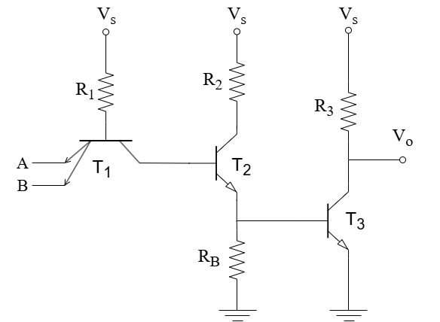

**Given,** Vs = 9 V , R2 = 2k , R3 = 4.4k, RB = 4.4k

**Question 1:** Determine the power dissipation of this TTL circuit when both inputs are HIGH. You must show your calculation. Assume R1 = 6.7k for this question only

**Question 2:** Suppose you are selling this TTL logic gate to a customer and he states a strict criteria of keeping the power dissipation below 1.23 mW when both inputs are LOW (0 V). Determine the maximum value of R1 you can use to satisfy this criteria.