Poster: Proposed Methodology

Abstract
This poster presents a multimodal engine health grading pipeline that combines pretrained OBD2 sensor and audio encoders. It focuses on methodology, data preparation, fusion architecture, and evaluation metrics tailored for ordinal severity grading.

Study Pipeline
The proposed workflow consists of: data preprocessing for each modality, embedding extraction using frozen pretrained encoders, pseudo-paired dataset construction by matching health grades, and multimodal fusion training with an ordinal head.
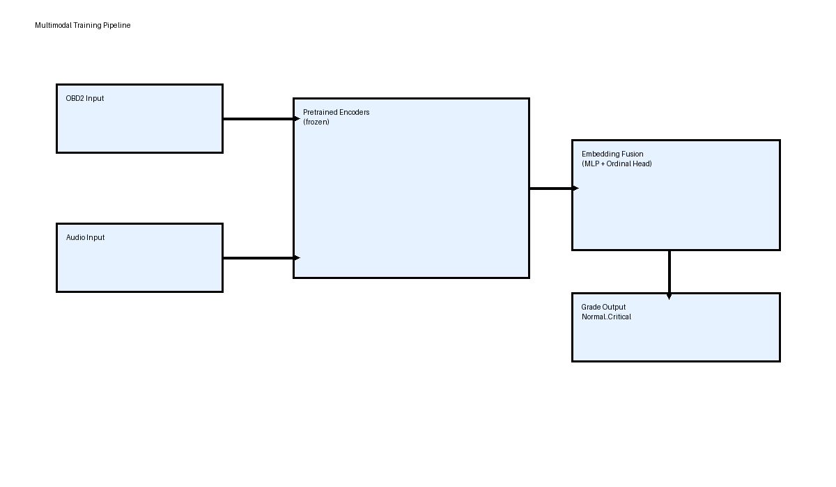

Model Architecture
The fusion model concatenates OBD2 and audio embeddings and passes them through a compact MLP with ordinal regression. This architecture preserves the pretrained encoders while learning cross-modal interactions in the fusion head.
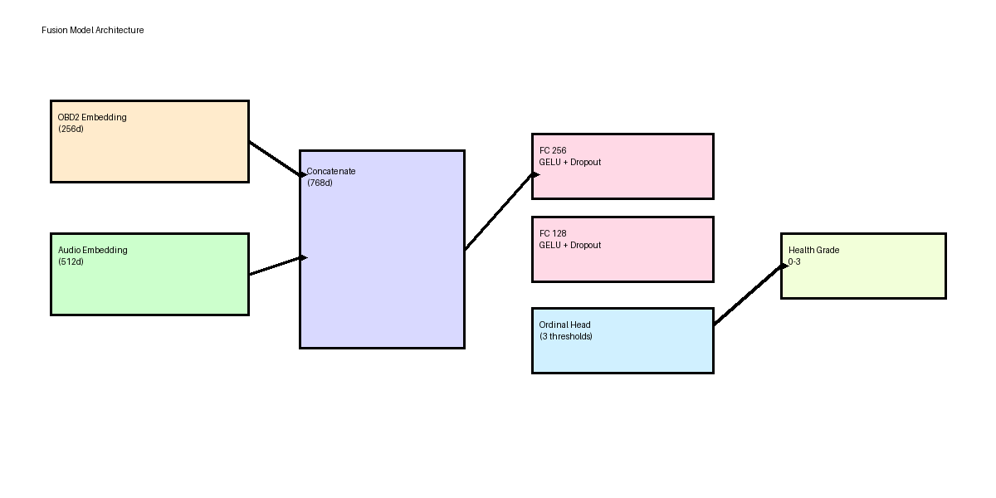

Methodology Details
Alternative approaches examined:
- - OBD2-only classification using the pretrained CNN+BiGRU+Attention encoder
- - Audio-only classification using the pretrained MSDA-Net encoder
- - Weighted average fusion of branch probabilities
- - Confidence-weighted dynamic fusion
The selected model is a learned fusion approach with pseudo-paired training, which offers the best mix of interpretability and ordinal performance in this problem setting.

Data Preparation
OBD2 data pipeline:
- - 30-step windows of 8 operational engine features.
- - Sliding window overlap ensures sufficient sample coverage.
- - Labels derived from diagnostic severity scoring and encoded as 0–3.
Audio data pipeline:
- - 44.1 kHz recordings segmented into 3-second windows with 1-second hop.
- - Mel spectrogram extraction using 128 mel bins and bandpass 20–16000 Hz.
- - Data augmentation includes noise injection, mixup, and spectrogram masking.
Integration:
- - Pseudo-pair OBD2 and audio embeddings of the same grade for training.

Evaluation
The fusion model is validated using macro F1 and quadratic weighted kappa. Training uses cosine annealing with warmup, early stopping, and balanced sampling to handle class imbalance.
Output files include fused embedding datasets, trained checkpoints, and evaluation reports for test performance.

References
External repositories used for encoder design and preprocessing: E:\Thesis\Car engine health ob2 model and E:\Thesis\Car_Engine_audio_model(final).These sources define the OBD2 feature extraction, audio spectrogram pipeline, and pretrained encoder behavior.

