Poster: Proposed Methodology

1. Abstract
A multimodal engine health grading system combines pretrained OBD2 and audio encoders with a learned fusion head. This poster explains the pipeline, architecture, data preparation, and evaluation metrics.

2. Study Pipeline
The end-to-end training pipeline consists of:
- - OBD2 and audio preprocessing
- - Embedding extraction from frozen pretrained models
- - Pseudo-paired multimodal dataset construction
- - Fusion model training with ordinal regression
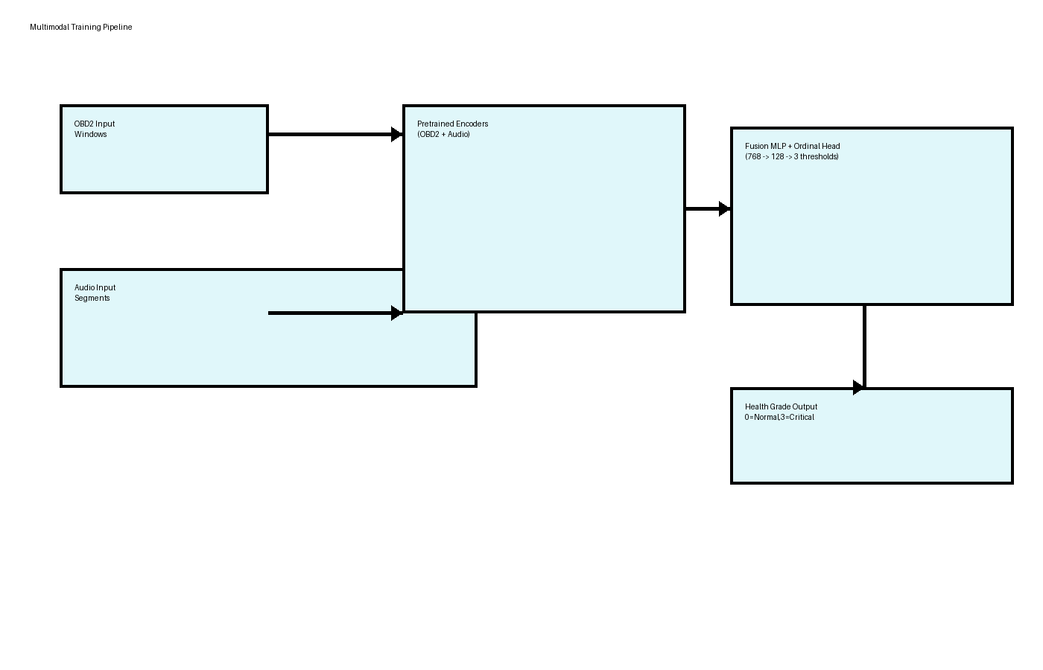
Figure 1: Multimodal training pipeline.

3. Fusion Model Architecture
The fusion model concatenates OBD2 and audio embeddings and processes them through a compact MLP with an ordinal head.
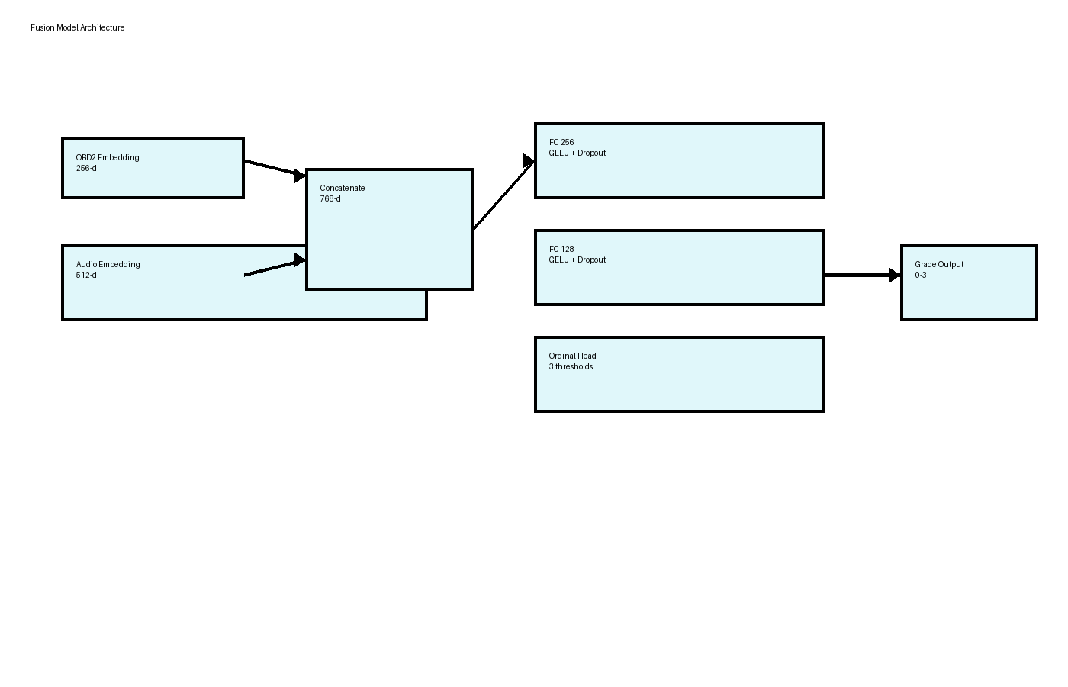
Figure 2: Fusion model architecture with ordinal output.

4. Data Preparation
OBD2 preprocessing: 30-step windows from 8 engine features (RPM, coolant temp, engine load, map pressure, intake air temp, throttle position, speed, catalyst temp).
Audio preprocessing: 3-second audio segments at 44.1 kHz, mel spectrograms with 128 mel bins and 20–16kHz bandpass. Augmentation includes noise, mixup, and spectrogram masking.

5. Methodology
A learned fusion approach was selected over unimodal baselines and probability-based fusion because it provides the best tradeoff between accuracy and ordinal consistency.

6. Evaluation
Validation uses macro F1 and quadratic weighted kappa. Training uses cosine annealing, warmup, early stopping, and balanced sampling to reduce class imbalance.

