Data Cleaning and Visualization Report
Academic Success Project
Phase covered: data loading, cleaning, data-quality checks, initial visualizations, and handover to modeling.

Rows | 4424
Columns | 39
Target classes | Dropout, Enrolled, Graduate
Clean dataset | academic_success_clean.csv

1. Project goal
The goal of this phase was to understand, clean, and visualize the Academic Success dataset. The target variable contains three possible student outcomes: Dropout, Enrolled, and Graduate.
My responsibility in the team was the first phase: data understanding, data cleaning, data quality checks, initial visualizations, and preparing a clear handover for the modeling phase.

2. Dataset overview
Metric | Value | Percentage
Rows | 4424
Columns | 39
Graduate | 2209 | 49.93%
Dropout | 1421 | 32.12%
Enrolled | 794 | 17.95%

The target variable is imbalanced because the Enrolled class is much smaller than the Graduate class. This is important for the later evaluation phase because accuracy alone can be misleading.
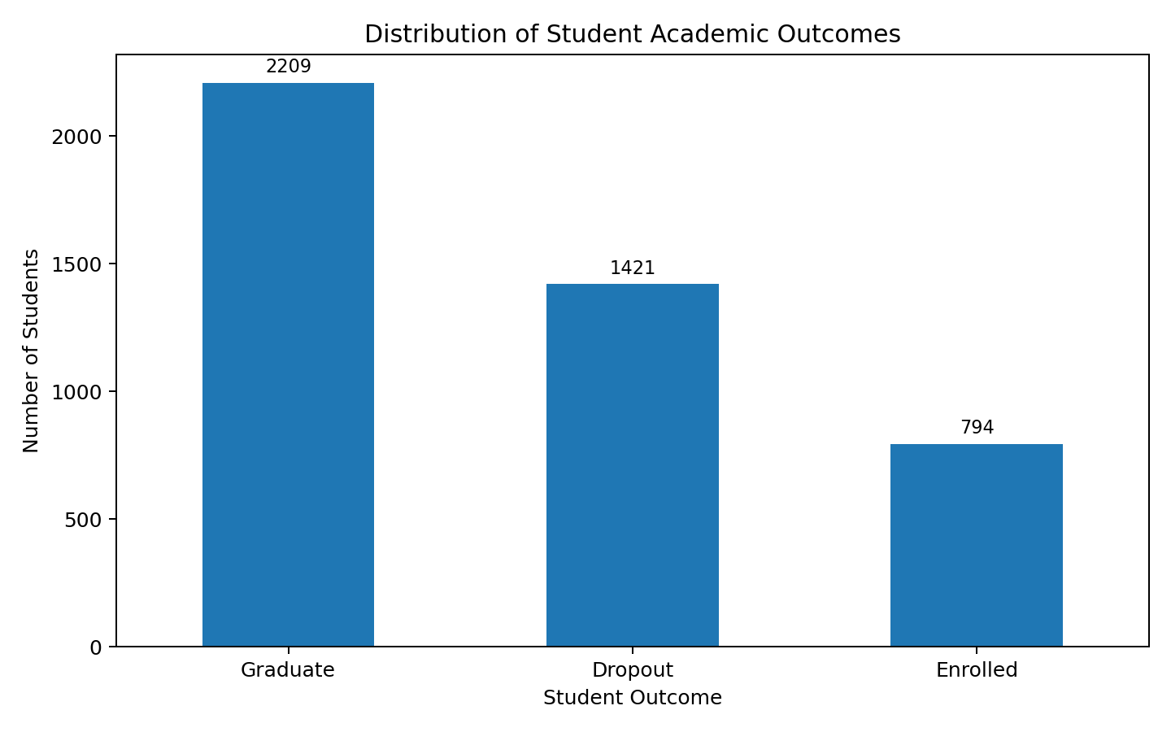
Figure 1. Distribution of student academic outcomes.

3. Data loading and column-name cleaning
The CSV file required special handling. It uses semicolon-separated values and includes characters that had to be cleaned from the column names. The final safe loading block is shown below.
import pandas as pd
import csv
df = pd.read_csv(
"academic_success.csv",
sep=";",
encoding="utf-8-sig",
quoting=csv.QUOTE_NONE
)
df.columns = df.columns.str.replace("\ufeff", "", regex=False)
df.columns = df.columns.str.replace('"', "", regex=False)
df.columns = df.columns.str.replace("\t", "", regex=False)
df.columns = df.columns.str.strip()
After this correction, the dataset loaded correctly with shape (4424, 37).

4. Feature groups
Group | Count | Meaning | Decision
Target | 1 | The outcome to predict: Dropout, Enrolled, or Graduate. | Use as label/target variable.
Binary | 8 | Two-value variables, mostly 0/1. | Keep as 0/1.
Categorical | 10 | Numeric codes representing categories. | Keep original codes in clean dataset; encode before modeling.
Numerical | 18 | Real measurable values such as grades, age, approved units, and economic indicators. | Keep numeric; scale later only if the selected model requires it.

Important decision: categorical codes were kept in the clean dataset. They should be encoded later by the modeling teammate, because values such as course code 9500 and course code 171 are labels, not continuous quantities.

5. Cleaning checks and decisions
Cleaning step | Result | Decision
Data loading | Dataset loaded successfully after using semicolon separator and safe encoding. | Use the safe loading block for all future work.
Column name cleaning | Column names were cleaned successfully. | Use cleaned column names in all scripts.
Missing value check | No missing values found. | No imputation or row removal needed.
Duplicate row check | No duplicate rows found. | No duplicate removal needed.
Binary column validation | All binary columns contain only 0 and 1. | Keep binary columns as 0/1.
Categorical column validation | No invalid categorical codes were found. | Keep original category codes in the clean dataset; encode them later for modeling.
Numerical range validation | No invalid values found. Negative values only appeared in GDP and inflation rate, which are valid economic indicators. | Keep numerical values as they are.
Clean dataset creation | Clean dataset saved successfully. | Use academic_success_clean.csv as the base file for analysis and modeling.

6. Clean dataset
After all checks, the cleaned dataset was saved as academic_success_clean.csv. No rows were removed because no missing values, duplicate rows, or invalid values were found. The cleaned dataset keeps the original category codes but has cleaned column names.

7. Visualizations and findings

7.1 Tuition fees up to date vs target
Students whose tuition fees are not up to date show a much higher dropout count. This feature is likely important for dropout prediction.
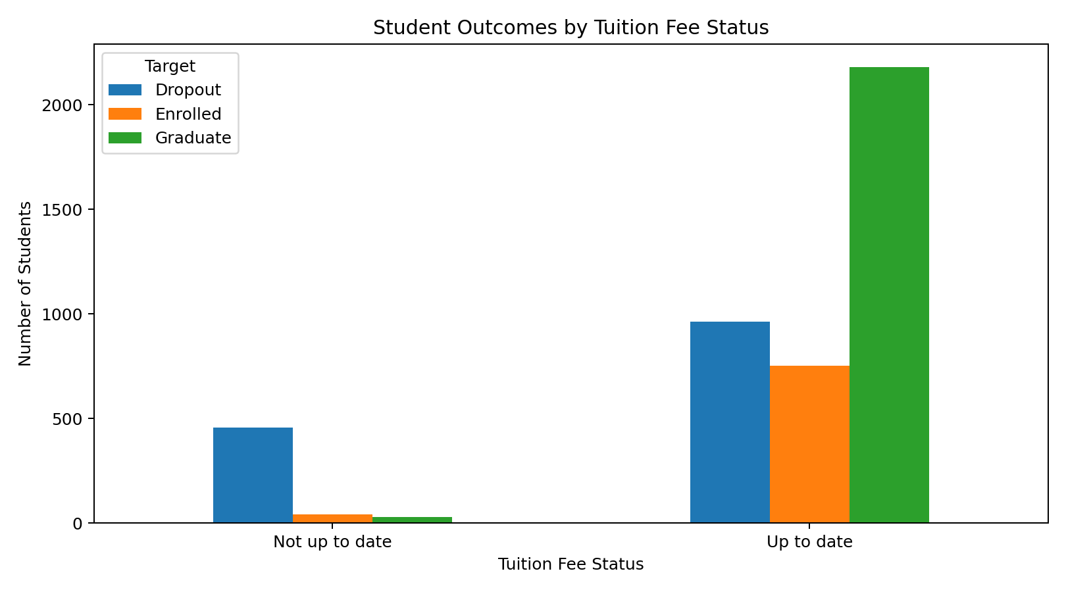
Figure 2. 1 tuition fees up to date vs target.

7.2 Debtor status vs target
Debtor students show a higher dropout count compared with non-debtor students. This feature is likely important for predicting dropout risk.
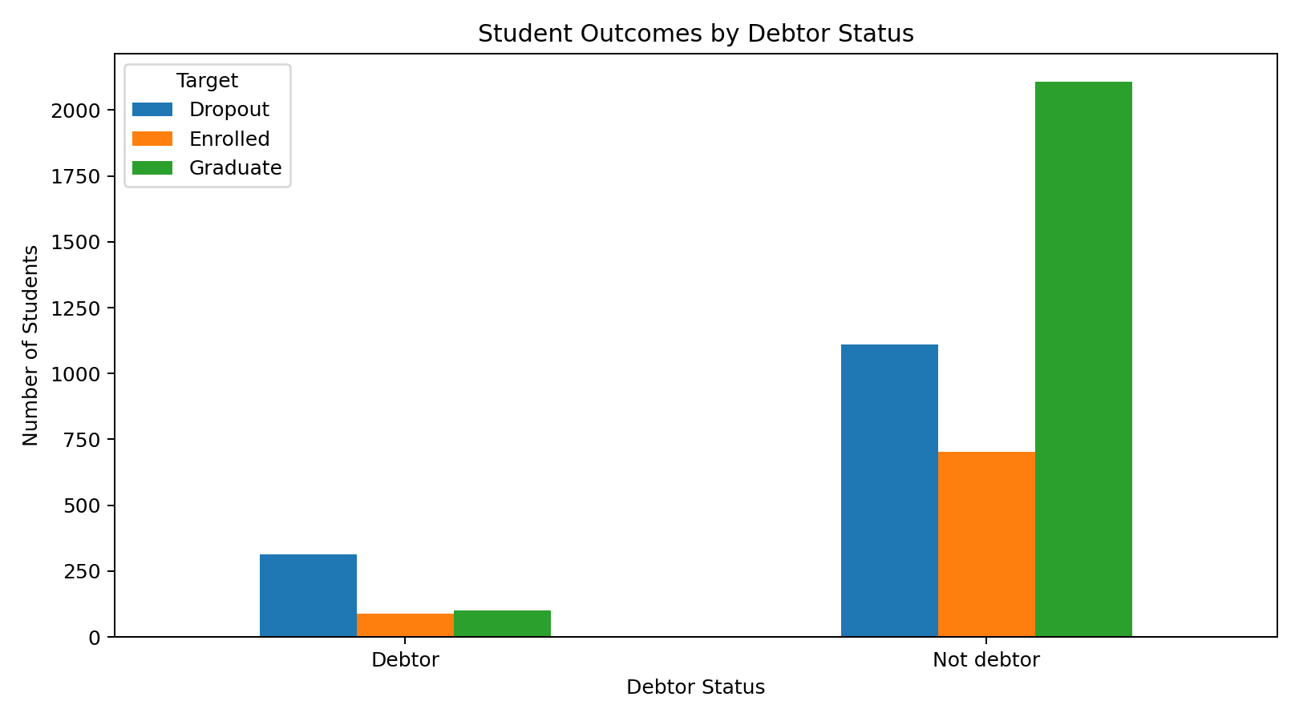
Figure 3. 2 debtor status vs target.

7.3 1st semester approved units vs target
Dropout students usually approved fewer units in the first semester. This is a strong academic-performance signal.
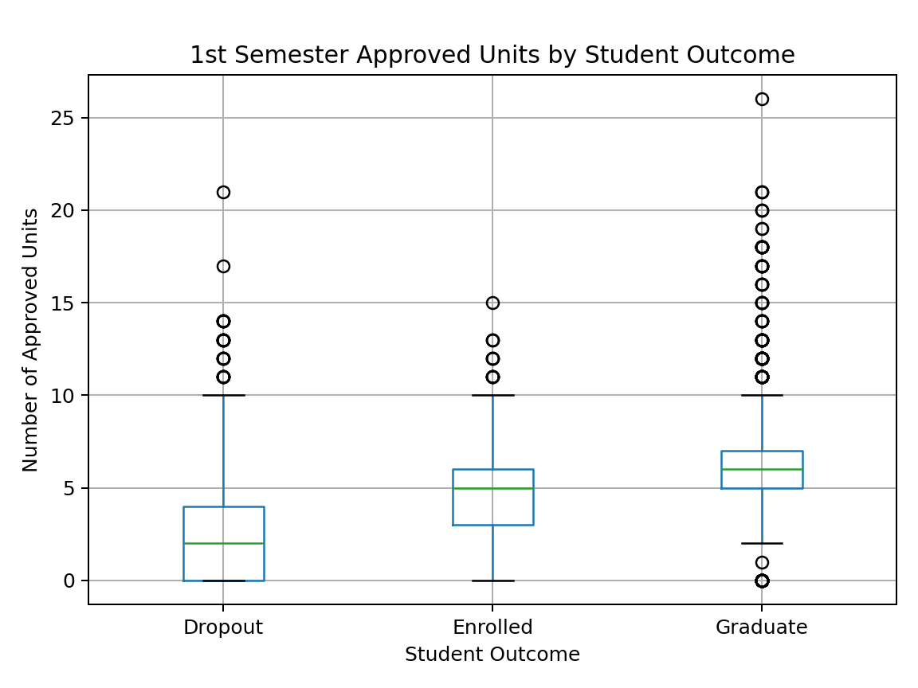
Figure 4. 3 1st semester approved units vs target.

7.4 2nd semester approved units vs target
Dropout students usually approved very few or zero units in the second semester. This is likely one of the strongest predictors.
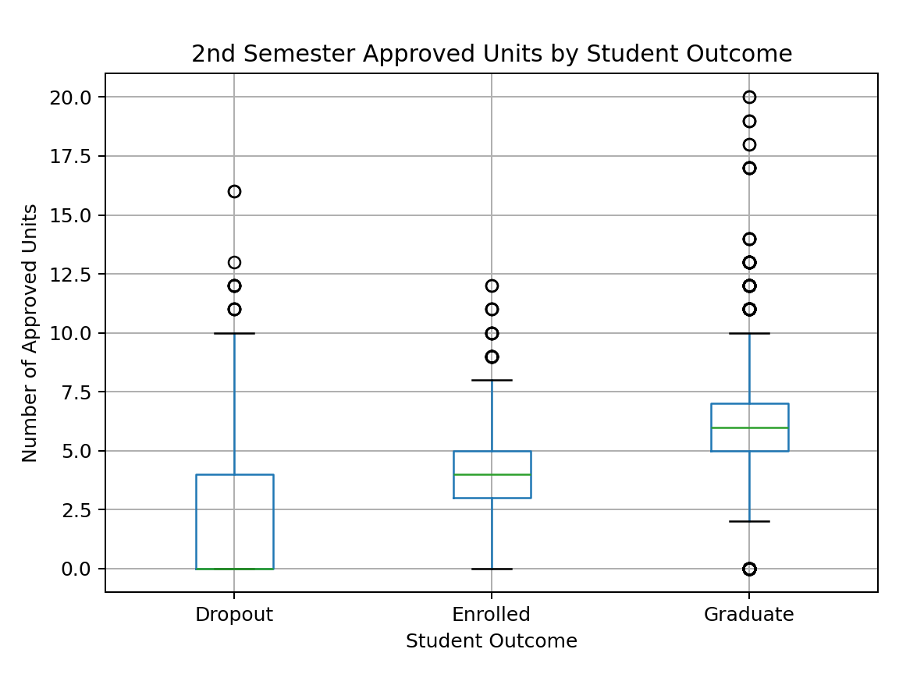
Figure 5. 4 2nd semester approved units vs target.

7.5 1st semester grade vs target
Dropout students generally have lower first-semester grades. This feature should be included as an academic-performance variable.
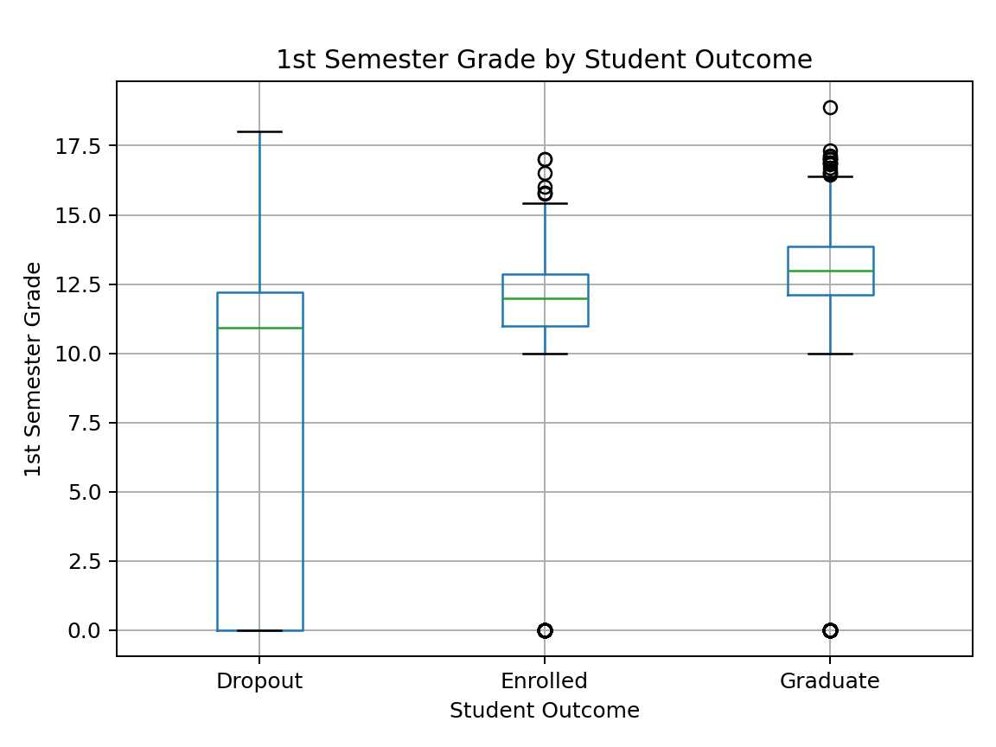
Figure 6. 5 1st semester grade vs target.

7.6 2nd semester grade vs target
Dropout students have much lower second-semester grades, often close to zero. This feature is likely very important for prediction.
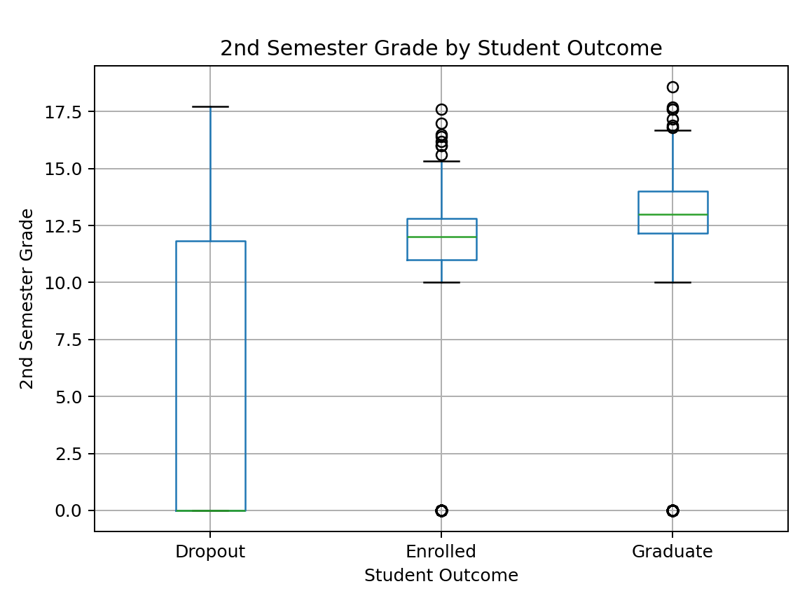
Figure 7. 6 2nd semester grade vs target.

7.7 Age at enrollment vs target
Dropout students are older on average, but age alone does not clearly separate the classes. It should be kept, but it is weaker than academic-performance and financial-status features.
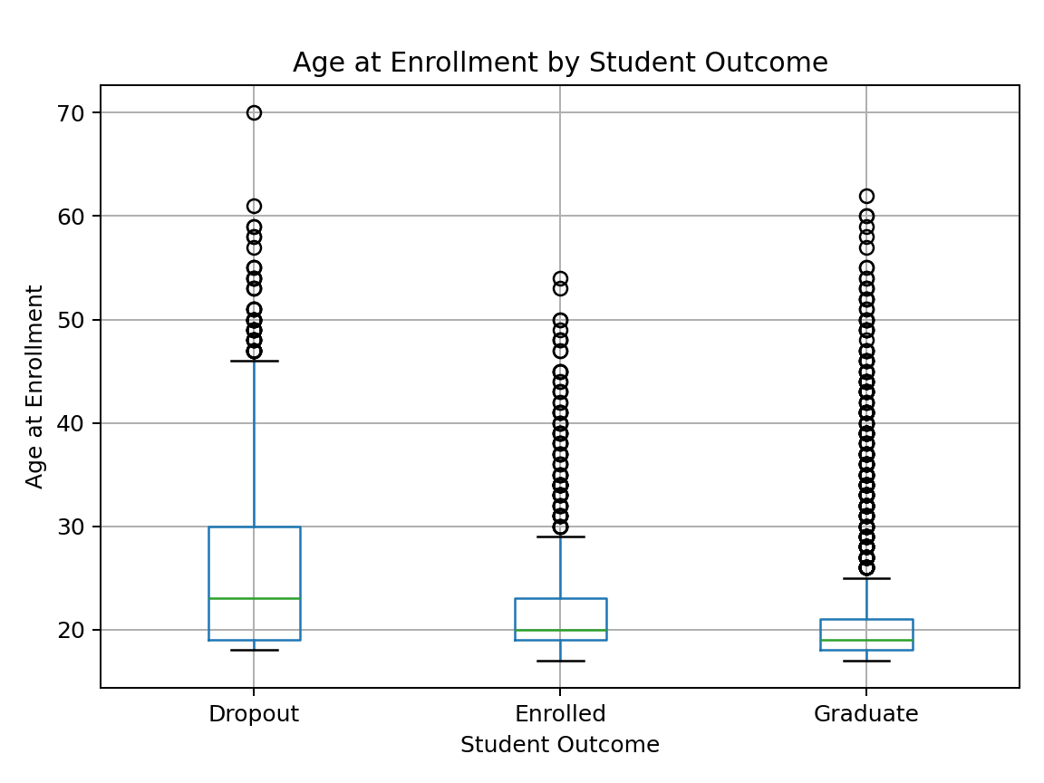
Figure 8. 7 age at enrollment vs target.

7.8 Numerical correlation heatmap
Academic performance variables are strongly correlated with each other. Economic indicators show weaker relationships with most academic-performance variables.
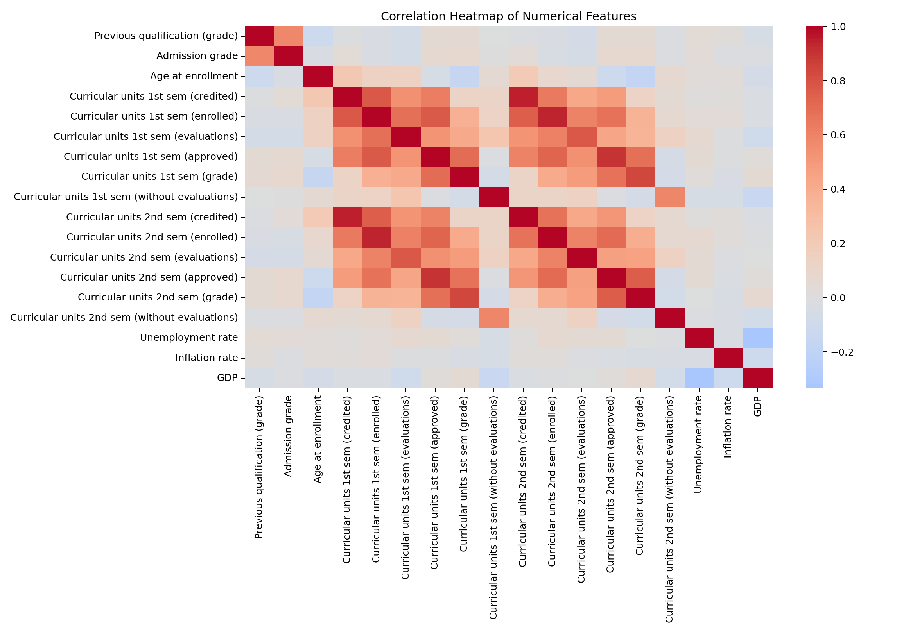
Figure 9. 8 numerical correlation heatmap.

8. Main insights
- The target variable is imbalanced.
- Students with unpaid tuition fees show higher dropout risk.
- Debtor students show higher dropout risk.
- Students who approved fewer units are more likely to drop out.
- Lower semester grades are connected to dropout.
- Dropout students are older on average, but age alone is not enough.
- Academic performance variables are strongly connected with each other and are likely important for modeling.

9. Handover to modeling teammate
The modeling teammate should start from academic_success_clean.csv.
Recommended next steps:
- Define X and y.
- Encode the target variable.
- Encode categorical variables properly.
- Keep binary columns as 0/1.
- Scale numerical columns if the selected model requires it.
- Use stratified train/test split because the target is imbalanced.
- Use precision, recall, F1-score, and confusion matrix, not accuracy only.

10. Files created
- academic_success_clean.csv
- cleaning_report_summary.csv
- feature_group_summary.csv
- key_findings_summary.csv
- numerical_summary.csv
- numerical_correlation_matrix.csv
- handover_note_for_modeling.md
- target_distribution.png
- tuition_status_vs_target.png
- debtor_status_vs_target.png
- first_sem_approved_vs_target.png
- second_sem_approved_vs_target.png
- first_sem_grade_vs_target.png
- second_sem_grade_vs_target.png
- age_at_enrollment_vs_target.png
- numerical_correlation_heatmap.png

11. Appendix: code snippets used

A. Cleaning report table code
cleaning_report = pd.DataFrame({
"Cleaning step": [...],
"Result": [...],
"Decision": [...]
})
cleaning_report.to_csv("outputs/cleaning_report_summary.csv", index=False)

B. Target distribution chart code
target_counts = df["Target"].value_counts()
target_counts.plot(kind="bar")
plt.title("Distribution of Student Academic Outcomes")
plt.xlabel("Student Outcome")
plt.ylabel("Number of Students")
plt.savefig("target_distribution.png")

C. Cross-tab visualization code
tuition_target = pd.crosstab(df["Tuition status"], df["Target"])
tuition_target.plot(kind="bar")
plt.savefig("tuition_status_vs_target.png")

D. Boxplot visualization code
df.boxplot(
column="Curricular units 1st sem (approved)",
by="Target"
)
plt.savefig("first_sem_approved_vs_target.png")

E. Correlation heatmap code
correlation_matrix = df[numerical_columns].corr()
sns.heatmap(correlation_matrix, annot=False, cmap="coolwarm", center=0)
plt.savefig("numerical_correlation_heatmap.png")

12. Final status
The data cleaning and initial visualization phase is complete. The dataset is ready to be handed over to the modeling phase.

