Portfolio Title

An Exploratory Benchmark for Information Retrieval using NDCG

Project Time : 24 / 8 / 2026 - 25 / 9 / 2026

Owner : Nobody_2114

Version : V.1.0

Table of Content

1. Abstract 3
2. Objective 3
3. Evalution & Benchmark 3
4. Method used 4
4.1 Insert new row data 4
4.2 Embedding file 4
4.2.1 Embedding language model 5
4.3 inverted index file 5
4.4 Ground truth 5
4.5 NDCG 5
4.6 Code Outcome 6
4.7 Retrieval method 7
4.7.1 Hybrid ruled model 7
4.7.2 BM25 model 9
4.7.3 Hybrid LTR model 10
5. Future Enhancement 13
6. Thing I like to say 14

Abstract
This portfolio presents a comparative benchmark of different retrieval methods, quantified by NDCG metrics, to determine the most effective strategy for large-scale production stages. Leveraging AI-assisted engineering and agile methodologies, this project demonstrates a rapid zero-to-one implementation of core Information Retrieval (IR) and Python paradigms. It establishes a solid evaluation baseline while mapping out the architecture for RAG integrations as future scalable enhancements.

Objective

- To build a foundational understanding of modern search architectures by establishing the design patterns across traditional Information Retrieval (IR) using Python.

- To evaluate and benchmark the performance of various retrieval methodologies quantified through Normalized Discounted Cumulative Gain (NDCG) metrics.

- To design a scalable roadmap for production systems, evaluating which retrieval layers are most optimal for the current stage before migrating to resource-intensive RAG components.

3. Evalution & Benchmark
To evaluate which model delivers a superior user experience, this portfolio relies on the NDCG score; a higher score indicates greater accuracy. Diagram 3.1 illustrates the performance of the three models using the exact same query, highlighting their differing NDCG scores.

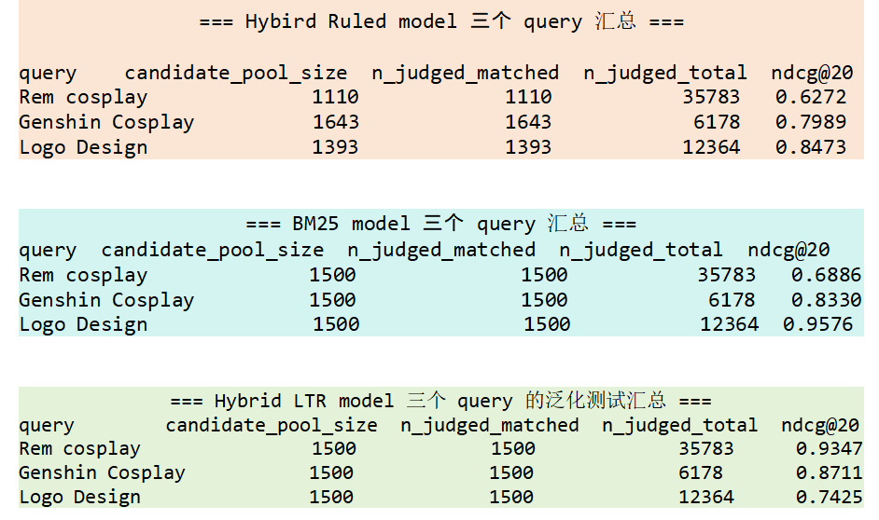

Diagram 3.1 NDCG performance across the three models

Across three test queries, the Hybrid LTR model emerged as the winner in two—specifically for "Rem cosplay" and "Genshin cosplay"—outperforming the other two models. This further demonstrates that the Hybrid LTR model is the most effective choice for this portfolio, aligning well with the demands of modern, rapid data accumulation. However, it underperformed on the "Logo Design" query. The underlying reasons for this loss, alongside a detailed breakdown of the techniques employed by each model, will be analyzed in Chapter 4 (Methods Used).

Method used
This chapter will first examine the shared techniques used across all three retrieval models, and then provide a detailed analysis of the specific techniques adopted by each individual model.

Insert new row data
The technique of inserting new rows of data into the Parquet file was utilized for this portfolio. Given that the original Parquet dataset already contains 1 million rows, a preliminary test query for "Rem Cosplay" returned only 1 exact match and 1 relevant match. To prevent poor training outcomes caused by data scarcity (or "data hungry"), 6 new data points related to "Rem Cosplay" and "Rem figure" were inserted.

Embedding file
In simple terms, an embedded file is a cache file that stores all data in a multi-dimensional space and assigns a precise coordinate to each data point (similar to longitude and latitude on Google Maps, but in multiple dimensions). When a query (user input) is received, the system calculates the cosine similarity against all stored data to find relevant matches. Creating an embedded cache file is a crucial process because it speeds up execution time. Without the cache file, the multi-dimensional vectors would need to be regenerated every time the code runs.

The embedded files used by the models are 'Hybrid Ruled' and 'Hybrid LTR'. Note that the BM25 model does not utilize an embedded cache file because it relies on keyword matching rather than vector similarity—retrieving data rows based on exact term overlapping with the user query.

Performance Comparison:
- Without Embedded File : Code runtime is approximately 45 minutes.
- With Embedded File : Code runtime is approximately 30 minutes.

Pros
- Speeds up the retrieval process and reduces user search time.

Cons
- Inserting new data requires updating the embedded cache file; otherwise, the new data will not appear in the results.

4.2.1 Embedding language model
The embedding language model utilized in this portfolio is paraphrase-multilingual-MiniLM-L12-v2. This model supports up to 50 languages, possesses the capability to understand emojis and their semantic meanings, and is lightweight enough to run efficiently on low-specification hardware.

inverted index file
Inverted index cache file is like a table of content listed all of the word used in the entire parquet, so when call out query finding the word, will check the table of content first, then find which row of data contain this word and recall for future step. It also a very important stage for safeting time.

I created two different inverted index files for this portfolio: one for the hybrid-ruled model and another for the BM25 model. The hybrid LTR model requires a dedicated inverted index, the rationale for which is explained in Section 4.6.3.4 (Wordninja).

Without Inverted index cache file
- Code run time close to 30 minute.

With Inverted index cachefile
- Code run time close to 15 minute.

4.4 Ground truth
In this project, I constructed three distinct ground truth datasets corresponding to three specific search queries. To maximize data recall and ensure no relevant items were missed, I implemented a boolean retrieval function to compile the initial candidate pools. Once the data was exported into Excel, I conducted a manual data labeling process, annotating a granular relevance score for every single row.

4.5 NDCG
Normalized Discounted Cumulative Gain (NDCG) is a standard evaluation metric used to measure the ranking quality of a system's output. To fully understand NDCG, the metric can be broken down into four core mathematical components:

- Cumulative Gain (CG): This is the simple sum of relevance scores for all retrieved items. However, CG has a critical flaw: it completely ignores the position of the items. In modern applications, users rarely scroll through thousands of results—they expect the most accurate answers right at the top. This limitation directly motivates the need for DCG.

- Discounted Cumulative Gain (DCG): DCG introduces a positional penalty (discount). As the rank position drops, the impact of a relevant item on the total score diminishes. Essentially, DCG establishes a "soft boundary" where highly relevant data must appear early in the sequence before the ranking penalty kicks in heavily.

- Ideal DCG (IDCG): IDCG represents the theoretical maximum score a system can achieve for a specific request. Derived directly from the evaluation dataset, it serves as the ultimate "Ground Truth" or baseline sequence where all items are sorted strictly from highest relevance to lowest. Programmatically, the system ingests the raw ground truth labels, creates a duplicate in memory, rearranges those scores in descending order, and calculates the cumulative point score based on this perfect arrangement.

- Normalized DCG (NDCG): Calculated by dividing the actual DCG by the perfect IDCG , this final metric scales the score between 0 and 1. A figure close to 1 mathematically proves that the system's current ranking aligns closely with user expectations and successfully surfaces the most relevant data first.

To evaluate the retrieval performance, all three methods were compared using a consistent cutoff of “K = 20”, measuring the Normalized Discounted Cumulative Gain (NDCG) across the top 20 recommended videos.

4.6 Code Outcome
All three retrieval models share a standardized output logging format that provides a comprehensive breakdown of evaluation metrics, ranging from total human-labeled ground truth counts to final NDCG scores. While every data point offers valuable insights, the subsequent analysis explicitly distinguishes between core focus areas and supplementary metrics.

Diagram 4.6.1.5.1 has been trimmed to exclude irrelevant details for clearer explanation. In this portfolio, the primary focus is on missing highly relevant recall data. As shown in the diagram, the count of highly relevant items (ground truth ratings of 3 and 4) is 0, indicating that the top-tier relevant items were successfully recalled. However, the NDCG@20 value remains relatively low at 0.6272 (categorized as low performance). To investigate the root cause of this low score, the system inspects the top 20 retrieved videos alongside key metadata, including:

- row
- combined text (data description + hashtags)
- url
- similarity score

Finally, the summary output details the query execution metrics, categorized into:

- query name
- system recall corpus pool
- did recall corpus in ground truth (whether ground truth was recalled)
- ground truth total row
- ndcg@20 scoring for this query
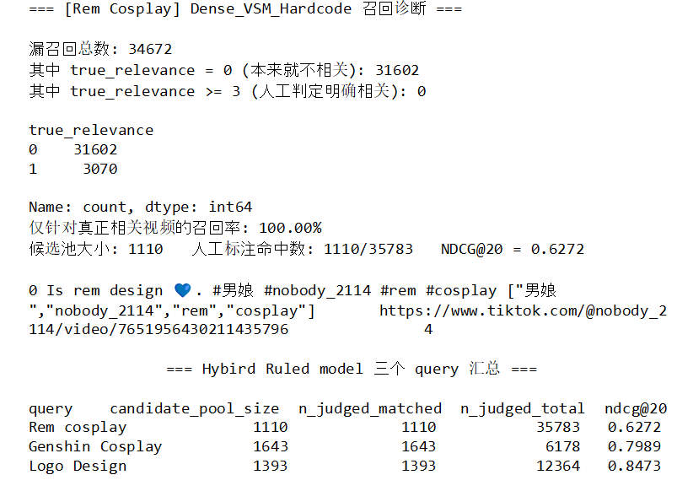

Diagram 4.6.1.5.1 trimmed outcome of coding output

4.7 Retrieval method
This portfolio employs three distinct models: the 'Hybrid Ruled' model, the 'BM25' model, and the 'Hybrid LTR' model. Each model is detailed below.

4.7.1 Hybrid ruled model
The hybrid rule-based model combines a Dense Vector Space Method (Dense VSM) with a Boolean retrieval approach, commonly known as a hybrid search method. During the ranking stage, it incorporates Boolean-filtered keyword matching to boost scores or not, utilizing an engagement score as a secondary tie-breaker when videos share the same score.

4.7.1.1 Retrieval Stage
The retrieval stage begins with query tokenization, where the search query is manually broken down into individual keywords and hardcoded into the system. The system then performs an inverted index lookup to identify candidate rows containing matching terms. Next, a semantic filtering step uses the Dense Vector Space Model (Dense VSM) to retrieve candidate embeddings and calculate their cosine similarity against the query, filtering out any rows with a score below 0.3. To prevent performance bottlenecks, pre-computed embedding cache files are read directly, avoiding the need to recreate the vector space model from scratch. Finally, the surviving rows undergo a Boolean check for keyword boosting; rows containing at least one query keyword receive a base match, with incremental score boosts added for matching additional query terms.

4.7.1.2 Ranking Stage
Data are ranked in descending order based on their final hybrid similarity scores. If multiple videos share the same similarity score, a weighted engagement score is employed as a secondary ranking factor to break ties. This engagement score is a hardcoded pseudo-label calculated from weighted metrics, including likes, shares, comments, bookmarks, and views."

4.7.1.3 NDCG
To evaluate performance, the system calculates the Discounted Cumulative Gain (DCG) of the resulting ranked order. This DCG value is then divided by the Ideal DCG (IDCG), which is derived from human-labeled ground truth data, to compute the final NDCG@20 evaluation metric.

4.7.1.4 Pseudo Scoring
As mentioned previously in the hybrid rule-based model, an engagement score serves as a secondary ranking factor to break ties. This score is calculated using the following hardcoded pseudo-label formula:

{Engagement Score} = ({bookmark score}* 2) + ( {comment score} * 2) + ({like score} * 1) + ({views score} * 1) + ({share score} * 3)

The design logic and anti-spam rationale of this formula, reflects a product strategy aimed at encouraging users to distribute content to external platforms, thereby driving new user acquisition. To mitigate spam and bot manipulation (e.g., automated view or like inflation), lower weights are assigned to passive or low-effort interactions like likes and views. Meanwhile, log1p serves to prevent the absolute figures of a single viral video (such as a million views) from completely overshadowing all other signals. Conversely, higher weights are given to more intentional engagements such as comments and bookmarks. Shares are assigned the highest weight because external distribution directly aligns with the primary goal of expanding platform reach and engaging new users.

4.7.1.5 Pros & Cons
Pros
- Strict Filtering: Highly suitable for hard-filtering processes where exact keyword matching is required.

- Lightweight Performance: Friendly and efficient for low-spec devices since it avoids heavy dynamic vector computations.

Cons

- Lack of Semantic Flexibility: Because the hybrid rule-based method relies on strict hardcoded matching, it fails to recognize compound or concatenated words. For example, if the query is "rem cosplay" but the user data contains "remcosplay", the system will incorrectly flag it as irrelevant.

- Engagement Bias (Ranking Flaw): If a non-relevant video shares the same similarity score as a relevant video, a higher engagement score can cause the non-relevant video to outrank the relevant one, ultimately lowering the NDCG@20 score.

4.7.2 BM25 model
BM25 is a classic, purely lexical (term-frequency based) retrieval method — it involves no embeddings, no semantic vectors, and no learned parameters.

4.7.2.1 Retrieval Stage
Retrieval begins with tokenization: both the query and every document in the corpus are lowercased and split into tokens using a simple regular expression. Building the BM25 index (BM25Okapi) requires scanning the entire tokenized corpus once upfront, since the scoring formula depends on corpus-wide statistics — each term's inverse document frequency (IDF) and the average document length across the whole collection. This initialization step cannot be skipped or narrowed, regardless of which query is later issued.

Once the index is built, candidate narrowing is done through an Inverted Index lookup: for every word in the query, the system retrieves the set of document IDs known to contain that word, and takes the union across all query words. For BM25, this lookup is exact, not an approximation. By definition, any document that contains none of the query's terms will always receive a BM25 score of exactly zero, so restricting scoring to documents found in the inverted index loses no information; it simply skips computing a score that is guaranteed to be zero. The system then computes BM25 scores only for this reduced candidate set (via get_batch_scores), rather than scoring every document in the corpus — this is the same design pattern used by production search engines such as Elasticsearch and Lucene.

4.7.2.2 Ranking Stage
The ranking stage for BM25 is intentionally minimal: candidates are sorted purely by their BM25 score, in descending order. No engagement metrics, no boosting rules, and no secondary tie-breaking signal are introduced at this stage. This is a deliberate design decision, not an oversight — the goal of this method is to serve as a clean, unmodified lexical baseline, so that any performance difference observed against the other two methods can be attributed to the underlying retrieval architecture itself (pure term-frequency statistics vs. semantic vectors vs. a learned model), rather than being muddied by an additional hand-tuned ranking layer on top.

4.7.2.3 Evaluation (NDCG)
To evaluate the retrieval performance of the baseline BM25 model, the system computes the NDCG@20 (Normalized Discounted Cumulative Gain at rank 20) score for each query. This is achieved by sorting the remaining candidate videos in descending order based on their assigned BM25 relevance scores, and then comparing this predicted ranking against the human-labeled ground truth relevance judgments to measure ranking quality.

4.7.2.4 Pros & Cons
Pros
- No Training Required: Unlike machine learning-based or neural retrieval models, BM25 is an unsupervised, heuristic-driven formula that works out of the box without needing large historical datasets for training.

- Strong Traditional Baseline: As an extension of the TF-IDF framework, BM25 effectively balances term frequency (TF) and inverse document frequency (IDF) while introducing term-frequency saturation, preventing overly repeated terms from disproportionately inflating scores.

Cons
- Lack of Semantic Understanding: BM25 relies strictly on exact or stemmed lexical matching. It fails to capture synonyms, contextual nuances, or deeper semantic relationships (e.g., missing the connection between "car" and "automobile").

- Vulnerability to Vocabulary Mismatch and Concatenation: It struggles heavily with unsegmented or concatenated text (such as hashtags like #remcosplay), often treating them as single.

4.7.3 Hybrid LTR model
The hybrid LTR model combines a Dense Vector Space Model (Dense VSM) with an Inverse Document Frequency (IDF) matching approach. Unlike rule-based methods, the ranking stage adopts LightGBM, a Learning-to-Rank (LTR) technique that automatically learns how to order results from most to least relevant.

4.7.3.1 Retrieval Stage
In this stage, manual keyword hardcoding is eliminated by integrating WordNinja, a Python module used to split or tokenize queries and recalled text for accurate matching. The system first queries the Inverted Index to recall candidate documents containing matching terms. Next, it retrieves pre-computed embedding cache files—generated by upstream code—to bypass rebuilding the vector space model from scratch and prevent performance bottlenecks. It then calculates the cosine similarity of these candidates. The surviving corpus passes into an IDF scoring stage, where rarer terms across the entire corpus are assigned higher weights, granting score boosts to data containing unique keywords.

4.7.3.2 Ranking Stage
During the ranking phase, LightGBM leverages the Learning-to-Rank approach to order videos based on 10 distinct feature values, sorting them seamlessly from highest to lowest relevance.

4.7.3.3 Evaluation (NDCG)
To evaluate the quality of the resulting ranked order, Normalized Discounted Cumulative Gain (NDCG) is used as the evaluation metric.

4.7.3.4 Word ninja
WordNinja is a Python module designed to split concatenated strings into distinct words. Powered by Natural Language Processing (NLP) backed by English Wikipedia unigram frequency data, it bridges the performance gaps inherent in rule-based models. For instance, taking the query "rem cosplay", if a database entry contains the concatenated string "remcosplay", WordNinja successfully tokenizes it into separate terms—"rem" and "cosplay". This capability significantly boosts the recall rate compared to the hybrid-ruled model while preventing false positives (such as mistakenly matching unrelated words like "remake" or "remaster" that carry entirely different semantic meanings).

Due to this functionality, the hybrid LTR model requires a dedicated inverted index file. This necessity stems from the interdependency between the model's two candidate generation stages: the index handles the initial coarse screening (determining eligibility for the candidate pool), while WordNinja performs the secondary fine-grained assessment (precisely verifying matches within that pool). If one were to reuse an index relying on simple regex-based tokenization, concatenated hashtags like "remcosplay" would be stored as indivisible, single entries. Consequently, queries for "rem" or "cosplay" would fail to match them, causing these candidates to be discarded during the coarse screening phase before they could ever reach WordNinja, rendering its precision capabilities useless. Therefore, the hybrid LTR model must be paired with an index built using WordNinja tokenization from the start, ensuring that both coarse screening and fine-grained assessment share a unified definition of a "match" without undermining each other's performance.

4.7.3.5 LTR (Learning To Rank)
Learning-to-Rank (LTR) transforms the traditional ranking problem into a machine learning task, utilizing a trained model to automatically predict relevance between items and optimize their order. While conventional ranking methods often rely on manually defined rules or basic relevance functions (such as keyword matching frequency)—which can lead to rigid ranking logic or spurious scoring—LTR leverages machine learning to dynamically determine the relative importance of various features throughout the ranking process.

Within the hybrid LTR model, LightGBM (acting as the LTR engine) learns to rank items by integrating ten distinct features: similarity scores (derived from the Dense VSM); match metrics (match ratio, exact match, phrase match, and tag match—weighted using IDF and WordNinja); and five item engagement metrics (views, likes, bookmarks, shares, and comments).1

4.7.3.6 Leave-one-query-out (LOQO)
Among the three retrieval methods in this portfolio, only Hybrid LTR model involves a trainable model (LightGBM LambdaRank). BM25 model and Hybrid Ruled model are both fixed-formula, rule-based methods with no learned parameters. Since nothing is "learned" from the data, there is no risk of the evaluation being contaminated by information the model has already seen. LOQO is therefore only relevant, and only applied, to the Hybrid_LTR pipeline.

LOQO is a query-level adaptation of leave-one-out cross-validation. Rather than holding out individual data rows, it holds out an entire query's candidate set at a time. For each of the three ground-truth queries (Rem Cosplay, Genshin Cosplay, Logo Design), the model is retrained from scratch using only the remaining queries' data, then evaluated on the one query it has never encountered during training.

A standard random train/test split (holding out individual rows) would still let the model see other videos from the same query during training. Because LambdaRank learns ranking patterns within each query's group, this creates a risk that the model partially memorizes query-specific shortcuts (e.g., "in this particular query's candidate pool, high engagement always coincides with relevance") rather than learning a genuinely transferable notion of relevance. Removing the entire query — not just some of its rows — forces the model to rely only on patterns that generalize across different queries, which is what a production system actually needs when a brand-new, never-seen query arrives.

4.7.3.7 Reason win 2 out of 3
When comparing the NDCG@20 values across all three models, the current hybrid LTR model outperformed the others in two out of three queries, but underperformed on one. Manual inspection of the top-20 results for the query "Logo Design" revealed that the model consistently misranked promotional spam posts—such as neon-sign business advertisements repeating the exact phrase "logo design"—above genuinely relevant content.

Because the leave-one-query-out training set consisted exclusively of cosplay-domain queries, the model had never encountered this type of keyword-stuffed commercial content during training, and thus lacked the signals needed to downweight it. The feature weights learned by the model (e.g., IDF weights for terms like "Rem" or hashtag relevance patterns) were optimized specifically for cosplay-related data. When exposed to a domain with an entirely different semantic and hashtag ecosystem, the model's generalization capability degrades. This limitation stems from a domain mismatch between the training data and the test query rather than an issue with the candidate pool size. While this vulnerability is currently amplified by the small sample size of a three-query leave-one-out validation, it is expected to be mitigated as query volume and domain coverage expand.

4.6.3.8 Pros & Cons
Pros:

- Automated Query Processing: Eliminates the need for manual keyword hardcoding. The system automatically tokenizes queries using WordNinja and performs efficient matching against Parquet data files.

- Data-Driven Ranking: Overcomes the limitation of hardcoded pseudo-labels for scoring by implementing Learning-to-Rank (LTR), allowing the system to automatically learn optimal ranking functions from data.

Cons:

- Domain Generalization / Data Scarcity: To address the data scarcity issue introduced by the leave-one-query-out cross-validation strategy, the training set must be expanded to include a more diverse range of relevant query domains.

Future Enhancement
Overcoming Data Sparsity in LTR: The current Hybrid LTR model suffers from data sparsity (data hungry), which explains why the "Logo Design" query achieved a lower NDCG score compared to others. Future iterations will expand the training pool with more diverse queries — including domains prone to promotional spam — so the model can learn to distinguish genuine relevance from keyword-stuffed advertising.To resolve this, future iterations will expand the training pool by introducing more diverse queries and corresponding ground truth tables.

Processing the original 10M-row Parquet file takes roughly 45 minutes on my current hardware (16GB RAM, GTX 1650 Ti), creating a bottleneck before any retrieval algorithm even runs. This is fundamentally a memory-and-throughput constraint, distinct from (but solvable with the same underlying technique as) the incremental-update problem faced by production search systems — where new crawled data arrives continuously and re-embedding the entire corpus daily would be wasteful. In both cases, the solution is chunked/batched processing: split the corpus into manageable chunks, run the embedding and Inverted Index pipeline on each chunk sequentially (writing intermediate results to disk rather than holding everything in memory), then merge the chunk-level indexes into a unified cache. For the 10M-row case, this makes full-corpus processing feasible on limited hardware; for a production system, the same chunking logic applies only to newly-crawled data, appended to the existing index rather than triggering a full rebuild

Integrating Retrieval-Augmented Generation (RAG): To further elevate the system, RAG can be introduced into the pipeline. While the current pipeline already leverages dense vector semantics for retrieval and ranking, it stops at returning a ranked list of candidates — it does not synthesize or explain the results. Retrieval-Augmented Generation (RAG) would add a generation layer on top of the existing retrieval pipeline: after retrieving and ranking the top candidates, an LLM would consume that context to produce natural-language summaries, comparisons, or direct answers to more open-ended queries (e.g., "which of these cosplay videos has the most polished costume work, and why?") — a capability the current keyword-and-embedding-based ranking system cannot provide on its own.

Thing I like to say
I would like to say thank you to you read until here, here will show how this portfolio comes out and something i like to disclaimer.

I do not have good english, here will show clearly, because this entire paragraph is i write directly without packaging.

This portfolio comes out due to several company tell me that i can try learning information retrieval (IR), Artificial intelligence (AI) and deeper knowledge, but I learn C programming back in 2019 and last time i code is 2025 which doing game design & development using C#, so i do not have any knowledge about python programming, IR, LLM, RAG, that is why i mention 'Leveraging AI-assisted engineering' . At the first i research the defination and background of IR/LLM/RAG, yes this three knowledge i learn at the sametime which around 2 week keep watching video to understand, but it is very confuse if not writing any coding to dissect it, so the first version of the coding pop out which is the 'Hybrid LTR', i learn how to using different famous module always used in AI training model file like ' pickle','numpy','sentenceTransformer' and etc, understand how to insert new data to parquet, how to create embedded cache file and inverted index file. After having all the cache file, start create boolean combine with Dense VSM model, but the first time NDCG scoring and exported video is not fully cover query required, so trying different combination like given specific word more score ( Not IDF, pure hardcode), IDF, word ninja, to get the better outcome. After getting the correct data, try to twist into 'Hybrid Ruled' and 'BM25' version is to understand why ' Hybrid LTR' is better system for future implementation.

You saw there have RAG model code, but i did not run it on my laptop, is because my laptop having 16GB RAM + GTX1650 Ti, it technically can run RAG model, but must be becareful to avoid RAM overflow and cause the RAG process very slow.

Thanks again you read until here, this documentation technically not formal article, because is just let me remember the detail of the process also is like a end call of this portfolio.

I'm Nobody_2114 see you soon in other area.

