Modeling Hinting Strategies for Geometry
Theorem Proving
To appear in Proc. of the 9th International Conference on User Modeling, Pittsburgh, PA, 2003
Noboru Matsuda and Kurt VanLehn
Intelligent Systems Program
University of Pittsburgh
mazda@pitt.edu, vanlehn@cs.pitt.edu
Abstract. This study characterizes hinting strategies used by a human tutor to help students learn geometry theorem proving. Current tutoring systems for theorem proving provide hints that encourage (or force) the student to follow a fixed forward and/or backward chaining strategy. In order to find out if human tutors observed a similar constraint, a study was conducted with students proving geometry theorems individually with a human tutor. When working successfully (without hints), students did not consistently follow the forward and/or backward chaining strategy. Moreover, the human tutor hinted steps that were seldom ones that would be picked by such tutoring systems. Lastly, we discovered a simple categorization of hints that covered 97% of the hints given by the human tutor.
1 Introduction
As a first step in designing an improved intelligent tutoring system for geometry theorem proving, we sought to characterize the hints given by a human tutor to students trying to prove geometry theorems. Little is known about the mechanism of effective hinting strategy [1, 2], but current tutoring systems have relatively simple, inflexible hinting policies. Some tutoring systems demand that the students follow a prescribed problem solving strategy, such as forward or backward chaining [3], so their hints are always aimed at the next step taken by the prescribed strategy. Other tutoring systems accept any correct inference even if it is not on an ideal solution path [4], but when a student reaches an impasse, the tutor provides a hint on the next step that is a strict backward or forward inference no matter what assertions the student has made so far. Not only are the steps targeted by hints often quite inflexibly chosen, the hints themselves are usually a simple human-authored sequence that proceeds from general hints to specific hints, and usually culminates in a “bottom out” hint that describes exactly what the student should enter. We hypothesize that human tutors have less rigid hinting policies, and this might cause increased learning. This paper tests the first conjecture by characterizing the hinting strategy of a single human tutor.
2. The study
Nine students were randomly selected from a Japanese middle school. Three geometry proof-problems were used. Two problems were construction problems, which require students to draw additional lines by compasses and straightedges to complete a proof. Each student solved problems individually while thinking out aloud. The tutor was asked to provide hints only when the students could not otherwise proceed. The sessions were videotaped and transcribed. The students’ utterances were segmented so that a single segment corresponds to a proof step or a response to the tutor’s assistance. The tutor’s utterances were segmented so that a single segment corresponds to a hint. The following sections present an analysis of these protocol data.
3. Students’ Problem Solving Strategies
In order to determine whether students followed the forward and/or backward chaining strategies prescribed by tutoring system for theorem proving, we located individual students’ utterances in a proof tree and observed a pattern of progress in their proof. As an example, Fig. 1 shows a chronological progress of a student’s reasoning. The goal to be proven is shown at the top of the tree, with the givens at the bottom. A branching link shows a conjunctive justification. Nodes with a rectangle show the propositions that this student asserted. The numbers on their shoulder show the order of assertion. Since the proposition Bx//AP is a premise for both ∠BxM=∠APM and ∠PAM=∠MBx, the first assertion is located on two places.
As shown in the figure, this student built up a proof neither in a strict forward chaining nor in a strict backward chaining manner. Rather she seems to assert facts (i.e., propositions) that were eventually recognized. This opportunistic ordering is not peculiar to this particular student. All students participating in our study showed the same behavior.
4. Topics of Hint Events
We observed 31 hint events, each consisting of a sequence of hints on the same topic. They were categorized into 4 types of hint events; (a) 10 hint events for a next step, (b) 14 hint events for a justification of proposition that the student had just mentioned, (c) 3 hint events for a geometry construction, (d) 1 hint event to get started on a proof, and (e) 3 hint events that do not fall under any of these types. Because tutoring systems often follow rigid policies when selecting the target step for a next-step hint, we analyzed the 10 next-step hint events in more detail.
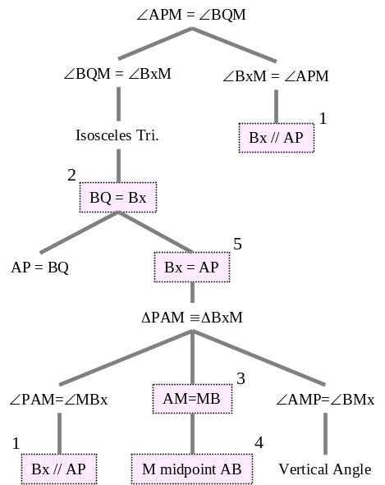
Fig. 1. A typical progress of student’s input over a proof tree
If we define a step to be applying a postulate to some premises and producing a conclusion, then the human tutor always provided a next-step hint on a single step (as opposed to discussing a generic strategy and no steps). Steps can be categorized by which elements (premises, conclusions) have been mentioned already by the student or tutor. In particular, let us use the first two letters of the classification to show whether the conclusion is asserted (C1) or not asserted (C0), and the second two letters for whether all the premises are asserted (Pa), none are asserted (P0), only some of the premises are asserted (Ps), or all but one premises are asserted (P1). Table 1 shows the results of applying this classification to the protocol data. It indicates the number of times a step was chosen as target (first row) and the number of steps available at the time a next-step help event began (second row).
The human tutor always chose either C0Pa or C0P1 as a target of a next-step hint event. Several existing tutoring systems, such as GPT [3], ANGLE [4], and CPT [5], choose target steps that would be picked by forward or backward chaining, which means either C0Pa or C1P0. Clearly, the human tutor’s target steps seldom agreed with those that would be chosen by these tutoring systems.
Table 1. Frequency of motivation of hinting in the ‘next step’ hint events
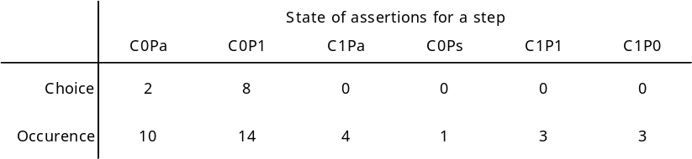
5. A Classification of Hints
So far, we have discussed only hint events and their targets, but not the hints that comprise hint events. In order to understand the structure of human tutoring better, this section categorizes the hints from the hint-events for justifications, next-steps, and the first step of the proof. There were 90 hints observed in these 25 hint events.
The individual hints were organized into a Cartesian product with respect to the focus and format of the hint. There are four categories regarding the focus of hint: (1) a hint on a whole application of a postulate (e.g., “Remember if two sides of triangle are equal, then the base angles are also equal”), (2) a hint on a premise of a postulate application (e.g., “If you want to prove these two angles are equal, what should be true among these two segments?”), (3) a hint on a conclusion of a postulate application (e.g., “What can you conclude about the base angles in a triangle with two equal sides?”), and (4) a hint on a proposition apparently involved in a postulate application but not mentioning it explicitly (e.g., “Can you say anything about these two segments?”).
We observed five different forms of hint; (1) a direct exhibition, (2) a question asking a whole postulate/proposition, (3) a question asking about a relationship in the proposition, (4) a question asking about the elements involved in a proposition, and (5) mentioning or pointing to a related configuration in the problem figure.
As an illustration of this Cartesian product categorization, Table 2 shows all possible hints for a proof step that invokes the theorem of isosceles triangle (i.e., if two sides of a triangle are equal, then the base angles are also equal).
We could classify 87 hints (out of 90; 97%) with the coding schema shown in Table 2. The parenthesized numbers in Table 2 shows the number of hints in each category.
Table 2. The type of hints for a next-step hint
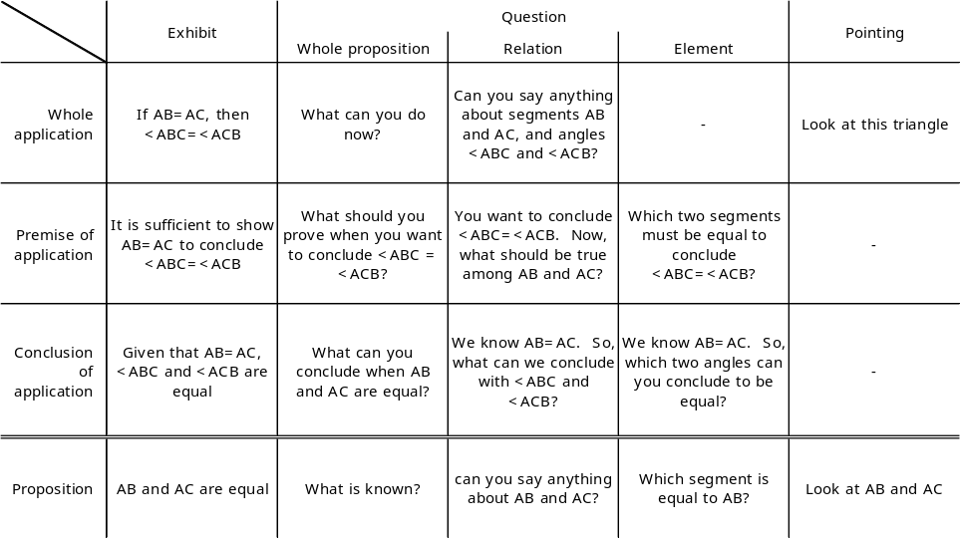
6. Conclusion
The analysis of protocol data gathered from students in middle school has shown several aspects of hinting in a learning context where the tutor acts as a helper for students to overcome an impasse.
We found that students tend to make opportunistic assertions that follow neither a strict forward nor backward chaining order.
Accepting their reasoning style might be beneficial for students, but it requires that the tutoring system be more complex so that it can provide an appropriate hint depending on the students’ reasoning. We discovered that human tutors prefer to hint steps where one or more premises have been mentioned, although not necessarily recently, and the conclusion has not been mentioned. It is not clear yet how the tutor decides which step to pick when there are several that meet this criterion. The human tutor’s policy for choosing target steps does not correspond to the policies of existing tutoring systems for theorem proving, but it might be easy to modify such systems to follow the human tutor’s policy.
Moreover, 97% of the hints observed in our study fell into a simple Cartesian product categorization. This categorization appears amenable to incorporation in the hint generation module of a tutoring system.

References
1. Hume, G., J. Michael, A. Rovick, and M. Evens, Hinting as a tactic in one-on-one tutoring. Journal of the Learning Sciences, 1996. 5(1): p. 23-47.
2. DiPaolo, R.E., A.C. Graesser, D.J. Hacker, and H.A. White, Hints in Human and Computer Tutoring, in The impact of media on technology of instruction, M. Rabinowitz, Editor. 2002, Erlbaum: Mahwah, NJ.
3. Anderson, J.R., C.F. Boyle, and G. Yost, The geometry tutor. Proceedings of the International Joint Conference on Artificial Intelligence, 1985: p. 1-7.
4. Koedinger, K.R. and J.R. Anderson, Reifying implicit planning in geometry: Guidelines for model-based intelligent tutoring system design, in Computers as cognitive tools, S.P. Lajoie and S.J. Derry, Editors. 1993, Lawrence Erlbaum Associates: Hillsdale, NJ. p. 15-45.
5. Scheines, R. and W. Sieg, Computer Environments for Proof Construction. Interactive Learning Environments, 1994. 4(2): p. 159-169.

This research was supported by NSF Grant 9720359.

