
Guidance Note on Producing Poverty
Maps Using Univariate and Multivariate
Fay–Herriot Models (UFH and MFH)
Operational guidance for area-level small area estimation of poverty
over time, with the EU SAE Workbench
Release-candidate editor: Nobuo Yoshida
Candidate 5.2.0-rc.6-wizard.5.20 (w5p) • October 2026
Table of Contents
About this guidance note 9
5.2.0-rc.6 release-candidate update 10
Section 1 Introduction and Objectives 13
1.1 Purpose of this guidance note 13
1.2 Intended users 14
1.3 Scope of the note 14
1.4 Main outputs 15
1.5 How to use this guidance note 15
Companion technical notes and where to use them 15
Section 2 Overview of the Poverty Mapping Workflow 17
2.1 Conceptual workflow 17
2.2 Role of direct estimates in the workflow 19
2.3 When to use UFH 19
2.4 When to use MFH 19
2.5 How UFH and MFH should be reported together 20
2.6 Key decision points 20
2.7 Recommended default workflow 20
Section 3 Data Requirements 22
3.1 Overview of required inputs 22
3.2 Required survey microdata 22
3.3 Survey data quality requirements 23
3.4 Required auxiliary data 24
3.5 Auxiliary data quality requirements 24
3.6 Required geographic data 25
3.7 Population-size data 26
3.8 Optional benchmark data 27
3.9 Minimum data-readiness checklist 28
3.10 Preparing supplementary CPI data 28
Section 4 Preparing the Survey Data 30
4.1 Purpose of survey data preparation 30
4.2 Harmonizing area identifiers 30
4.3 Defining the welfare variable 30
4.4 Defining the poverty line 31
4.5 Constructing FGT poverty indicators 32
4.6 Applying survey weights 32
4.7 Preparing survey design variables 33
4.8 Handling small or zero samples 33
4.9 Preparing repeated cross-sections for MFH 34
4.10 Preparing the analysis dataset for the app 34
4.11 Survey data preparation checklist 34
Section 5 Preparing Auxiliary Data 36
5.1 Purpose of auxiliary data 36
5.2 Selecting candidate covariates 36
5.3 Aligning covariates over time 37
5.4 Harmonizing area identifiers and years 37
5.5 Transforming covariates 37
5.6 Checking missing values and coverage 38
5.7 Checking outliers and implausible values 38
5.8 Checking collinearity and redundancy 38
5.9 Avoiding overfitting 39
5.10 Preparing the auxiliary dataset for the app 39
5.11 Auxiliary data preparation checklist 39
Section 6 Direct Estimates and Sampling Variances 41
6.1 Role of direct estimates 41
6.2 Computing direct estimates 41
6.3 Computing sampling variances 42
6.4 Standard errors and coefficients of variation 43
6.5 Handling zero, one, and missing direct estimates 43
6.6 Smoothing sampling variances 43
6.7 Sampling covariance over time 45
6.8 Quality checks for direct estimates 46
6.9 Direct-estimate outputs for the app 46
6.10 Direct-estimate checklist 46
Section 7 UFH Methodology 47
7.1 Purpose of the UFH model 47
7.2 Model intuition 47
7.3 What Fay–Herriot aims to estimate 48
7.4 Model specification 49
7.5 Inputs required for UFH 50
7.6 Transformations 50
7.7 Bias correction after back-transformation 50
7.8 Covariate selection 51
7.9 Variance options 51
7.10 Model diagnostics 52
7.11 Interpreting UFH estimates 53
7.12 Benchmarking UFH estimates 54
7.13 UFH outputs 55
7.14 UFH checklist 55
Section 8 MFH Methodology 57
8.1 Purpose of the MFH model 57
8.2 Why is MFH needed 57
8.3 MFH model structure 58
8.4 Inputs required for MFH 59
8.5 MFH model variants 59
8.6 Choosing among MFH1, MFH2, and MFH3 60
8.7 Sampling covariance over time 61
8.8 Transformations and scale of estimation 63
8.9 MFH diagnostics 63
8.10 Interpreting MFH estimates 65
8.11 Covariance specification and the interpretation of EBLUP 65
8.12 Statistical comparison over time 66
8.13 MFH outputs 67
8.14 MFH checklist 68
Section 9 Comparing UFH and MFH Results 70
9.1 Purpose of the comparison stage 70
9.2 Why comparison is necessary 70
9.3 Main dimensions of comparison 71
9.4 Comparing direct and UFH estimates 72
9.5 Comparing UFH and MFH estimates 72
9.6 Interpreting differences among estimates 73
9.7 Choosing final estimates 74
9.8 Recommended comparison tables 74
9.9 Recommended comparison figures and maps 75
9.10 Diagnostic flags for review 75
9.11 Documenting the comparison 76
9.12 Comparison-stage checklist 76
Section 10 Preparing Poverty Maps 78
10.1 Mapping estimates 78
10.2 Mapping uncertainty 78
10.3 Mapping changes over time 79
10.4 Class intervals and legends 80
10.5 Avoiding misleading maps 81
Section 11 Using the EU SAE Workbench 82
11.1 Installing and launching the Workbench 82
11.2 Navigation, configurations and the seven-step workflow 84
11.3 Step 1 - Input data 85
11.4 Step 2 - Map variables 86
11.5 Step 3 - Configure analysis 87
11.6 Step 4 - Configure model 89
11.7 Step 5 - Add AI assistant (optional) 91
11.8 Steps 6 and 7 - Review configuration and Run model 92
11.9 Reviewing and retaining outputs 94
11.10 Poverty headcounts with year-specific poverty lines 95
11.10.1 Prepare the survey and lines 95
11.10.2 Select the settings 95
11.10.3 Interpret the headcount change 95
11.11 Poverty headcounts with an anchored poverty line 96
11.11.1 Supply anchored poverty lines 96
11.11.2 Interpret and report anchored poverty 97
11.12 Real mean welfare 98
11.12.1 Route A: Supply welfare already in real prices 98
11.12.2 Route B: Convert current welfare with CPI 98
11.12.3 CPI file structure and the three formats 99
11.12.4 Check the conversion and model target 100
11.12.5 Read real welfare outputs correctly 100
11.13 Reading the change outputs 101
Section 12 Quality Assurance and Validation 103
12.1 Internal consistency checks 103
12.2 Direct estimate checks 103
12.3 Model diagnostics 103
12.4 Sensitivity analysis 104
12.5 Benchmarking checks 104
12.6 Documentation checklist 104
Section 13 Reporting Results 105
13.1 Recommended structure of the final poverty-mapping report 105
13.2 Tables to include 106
13.3 Figures and maps to include 106
13.4 Writing the interpretation 106
Section 14 Practical Recommendations 108
14.1 Recommended default workflow 108
14.2 Recommended default app settings 108
14.3 When to avoid publishing estimates 108
14.4 Recommended review process 109
Section 15 Limitations and Future Extensions 110
15.1 Limitations of area-level SAE 110
15.2 Limitations of MFH 110
15.3 Limitations of time comparisons 112
15.4 Spatio-temporal Fay–Herriot models, covariance misspecification, and comparison with MFH 112
15.5 Areas and area-years without direct estimates 114
Annexes 116
Annex A Glossary 117
Annex B Data Templates 120
Annex C App Input Checklist 123
Annex D Model Diagnostics Checklist 125
Annex E Example App Walkthrough 126
Annex F Troubleshooting Guide 128
Annex G Technical Notes 130
G.1 Direct estimators and sampling variances 130
G.2 The univariate Fay–Herriot model 130
G.3 Variance smoothing 131
G.4 Transformations and bias correction 131
G.5 The multivariate Fay–Herriot model 132
G.6 Benchmarking 132
G.7 Inference for change over time 133
G.8 The sampling-error covariance matrix 134
G.9 Constrained-REML safeguard for boundary MFH2 fits 134
G.10 Covariance misspecification and the choice between MFH and STFH 134
Annex H: Comparison with Molina and Romero (2025) 136
H.1 Overall interpretation 138
H.2 MCPE bootstrap process and provenance 138
H.3 Validation status and recommended assurance 139
H.4 Pointwise, BH and Bonferroni reporting 139
Annex I References 140

About this guidance note
Release-candidate notice. This guidance is outside the repository's MIT software license. Institutional publication authority and non-code rights remain to be confirmed. See NOTICE, THIRD_PARTY_NOTICES.md, GOVERNANCE.md, and REVISION_STATUS.md in the package.
This note explains how to estimate and compare poverty headcount rates and mean welfare for small geographic areas using direct survey estimates, the Univariate Fay-Herriot (UFH) model, and the Multivariate Fay-Herriot (MFH) model. The practical instructions cover three analyses: poverty headcounts with year-specific poverty lines, poverty headcounts with an anchored poverty line, and mean welfare in constant prices. The methodology sections provide the assumptions, diagnostics, and uncertainty measures needed to assess the estimates.
QER methodology revision. This manual describes candidate 5.2.0-rc.6-wizard.5.20 (w5p) of the EU SAE Workbench. It keeps the methods of the QER revision of w5n (5.2.0-rc.6-wizard.5.14), which corrected log-area estimation, bootstrap benchmarking, numerical convergence and joint uncertainty, and adds the interface and data checks summarized in the release-candidate update below. Section 11 retains historical w5o screenshots and country examples. Their displayed sm_out / rho_sm_out choices match the current defaults, but their numerical results are historical. Regenerate results under the chosen settings before using numerical conclusions. The implementation checks and simulation evidence are documented in docs/guidance/METHODOLOGY_ALIGNMENT.md and docs/validation/MCPE_VALIDATION_STATUS.md. Numerical agreement and Monte Carlo precision do not certify interval coverage for all survey designs. Review model assumptions, boundary sensitivity and any undercoverage before dissemination. Use the latest validation status for current experiment counts and results.
The methodological foundation of the note is the working document Comparable Small Area Estimates over Time by Isabel Molina and Eva Romero, which describes the estimators, their assumptions, and their implementation in the R packages sae and msae. The note translates that methodology into an operational workflow. It links each step to the EU SAE Workbench, an R Shiny application that automates the full pipeline: direct estimation, UFH estimation, MFH estimation, model comparison, mapping, diagnostics, and reporting. Annex H compares the published framework with the package implementation and identifies the package-specific extensions and safeguards.
Methodological basis. The Workbench uses Molina and Romero (2025) as its principal methodological guide while making a limited number of implementation adjustments for operational use; Annex H lists and explains these adjustments in comparison with Molina and Romero (2025). The package team remains responsible for final integration, validation, and operational use.
This version of the guidance note focuses on the methods currently implemented in the EU SAE Workbench. It does not provide a detailed, step-by-step description of how to run spatio-temporal Fay–Herriot (STFH) models. STFH requires additional implementation choices, including constructing a spatial proximity or weight matrix, specifying the spatiotemporal covariance structure, estimating STFH predictors, and calculating corresponding MSE or bootstrap uncertainty estimates. These elements are therefore outside the current Workbench workflow.
STFH is nevertheless an important methodological extension. Section 15 discusses how STFH relates to the UFH and MFH approaches covered in this note, particularly regarding covariance specification, spatial and temporal borrowing, and the interpretation of EBLUPs under possible covariance misspecification. The EU_SAE_Application_Package — referred to in this note as the Package — includes the EU SAE Workbench, sample R code, and example reports showing how the currently implemented methods are applied. In addition, Molina and Romero (2025) describe the underlying methodology and provide useful code for implementation. Adding STFH to the Workbench and expanding this guidance note to include a full STFH workflow would be an important next step. Such an extension would allow analysts to compare UFH, MFH, and STFH estimates within a common area-year output structure, including point estimates, MSEs, RMSEs, coefficients of variation, maps, change estimates, and diagnostic flags.
The emphasis throughout is operational. Mathematical detail is kept to what an analyst needs to understand the choices the software asks them to make; the full set of formulas, including mean squared error (MSE) approximations and the inference used to compare two time periods, is collected in Annex G for readers who want it.
How to use this note. Start with Section 11 for installation and a complete walkthrough of the seven guided steps, including reviewing and retaining outputs. Then choose the relevant example: Section 11.10 for year-specific poverty lines, Section 11.11 for an anchored poverty line, or Section 11.12 for real mean welfare. These examples apply the same workflow and explain the settings that differ. Consult Sections 3 to 5 for data preparation, Sections 6 to 9 for direct, UFH, and MFH estimation and comparison, Section 10 for maps, and Sections 12 and 13 for quality assurance and reporting. Annexes C and D contain input and diagnostic checklists. Annex G collects the formulas, and Annex H explains the relationship to Molina and Romero (2025), the sampling-error covariance guidance, and the origins of the MCPE bootstrap. The companion technical-note roadmap below identifies the detailed implementation notes.
Three short companion guides are supplied in docs/instructions: Guide 1, Install and start; Guide 2, Running the Workbench, on the seven steps; and Guide 3, Estimating poverty and welfare, on year-specific and anchored poverty lines and mean welfare. Each guide is also supplied in Polish and Greek (files ending _PL and _GR). Section 11 follows the same sequence through the workflow and examples. The statistical estimates do not depend on enabling AI.

5.2.0-rc.6 release-candidate update
This revision is aligned with the history-free 5.2.0-rc.6 clean distribution. This candidate includes testing examples under Data/Spain/ and Data/simulated/. It excludes non-inventory literature, run histories, generated outputs, superseded documents, and local diagnostics. It is a release candidate for review and testing. Whether to publish estimates as official statistics is for each national statistical office to decide. In rc.6, optional AI interpretations are saved as structured run data and interleaved with the corresponding statistical sections in final_report.html and its editable Word companion, final_report.docx; each expected section is marked generated, failed, or disabled and requires human review before dissemination.
Survey and auxiliary inputs now support RDS/RData, CSV/TSV/TXT/DAT, Stata, SPSS, SAS, Parquet/Feather, and Excel formats. Python users should export pandas data as Parquet or Feather rather than pickle.
Direct poverty and welfare estimates are person-weighted. When each row of the survey file is a household, population_weight = survey weight x household size; when each row is a person, population_weight = survey weight (Section 4.6). Person weighting can change direct estimates and therefore the selected FH/MFH covariates compared with older household-weighted runs.
UFH and MFH now include optional LASSO covariate screening before AIC/BIC stepwise selection. LASSO is a screening stage only; the final model is still selected by the existing information-criterion stepwise procedure.
Numeric poverty lines are now entered separately for each selected analysis year. Column-based poverty lines continue to use the survey column and are summarized in outputs.
The final report and output tables include model-fit and selection diagnostics, population, direct and model estimates, MSE, RMSE, CV, and benchmarked estimates where applicable. Poverty outputs also record the poverty line used; mean-welfare outputs record the currency and price basis.
Wizard 5.12 update (October 2026). Real mean welfare has two supported routes: supply welfare already in constant prices, or supply current-price welfare and let the app convert household observations using CPI values typed in or read from a CPI file. Section 11.12 explains both routes, income reference years, the price base year, and the three supported CPI formats. Changes are reported as percentage changes of mean welfare, with intervals derived from the log ratio of the two means (Section 8.12 and Annex G.7). Anchored poverty uses supplied anchored lines: official anchored thresholds where available, or lines prepared outside the app, entered in Step 3 as one numeric line per survey year or stored in a survey column (Section 11.11).
The covariance-adjusted variance of a change is now used whenever it is positive; the earlier rule that replaced it by the independence variance when it was below 1% of that variance has been removed (Section 8.12). When mean welfare is fitted in logs, benchmarking to an uploaded Benchmark Target Database is completed on the currency scale, so the benchmarked estimates reproduce the uploaded targets (Sections 7.12 and G.6). The report's box plots now show the estimated changes and their RMSEs for Direct, UFH, UFH benchmarked, MFH, and MFH benchmarked (Section 11.13).
Workbench 5.15 update (w5o, October 2026). The application is now called the EU SAE Workbench. Its guided version has seven steps: Input data, Map variables, Configure analysis, Configure model, Add AI assistant (optional), Review configuration and Run model (Section 11). Settings are saved and loaded as model run configurations, and each run keeps its configuration in its run folder. A new setting, Each row of the survey file is: a household or a person, corrects the weighting of person-level files. Earlier versions weighted every row by survey weight × household size, so a person-level file had to carry a household size of 1, as earlier versions of this note advised; with the actual household size, each person was counted once per household member (Sections 3.2 and 4.6); household-level files give the same results as before. With grouped benchmarking, each domain must belong to exactly one benchmark group (Section 3.8). The data readiness check reports both (Tests 0f and 0g), and changes to the price settings of mean welfare now also require a new check (Section 11.2). The w5p input, reporting and inference-qualification revisions are explained in the separate Molina and Romero deviations note.
Variance default update (after w5p, October 2026). New or omitted variance settings now default to sm_out, with rho_sm_out as the matching MFH covariance, instead of sm_all and rho_sm_all. Explicit choices in saved configurations are preserved. Section 6.6 explains why full smoothing can overstate the sampling variances of low-poverty areas and when sm_all remains appropriate.
Cross-year PSU design update (after w5p, October 2026). Step 4 replaces the PSU-consistency checkbox with an explicit choice: same PSUs across years, independently sampled surveys, or not specified. MFH does not run until the first or second is chosen. Independently sampled surveys use year-specific PSUs and strata and zero cross-year sampling covariance, without constraining the MFH random-effect covariance. Earlier checked settings load as linked and earlier unchecked settings as not specified.
Sampling correlation update (QER-RC4, November 2026). The rho_dir, rho_sm_out and rho_sm_all options now estimate the sampling-error correlation after removing each domain-year mean. The calculation stays at PSU level, so it keeps household overlap and PSU persistence, but lasting differences between domains no longer inflate it. Direct variances that are only rounding residue are treated as zero. MFH results on same-PSU surveys therefore differ from earlier releases. In known-truth simulations of one synthetic scenario, intervals stayed too narrow in high-poverty domains and in domains with few PSUs, and UFH change intervals were conservative when the years were correlated. See the MCPE validation status note.

Section 1
Introduction and Objectives

1.1 Purpose of this guidance note
This guidance note provides practical guidance on producing poverty maps using area-level small-area estimation methods, with a focus on Univariate Fay-Herriot (UFH) and Multivariate Fay-Herriot (MFH) models. It is intended for national statistical offices, World Bank poverty teams, and technical partners who need to produce, review, or use small-area poverty estimates for policy analysis, targeting, monitoring, and reporting.
Poverty maps are useful when household surveys provide reliable estimates at national or broad regional levels, but are not sufficiently precise for smaller geographic areas. Direct survey estimates for small areas may have large standard errors, high coefficients of variation, or missing values when sample sizes are limited. Area-level small area estimation addresses this problem by combining direct survey estimates with auxiliary information available for all target areas, such as census, register, administrative, or geospatial indicators.
The note is operational rather than theoretical. It explains the main concepts needed to understand the methodology. However, its primary objective is to guide users through the practical steps for preparing data, estimating models, assessing quality, interpreting results, and producing report-ready poverty maps. Formulas appear only when they clarify the workflow or the interpretation of model outputs.
Like modern small area estimation software more generally, the EU SAE Workbench is built around a complete analysis procedure: it supports not only model estimation but also data-readiness checking, direct estimation, model building and diagnostics, benchmarking, comparison of methods, mapping, and export, so that the analyst can move from raw inputs to report-ready outputs within a single workflow (Harmening et al., 2023; Molina and Marhuenda, 2015). Throughout the note, UFH denotes the single-period area-level Fay–Herriot model, estimated one year at a time, and MFH denotes its multivariate extension, which estimates several years jointly so that the resulting small-area estimates are comparable over time.
This note draws on three primary sources, each listed in full in Annex I. For the underlying methodology, it refers to Molina and Romero (2025), Comparable Small Area Estimates over Time, which defines the UFH and MFH estimators, their assumptions, and their implementation in R. For the estimation of UFH models, it relies on the area-level Fay–Herriot framework of the emdi R package, documented in Harmening et al. (2023). The estimation of MFH models relies on Edochie (2025), “Stable FH Estimators over T time periods: The Multivariate Fay Herriot Modeling Approach,” available at https://rpubs.com/ifeanyi588/1318320.

1.2 Intended users
The guidance note is designed for four main groups of users.
First, it supports national statistical offices that are responsible for producing official or experimental small-area poverty estimates. For these users, the note emphasizes data preparation, model validation, quality assurance, documentation, and communication of uncertainty.
Second, it supports development practitioners who provide technical assistance on poverty mapping and welfare monitoring. For these users, the note provides a common workflow for reviewing data inputs, selecting model options, interpreting diagnostics, and preparing outputs for policy dialogue.
Third, it supports analysts working with household surveys, census or register data, administrative data, and geographic boundary files. For these users, the note explains the required data structure, common data problems, recommended checks, and how to use the accompanying Shiny app.
Fourth, it helps technical reviewers assess whether poverty maps are sufficiently reliable for dissemination. For these users, the note highlights diagnostics, sensitivity checks, uncertainty measures, and cases in which estimates should be interpreted with caution or not published without further review.
The note assumes that users have basic familiarity with household survey data and poverty measurement. It does not assume advanced knowledge of small area estimation, although statistical expertise is recommended for model selection, diagnostics, and final validation.

1.3 Scope of the note
This note focuses on area-level small area estimation. In area-level models, the main inputs are direct estimates for each area and year, their sampling variances, and auxiliary variables measured at the same area level. The models are fitted to area-level summaries rather than to household- or individual-level microdata.
This approach differs from unit-level poverty mapping, where a welfare model is estimated using household or individual microdata and then applied to census or register records. Unit-level and area-level methods can both be useful, but they require different data, assumptions, and implementation steps. This note focuses only on area-level UFH and MFH approaches.
The note covers both single-year and multi-year poverty mapping. UFH models are estimated separately by year and are useful for producing cross-sectional small-area estimates. MFH models jointly estimate multiple years and are especially useful for comparing poverty over time. MFH can improve stability and comparability by accounting for correlations in poverty estimates for the same area across years.
The primary indicator considered in this note is the poverty headcount ratio, or FGT(0). The same workflow can also be applied, with appropriate checks, to other Foster-Greer-Thorbecke indicators such as the poverty gap and poverty severity, and to mean welfare indicators when the data and model assumptions are suitable.
The current EU SAE Workbench estimates UFH and MFH for area-year cells that have a valid direct estimate and sampling variance. Area-year cells without a direct estimate are handled as data-readiness issues rather than estimated directly. Fay–Herriot prediction for area-years without direct estimates, and spatio-temporal (STFH) estimation, are not yet implemented in the Workbench and are discussed as future extensions in Section 15.

1.4 Main outputs
The expected outputs of the poverty mapping workflow are direct poverty estimates by area and year, based only on the survey observations in each area; sampling variances, standard errors, and coefficients of variation for the direct estimates; UFH estimates by area and year, including measures of uncertainty; MFH estimates by area and year, including measures of uncertainty; comparisons between direct, UFH, and MFH estimates; statistical comparisons of poverty estimates across two time points; poverty maps, uncertainty maps, and maps of changes over time; diagnostic tables and figures for assessing model quality; sensitivity checks for key modeling choices; and a final poverty mapping report suitable for technical review, policy use, and possible publication.
The final outputs should not present point estimates alone. Poverty maps should include uncertainty measures and diagnostic evidence so users can distinguish robust spatial patterns from estimates too uncertain to support strong conclusions.

1.5 How to use this guidance note
Users should treat this note as a workflow document. To run an analysis, start with Section 11, as described under How to use this note at the start of the note. Sections 2 to 10 explain the data preparation and methods behind each step, and Sections 12 to 15 cover quality assurance, reporting, practical recommendations, limitations, and possible extensions. In this note, “the Workbench” means the EU SAE Workbench as a whole; it has two interfaces, the seven-step guided version (started with Start_Wizard and recommended for routine use) and the classic dashboard (Start_Dashboard), which has the same settings on one page.
In practice, users should not move directly from model estimation to publication. A complete poverty mapping exercise should include data readiness checks, direct estimate review, model diagnostics, comparison of UFH and MFH estimates, sensitivity analysis, mapping checks, and technical review before final dissemination.

Companion technical notes and where to use them
The files listed below are supplied in the docs/guidance/Technical notes folder. They support implementation rather than providing instructions for running the Workbench. Where GVF smoothing applies, new configurations use sm_out variances, which replace only missing, non-finite, or strictly below-0.001 direct variances, and matching rho_sm_out MFH covariance. Explicit saved settings are retained. Optional sm_all replaces all variances with GVF predictions; Section 6.6 explains when it overstates variances. The MSE note, like this guidance, treats pointwise significance as primary and exports BH and Bonferroni alternatives. Counts across areas summarize exploratory pointwise results.
Companion file | Key message used in this guidance | Where incorporated
Note on eblupMFH2_robust.R.docx | Explains the independent REML endpoint checks and constrained refitting used for MFH2. The safeguard preserves usable fits, checks positive and zero variance endpoints, rejects inferior refits, and records numerical diagnostics. Bootstrap uncertainty does not require an available analytic g3 term. | Sections 8.5 and 8.9; Annex G.9
Note on Estimating the Sampling-Error Covariance Matrix (revised).docx | Derives the cross-year sampling-error covariance from the full survey design, explains why a panel-household-only shortcut can understate covariance, and motivates a stable nationally pooled correlation when domain covariance estimates are noisy. The note and guidance use sm_out, with its fixed below-0.001 rule, and rho_sm_out as the default, retaining sm_all with rho_sm_all as an option. | Sections 6.7 and 8.7; Annex G.8
Note on MSE Estimation - Levels and Changes.docx | Documents analytical or bootstrap UFH MSE by transformation, jointly bootstrapped MFH MSE and MCPE, final original-scale benchmarking inside every replicate, and coherent uncertainty for changes and percentage changes. Pointwise significance remains primary; BH and Bonferroni are supplementary. | Sections 7.12 and 8.12; Sections 12 and 15.3; Annexes G.6-G.7 and H.2-H.4
FH_prediction_covariance_paper_with_annex_REVISED_section11_annexA.docx | Explains that FH predicts a realized area parameter rather than only a regression mean; covariance misspecification changes the BLUP being approximated; full sampling-error covariance can be essential; and an area-year without a direct estimate is only a covariance-anchored BLUP-type prediction when it is linked to observed estimates through the model covariance. | Sections 7.3, 8.11, 9.7, 15.4, and 15.5; Annex G.10

Section 2
Overview of the Poverty Mapping Workflow

2.1 Conceptual workflow
The recommended poverty mapping workflow has seven main steps. These steps should be followed in sequence, because problems in the early stages—especially in the direct estimates, sampling variances, area identifiers, or auxiliary data—will affect all subsequent model results.
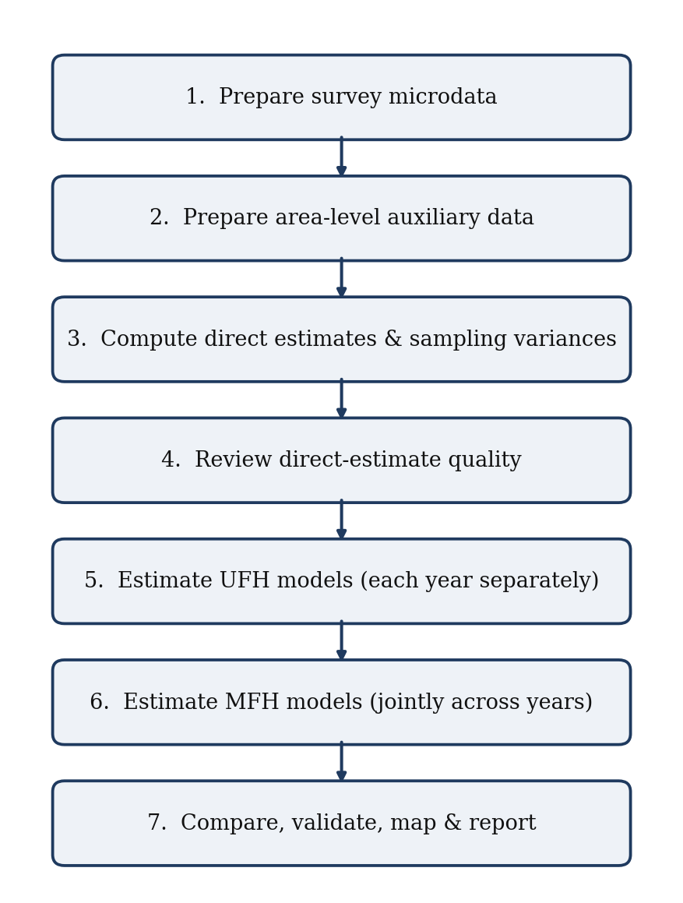
Figure 1. The seven-step poverty-mapping workflow.

Step 1. Prepare the household survey microdata.
The survey data must contain the welfare variable, survey weights, household size when each row is a household, geographic domain identifier, year, and, where available, PSU and strata identifiers. Poverty estimation also requires a poverty-line column or a numeric line for each analysis year. Mean-welfare estimation does not require a poverty line. These inputs support consistent direct estimates for each target area and year.
Step 2. Prepare the area-level auxiliary data.
Auxiliary variables should be available for all target areas and should be conceptually related to poverty or welfare. They may come from a census, a population register, an administrative database, satellite data, or another reliable source. These variables provide additional information that allows the Fay-Herriot models to improve on direct survey estimates.
Step 3. Compute direct estimates and sampling variances.
Direct estimates are survey-based poverty estimates for each area and year. They use only the sample observations from the area itself. These estimates are the starting point for the small area models. Their sampling variances are equally important because they determine how much weight the model gives to the direct survey estimate relative to the model prediction.
Step 4. Review the quality of the direct estimates.
Before fitting UFH or MFH models, users should review sample sizes, standard errors, coefficients of variation, missing estimates, zero or missing variances, and outlier values. This step is essential because the Fay-Herriot models do not replace the survey evidence; they build on it. Weak or inconsistent direct estimates should be understood before model-based estimates are produced.
Step 5. Estimate UFH models.
UFH models are estimated separately for each year. They combine direct estimates with area-level covariates to improve precision, especially in areas with small sample sizes or high sampling variability. UFH provides a cross-sectional, model-based estimate for each year and serves as an important benchmark, even when MFH is ultimately preferred.
Step 6. Estimate MFH models.
MFH models estimate multiple years jointly. They borrow strength not only across areas but also across time by allowing poverty estimates for the same area to be correlated across years. This can improve the stability and comparability of estimates over time, especially when the objective is to assess changes between two or more survey rounds.
Step 7. Compare, validate, map, and report results.
The final stage is not simply to select one set of estimates. Users should compare direct, UFH, and MFH estimates; review uncertainty measures and diagnostics; examine maps and changes over time; conduct sensitivity checks; and prepare documentation. The final report should clearly explain the data sources, model choices, diagnostics, limitations, and recommended estimates.

2.2 Role of direct estimates in the workflow
Direct estimates should always be produced and reviewed, even when they are too imprecise for final reporting at the small-area level. They provide an empirical anchor for the UFH and MFH models.
Direct estimates answer: what does the survey alone imply for each area and year?
UFH estimates answer: what does the survey imply after borrowing strength across areas within a year? MFH estimates answer: what does the survey imply after borrowing strength across areas and across time?
This distinction is important for interpretation. Model-based estimates should not be treated as independent of the survey. They are improved estimates that combine survey information with auxiliary data under explicit modeling assumptions. For this reason, large differences between direct, UFH, and MFH estimates should be investigated rather than ignored.

2.3 When to use UFH
UFH should be used when the objective is to produce small-area poverty estimates for a single year, or when each year is to be modeled separately. It is also the recommended first model to run before fitting MFH, because it provides a cross-sectional benchmark for each year.
UFH is appropriate when only one survey year is available; the main objective is a poverty map for a single point in time; time comparability is not the central objective; the user wants a baseline model before estimating MFH; the number of years is too small for MFH to be useful; MFH models do not converge or fail key diagnostics; or direct estimates are available by area, but some have high standard errors or high coefficients of variation.
UFH should normally be reported even when MFH is used. It helps users understand how much the final estimates depend on the time-correlation structure introduced by MFH.

2.4 When to use MFH
MFH should be used when estimates are needed for multiple years, and comparability over time is important. Separate UFH models may produce reasonable estimates within each year. However, they can generate unstable year-to-year patterns if direct estimates are noisy, covariates differ across years, or sampling variation is large in some areas.
MFH is appropriate when poverty maps are needed for two or more time points; analysts want to assess changes in poverty over time; direct estimates are unstable in some areas or years; there is reason to expect area-level poverty to be correlated over time; the number of areas is sufficient to estimate the model reliably; the same or comparable area definitions are available across years; or the welfare aggregate, poverty line, and auxiliary variables are sufficiently comparable across years.
MFH is often preferred for trend analysis because it reduces unstable year-to-year movements that arise from sampling variation. However, MFH should not be accepted mechanically. It should be used only when diagnostics are satisfactory and when the resulting trends are plausible in light of the direct estimates, auxiliary data, and country context.

2.5 How UFH and MFH should be reported together
The recommended reporting approach is to present direct, UFH, and MFH estimates together.
Direct estimates show the survey-only evidence. UFH estimates show cross-sectional model-based results. MFH estimates show time-consistent model-based results. Presenting the three estimates together improves transparency and helps users understand the model’s contribution.
When the objective is a single-year poverty map, UFH may be the preferred model-based estimate. When the objective is to compare poverty across years, MFH may be the preferred estimate if model diagnostics are satisfactory. In both cases, direct estimates should remain visible in the analysis because they are the basis for validating the model results.
A practical reporting table should therefore include, for each area and year, direct estimate, direct standard error, and coefficient of variation; UFH estimate and uncertainty measure; MFH estimate and uncertainty measure, when applicable; difference between UFH and MFH estimates; and flags for areas with high uncertainty, large model adjustments, or diagnostic concerns.

2.6 Key decision points
Users should make several decisions before finalizing results.
First, they should decide whether the main objective is cross-sectional mapping, trend analysis, or both. This determines whether UFH alone is sufficient or MFH should be the preferred model.
Second, they should decide whether the direct estimates are reliable enough to support modeling. Areas with very small samples, missing variances, or extremely high coefficients of variation should be flagged before model estimation.
Third, they should assess whether the auxiliary variables are suitable. Covariates should be available for all target areas, conceptually related to poverty, and measured consistently across areas and years.
Fourth, they should decide whether the model estimates are credible. This requires reviewing diagnostics, comparing direct, UFH, and MFH estimates, checking sensitivity to model choices, and verifying that maps show no implausible spatial or temporal patterns.
Fifth, they should decide which estimates are appropriate for publication. Estimates should not be published only because the model ran successfully. Publication should depend on data quality, model diagnostics, uncertainty measures, sensitivity checks, and technical review.

2.7 Recommended default workflow
For most applications, the recommended default workflow is:
- Prepare and harmonize survey, auxiliary, population, and geographic data.
- Compute direct estimates and sampling variances for each area and year.
- Review direct estimates, sample sizes, standard errors, and coefficients of variation.
- Run UFH models separately by year.
- Review UFH diagnostics and compare UFH estimates with direct estimates.
- Run MFH models when two or more comparable years are available.
- Compare direct, UFH, and MFH estimates.
- Review uncertainty, diagnostics, sensitivity checks, and maps.
- Select recommended estimates for reporting.
- Document all data sources, model choices, diagnostics, limitations, and interpretation guidance.
This workflow should be applied iteratively. If diagnostics reveal problems, users should return to earlier steps, review the input data, adjust covariates, reconsider variance options, or simplify the model before producing final maps.

Section 3
Data Requirements
The Workbench requires three files: survey microdata, area-level auxiliary data, and geographic boundaries. Population sizes may come from an optional file or be estimated from the survey. The domain identifiers in these sources must describe the same geographic areas. CPI and external benchmark data are supplementary inputs used only when the chosen analysis needs them.

3.1 Overview of required inputs
Prepare the inputs before estimation. The same three required files support poverty and mean-welfare analyses; the indicator and price-basis choices determine which supplementary information is needed.
Survey microdata provide direct estimates and sampling variances; auxiliary data provide area-year covariates for UFH and MFH; and geometry provides boundaries for maps. A population file is optional. If it is omitted, the app estimates domain populations as the sum of the population weights: the survey weight multiplied by household size when each row is a household, and the survey weight when each row is a person.
Supplementary inputs include a CPI database for converting current-price welfare to real welfare, a population file for aggregation and benchmarking, and an external benchmark-target file when credible higher-level estimates should be preserved. A CPI file is unnecessary when welfare is already real. CPI inputs are applied only to mean welfare; anchored poverty lines are entered as numeric values by survey year or supplied in a survey column (Section 11.11).
Domain codes must match across survey, auxiliary, geometry, population, and benchmark data, where those sources are used. Survey, auxiliary, population, and benchmark records must use the selected analysis years consistently. CPI rows instead refer to calendar price years, which may be the year before each survey. Harmonize changing boundaries before estimation; confirm the income years and CPI coverage separately.

3.2 Required survey microdata
Survey data provide direct poverty or mean-welfare estimates and their sampling variances for each target domain and survey year. Use one record per household or one record per person, and say which in Step 2 of the Workbench, Map variables (Each row of the survey file is: a household or a person). Use a welfare measure and weights appropriate to person-level reporting. The welfare variable should already be per capita or equivalized where the methodology requires it; the app does not divide a household total by household size.
The minimum required variables are:
TABLE I
Required Survey Microdata Variables
Variable | Description
year | Survey year or survey round.
domain | Small-area identifier, such as province, district, NUTS3, LAU1, municipality, or another target geography.
welfare | Per-capita or equivalized welfare used for the indicator. A household total must first be converted according to the chosen methodology.
povline | Needed only for poverty when Column in data is selected. Otherwise enter a positive numeric line for each survey year. Not required for mean welfare.
weight | Survey sampling weight.
hhsize | Household size; required when each row is a household. The app then uses weight x hhsize for person weighting and, if needed, population totals. Not used when each row is a person: the weight is used as it is.
psu | Primary sampling unit identifier, if available.
strata | Survey stratum identifier, if available.
household_id | Household identifier, optional but recommended. When it is mapped, the data readiness check (Test 0f) checks that the rows match the chosen unit.
The app allows users to map the names of these variables. Therefore, the variables do not need to have exactly the names shown above, but users must correctly identify them in the app.
Survey design variables should be retained whenever available. PSU and strata identifiers are important for estimating sampling variances. They may also be needed when estimating covariance across years, especially if there is sample overlap or repeated survey structure.
Before computing direct estimates, users should confirm that the welfare aggregate, poverty line, weights, and geographic identifiers are final and consistent with the official poverty measurement framework.

3.3 Survey data quality requirements
Review the survey microdata before using the app. Check for missing, zero, negative, or implausibly large welfare values; positive and plausible survey weights and household sizes; correctly coded PSU and strata identifiers, where available; a valid domain and year for each observation; unintended duplicate records; and area-code problems such as lost leading zeros or hidden spaces. For poverty estimation, also check that the poverty line matches the welfare concept, units, and price basis. For mean welfare, follow the price-basis checks in Section 11.12.
For repeated cross-sections, users should also verify that the welfare aggregate, poverty line, survey weights, and domain definitions are comparable across years. If comparability problems exist, they should be documented and resolved before MFH is used for trend analysis.

3.4 Required auxiliary data
Auxiliary data are area-level variables used as predictors in the UFH and MFH models. These variables should be available for all target areas, including areas with small or zero survey sample sizes.
Auxiliary variables may come from population censuses; population registers; administrative records; tax or social registry data, where appropriate and available; labor market or education administrative systems; geospatial indicators, such as nighttime lights or accessibility measures; and other reliable area-level data sources.
Examples of useful auxiliary variables include population age structure, education levels, employment and unemployment indicators, household size indicators, housing quality indicators, urbanization indicators, asset ownership rates, administrative income or benefit indicators, census- or register-based welfare proxies, and nighttime lights or other geospatial indicators, where appropriate.
The auxiliary data should include:
TABLE II
Required Auxiliary Data Variables
Variable | Description
domain | Area identifier matching the survey, population data, and shapefile.
year | Year, if covariates vary over time.
Covariates | Area-level predictors used in the UFH and MFH models.
If covariates are fixed over time, such as census variables, they can be used for all years, provided this is conceptually appropriate. If time-varying covariates are available, they should be aligned as closely as possible with the survey years.

3.5 Auxiliary data quality requirements
Auxiliary variables should be selected because they are conceptually related to poverty and available for all areas, not only because they improve the fit in the sample.
Before modeling, users should check whether each target area has a complete set of auxiliary variables; whether covariates are measured consistently across areas; whether time-varying covariates correspond to the correct years; whether variables have missing values, outliers, or implausible values; whether variables are constant or nearly constant across areas; whether highly correlated variables may create multicollinearity; and whether the covariate source is suitable for area-level prediction.
For poverty mapping, the preferred auxiliary variables should come from sources that cover all target areas, such as censuses, population registers, administrative records, and geospatial data. Variables constructed from household surveys or other sample surveys are generally not recommended as auxiliary covariates because they may be too noisy at the small-area level and may not provide complete coverage for all target domains.
When using administrative or register-based data, users should check whether coverage differs across areas. For example, indicators based on program participation may reflect both poverty and program coverage, which should be considered when interpreting model results.

3.6 Required geographic data
To produce maps, the user needs a geographic boundary file for the target areas. The app can read an RDS or RData/rda sf object, an ESRI shapefile uploaded as a single .zip file, GeoPackage (.gpkg), GeoJSON/JSON, KML, or GML.
The geographic file should include:
TABLE III
Required Geographic Data Fields
Variable | Description
domain | Area identifier matching the survey, auxiliary data, and population data.
Geometry | Polygon geometry for each target area.
Area name | Optional human-readable area label.
The domain codes in the shapefile or geometry file must match those in the survey and auxiliary data. Each target area should appear exactly once in the geographic file. For ESRI shapefiles, upload one .zip containing the shapefile components, especially .shp, .shx, and .dbf. The .dbf normally contains the domain code used for the map join, so a .shp file alone is usually not sufficient. Include .prj when available.
Before mapping, users should check whether every model estimate joins to one polygon, whether every polygon has a matching estimate, whether there are duplicate domain codes, whether boundaries correspond to the same reference year as the statistical data, whether the coordinate reference system is appropriate for mapping, and whether any boundary changes occurred between survey years.
If boundaries changed over time, users should harmonize all data to a common geography before estimating changes or producing comparable maps.

3.7 Population-size data
Population-size data are needed for aggregation, benchmarking, and interpretation. They are also useful for producing weighted summaries across areas and for understanding the policy relevance of area-level estimates. In the Workbench, the population file is optional. When no population file is supplied, the app estimates domain populations from the survey itself as the sum of the population weights by domain and year: sum(weight × household size) when each row is a household, and sum(weight) when each row is a person. Supplying an external population file is still recommended when reliable official population totals are available.
The population file may be in long or wide format. Require one row per domain-year in long form or per domain in wide form, including when duplicate values agree. Supply aggregate totals rather than sex/age rows. Named matrix years are matched by label; fully unnamed year columns must exactly match the selected-year order, with a warning. Preserve leading zeros in domain identifiers.
Long format:
TABLE IV
Population-Size Data, Long Format
domain | year | population
A001 | 2012 | 125000
A001 | 2013 | 126500
Wide format:
TABLE V
Population-Size Data, Wide Format
domain | pop_2012 | pop_2013
A001 | 125000 | 126500
Population sizes should match the population universe used for the survey estimates. For example, if poverty is estimated at the individual level, population counts should refer to individuals. If estimates are at the household level, the population file should match that unit of analysis or clearly document any differences.
Users should check that population values are positive and plausible; population totals by year are consistent with official statistics; the population file includes all target areas; population definitions are consistent across years; and the population universe matches the survey and poverty indicator.

3.8 Optional benchmark data
Benchmark data may be used to align small area estimates with trusted estimates at a higher geographic level, such as regions or national totals. Benchmarking is useful when official regional or national estimates are considered reliable and should be preserved in the final results.
Benchmark data should include:
TABLE VI
Optional Benchmark Data
Variable | Description
Benchmark area | Higher-level geographic unit, such as a region or the national total. Column: the selected benchmark-level variable, or benchmark_level, level, group, group_id, region, reg or region_id; it can be omitted when there is a single group.
Year | Analysis year matching the survey-year labels. Name the column year, time or period. CPI conversion separately determines the income reference year.
Benchmark estimate | Direct, official, or otherwise trusted estimate. Name the column benchmark or target (also accepted: B_r, benchmark_target, regional_benchmark, direct, direct_rate, poverty_rate).
Population | Aggregation populations come from the population file or survey (Section 3.7), not the target file. Targets require one row per group-year in long form or group in wide form. Duplicate keys are errors even when values agree. Matrix year labels are matched by name; fully unnamed columns require exactly the selected years in their selected order and generate a warning.
Benchmarking should be used only when the benchmark estimate is credible and corresponds to the same welfare variable, poverty line, population universe, and reference year as the small-area estimates. If the benchmark and small-area inputs are not conceptually aligned, benchmarking may create inconsistencies rather than improve the results.
For mean welfare, benchmark targets must share the input survey welfare price basis. If the app converts welfare to constant prices, it applies the same CPI factors to uploaded targets. When welfare is already in constant prices, targets must use those same prices. Benchmarking requires usable estimates and positive population weights for the requested benchmark population; incomplete coverage must be resolved, not silently scaled to a whole-area target.
With grouped benchmarking, the groups come from a survey column, such as region or NUTS-2, and each domain must belong to exactly one group in the analysis years. When a domain has more than one group code (a missing code counts as a separate value), the data readiness check (Test 0g) and the UFH and MFH steps stop with a message that names the domain, its group codes, the years and the number of rows. Correct the codes in the survey file before running.

3.9 Minimum data-readiness checklist
Before running UFH or MFH models, users should confirm that:
- Survey data contain year, domain, welfare, survey weight, household size (when each row is a household), and the survey-design variables needed for estimation. For poverty, also prepare a poverty-line column or a positive numeric line for each selected analysis year; mean welfare does not require a poverty line.
- PSU and strata variables are available, or their absence is documented.
- Direct estimates can be computed for the target areas and years.
- Sampling variances can be computed, or a clear variance-smoothing strategy is available.
- Auxiliary variables are available for all target areas.
- Domain identifiers match across surveys, auxiliary, population, and geographic data.
- Population sizes use the same universe and domains as the survey, whether supplied in an optional file or estimated from the survey’s population weights.
- Geographic boundaries match the target domains.
- Repeated cross-sections use comparable welfare variables, poverty lines, weights, and area definitions.
- Optional benchmark data, if used, match the indicator, population, survey years, and input price basis. For real mean welfare, either verify that welfare is already in a common price basis or check the CPI values and required years for conversion (Section 11.12).
- With grouped benchmarking, each domain belongs to one benchmark group in the analysis years.
Users should not proceed to model estimation until major inconsistencies in identifiers, years, welfare definitions, poverty lines, or population universes have been resolved. These issues are usually easier to correct before model estimation than after results have been produced.

3.10 Preparing supplementary CPI data
Use CPI data when the app must convert current-price welfare to a common real-price basis. Supply one annual series for the relevant country or territory, with a calendar-year column and numeric CPI values. Fixed-reference indices, previous-year-equals-100 indices, and annual percentage changes are supported for mean welfare. Section 11.12.3 gives the file structure, format choices, and year-coverage rules.
The survey year, the income reference year, the CPI reference year, and the chosen price base year serve different purposes. For example, a 2023 survey may measure 2022 income and be expressed in constant 2021 prices using a CPI series published with 2015 = 100. Always select CPI for the income reference year. Anchored poverty does not use the CPI input: enter the anchored lines as numeric values by survey year or supply them in a survey column and, if you calculate them yourself, apply the same CPI principles outside the app (Section 11.11).

Section 4
Preparing the Survey Data

4.1 Purpose of survey data preparation
Survey data preparation is the first substantive step in the poverty mapping workflow. The objective is to produce reliable direct estimates and sampling variances for each target area and year. These direct estimates are the dependent variable in the UFH and MFH models, so errors during survey preparation will carry over into all model-based results.
Before running the app, users should confirm that the survey data are clean, consistently coded, and aligned with the poverty measurement framework used for official or analytical reporting. Particular attention should be given to the welfare aggregate, poverty line, survey weights, area identifiers, year identifiers, and survey design variables.

4.2 Harmonizing area identifiers
Area identifiers must be consistent across all data sources. The same code should refer to the same geographic area in the survey data, auxiliary data, population data, benchmark data, and shapefile.
Before running the model, users should check that every survey domain appears in the auxiliary data; every survey domain appears in the population data, when population data are used; every target domain appears in the shapefile; every target domain has a unique code; no domain codes differ only because of formatting differences; and domain codes are stable across survey years, or have been harmonized to a common geography.
Common problems include leading zeros, capitalization differences, spaces, punctuation, or changes in administrative boundaries. For example, the codes 001, 1, and A001 may refer to the same area but will be treated as different unless harmonized.
If boundaries changed between survey years, users should not compare estimates over time until all data have been converted to a consistent geographic definition. This may require aggregating areas, splitting areas using population shares, or adopting a common reference geography.

4.3 Defining the welfare variable
The welfare variable should be the final welfare aggregate used for poverty measurement. For income-based poverty maps, this may be equivalized disposable income. For consumption-based poverty maps, it may be household consumption per capita, household consumption per adult equivalent, or another welfare aggregate consistent with the country’s poverty methodology.
Before estimation, users should check missing welfare values, zero or negative welfare values, extreme outliers, consistency of currency units, consistency of nominal or real values across years, whether welfare has already been adjusted for household size or equivalence scales, whether spatial or temporal price adjustments have already been applied, and whether the welfare aggregate corresponds to the poverty line that will be used.
For poverty, welfare and the poverty line define each household’s indicator. For mean welfare, the app first estimates the survey-weighted arithmetic area mean, including individual zero and negative values. An optional log model transforms that area mean after aggregation.
Real mean welfare has two routes. If welfare has already been adjusted for inflation, select constant (real) prices already: no price index needed. All survey years must use the same price year and adjustment basis. If welfare is in current prices, select current prices: convert with a price index and provide CPI values. The app multiplies each household welfare observation by the price level of the base year divided by the price level of its income reference year, before computing direct estimates or fitting models. Section 11.12 gives the complete settings and worked calculation. The separate default choice, current prices: no conversion, produces nominal welfare changes that include inflation.
The two income-period choices cover calendar years only. For a fiscal year, a rolling 12-month period before the interview, or reference periods that differ between households, welfare should be deflated before it is loaded (for example, household by household with the average index of its own reference period), and the constant-prices-already choice should then be selected. Welfare already in real terms must be in the prices of the same year in every survey year, and on the same basis if spatial price adjustments were made; the Workbench cannot check this. Poverty indicators are never converted: the welfare variable and the poverty line must already be in the same prices in each year.

4.4 Defining the poverty line
The poverty line must be defined before computing poverty indicators. It should be expressed in the same units and price base as the welfare variable.
The app allows two main poverty-line options.
First, the poverty line can come from a column in the survey data. This option should be used when the poverty line varies by year, region, household type, household size, equivalence scale, or other characteristics.
Second, select Numeric value and enter a positive poverty line separately for each selected analysis year. This is appropriate when one common line applies to all observations within each year. The two values may differ; a single line should be reused only when it is appropriate for both years and the welfare price basis.
Before computing poverty indicators, users should check whether the poverty line is missing for any observation, whether the poverty line is expressed in the same currency and time period as welfare, whether the poverty line is nominal or real, whether the poverty line varies by year or area, whether spatial price adjustments are already incorporated, and whether the line corresponds to the intended welfare aggregate and population universe.
A common source of error is applying a poverty line in one price base to a welfare aggregate in another. This should be checked carefully, especially in multi-year analyses.
For an anchored poverty line, keep the anchor-year threshold fixed in real terms and express it in the same prices as each survey welfare observation. Enter the anchored lines in Step 3 as one numeric value per survey year, or supply them in a survey column when they vary across records, using official anchored thresholds where available (Section 11.11).

4.5 Constructing FGT poverty indicators
The Foster-Greer-Thorbecke family of poverty measures summarizes poverty using the welfare variable and poverty line. For household or individual (i), welfare is denoted by $y_{i}$, and the poverty line is denoted by $z_{i}$ if the line varies across observations or (z) if it is common to all observations.
For a target area (d), the general FGT indicator can be written as:
$$FGT_{α,d}\text{=}\frac{\sum_{i∈d}{w_{i}}{\left(\frac{z_{i}\text{-}y_{i}}{z_{i}}\right)}^{α}I(y_{i}\text{<}z_{i})}{\sum_{i∈d}{w_{i}}}$$
where $w_{i}$ is the population weight, survey weight × household size when each row is a household and the survey weight when each row is a person, (I$y_{i}\text{<}z_{i}$) identifies poor households or individuals, and $α$ determines the poverty measure.
Operationally, FGT(0) is the poverty headcount ratio, the weighted share of the population below the poverty line; FGT(1) is the poverty gap, the average proportional shortfall from the line, counting the non-poor as having zero shortfall; and FGT(2) is poverty severity, which gives greater weight to households or individuals further below the line.
For most poverty mapping applications, FGT(0) is the primary indicator. FGT(1) and FGT(2) may also be produced when sample sizes are sufficient and when the resulting direct estimates and sampling variances are reliable enough for modeling.

4.6 Applying survey weights
Survey weights should be used by default when computing direct estimates because they account for unequal selection probabilities, non-response adjustments, and calibration to population totals. Unweighted estimates may be useful for diagnostics, but they should not normally replace weighted estimates. In the Workbench, the analysis weight used for direct poverty-rate and mean-welfare estimates is the population weight. Step 2 of the Workbench, Map variables, asks what one row of the survey file is. When each row is a household, population_weight = weight × household size (the survey weight multiplied by household size), which expands sampled households to persons, and household size must be supplied in the survey data and mapped in the app. When each row is a person, population_weight = weight: the person weight is used as it is, and household size is not used. Choosing a household for a file with one row per person would count each person once per household member, inflating population totals and giving large households too much weight in the direct estimates and in survey-based benchmark targets. The data readiness check (Test 0f) reports the weighted population total; when a household ID is mapped, it also stops the run when the file appears to have one row per person but a household is selected, and gives a warning in other doubtful cases. Versions before w5o had no such setting, so person-level files had to carry a household size of 1.
Recommended checks include comparing weighted and unweighted poverty estimates by area; checking whether weights are missing, zero, negative, or extreme; reviewing whether weights sum to reasonable population totals; confirming whether weights are household weights, individual weights, or another type of weight; confirming that the weight is appropriate for the unit of analysis; and checking whether weights are year-specific in repeated cross-sections.
Large differences between weighted and unweighted estimates should be investigated. They may reflect a correct survey design feature, but they may also reveal coding problems, outlier weights, or incorrect use of household and individual weights.

4.7 Preparing survey design variables
Sampling variances are required inputs for UFH and MFH. These variances should reflect the survey design as much as possible. Users should therefore retain survey design variables, including PSU and stratum identifiers, whenever available.
Before computing sampling variances, users should check whether PSU identifiers are available and uniquely coded, whether strata identifiers are available and correctly matched to PSUs, whether PSU and strata codes are unique within year or need to be combined with year identifiers, whether single-PSU strata require special treatment, whether replicate weights are available and should be used, and whether the survey design changed across years.
If PSU or strata variables are unavailable, users should document how sampling variances were estimated and discuss the implications for uncertainty. The absence of design variables does not necessarily prevent SAE, but it may weaken the reliability of the variance estimates.

4.8 Handling small or zero samples
Small area estimation improves estimates for areas with limited survey sample sizes, but model quality still depends on the information available in the direct estimates and auxiliary data.
Users should flag areas with very small sample sizes, areas with zero sample observations, areas with missing direct estimates, areas with zero or missing sampling variances, areas with extremely high coefficients of variation, areas with direct estimates equal to exactly zero or one, and areas with direct estimates that appear inconsistent with neighboring areas or with auxiliary indicators.
Areas with zero sample observations require special attention. In the current Workbench workflow, area-year cells without direct estimates should be treated as data-readiness issues. They should be flagged, reviewed, and either resolved, aggregated, excluded, or documented before model estimation. FH prediction for area-years without direct estimates is discussed as a future extension in Section 15.5.
Areas with very small sample sizes may still contribute useful information, but their sampling variances should be carefully reviewed. If variance estimates are unstable, variance smoothing may be needed before fitting the FH model.

4.9 Preparing repeated cross-sections for MFH
MFH requires comparable data across years. Users should not use MFH for trend analysis unless survey data, welfare aggregates, poverty lines, weights, and domain definitions are sufficiently consistent over time.
For repeated cross-sections, users should check that domain definitions are stable across years; welfare variables are constructed using comparable methods; poverty lines are consistently defined; price adjustments are applied consistently; survey weights are year-specific and correctly used; PSU and strata identifiers are correctly coded within each year; auxiliary variables correspond to the appropriate years; population data correspond to the same geographic and population universe; changes in survey design are documented; and domains are not split, merged, or redefined without adjustment.
If domain boundaries changed over time, users should harmonize all years to a common geography before estimating MFH models or comparing changes in poverty. If welfare measurement changed substantially, trend estimates should be interpreted cautiously and may require additional adjustment or documentation.

4.10 Preparing the analysis dataset for the app
After cleaning the survey data, users should prepare an analysis file containing the variables required by the app. The file should include one record per household or individual and should retain the variables needed to compute direct estimates and sampling variances.
At minimum, include the year or survey round, domain identifier, welfare variable, survey weight, and, when each row is a household, household size for person weighting. Include PSU and strata identifiers and a household identifier where available; with it, the readiness check can confirm the row type. For person-level records, choose a person in Step 2 (Map variables); no household size is needed. Poverty estimation also needs a poverty-line column unless a numeric line will be entered for each analysis year; mean-welfare estimation needs no poverty line.
Users should save the cleaned survey dataset in the required format and keep a log of all changes made during preparation. The documentation should record how welfare was defined, how the poverty line was applied, how area codes were harmonized, how weights were used, and how missing or problematic observations were handled.

4.11 Survey data preparation checklist
Before proceeding to direct estimation, users should confirm that:
- Area identifiers are harmonized across all input files.
- The welfare variable is final, clean, and expressed in the correct units.
- For poverty estimation, the poverty line is correctly defined and aligned with the welfare variable. For real mean welfare, all observations use the same price basis after any CPI conversion.
- Survey weights are valid and appropriate for the unit of analysis.
- PSU and strata variables are available, or their absence is documented.
- Missing or implausible welfare values have been reviewed.
- Small-sample and zero-sample areas have been flagged.
- Repeated cross-sections are comparable across years.
- Any boundary changes have been addressed.
- The cleaned survey dataset is saved and documented.
Users should not proceed to model estimation until these checks have been completed. Most problems discovered during UFH or MFH estimation are easier to resolve during survey preparation than after producing model outputs.

Section 5
Preparing Auxiliary Data

5.1 Purpose of auxiliary data
Auxiliary data provides the area-level predictors used in UFH and MFH models. These variables allow the model to borrow strength across areas by relating direct poverty estimates to characteristics observed for all target areas.
Good auxiliary data are essential for reliable poverty maps. If auxiliary variables are weak, inconsistent, missing for some areas, or not comparable over time, model-based estimates may be unstable or misleading. Auxiliary data should therefore be prepared and reviewed as carefully as the survey data.
In an area-level Fay-Herriot model, auxiliary variables must be available at the same geographic level as the target estimates. For example, if poverty estimates are required at the district level, the auxiliary variables should also be available for every district. Variables measured at higher levels may be used only if they are meaningful at the target level and do not create artificial similarity across areas.

5.2 Selecting candidate covariates
Candidate covariates should be selected because they are conceptually related to poverty or welfare and are available for all target areas. They should not be selected only because they fit the sample well.
Useful covariates often describe structural characteristics of areas, such as demographic composition, education, labor market conditions, housing quality, urbanization, asset ownership, administrative income proxies, or geospatial indicators. The exact choice should reflect the country context, the concept of poverty, and the available data.
Good covariates should be measured consistently across areas, available for all target areas, conceptually related to poverty or welfare, based on reliable non-sample-survey sources such as censuses, registers, administrative systems, or geospatial data, stable enough to support prediction, interpretable for technical review and policy communication, and comparable across years when used in MFH.
Users should avoid including covariates only because they improve the in-sample fit. A model with many weak or opportunistically selected variables may appear to perform well but can produce unreliable estimates, especially when the number of target areas is limited.

5.3 Aligning covariates over time
For UFH, each year can be modeled separately so that covariates may be year-specific. For MFH, covariates must be organized consistently across years because the model estimates multiple years jointly.
Users should distinguish among the three types of covariates.
First, time-invariant covariates are fixed across years, such as baseline census characteristics or geographic indicators. These variables can be used for multiple years when they represent structural area characteristics that are not expected to change quickly.
Second, time-varying covariates change by year, such as unemployment rates, administrative income indicators, school enrollment rates, population structure, or nighttime lights. These variables should be aligned with the relevant survey years as closely as possible.
Third, lagged covariates may be used when current-year covariates are unavailable. For example, administrative indicators from year (t-1) may be used to predict poverty in year (t). When lagged variables are used, the timing should be documented and justified.
For MFH, users should check whether differences across years reflect real changes or changes in definitions, coverage, data collection systems, or administrative reporting. Apparent changes in covariates can create misleading poverty trends if measurement changes, rather than real area-level changes, drive them.

5.4 Harmonizing area identifiers and years
Auxiliary data must match the survey's direct estimates. The area identifier in the auxiliary file should correspond exactly to the domain identifier used in the survey data, population data, and shapefile.
Before modeling, users should check whether all target areas appear in the auxiliary data; whether each target area appears only once per year; whether domain codes use consistent formatting; whether leading zeros, spaces, capitalization, or punctuation create mismatches; whether auxiliary variables correspond to the correct survey years; whether areas that changed boundaries over time have been harmonized; and whether national or regional totals implied by the auxiliary data are plausible.
If the auxiliary data are available at a different geographic level than the target estimates, they should be converted to the target geography before modeling. The conversion method should be documented, especially if population weights, area shares, or administrative crosswalks are used.

5.5 Transforming covariates
Covariates may need transformation before modeling. Transformations can improve interpretability, reduce the influence of outliers, and stabilize relationships with poverty.
Common transformations include converting counts into shares or rates, taking logs of highly skewed positive variables, standardizing variables measured in different units, grouping categories into interpretable indicators, constructing interactions when there is a clear conceptual reason, and winsorizing or otherwise treating extreme outliers when justified.
All transformations should be documented. Users should record the original variable, the transformation applied, and the reason for applying it.
Transformations should not be used mechanically. For example, a log transformation is appropriate only for positive variables and should be avoided or modified when variables contain zeros or negative values. Similarly, interactions should be used sparingly because they can increase the risk of overfitting.

5.6 Checking missing values and coverage
Auxiliary variables should be available for all target areas. Missing values are especially problematic because areas with missing covariates cannot be predicted reliably.
Before modeling, users should check whether any target area has missing covariates; whether missingness is concentrated in specific regions or types of areas; whether missing values reflect true zero values, unavailable data, or coding errors; whether imputation is needed and defensible; and whether the same missing-value treatment is applied consistently across years.
If missing values are limited and clearly due to coding errors, they should be corrected using the source data. If values are genuinely unavailable, users may consider imputation, but this should be done cautiously and documented. Variables with many missing values should generally be excluded from the candidate covariate set.

5.7 Checking outliers and implausible values
Outliers in auxiliary variables can strongly influence Fay-Herriot models, especially when the number of areas is small. Users should review distributions of all candidate covariates before estimation.
Recommended checks include minimum and maximum values, histograms or density plots, boxplots by year or region, maps of key covariates, correlations with direct poverty estimates (the Data Readiness covariate summary reports these by year and pooled, with p-values and significance codes), and comparison with known country patterns.
Outliers should not be removed automatically. Some outliers may represent genuinely unusual areas, such as capital cities, remote regions, or sparsely populated areas. Others may reflect coding errors, inconsistent definitions, or unit problems. Users should investigate outliers and decide whether to correct, transform, winsorize, retain, or exclude the variable.

5.8 Checking collinearity and redundancy
Many area-level covariates are highly correlated. For example, education, housing quality, employment structure, and urbanization may all capture similar dimensions of development. Including many highly correlated variables can destabilize model estimates and make them hard to interpret.
Before model selection, users should review pairwise correlations among covariates, including variables that are nearly identical by construction, linear combinations of other variables, differ only in scale or denominator, and groups of indicators that capture the same concept.
When several variables measure similar concepts, users should retain the one that is most reliable, interpretable, and consistently measured across areas and years. Alternatively, users may construct a small number of summary indicators, provided the construction is transparent and documented.

5.9 Avoiding overfitting
Overfitting is a major risk in area-level models because the number of areas may be limited. A model with too many covariates may fit the direct estimates well but perform poorly for prediction and may produce unstable estimates for areas with noisy or missing direct estimates.
Recommended practice is to start with a small, conceptually justified set of covariates; avoid including many variables relative to the number of areas; use BIC when parsimony is important; use AIC as a sensitivity check when predictive performance is prioritized and the number of areas is adequate; avoid highly collinear variables; review whether selected covariates have plausible signs and magnitudes; check whether selected covariates are stable across years; and compare results across reasonable alternative covariate sets.
Automatic model selection should support, not replace, substantive judgment. The final model should be statistically defensible, interpretable, and credible to country experts.

5.10 Preparing the auxiliary dataset for the app
The auxiliary dataset should contain one row per target area and year when covariates vary over time. If covariates are time-invariant, the dataset may contain one row per area, or the same values may be repeated for each year, depending on the app workflow.
At minimum, the auxiliary dataset should include the domain identifier, the year (where covariates vary over time), the candidate covariates, and, optionally, area names or labels for review.
The dataset should not include variables that are identifiers, labels, or administrative metadata as candidate covariates unless they have been intentionally constructed as meaningful predictors.
Before uploading the file to the app, users should confirm that numeric covariates are stored as numeric variables, not as text; categorical variables have been converted into usable indicators if needed; and variable names are clear enough to be reviewed in model outputs.

5.11 Auxiliary data preparation checklist
Before proceeding to model estimation, users should confirm that:
- Auxiliary variables are available for all target areas.
- Domain codes match the survey, population, and shapefile domain codes.
- Year definitions are correct and aligned with survey years.
- Covariates are conceptually related to poverty or welfare.
- Covariates come from appropriate non-sample-survey sources, such as censuses, registers, administrative records, or geospatial data.
- Missing values have been reviewed and addressed.
- Outliers and implausible values have been investigated.
- Highly collinear or redundant variables have been reviewed.
- Transformations have been documented.
- The candidate covariate set is not too large relative to the number of areas.
- Time-varying covariates are comparable across years.
- The final auxiliary dataset is saved and documented.
Users should not proceed to UFH or MFH estimation until the auxiliary data have passed these checks. Poor auxiliary data can produce precise-looking but unreliable poverty maps.

Section 6
Direct Estimates and Sampling Variances

6.1 Role of direct estimates
Direct estimates are the survey-based estimates of poverty for each area and year. They use only observations sampled within the area itself, along with survey weights and survey design information. They are called “direct” because they do not rely on a model linking poverty to auxiliary variables.
In the Fay-Herriot framework, direct estimates are the dependent variable. UFH and MFH models improve precision by combining these direct estimates with area-level auxiliary information. Direct estimates, therefore, provide the empirical anchor for the model-based estimates.
Direct estimates answer the question: what does the survey alone imply for each area and year? Model-based estimates answer a different question: what is the best estimate after combining the survey evidence with auxiliary data, under the model's assumptions?
This distinction is important. Direct estimates should always be produced and reviewed, even if they are too imprecise to publish for all areas. If the direct estimates contain errors, inconsistencies, or implausible values, the UFH and MFH estimates are likely to be affected as well.

6.2 Computing direct estimates
For each area (d) and year (t), let ${\hat{θ}}_{dt}^{DIR}$ denote the direct estimate of the poverty indicator, and let $θ_{dt}$ denote the true but unknown area poverty indicator.
For a poverty headcount ratio, the direct estimate is the weighted share of persons whose welfare is below the poverty line:
$${\hat{θ}}_{dt}^{DIR}\text{=}\frac{\sum_{i∈d,t}{w_{i}}I(y_{i}\text{<}z_{i})}{\sum_{i∈d,t}{w_{i}}}$$
where $w_{i}$ is the population weight (survey weight × household size for household rows and the survey weight for person rows; Section 4.6), $y_{i}$ is the welfare aggregate, $z_{i}$ is the poverty line, and $I(y_{i}\text{<}z_{i})$ is an indicator equal to one when observation (i) is poor.
If the poverty line is common to all observations, $z_{i}$ can be replaced by (z). If the poverty line varies by year, area, household type, or another characteristic, the observation-specific poverty line $z_{i}$ should be used.
Operationally, users should produce a direct-estimate table with the following variables:
TABLE VII
Variables in the Direct-Estimate Table
Variable | Description
domain | Small-area identifier.
year | Survey year or round.
sample_size | Number of sampled observations in the area-year cell.
direct_estimate | Direct poverty estimate.
sampling_variance | Estimated sampling variance of the direct estimate.
standard_error | Square root of the sampling variance.
cv | Coefficient of variation: standard error divided by the direct estimate, often shown as a percentage.
Direct estimates should be computed using the appropriate survey weights and, where possible, the survey design variables. In the Workbench, direct estimates are therefore person-weighted: with household rows, household size must be present in the survey data and mapped in the app; with person rows, choose a person in Step 2 (Map variables) and the person weight is used as it is (Section 4.6).

6.3 Computing sampling variances
The sampling variance measures the uncertainty of the direct estimate caused by the survey design and sample size. It is a required input for UFH and MFH models.
The Fay-Herriot measurement equation can be written as:
$${\hat{θ}}_{dt}^{DIR}\text{=}θ_{dt}\text{+}e_{dt}$$
where ${\hat{θ}}_{dt}^{DIR}$ is the direct estimate, $θ_{dt}$ is the true area poverty indicator, and $e_{dt}$ is the sampling error. The sampling variance is:
$$Var(e_{dt})\text{=}ψ_{dt}.$$
The value of $ψ_{dt}$ determines how much weight the model gives to the direct estimate. Areas with small sampling variances are treated as having more precise survey information and receive less shrinkage toward the model prediction. Areas with large sampling variances are treated as less precise and receive more shrinkage toward the prediction from auxiliary variables.
Sampling variances should be estimated using the survey design whenever possible. This may require PSU identifiers, strata identifiers, replicate weights, or other design information. If design variables are unavailable, users should document the variance estimation approach and its limitations.

6.4 Standard errors and coefficients of variation
The standard error is the square root of the sampling variance:
$$SE({\hat{θ}}_{dt}^{DIR})\text{=}\sqrt{ψ_{dt}}.$$
The coefficient of variation is commonly computed as:
$$CV({\hat{θ}}_{dt}^{DIR})\text{=}\frac{SE({\hat{θ}}_{dt}^{DIR})}{{\hat{θ}}_{dt}^{DIR}}.$$
The CV is useful because it quantifies uncertainty about the size of the estimate. The Workbench stores CVs as ratios: 0.09 means 9%. Multiply by 100 to present a CV as a percentage. High CVs indicate that the direct estimate is imprecise and that model-based estimates may add value.
Users should interpret CVs carefully when the direct estimate is close to zero. In such cases, the CV can be extremely large or unstable even when the standard error is not unusually high. For this reason, standard errors, confidence intervals, sample sizes, and direct estimates should be reviewed together.

6.5 Handling zero, one, and missing direct estimates
Direct estimates of exactly zero or one can occur when all sampled observations in an area are classified as either non-poor or poor. These values may be correct, especially in very small samples, but they can create difficulties for transformations and variance estimation.
Users should flag areas with direct estimates equal to zero, areas with direct estimates equal to one, areas with missing direct estimates, areas with zero or missing sampling variances, areas with very small sample sizes, and areas with unusually high or low direct estimates relative to neighboring areas or similar areas.
A zero or one direct estimate should not automatically be changed. The first step is to check whether it reflects the underlying survey data or a data-processing error. If the value reflects a very small sample, the estimate should be retained but flagged, and its sampling variance should be carefully reviewed.
Areas with no sampled observations have no direct estimates. In the current Workbench workflow, area-year cells without direct estimates should be treated as data-readiness issues. They should be flagged, reviewed, and either resolved, aggregated, excluded, or documented before model estimation. FH prediction for area-years without direct estimates is discussed as a future extension in Section 15.5.

6.6 Smoothing sampling variances
Direct variance estimates can be unstable when area sample sizes are small. Some areas may have variance estimates that are zero, missing, or implausibly large or small. If these unstable variance estimates are used directly, they can distort the UFH or MFH model.
Variance smoothing uses a regression-based or related approach to stabilize sampling variances before using them in the model. The purpose is not to hide uncertainty. The purpose is to prevent unreliable variance estimates from misleading the model into thinking that some direct estimates are precise and others are noisy.
In the app, variance smoothing is implemented through a generalized variance function (GVF): the logarithm of the estimated sampling variance is regressed on the logarithm of the area sample size, and the fitted values are back-transformed and treated as the known sampling variances in the model. Annex G.3 presents the exact formulas.
Start with sm_out, the default for new configurations. It keeps each area's direct variance and replaces only a missing, non-finite, or strictly below-0.001 value with its GVF prediction; large direct variances are not replaced. Use sm_all, which replaces all working sampling variances with GVF predictions, only when direct variances are broadly unstable and the GVF fits well. Compare with direct when design variances are credible, and document the chosen treatment.
In the app, the main variance options are:
TABLE VIII
Sampling-Variance Options
Option | Interpretation
direct | Use the raw survey variance estimates.
sm_out | Retain a finite direct variance when it is at least 0.001; replace a missing, non-finite, or smaller variance with its GVF-smoothed value. Large direct variances are not replaced.
sm_all | Replace all variances with GVF-smoothed variances. The GVF uses sample size only, so it can overstate variances where poverty rates are low (Section 6.6).
New configurations default to sm_out. Explicit variance choices in saved configurations are preserved; compare with direct and sm_all where feasible.
Choosing between sm_out and sm_all. Full smoothing (sm_all) follows the full-smoothing illustration in Molina and Romero (2025) and removes the noise in individual variance estimates, but it is only as good as the GVF. Because the GVF predicts each variance from the area sample size alone, areas with similar sample sizes receive similar variances whatever the value of the indicator. For a poverty headcount, the sampling variance is approximately p(1 − p) deff / n, so it depends strongly on the poverty rate p. When poverty rates differ widely across areas of similar size, sm_all overestimates the sampling variances of low-poverty areas and underestimates those of high-poverty areas. The lognormal correction in Annex G.3 raises every smoothed variance further when the GVF explains little of the variation in the direct variances.
Overstated variances have visible consequences. The model gives too little weight to the direct estimates of low-poverty areas and shrinks them too far toward the regression prediction, and their reported MSEs reflect the inflated variance rather than the survey data. MFH RMSEs then look almost constant across areas, and model RMSEs can exceed direct RMSEs mainly where poverty is low. In the two-year Spanish teaching example (Data/Spain_2y), sm_all assigned low-poverty provinces about 2.4 to 2.5 times their direct variances, and MFH RMSEs were below direct RMSEs in 63 to 73 percent of provinces, against 94 percent under sm_out.
Because most Workbench applications estimate poverty rates, new configurations default to sm_out. Prefer sm_all only when direct variances are broadly unreliable, for example when many are zero or missing or areas have very few PSUs, and when the GVF fits well. For mean welfare modeled in logs, the sampling variance of the log area mean depends mainly on the sample size and the dispersion of welfare rather than on its level, so the GVF is usually better suited there. Whichever option is used, compare model and direct RMSEs across the range of the indicator: nearly constant model RMSEs, or model RMSEs above direct RMSEs concentrated in low-poverty areas, suggest that full smoothing overstates variances. Under sm_out, direct variances from small samples remain noisy and are treated as known, so individual model RMSEs should be read with care.

6.7 Sampling covariance over time
When comparing estimates over time, the covariance of sampling errors across years may matter. This is especially relevant when surveys have overlapping samples, repeated PSUs, rotating panels, or other design features that create correlation between direct estimates in different years.
The cross-year covariance arises from design features shared across rounds, particularly reused PSUs: households in a common PSU carry a persistent cluster component even when they are not the same re-interviewed households. The covariance should therefore be estimated from the full sample and the full survey design in both rounds, not from panel households alone. Note on Estimating the Sampling-Error Covariance Matrix (revised).docx derives this result and gives the operational checks: use consistent PSU identifiers; align the variance basis on the diagonal and off-diagonal; prefer the nationally pooled correlation when separate domain covariances are too noisy; confirm that each supplied covariance matrix is positive definite; and document any repair or sensitivity specification. Section 8.7 develops the Workbench options.
For two years $t_{1}$ and $t_{2}$, the sampling covariance can be written as:
$$Cov(e_{dt_{1}},e_{dt_{2}}).$$
This covariance affects the standard error of estimated changes in poverty. For example, the variance of the difference between two direct estimates is:
$$Var\left({\hat{θ}}_{dt_{2}}^{DIR}\text{-}{\hat{θ}}_{dt_{1}}^{DIR}\right)\text{=}Var\left({\hat{θ}}_{dt_{2}}^{DIR}\right)\text{+}Var\left({\hat{θ}}_{dt_{1}}^{DIR}\right)\text{-}2Cov\left(e_{dt_{2}},e_{dt_{1}}\right)$$
If the covariance is ignored when it is important, uncertainty around changes over time may be overestimated or underestimated. Users should therefore review whether the survey design creates cross-year dependence and select the covariance option accordingly in the MFH and comparison stages.
If samples are independent across years, assuming zero covariance may be reasonable. If the same PSUs or households are observed across years, a covariance option that allows cross-year correlation is usually preferable.

6.8 Quality checks for direct estimates
Before fitting UFH or MFH models, users should review the direct estimates and their uncertainty. Recommended checks include sample size by area and year; direct poverty rate by area and year; sampling variance by area and year; standard error by area and year; coefficient of variation by area and year; areas with zero, one, or missing direct estimates; areas with zero, missing, or extreme sampling variances; areas with unusually high or low poverty estimates; weighted versus unweighted direct estimates; consistency of direct estimates with known country patterns; and consistency of direct estimates across years.
Direct estimates of high CVs are not necessarily wrong. They often indicate areas where model-based estimates are most useful. However, direct estimates that are implausible, incorrectly computed, or based on inconsistent inputs should be corrected before modeling.

6.9 Direct-estimate outputs for the app
The direct-estimate stage should produce a clean area-year dataset that can be used by the UFH and MFH models. The dataset should include domain identifier, year, direct estimate, sampling variance, standard error, coefficient of variation, sample size, and optional flags for small samples, missing values, zero or one estimates, and variance problems.
Users should save and review this dataset before proceeding. It is good practice to include this table in the technical annex of the final report because it presents the survey evidence on which the small-area estimates are based.

6.10 Direct-estimate checklist
Before proceeding to UFH or MFH estimation, users should confirm that:
- Direct estimates use the correct welfare variable and person weights, with a matching poverty line for poverty estimation or a common price basis for real mean welfare.
- Survey weights have been applied correctly.
- Sampling variances have been computed using the best available survey design information.
- Standard errors and CVs have been reviewed.
- Small-sample and zero-sample areas have been flagged.
- Zero, one, and missing direct estimates have been investigated.
- Zero, missing, or outlier sampling variances have been addressed or flagged.
- The variance smoothing strategy has been selected and documented.
- Cross-year sampling covariance has been considered for repeated surveys.
- Direct estimates are plausible in light of country knowledge and auxiliary data.
Users should not proceed to final model selection until the direct estimates and sampling variances have passed these checks.

Section 7
UFH Methodology

7.1 Purpose of the UFH model
The Univariate Fay-Herriot model is an area-level small-area estimation model that improves the precision of direct estimates for a single year. It combines two sources of information: the direct survey estimate for each area and the prediction from area-level auxiliary variables.
The direct estimate provides the survey evidence for the area. The auxiliary variables provide information about how poverty varies across areas. The UFH model combines these two sources in a statistically disciplined way, giving more weight to the direct estimate when it is precise and more weight to the model prediction when the direct estimate is noisy.
UFH is especially useful when some areas have small sample sizes, high standard errors, or high coefficients of variation. It should normally be estimated separately for each survey year and used as the main cross-sectional benchmark before fitting MFH.

7.2 Model intuition
The UFH model produces a composite estimate. This means that the final estimate is partly based on the direct survey estimate and partly based on the regression prediction from auxiliary variables.
In areas with precise direct estimates, the UFH estimate usually stays close to the direct estimate. For areas with noisy direct estimates, the UFH estimate will rely more heavily on the model prediction. This movement toward the model prediction is often called shrinkage.
Equivalently, the UFH (EBLUP) estimator can be understood as a weighted average of the direct estimator and the regression-synthetic part. The estimated shrinkage factor places more weight on the direct estimator when its sampling variance is small and on the regression-synthetic prediction when it is large. For an out-of-sample area – one with no survey observations – the prediction reduces to the regression-synthetic component alone, and such estimates should be clearly flagged because they are not anchored in any area-specific survey evidence.
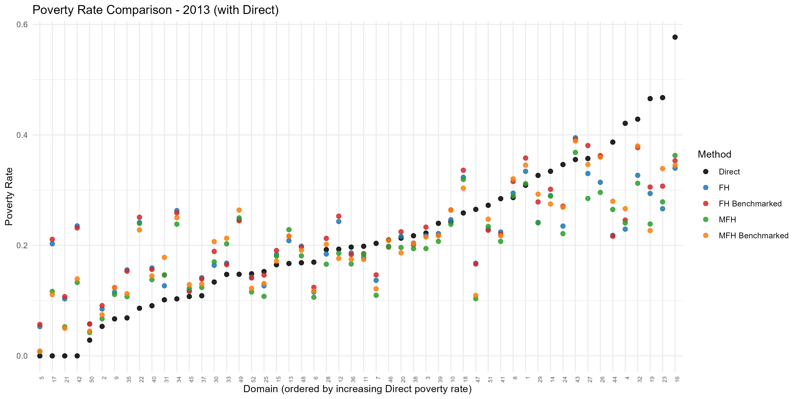
Figure 2. Earlier-run illustration of 2013 Direct, FH and MFH estimates, ordered by Direct poverty rate. Regenerate these estimates with the current revision before interpreting numerical differences.
Shrinkage is not a mechanical correction toward the national mean. It moves toward the value predicted by the area’s characteristics. If an area has auxiliary variables associated with high poverty, the model prediction may also be high. If an area has auxiliary variables associated with low poverty, the model prediction may be low.
Operationally, the UFH model answers the question: given the direct survey estimate, its sampling variance, and the area’s auxiliary characteristics, what is the best model-based estimate of poverty for this area?

7.3 What Fay–Herriot aims to estimate
It helps to be clear about what the Fay–Herriot model estimates. The estimates should be interpreted as predictors of realized area-level poverty parameters, not merely as fitted values from a regression of poverty on covariates. For area i, the target is the realized area parameter:
$$θ_{i}=x_{i}'β+u_{i}$$
Here xᵢ′β is the regression-synthetic component — the conditional mean implied by the area’s covariates — and uᵢ is the realized area effect, the part of area poverty that the covariates do not explain. A purely synthetic estimate (the regression prediction evaluated at the estimated coefficients) estimates only this conditional mean. The FH predictor goes further: it uses the direct estimate and its sampling variance to infer the realized area effect uᵢ for that specific area.
This distinction matters in practice. Fay–Herriot is not simply a smoothed regression fitted value; it is a model-based predictor of the realized area-level poverty parameter. The adjustment from the synthetic component to the FH predictor is governed by the covariance structure of the area effects and the sampling errors. That is why the covariance assumptions — how the area effects and the sampling errors are assumed to vary and co-vary — are not secondary technical details but part of what the model estimates (see Section 8.11 and Annex G.10). The companion paper What Does Fay-Herriot Predict? BLUPs, Covariance Misspecification, and Missing Direct Estimates (file FH_prediction_covariance_paper_with_annex_REVISED_section11_annexA.docx) develops this prediction-versus-mean distinction and shows why a synthetic fitted value is not automatically a BLUP of the realized area parameter.

7.4 Model specification
For a fixed year, the UFH model can be written as:
$${\hat{θ}}_{d}^{DIR}\text{=}x_{d}'β\text{+}u_{d}\text{+}e_{d}$$
where ${\hat{θ}}_{d}^{DIR}$ is the direct estimate for area (d); $x_{d}$ is the vector of area-level auxiliary variables; $β$ is the vector of regression coefficients; $u_{d}$ is the area random effect; and $e_{d}$ is the sampling error of the direct estimate.
The sampling error is assumed to have mean zero and known or estimated sampling variance:
$$e_{d}∼N(0,ψ_{d})$$
where $ψ_{d}$ is the sampling variance of the direct estimate.
The area random effect captures area-level variation that is not explained by the auxiliary variables:
$$u_{d}∼N(0,σ_{u}^{2}).$$
The UFH estimate is the empirical best linear unbiased predictor of the true area indicator. In practical terms, it adjusts the regression prediction using information from the direct estimate. The adjustment is larger when the direct estimate is precise and smaller when it is noisy.
Formally, the UFH estimate for area (d) is:
$${\hat{θ}}_{d}^{\text{UFH}}={\hat{γ}}_{d}{\hat{θ}}_{d}^{\text{DIR}}+\left(1-{\hat{γ}}_{d}\right)x_{d}'\hat{β}$$
where the estimated shrinkage weight is:
$${\hat{γ}}_{d}=\frac{{\hat{σ}}_{u}^{2}}{{\hat{σ}}_{u}^{2}+ψ_{d}}$$
The shrinkage weight lies between zero and one. It is close to one when the direct estimate is precise (small sampling variance), so the UFH estimate stays close to the direct estimate; it is close to zero when the direct estimate is noisy, so the UFH estimate relies mainly on the regression prediction. The regression coefficients are estimated by weighted least squares; Annex G. 2 gives the full formulas, including the MSE estimator.
The two lines of the model have direct interpretations. The first is the sampling model: the direct estimate equals the true area value plus sampling error, whose known (or estimated) variance measures the noise in the survey estimate. The second is the linking model: the true area value is a regression on area-level covariates plus an area random effect that captures area-level variation the covariates do not explain. The FH estimate should be consistent with the direct estimates for areas with small sampling variance or large sample sizes, while drawing more on the covariates where the direct estimate is weak.

7.5 Inputs required for UFH
The UFH model requires the following area-level inputs for each domain and year: a direct estimate for each area; the sampling variance of the direct estimate; area-level auxiliary variables; the population size, if aggregation or benchmarking is needed; and a geographic boundary file, if maps will be produced.
Before fitting UFH, users should confirm that the direct estimates and sampling variances have been reviewed, that auxiliary variables are available for all target areas, and that domain codes match across all input files.
In the current Workbench workflow, area-year cells without direct estimates should be treated as data-readiness issues. They should be flagged, reviewed, and either resolved, aggregated, excluded, or documented before model estimation. FH prediction for area-years without direct estimates is discussed as a future extension in Section 15.5.

7.6 Transformations
For poverty rates and other bounded indicators, transformations may be used to improve model performance and keep estimates within the valid range. For mean welfare, transformations may be used to reduce skewness and improve model fit.
The app supports four UFH transformation options: arcsin or no transformation for the headcount ratio (FGT(0)), and log or no transformation for mean welfare. FGT(1) and FGT(2) are always modeled without transformation.
For poverty rates, the arcsin transformation is often useful because it stabilizes variance and reduces the risk of producing predictions outside the valid range (Casas-Cordero Valencia, Encina, and Lahiri, 2016; Schmid et al., 2017). For mean welfare, a log transformation may help when the welfare distribution is highly skewed.
As a default, start with the arcsin transformation for poverty rates and, for mean welfare, the log transformation when welfare is strongly skewed; use no transformation as a sensitivity check and review whether the transformed and untransformed models yield materially different conclusions.
Transformations should improve stability and interpretation. They should not be used to hide poor model fit or unresolved data problems.

7.7 Bias correction after back-transformation
When a model is estimated on a transformed scale, the results must be back-transformed to the original scale before interpretation. Back-transformation can introduce bias because the expected value of a nonlinear transformation is not generally equal to the inverse transformation of the expected value.
Log mean welfare uses the log of the survey-weighted arithmetic Direct area mean, with sampling variance V/mean². Zero and negative individual welfare values remain in the arithmetic mean; the area mean must be positive and finite. UFH bias correction uses native emdi Slud–Maiti bc_sm with ML fitting and its original-scale analytical MSE. The naive option exponentiates the same fitted log-area mean and uses bootstrap MSE; it does not change the target into a geometric mean. The arcsine option follows the installed emdi point estimator; its upper-boundary limitation is disclosed in Annex G.4.
Review model diagnostics on the scale on which each model is fitted. Report final poverty rates and mean-welfare levels on the indicator scale. Some change diagnostics intentionally use another scale: the mean-welfare change box plots show raw log ratios and their RMSEs, whereas the main change tables and maps show percentage changes (Section 11.13).
Recommended practice is to use bias correction when applying nonlinear transformations, report final estimates on the original scale, document the transformation and bias-correction method, and, when feasible, compare transformed and untransformed results as a sensitivity check.

7.8 Covariate selection
UFH models should use a parsimonious and conceptually justified set of covariates. Because area-level models often have a limited number of observations, overfitting is a major risk.
The app can select covariates automatically using AIC or BIC. Users can also force specific covariates by entering comma-separated variable names.
The app also offers an optional first-stage LASSO screen for UFH and MFH. This screen uses numeric, non-degenerate candidate covariates with complete cases and passes the screened set to the AIC/BIC stepwise procedure. It should be treated as a dimension-reduction aid, not as the final model-selection rule. A year-specific covariate list defines the LASSO candidate pool when screening is enabled; when screening is disabled, the same list defines the fixed model specification. If no list is supplied, the eligible auxiliary variables are used. If LASSO selects no variables, the app falls back to the original candidate pool or a safe intercept-only model when no usable covariates remain.
As a recommended default, use BIC when the number of areas is limited, or parsimony is preferred, and AIC as a sensitivity check when predictive performance is prioritized, and the number of areas is adequate; force manual covariates only when there are strong substantive reasons to include specific variables. In all cases, review the selected covariates for plausibility, sign, and stability, and avoid variables that are highly collinear, redundant, or based on noisy sample-survey area estimates.
Automatic model selection should support, not replace, technical judgment. The final model should be explainable to statistical reviewers and country counterparts.

7.9 Variance options
The sampling variance of the direct estimate determines how much weight the UFH model assigns to it relative to the regression prediction. If sampling variances are unstable, zero, missing, or affected by very small samples, they can distort the model.
With no transformation or a log transformation, the app allows the following UFH variance options:
TABLE IX
UFH Variance Options
Option | Interpretation
direct | Use the raw survey variance estimates.
sm_out | Retain a finite direct variance when it is at least 0.001; replace a missing, non-finite, or smaller variance with its GVF-smoothed value. Large direct variances are not replaced.
sm_all | Replace all variances with GVF-smoothed variances. The GVF uses sample size only, so it can overstate variances where poverty rates are low (Section 6.6).
UFH defaults to sm_out with no transformation and with log mean welfare. The selected option is honored and saved. Compare with direct when raw design variances are credible, and with sm_all when direct variances are broadly unstable and the GVF fits well (Section 6.6). sm_out replaces missing, non-finite, or strictly below-0.001 variances; a variance equal to 0.001 is retained. With logs, the option and cutoff apply to the sampling variance of the log area mean. Document the setting used.
The UFH variance selector is available for no transformation and log mean welfare. Arcsine remains separate: fitting uses the effective-sample-size variance 1/(4 n_eff), with a fallback to the observed sample size if the design-effect-based effective sample size is invalid; neither sm_out nor sm_all replaces that analytical treatment. MFH has its own variance and covariance controls, including for log mean welfare. Explicit saved choices are retained. Review the raw Direct uncertainty and actual working-variance settings recorded in the run.

7.10 Model diagnostics
UFH estimates should not be accepted simply because the model converged. Users should review diagnostics to assess whether the model is credible and whether the resulting estimates are suitable for reporting.
UFH diagnostics should include:
- Model convergence status.
- Selected covariates and their plausibility.
- Residual plots.
- Q-Q plots of residuals.
- Q-Q plots or histograms of random effects.
- Outlier areas.
- Estimated random-effect variance.
- Comparison of direct and UFH estimates.
- Comparison of direct and UFH standard errors or CVs.
- Sensitivity to covariate selection.
- Sensitivity to variance smoothing.
- Maps of estimates and uncertainty.
The Workbench writes model-fit diagnostics for UFH and MFH, including selected formula, number of domains used, number of predictors, AIC, BIC, log likelihood where available, residual SD/sigma, random-effect variance, and OLS companion R2 and adjusted R2. The R2 values should be labeled as OLS companion diagnostics for the selected formula, not as definitive mixed-model fit measures.
A good UFH model should improve precision without producing implausible estimates or excessive shrinkage. Areas with large differences between direct and UFH estimates should be reviewed carefully. Large differences may be reasonable when direct estimates are very noisy, but they may also indicate weak covariates, data errors, outliers, or model misspecification.
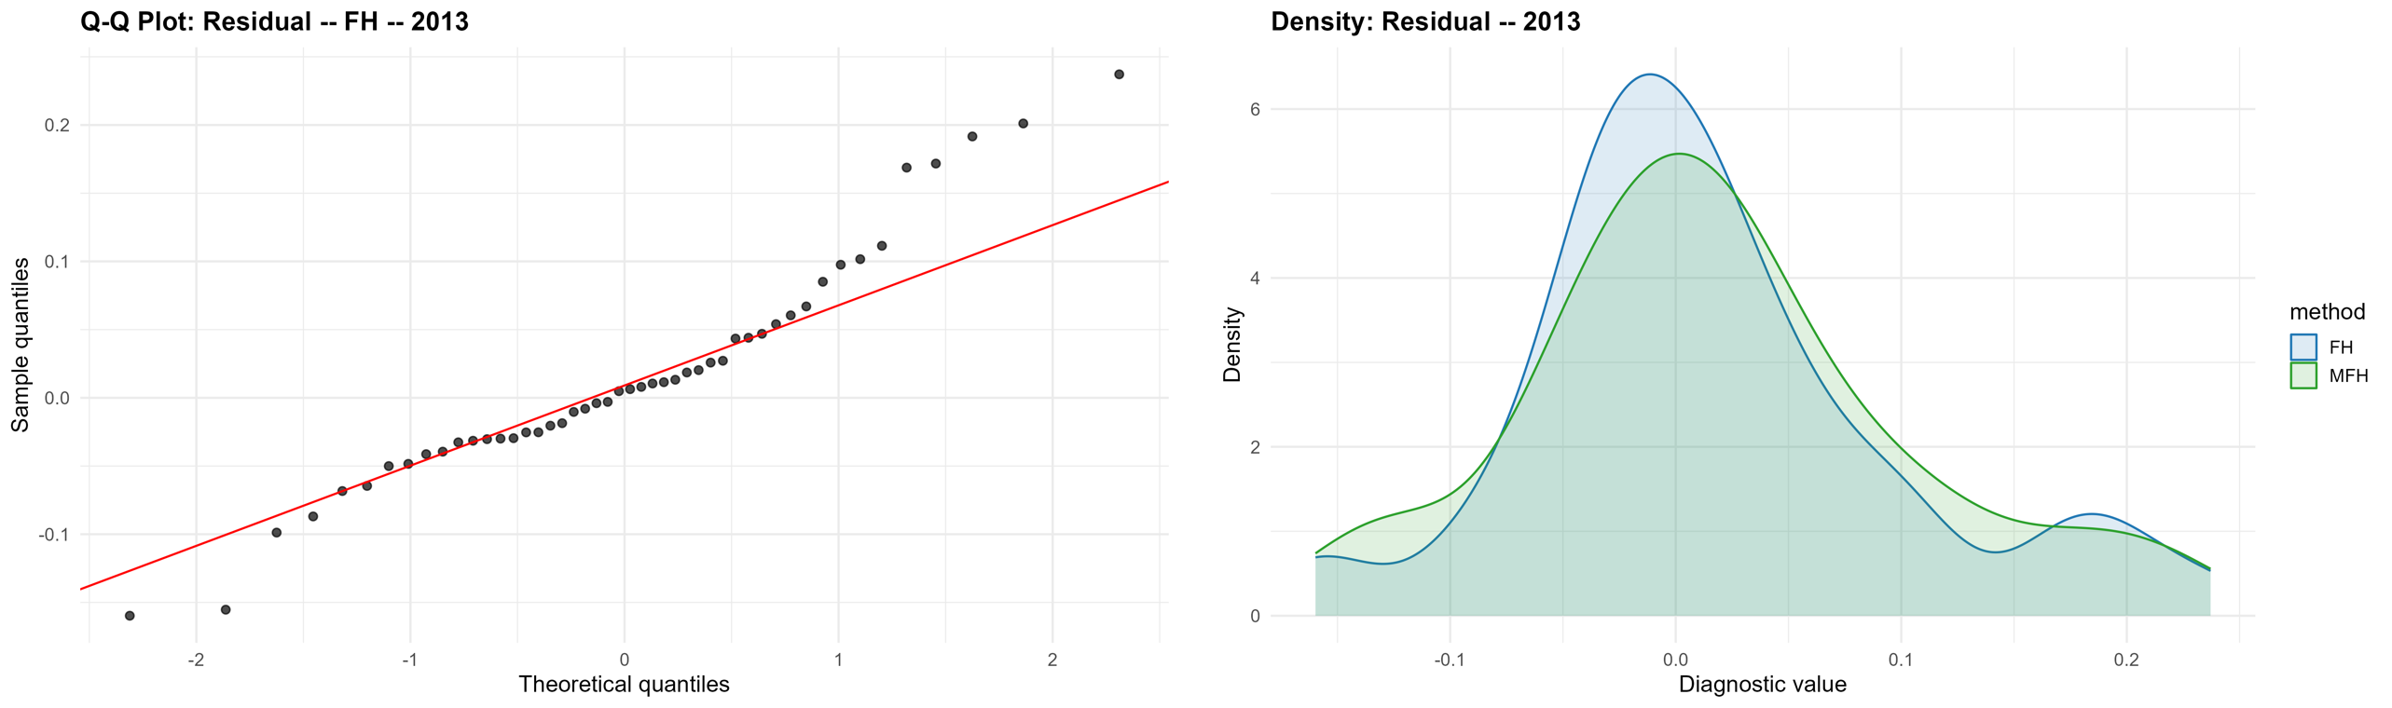
Figure 3. Earlier-run illustration of UFH residual diagnostics for 2013. Current numerical diagnostics must be regenerated with the revised estimator.

7.11 Interpreting UFH estimates
UFH estimates should be interpreted as model-based estimates that combine survey evidence with auxiliary data. They are usually more precise than direct estimates, but they depend on model assumptions.
Users should avoid presenting UFH estimates as directly observed survey estimates. Instead, reports should explain that UFH estimates borrow strength across areas and that uncertainty measures reflect both sampling error and model uncertainty.
When interpreting results, users should consider whether UFH estimates are broadly consistent with direct estimates; whether areas with high direct-estimate uncertainty show greater model adjustment; whether estimated spatial patterns are plausible; whether uncertainty remains high in some areas; whether rankings are robust to uncertainty; and whether results are sensitive to alternative model choices.
UFH estimates are most useful when they reduce uncertainty while preserving credible spatial patterns. They should be interpreted cautiously when covariates are weak, diagnostics are poor, or estimates are highly sensitive to model choices.

7.12 Benchmarking UFH estimates
Benchmarking adjusts small-area estimates so they aggregate to trusted estimates at a higher geographic level, such as regions or national totals. Benchmarking can be useful when official higher-level estimates are considered reliable and should be preserved.
Benchmarking applies a common ratio factor within each national or grouped benchmark area so that the population-weighted aggregate matches the target. A positive factor preserves nonnegativity and ordering only for predictions that are already nonnegative. It does not repair negative predictions or ensure an upper bound of one; check both bounds for poverty estimates. Ratio benchmarking is an implementation choice among alternatives including additive, difference and more general constrained adjustments (Datta et al., 2011; Bell, Datta, and Ghosh, 2013).
In practice, the Workbench carries out benchmarking in the following sequence. First, it determines the benchmark level: national, in which all domains form a single group, or grouped, in which the domains are partitioned by a mapped benchmark-level column such as region or NUTS-2; each domain must belong to exactly one group in the analysis years, or the run stops (Section 3.8). Second, it obtains each domain’s population size, taken from an uploaded population file when one is provided and otherwise estimated from the survey as the sum of the population weights by domain and year (Section 3.7); these sizes define the population weights used in aggregation. Third, it sets the benchmark target for each group and year: when a Benchmark Target Database is uploaded, its values are used directly; otherwise the target is the population-weighted average of the direct domain estimates within the group. Fourth, it computes, for each group and year, a single ratio factor equal to the target divided by the population-weighted average of the model (EBLUP) estimates in that group, and multiplies every domain estimate in the group by this factor. Because the factor is common within a group and multiplicative, a positive factor keeps non-negative estimates non-negative, preserves the ordering of areas within the group, and makes the group aggregate equal the target. Three caveats apply. An uploaded Benchmark Target Database must give a finite target for every group and year, or the run stops with an error. Nonfinite inputs are rejected. A zero model aggregate with a nonzero target cannot satisfy the constraint and is an error. For a zero target and zero model aggregate within numerical tolerance, UFH sets the group predictions to zero and records an undefined ratio; MFH retains them with factor 1. These are explicit degenerate-case conventions. Inspect any recorded unavailable-benchmark status rather than assuming that a unit adjustment was applied. The ratio does not keep poverty rates at or below 1.
The bootstrap simulates Gaussian random effects and sampling errors under the fitted model, refits the same estimator, and repeats back-transformation and the final ratio benchmark in reported units. Survey-derived targets are recomputed from the same replicate’s Direct estimates in both UFH and MFH. Uploaded targets remain fixed, so their own uncertainty is excluded. Errors are measured against the unbenchmarked synthetic area truth. Auxiliary variables, selected formulas, selected MFH type, populations and estimated sampling covariance inputs are held fixed. Variable selection, MFH3/MFH2 selection, GVF fitting and sampling-covariance estimation are not repeated in each draw; their uncertainty is excluded. The shared Bootstrap replicates control defaults to 500 for UFH, MFH and benchmarking; explicit counts restored from older configurations are retained. Successful finite replicates and rejected fits are counted; insufficient draws make uncertainty unavailable. More draws improve Monte Carlo precision, not model validity or guaranteed coverage.
Benchmarking restores aggregate consistency but does not create new information: it is worthwhile only when the benchmark is more reliable than the small-area estimates being adjusted, and a thin region–period cell can transmit noise from the benchmark into every area it contains.
Benchmarking should be applied cautiously. It can improve consistency with official estimates, but it may also shift small-area estimates and affect area rankings. Users should compare estimates before and after benchmarking and document the benchmark source, benchmark level, and benchmarking method.
When reporting benchmarked estimates, their uncertainty should reflect the benchmarking step. Because the benchmark factor is estimated from the data and the benchmarked estimate is a nonlinear function of the fitted EBLUPs, the Workbench estimates the benchmarked MSE by bootstrap rather than simply reusing the analytical MSE of the unbenchmarked Fay–Herriot estimator; for MFH, it produces, in the same way, the cross-time error (MCPE) needed for inference on benchmarked changes (Section 8.12).
Mean welfare fitted in logs. The bootstrap simulates Gaussian random effects and sampling errors under the fitted model, refits the same estimator, and repeats back-transformation and the final ratio benchmark in reported units. Survey-derived targets are recomputed from the same replicate’s Direct estimates in both UFH and MFH. Uploaded targets remain fixed, so their own uncertainty is excluded. Errors are measured against the unbenchmarked synthetic area truth. Auxiliary variables, selected formulas, selected MFH type, populations and estimated sampling covariance inputs are held fixed. Variable selection, MFH3/MFH2 selection, GVF fitting and sampling-covariance estimation are not repeated in each draw; their uncertainty is excluded. There is no separate post-bootstrap currency adjustment and no reuse of a log-scale coefficient of variation as the MSE of the final estimator.
Benchmarking is most appropriate when the benchmark estimate is reliable; the benchmark uses the same welfare variable and poverty line; the benchmark refers to the same population universe; the benchmark geography is consistent with the small-area geography; and the benchmark year matches the survey year.
Benchmarking should not be used to force consistency with a benchmark that is conceptually different from the small-area estimates.

7.13 UFH outputs
The UFH stage should produce a complete set of model outputs for review, mapping, and reporting. These outputs should include area-level UFH estimates by year, standard errors or MSEs, coefficients of variation, direct versus UFH comparison tables, covariates selected for each year, model diagnostics, flags for outliers or areas with large model adjustments, maps of UFH estimates, maps of uncertainty, and output files for the MFH and comparison stages.
The UFH output table should retain the direct estimates alongside the UFH estimates. This makes it possible to assess how much the model changes the survey-only evidence and whether the changes are reasonable.

7.14 UFH checklist
Before accepting UFH results, users should confirm that:
- Direct estimates and sampling variances have been reviewed.
- Auxiliary variables are available for all target areas.
- The selected transformation is appropriate.
- Bias correction is applied when needed.
- The variance option is appropriate and documented.
- The selected covariates are plausible and not overfitted.
- The model converged successfully.
- Residuals and random effects do not show major problems.
- UFH estimates are broadly consistent with direct estimates.
- UFH standard errors or CVs show reasonable precision gains.
- Results are not highly sensitive to reasonable alternative settings.
- Benchmarking, if used, is documented and reviewed.
- Final maps include uncertainty information.
UFH results should be treated as provisional until these checks have been completed.

Section 8
MFH Methodology

8.1 Purpose of the MFH model
The Multivariate Fay-Herriot model extends the UFH framework to multiple years. While UFH estimates each year separately, MFH estimates several years jointly and allows poverty estimates for the same area to be correlated over time.
MFH is useful when the objective is not only to produce poverty maps for individual years but also to compare poverty across years. In many applications, separate UFH models may produce reasonable estimates for each year. However, the resulting trends can be unstable if direct estimates are noisy, covariates differ across years, or sampling variation is large in some areas. MFH addresses this problem by borrowing strength across both areas and time.
Operationally, MFH answers the question: given the direct estimates, their sampling variances, the auxiliary variables, and the relationship between the same areas across time, what are the best model-based estimates for each area-year?

8.2 Why is MFH needed
Area-level poverty often changes gradually over time, unless there is a major economic shock, conflict, natural disaster, policy change, or a change in survey methodology. The poverty level of an area in one year is therefore usually informative about its poverty level in another year.
Separate UFH models do not use this information directly. Each year is estimated independently, so the estimates for year $t_{1}$ do not help inform the estimates for year $t_{2}$. This can be a limitation when direct estimates are imprecise or when analysts need reliable estimates of change.
MFH is designed for these situations. Estimating multiple years jointly can reduce unstable year-to-year movements arising from sampling variation while still allowing genuine changes in poverty to appear in the estimates.
MFH is especially useful when poverty maps are needed for two or more years; the main objective is to analyze changes over time; direct estimates are noisy in some areas or years; area-level poverty is expected to be correlated over time; the same or comparable geographic domains are available across years; welfare aggregates and poverty lines are comparable across years; or auxiliary variables are consistently measured across years.
MFH should not be used mechanically. If the survey data, poverty lines, area definitions, or auxiliary variables are not comparable across years, MFH estimates may impose artificial stability on data that are not truly comparable.

8.3 MFH model structure
For area (d) and year (t), the MFH model can be written as:
$${\hat{θ}}_{dt}^{DIR}\text{=}x_{dt}'β_{t}\text{+}u_{dt}\text{+}e_{dt}$$
where ${\hat{θ}}_{dt}^{DIR}$ is the direct estimate for area (d) in year (t); $x_{dt}$ is the vector of area-level auxiliary variables; $β_{t}$ is the vector of regression coefficients, which may vary by year; $u_{dt}$ is the area-time random effect; and $e_{dt}$ is the sampling error of the direct estimate.
The sampling error has variance:
$$Var(e_{dt})\text{=}ψ_{dt}$$
where $ψ_{dt}$ is the sampling variance of the direct estimate.
The key feature of MFH is that the random effects for the same area can be correlated across time. For example, if an area has poverty above the level predicted by its covariates in one year, the model allows that unexplained component to be related to the unexplained component in another year.
This time correlation is what allows MFH to borrow strength across years.
Stacking the years for area (d), the MFH estimate is the multivariate empirical best linear unbiased predictor:
$${\hat{θ}}_{d}^{\text{MFH}}=X_{d}\hat{β}+{\hat{Σ}}_{u}{\left({\hat{Σ}}_{u}+Ψ_{d}\right)}^{-1}\left({\hat{θ}}_{d}^{\text{DIR}}-X_{d}\hat{β}\right)$$
where the first term collects the regression predictions for all years and the second term shrinks the vector of direct estimates toward those predictions, using the estimated random-effects covariance matrix and the sampling-error covariance matrix of the direct estimates. This is the multivariate analog of the univariate shrinkage formula in Section 7.4: each year’s estimate is a weighted combination of the direct estimate and the regression prediction, with weights that exploit the estimated correlation across years. Annex G. 5 gives the full matrix formulas for the MFH variants and their MSE estimators.
In this expression, ${\hat{θ}}_{d}^{DIR}=({\hat{θ}}_{d1}^{DIR},…,{\hat{θ}}_{dT}^{DIR})'$ is the vector of direct estimates for area (d) across the $T$ years; $X_{d}$ is the $T×p$ matrix of auxiliary variables whose row for year $t$ is $x_{dt}'$; $\hat{β}$ is the vector of estimated regression coefficients; ${\hat{Σ}}_{u}$ is the estimated $T×T$ covariance matrix of the random effects $u_{d}=(u_{d1},…,u_{dT})'$, whose assumed structure is what distinguishes the MFH variants (Section 8.5); and $Ψ_{d}$ is the $T×T$ sampling-error covariance matrix of $e_{d}=(e_{d1},…,e_{dT})'$, which carries the sampling variances $ψ_{dt}$ on its diagonal and the cross-year sampling covariances off the diagonal (Section 8.7).
Two distinct covariance matrices appear in the MFH model, each playing a different role. The random-effects covariance matrix governs how each area’s unexplained component correlates across years; the model estimates it, and its assumed structure distinguishes the MFH variants (Section 8.5). The sampling-error covariance matrix, by contrast, is not estimated by the model – it is supplied to the model as data and must be estimated from the survey beforehand (Section 8.7). Keeping the two separate avoids a common source of confusion: the model learns the first, but the analyst must provide the second.

8.4 Inputs required for MFH
MFH requires the same types of inputs as UFH, but they need to be organized consistently across multiple years. The required inputs are domain identifier, year identifier, direct estimate for each area-year, sampling variance for each area-year, area-level auxiliary variables for each area-year or time-invariant auxiliary variables repeated across years, population sizes, if aggregation or benchmarking is needed, geographic boundaries, if maps will be produced, and sampling covariance information, if cross-year sampling errors are correlated and covariance estimation is feasible.
Before fitting MFH, users should confirm that area definitions, welfare aggregates, poverty lines, weights, and auxiliary variables are comparable across years. If domain boundaries changed over time, the data should be harmonized to a common geography before using MFH.

8.5 MFH model variants
The app includes three MFH variants: MFH1, MFH2, and MFH3. The main difference among them is how they model the covariance structure of the area-time random effects.
MFH1: diagonal (independent years).
MFH1 gives each year its own random-effect variance but assumes no correlation between years—a diagonal covariance matrix with $T$ parameters. This is the structure fitted by msae::eblupMFH1 and the package’s bootstrap routine. It borrows strength across areas and, where specified, through the sampling-error covariance, but—unlike MFH2 and MFH3—it does not borrow strength across time through the random effects.
MFH2: homoskedastic AR(1) structure.
MFH2 uses a stationary AR(1) area-effect covariance with common innovation variance. Its marginal variance is innovation variance divided by (1 − rho²). MFH2 remains the default because MFH3 failed to converge in the Spanish and Polish applications. The numerical safeguard checks the same REML model; it does not add an adjusted likelihood.
MFH3: heteroskedastic AR(1) structure.
MFH3 permits time-varying innovation variances and uses u0 ~ N(0,1), with u1 = rho × u0 + a1. The fit and bootstrap use this same initial state. Its fixed initial variance makes the model sensitive to outcome measurement scale and can complicate fitting. An unusable MFH3 endpoint leads to MFH2 with the reason recorded.
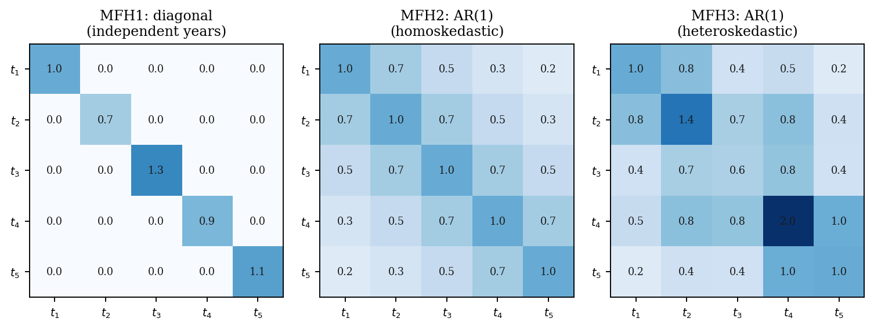
Figure 4. The three MFH random-effect covariance structures over T = 5 periods: MFH1 (diagonal / independent years), MFH2 (homoskedastic AR(1)), and MFH3 (heteroskedastic AR(1)).

8.6 Choosing among MFH1, MFH2, and MFH3
MFH2 is the default. Selecting MFH3 starts the Molina–Romero sequence: fit MFH3, require a usable numerical endpoint, and retain it only if an adjusted reference-variance contrast rejects equality at alpha = 0.05. Otherwise select MFH2. A computational error and a failed convergence check are recorded separately.
Recommended practice is to use MFH2 for the default primary run. Select MFH3 when heteroskedastic time-specific random-effect variances are substantively or diagnostically plausible; when MFH3 is selected, use Bonferroni adjustment for the confirmatory model-selection decision and BH as a sensitivity option, review the selected model, convergence status, variance-test table, and model diagnostics, and allow the package to return to MFH2 unless the converged MFH3 fit provides adjusted evidence of time-varying random-effect variances. Use MFH1 as an additional sensitivity model when temporal random-effect correlation is doubtful.
Method box: Bonferroni and BH in MFH2/MFH3 selection
What is adjusted. When the user selects MFH3, its reference-variance procedure compares pairs of time-specific random-effect variances. Multiplicity is therefore across year-pair variance contrasts, not across geographic areas.
Bonferroni. Bonferroni controls the probability of making at least one false rejection within this family. It is conservative and is the package's confirmatory default for deciding between MFH2 and MFH3.
Benjamini-Hochberg. BH controls the expected false-discovery rate among rejected contrasts. It is generally less conservative and is available as a sensitivity option.
Current two-year scope. The Workbench analyzes exactly two years, so MFH3 produces only one pairwise variance contrast. With one test, the raw, Bonferroni, and BH p-values are identical. The choice matters only if a future version supports three or more years.
Do not confuse the two uses of BH. This model-selection adjustment is separate from the report's supplementary BH adjustment across area-level tests of poverty change. The two procedures answer different questions and use different families of hypotheses.
Model choice should be based on convergence, diagnostics, the plausibility of the estimated correlations and variances, comparison with UFH, and the sensitivity of the final estimates. A more complex model is not necessarily better if it produces unstable or difficult-to-interpret results.

8.7 Sampling covariance over time
When comparing estimates over time, the covariance of sampling errors matters. Sampling errors may be correlated across years if the survey uses overlapping samples, repeated PSUs, panel components, rotating panels, or other design features that create dependence across survey rounds.
Under a persistent positive cluster-effect model, reused PSUs can induce positive cross-year covariance even when different households are sampled. Its actual magnitude and sign depend on the joint survey design, population evolution and overlap; PSU reuse alone does not establish either. Estimate covariance using the correctly specified joint design, stable PSU identifiers and the full relevant sample, including non-panel households in shared PSUs. Independent sampling supports zero design covariance. Review design assumptions and sensitivity to the working covariance specification (Yoshida, 2025).
For two years $t_{1}$ and $t_{2}$, the sampling covariance for area (d) can be written as:
$$Cov(e_{dt_{1}},e_{dt_{2}}).$$
In practice, the app estimates this covariance in one of two main ways. The first is direct estimation: with the PSUs declared as the first-stage units, the design-based covariance between the two years’ direct estimates is computed for each area from the full samples of both rounds (the direct option in Table X). The second is to estimate a single autocorrelation of the sampling errors, pooled over domains, and multiply it by the two years’ sampling variances for each area:
$$\hat{\text{Cov}}\left(e_{dt_{1}},e_{dt_{2}}\right)=\hat{ρ}\sqrt{ψ_{dt_{1}}ψ_{dt_{2}}}$$
The variances entering this formula can be the direct variances (rho_dir); sm_out variances, for which a finite direct variance is retained when it is at least 0.001 and a missing, non-finite, or smaller value is replaced with its GVF-smoothed value (rho_sm_out); or fully smoothed variances (rho_sm_all). The pooled-correlation options adapt the pooled sampling-correlation strategy of Boonstra and van den Brakel (2019) to PSU-level dependence, for situations in which area-level covariance estimates are too unstable to use directly: the sampling-error correlation is estimated from the full sample at PSU level after removing each domain-year mean, and combined with domain variances on the selected basis. This keeps household overlap and PSU persistence, and excludes lasting differences between domains, which the model should capture. New configurations pair sm_out with rho_sm_out; rho_sm_all, with fully smoothed variances, remains an option. Annex G.8 describes the calculation, and Annex H explains its relationship to the published framework.
When a Boonstra-type approach is used (Boonstra and van den Brakel, 2019), the sampling-error covariance requires both the marginal sampling variances and an estimated sampling-error autocorrelation. The autocorrelation alone is not sufficient to determine the covariance scale. If marginal sampling variances are unavailable or unreliable, they should first be obtained or approximated — through survey-design estimation, replicate weights, a generalized variance function, or a defensible effective-sample-size approximation — before forming the cross-year covariance.
This covariance affects the uncertainty of estimated changes. The variance of the difference between two direct estimates is:
$$Var\left({\hat{θ}}_{dt_{2}}^{DIR}\text{-}{\hat{θ}}_{dt_{1}}^{DIR}\right)\text{=}Var\left({\hat{θ}}_{dt_{2}}^{DIR}\right)\text{+}Var\left({\hat{θ}}_{dt_{1}}^{DIR}\right)\text{-}2Cov\left(e_{dt_{2}},e_{dt_{1}}\right)$$
If the covariance is ignored when it is important, confidence intervals for changes may be misleading. The direction of the effect depends on whether the covariance is positive or negative.
The app includes several covariance options:
TABLE X
Cross-Year Sampling-Covariance Options
Option | Interpretation
rho_sm_out | Use one pooled sampling-error correlation with sm_out variances; GVF-smoothed values replace missing, non-finite, or below-0.001 direct variances. The option is based on Boonstra and van den Brakel (2019).
rho_sm_all | Use one pooled sampling-error correlation with fully smoothed variances.
rho_dir | Use one pooled sampling-error correlation with direct variances after required safety backfills.
direct | Use the design-based domain covariance estimated from the full survey design.
zero | Assume zero cross-year sampling-error covariance; appropriate for independent survey rounds or as a documented sensitivity analysis.
New MFH configurations default to sm_out variances with rho_sm_out covariance, combining a pooled sampling-error correlation with selectively smoothed domain variances. Choose the cross-year PSU design in Step 4 from the survey documentation, and check that sampling dependence is plausible. Choosing independently sampled surveys sets the sampling covariance to zero. On linked surveys, zero covariance is only a documented sensitivity. Compare direct domain covariance and other compatible variance–covariance choices when supported by the design and diagnostics.
The selected covariance option should be documented because it affects uncertainty estimates for changes over time.
Two practical cautions apply. First, the variances used on the diagonal of the covariance matrix and the variances used inside its off-diagonal covariances should share the same basis; the Workbench offers compatible covariance choices for this reason. An omitted covariance setting is derived from the effective variance choice (sm_out with rho_sm_out, sm_all with rho_sm_all, direct with rho_dir); explicit saved settings are preserved. Second, non-zero covariance inputs can make a multivariate fit more difficult. If convergence fails, first verify year and PSU identifiers and inspect the covariance estimates; then consider moving from unstable direct domain covariances to rho_sm_out, rho_sm_all or another documented stabilized specification. The pooled-correlation approach adapts the pooled sampling-correlation strategy of Boonstra and van den Brakel (2019) to PSU-level dependence. Setting covariance to zero should be a last resort unless survey rounds are genuinely independent, because doing so can misstate the uncertainty of changes over time (Yoshida, 2025).

8.8 Transformations and scale of estimation
In the current app workflow, MFH poverty indicators are modeled on the identity scale. Mean welfare can be modeled on the log scale or the original scale, depending on the selected transformation option.
Users should confirm that model outputs are interpreted on the correct scale. For poverty rates, estimates should remain within the feasible range of 0 to 1. If results fall outside this range or appear implausible, users should review the data, model specification, and diagnostics before accepting the results.
MFH log models also transform the arithmetic Direct area means. Corrected currency predictions use the Gaussian conditional mean exp(eta + v/2), where v is the diagonal of G − G(G + R)⁻¹G. The naive option uses exp(eta). This multivariate extension is distinct from emdi’s univariate Slud–Maiti method; saved MFH settings named bc_sm are accepted as a legacy alias. Original-scale MSE and MCPE are estimated after inverse transformation inside the bootstrap. CPI conversion precedes direct estimation and serves a different purpose from the model transformation.

8.9 MFH diagnostics
MFH estimates should not be accepted only because the model converged. Users should review diagnostics carefully because MFH imposes additional structure across time.
MFH diagnostics should include:
- Model convergence.
- Estimated time correlation.
- Estimated random-effect variance.
- Plausibility of the covariance structure.
- Residual diagnostics by year.
- Random-effect diagnostics by year.
- Comparison of direct, UFH, and MFH estimates.
- Comparison of UFH and MFH standard errors or CVs.
- Stability of area trends.
- Sensitivity to covariance assumptions.
- Sensitivity to MFH1, MFH2, and MFH3.
- Maps of estimates and uncertainty by year.
- Maps of changes over time.
A good MFH model should reduce unstable year-to-year movements caused by sampling variation without eliminating genuine changes. If MFH produces trends that are too smooth, too volatile, or inconsistent with known events, users should revisit the data, covariates, covariance assumptions, and model variant.
The numerical check assesses REML score, local curvature and feasible boundary directions in addition to the package convergence flag. A positive variance alone does not establish convergence. MFH2 is refitted when necessary using the same REML objective, exact gradients and several feasible starts; a usable original fit is preserved and an inferior refit is rejected. A valid zero random-effect covariance is allowed, including in bootstrap refits. The AR(1) correlation is bounded numerically at ±0.999999; an accepted endpoint approximates a limiting stationary fit and warrants sensitivity review. The selected model’s annual uncertainty is bootstrapped; missing analytic Fisher-information or g3 calculations are disclosed without preventing an otherwise valid bootstrap.
Boundary-sensitive inference. If the original MFH fit has zero random-effect covariance or reaches the numerical correlation limit, point estimates are retained and inference_status is boundary_sensitive. Normal or delta-method intervals and p-values are provisional: numerical convergence does not establish their coverage. Reports flag this condition and record the count and fraction of accepted bootstrap fits at a boundary. Increasing the bootstrap count reduces Monte Carlo error but does not remedy boundary undercoverage. Review the current validation status and assess model sensitivity before using these results for substantive significance claims.
MFH residual plots standardize Direct minus EBLUP by sqrt(diag(R P R)), where P accounts for fitted fixed effects. The residuals remain correlated. Q–Q plots, Shapiro–Wilk and residual-versus-fitted regressions are descriptive checks, not exact independent-sample tests.
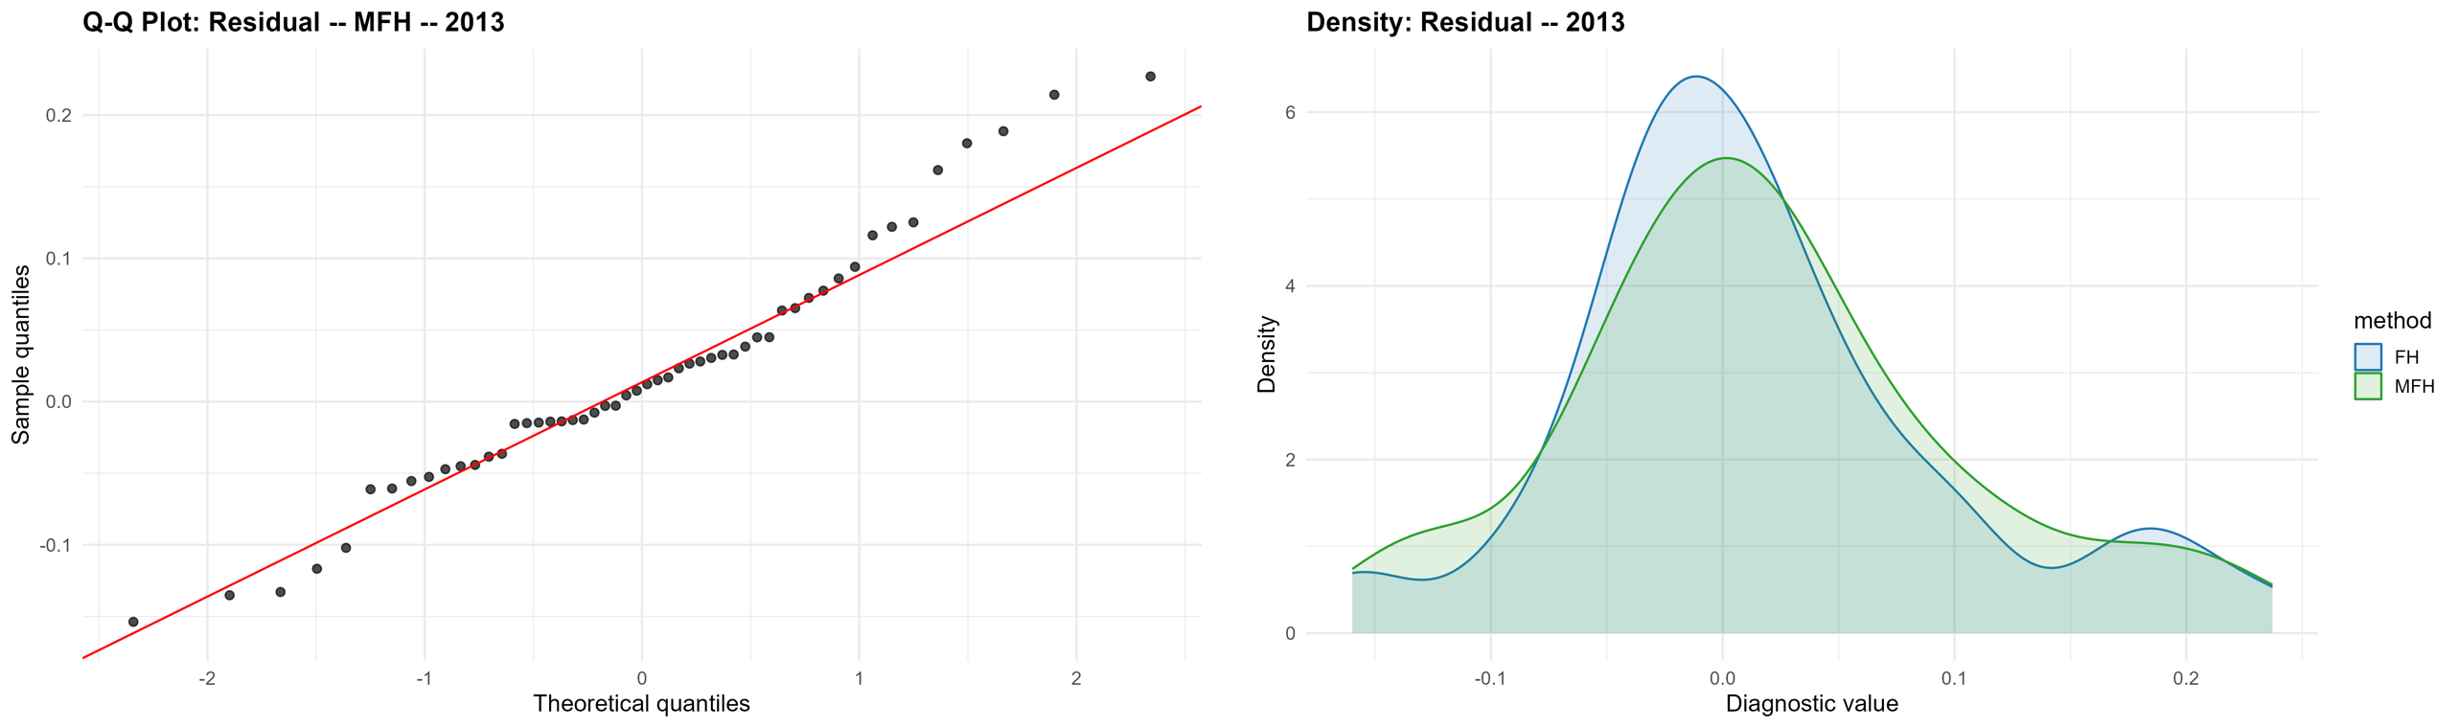
Figure 5. Earlier-run MFH residual plots for 2013. These images predate the revised standardization; current plots use the model-based residual variance described above.

8.10 Interpreting MFH estimates
MFH estimates should be interpreted as model-based estimates that combine survey evidence, auxiliary data, and information about the relationship between years. They are designed to improve comparability over time, but they rely on stronger assumptions than separate UFH models do.
When interpreting MFH estimates, users should consider whether the estimated time correlation is plausible; whether MFH estimates are broadly consistent with direct and UFH estimates; whether MFH reduces unstable movements without suppressing real changes; whether areas with large changes have direct-estimate support, auxiliary-data support, or a plausible contextual explanation; whether uncertainty around changes is large; and whether results are sensitive to covariance assumptions or model variants.
MFH is often preferred for trend analysis, but only when diagnostics are satisfactory and the input data are comparable across years.

8.11 Covariance specification and the interpretation of EBLUP
The EBLUP produced by UFH or MFH is defined relative to the model's assumed covariance structure. Two covariance matrices determine the prediction weights: the covariance of the area random effects and the covariance of the sampling errors. If these matrices are correctly specified and their unknown parameters are consistently estimated, the FH or MFH estimator can be interpreted as an empirical best linear unbiased predictor (BLUP) of the target area parameter.
If the covariance structure is misspecified, the resulting estimator should not be interpreted as the EBLUP under the true covariance structure; it is only an EBLUP under the working covariance model. The practical message for multiyear poverty mapping is direct: when sampling errors are correlated over time — because of rotating panels, retained PSUs, or overlapping samples — UFH is not the BLUP for the relevant multiyear prediction problem, because it treats each area-year separately and applies a shrinkage rule that ignores cross-year sampling-error covariance.
Moving from UFH to MFH does not by itself resolve this. An MFH model that estimates the area-effect covariance but assumes a diagonal sampling-error covariance can still use distorted prediction weights, and may attribute design-induced sampling-error correlation to the area effects (Yoshida, 2026). Analysts should therefore treat covariance assumptions as part of model specification, not secondary technical details, and should document the chosen sampling-error covariance option (Section 8.7) alongside the random-effects structure (Section 8.5). Annex G.10 develops this point and its implications for comparing MFH and spatio-temporal models. The companion paper What Does Fay-Herriot Predict? BLUPs, Covariance Misspecification, and Missing Direct Estimates (file FH_prediction_covariance_paper_with_annex_REVISED_section11_annexA.docx) formalizes this result and reports Monte Carlo evidence that an MFH model with a misspecified diagonal sampling-error covariance can be less accurate than UFH even though prediction bias averages near zero across areas.

8.12 Statistical comparison over time
To compare poverty between two years, users should compute the change in poverty for each area. For area (d), the change between years $t_{1}$ and $t_{2}$ is:
$$Δ_{d}\text{=}θ_{d,t_{2}}\text{-}θ_{d,t_{1}}.$$
The estimated change is:
$${\hat{Δ}}_{d}\text{=}{\hat{θ}}_{d,t_{2}}\text{-}{\hat{θ}}_{d,t_{1}}.$$
A positive value indicates an estimated increase in poverty, while a negative value indicates an estimated decline. However, users should not interpret every estimated change as statistically meaningful. The uncertainty in the difference must account for the uncertainties in both estimates and the covariance between them.
MFH annual MSEs and cross-year MCPE come from the same jointly accepted bootstrap draws. The change MSE is MSE1 + MSE2 − 2 MCPE. These are prediction-error second moments, not centered sample covariances. Invalid joint moments, unavailable moments or zero inferential variance produce unavailable inference with a diagnostic; they never trigger an invented independence fallback. Direct and separately fitted UFH changes retain the explicitly reported period-independence assumption, which needs care with overlapping surveys. The companion MSE note documents this calculation. The distinct sampling-error covariance supplied to the model is described in the sampling-covariance note. Annex H records bootstrap provenance and validation limits.
Operationally, users should report estimated poverty in the first year; estimated poverty in the second year; estimated change in percentage points (for mean welfare, in percent of the earlier year's mean); standard error and pointwise 95% confidence interval for the change; the raw p_value; and the principal significant flag based on p_value < alpha. The Workbench's red/gray change figures use this pointwise two-sided test. At alpha = 0.05, a change is marked significant exactly when its pointwise 95% confidence interval excludes zero. The p_value_bh/significant_bh and p_value_bonferroni/significant_bonferroni fields provide BH and Bonferroni results. They do not control primary figures or headline counts, which summarize exploratory pointwise results rather than familywide evidence.
Changes in mean welfare are reported as 100 × (later mean / earlier mean − 1). The interval and p-value use a first-order log-ratio variance calculated from coherent original-scale annual MSEs and MCPE. The interval is asymmetric and bounded below by −100%. Currency differences remain in fields ending in _eur. Old MFH outputs without joint annual moments must be rerun before change inference.
Interpretation box: Pointwise, BH and Bonferroni significance
Pointwise result. A pointwise 95% confidence interval asks whether an area's change differs from zero when considered on its own. At alpha = 0.05, the interval excludes zero exactly when p_value < 0.05.
Multiplicity. BH controls the expected false-discovery rate under its assumptions; Bonferroni controls familywise error for the declared family of tests. Molina and Romero (2025, p37) accept individual-area comparisons, explain that a family of area tests needs correction such as Bonferroni, and caution against many-area testing because power becomes poor. Neither correction repairs invalid underlying p-values.
How to read the outputs. p_value and significant_unadjusted are pointwise results; p_value_bh and significant_bh are BH results; p_value_bonferroni and significant_bonferroni are Bonferroni results. The primary significant flag follows the pointwise rule. Different decisions are expected because the methods answer different inferential questions.
Recommended reporting. Discuss a prespecified individual area pointwise when the interval assumptions are credible. Label broad scans and counts of pointwise findings exploratory. For a familywide claim, define the family and error-control rule in advance and use the corresponding adjusted results. Retain boundary-sensitive or unavailable-inference qualifications; software completion does not establish calibrated coverage.
Users should avoid overinterpreting small changes when uncertainty is large. Maps of changes should distinguish statistically significant changes from those that are not.
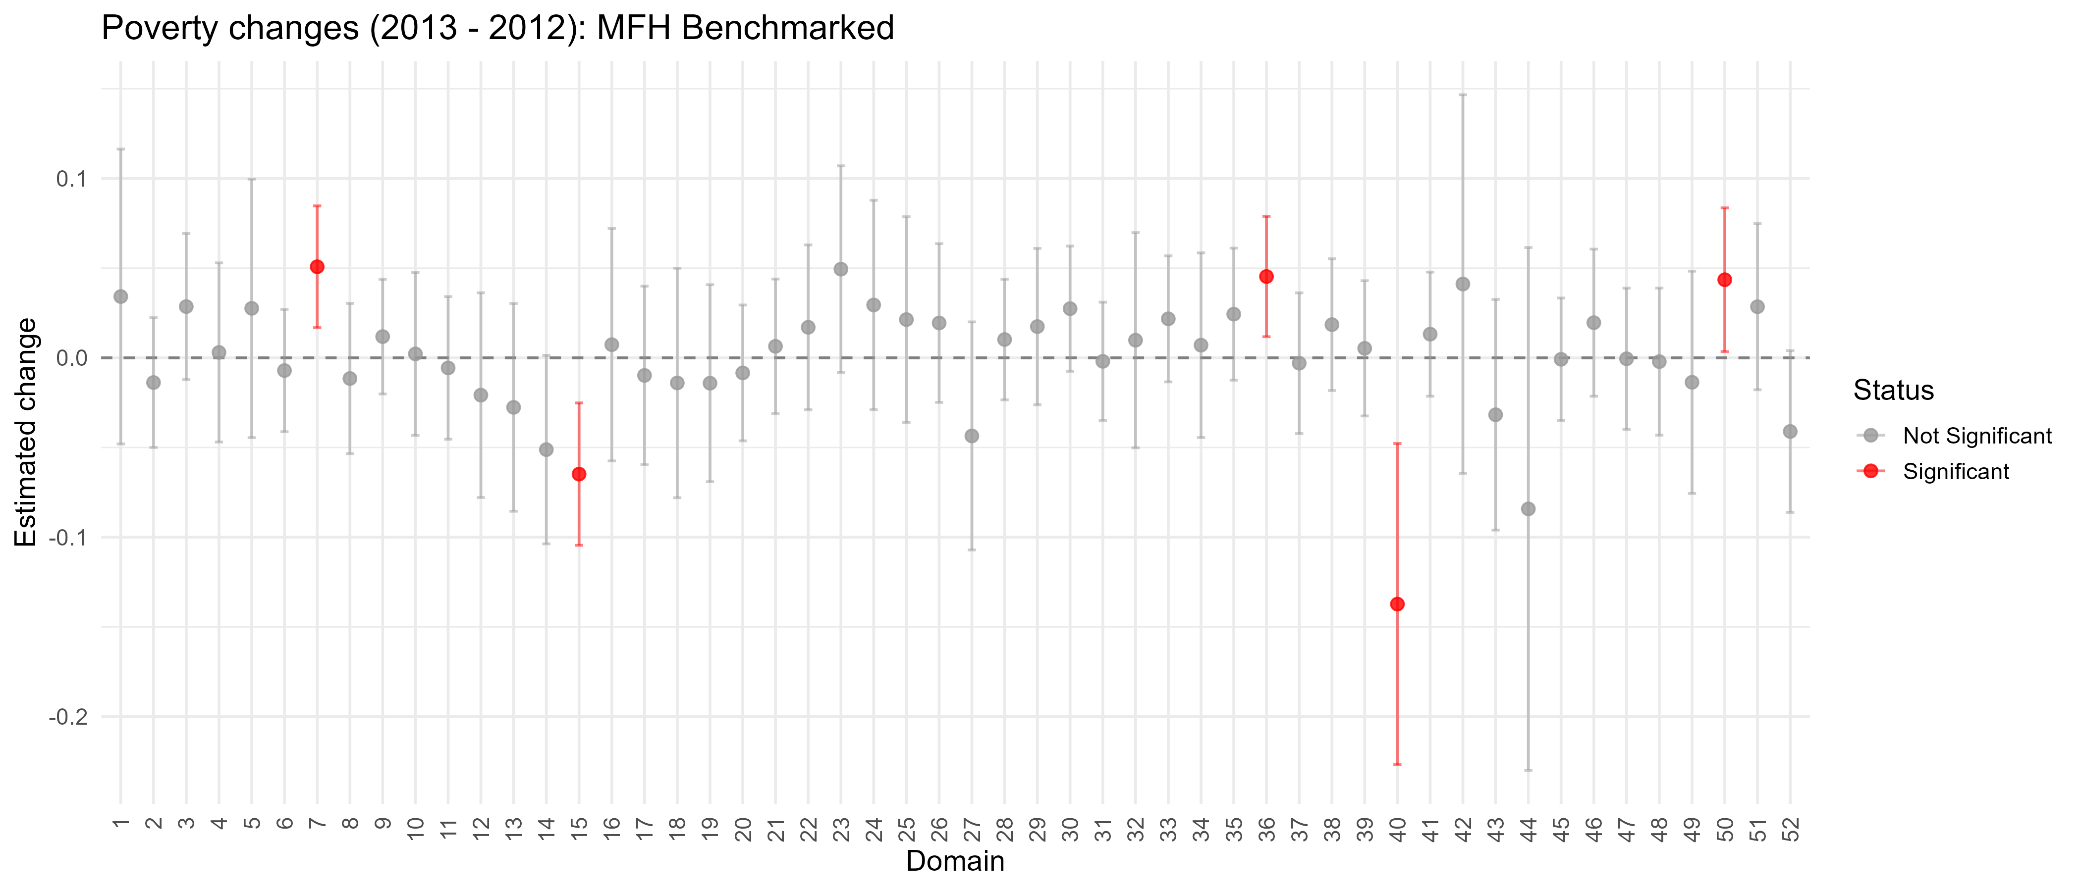
Figure 6. Earlier-run illustration of benchmarked MFH poverty changes and pointwise significance, 2012–2013. Rerun the revised estimator and joint uncertainty before interpreting significance.

8.13 MFH outputs
The MFH stage should produce outputs that support both cross-sectional mapping and time-comparison analysis. These outputs should include:
- Area-year MFH estimates.
- Standard errors or MSEs.
- Coefficients of variation.
- Estimated changes between selected years.
- Standard errors and confidence intervals for changes.
- Significance flags for increases and decreases.
- Comparison tables with direct and UFH estimates.
- Model diagnostics.
- Selected covariates.
- Estimated covariance or correlation parameters.
- Maps by year.
- Maps of changes over time.
- Maps of statistically significant changes.
- Output files for the comparison stage.
MFH outputs should retain direct and UFH estimates alongside MFH estimates. This lets users assess whether MFH substantially changes the results and whether those changes are justified by the model and data.

8.14 MFH checklist
Before accepting MFH results, users should confirm that:
- Two or more comparable survey years are available.
- Domain definitions are consistent across years or have been harmonized.
- Welfare variables and poverty lines are comparable across years.
- Direct estimates and sampling variances have been reviewed for all area-year cells.
- Auxiliary variables are available and comparable across years.
- The selected MFH variant converged successfully.
- The estimated time correlation is plausible.
- Random-effect variances are plausible.
- Residuals and random effects do not show major problems.
- MFH estimates are compared with direct and UFH estimates.
- Large differences between UFH and MFH estimates are investigated.
- Time trends are plausible in light of the country context.
- Covariance assumptions have been reviewed.
- Sensitivity checks have been conducted where feasible.
- Estimated changes are reported with standard errors and confidence intervals.
- Maps of changes distinguish statistically significant and non-significant changes.
- Limitations are documented.
MFH results should be treated as provisional until these checks have been completed. When diagnostics are weak, or results are highly sensitive to reasonable model choices, MFH should not be used as the preferred estimate without further review.

Section 9
Comparing UFH and MFH Results

9.1 Purpose of the comparison stage
The comparison stage is central to quality assurance. UFH and MFH estimates should not be accepted simply because the models run successfully. They should be compared with each other and with the direct estimates to assess whether the final results are credible, stable, and suitable for reporting.
Direct estimates provide the survey-only evidence. UFH estimates show the cross-sectional model-based results for each year. MFH estimates show the model-based results when information is borrowed across both areas and time. Comparing the three helps users understand how much each modeling step changes the results and whether those changes are reasonable.
The comparison stage should answer four practical questions:
- Are the model-based estimates broadly consistent with the direct survey evidence?
- Do UFH and MFH improve precision without producing implausible estimates?
- Does MFH improve time comparability relative to separate UFH models?
- Are the final recommended estimates robust enough for mapping, reporting, and policy use?
If the answer to any of these questions is unclear, users should review the input data, model specification, covariance assumptions, and diagnostics before finalizing results.

9.2 Why comparison is necessary
MFH should not be accepted mechanically as the preferred estimate. Although MFH can improve stability over time, it also imposes additional assumptions about the relationship between years. These assumptions are useful when supported by the data. However, they can be misleading if the input data are not comparable across years or if the estimated temporal correlation is implausible.
Comparison is especially important when the number of areas is small; direct estimates are noisy; many areas have small sample sizes; covariates are weak or unstable; domain definitions changed over time; welfare variables or poverty lines are not fully comparable across years; MFH and UFH estimates differ substantially; some areas show large estimated changes over time; MFH produces very smooth or very volatile trends; or model outputs are sensitive to covariance assumptions or model variants.
In these cases, comparison helps determine whether MFH adds useful information or imposes a structure that is not adequately supported by the data.

9.3 Main dimensions of comparison
The comparison should cover both point estimates and uncertainty measures. Users should review the following dimensions.
Point estimates. Compare direct, UFH, and MFH estimates by area and year. Large differences should be investigated, especially when the direct estimate is precise.
Standard errors and coefficients of variation. Compare uncertainty measures across direct, UFH, and MFH estimates. Model-based estimates should usually reduce uncertainty, but large gains in precision should be checked to ensure they are not driven by implausible model assumptions.
Precision gains. Assess whether UFH and MFH improve precision relative to direct estimates, particularly in areas with small samples or high direct-estimate CVs.
Area rankings. Review whether rankings change substantially across direct, UFH, and MFH estimates. Rankings should be interpreted cautiously when confidence intervals overlap.
Maps.
Compare maps of direct, UFH, and MFH estimates. Maps can reveal spatial patterns, outliers, or discontinuities that are not obvious in tables.
Uncertainty maps. Compare CV maps, standard error maps, or confidence-interval-width maps. These maps show where estimates are strong and where they remain uncertain.
Time trends. Compare UFH and MFH trends for each area. MFH should reduce noise-driven instability, but it should not eliminate genuine changes.
Estimated changes. Compare changes over time using UFH and MFH estimates. Changes should be accompanied by standard errors and confidence intervals.
Statistical significance of changes. Review whether estimated increases or decreases are statistically meaningful. Change maps should distinguish significant changes from changes that are not statistically significant.
Benchmark consistency. If benchmarking is used, compare estimates before and after benchmarking and check whether the adjustment materially changes results.
Diagnostic flags. Review areas with large model adjustments, high uncertainty, unstable trends, outlier residuals, or sensitivity to model settings.

9.4 Comparing direct and UFH estimates
The comparison between direct and UFH estimates shows how much the cross-sectional model changes the survey-only evidence. This comparison should be conducted separately for each year.
Users should expect larger differences between direct and UFH estimates in areas where direct estimates have high sampling variances. Smaller differences are expected in areas where direct estimates are precise.
Large differences between direct and UFH estimates may be acceptable when the direct estimate has a large standard error or high CV; the area has a small sample size; the auxiliary variables strongly indicate a different poverty level; neighboring or similar areas show a consistent pattern; or the UFH estimate remains plausible in the country context.
Large differences require further review when the direct estimate is precise; the UFH estimate strongly conflicts with the direct evidence; the selected covariates are weak or difficult to interpret; the area is an outlier in the residual diagnostics; or the model produces implausible spatial patterns.
The objective is not for UFH to reproduce direct estimates exactly. The objective is for UFH to improve precision while remaining anchored in the survey evidence.

9.5 Comparing UFH and MFH estimates
The comparison between UFH and MFH estimates shows the effect of borrowing strength across time. This comparison is especially important when MFH is being considered as the preferred estimate for trend analysis.
If UFH and MFH estimates are similar, this increases confidence that the time-correlation structure is not materially changing the results. If MFH is smoother than UFH, this may indicate that MFH is reducing sampling noise over time. This is often desirable when direct estimates are noisy and year-to-year movements are implausibly volatile.
However, large differences between UFH and MFH should be investigated. Users should check whether direct estimates are noisy in the relevant areas or years, whether UFH estimates are unstable because each year is modeled separately, whether MFH is imposing excessive smoothness over time, whether a real shock or policy change may justify a large change, whether covariates are comparable and consistently measured across years, whether the estimated time correlation is plausible, and whether results are sensitive to the MFH variant or covariance option.
MFH should improve comparability over time, but it should not suppress genuine changes in poverty. If MFH removes changes that are supported by survey evidence, auxiliary data, and country context, users should revisit the model specification.
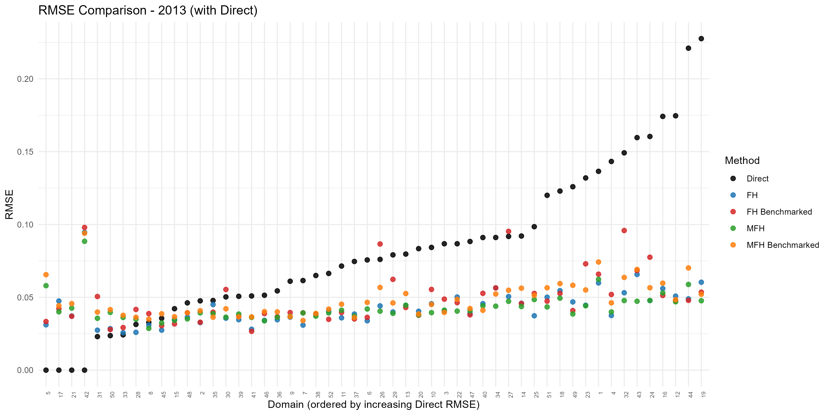
Figure 7. Earlier-run illustration of RMSE by method in 2013. These values predate the methodology revision and do not establish the current relative precision of Direct, UFH and MFH.

9.6 Interpreting differences among estimates
Differences among direct, UFH, and MFH estimates should be interpreted in light of sampling uncertainty, model assumptions, and the scale on which the model is estimated. In many applications, UFH estimates are obtained via an arcsine transformation, whereas MFH estimates are obtained without transformation. As a result, differences between UFH and MFH may reflect not only the use of intertemporal correlation in MFH, but also differences arising from transformation and back-transformation.
A useful interpretation framework is the following. When the direct estimate differs from the UFH or MFH estimate but has high sampling uncertainty, a model-based adjustment may be reasonable, as the direct estimate is relatively noisy. When the direct estimate differs from the model-based estimates and has low sampling uncertainty, users should carefully examine the model specification, covariates, and diagnostics. When UFH and MFH estimates are similar, the results are likely robust to both the modeling scale and the assumed treatment of time correlation. When MFH is smoother than UFH, this may reflect useful stabilization from borrowing strength over time. However, users should also consider whether part of the difference comes from the absence of transformation in MFH. When MFH differs sharply from UFH, users should review not only the covariance assumptions and model diagnostics but also whether the transformation used in UFH and the untransformed scale used in MFH contribute to the divergence. If MFH shows little or no change despite strong external or direct evidence of change, the model may be over-smoothing. Conversely, if MFH shows large changes that are not visible in the direct or UFH estimates, users should check whether the results are unstable, driven disproportionately by covariates, or affected by differences in modeling scale.
Users should avoid treating any single estimate as automatically correct. The preferred estimate should be selected only after reviewing the full pattern of evidence, including sampling errors, model diagnostics, covariate quality, consistency over time, transformation choices, and country-specific knowledge.

9.7 Choosing final estimates
The choice between UFH and MFH should be guided by the objective of the exercise and by empirical evidence on the error structure. When the evidence suggests that sampling errors or area effects are not correlated over time, UFH may provide an appropriate model-based estimate for a single-year poverty map. However, if diagnostics indicate meaningful intertemporal correlation, the single-year UFH model is likely to be misspecified for the relevant prediction problem. In that case, UFH may use an incorrect shrinkage structure because it treats each year separately and ignores information from other years.
MFH is therefore preferred when the objective is to produce poverty maps over multiple years and when evidence suggests intertemporal correlation is important. By modeling the covariance structure across years, MFH can produce year-specific predictors that better reflect the multiyear information structure. However, MFH also depends on its working model. If the multiyear covariance structure is poorly specified, implausibly estimated, or unstable, MFH may also fail to approximate the appropriate BLUP. For this reason, MFH should be used as the preferred estimate only when the input data are comparable across years, the model converges, the estimated covariance structure is plausible, and the results are robust to reasonable modeling choices.
When STFH estimates or predictions for area-years without direct estimates are available — for example, produced outside the current app — the comparison stage should include them in the same area-year structure used for direct, UFH, and MFH results. The comparison should include point estimates, MSE, RMSE, CV, maps, change estimates, and diagnostic flags. The objective is to assess robustness across alternative covariance structures and information sets, not to treat any single model as automatically preferred.

9.8 Recommended comparison tables
The comparison stage should produce tables that allow users to review estimates, uncertainty, and differences across methods. Recommended tables include:
TABLE XI
Recommended Comparison Tables
Table | Purpose
Direct, UFH, and MFH estimates by area-year | Shows all main estimates together.
Standard errors and CVs by method | Compares uncertainty across methods.
UFH minus direct differences | Shows cross-sectional model adjustments.
MFH minus UFH differences | Shows the effect of borrowing strength over time.
Estimated changes over time | Shows area-level changes between two years.
Confidence intervals for changes | Distinguishes meaningful changes from uncertain changes.
Diagnostic flags | Identifies areas requiring review.
Benchmark comparison | Shows the effect of benchmarking, if used.
These tables should be reviewed before maps are produced for publication. Maps are useful for communication, but tables are often better for diagnosing the size and source of differences.

9.9 Recommended comparison figures and maps
Figures and maps can help identify patterns that are difficult to see in tables. Recommended outputs include:
- Scatter plot of direct versus UFH estimates.
- Scatter plot of UFH versus MFH estimates.
- Scatter plot of direct versus MFH estimates.
- Maps of direct estimates.
- Maps of UFH estimates.
- Maps of MFH estimates.
- Maps of standard errors or CVs.
- Maps of estimated changes over time.
- Box plots of the estimated changes and of their RMSEs across domains, by method (Direct, UFH, UFH benchmarked, MFH, MFH benchmarked).
- Maps of statistically significant increases and decreases.
- Trend plots for selected areas.
When comparing maps over time, users should use common class intervals so that the same color represents the same poverty range in each year. Maps of changes should always be accompanied by uncertainty information.

9.10 Diagnostic flags for review
The comparison stage should identify areas that require additional review. Suggested flags include:
- Very small sample size.
- Missing direct estimate.
- Zero or one direct estimate.
- High direct-estimate CV.
- Zero, missing, or smoothed sampling variance.
- Large UFH-minus-direct difference.
- Large MFH-minus-UFH difference.
- Large estimated change over time.
- Statistically significant increase or decrease.
- Large change that is not statistically significant.
- Outlier residual.
- High final CV or wide confidence interval.
- Area affected by boundary changes.
- Area affected by known shock, conflict, disaster, or policy change.
These flags should not automatically exclude an estimate. They are intended to guide technical review and interpretation.

9.11 Documenting the comparison
The final report should explain how direct, UFH, and MFH estimates were compared and how the preferred estimates were chosen. The documentation should include the purpose of the comparison; the methods compared; the main differences among direct, UFH, and MFH estimates; the effect of MFH on time trends; the effect of benchmarking, if used; diagnostics reviewed; sensitivity checks conducted; areas or years requiring caution; and justification for the final recommended estimates.
A short narrative should accompany the tables and maps. For example, the report may state that MFH was selected as the preferred estimate because it improved stability over time, reduced uncertainty, and produced results broadly consistent with direct and UFH estimates. If some areas show large adjustments or high uncertainty, these should be explicitly noted.

9.12 Comparison-stage checklist
Before finalizing estimates, users should confirm that:
- Direct, UFH, and MFH estimates have been compared side by side.
- Standard errors, CVs, and confidence intervals have been reviewed.
- Large differences between direct and UFH estimates have been investigated.
- Large differences between UFH and MFH estimates have been investigated.
- Estimated time trends are plausible.
- Change estimates include standard errors and confidence intervals.
- Statistically significant and non-significant changes are clearly distinguished.
- Maps use consistent class intervals across years.
- Uncertainty maps are reviewed alongside point-estimate maps.
- Diagnostic flags are reviewed.
- Sensitivity checks are documented.
- The preferred estimate is justified.
- Limitations are clearly stated.
The comparison stage should be completed before producing final maps and before recommending estimates for publication or policy use.

Section 10
Preparing Poverty Maps

10.1 Mapping estimates
A poverty map is produced by joining the small-area estimates to the geographic boundaries on the shared area code and shading each area by its estimated poverty. The join is only as good as the consistency of the area codes (Section 4.2); a single mismatched code leaves an area blank or, worse, mislabeled. The Workbench performs this join automatically using the geometry supplied at upload and produces the maps with every run.
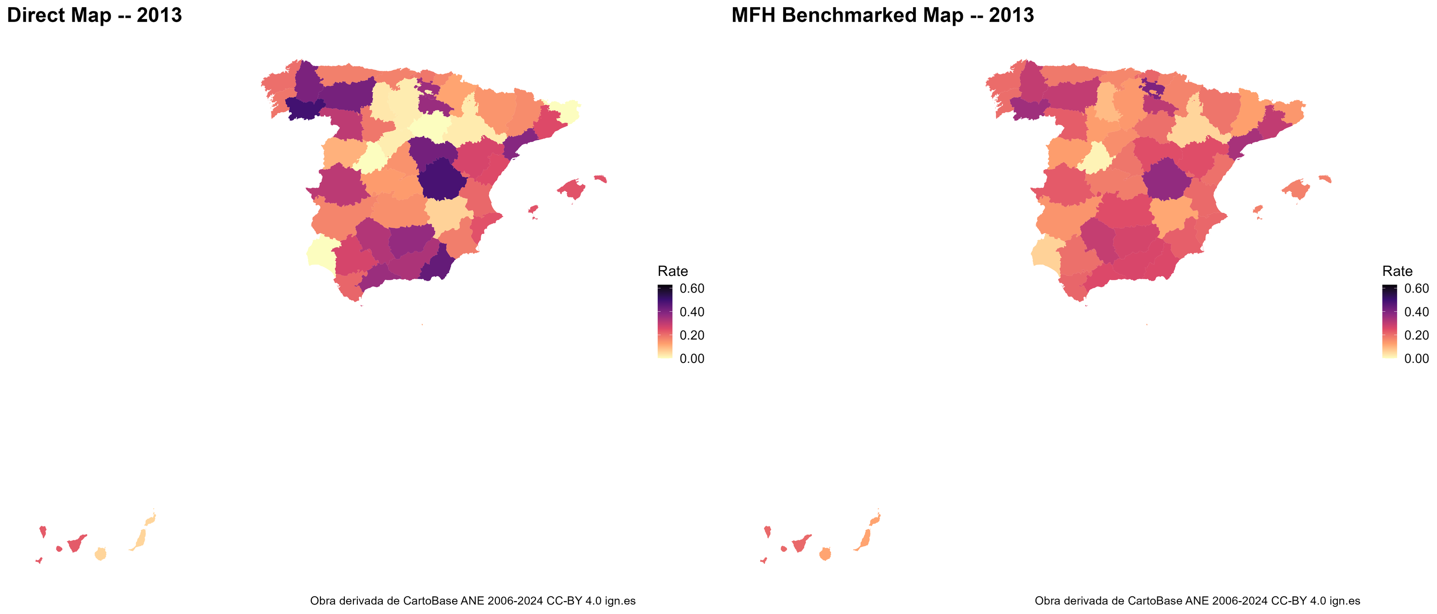
Figure 8a. Earlier-run maps of Direct and benchmarked MFH poverty in 2013, using a common color scale. Smoothness alone does not establish greater accuracy. Regenerate current estimates before use. Boundaries: Obra derivada de CartoBase ANE 2006-2024 CC-BY 4.0 ign.es.

10.2 Mapping uncertainty
A map of point estimates alone can mislead, because it gives every area the same visual authority regardless of how precisely it is estimated. Always accompany the estimate map with a map of uncertainty — typically the coefficient of variation, or alternatively the width of the confidence interval. Reading the two together shows not only where poverty is high but also where the evidence for it is strong, and it prevents readers from overinterpreting areas where estimates are imprecise.
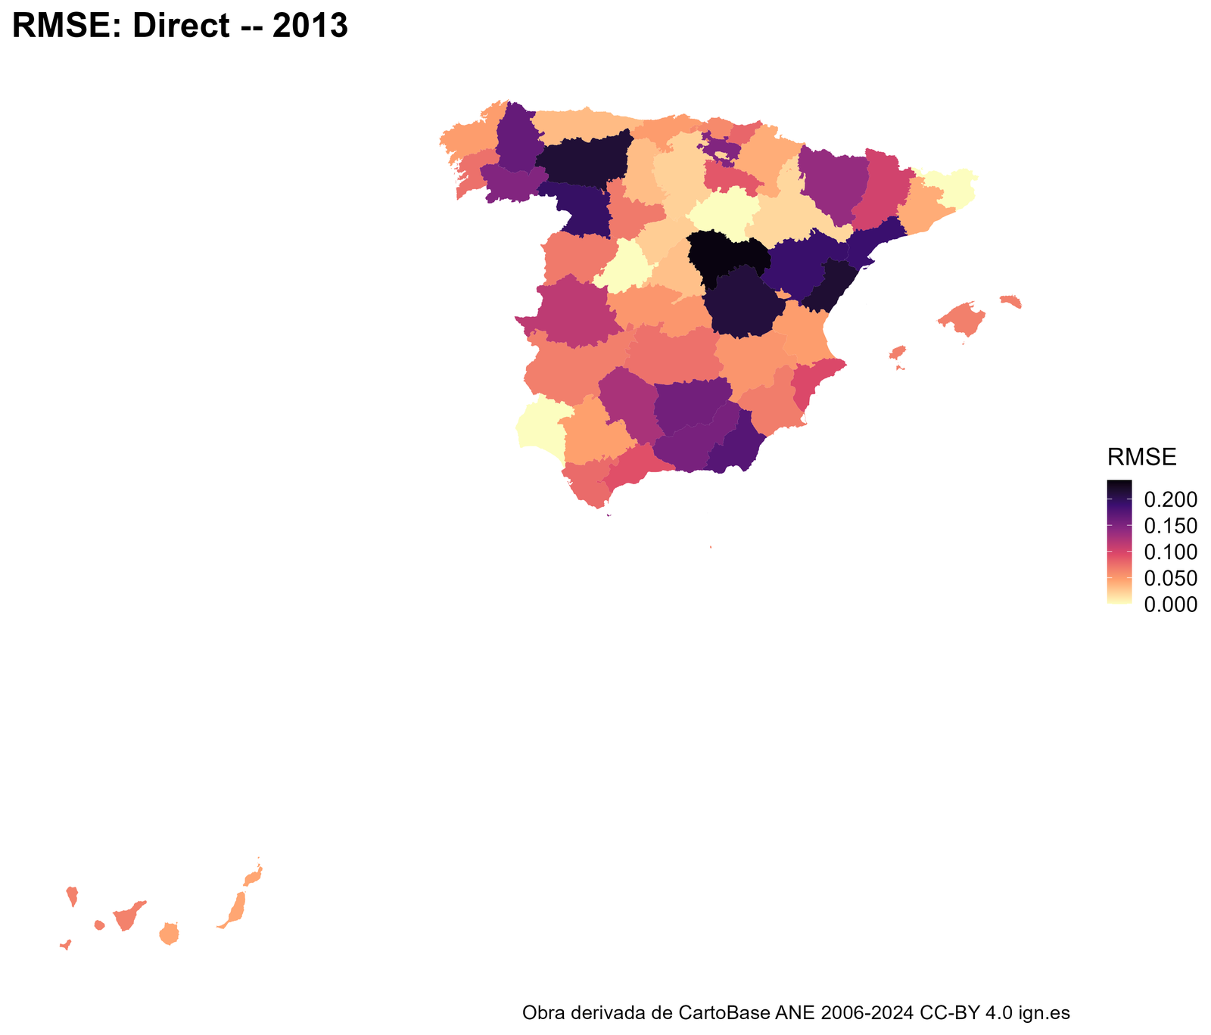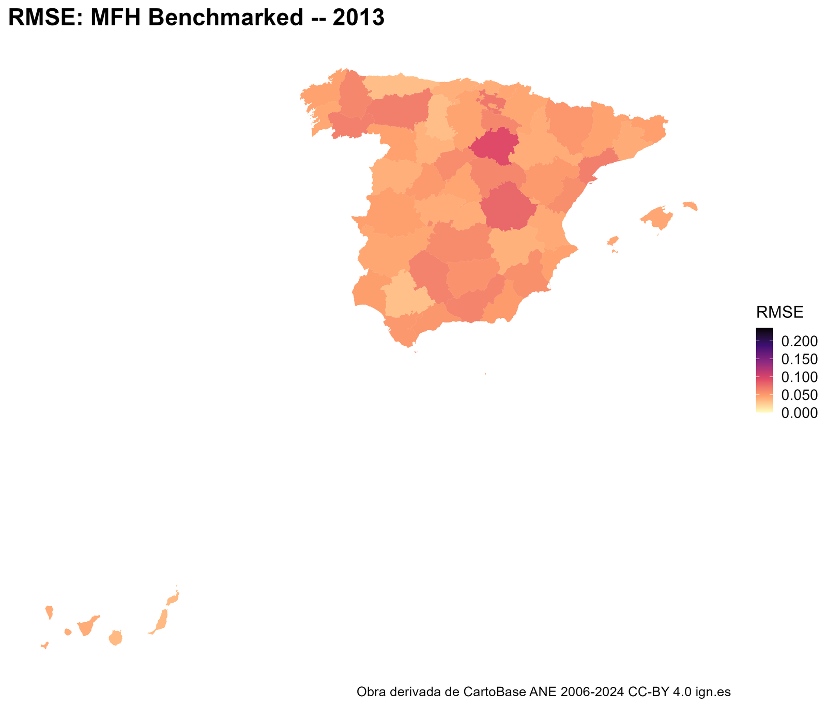
Figure 8b. Earlier-run Direct and benchmarked MFH RMSE maps for 2013. Current uncertainty must be regenerated with the revised estimator. Boundaries: Obra derivada de CartoBase ANE 2006-2024 CC-BY 4.0 ign.es.

10.3 Mapping changes over time
When two or more years are analyzed, a map of the change in poverty is often the most policy-relevant output. Such a map should distinguish statistically meaningful changes from those that are not: shading an area by its estimated change, without regard to significance, invites readers to see movement where there is only noise. The recommended practice is to map the change but to mark — by hatching, desaturation, or a separate significance map — those areas whose change is not distinguishable from zero under the test of Section 8.12. The Workbench produces both the change maps and the supporting significance assessment.
For mean welfare, the change maps show the percentage change of the mean (Section 8.12), and map titles and legends name the indicator rather than poverty.
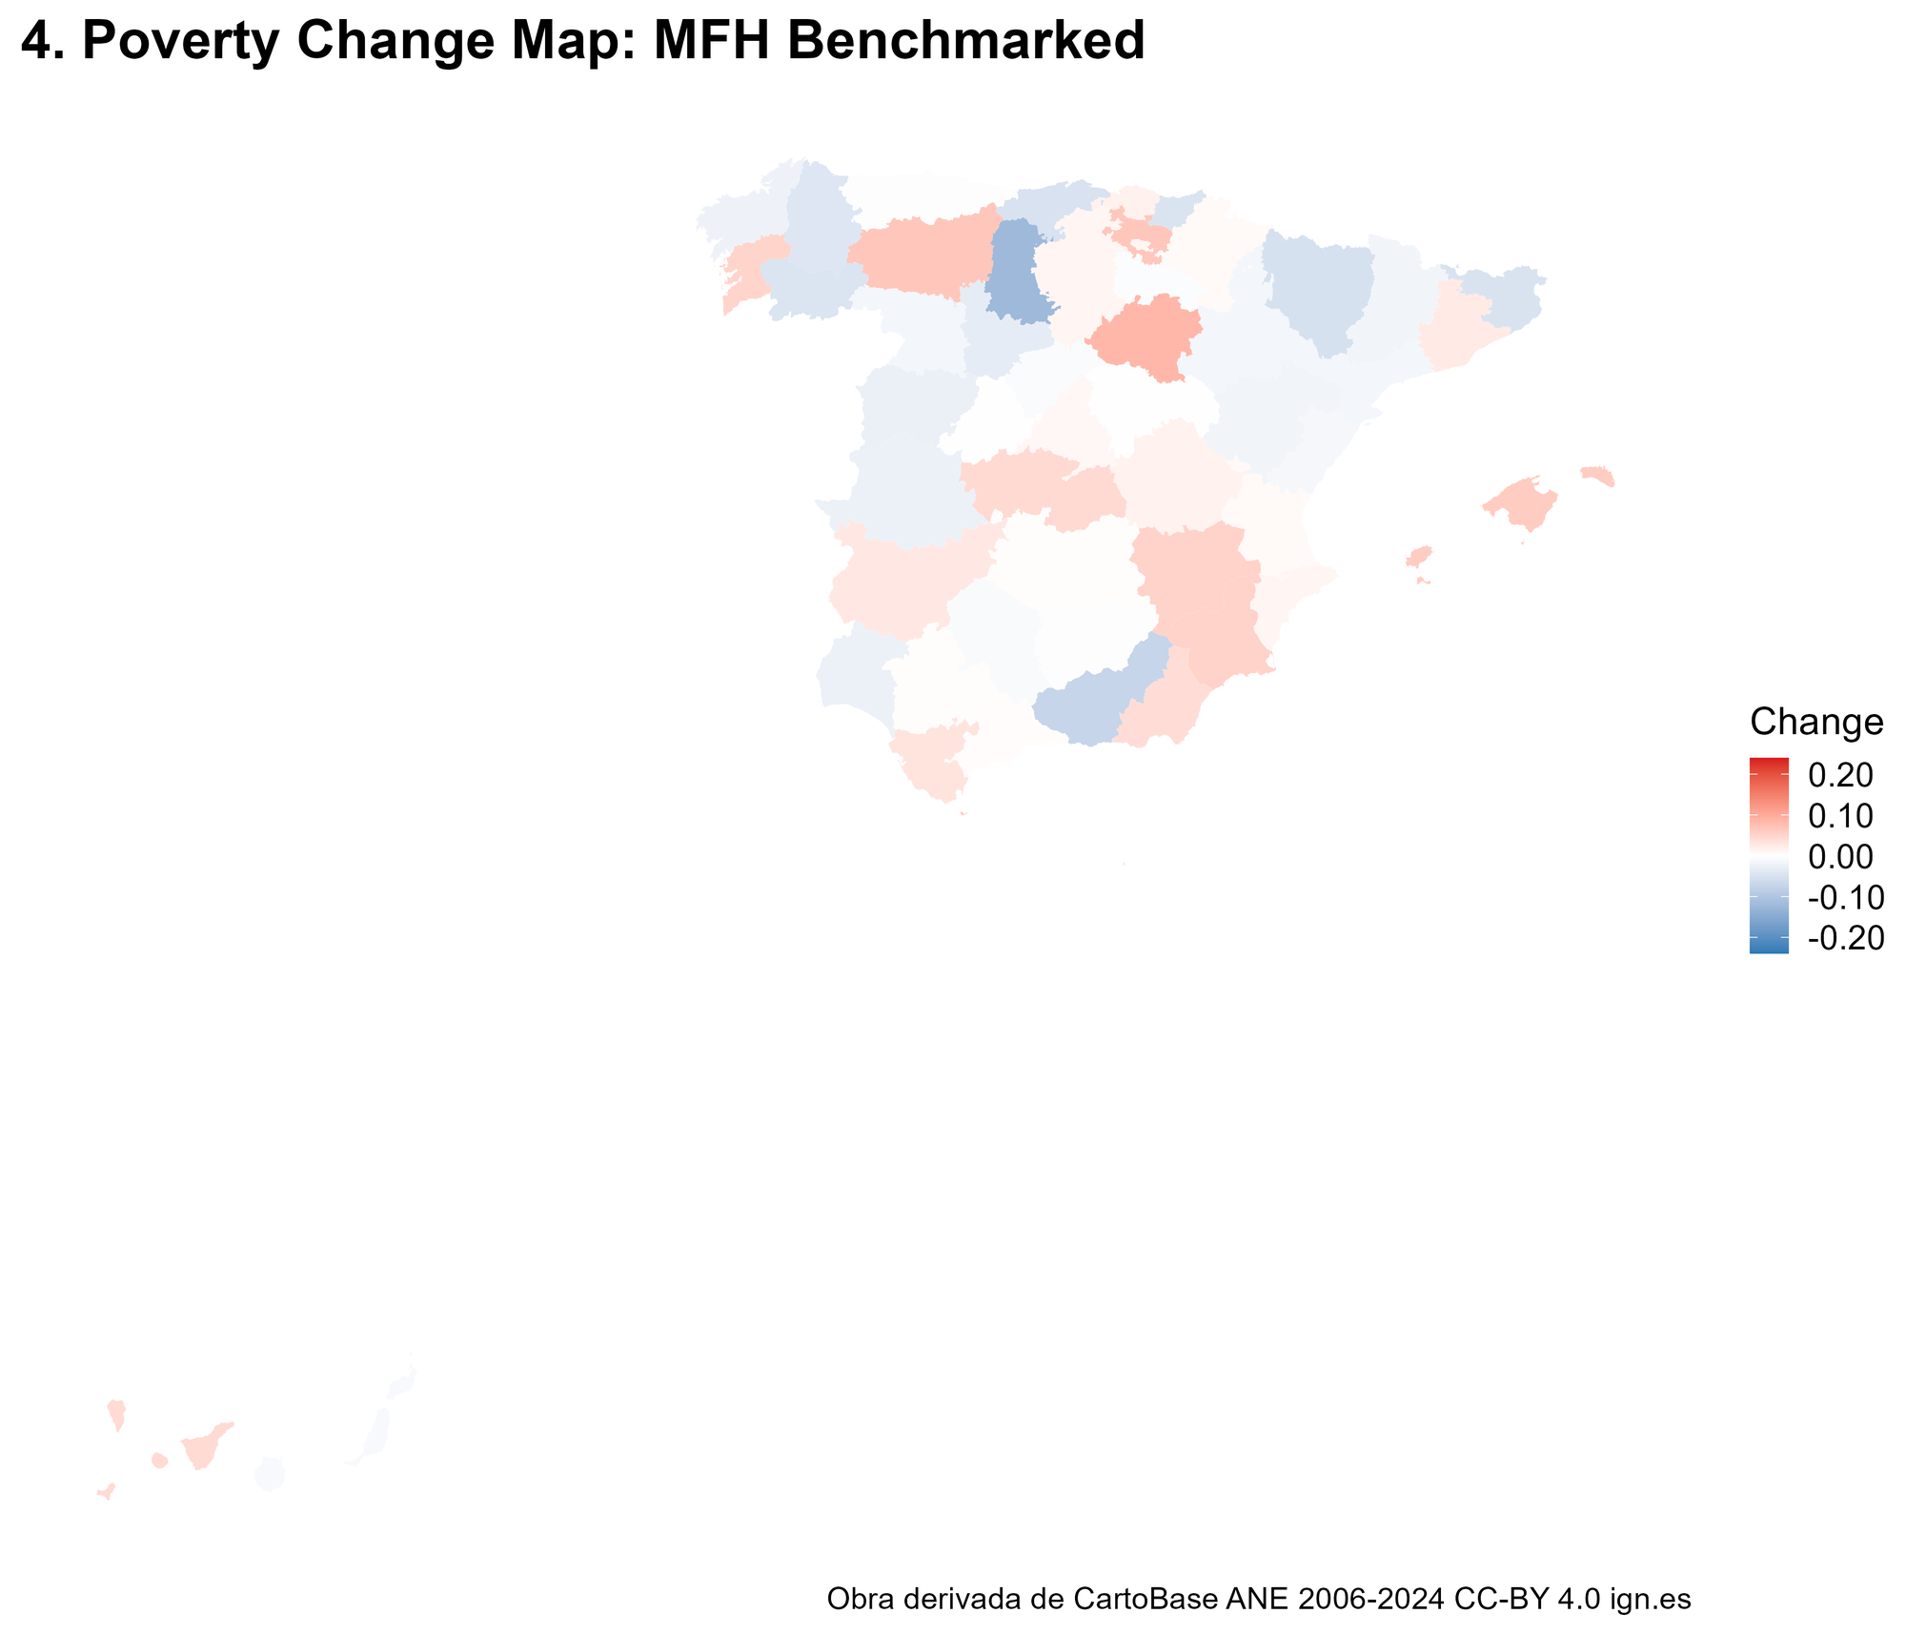
Figure 9. Earlier-run benchmarked MFH change map, 2012–2013. Blue denotes decreases and red increases. Rerun current estimates and uncertainty before drawing conclusions. Boundaries: Obra derivada de CartoBase ANE 2006-2024 CC-BY 4.0 ign.es.

10.4 Class intervals and legends
Use consistent class intervals across years and across methods. If the 2012 and 2013 maps, or the UFH and MFH maps for the same year, use different breaks or color scales, the reader cannot compare them visually and may perceive differences that are artifacts of the legend. Fix the intervals once — by a defensible rule such as quantiles of the pooled distribution, equal intervals, or substantively meaningful thresholds — and apply them to every map in the set. Choose a color ramp that is perceptually uniform and legible to readers with color-vision deficiency. The EU SAE Workbench applies this rule automatically on a continuous scale. In the final report, all poverty maps (every method and both years) share one legend range, all RMSE maps share another, and the poverty-change maps share one range centered on zero; the UFH and MFH step figures in outputs/figures use one range across both years within their own step. Level maps run from light (lower) to dark (higher) on the perceptually uniform magma scale; change maps run from blue (decrease) through white to red (increase).

10.5 Avoiding misleading maps
Three cautions recur. First, do not over-interpret small differences between areas whose estimates have overlapping confidence intervals. Second, beware the visual weight of large but sparsely populated areas, which can dominate a map while representing few people; a cartogram or a population-referenced reading can help. Third, never present a change map without conveying uncertainty. A poverty map is a powerful communication device precisely because it is read quickly and intuitively, which is also why a misleading one does damage quickly; the uncertainty information is not an optional technical addendum but part of the map’s honest meaning.

Section 11
Using the EU SAE Workbench
The guided version of the EU SAE Workbench takes you through the full workflow: direct estimation, UFH, MFH, comparison, benchmarking, maps, diagnostics, and reports. Sections 11.1 to 11.9 explain the general workflow from installation to retaining outputs. Read it once, then use one of the three examples in Sections 11.10 to 11.12 to set the indicator and price basis; Section 11.13 explains how to read the change outputs. The classic dashboard remains available, with the same settings on one page; the guided version is recommended for routine use. These instructions refer to application 5.2.0-rc.6-wizard.5.20 (w5p). The screenshots and worked examples retain historical w5o runs on Data/simulated (survey years 2022 and 2023). Displayed sm_out / rho_sm_out choices match the current defaults where GVF applies; numerical results are historical, and the UFH log variance selector is now available.

11.1 Installing and launching the Workbench
Install R 4.2 or later from https://cran.r-project.org/, using a current version approved by your organization. RStudio Desktop is optional. If you already use it and Pandoc is missing or too old, update it to the latest stable version compatible with your computer and restart the Workbench: https://posit.co/download/rstudio-desktop/. RStudio supplies Pandoc. HTML and Word reports require Pandoc 2.17 or later. The launcher reuses a compatible installed copy from RStudio, Quarto, Positron, or standalone Pandoc, or downloads a checksum-verified copy on first use. For offline use, install a compatible copy beforehand (https://pandoc.org/installing.html).
Download the package from https://github.com/Noboyoshida227/eu-sae-application/releases. Under Assets, choose the application ZIP and compare its SHA-256 with the release value. Extract the entire archive before launching. The release candidate is for review and testing; it is not an official World Bank Group product and is not approved for official statistics.
An AI API key is optional. No key is needed for direct, UFH, MFH, comparison, maps, or statistical reports. Step 5 explains how to connect an approved Claude or OpenAI provider or gateway when AI interpretation is wanted.
After extracting the archive, open the folder shown below. The guided version and the classic dashboard share the same validated analysis server and output structure.
EU_SAE_520_w5t/
|-- app_wizard.R # seven-step guided version
|-- app.R # classic dashboard and shared server
|-- Start_Here/Start_Wizard.bat # Windows wizard
|-- Start_Here/Start_Wizard.command # macOS/Linux wizard
|-- Start_Here/Start_Dashboard.bat # Windows classic
|-- Start_Here/Start_Dashboard.command # macOS/Linux classic
|-- install_packages.R # package installer
|-- R/ and scripts/ # validation, estimation and reporting
|-- tests/ # targeted checks
|-- outputs/ # initially empty output structure
|-- docs/guidance/ and docs/instructions/
|-- LICENSE, NOTICE and THIRD_PARTY_NOTICES.md
`-- release_manifest.csv # file sizes and SHA-256 checksums
After extracting the whole ZIP, open Start_Here. On Windows, double-click Start_Wizard.bat. On macOS, double-click Start_Wizard.command; if macOS blocks it, open System Settings → Privacy & Security and choose Open Anyway (macOS 15 or later), or Control-click the file and choose Open (macOS 14 or earlier). On Linux, run bash Start_Here/Start_Wizard.command from a terminal. The first launch checks required R packages and installs missing or outdated dependencies, so it needs an internet connection and may take several minutes. Keep the launcher or Terminal window open while using the Workbench. On the front page, select New model run to start from the default settings, or Load saved configuration to continue from a saved configuration (Section 11.2). See Start_Here/README.md for detailed macOS permission help.

Figure 10. The front page of the EU SAE Workbench. New model run opens Step 1 with the default settings; Load saved configuration restores a saved configuration and opens Step 6.

11.2 Navigation, configurations and the seven-step workflow
The row of step buttons shows the complete workflow: 1 Input data, 2 Map variables, 3 Configure analysis, 4 Configure model, 5 Add AI assistant, 6 Review configuration and 7 Run model. A green button marks a completed step, an amber button a step with outstanding items, and a blue button the current step. Use Next and Back to move in order, or select a step button to go to any step. Each step lists what is still missing, but you can continue; required fields carry a red asterisk. In the guided version, Run model becomes available once the three required data files are selected and two analysis years are chosen, but a run starts only after Check data readiness, in Step 6, has passed without an ERROR. Changing the survey, auxiliary, geometry, benchmark-target or population file, the variable mapping (including the survey unit and household ID), the analysis years, the poverty line, the indicator, the price settings of mean welfare (including the CPI file and index values), the transformation and back-transformation choices, LASSO, the seed, the bootstrap replicates, the steps to run, or the benchmarking choice and level resets that check. Some other changes, including the variance and covariance options, the MFH model choice, the covariate lists and the run label, do not, so run the check again after any change (Section 11.8). At execution entry, consumed population/target inputs are validated again before output cleanup. MFH requires supported Direct cells in both years; missing cells block that run. Unused optional paths do not block a run.
The settings form a model run configuration: the data files, the variable mapping, and the analysis and model settings. Save configuration records the present configuration and copies files selected with Browse to app_runs/_last_setup_files; a successful run also saves its configuration as the last saved configuration, replacing an earlier save. Load configuration restores the last saved configuration or a configuration file, such as the model_run_configuration.yml that every run stores in its folder under app_runs/; a configuration file must contain an inputs section. After loading, the guided version opens Step 6, Review configuration; both versions warn when a data file has changed since the configuration was saved. On the front page, Load saved configuration does the same. Reset to defaults (in the Load configuration menu of the guided version) returns the settings to their initial values and deletes the last saved configuration and the file copies in app_runs/_last_setup_files; configurations saved earlier, including those in run folders, then need their data files browsed again. Always review a loaded configuration before running, particularly the active files, years, indicator, model options, and benchmarking.
The estimation pipeline itself remains UFH, followed by MFH, followed by Comparison. The guided version changes how the settings are organized and reviewed; it does not introduce a second statistical implementation.

11.3 Step 1 - Input data
Step 1 collects the data files. The survey microdata, auxiliary covariates and geometry files are required and marked with a red asterisk; they can be in any folder. After a configuration is loaded, its files are listed under each Browse button; browse only to change one.
A domain-population file is optional; if it is absent, the app estimates domain populations from the survey as the sum of the population weights (Section 3.7). Survey and auxiliary inputs may be supplied in the supported R, delimited-text, Stata, SPSS, SAS, Parquet/Feather, or Excel formats. Geometry may be supplied as R data, a zipped ESRI shapefile, GeoPackage, GeoJSON, KML, or GML. Examples in Data/Spain/ and Data/simulated/ are for testing only; use approved local inputs for actual estimates.
For current-price welfare that will be converted to real welfare, select the optional Consumer price index file here, or plan to type the CPI values in Step 3. Use one country or territory and one row per calendar year, with a year column and a numeric CPI column. CSV or Excel are convenient formats; Step 3 selects the columns and CPI format. No CPI input is needed for welfare already in real prices. The file structure, year coverage, and format examples are in Section 11.12.3. Poverty runs, including anchored poverty, do not use the CPI input.
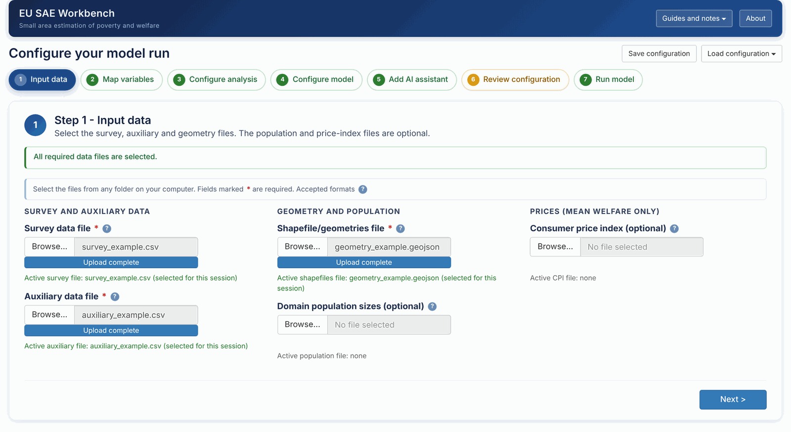
Figure 11. Step 1, Input data, with the three required files of the simulated example selected.

11.4 Step 2 - Map variables
Map year, domain, PSU and weight in the survey, and strata when they are part of the design. Under Each row of the survey file is, choose a household or a person. With a household, map household size: the app uses population_weight = weight x household size for direct estimates. With a person, household size is not used and the person weight is used as it is; do not choose a household for a person-level file, which would count each person once per household member (Section 4.6). An optional household ID lets the readiness check (Test 0f) confirm the choice. Map welfare and confirm that it is already per capita or equivalized as required. Then map the auxiliary domain key and the geometry domain field.
The selectors can be searched, and a column name can also be typed directly. A red field means that the current name is not found in the relevant data set. Do not continue merely because a name looks plausible: confirm that the mapping summary says all required columns are mapped and that the domain keys use the same coding system.
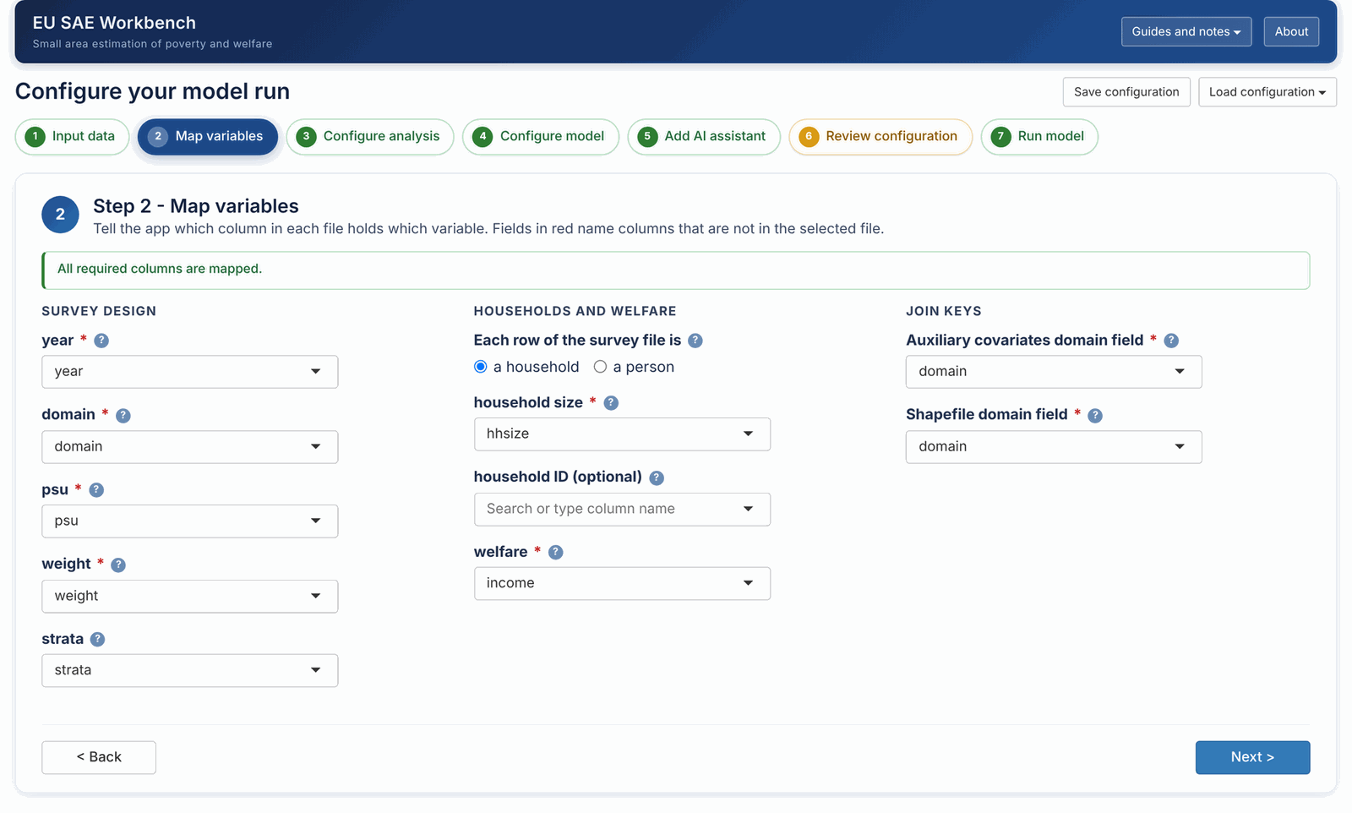
Figure 12. Step 2, Map variables: survey design, households and welfare, and join keys.

11.5 Step 3 - Configure analysis
Choose the two analysis years from the years found in the survey file, which the step lists. Analysis years are the survey years used in the files and output labels, even when incomes refer to the preceding calendar year. Enter the optional country or territory label, used only in report titles, and the reproducibility seed. The seed controls LASSO folds and bootstrap draws; use a recorded value such as 123 for reproducibility.
Then choose the indicator. Poverty (FGT) uses welfare and a poverty line; select FGT(0) for headcounts, FGT(1) for the poverty gap, or FGT(2) for poverty severity. Mean welfare uses the welfare variable directly and hides the poverty-line and FGT controls. Enter a currency label for mean welfare. The examples below focus on FGT(0) headcounts and real mean welfare.
For poverty, select Column in data and map the actual poverty-line column, or select Numeric value and enter a positive line for each analysis year. Welfare and the line must match in currency, time unit, welfare concept, and price basis. Section 11.10 applies year-specific lines; Section 11.11 applies supplied anchored lines.
For real mean welfare, choose the route that matches the input: constant (real) prices already: no price index needed, or current prices: convert with a price index. The optional price-year label in the first route does not perform a conversion. The default, current prices: no conversion (changes include inflation), produces nominal results. Change that default when real welfare is the objective.
When converting, choose whether CPI values are typed in or read from the Step 1 file, specify the income reference period, select the CPI format, and choose the price base year. Confirm that the displayed values cover all required years before continuing. Section 11.12 gives both real-welfare routes, the CPI formats, and a worked calculation.
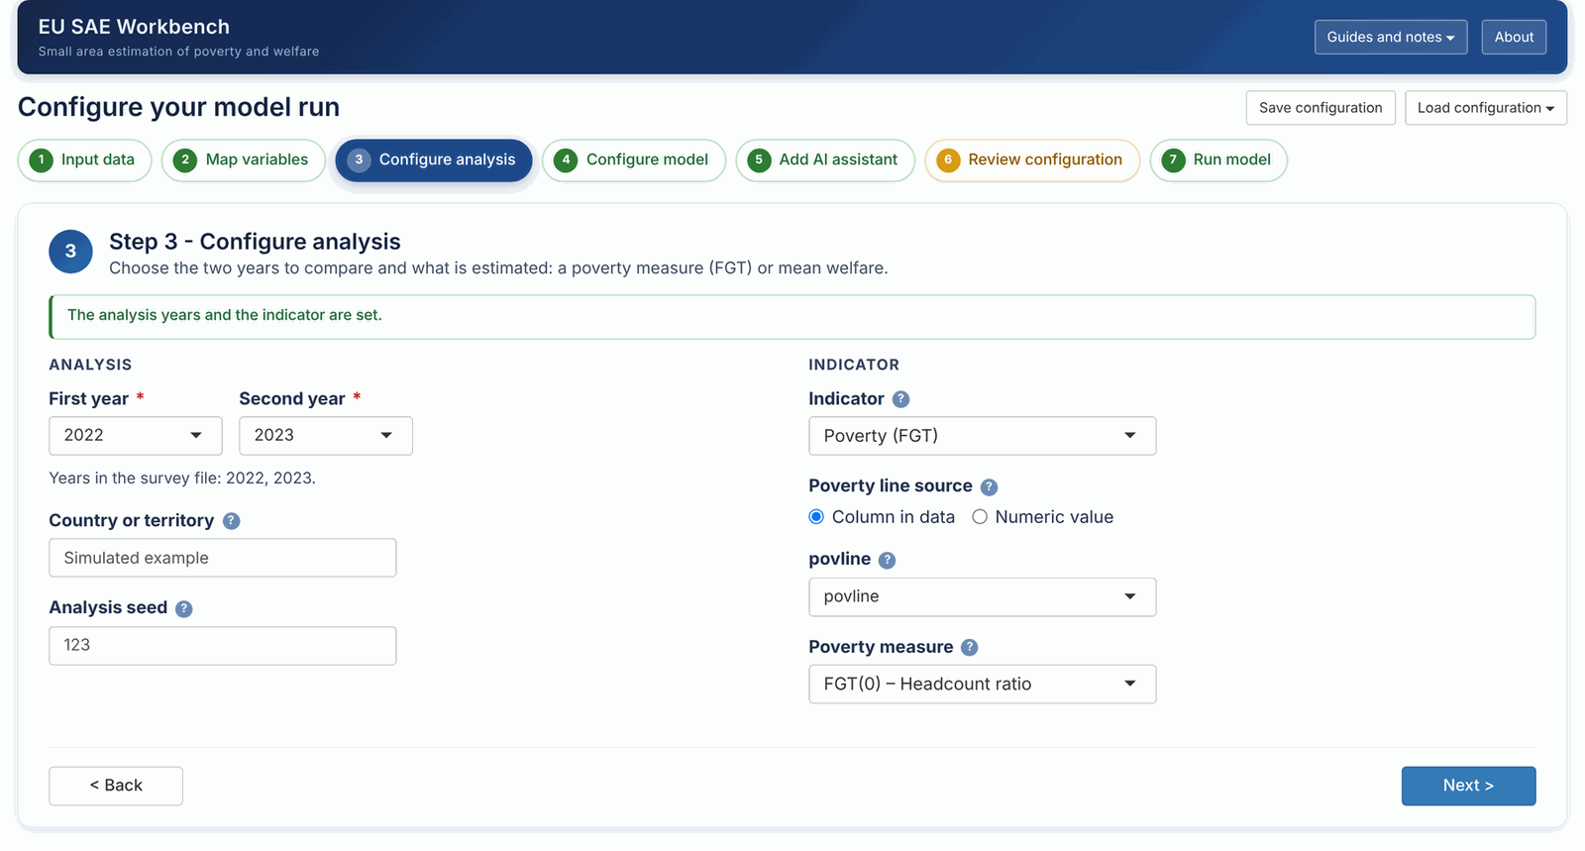
Figure 13. Step 3, Configure analysis: the two analysis years, country label and seed, and the indicator, poverty-line source and FGT measure.
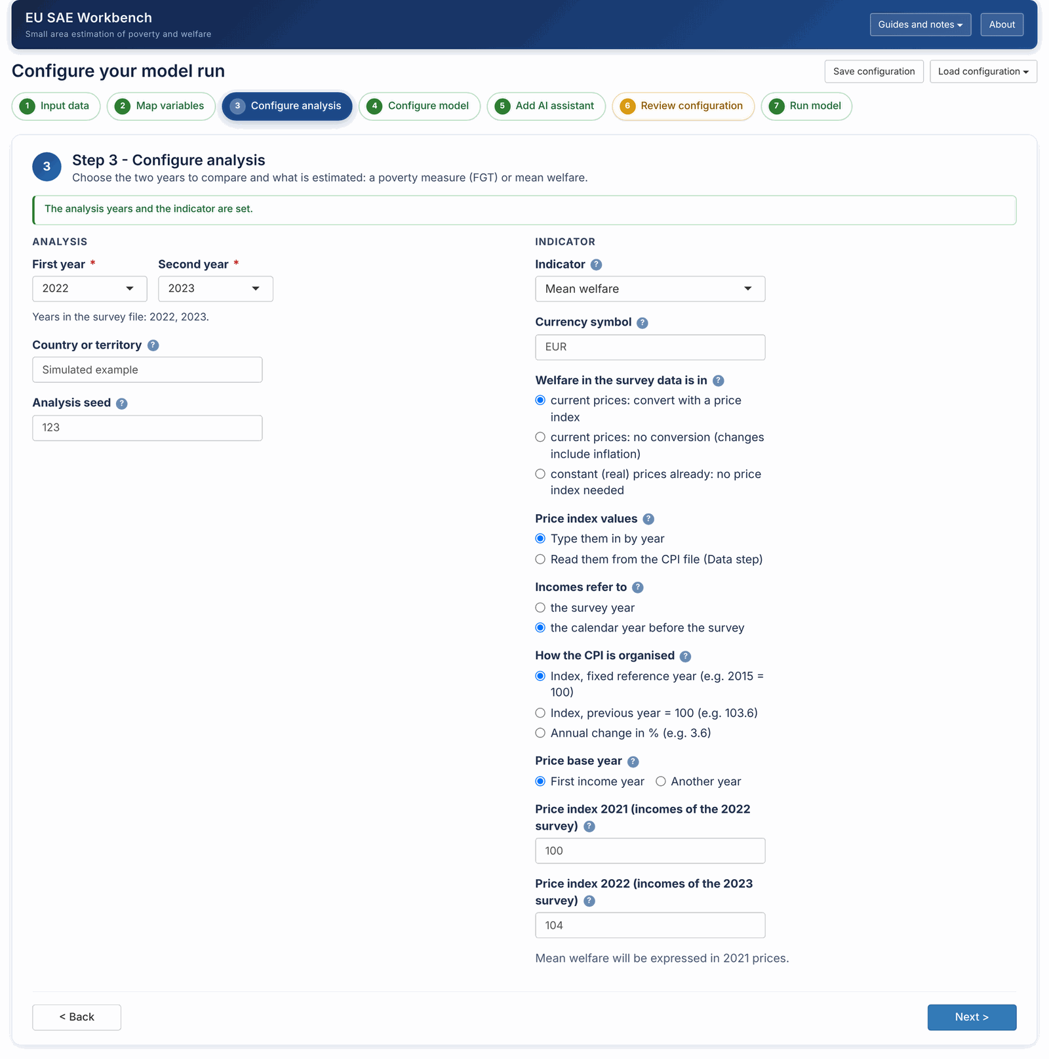
Figure 13b. Step 3 for mean welfare converted with a price index: prices of welfare, price index source, income reference period, CPI organisation, price base year and index values.

11.6 Step 4 - Configure model
Leave UFH, MFH, and Comparison selected for a complete run. For UFH, choose the context-dependent transformation (arcsin or no transformation for FGT(0) headcounts, no transformation for FGT(1) and FGT(2); log or no transformation for mean welfare), the associated bias correction, AIC or BIC, optional LASSO screening, and optional year-specific covariates. With no transformation or log, also choose sm_out (the default), sm_all, or direct sampling variances. With LASSO enabled, a year-specific covariate list is the screening pool; with LASSO disabled, it is the fixed specification.
Log mean welfare uses the log of the survey-weighted arithmetic Direct area mean, with sampling variance V/mean². Zero and negative individual welfare values remain in the arithmetic mean; the area mean must be positive and finite. UFH bias correction uses native emdi Slud–Maiti bc_sm with ML fitting and its original-scale analytical MSE. The naive option exponentiates the same fitted log-area mean and uses bootstrap MSE; it does not change the target into a geometric mean. MFH uses its separate conditional-lognormal correction, described in Annex G.4. Check the recorded method after loading an older configuration.
For MFH, review covariates, selection criterion, LASSO, variance and compatible sampling-covariance options, model, variance-test adjustment and bootstrap count. Poverty uses the identity scale. Mean welfare can use log with conditional-lognormal correction. MFH2 remains default; selecting MFH3 tries it first and retains it only after numerical checks and adjusted variance-test support. Also fit MFH3 adds a comparison fit without changing the selected model.
Benchmarking is off by default. To enable it, tick Apply benchmarking and choose National, or Grouped by a survey variable and map the grouped benchmark variable; with grouped benchmarking, each domain must belong to exactly one group in the analysis years (Test 0g; Section 3.8). An external target file is optional; the app otherwise derives survey targets. Mean-welfare targets must have the same input prices as survey welfare; CPI conversion, when selected, converts both (Section 3.8). Choose the cross-year PSU design from the survey documentation. Same PSUs across years uses the selected covariance option. Independently sampled surveys use year-specific designs and zero sampling covariance. With Not specified, MFH does not run; to run UFH alone, select only UFH, because Comparison needs both models. Identical code values alone establish neither linkage nor independence.
Bootstrap replicates defaults to 500 and applies to UFH bootstrap MSE, MFH MSE/MCPE and both benchmark paths. Explicit older saved counts are retained; check the restored value. The Step 6 summary flags counts below 500. More draws reduce Monte Carlo error but do not guarantee coverage. Pointwise significance remains primary; BH and Bonferroni are supplementary sensitivities.
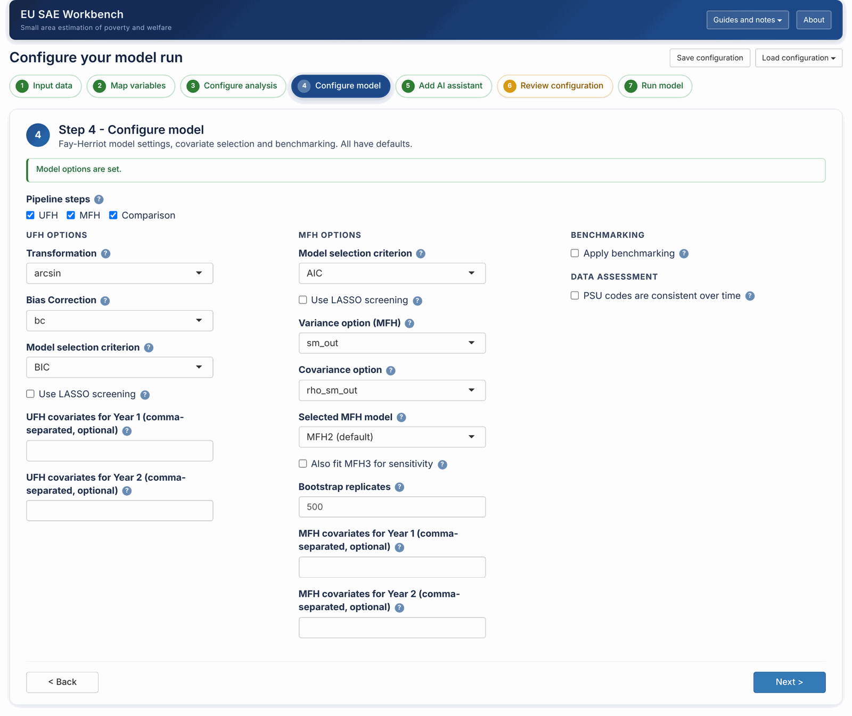
Figure 14. Step 4, Configure model: pipeline steps, UFH and MFH options, benchmarking and the cross-year PSU design (the screenshot shows the earlier checkbox), with the default settings for poverty (500 bootstrap replicates).

11.7 Step 5 - Add AI assistant (optional)
AI is off by default, and the statistical analysis runs identically when it remains off. Enable it only when an institutionally approved provider or gateway is available. Before entering a key, separately acknowledge the external transfer and select the interpretation language. The supplied code does not send household microdata and removes geographic identifiers from comparison prompts, but prompts may still contain unpublished aggregate estimates, uncertainty measures, diagnostics, and counts.
When requested, AI sections are saved in outputs/data/ai_interpretations.rds with provider, model, timestamp, language and generated/failed/disabled status. Both report formats include AI recommendation on UFH or MFH: an advisory recommendation grounded in available aggregate diagnostics, precision and change uncertainty, distinguishing levels from changes where appropriate. Missing or weak evidence and boundary-sensitive or unavailable uncertainty qualify the advice; no firm preference may be justified. It never reruns estimation or switches the fitted model. Failed sections remain visible. Numeric-provenance checks are warning-only; human review is required before dissemination. Section 13.5 explains what the AI interpretations and recommendation contain, how they are produced and how to review them.
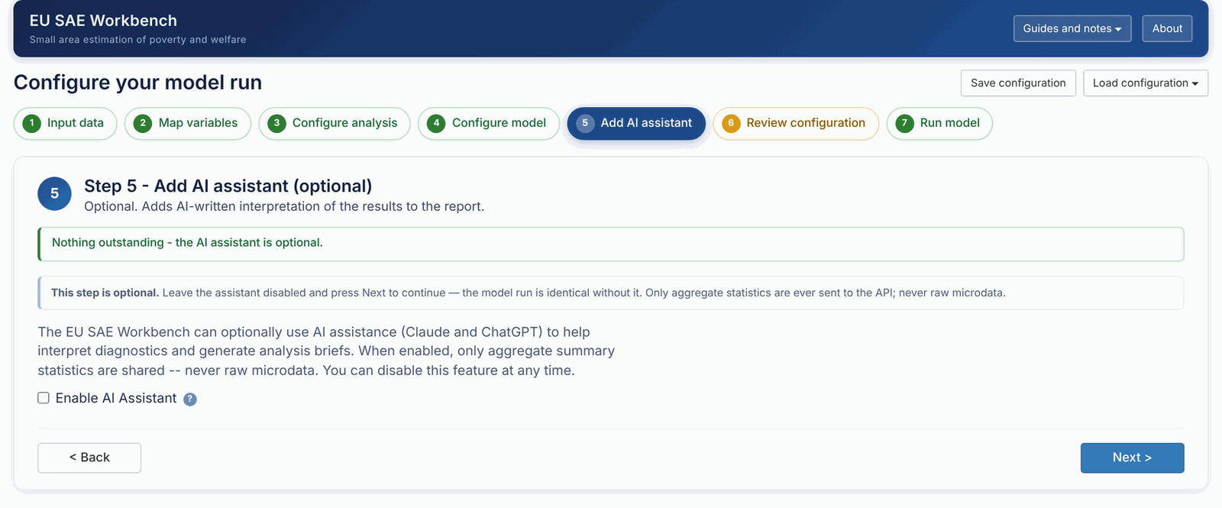
Figure 15. Step 5, Add AI assistant: the optional assistant in its default off state.

11.8 Steps 6 and 7 - Review configuration and Run model
Step 6 shows the configuration summary, the data files of the configuration and whether data readiness has been checked for the current configuration. The summary repeats the active files, mapping (including the survey unit), years, indicator, the price basis of mean welfare (with the CPI file, when used), UFH and MFH choices, benchmarking, PSU assessment, bootstrap count, and AI status. Return to the relevant step when any entry is unexpected. The Preflight tab checks the project root, report-rendering dependency, years, required input files, and spatial dependency.
Press Check data readiness, which must pass without an ERROR before the model can run. The readiness assessment checks required columns, the analysis years, population weights, domain consistency, missing direct estimates and sampling variances, national indicator totals, and auxiliary-variable summaries. Test 0f reports the weighted population total and, with a household ID, whether the rows match the chosen survey unit; with grouped benchmarking, Test 0g checks that each domain belongs to one benchmark group. For each auxiliary covariate, the summary reports its mean, standard error and correlation with the target indicator, with the p-value of that correlation and significance codes, for each year and pooled; covariates are listed from the most to the least significant. Use these bivariate tests to screen candidates only: covariate selection happens in the models (Section 7.8). The readiness tables are saved in outputs/tables/ and kept with the run’s archive. Resolve, aggregate, exclude, or document problematic area-year cells before model estimation; the current workflow requires a valid direct estimate and sampling variance for each fitted cell.
In Step 7, Run model, enter an optional run label and press Run model. The run executes UFH, MFH, and Comparison in a separate R process. A progress panel shows the stages of the run with a progress bar, then the result, with buttons to open the report or the output folder and to view the configuration; after a failed or stopped run, the panel shows the reason and a button that opens the run folder. The run log, in a collapsible section, reports the current stage, model fallback conditions, and output locations. Only one model run at a time is possible. Stop ends the run; already-written files remain in outputs and the stopped run is not archived. Completed runs are archived under app_runs/<timestamp>_<run_label>/, with a copy of outputs/, the run log and model_run_configuration.yml. The current outputs folder is reused by later runs, so keep the archive or a separate copy. In the classic dashboard, 1. Check data readiness and 2. Run model are in the sidebar, and the Status tab shows the progress.
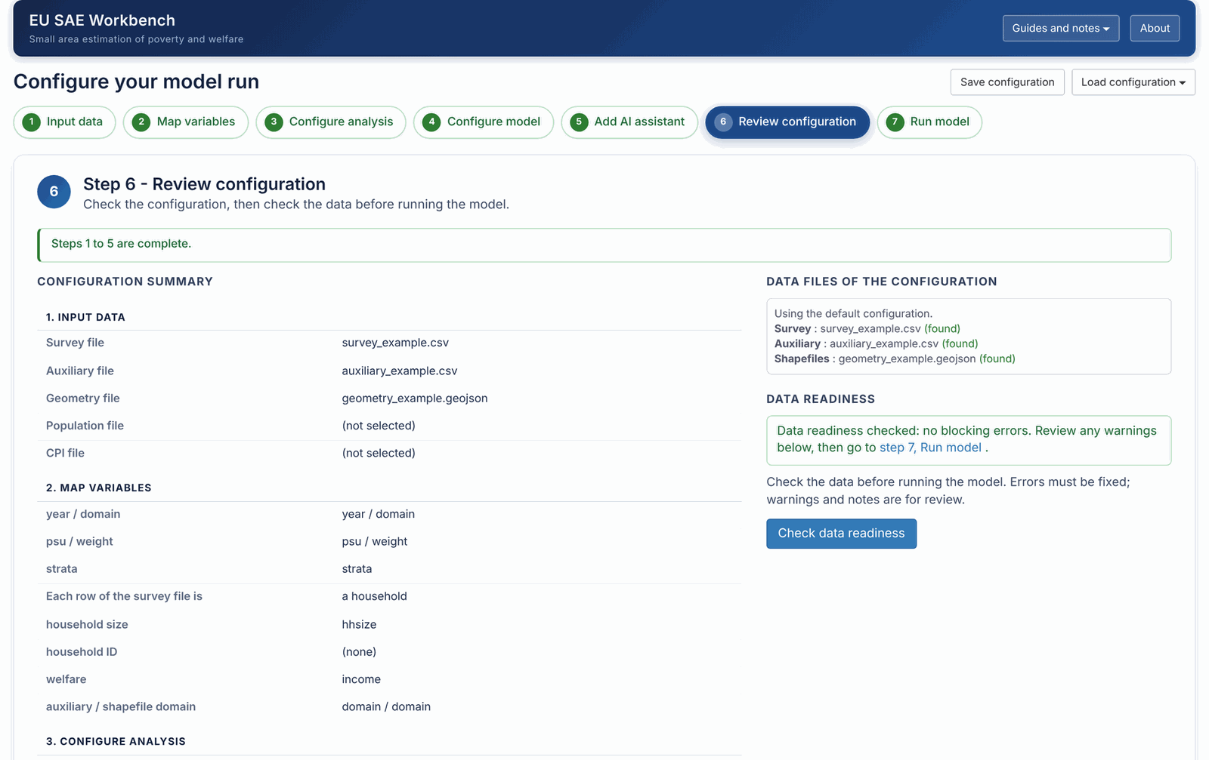
Figure 16. Step 6, Review configuration: the configuration summary, the data files of the configuration and the data readiness check.
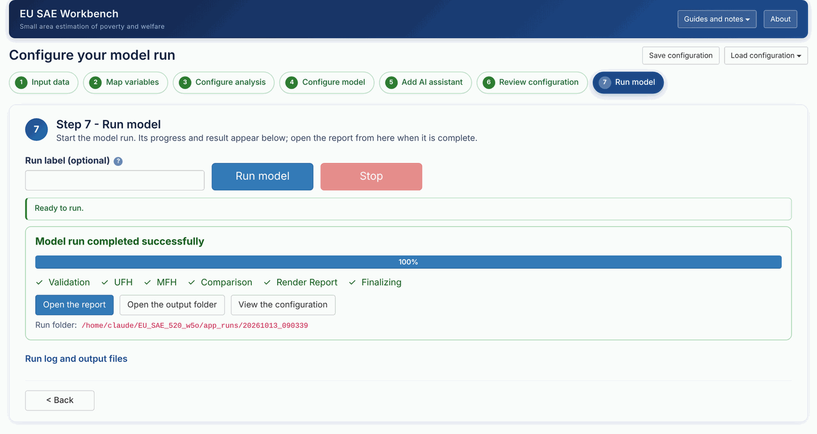
Figure 16b. Step 7, Run model: a completed run, with buttons to open the report, the output folder or the configuration.

11.9 Reviewing and retaining outputs
Review outputs/final_report.html and the editable outputs/final_report.docx after a successful run. Both contain the same setup, estimates, diagnostics, precision comparisons, maps and pointwise change-significance results. Optional AI interpretations accompany the statistical sections; AI recommendation on UFH or MFH appears near the end. Retain its evidence limitations, warnings and human-review status. With AI disabled, both statistical reports remain complete.
The outputs/data folder contains the detailed FH, MFH, and comparison workbooks, model and run metadata, and ai_interpretations.rds when applicable. The outputs/tables and outputs/figures folders contain the supporting diagnostics and visuals. Retain the archived run folder, configuration (model_run_configuration.yml), input hashes, seed, package version, bootstrap settings, and review decisions together. Passing tests or producing an HTML or Word report does not by itself approve the data, model, AI text, or results for publication.
The Word file contains editable text and native tables; figures are embedded images that can be copied into a draft report. Wide tables are split into readable panels with identifying columns repeated. Save a separate working copy before editing, because a later run replaces the current outputs. Preserve both reports and the adjacent outputs/data/ folder for linked Excel tables; archived run copies are under app_runs/<timestamp>_<run_label>/outputs/. A clean release ZIP contains the software and output placeholders, not your generated reports.
Section 11.13 explains how to read the change outputs: their units (percentage points for headcounts, percent for mean welfare, raw log ratios in the box plots), the uncertainty behind each method, and the output fields that hold them.
If HTML exists but Word is missing, check the run log for the conversion warning. Confirm that Pandoc and the R packages xml2 and zip are available, rerun install_packages.R if needed, and regenerate the report. A Word-conversion failure does not remove the completed HTML. Neither report format changes the statistical estimates or authorizes publication.

11.10 Poverty headcounts with year-specific poverty lines
Use year-specific lines when each survey is assessed against its own national line or contemporaneous relative threshold. Match each line to the welfare concept, units, and prices of the income measured. Apply the same seven-step workflow, with the indicator and line choices below.

11.10.1 Prepare the survey and lines
Prepare per-capita or equivalized welfare, appropriate weights, and a line for each year. Store lines in a survey column if they vary across observations; otherwise enter one numeric line per survey year. The poverty pipeline compares welfare with the supplied line without automatically converting either for inflation.
Illustration. This table assumes previous-calendar-year income. The headcounts are invented to explain the change; they are not sample-file outputs or official statistics.
Survey year | Income year | Line in income year prices | Illustrative headcount
2022 | 2021 | 7,860.87 EUR | 20%
2023 | 2022 | 8,007.27 EUR | 18%

11.10.2 Select the settings
Step 1 Input data. Load survey, auxiliary, and geometry. Population data are optional; CPI is not used for poverty.
Step 2 Map variables. Map the survey and domain fields and choose the survey unit. Confirm that welfare and the line share a welfare definition, time unit, and price basis.
Step 3 Configure analysis. Select survey years 2022 and 2023, Poverty (FGT), then FGT(0) Headcount ratio. Select Numeric value and enter 7,860.87 for survey year 2022 and 8,007.27 for survey year 2023; alternatively select Column in data and map the prepared line column. These inputs are attached to survey years even though the welfare refers to 2021 and 2022 incomes.
Steps 4 to 7. Keep UFH, MFH, and Comparison selected, review the model settings, leave AI off unless required. In Step 6, check the poverty lines in the summary and press Check data readiness; then press Run model in Step 7.

11.10.3 Interpret the headcount change
A fall from 20% to 18% is −2 percentage points, or a −10% relative change. Current change maps, significance plots, report significance tables and change-comparison summaries display headcount changes in percentage points. The underlying significance workbook and raw change fields retain proportions: −0.020 is −2.0 points (Section 11.13). Review estimates, RMSEs, intervals and pointwise significance from the actual run. A contemporaneous relative line moves with the income distribution, so the change describes poverty under each year’s threshold.

11.11 Poverty headcounts with an anchored poverty line
An anchored line fixes the poverty threshold’s purchasing power in a chosen anchor income year. In an EU relative-poverty application, this can start with the threshold equal to 60% of median equivalized disposable income in that anchor year, then adjust it only for prices. It is different from recalculating 60% of the median in each later year.

11.11.1 Supply anchored poverty lines
Use official anchored thresholds where available, and check their anchor year, income reference years, currency, welfare definition and units. Otherwise, choose the anchor income year and its threshold and, if welfare is in current prices, calculate the line for each income year outside the app using a consistent annual-average CPI or HICP series, first chained into price levels if it is a previous-year index or an annual percentage change (Section 11.12.3):
$$Anchored line in income year prices = \frac{Anchor year line × CPI(income year)}{CPI(anchor year)}$$
If welfare is already expressed in the anchor year’s real prices, use the anchor-year line unchanged. If welfare uses another real-price base, express the anchored threshold in that same base. The line and welfare must also use the same currency, time unit, equivalence scale, and population definition.
Illustration. Choose anchor income year 2021 and an annual threshold of 10,000 EUR. With CPI 2021 = 100 and CPI 2022 = 104, the anchored line is 10,000 EUR for 2021 incomes and 10,400 EUR for 2022 incomes. CPI 2023 = 106.08 would give 10,608 EUR for 2023 incomes; it is not needed for the two surveys below when their incomes refer to the previous year.
Survey year | Income year | CPI level | Anchored line
2022 | 2021 | 100.00 | 10,000 EUR
2023 | 2022 | 104.00 | 10,400 EUR

Enter the lines in Step 3. Under Poverty line source, choose one of two inputs. Numeric value: when one line applies to every record in a survey year, as with a national anchored threshold, type each survey year’s line in its Poverty line box. The boxes are labelled by survey year, so enter the line for that survey’s income reference year: 10,000 for survey year 2022 and 10,400 for survey year 2023 in this example. Check every box, because a box can hold a pre-filled default (5,000) or a value restored from a saved configuration. No survey column is needed. Column in data: when the line varies across records within a year, for example by region or household type, add a column such as anchored_povline to survey.rds or another supported survey format, give every included observation its applicable line, and map that column. Merely naming a column anchored_povline does not perform any CPI adjustment. Either way, the app attaches the line to every record before estimation, so the two inputs give the same Direct, UFH and MFH estimates, MSEs, changes and survey-based benchmark targets when they assign the same line to every record.
Settings. In Step 1 choose the required files. In Step 2 map welfare and the survey-design and join fields. In Step 3 choose the two survey years, select Poverty (FGT) and FGT(0) Headcount ratio, then either Numeric value with the two lines or Column in data with anchored_povline. Finish Steps 4 to 7 as in the general workflow. With Numeric value, the Poverty line source row of the Step 6 summary should read “numeric: 2022 = 10000; 2023 = 10400” in this example; with a column, check its values by survey year before loading the file. Check data readiness again after changing the lines.
The current poverty pipeline does not read the CPI controls or deflate welfare. The analyst is responsible for preparing and verifying the anchored line. Neither input checks the threshold’s source or price basis. Numeric lines are recorded in the run log and in saved configurations; with a column, keep the prepared survey file with the run.

11.11.2 Interpret and report anchored poverty
Report the source of the thresholds, the anchor income year and threshold, the income reference years, and the lines actually applied; if you calculated the lines yourself, also report the method and the CPI series (source and frequency). Headcount changes are percentage-point changes; Section 11.13 explains how each output stores them. An anchored headcount describes how the share below a threshold with fixed purchasing power changes; a contemporaneous relative headcount describes the share below each year’s relative threshold. Present their definitions clearly when comparing the two.

11.12 Real mean welfare
Select Mean welfare. Within each domain and year, the Direct mean is sum(population weight × welfare) / sum(population weight), where population weight = survey weight × household size for household rows and the survey weight for person rows. A poverty line is not needed. Real mean welfare removes inflation: either supply welfare in a common constant-price basis or let the app use CPI to convert each observation before direct, UFH, and MFH estimation.

11.12.1 Route A: Supply welfare already in real prices
Prepare the welfare variable in constant prices of the same year for both surveys. Document any spatial price adjustments and use a consistent welfare concept and unit. This route is also appropriate when the reference period is a fiscal year, a rolling period, or varies by household and you have performed the required deflation outside the app.
In Step 1 select the three required files; no CPI file is needed. In Step 2 map the real-welfare column and the survey-design and domain fields. In Step 3 choose the two survey years, select Mean welfare, enter the currency label, and select constant (real) prices already: no price index needed. Optionally enter Year of those prices for the report label. That label does not convert the values or verify that their bases agree.
Finish Steps 4 to 7 using the model and review choices below. Do not apply CPI conversion again to welfare that is already real. If the two surveys use different price bases, harmonize them before loading rather than labeling them as a common base.

11.12.2 Route B: Convert current welfare with CPI
Start with welfare in current prices. In Step 1 select the required files; upload a CPI file if using a database. In Step 2 map the current-welfare column. In Step 3 choose the two survey years, Mean welfare, the currency label, and current prices: convert with a price index.
Choose Price index values. Select Read them from the CPI file (Data step) and map Year column and CPI column, or select Type them in by year and enter the required values. Both use the same conversion rules.
Choose Incomes refer to. Select the survey year if it matches the welfare reference period. Select the calendar year before the survey when applicable, such as the previous-calendar-year income period in EU-SILC. Keep the survey year in the data and output labels; the app uses the corresponding income year to select CPI.
Choose How the CPI is organised. Match the actual series format: Index, fixed reference year; Index, previous year = 100; or Annual change in %. Do not enter 4 as a previous-year index or 104 as a percentage change.
Choose Price base year. First income year uses the earlier income year. Another year lets you choose a different constant-price basis. A fixed-reference CPI series must contain that base year’s own index value if it is outside the income years. Review the displayed factors and resolve missing years before continuing.
Example settings. For survey years 2022 and 2023 with incomes from 2021 and 2022, choose the calendar year before the survey, fixed-reference CPI, and first income year as the price base. Supply CPI 2021 = 100 and CPI 2022 = 104. The output remains labeled by surveys 2022 and 2023 but reports welfare in constant 2021 prices.

11.12.3 CPI file structure and the three formats
Prepare one country or territory and one row per calendar year. A simple file has columns year and cpi. CSV and Excel are convenient; CSV can use commas or semicolons, with decimal commas accepted by the importer. An Excel source can have more than one CPI column, but select one coherent series and the correct format. Avoid duplicate years, mixed frequencies, mixed countries, missing required values, or mixing index bases within the chosen series. Use annual-average CPI or HICP for annual income; monthly or December-on-December figures are different measures.
year | cpi
2021 | 100.00
2022 | 104.00

The following alternatives describe the same price movements: 4% from 2021 to 2022 and 2% from 2022 to 2023. A CPI with a fixed benchmark year, such as 2021 = 100, is the fixed-reference format; it is not a fourth format.
Calendar year | Fixed reference index | Previous year = 100 | Annual change in %
2021 | 100.00 | Not required here | Not required here
2022 | 104.00 | 104.00 | 4.00
2023 | 106.08 | 102.00 | 2.00

Fixed-reference index. Supply the price levels for each income year and the selected price base year, all from the same series. The published reference year (for example 2015 = 100) need not equal the chosen output price base year (for example constant 2021 prices); ratios of the series levels perform the conversion.
Previous-year index or annual change. Supply every annual movement after the earliest and through the latest of the income years and the selected price base year. The app chains the movements. It normalizes the earliest required year’s price level, so an annual change for that earliest year is not needed. If the surveys are several years apart, include the intervening years. For a 2021 base and 2022 income, enter 104 for the previous-year index or 4 for annual percent change; the 2023 movement is needed only if the income or base coverage extends to 2023.
Chaining illustration. From 2021 = 100, 100 x 1.04 = 104 in 2022, and 104 x 1.02 = 106.08 in 2023. Do not add 4 and 2 to obtain a price level of 106; annual rates compound.

11.12.4 Check the conversion and model target
For current-price input, the app converts household observations before computing direct means and variances or fitting models:
$$Real welfare = \frac{Current welfare × CPI(price base year)}{CPI(income reference year)}$$
Illustration. Suppose the population-weighted current-price means are 10,400 EUR for survey 2022 and 10,920 EUR for survey 2023. With the previous-year income setting and constant 2021 prices, the factors are 100/100 and 100/104:
Survey year | Income year | Current mean EUR | CPI level | Real mean in 2021 EUR
2022 | 2021 | 10,400 | 100 | 10,400
2023 | 2022 | 10,920 | 104 | 10,500

The nominal mean rises by 5%. The real mean rises by 100 x (10,500 / 10,400 - 1), or about 0.96%. These are illustrative direct means. UFH and MFH predictions may differ because their models borrow information across domains and, for MFH, years. The app converts the observations before estimation; it does not simply deflate the final model predictions.
Step 4 Configure model. Keep UFH, MFH, and Comparison selected. If a log model is appropriate, retain individual zero and negative welfare in the arithmetic Direct means and verify positive finite area means. UFH correction is native emdi Slud–Maiti with ML fitting; MFH correction is conditional lognormal. The naive option keeps the same area-mean target but omits the correction. Compare with no transformation when model assumptions are doubtful.
MFH2 is the initial model. Review variance and covariance choices, bootstrap failures and Monte Carlo stability. Use at least 500 replications for final inference after a stability study. Benchmarking is optional; supplied targets must share the survey’s input price basis. CPI conversion applies the same factors to welfare and targets. The complete currency estimator and benchmark are recomputed within every replicate.
Steps 5 to 7. Leave AI off unless wanted and authorized. Confirm survey and income years, price basis, CPI values, base year, currency, log-model and correction choices, and benchmark targets. Press Check data readiness in Step 6, resolve errors, then press Run model in Step 7. Confirm the report states the intended price basis and actual estimator.

11.12.5 Read real welfare outputs correctly
Levels and level RMSEs use currency units of the constant-price year. UFH corrected log MSE uses emdi’s Slud–Maiti calculation; UFH naive and selected MFH log uncertainty use original-scale bootstrap errors. Main change outputs report 100 × (later mean / earlier mean − 1), with log-ratio intervals. A common positive rescaling leaves a given pair’s percentage change unchanged; refitting MFH3 can be scale-sensitive because its initial variance is fixed.
Box plots use raw ln(later mean / earlier mean) and log-scale RMSE. The example’s log ratio is 0.00957, corresponding to an exact real change of about 0.962%. For small changes, 100 times the log ratio approximates the percentage; it is not already a percent value. Section 11.13 explains the currency-difference fields, and Section 11.9 explains how to retain the reports and run archive.

11.13 Reading the change outputs
The change box plots compare Direct, UFH, the selected MFH model, and benchmarked estimates when enabled. For poverty, the box plots, change_rmse_by_method.csv and the Change and RMSE by method and Change and RMSE summary sheets show changes and RMSEs in percentage points. The Domain changes sheet of change_estimate_comparison.xlsx shows unbenchmarked UFH and MFH changes and intervals in percentage points, without RMSEs. Current change maps, significance plots and report significance tables also display percentage points. The report multiplies stored changes and interval endpoints by 100, and stored MSE by 10,000 to show squared percentage points (pp²). The statistical_significance_comparison.xlsx workbook and raw change/interval fields in the underlying CSV exports retain proportions, and their MSE fields retain squared proportions: −0.020 represents −2.0 percentage points. Mean-welfare box plots use the raw log ratio ln(later mean / earlier mean), with RMSE on that log scale; neither is multiplied by 100. For small changes, 100 times the log ratio approximates a percentage change; the exact percentage is 100 × (exp(log ratio) − 1). Main mean-welfare change maps and tables report the exact percentage change.
For Direct and UFH, the MSE of a change is the sum of the two level MSEs, MSE₁ + MSE₂: the years are treated as independent, and no cross-year covariance is used. For headcounts, the level MSEs are in squared proportions, so the box-plot RMSE in percentage points is 100 × √(MSE₁ + MSE₂). For mean-welfare log ratios, the delta-method variance is MSE₁/m₁² + MSE₂/m₂², where m₁ and m₂ are the two level means, and the box-plot RMSE is its square root. For Direct, the omitted term is the cross-year sampling covariance of Section 6.7. Under the cluster model of Section 8.7 it is positive when PSUs are reused, so independence then overstates the uncertainty of Direct changes; a negative covariance would make it understate it. For UFH, the omitted term is the cross-year prediction-error covariance, which the application does not estimate; PSU reuse alone does not determine its sign. Direct changes appear only in the box plots and their supporting exports (change_rmse_by_method.csv and the Change and RMSE sheets); the significance tables and change maps report UFH changes on this independence basis and MFH changes with the cross-year prediction-error covariance (MCPE). These are uncertainty measures, not the observed spread of changes across domains.
The box-plot figure is saved as outputs/figures/change_comparisons/change_rmse_boxplots.png, with values in outputs/tables/change_rmse_by_method.csv and the Change and RMSE by method and Change and RMSE summary sheets of change_estimate_comparison.xlsx and EU_SAE_results.xlsx. HTML offers a Methods selector; Word shows all methods. Currency differences and their intervals are retained as diff_eur, lb_eur, and ub_eur; mse_eur has squared-currency units and p_value_eur is unitless. The _eur suffix is used for these fields even when another currency label is selected.
A narrower distribution of MFH estimated changes is compatible with borrowing information across correlated years, but it is not itself evidence of smaller prediction error or a statistically significant variance reduction. MFH2 and MFH3 model temporal dependence in area effects. For change uncertainty, MSE(change) = MSE(year 2) + MSE(year 1) - 2 x MCPE, where MCPE is the expected cross-product of the two prediction errors. A positive MCPE reduces change MSE when the two level MSEs are held fixed. Assess bias, interval coverage, fitted dependence, model sensitivity, and bootstrap stability before interpreting a tighter distribution as an accuracy gain (see Sections 8.7 and 12).

Section 12
Quality Assurance and Validation

12.1 Internal consistency checks
Before proceeding, confirm that domain codes, years, population totals, and covariates are consistent across all data sources. The readiness check (Section 11.8) automates much of this, but the analyst should still inspect the domain-consistency and national-rate tables directly. A mismatch here invalidates everything downstream, no matter how good the model.

12.2 Direct estimate checks
Review the direct estimates that feed the model: flag areas with high CVs, zero or implausibly small sampling variances, missing values, or extreme estimates. These are the inputs the model treats as data and as known error variances, so a defect here propagates into the model-based estimates. Decide explicitly how each flagged area is handled — smoothed variance, exclusion, or a note in the documentation.
For change analysis, also confirm that the cross-year sampling-covariance option matches the survey design (Section 8.7): an inappropriate covariance assumption can distort the uncertainty of change estimates, even when the level estimates look fine.

12.3 Model diagnostics
Work through the diagnostics of Sections 7.10 and 8.9: residual and random-effect normality, outlying areas, convergence, admissibility of the variance components, and sensitivity to the chosen transformation. A model that fails these checks should not be published even if its point estimates look reasonable.
It helps to distinguish three kinds of diagnostic signal: those pointing to data problems (mismatched codes, implausible direct estimates, unstable variances), those pointing to model problems (non-normal residuals, a boundary variance component, non-convergence), and those pointing to interpretation or reporting limits (high CVs, wide change intervals, sensitivity to model choices). Each calls for a different response – fix the data, reconsider the model, or qualify the claim.

12.4 Sensitivity analysis
Because several modeling choices are judgment calls, test how sensitive the results are to them. Recommended comparisons include alternative covariate sets; AIC versus BIC selection; raw versus smoothed sampling variances; alternative cross-year covariance assumptions; UFH versus MFH; and, where feasible, MFH2 versus MFH3. If the substantive conclusions are stable across reasonable alternatives, confidence in them is well founded; if they swing on a single choice, justify and disclose that choice.

12.5 Benchmarking checks
Verify that the small-area estimates aggregate consistently with trusted regional or national totals (Section 7.12). A large gap between the population-weighted aggregate of the small-area estimates and the reliable higher-level direct estimate signals a systematic problem — often a covariate that behaves differently in aggregate, or an unmodelled bias — and should be resolved before publication.

12.6 Documentation checklist
Document every consequential choice so the analysis can be reproduced and reviewed: the data sources and reference periods; the welfare definition and poverty line; the treatment of missing, zero, and negative values; the covariate set and how it was selected; the transformation and bias-correction options; the variance and covariance options; the MFH variant chosen and why; the benchmarking level; and the criteria used to flag or withhold estimates. Annex D provides a checklist that can be completed alongside the run.

Section 13
Reporting Results

13.1 Recommended structure of the final poverty-mapping report
A poverty-mapping report based on this methodology can be organized around a clear sequence that moves from the purpose of the exercise, through data and methods, to results, recommended estimates, and caveats. A recommended structure is as follows.
The report should begin with Background and objective, explaining why subnational poverty estimates are needed and how they will be used. The next section, Data sources, should describe the survey data, auxiliary data, geographic identifiers, and population data, including their reference periods and any comparability issues. The section on Direct estimates should present the survey-based starting point, with particular attention to sampling errors, coefficients of variation, and areas where direct estimates are too imprecise to use reliably.
The report should then present UFH methodology and results, covering the cross-sectional model, covariates, transformation choices, diagnostics, and resulting estimates. This should be followed by MFH methodology and results, describing the multiyear model, the treatment of intertemporal covariance, diagnostics, and estimates. A separate section on Comparison of UFH and MFH should provide a side-by-side assessment of the two model-based approaches and explain the rationale for the preferred series. This comparison should consider not only the objective of the exercise, but also the evidence on intertemporal dependence, the plausibility of covariance assumptions, transformation choices, model convergence, robustness, and consistency with country context.
The report should then present the Poverty maps, showing estimated levels, uncertainty, and, where relevant, changes over time. A consolidated section on Uncertainty and diagnostics should summarize the precision of direct, UFH, and MFH estimates and assess model adequacy. The section on Recommended estimates should identify the estimates proposed for use, report their uncertainty measures such as standard errors and coefficients of variation, and explain why they were selected. The report should conclude with Limitations and next steps, including remaining data constraints, methodological caveats, and priorities for future updates or validation.
The Workbench’s final report, described in Section 11.9, provides a useful first draft of the methods-and-results sections. It can be used as the starting point for documenting the direct estimates, UFH and MFH results, diagnostics, maps, and recommended estimates, while the final report should add the broader context, interpretation, caveats, and country-specific policy relevance.

13.2 Tables to include
At a minimum, the report should include the core tables and diagnostics needed to assess the reliability and usability of the poverty-map estimates. These should include sample sizes by area and year; direct estimates with coefficients of variation; UFH and MFH estimates with MSE, RMSE, and CV; benchmarked estimates and uncertainty measures when benchmarking is used; selected formulas and coefficients; model-fit diagnostics including AIC, BIC, logLik, sigma, random-effect variance, and OLS companion R2/adjusted R2; selection diagnostics including whether LASSO was used; and statistical tests for changes over time.
For mean welfare, the report should state the price basis: current prices; constant prices of a stated base year, with the price index, its source and the income reference period; or constant prices as provided in the survey data. The Workbench writes this description to the run log, the report, and outputs/tables/indicator_info.csv.

13.3 Figures and maps to include
The core visual outputs should include poverty maps for each year; uncertainty maps based on MSE, RMSE, and coefficients of variation; change maps with statistically significant changes clearly indicated; box plots of the changes and their RMSEs by method; direct-versus-UFH scatter plots; UFH-versus-MFH scatter plots; residual plots and Q–Q plots for diagnostic assessment; and trend plots for selected areas. Together, these visuals help users assess the geographic pattern of poverty, the precision of the estimates, the extent of change over time, and model performance.
For tabular outputs, the report should present direct, UFH, and MFH estimates alongside their MSEs, RMSEs, and CVs. RMSE is often easier to interpret because it is expressed in the same unit as the poverty estimate, while CV provides a scale-free measure of relative precision. MSE should be retained because it is the fundamental uncertainty measure produced by the SAE procedure and is needed for statistical comparisons and uncertainty calculations.
For app-guidance materials, it is also useful to include screenshots of the Workbench launch screen, the main workspace, the variable-mapping interface, model settings, the readiness check, output status, and the overall pipeline flow. These screenshots help users understand the application's workflow and make it easier to follow the sequence from data input to final outputs.
When STFH estimates or predictions for area-years without direct estimates are available, the reporting and comparison should include them in the same area-year structure used for direct, UFH, and MFH results, with point estimates, MSE, RMSE, CV, maps, change estimates, and diagnostic flags. The objective is to assess robustness across alternative covariance structures and information sets, not to treat any single model as automatically preferred.

13.4 Writing the interpretation
Interpretation should reflect the uncertainty around the estimates rather than presenting point estimates as exact values. The report should prefer qualified statements and ranges over bare point figures. For example, instead of stating simply that “poverty in Area X is 18 percent,” the report should state that “poverty in Area X is estimated at 18 percent, with a coefficient of variation of 9 percent,” or provide the estimate together with its RMSE, CV, and confidence interval where available.
Claims about differences between areas or changes over time should be made only when supported by the relevant uncertainty measures. Statements about change should indicate whether the confidence interval for the change excludes zero. Similarly, differences between areas should not be emphasized unless the estimated difference is large relative to its uncertainty. Where the relevant interval includes zero, the report should use cautious language, such as “the estimates suggest a possible difference, but the evidence is not sufficient to conclude that poverty is higher in one area than the other.”
The report should be explicit about which series is being reported — direct, UFH, or MFH — and why that series was selected. For example, MFH may be reported as the preferred series for multiyear poverty mapping when the input data are comparable across years, diagnostics support the multiyear model, and the estimated covariance structure is plausible. UFH may be used as the main model-based series for a single-year poverty map or as a cross-sectional benchmark. Direct estimates should be retained for transparency and validation.
When MFH estimates are produced under the two-year rolling publication policy, state which estimates are provisional or final, archive each release's estimation window and vintage, and record the once-only routine revision. The NSO must enforce freezing and document exceptional reopening. A within-run MSE/MCPE change test does not apply automatically to published estimates retained from different windows.
The report should avoid highlighting area-level rankings, small differences across areas, or small year-to-year changes that the data cannot support. The aim is to ensure that every quantitative claim is consistent with the reported MSEs, RMSEs, coefficients of variation, and confidence intervals, and would withstand scrutiny by a careful reader reviewing the uncertainty measures alongside the estimates.

13.5 AI-assisted interpretation and model recommendation
The Workbench can add AI-written text to the final report. This is optional and off by default, and it changes no estimate: the statistical results remain authoritative. This section explains what the AI text contains, how it is produced, and how analysts should use and review it.
What the AI adds. When AI is enabled in Step 5, the final HTML and Word reports contain two kinds of text, each in a labelled block beside the statistical results it discusses. Interpretations are plain-language comments on seven report sections: the overview, normality diagnostics, poverty rate comparisons, MSE, RMSE and CV comparisons, the statistical significance of changes, poverty maps and poverty change maps. They describe what the tables and figures show and point out cautions. The recommendation on UFH or MFH gives advice on which model is better supported for annual levels and which for changes between the two years.
How the recommendation is formed. The Workbench first assembles a fixed set of aggregate evidence on the analyst’s computer. It covers the selected MFH model and its convergence and inference status (regular, boundary-sensitive or unavailable); completeness and matching of UFH and MFH results by domain and year; average MSE, RMSE and CV over matched domain-years, kept separate for benchmarked and unbenchmarked results; average change MSE and interval widths over matched domains, with the number of boundary-sensitive pairs; summary model and normality diagnostics; and MFH bootstrap diagnostics, such as failed refits, covariance-boundary counts and Monte Carlo error. This evidence contains no microdata, domain names or codes, model formulas or file paths. The provider receives it with fixed instructions and writes three short paragraphs: one on annual levels, one on change, and one on the qualifications and checks needed before use.
Rules the recommendation must follow. The fixed instructions allow the recommendation to favour UFH or MFH, to find no clear preference, or to report that the evidence is insufficient; it must not force a choice, and the preference may differ between levels and change. Lower estimated MSE or CV, narrower intervals, closer agreement with direct estimates or more significant domains do not by themselves show that a model is better. Boundary-sensitive results are treated as provisional, and failed or unavailable results are stated as such. UFH change uncertainty is described as assuming independence between years, which overlapping samples can invalidate. MFH change uncertainty applies only to estimates from the same two-year fit, not to annual figures taken from different releases. Bootstrap and diagnostic summaries are treated as numerical checks, not as proof of interval coverage.
Why it can help. The evidence for choosing between UFH and MFH is spread over several tables and figures, and reading it correctly takes care. The recommendation brings the main points together and applies the same cautions every time. This can help analysts, particularly those new to these models, to review the choice systematically and to record why a series was selected (Section 13.4).
Limits. The recommendation is advice, not model selection. It never refits a model, changes the reported series or alters an estimate. It uses only the summary evidence described above: it cannot see the maps or plots, the survey design documentation or the publication objective, and it is told not to assume an objective. Provider text can be wrong. A numeric-provenance check compares numbers in the AI text with the source evidence, but it gives warnings only and does not establish that the text is correct. Validation for this release also found that estimated uncertainty can be too small in some settings, so comparisons of estimated precision should be read with that in mind.
Data transfer and approval. Enabling AI sends the aggregate evidence and prompt text to the selected external provider or approved gateway. No microdata are sent, and the interpretation prompts remove geographic identifiers from the tables they include. Unpublished aggregate estimates can still be sensitive, so the analyst must acknowledge the transfer before entering a key, and institutional approval should be obtained first. API keys are not saved.
Review before use. Each AI block records its provider, model, time, language and status (generated, failed or disabled) in outputs/data/ai_interpretations.rds, and failed sections are shown as failed. Before dissemination, an analyst should check the AI text against the statistical tables, correct or remove anything the results do not support, and record this review under the applicable sign-off process. The choice of the reported series remains the analyst’s.

Section 14
Practical Recommendations

14.1 Recommended default workflow
Use the direct estimates as a diagnostic and a design-based anchor; use UFH as the first model-based baseline and the cross-sectional reference; and use MFH as the preferred method when comparable estimates over time are required. Always produce all three and report them together. Treat the readiness check as mandatory and the sensitivity analysis as routine rather than optional.

14.2 Recommended default app settings
Use arcsine with package bias correction for UFH headcounts, BIC for UFH selection, AIC for MFH selection and MFH2 as starting settings; review diagnostics and sensitivity. New configurations use sm_out for UFH with no transformation or log mean welfare, and sm_out with rho_sm_out for MFH. Explicit saved choices are retained. Consider sm_all only when direct variances are broadly unstable and the GVF fits well; it can overstate variances where poverty rates are low (Section 6.6). Arcsine retains its effective-sample-size variance. Log models target arithmetic area means: UFH uses emdi Slud–Maiti correction and MFH uses conditional-lognormal correction. The sm_out default keeps its 0.001 cutoff on the modeled response scale. Use zero covariance for independent rounds or a documented sensitivity. The bootstrap default is 500; inspect Monte Carlo error, convergence and boundary sensitivity.
These are defaults, not prescriptions: each should be revisited if the diagnostics or the sensitivity analysis indicate a problem.

14.3 When to avoid publishing estimates
Withhold or clearly flag estimates in any of the following situations: very weak model diagnostics (clear non-normality, strong residual structure, poor fit); severe gaps in covariate coverage for the affected areas; non-convergence of the model, or an admissibility failure such as a zero or boundary variance estimate; extreme outliers that the model cannot accommodate; very high uncertainty (for example, a CV above a pre-agreed threshold); or unstable or inconsistent domain definitions across the data sources or over time.
The same caution applies when: the direct estimates are of poor quality or their sampling variances are unstable or missing; the cross-year sampling covariance is unresolved but a change over time is being reported; the covariates are weak or implausible; a boundary or zero random-effect variance cannot be resolved by the robust refit and is not clearly justified; the shrinkage is implausible (estimates pulled far from precise direct estimates); the conclusions are highly sensitive to reasonable model choices; the benchmark target is unreliable or conceptually misaligned; the coefficients of variation are very high or the change intervals very wide; or the welfare definition or geography is not consistent over time.
Publishing a flagged estimate without its caveats is worse than publishing none, because it carries unwarranted authority.

14.4 Recommended review process
Before publication, subject the analysis to a technical review covering at least the following: data preparation and harmonization; direct estimates and their variances; model diagnostics and model choice; mapping outputs and their class intervals; and written interpretation. A reviewer who was not involved in the run, working from the documentation checklist of Section 12.6, is the most effective safeguard against the errors that are easiest to make and hardest to see in one’s own work.

Section 15
Limitations and Future Extensions

15.1 Limitations of area-level SAE
Area-level methods inherit the quality of their inputs. They depend on the direct estimates being approximately unbiased and the supplied sampling variances being reasonable; on the availability of area-level covariates that genuinely predict poverty; and on the model’s linearity and normality assumptions. Where the covariates are weak, or the direct estimates are badly behaved, the model can do little. Area-level models also estimate only the indicators for which direct estimates and covariates are available; unlike unit-level methods, they do not reconstruct the underlying welfare distribution.

15.2 Limitations of MFH
The multivariate model adds parameters, and estimating them reliably requires a reasonably large number of areas. With too few areas, the estimation can fail to converge, reach a valid zero random-effect variance boundary, or return inadmissible values such as an autocorrelation outside its valid range. Boundary estimates require the inferential qualifications described in Section 8.9. The model’s gains also depend on its covariance assumptions: if the AR(1) structure of MFH2 or MFH3 does not describe the data, the borrowed strength may be misapplied. This is why the note recommends starting with the most parsimonious variant and confirming every step against the diagnostics and the univariate benchmark.
MFH estimates for a given year depend on the data window used to fit the joint model. The two-period implementation supports a manageable official-statistics revision policy: each newly reported year is provisional, is routinely revised once when it becomes the earlier year in the next window, and is then frozen. This operational rationale for T = 2 does not change the general multivariate model in Molina and Romero (2025).
Policy 1: finalize the earlier year of each two-year MFH run. For successive windows (2022, 2024), (2024, 2025), and (2025, 2026), publish 2024 provisionally from the first run, revise and finalize it in the second, then retain that frozen 2024 estimate. Publish 2025 provisionally in the second run, revise and finalize it in the third, and publish 2026 provisionally. At each release, at most one previously published year is routinely revised. The initial window need not contain consecutive calendar years; the initial earlier year's publication status requires an NSO decision.
With T > 2, a rolling-window policy that finalizes the oldest year can leave several overlapping years provisional. Those years may be revised repeatedly before finalization, increasing publication delays and the revision history to maintain. T = 2 limits that routine revision burden under Policy 1. Window length alone neither freezes past estimates nor prevents reopening them: the NSO must maintain a vintage archive, enforce the agreed freeze, and document exceptional data corrections or methodological revisions.
Policy 2: finalize only the second year of each two-year MFH run. Under the approach described by the Polish team, the second-year estimate is published as final immediately. The first-year estimate from the same run does not replace the previously published rate. For example, the final 2025 rate comes from the 2024-2025 run. The next run, covering 2025-2026, supplies the final 2026 rate, while the published 2025 rate remains unchanged. Both years still contribute to fitting MFH; the publication rule selects which estimate enters the annual series.
For a longer window, the corresponding policy would publish only the latest year as final. A three-year run covering 2024-2026 would publish its 2026 estimate but leave its newly estimated 2024 and 2025 rates out of the published annual series. Thus, each round gives up publication of two annual estimates from that run, retaining the rates previously published for those years. A four-year run would similarly leave three newly estimated annual rates unpublished. These estimates should still be retained for diagnostics and internal analysis; the earlier years' data continue to contribute to MFH estimation. At the beginning of a series, earlier years without previously published estimates require a separate publication decision.
Implications for comparisons over time. Under either policy, consecutive final poverty rates may come from different MFH runs. Their difference can be reported descriptively, but the current run's confidence interval and significance test concern the two estimates produced together in that run. They do not automatically apply to the difference between published rates drawn from separate runs. Formal inference for that difference requires an uncertainty calculation accounting for the relevant MSEs and prediction-error covariance across runs (Sections 8.12 and 15.3).
The Workbench fits exactly two selected years, but it does not enforce adjacency, a rolling release schedule, or a publication freeze. Agree the publication policy before releasing results and archive each published estimate with its window, vintage and uncertainty. Policy 1 uses one subsequent window to revise the latest year before freezing it; Policy 2 publishes the latest year as final without routine revision. Longer windows may offer more borrowing, but can increase overlapping provisional revisions under Policy 1. Neither policy removes model-validation requirements or supplies uncertainty for differences between estimates from different runs.
Panel A. First-year estimates are final; second-year estimates are preliminary
Two-year MFH window | 2024 | 2025 | 2026 | 2027
2024-2025 | Final | Preliminary
2025-2026 |  | Final | Preliminary
2026-2027 |  |  | Final | Preliminary
Each preliminary estimate is replaced once, when that year becomes the first year of the next run. Earlier final estimates are retained.
Panel B. Only second-year estimates are published as final
Two-year MFH window | 2024 | 2025 | 2026 | 2027
2024-2025 | Retain prior | Final
2025-2026 |  | Retain prior | Final
2026-2027 |  |  | Retain prior | Final
Retain prior means retain the final rate from the preceding run, when that year was the second year. The current run's first-year estimate is not published as a replacement.
Figure 17. Two publication policies for rolling two-year MFH estimates.
Note: Final denotes publication status; it does not mean that refitting the model with a different data window could never produce another estimate. Both policies retain the full run outputs for audit and analysis.

15.3 Limitations of time comparisons
Comparing change over time requires accounting for two different covariances: the sampling-error covariance supplied to the MFH model when samples overlap, and the prediction-error covariance (MCPE) used when differencing two estimated levels. Note on Estimating the Sampling-Error Covariance Matrix (revised).docx documents the first; Note on MSE Estimation - Levels and Changes.docx documents the second and the resulting change MSE. If either covariance is misestimated or assumed away, the stated uncertainty of change can be wrong. The bootstrap also introduces simulation error, failed refits can reduce its effective replication count, and benchmarking must be repeated within each replicate. Conclusions close to the significance threshold should therefore be checked with a larger bootstrap and sensitivity specifications. Testing changes across many areas also creates the multiple-comparisons issue described in Section 8.12; the Workbench uses pointwise 95% intervals for its primary classification and retains BH and Bonferroni results as supplementary evidence. Counts across areas are exploratory pointwise summaries.
For mean welfare, real changes depend on the price index. The Workbench applies one national index to all domains, so it does not adjust for regional differences in price levels, regional inflation, or consumption baskets, and its two income-period choices assume calendar-year reference periods (Section 4.3). Deflating household welfare before estimation is the recommended order. For UFH and log-scale models, deflating before or after estimation gives the same estimates apart from numerical tolerances; for MFH2 fitted on the currency scale, which uses one random-effect variance for both years, it does not (on the Spain example, the estimates differ by at most 0.28% with 1.4% inflation and by 1.9% with 10% inflation).

15.4 Spatio-temporal Fay–Herriot models, covariance misspecification, and comparison with MFH
A natural and recommended extension of the Workbench is to include spatio-temporal Fay–Herriot (STFH) models. STFH models add spatial borrowing across neighboring areas to temporal borrowing across years. They are especially useful when the objective is to assess the spatial distribution of poverty and when residual diagnostics suggest that neighboring areas remain correlated after accounting for covariates and temporal structure. Molina and Romero (2025) provide implementation details, including the required proximity matrix, estimation steps, STFH EBLUPs, and bootstrap MSE estimation.
STFH should be viewed as complementary to MFH, not as a replacement, and not as a model that is automatically superior or inferior. MFH and STFH emphasize different dimensions of the information structure. MFH is especially useful for time-comparable poverty mapping because it models relationships within the same area across years and can incorporate cross-year sampling-error covariance when the survey design implies it. STFH is especially useful for assessing whether spatial dependence across neighboring areas adds information beyond the covariates and temporal structure.
Yoshida (2026) emphasizes that this comparison is not merely a question of choosing among model names. Fay–Herriot predictors estimate realized area-specific quantities, and the BLUP depends directly on the assumed covariance structure. If the working covariance structure is misspecified, the resulting EBLUP converges to the BLUP under the working covariance model, not necessarily to the BLUP under the true covariance structure. Misspecification may arise from the covariance of the area random effects, the covariance of the sampling errors, or both.
This point is especially important for repeated surveys. When samples overlap across years, or when surveys reuse households, PSUs, or rotating-panel structures, the sampling errors of direct estimates may be correlated over time. Ignoring this design-induced covariance is not a neutral simplification. It changes the prediction weights. Yoshida (2026) shows that an MFH model that estimates the area-effect covariance but assumes a diagonal sampling-error covariance can absorb sampling-error correlation into the estimated area-effect correlation and may perform worse than UFH. The same caution applies when comparing MFH and STFH: a standard STFH specification that assumes zero cross-year sampling-error covariance may be useful for spatial assessment, but it should be interpreted in light of that assumption.
STFH also imposes other modeling choices that should be documented. Standard implementations may use a common synthetic relationship over time and require a specified spatial proximity matrix. These assumptions can be reasonable, but they should be checked against the data. If the relationship between covariates and poverty changes over time, or if the chosen neighborhood matrix does not reflect meaningful spatial dependence, STFH estimates may reflect the working model rather than the true spatial-temporal structure.
Having both MFH and STFH estimates would provide a more comprehensive assessment of the spatial distribution of poverty. If MFH and STFH produce similar spatial patterns, this increases confidence that the poverty geography is robust to alternative covariance structures. If they differ substantially, the differences are informative: they may indicate residual spatial dependence, sensitivity to the assumed neighborhood structure, sensitivity to how sampling-error covariance is treated, instability from limited area-level observations, or changes in the poverty–covariate relationship over time.
The current Workbench does not implement STFH. However, future versions should make STFH results easier to compare with MFH by using a common output structure. If STFH estimates are produced outside the app, they should be organized in the same area-year format as the direct, UFH, and MFH estimates, including point estimates, MSE, RMSE, CV, model flags, and diagnostic information. This would allow analysts to compare MFH and STFH maps, uncertainty measures, area rankings, estimated changes over time, and diagnostic flags in a consistent framework.
The recommended practice is therefore to use UFH as the cross-sectional benchmark, MFH as the main multiyear model when time comparability and sampling-error covariance are central, and STFH as a recommended complementary specification for spatial assessment. The final choice of estimates for publication should depend on the purpose of the exercise, survey design, plausibility of the covariance assumptions, model diagnostics, uncertainty measures, and robustness of spatial and temporal patterns. No estimate should be selected solely because it comes from the most complex model.

15.5 Areas and area-years without direct estimates
The current Workbench estimates UFH and MFH only for area-year cells that have a direct estimate and a sampling variance. It does not yet implement Fay–Herriot prediction for area-years without a direct estimate. This subsection explains how to handle such cases in future extensions and what they imply for interpretation. It is useful to distinguish three cases. The formal partitioned-prediction argument and Monte Carlo evidence are provided in What Does Fay-Herriot Predict? BLUPs, Covariance Misspecification, and Missing Direct Estimates (file FH_prediction_covariance_paper_with_annex_REVISED_section11_annexA.docx).
Case 1. Direct estimates are available every year. MFH uses the full vector of observed direct estimates. The EBLUP combines the synthetic component with a covariance-based adjustment using residuals from the observed direct estimates. This is the strongest information case, because the target year itself is anchored in survey evidence.
Case 2. A direct estimate is missing in one year, but the same area has direct estimates in other years. MFH can still produce a BLUP-type prediction for the missing area-year, provided the missing target is connected to the observed years via non-zero area-effect covariance. Writing m for the missing year and o for the observed years, the prediction takes the form:
$${\hat{θ}}_{im}^{MFH}=X_{im}\hat{β}+{\hat{C}}_{mo}{\hat{V}}_{i,oo}^{-1}(y_{io}-X_{io}\hat{β})$$
where β and the covariance blocks are replaced by their estimates. The second term uses the observed years to infer the realized area effect in the missing year, and can improve on the purely synthetic estimate when area effects are persistent over time, and the observed direct estimates are informative. The sampling-error covariance does not define the target, but it affects the prediction weights through the covariance of the observed direct estimates:
$$V_{i,oo}=G_{oo}+D_{i,oo}$$
Prediction, therefore, does not require a sampling variance for the missing area-year itself. However, it does require a working covariance matrix for the observed direct estimates used in the prediction.
Case 3. An area has no direct estimate in any year. Basic MFH without spatial links cannot infer an area-specific random effect for such an area, and the estimate reduces to the regression-synthetic prediction:
$${\hat{θ}}_{im}=X_{im}\hat{β}$$
This estimate may still be useful, but it should not be presented as equivalent to an EBLUP anchored in area-specific survey evidence. If a spatial or spatio-temporal model is used, an area with no direct estimates may receive a BLUP-type prediction only when the model includes a valid spatial covariance structure linking that area to observed neighboring areas.
Several operational safeguards apply. Missing direct estimates should be coded as missing — not as zero poverty, and not as ordinary direct estimates with artificially large variances unless the method explicitly supports that approximation. The estimation dataset should stack the observed direct estimates and use a partitioned MFH or STFH predictor for the missing components. Reported uncertainty should reflect the additional model dependence of predicted area-years. Output tables and maps should include information-source flags so that users can see what each estimate rests on.
Recommended flags include: direct_available, missing_direct_estimate, zero_sample_area, missing_sampling_variance, small_sample_area, temporal_borrowing_only, spatial_borrowing_used, and synthetic_only.

Annexes

Annex A
Glossary
Direct estimate. A poverty estimate for an area, computed from that area’s own sampled households using survey sampling theory, with no model assumptions. The starting point and design-based anchor for SAE.
UFH (Univariate Fay–Herriot). An area-level model that estimates poverty for one time period by combining the direct estimate with a regression on area-level covariates and a random area effect.
MFH (Multivariate Fay–Herriot). The extension of UFH that estimates several time periods jointly and allows each area’s random effect to be correlated across time, yielding stable, comparable estimates over time.
EBLUP (Empirical Best Linear Unbiased Predictor). The model-based predictor of the area indicator obtained from the fitted mixed model; “empirical” because the unknown variance components are replaced by their estimates. It is defined relative to the assumed covariance structure: under a misspecified covariance it is an EBLUP only under the working model, not under the true covariance structure.
MSE (Mean Squared Error). The measure of precision of a model-based predictor combines prediction variability and error from estimating model parameters. Its square root, the root mean squared error (RMSE), is in the units of the estimate and is the model-based counterpart of a standard error.
CV (Coefficient of Variation). The standard error (the RMSE for model-based estimates) expressed as a percentage of the estimate, $\text{CV=}100×\text{SE/|estimate|}$; the standard summary of relative precision.
Benchmarking. Adjusting small-area estimates so that their population-weighted aggregate reproduces a trusted higher-level (regional or national) total.
FGT (Foster–Greer–Thorbecke). The family of poverty indicators indexed by $α$: the headcount rate ($α\text{=}0$), the poverty gap ($α\text{=}1$), and poverty severity ($α\text{=}2$).
Sampling variance. The design-based variance of a direct estimate, $σ_{\text{ed}}^{2}$; treated as known and supplied to the Fay–Herriot model as the error variance.
Sampling covariance. The design-based covariance between two direct estimates — here, between the same area’s estimates in two years — can be non-zero when survey rounds share PSUs (for example, rotating panels or retained clusters), even when different households are interviewed; under the cluster model of Section 8.7 it is positive.
MCPE (Mean Crossed Product Error). The cross-year analog of the MSE: the expected product of the prediction errors of two EBLUPs, needed to compute the uncertainty of an estimated change over time.
GVF (Generalized Variance Function). A smoothing model (here, a regression of log variance on log sample size) replaces unstable direct sampling-variance estimates with smoothed values.
Arcsin transformation. The variance-stabilizing transform $\text{arcsin}(\sqrt{p})$ applied to poverty rates so that model estimates stay within $[0,1]$ and variances are stabilized.
REML (Restricted Maximum Likelihood). The variance-fitting criterion used for ordinary UFH and MFH. Corrected and naive UFH log models use ML to match emdi’s Slud–Maiti implementation.
Shrinkage weight ($γ_{d}$). The weight the EBLUP places on the direct estimate relative to the regression prediction; close to 1 when the direct estimate is precise, close to 0 when it is not.
Regression-synthetic estimate. The prediction from the area-level regression alone (covariates times estimated coefficients), without the area random effect. The EBLUP shrinks toward this part, and out-of-sample areas take it as their estimate.
Random-effects covariance. The covariance of the area random effects across years, estimated by the MFH model; its assumed structure defines the variant. Distinct from the sampling-error covariance, which is supplied to the model as data.
MFH1, MFH2, MFH3. The three multivariate variants, differing in the random-effects covariance: MFH1 treats years as independent with year-specific variances; MFH2 is a homoskedastic AR(1) with a common variance and temporal correlation; MFH3 is a heteroskedastic AR(1) with year-specific variances and temporal correlation. MFH2 is the recommended default.
Boundary (zero) variance estimate. A fitted random-effect variance of zero, at the edge of the admissible parameter space; it removes the area random effect and collapses the EBLUP onto the regression-synthetic part. Treated as a diagnostic warning to be reviewed, not an automatic result.
Numerical safeguard. Independent REML endpoint checks and constrained MFH2 refitting when needed. Valid positive or zero variance fits may be retained; a package convergence flag alone is insufficient.
Ratio benchmarking. The multiplicative benchmarking adjustment the Workbench uses for poverty rates and mean welfare, applying a common factor within each benchmark area; with a positive factor, it preserves non-negativity and the ordering of areas within the group. The main alternative is additive (difference) benchmarking; raking is an iterative ratio method.
Log transformation. The log of an arithmetic Direct area mean, with delta sampling variance. It requires a positive area mean, while retaining individual zero and negative welfare. UFH uses emdi Slud–Maiti correction; MFH uses conditional-lognormal correction. Neither model fits household log welfare.
Bias correction. The adjustment applied when back-transforming from a modeling scale (arcsin or log) to the reporting scale, because the inverse transform of a mean is not the mean of the inverse transform.
Realized area parameter. The true poverty value for a specific area (and year) that the Fay–Herriot model aims to predict, θᵢ = xᵢ′β + uᵢ. It is the sum of the regression-synthetic component and the realized area effect, and is the target of prediction rather than a conditional mean.
BLUP (Best Linear Unbiased Predictor). The minimum mean-squared-error linear predictor of a realized area parameter under a given covariance structure. It adds a covariance-based adjustment to the regression-synthetic component, using the observed direct estimates to infer the realized area effect.
Working covariance. The covariance structure assumed by the fitted model. If it differs from the true covariance structure, the EBLUP converges to the BLUP under the working model, not necessarily to the BLUP under the true structure.
Sampling-error covariance. The covariance of the sampling errors of the direct estimates, including the cross-year terms that arise when survey rounds share PSUs. It is supplied to the MFH model as data; its diagonal holds the sampling variances.
Area-effect covariance. The model-estimated covariance structure of area-level random effects across years and, in spatial models, across areas. It is also referred to as the random-effects covariance.
Synthetic-only prediction. An estimate based on the regression-synthetic component alone (covariates times estimated coefficients), with no area-specific adjustment from a direct estimate. It is the fallback for areas with no direct estimate, but is not anchored in area-specific survey evidence.
Temporal borrowing. Using an area’s direct estimates from other years to improve the estimate for the target year, through the modeled correlation of the area effects over time. This is the basis of MFH.
Spatial borrowing. Using direct estimates from neighboring areas to improve an area’s estimate, through a modeled spatial covariance structure. This underpins spatio-temporal Fay–Herriot (STFH) models.
Information-source flag. A label recorded for each estimate indicating what it rests on — for example, an own direct estimate, temporal borrowing, spatial borrowing, or synthetic-only prediction — so that users can judge its evidentiary basis.

Annex B
Data Templates
Three files are required: survey, auxiliary, and geometry. Population data are optional. Domain codes must agree across the files in use, and tabular records use survey years. Column names can differ from the examples because the app maps columns to roles. CPI data are a separate year-value table used for mean-welfare conversion; see Section 11.12.3.
Survey microdata (one row per household or one row per person; say which in Step 2, Map variables).
TABLE XII
Survey Microdata Template
Column | Role | Example | Notes
domain | Area identifier | 28 | Must match auxiliary, population, geometry
year | Time period | 2012 | One value per survey round
weight | Survey weight | 347.7 | Positive; non-response adjusted
welfare | Income/consumption | 9778.7 | Per capita or adult-equivalent
povline | Poverty line | 6477.5 | Poverty only: map this column, or enter one numeric line per survey year.
psu | Primary sampling unit | 805 | For design-based variances
hhsize | Household size | 4 | Required when each row is a household; not used when each row is a person.
household_id | Household ID | 1024 | Optional; lets the readiness check confirm the survey unit (Test 0f)
Auxiliary data (one row per area–year).
TABLE XIII
Auxiliary Data Template
Column | Role | Example | Notes
domain | Area identifier | 28 | Matches survey
year | Time period | 2012 | All target years
x1, x2, … | Covariates | 0.43 | Complete for all areas; means/proportions
Population data (optional; one row per area-year). If omitted, the app derives domain populations from the survey’s population weights (Section 3.7).
TABLE XIV
Population Data Template
Column | Role | Example | Notes
domain | Area identifier | 28 | Matches survey
year | Time period | 2012
N | Population size | 645123 | For benchmarking and aggregation
Geometry (one row per area).
TABLE XV
Geometry Template
Column | Role | Example | Notes
domain | Area code | 28 | Matches all files exactly
name | Area name | Madrid | For labelling
geometry | Polygon | — | ESRI shapefile ZIP (.shp, .shx, .dbf), RDS, RData, GeoPackage, GeoJSON, JSON, KML, or GML.
Direct-estimate data. Not an input: the guided version and the classic dashboard always compute direct estimates, sampling variances and cross-year covariances from the survey microdata (Sections 6 and 8.7).

Annex C
App Input Checklist
Complete before clicking Check data readiness:
☐ R 4.2 or later installed. RStudio Desktop optional; existing users can update it if Pandoc is missing or too old. Pandoc 2.17 or later available or downloadable by the launcher; preinstall for offline use. Required R packages installed or available for first-launch installation.
☐ Survey file ready with year, domain, weight, household size (household rows only), welfare, and the required survey-design variables. Poverty additionally requires a line column or year-specific numeric lines. Accepted formats include RDS/RData, CSV/TSV/TXT/DAT, Stata, SPSS, SAS, Parquet/Feather, and Excel.
☐ Auxiliary file ready, in area-year format, covariates complete for all areas and years, and saved in an accepted tabular format such as RDS/RData, CSV/TSV/TXT/DAT, Stata, SPSS, SAS, Parquet/Feather, or Excel.
☐ Population file (optional) ready, by area and year. If omitted, the app estimates domain populations from the survey as the sum of the population weights.
☐ Benchmark target file (optional) for the same welfare concept, prices, population, and benchmark areas as the analysis.
☐ Geometry file ready, with an area code that matches the other files exactly.
☐ Domain codes agree in type and value across survey, auxiliary, geometry, and optional population or benchmark files. CPI uses calendar price years and does not need a domain join key.
☐ Exactly two survey years selected in Step 3. Income reference years checked separately when a price index is used.
☐ Indicator chosen (poverty FGT or mean welfare); FGT order selected if applicable.
☐ For real mean welfare, choose either already-real input with a common price basis and no CPI conversion, or current-price input with CPI conversion. For conversion, check CPI format, income reference years, base year, and every required index or annual change (Section 11.12).
☐ For poverty only, choose a mapped line column or a positive numeric line for each survey year. For anchored poverty, enter each survey year’s anchored line as a numeric value, or prepare a line column before loading the data (Section 11.11); the app does not calculate it from the CPI.
☐ Variable mapping completed for every role.
☐ Survey unit chosen (a household or a person); household size mapped for household rows; household ID mapped where available. Map the benchmark group field when grouped benchmarking is used; each domain must belong to one group.
☐ Cross-year PSU design confirmed from the survey documentation and selected. The sampling-covariance choice reflects that design.
☐ Area-year cells included in estimation have a valid direct estimate and sampling variance; cells without a direct estimate are flagged and resolved, aggregated, excluded, or documented (see Section 15.5).
☐ Transformation, variance, covariance, LASSO-screening, and AIC/BIC model-selection settings reviewed (defaults are a sound start).
☐ AI assistant left disconnected unless aggregate-only sharing is cleared.

Annex D
Model Diagnostics Checklist
UFH (per year):
☐ Model endpoint is usable; positive or zero variance is supported by numerical checks and sensitivity review.
☐ Residuals-versus-fitted plot shows no systematic structure.
☐ Normality plots reviewed as descriptive diagnostics; correlated residuals do not supply exact independent-sample normality tests.
☐ Outlying areas identified and explained.
☐ UFH-versus-direct scatter behaves sensibly (tracks precise direct estimates).
☐ CV reduction relative to direct estimates is material.
☐ Benchmarking gap to trusted totals is acceptable.
MFH (additional):
☐ MFH REML score, curvature, boundary checks and refit diagnostics reviewed; selected annual MSE and MCPE use accepted joint bootstrap draws.
☐ Estimated temporal correlation $\hat{ρ}$ plausible in sign and size.
☐ For MFH3, refvarTest reviewed to justify heteroskedasticity (else use MFH2).
☐ Residual and normality diagnostics acceptable for each year.
☐ MFH estimates consistent with UFH and direct, except where smoothing is expected.
☐ Trends stable and not driven by a single noisy year.
☐ Cross-year sampling covariance option appropriate to the survey design.
☐ MCPE-based change uncertainty computed where changes are reported.

Annex E
Example App Walkthrough
Section 11 is the main walkthrough. This compact checklist applies it to two survey years using analyst-provided files or learning examples in Data/Spain/ and Data/simulated/. Choose the detailed indicator example in Section 11.10, 11.11, or 11.12 before running. Sample files are for learning and testing.
- Launch the Workbench. Open Start_Here and double-click Start_Wizard.bat on Windows or Start_Wizard.command on macOS. On Linux, run bash Start_Here/Start_Wizard.command. Keep the launcher open, wait for dependency checks, and select New model run.
- Step 1 Input data. Load the required survey, auxiliary, and geometry files. Add population data if used and a CPI file if converting current-price welfare.
- Check the files. Domain codes must match. For ESRI shapefiles, upload a ZIP containing .shp, .shx, and .dbf. CPI rows use the relevant calendar income years, not automatically the survey years.
- Step 2 Map variables. Map survey year, domain, welfare, weight and design variables; choose whether each row is a household or a person and, for households, map household size; map the auxiliary and geometry domain keys. Confirm a valid per-capita or equivalized welfare measure.
- Step 3 Configure analysis. Select exactly two survey years and record a seed. For headcounts, select Poverty (FGT) and FGT(0); for real mean welfare, select Mean welfare and the appropriate real-price route.
- Set the line or price basis. Use year-specific lines (Section 11.10), anchored lines entered as numeric values or as a column (Section 11.11), or already-real/CPI-converted welfare (Section 11.12). A poverty line is unnecessary for mean welfare.
- Step 4 Configure model. Keep UFH, MFH, and Comparison selected. Review transformations, model-specific corrections, covariates, variance and covariance inputs, benchmarking, MFH selection and bootstrap settings.
- Record survey-design assessment. Check PSU meanings across years and choose the cross-year PSU design and sampling-covariance option accordingly. MFH does not run while the design is not specified.
- Step 5 Add AI assistant. Leave AI off unless an approved provider or gateway, API key, and external-transfer acknowledgment are available. AI is optional and does not change the statistical estimates.
- Step 6 Review configuration. Review all settings and Preflight, then select Check data readiness. Resolve flagged domain, estimate, variance, covariate, survey-unit, benchmark-group and price-index problems.
- Step 7 Run model. Enter an optional run label and select Run model. Follow the progress panel and the run log. Stop ends a run early; a stopped run is not archived.
- Review and retain outputs. Inspect final_report.html and final_report.docx, maps, diagnostics, and uncertainty. Preserve the completed run archive and linked data files (Section 11.9).
Apply the quality and reporting checks in Sections 12 and 13. Confirm units before interpreting results: current poverty-change maps, plots and report tables display percentage points, while the underlying significance workbook and raw change fields retain proportions; real mean-welfare changes use percent and mean-welfare box plots use raw log ratios (Section 11.13).

Annex F
Troubleshooting Guide
TABLE XVI
Troubleshooting Guide
Symptom | Likely cause | Remedy
Readiness check reports a missing variable | A mapped column name is wrong or absent | Re-check the variable mapping (Section 11.4) against the actual column names
Run model is disabled | A required data file or one of the two analysis years is missing | Complete Step 1 and the years in Step 3; Step 7 lists what is missing
Readiness Test 0f reports an ERROR about household IDs | The file has one row per person, but Each row of the survey file is set to a household | Choose a person in Step 2, or use a file with one row per household (Sections 4.6 and 11.4)
Readiness Test 0g reports a domain in more than one benchmark group | The group column gives a domain different codes, or a missing code, in the analysis years | Correct the group codes in the survey file so that each domain has one group (Section 3.8)
A loaded configuration warns that a data file has changed | The file was replaced after the configuration was saved | Check that the new file is intended; then save the configuration again (Section 11.2)
Areas appear blank on the map; domain inconsistency flagged | Area codes differ across files (type or value) | Harmonize codes to a single type and value set (Section 4.2)
Missing poverty rates for some area–years | No sampled households, or all on one side of the line | Treat as small/zero-sample areas (Section 4.8); consider exclusion
MFH endpoint fails its numerical checks | Weak identification, difficult optimization or unstable sampling covariance | Inspect score, curvature, boundary and covariance diagnostics; assess MFH2 or UFH sensitivity. Zero variance alone is not failure.
Invalid or zero sampling variances | Unstable direct variances in small areas | Use a smoothing option (sm_out or sm_all, Section 6.6)
Map fails to render | Geometry missing, incomplete ESRI shapefile, or code does not match | For ESRI shapefiles, upload a .zip containing .shp, .shx, and .dbf; confirm the area code matches the data
App will not start, or a package is missing | Installation incomplete, or R older than 4.2 | Re-run install_packages.R; update R; re-launch
Change significance looks implausible | Cross-year sampling covariance mis-specified | Set the covariance option to match the design (Section 8.7)
Word report missing but HTML exists | Pandoc or the Word-conversion packages are unavailable | Check the run warning; ensure compatible Pandoc and R packages xml2 and zip. Install current compatible RStudio Desktop or standalone Pandoc for offline use; regenerate the report (Section 11.9).
CPI conversion reports missing years | Survey years were used instead of income years, the base-year index is absent, or the chain has gaps | Check Incomes refer to, the selected CPI columns and format, and every required year (Section 11.12.3).
Real welfare changes look like nominal changes | Current prices: no conversion was left selected | Choose the already-real route or CPI conversion to match the input; check the report price basis (Section 11.12).
Anchored poverty does not use the uploaded CPI | The app does not calculate anchored lines from the CPI; poverty runs use the supplied line as is | Prepare and verify anchored lines outside the app, then enter them as numeric values by survey year, or map the line column, with Poverty (FGT) and FGT(0) (Section 11.11).

Annex G
Technical Notes
This annex collects the formulas underlying the methods, for readers preparing a methods appendix or a technical review. The notation follows Molina and Romero; full derivations are in Rao and Molina (2015). In this annex, δ denotes the area indicator and σ_{ed}² its sampling variance; Sections 6 to 8 write these as θ and ψ.

G.1 Direct estimators and sampling variances
For area $d$ with sampled units $s_{d}$, population weights $w_{\text{di}}$, and ${\hat{N}}_{d}\text{=}\sum_{i∈s_{d}}{w_{\text{di}}}$, the survey-weighted (Hájek) direct estimator of an FGT indicator is
$${\hat{F}}_{\text{αd}}\text{=}\frac{1}{{\hat{N}}_{d}}\sum_{i∈s_{d}}{w_{\text{di}}}F_{α,\text{di}},$$
with $F_{α,\text{di}}\text{=}((z\text{-}E_{\text{di}})\text{/}z)^{α}I(E_{\text{di}}\text{<}z)$. The headcount uses $α\text{=}0$, so $F_{0,\text{di}}\text{=}I(E_{\text{di}}\text{<}z)$.
In the package, the weights are population weights (survey weight × household size for household rows and the survey weight for person rows), so the denominator estimates the number of persons in the domain; for mean welfare, the FGT term is replaced by the welfare value. The package estimates the sampling variance of this Hájek mean by Taylor linearization with the R survey package (svydesign and svymean), using the PSUs as clusters, the strata where mapped and the population weights, without a finite-population correction (Section 4.7).

G.2 The univariate Fay–Herriot model
Linking, sampling, and combined models:
$$δ_{d}\text{=}x_{d}'β\text{+}u_{d},u_{d}∼N(0,σ_{u}^{2});{\hat{δ}}_{d}\text{=}δ_{d}\text{+}e_{d},e_{d}∼N(0,σ_{\text{ed}}^{2});{\hat{δ}}_{d}\text{=}x_{d}'β\text{+}u_{d}\text{+}e_{d}.$$
The EBLUP, with ${\hat{γ}}_{d}\text{=}{\hat{σ}}_{u}^{2}\text{/}({\hat{σ}}_{u}^{2}\text{+}σ_{\text{ed}}^{2})$ and $\hat{β},$ the weighted least squares estimator, is
$${\hat{δ}}_{d}^{\text{FH}}\text{=}{\hat{γ}}_{d}{\hat{δ}}_{d}\text{+}(1\text{-}{\hat{γ}}_{d})x_{d}'\hat{β},\hat{β}\text{=}(\sum_{l\text{=}1}^{D}{\frac{x_{l}x_{l}'}{{\hat{σ}}_{u}^{2}\text{+}σ_{\text{el}}^{2}}})^{\text{-}1}\sum_{l\text{=}1}^{D}{\frac{x_{l}{\hat{δ}}_{l}}{{\hat{σ}}_{u}^{2}\text{+}σ_{\text{el}}^{2}}}.$$
The Prasad–Rao approximation to the MSE (error $o(D^{\text{-}1})$) is the sum of three terms,
$$\text{MSE}({\hat{δ}}_{d}^{\text{FH}})≈g_{1d}\text{+}g_{2d}\text{+}g_{3d},$$
$$g_{1d}\text{=}γ_{d}σ_{ed}^{2},g_{2d}\text{=}(1\text{-}γ_{d})^{2}x_{d}'(\sum_{l\text{=}1}^{D}{\frac{x_{l}x_{l}'}{σ_{u}^{2}\text{+}σ_{\text{el}}^{2}}})^{\text{-}1}x_{d},g_{3d}\text{=}\frac{σ_{\text{ed}}^{4}}{(σ_{u}^{2}\text{+}σ_{\text{ed}}^{2})^{3}}\overline{V}({\hat{σ}}_{u}^{2}),$$
where $g_{1d}$ is the leading (order $O(1)$) term, $g_{2d}$ reflects the estimation of $β$, $g_{3d}$ reflects the estimation of $σ_{u}^{2}$, and $\overline{V}({\hat{σ}}_{u}^{2})$ is the asymptotic variance of the variance-component estimator. The (nearly unbiased) MSE estimator adds the $g_{3d}$ term once more, $\hat{\text{MSE}}\text{=}g_{1d}\text{+}g_{2d}\text{+}2g_{3d}$, evaluated at ${\hat{σ}}_{u}^{2}$.

G.3 Variance smoothing
The generalized variance function smooths unstable direct variances by regressing their logarithm on the log area sample size (Valliant, 1987; Wolter, 2007),
$$\text{log}({\hat{\text{var}}}_{d})\text{=}γ_{0}\text{+}γ_{1}\text{log}(n_{d})\text{+}ε_{d},{\hat{σ}}_{\text{ed}}^{2}\text{=exp}({\hat{γ}}_{0}\text{+}{\hat{γ}}_{1}\text{log}n_{d}),$$
The implementation returns exp(fitted log variance + residual variance/2), a lognormal correction to the displayed basic GVF. With too little training variation, a constant-variance fallback is flagged. Because the basic GVF uses only log sample size, its predictions do not vary with the level of the indicator; Section 6.6 explains why full smoothing can then overstate variances for low poverty rates. New configurations use sm_out; the selected UFH option is honored for log mean welfare. The sm_out threshold of 0.001 is application-specific; for log means it applies to the sampling variance of the log area mean. Arcsine fitting instead uses 1/(4 n_eff). Estimated working variances remain fixed in the bootstrap.

G.4 Transformations and bias correction
Arcsin (poverty rates). Fit the model to ${\hat{z}}_{d}\text{=arcsin}(\sqrt{{\hat{p}}_{d}})$, for which the sampling variance is approximately $σ_{\text{ed}}^{2}≈1\text{/}(4n_{d})$ (with $n_{d}$ the effective sample size). The fitted value is returned to the rate scale by ${\hat{p}}_{d}\text{=}{\text{sin}}^{2}({\hat{z}}_{d}^{\text{FH}})$; the bias-corrected back-transform integrates ${\text{sin}}^{2}(⋅)$ against the predictive distribution of $z_{d}$ rather than evaluating it at the point estimate.
EMDI compatibility limit. The supplied note displays a full-real-line corrected arcsine integral; tested emdi 2.2.3 integrates only over [0, pi/2]. The package preserves that point rule and warns when fitted Gaussian mass above pi/2 exceeds 1%. Its bootstrap evaluates the same estimator against clamped latent truth. The naive inverse clamps to [0, pi/2] before sin² in both point estimates and replicates. Consistency of that calculation does not establish unbiasedness near boundaries.
Log mean welfare. Both UFH and MFH transform the arithmetic Direct area mean after survey aggregation. The delta sampling variance is V/mean²; cross-year covariance becomes C/(mean1 × mean2). Individual zero and negative welfare is retained. Each modeled area mean must be positive and finite.
$$UFH bc_sm: μ̂ = exp\{η̂ + ½ Â(1 - γ̂)\}$$
Here eta is the fitted log-area predictor, A is the UFH random-effect variance, gamma = A/(A + D), and D is the log-scale sampling variance. Native emdi bc_sm uses ML and its Slud–Maiti analytical MSE. Naive UFH uses exp(eta) from the same ML fit and original-scale bootstrap MSE. Neither uses empirical micro-log smearing.
MFH log models also transform the arithmetic Direct area means. Corrected currency predictions use the Gaussian conditional mean exp(eta + v/2), where v is the diagonal of G − G(G + R)⁻¹G. The naive option uses exp(eta). This multivariate extension is distinct from emdi’s univariate Slud–Maiti method; saved MFH settings named bc_sm are accepted as a legacy alias. Original-scale MSE and MCPE are estimated after inverse transformation inside the bootstrap. Native emdi bc_sm leaves corrected log predictions for unsampled areas unavailable. Benchmarking cannot proceed for an incomplete requested population; no ad hoc correction is substituted.

G.5 The multivariate Fay–Herriot model
Stacking the $T$ years for area $d$,
$${\hat{δ}}_{d}\text{=}X_{d}β\text{+}u_{d}\text{+}e_{d},u_{d}∼N(0,Σ_{u}),e_{d}∼N(0,Σ_{\text{ed}}),$$
the variants differ only in $Σ_{u}$:
$$\text{MFH1:}Σ_{u}\text{=diag}(σ_{u1}^{2},…,σ_{\text{uT}}^{2});\text{MFH2:}(Σ_{u})_{\text{ts}}\text{=}\frac{σ_{u}^{2}}{1\text{-}ρ^{2}}ρ^{\text{|}t\text{-}s\text{|}};$$
$$\text{MFH3:}u_{\text{dt}}\text{=}ρu_{d,t\text{-}1}\text{+}a_{\text{dt}},a_{\text{dt}}∼N(0,σ_{t}^{2}).$$
MFH2 uses stationary initialization, so its marginal variance is innovation variance/(1 − rho²). MFH3 starts from u0 ~ N(0,1), then u1 = rho × u0 + a1. This initial-state convention is used in fitting and simulation and makes MFH3 sensitive to the outcome scale.
MFH1 has $T$ parameters, MFH2 has $2$ parameters $(σ_{u}^{2},ρ)$, and MFH3 has $T\text{+}1$ parameters $(σ_{1}^{2},…,σ_{T}^{2},ρ)$. The EBLUP is the multivariate analog of the univariate composite estimator; closed-form MSE estimators follow Benavent and Morales (2016) via the Prasad–Rao approach, and bootstrap MSE estimators are also available.

G.6 Benchmarking
The bootstrap simulates Gaussian random effects and sampling errors under the fitted model, refits the same estimator, and repeats back-transformation and the final ratio benchmark in reported units. Survey-derived targets are recomputed from the same replicate’s Direct estimates in both UFH and MFH. Uploaded targets remain fixed, so their own uncertainty is excluded. Errors are measured against the unbenchmarked synthetic area truth. Auxiliary variables, selected formulas, selected MFH type, populations and estimated sampling covariance inputs are held fixed. Variable selection, MFH3/MFH2 selection, GVF fitting and sampling-covariance estimation are not repeated in each draw; their uncertainty is excluded.
Let ${\hat{δ}}_{d}^{\text{FH}}$ be the model estimates and ${\hat{δ}}^{\text{DIR}}$ the reliable aggregate (regional or national) direct estimate, with area population shares $W_{d}\text{=}N_{d}\text{/}\sum_{l}{N_{l}}$. The ratio and additive benchmarked estimators are
$${\hat{δ}}_{d}^{\text{BM},\text{ratio}}\text{=}{\hat{δ}}_{d}^{\text{FH}}⋅\frac{{\hat{δ}}^{\text{DIR}}}{\sum_{l}{W_{l}}{\hat{δ}}_{l}^{\text{FH}}},{\hat{δ}}_{d}^{\text{BM},\text{add}}\text{=}{\hat{δ}}_{d}^{\text{FH}}\text{+}({\hat{δ}}^{\text{DIR}}\text{-}\sum_{l}{W_{l}}{\hat{δ}}_{l}^{\text{FH}}),$$
each of which forces the population-weighted aggregate of the small-area estimates to equal the trusted total. The Workbench uses the ratio form for both poverty rates and mean welfare (Section 7.12); the additive form is shown for reference.
For log mean welfare, these ratio formulas use currency-scale predictions and currency targets after back-transformation. The complete adjustment is repeated inside every bootstrap draw. Original-scale MSE and MCPE describe that same final estimator.

G.7 Inference for change over time
For periods $s\text{<}t$, the change $Δ_{d}\text{=}δ_{\text{dt}}\text{-}δ_{\text{ds}}$ is estimated by ${\hat{Δ}}_{d}\text{=}{\hat{δ}}_{\text{dt}}\text{-}{\hat{δ}}_{\text{ds}}$, with
$$\text{MSE}({\hat{Δ}}_{d})\text{=MSE}({\hat{δ}}_{\text{dt}})\text{+MSE}({\hat{δ}}_{\text{ds}})\text{-}2\text{MCPE}({\hat{δ}}_{\text{dt}},{\hat{δ}}_{\text{ds}}),$$
and an approximate $1\text{-}α$ confidence interval
$${\text{CI}}_{α}(Δ_{d})\text{=}{\hat{Δ}}_{d}∓z_{α\text{/}2}\sqrt{\hat{\text{MSE}}({\hat{Δ}}_{d})}.$$
MCPE is estimated by the package bootstrap (Annex H.2). All three joint moments use the same accepted draws. Pointwise raw tests remain the primary significance display; BH and Bonferroni sensitivity fields are exported. Area-level multiplicity differs from the MFH variance-structure test in Section 8.6. The implementation checks and simulation evidence are documented in docs/guidance/METHODOLOGY_ALIGNMENT.md and docs/validation/MCPE_VALIDATION_STATUS.md. Numerical agreement and Monte Carlo precision do not certify interval coverage for all survey designs. Review model assumptions, boundary sensitivity and any undercoverage before dissemination. Use the latest validation status for current experiment counts and results.
For mean welfare, the change is reported as a percentage of the earlier year's mean,
$${\hat{Δ}}_{d}^{\%}\text{=}100·\left(\frac{{\hat{δ}}_{dt}}{{\hat{δ}}_{ds}}-1\right)$$
Inference uses the log of the ratio of the two means, with variance approximated by the delta method,
$${\hat{r}}_{d}\text{=log}\left(\frac{{\hat{δ}}_{dt}}{{\hat{δ}}_{ds}}\right), {\hat{v}}_{d}\text{=}\frac{\text{MSE}\left({\hat{δ}}_{dt}\right)}{{\hat{δ}}_{dt}^{2}}+\frac{\text{MSE}\left({\hat{δ}}_{ds}\right)}{{\hat{δ}}_{ds}^{2}}-\frac{2\text{MCPE}\left({\hat{δ}}_{dt},{\hat{δ}}_{ds}\right)}{{\hat{δ}}_{dt}{\hat{δ}}_{ds}}$$
and the interval
$${\text{CI}}_{α}\left(Δ_{d}^{\%}\right)\text{=}100·\left(\text{exp}\left({\hat{r}}_{d}∓z_{α\text{/}2}\sqrt{{\hat{v}}_{d}}\right)-1\right)$$
The interval is asymmetric and bounded below by −100%. MFH uses the jointly exported annual_mse_y1, annual_mse_y2 and annual_mcpe from the same final-estimator bootstrap. It never reconstructs MCPE by mixing analytic level MSE with a bootstrap change MSE. Invalid joint moments or nonpositive inferential variance produce unavailable inference. Direct and UFH use the explicitly reported zero-MCPE assumption.

G.8 The sampling-error covariance matrix
MFH requires the per-area sampling-error covariance matrix of the direct estimates over time as a known input. Its diagonal holds the year-by-year sampling variances; its off-diagonals hold the cross-year covariances, which can be non-zero when survey rounds share PSUs. Under a cluster random-effects model for the household data, two households in the same PSU – whether or not both are re-interviewed – share the cluster effect, so the cross-year covariance of two area means is positive whenever PSUs are reused and zero under independent sampling. With the PSUs declared as the first-stage units, Taylor linearization treats each PSU total as a single observation, and an ordinary survey-design covariance command returns exactly this quantity; restricting it to panel households omits the non-panel members of shared PSUs and understates it. The Workbench offers the covariance as a direct design-based domain covariance; as a single correlation pooled over domains and applied to each domain’s variances (using raw, sm_out, or fully smoothed variances; sm_out replaces only missing, non-finite, or below-0.001 direct variances); or as zero. Fitting MFH with a diagonal matrix when the true off-diagonals are nonzero leaves the point estimates unbiased in expectation but biases the reported MSE, and, in particular, the uncertainty of changes over time (Benavent and Morales, 2016; Yoshida, 2026). The design-based derivation, national-correlation stabilization, positive-definiteness checks, and warning against panel-only estimation are developed in Note on Estimating the Sampling-Error Covariance Matrix (revised).docx. The fixed below-0.001 sm_out rule is an application policy and does not replace large variances; the companion note now states the same rule.

G.9 Constrained-REML safeguard for boundary MFH2 fits
The numerical check assesses REML score, local curvature and feasible boundary directions in addition to the package convergence flag. A positive variance alone does not establish convergence. MFH2 is refitted when necessary using the same REML objective, exact gradients and several feasible starts; a usable original fit is preserved and an inferior refit is rejected. A valid zero random-effect covariance is allowed, including in bootstrap refits. The AR(1) correlation is bounded numerically at ±0.999999; an accepted endpoint approximates a limiting stationary fit and warrants sensitivity review.
The numerical check changes the optimization route, not the MFH2 likelihood or covariance model. Sampling covariance matrices are repaired, if required, once before the original fit, and the exact same matrices are used for simulation and refitting. Repairs and endpoint checks are retained with run diagnostics. Increasing bootstrap replication cannot correct a misspecified model or an unusable fitted endpoint.

G.10 Covariance misspecification and the choice between MFH and STFH
These results are developed in full in the companion technical note What Does Fay-Herriot Predict? BLUPs, Covariance Misspecification, and Missing Direct Estimates (file FH_prediction_covariance_paper_with_annex_REVISED_section11_annexA.docx). Its central operational result is that the EBLUP approaches the BLUP under the working covariance, which need not be the true BLUP; therefore, model labels alone do not establish superiority, and missing area-years must be distinguished as data-anchored, covariance-anchored, or synthetic-only predictions.
Stacking all areas and years, the direct estimates can be written as
$$\hat{δ}=Xβ+u+e, u∼N(0,G), e∼N(0,D), V=Var(\hat{δ})=G+D,$$
where $G$ collects the random-effects covariances (block-diagonal in the per-area matrices $Σ_{u}$ of Annex G.5) and $D$ collects the sampling-error covariances (block-diagonal in $Σ_{ed}$). The BLUP of the target vector $δ=Xβ+u$ is
$${\hat{δ}}^{BLUP}=X{\hat{β}}_{V}+GV^{-1}(\hat{δ}-X{\hat{β}}_{V}), {\hat{β}}_{V}=(X'V^{-1}X)^{-1}X'V^{-1}\hat{δ}.$$
The covariance structure $V=G+D$ therefore determines both the generalized least squares estimation of the regression coefficients and the shrinkage applied to the direct-estimate residuals. The EBLUP replaces $G$ and $D$ with estimates. If the working covariance model is correctly specified and the estimated parameters converge to the true values, the EBLUP converges to the BLUP under the true covariance structure. $V_{0}$. If $V_{0}$ does not belong to the working model class, the estimated covariance parameters instead converge to pseudo-true values $ψ^{*}$, and
$${\hat{δ}}^{EBLUP}\overset{p}{→}{\hat{δ}}^{BLUP}(V(ψ^{*}))≠{\hat{δ}}^{BLUP}(V_{0}) unless V(ψ^{*})=V_{0}.$$
The EBLUP always converges to some BLUP; misspecification changes which BLUP it converges to. MFH and STFH embody different working covariance models. MFH models the intertemporal correlation of the random effects and admits a full cross-year sampling-error covariance matrix. Standard STFH specifications add spatial correlation of the random effects (through a chosen proximity matrix) to the temporal correlation, but typically treat the sampling errors as independent over time, with known variances. Neither dominates. If the dominant unmodeled dependence is the cross-year covariance of sampling errors – as the rotating-panel design of EU-SILC implies – a standard STFH leaves $D$ misspecified; if it is residual spatial correlation in the latent poverty risks, an MFH leaves $G$ misspecified.
Richer covariance structures are not automatically better, because their parameters must be estimated from a limited number of areas. A useful heuristic for the estimation error of the covariance matrix is
$$∥\hat{V}-V_{0}∥=O_{p}(C(p) m^{-1/2}),$$
where $m$ is the number of areas (or area-year observations), $p$ is the number of covariance parameters, and $C(p)$ increases with model complexity: a richer structure reduces misspecification bias but increases estimation variance. An unrestricted $T×T$ random-effects covariance matrix alone has $T(T+1)/2$ parameters, and a fully unstructured space-time covariance across areas and years is not estimable in typical applications. The practical principle is to model the dominant, design-supported source of dependence and to add covariance parameters only when diagnostics demand them: examine the off-diagonal elements of the estimated sampling-error covariance matrices, residual temporal and spatial correlation, and the stability of the variance components, and compare the EBLUPs across UFH, MFH with diagonal and with full sampling-error covariance, and STFH. For EU-SILC, MFH with cross-year sampling-error covariance is the defensible baseline; STFH (Marhuenda, Molina, and Morales, 2013) is a useful robustness check when residual spatial dependence is strong.

Annex H: Comparison with Molina and Romero (2025)
This annex explains how the EU SAE package relates to the framework presented in Comparable Small Area Estimates over Time. It distinguishes the published framework from the implementation adaptations made for the package. A package feature should not be read as appearing in the published paper unless the second column states that it does.
Responsibility. The core UFH/MFH framework follows Molina and Romero (2025); the pooled-correlation options, including the rho_sm_out default, adapt the pooled sampling-correlation strategy of Boonstra and van den Brakel (2019) to PSU-level dependence. The package team is responsible for the software integration, safeguards, documentation, and validation of the resulting implementation.
Aspect | Molina and Romero (2025) | EU SAE package implementation and relationship
Scope and time periods | The framework is written for T time periods and illustrates both fixed-time FH and multivariate models over time. | The Workbench uses T = 2 to support an official-statistics policy with one routine revision per newly reported year: publish provisionally, revise when it becomes the earlier year in the next window, then freeze. At most one prior year is routinely revised per release. This avoids repeated revisions of several overlapping years possible with longer windows. Freezing, exceptional reopening and the vintage archive remain NSO policy, not automatic consequences of T = 2 (Section 15.2).
Direct estimates | The worked example uses Horvitz-Thompson estimates, while the text also discusses Hajek estimators and recommends design-aware survey software when design information is available. | The package uses design-weighted survey means with PSU, optional strata, and person weights. This is consistent with the paper's broader design-based guidance, although it differs from the worked HT example.
UFH model | A separate Fay-Herriot model is fitted at each time point by REML, combining direct and regression-synthetic information. | The package fits each year separately with emdi. Original-scale and arcsine UFH use REML; log UFH uses ML with Slud-Maiti correction where selected. Log-MFH uses a distinct conditional-lognormal predictor. Selection and diagnostic automation add implementation choices.
Arcsine transformation | The paper's worked FH examples are presented on the original scale; it does not require arcsine transformation. | For FGT0 poverty rates, the Workbench defaults to arcsine transformation with bias-corrected back-transformation, following recommendations in the poverty-SAE literature. No transformation remains available for sensitivity analysis. Arcsine is not used for FGT1 or FGT2.
Sampling-variance smoothing | The paper recommends GVF or regression smoothing when direct variance estimates are unstable and illustrates replacing variances with fitted values. | sm_out is the default for untransformed and log working variances: it retains finite variances at least 0.001 and replaces nonfinite or smaller values; the scale-specific cutoff is an application policy. Optional sm_all follows the paper's full-smoothing illustration most closely but, because the GVF uses sample size only, can overstate variances where poverty rates are low. Arcsine retains its separate effective-sample-size treatment. The GVF uses exp(predicted log variance + residual variance/2), an additional conditional-mean correction under suitable lognormal, homoscedastic residual assumptions.
MFH random-effects structures | MFH1 uses time-specific variances with a diagonal random-effects covariance; MFH2 uses homoskedastic AR(1); MFH3 uses heteroskedastic AR(1). | The package calls the corresponding msae implementations. Its MFH1 implementation is diagonal, not an unrestricted random-effects covariance.
MFH2 versus MFH3 | The paper recommends fitting MFH3 and using its variance-homogeneity test to inform the choice between MFH3 and MFH2. | MFH2 remains default because MFH3 failed to converge in the Spanish and Polish applications. Selecting MFH3 invokes the paper’s sequence, with independent numerical endpoint checks and adjusted variance contrasts; MFH2 is selected if the endpoint or contrast evidence is insufficient. Bonferroni is default; BH is a sensitivity option.
Sampling-error covariance | The MFH model permits full, area-specific sampling-error covariance matrices; zero covariance is a reasonable approximation for independent survey rounds. | The package offers direct domain covariance, zero covariance, and pooled-correlation options. The default rho_sm_out combines a pooled sampling-error correlation with selectively smoothed (sm_out) variances; rho_sm_all, with fully smoothed variances, remains optional. These options adapt the pooled sampling-correlation strategy of Boonstra and van den Brakel (2019) to PSU-level dependence when domain covariance estimates are unstable. This pooled construction remains an application extension.
MCPE bootstrap | The paper gives the required MCPE-based change formula and identifies bootstrap implementation as needed because standard sae/msae outputs do not provide MCPE. | The bootstrap extends the supplied manuscript, which does not specify a complete implementation. It now uses matching MFH covariance structures, full original-scale estimators and common accepted draws for annual MSE and MCPE. Structural tests and simulation evidence are documented separately; they do not guarantee coverage under every design.
Change significance | The paper supports an approximate pointwise comparison for an individual area. Page 37 explains that testing a family of areas requires correction such as Bonferroni, then cautions against many-area testing because power becomes poor. | Pointwise, BH and Bonferroni results are exported. Pointwise 95% intervals drive primary figures; counts across areas are exploratory. BH addresses false-discovery rate and Bonferroni familywise error under the relevant assumptions. The departure is the prominence of pointwise counts, not absence of Bonferroni.
Numerical safeguards | The paper describes the statistical estimators and standard software implementations. | The package checks numerical endpoints, permits valid zero variance, refits MFH2 when necessary, and repairs sampling covariance once before original fitting. Invalid joint uncertainty is reported as unavailable. These implementation choices are logged and remain subject to model and inferential review.
Benchmarking and automation | Regional/national benchmarking and a guided software workflow are not central parts of the paper's UFH/MFH examples. | The package adds optional regional or national benchmarking, LASSO screening, reproducibility controls, mapping, diagnostics, and integrated reporting. These are package extensions and can change estimates or MSEs relative to an unbenchmarked paper-style run.

H.1 Overall interpretation
The package should be described as an operational implementation and extension of the Molina-Romero framework, not as a literal reproduction of every worked example. Its core UFH and MFH model equations are aligned with the paper. Differences mainly arise from survey-design implementation, transformation and smoothing defaults, stabilized covariance options, numerical safeguards, benchmarking, and the custom implementation of change inference.
For a run that is closest to the paper's untransformed examples, analysts can use no UFH transformation, no benchmarking, a documented direct or fully smoothed variance specification, and either direct domain covariance or zero covariance according to the survey design. That configuration is a sensitivity analysis rather than the only defensible specification: the Workbench's arcsine UFH default and rho_sm_out default address practical poverty-rate and covariance-instability concerns. The pooled-correlation approach adapts the pooled sampling-correlation strategy of Boonstra and van den Brakel (2019) to PSU-level dependence.

H.2 MCPE bootstrap process and provenance
The package uses a parametric bootstrap to estimate the year-specific MSEs and the cross-year mean crossed-product error needed for inference on change. The implementation is adapted so that the selected MFH1, MFH2, or MFH3 model can drive the calculation and so that the process integrates with the package's configuration, reproducibility, failure handling, Monte Carlo diagnostics, and output structure.
1. Start from the selected converged MFH fit, its regression coefficients, random-effect parameters, and the supplied domain sampling-error covariance matrices.
2. Simulate area-time random effects and sampling errors under that fitted model, then construct a bootstrap set of direct estimates.
3. Refit the selected MFH variant to each bootstrap sample, holding the selected formulas and input covariance matrices fixed. Do not repeat model/variable selection, GVF fitting or sampling-covariance estimation. Failed or non-converged refits are counted and retried subject to a maximum-attempt limit; review the failure rate.
4. For successful refits, accumulate squared prediction errors for each year and cross-products of prediction errors between years. Their averages estimate MSE and MCPE.
5. Calculate MSE(change) = MSE1 + MSE2 − 2 MCPE from the same accepted draws. Check the joint matrix for valid finite nonnegative diagonal moments and feasible cross-products. Invalid or zero inferential variance gives unavailable intervals and p-values with a recorded reason; no independence replacement is made.
6. Record the analysis seed, requested and successful bootstrap counts, failed-refit and covariance-repair counts, and MSE/MCPE Monte Carlo standard errors in the run outputs. Analysts should retain these records with the report.

H.3 Validation status and recommended assurance
The implementation checks and simulation evidence are documented in docs/guidance/METHODOLOGY_ALIGNMENT.md and docs/validation/MCPE_VALIDATION_STATUS.md. Numerical agreement and Monte Carlo precision do not certify interval coverage for all survey designs. Review model assumptions, boundary sensitivity and any undercoverage before dissemination. Use the latest validation status for current experiment counts and results. Native emdi point and MSE checks, independent joint-bootstrap identities, dense-versus-block REML checks, endpoint tests and fitted-model simulations support the current revision. The latest status file distinguishes exact-parameter checks from fitted-model coverage experiments.
• Run a simulation study for MFH1, MFH2, and MFH3 across different numbers of areas, temporal correlations, variance heterogeneity, sampling-error covariance structures, and variance-smoothing choices.
• Assess bias and Monte Carlo variability of MSE and MCPE estimates, empirical coverage of change intervals, and pointwise, BH and Bonferroni error behavior.
• Review failed refits, repaired covariance matrices, boundary endpoints, insufficient successful replicates and unavailable inference; retain diagnostic counts with the report.
• For production inference, use at least 500 bootstrap replications only after a stability study, and increase the count when significance conclusions change near the selected threshold.
• Until validation is complete, present MCPE-based change inference with transparent caveats and sensitivity results rather than as an independently certified method.

H.4 Pointwise, BH and Bonferroni reporting
Pointwise intervals answer an individual-area question when the area was selected independently of its result. BH controls the false-discovery rate under its assumptions (Benjamini and Hochberg, 1995); Bonferroni controls familywise error for a declared family. Molina and Romero (2025, p37) explain the family correction and caution that many-area testing has poor power. These inferential questions must remain distinct.
Primary figures use pointwise significance, consistent with whether a usable pointwise 95% interval excludes zero. Their counts across areas are exploratory. Tables retain p_value_bh/significant_bh and p_value_bonferroni/significant_bonferroni. Identify the inferential family and rule for any familywide conclusion. Neither adjustment repairs boundary-sensitive undercoverage. See Section 8.12 and docs/guidance/MOLINA_ROMERO_DEVIATIONS_w5p.md.

Annex I
References
Bates, D., Mächler, M., Bolker, B., and Walker, S. (2015). Fitting linear mixed-effects models using lme4. Journal of Statistical Software, 67(1), 1–48.
Bell, W. R., Datta, G. S., and Ghosh, M. (2013). Benchmarking small area estimators. Biometrika, 100(1), 189–202.
Benjamini, Y. and Hochberg, Y. (1995). Controlling the false discovery rate: A practical and powerful approach to multiple testing. Journal of the Royal Statistical Society: Series B, 57(1), 289–300.
Benavent, R. and Morales, D. (2016). Multivariate Fay–Herriot models for small area estimation. Computational Statistics & Data Analysis, 94, 372–390.
Boonstra, H. J. and van den Brakel, J. A. (2019). Estimation of level and change for unemployment using structural time series models. Survey Methodology, 45(3).
Burgard, J. P., Krause, J., Morales, D., and Wölwer, A.-L. (2024). Empirical best predictors under multivariate Fay–Herriot models and their numerical approximation. Econometrics and Statistics (in press).
Casas-Cordero Valencia, C., Encina, J., and Lahiri, P. (2016). Poverty mapping for the Chilean comunas. In M. Pratesi (ed.), Analysis of Poverty Data by Small Area Estimation. Wiley, Chichester, 379–404.
Corral, P., Molina, I., Cojocaru, A., and Segovia, S. (2022). Guidelines to Small Area Estimation for Poverty Mapping. The World Bank, Washington, DC.
Datta, G. S. and Lahiri, P. (2000). A unified measure of uncertainty of estimated best linear unbiased predictors in small area estimation problems. Statistica Sinica, 10(2), 613–627.
Datta, G. S., Ghosh, M., Steorts, R., and Maples, J. (2011). Bayesian benchmarking with applications to small area estimation. Test, 20(3), 574–588.
Deville, J. C. and Särndal, C. E. (1992). Calibration estimation in survey sampling. Journal of the American Statistical Association, 87, 376–382.
Duan, N. (1983). Smearing estimate: a nonparametric retransformation method. Journal of the American Statistical Association, 78(383), 605–610.
Edochie, I (2025). “Stable FH Estimators over T time periods: The Multivariate Fay Herriot Modeling Approach.” https://rpubs.com/ifeanyi588/1318320.
Fay, R. E. and Herriot, R. A. (1979). Estimation of income from small places: An application of James–Stein procedures to census data. Journal of the American Statistical Association, 74, 269–277.
Foster, J., Greer, J., and Thorbecke, E. (1984). A class of decomposable poverty measures. Econometrica, 52, 761–766.
Georgakis, A., Papageorgiou, V. E., and Stamatellos, G. (2024). A new approach to small area estimation: improving forest management unit estimates with advanced preprocessing in a multivariate Fay–Herriot model. Forestry: An International Journal of Forest Research.
Guadarrama, M., Molina, I., and Morales, D. (2021). Time-stable empirical best predictors under a unit-level model. Computational Statistics & Data Analysis, 160, 107226.
Halbmeier, C., Kreutzmann, A.-K., Schmid, T., and Schröder, C. (2019). The fayherriot command for estimating small-area indicators. The Stata Journal, 19(3), 626–644.
Harmening, S., Kreutzmann, A.-K., Schmidt, S., Salvati, N., and Schmid, T. (2023). A framework for producing small area estimates based on area-level models in R. The R Journal, 15(1), 316–341.
Henderson, C. R. (1975). Best linear unbiased estimation and prediction under a selection model. Biometrics, 31, 423–447.
Kreutzmann, A.-K., Pannier, S., Rojas-Perilla, N., Schmid, T., Templ, M., and Tzavidis, N. (2019). The R package emdi for estimating and mapping regionally disaggregated indicators. Journal of Statistical Software, 91(7), 1–33.
Li, H. and Lahiri, P. (2010). An adjusted maximum likelihood method for solving small area estimation problems. Journal of Multivariate Analysis, 101(4), 882–892.
Marhuenda, Y., Molina, I., and Morales, D. (2013). Small area estimation with spatio-temporal Fay–Herriot models. Computational Statistics & Data Analysis, 58, 308–325.
Molina, I., Corral, P., and Nguyen, M. (2022). Estimation of poverty and inequality in small areas: review and discussion. TEST, 31, 1143–1166.
Molina, I. and Marhuenda, Y. (2015). sae: An R package for small area estimation. The R Journal, 7(1), 81–98.
Molina, I. and Romero, E. (2025). Comparable Small Area Estimates over Time. Working document.
Permatasari, N. and Ubaidillah, A. (2021). msae: an R package of multivariate Fay–Herriot models for small area estimation. The R Journal, 13(2), 111–122.
Permatasari, N. and Ubaidillah, A. (2022). msae: Multivariate Fay–Herriot Models for Small Area Estimation. R package version 0.1.5.
Prasad, N. G. N. and Rao, J. N. K. (1990). The estimation of the mean squared error of small-area estimators. Journal of the American Statistical Association, 85, 163–171.
Rao, J. N. K. and Molina, I. (2015). Small Area Estimation, 2nd ed. Wiley, Hoboken, NJ.
Rubin-Bleuer, S. and You, Y. (2016). Comparison of some positive variance estimators for the Fay–Herriot small area model. Survey Methodology, 42(1), 63–85.
Schmid, T., Bruckschen, F., Salvati, N., and Zbiranski, T. (2017). Constructing sociodemographic indicators for national statistical institutes by using mobile phone data: estimating literacy rates in Senegal. Journal of the Royal Statistical Society: Series A, 180(4), 1163–1190.
Valliant, R. (1987). Generalized variance functions in stratified two-stage sampling. Journal of the American Statistical Association, 82(398), 499–508.
Wolter, K. M. (2007). Introduction to Variance Estimation, 2nd ed. Springer, New York.
Yoshida, N. (2025). Estimation of the sampling covariance of two national means in a two-wave household survey. Working note, World Bank, Washington, DC.
Yoshida, N. (2026). What Does Fay–Herriot Predict? BLUPs, Covariance Misspecification, and Missing Direct Estimates. Working paper, World Bank, Washington, DC.
Yoshimori, M. and Lahiri, P. (2014). A new adjusted maximum likelihood method for the Fay–Herriot small area model. Journal of Multivariate Analysis, 124, 281–294.

