Regional Autonomy and Economic Growth: Comparing German and Italian Sub-National Systems

Noah Ochital
Professor Simoncini
Pl-215: Italian Politics and Society
Fall 2025
John Cabot University
December 3, 2025
Introduction
Italy’s regional system is one of the most peculiar sub-national systems in Europe. Although Italy has a strong central government in Rome, its regions still retain a significant level of autonomy in areas such as healthcare, education, transportation, and other key policy areas. This is especially true for the five special statute regions, which enjoy an even greater degree of autonomy than the ordinary regions. However, even considering this significant autonomy, Italy’s regions remain completely subordinated to the central government, lacking the sub-national sovereignty that characterizes federal systems like the United States and Germany.
This institutional arrangement reflects Italy’s long history of fragmentation and foreign rule. After the fall of the Roman Empire in the West, the Italian peninsula was left fragmented and would not be reunified until 1861. During this interregnum, strong local and regional identities formed throughout the peninsula, which still exist today. By contrast, Italy’s experience with centralism is relatively recent, stemming from the Napoleonic imposition of French-style governments throughout the peninsula. Italy’s current system combines these entrenched regional identities with centralized government, creating a unique quasi-federal state.
Against this institutional backdrop, this paper examines the impact of regional autonomy on economic performance using three distinct dimensions of analysis. Specifically, I compare Italy’s northern ordinary regions, northern special statute regions, and select German Länder to investigate the impact of autonomy from within a federal state and a unitary one. Using a dataset from the Centre for North South Economic Research (1977 -1993), I estimate several panel fixed effects models to isolate the impact of government structure on economic output, economic growth, standard of living, and standard of living growth, using GDP and GDP per capita as proxies for these quantities.
Recent research underscores the importance of understanding the impacts of decentralization and greater autonomy. During the COVID-19 pandemic, Veneto significantly outperformed its northern neighbors in containing and treating the virus due to its uniquely organized healthcare system. Likewise, additional economic research shows that autonomy can enhance performance: Friuli-Venezia Giulia’s special status has significantly contributed to its growth, and work on regulatory complexity shows that complex regulatory frameworks can impede growth. Thus, regions that are free to define simpler regulatory systems can benefit from more growth than others.
Ultimately, across all my models, greater autonomy is associated with higher economic output and growth, though only the results for the special statute regions were statistically significant. This suggests that the impact of autonomy is highly dependent on the institutional context in which it is exercised. Within a unitary state, it can be more beneficial due to an autonomous region retaining strong support from the central state, while in a federal system, the benefit is offset by less central support and greater responsibilities.
The Historical Roots of Regionalism
Italy’s current regional system is rooted in its long history of political fragmentation and foreign rule. Following the fall of the Roman Empire, the Italian peninsula was not unified until 1861. In the meantime, its distinct regions developed their own dialects, cultures, and political histories, creating strong regional and local identities that would forever shape the Italian unitary state.
Starting with the northern regions of the Italian peninsula, the collapse of the Western Roman Empire produced long periods of territorial flux, allowing diverse regional identities to develop in the absence of a consistent political regime. During the medieval period, the Italian territories were briefly conquered by various Germanic tribes and states, who relied on the surviving network of Roman cities for administration. By adapting existing structures, rather than forging new ones, these new German rulers failed to uniformly impose their culture, instead allowing local traditions and governance to continue. As the medieval period gave way to the Renaissance, these northern city-states produced, for the first time, a corpus of artwork and literature written in local dialects and tied directly to the identity of each city. This cultural flourishing, combined with their longstanding local governance, reinforced strong urban and regional identities that endure to this day.
By contrast, the south of Italy remained more politically unified but under the continuous rule of foreign entities and dynasties. The south, unlike the north, had a significantly smaller network of former Roman cities; rather, there existed sparsely populated villages along the large agricultural estates, which maintained continuity instead. Projecting power onto these rural areas was difficult, especially those far from the South’s few urban cores. Thus, these foreign rulers relied on existing local elites to maintain control, collect taxes, and implement policies. As a result, localities were able to retain their village structures, local dialects, and traditions. The continuity of these elites and traditions throughout the series of foreign rulers led to the development of strong local identities and a lasting distrust of centralized authority, which persists to this day.
Italy’s Unitary Experience
Italy’s first unitary experience comes with the Napoleonic era. When Napoleon conquered the Italian peninsula, he not only consolidated the states politically but also imposed French-style centralized governance. These forceful French administrators brought the peninsula’s many rural peripheries under the direct control of the central government, without any intermediary institutions, for the very first time. Although this experience was short-lived, and the Congress of Vienna returned the Italian peninsula to its previously fragmented state, the ideas brought by the French were not as easily removed.
In the period after Napoleon, nationalist movements rose across Europe, advocating for both the existence of their nations and their respective nation-states. Italy was no different. The Congress of Vienna had placed seven of the nine restored Italian states under Austrian or Bourbon control, prompting many Italian bourgeois intellectuals to advocate for unification under the last remaining independent Italian state: The Kingdom of Sardinia. When Italy eventually became unified in this way, as the Kingdom of Italy in 1861, it simply inherited the unitary institutions of the Sardinian State following the French model. Although federalist intellectuals, who envisioned a federal state like Switzerland or the United States, existed, many intellectuals believed a unitary state was necessary to stamp out regional identities, which threatened the unity of the new kingdom. The modern Italian state is still constrained by this initial design, even if its reforms have offered more autonomy to the regions.
Italy’s Sub-National System
Italy’s current regime, the Italian Republic, was created in 1948 at the end of World War II, following a similar unitary framework, but with significant regional influences. Italy was defined with twenty regions based on the historical borders of the former Italian states, and the current borders of cultural regions. Fifteen of these regions are ordinary regions, which were not incorporated until the appropriate legislation was passed in 1970. Additionally, these regions did not have clearly defined powers until the 2001 constitutional amendments and associated reforms, making it unclear what role, if any, the regions were to take in governance. Today, ordinary regions enjoy power over healthcare, transportation, education, and labor relations, etc., but still lack adequate funding mechanisms to pursue projects independently of the central government. The majority of regional funding comes from taxes set by the state, with the regions receiving a share or direct state transfers. Ordinary regions have few taxes they can levy on their own, with the most prominent being the IRAP and IRPEF regional surtaxes on production and income tax. However, these surtaxes are only effective at raising revenue in the wealthier northern regions with larger income and commercial bases to tax. Further decentralizations of the tax system were intended, but the financial difficulties of the Sovereign Debt/Euro Crisis prevented their implementation. Although they certainly have more power than at their inception, today’s ordinary regions are still firmly under the control of the central state, whose lack of financial decentralization only allows regions to maintain their significant responsibilities, instead of extending new projects.
The other five regions are special statute regions, which each have bilaterally negotiated treaties with the Italian Republic, granting them a higher degree of autonomy than the fifteen other ordinary regions. Each of these regions was granted autonomy due to its linguistic and cultural differences from the rest of Italy. Although each’s level of autonomy differs, in general, they have greater powers to levy taxes independently of the state, and retain a higher percentage of the state-imposed taxes than ordinary regions. Additionally, they also benefit from the same system of state transfers that funds ordinary regions, bolstering their finances. This gives the special regions important autonomy to direct large independent projects without the support of the central state, due to their significantly more stable financial situations. These additional funds can also be further invested into regional infrastructure and healthcare, further enhancing the standard of living as compared to ordinary regions.
Examining the Impacts of Regionalism
Italy’s regional system has shaped both the functioning of the state and Italians’ standard of living. Recent research on Italian regions has made this apparent. Podestà’s work shows a direct link between greater regional autonomy and sustained high real GDP growth rates in Friuli-Venezia Giulia over 1965-1993. Using a synthetic control unit composed of the ordinary regions, he demonstrates that an autonomous Friuli-Venezia Giulia consistently outperforms this manufactured counterfactual and is robust to placebo tests. However, these regional returns to autonomy can be highly heterogeneous. Recent work by Di Vita shows how regional regulatory complexity in Italy is associated with slower judicial proceedings and lower economic output. Thus, it's possible for an autonomous region to either underperform or overperform non-autonomous regions. Autonomy simply allows for a greater degree of choice, and it's up to individual regions to make the proper decisions to achieve the potential for growth shown by Podestà.
These heterogeneous returns to autonomy have become clearer considering the COVID-19 pandemic. Italy was one of the first countries in Europe to be affected by the pandemic, and its decentralized healthcare system resulted in a fragmented national response. Regions pursued strategies independent of the central government and then proceeded to undermine national efforts when they occurred. Among the regions, the COVID-19 response was highly varied. Vento acted swiftly in introducing mass COVID-19 testing, gathering expert advice, and creating an expansive triage plan to conserve critical resources, all buoyed by their healthcare system’s organization. Other equally wealthy northern regions, such as Lombardia and Emilia-Romagna, produced less coherent responses, resulting in significantly higher death rates in these regions compared to Veneto. All of these regions are part of the wealthy north, so these differences cannot simply be chalked up to any deep structural or financial inequalities between them. Instead, they reflect the impacts of regional autonomy over healthcare, highlighting how each region’s autonomy has created a level of disparity in their implementation of basic services.
Together, this research highlights how regional autonomy has the potential for economic growth but also can carry risks in times of national or global crises, especially when overlapping policy mandates exist between the central and regional governments. Understanding this dual nature of autonomy is essential for evaluating its broader economic implications.
Data and Methodology
This paper analyzes the impact of regional autonomy on economic output and growth from three different dimensions: the ordinary Italian regions, the special statute Italian regions, and then select federal German Länder. This additional dimension of analysis allows for a discussion on the heterogeneity in the average return to autonomy from within a federal and unitary state. The data for this analysis comes from the Regio-EU 1977-1996 dataset compiled by the Centre for North South Economic Research from the Universities of Sassari and Caligari. This dataset contains regional GDP data from European Union member states from 1977 to 1993. For the analysis, I selected Italian regions from the larger Nord-Ovest and Nord-Est areas containing Liguria, Piemonte, Valle d’Aosta, Lombardia, Trentino-Alto Adige/Südtirol, Emilia-Romagna, Veneto, and Friuli-Venezia Giulia, alongside the German Länder of Bayern, Baden-Württemberg, Hessen, and Nordrhein-Westfalen. This produces a balanced sample of four ordinary Italian regions, three special statute regions, and four fully federal regions. I excluded Southern Italian regions because of the significant structural disparities between the north and south of Italy that would bias the analysis, and I chose these German Länder for their geographic proximity or similar economic structure to the Northern Italian regions.
In general, Italy and Germany make for a good comparison here. Both states had a shared fascist experience, which impacted their institutions in similar ways after World War II; both were reconstituted under an American Capitalist economic model, putting the two states on the same path in the post-war era. Additionally, Northern Italy and these Länder share a similar emphasis on industrial output and small to medium-sized specialty firms/manufacturers. The dataset also covers a period before the creation of the European Union and the introduction of the euro, avoiding potential issues caused by a larger monetary integration with the rest of Europe. All monetary values are reported in a purchasing power standard created by the dataset, at 1985 prices, ensuring comparisons can be made across countries and time in real instead of nominal terms. The data also covers a time after the incorporation of the Italian ordinary regions but before they gained significant autonomy, creating enough differences in the levels of autonomy to capture the full three dimensions of the analysis.
This analysis has two goals: first, to estimate differences in economic output and growth measured by the natural logarithm of GDP; and second, to evaluate differences in the standard of living represented by the natural logarithm of GDP per capita. To do this, I estimated several panel effects models following the standard econometric formulation:
$$y_{it}=β_{k}X_{it}+u_{i}+e_{t}+ϵ_{it}$$
Here $y_{it}$ represents the outcome for the region $i$ and time $t$.; $β_{k}$ is a vector of coefficients; $X_{it}$ is the set of explanatory variables; and $u_{i}$ and $e_{t}$ represent the unobserved regional and time heterogeneities.
I built on this standard basis to estimate three separate models for each outcome variable. The first model is simple, with only fixed time effects and the level of autonomy, represented by $λ_{t}$. These time fixed effects capture global economic factors that impact each region equally, which can be seen in the graphs of GDP and GDP per capita over time in Appendix B.
$$log⁡(y_{it})=β_{1}GovType_{i}+λ_{t}+u_{i}+ϵ_{it}$$
Then, there are 2 growth models, which contain regional fixed effects, represented by $α_{i}$, and the interaction between autonomy and time. This interaction shows how the levels of growth differ across levels of autonomy compared to the base level, while the regional fixed effects absorb the unobserved time-invariant heterogeneity across regions, separating the estimated effect of autonomy from each region’s long-standing characteristics.
$log⁡(y_{it})=$ $β_{1}(Year_{t})$ + $β_{2}\left(Year_{t}×{GovType}_{i}\right)+α_{i}+ϵ_{it}$
The second growth model contains additional sectoral economic composition covariates, represented by $γX_{it}$. These variables are time-variant, so they are not effectively captured by the regional fixed effects. However, this does not completely disregard the simpler model, because the change in sectoral composition could be a part of the return to regional autonomy and may not be necessary to control for.
$log⁡(y_{it})=$ $β_{1}(Year_{t})$ + $β_{2}\left(Year_{t}×GovType_{i}\right)+α_{i}+γX_{it}+ϵ_{it}$
In all the models, standard errors are clustered by time and region to account for the correlation structure in the panel, which is recommended by econometric literature in these cases. Using these standard errors, hypothesis tests were conducted on the coefficients of interest, using, in all cases: ${ H}_{0}:β=0$, $:β≠0$, and $α=0.05$. However, the lack of a true experimental structure precludes any of the results from being causal, even though the fixed effects can control many of the unobserved confounders. All of the analysis was conducted in R version 4.5.1, using the fixest package to estimate the panel fixed effects models. Other packages like the tidyverse set of packages, stargazer, magick, tinytex, and here were also used for data wrangling, visualization, and table-making. Supplementary materials, like summary statistic tables for each region, graphs of GDP/GDP per capita over time, and the full regression results, are available in Appendices A, B, and C. All code, data, and replication instructions are available on GitHub with the access link placed in Appendix D.
Results
The estimates of the absolute magnitudes, even controlling for time, only provide limited insights into the impacts of autonomy. The large differences in GDP across regions reflect mainly population size, and not government structure. The absolute model for GDP per capita is more pertinent here, with state regions and federal Länder having, on average, 1.33% and 0.7% larger GDP per capita, respectively, although these differences are not statistically significant at an $α$ $=0.05$. More informative results come from the growth models.
For GDP growth, the ordinary regions exhibit a baseline real growth rate of 0.88% per year in the simpler model. Both categories of autonomous regions were estimated to grow faster: special statute by an additional 0.50% (1.38%) and Länder by an additional 0.57% (1.45%). However, only the coefficient for the special statute region is statistically significant with 95% confidence, indicating their autonomy is associated with a higher growth rate, while for the Länder, it is inconclusive. While these differences may seem numerically small, they still accumulate substantially over time. A region growing even half a percentage point faster, especially in inflation-adjusted real terms, will significantly diverge positively over the years of compounding growth. In the more complex GDP growth model, results are similar, though with a slightly stronger coefficient for the special statute region (an additional 0.59%, 1.47% total). However, the sectoral controls result in the estimated additional growth rate for the Länder dropping to 0.21% (1.09%), indicating that the Länder’s high growth rate before could be due to a difference in their economic composition compared to the Italian regions, particularly in industry and services, because they have positive coefficients.
For GDP per capita growth, the pattern is similar though weaker. In the simple model, ordinary regions grow at an average rate of 1.08% per year, and neither autonomous region group is statistically significant. In the more complex growth model, the baseline increases to 1.26%, and the special statute regions gain an additional 0.38% (1.64%) per year, and the coefficient is statistically significant. Like the GDP growth models, the coefficients for the Länder remain statistically insignificant.
In all cases, the coefficients for the baseline of ordinary regions are statistically significant, so their positive direction can be assured, along with those for the special statute regions. However, the lack of statistical significance for any coefficient on the Länder highlights how their additional growth is probabilistically consistent with the true impact of a federal structure being 0% additional growth. Thus, the special statute regions consistently have significantly higher growth than the Länder, despite the Länder possessing greater autonomy. This suggests that the benefit to autonomy may depend on the institutional context of the central state or simply lies on a spectrum with its maximum in the center. Assuming that most of the economic growth in the ordinary regions is engendered by the policies of the Italian state, then it's clear that the special statute regions, still embedded within the unitary structure of the state, stand to benefit from these policies along with their autonomously created policies. On the other hand, the German Länder simply have broader fiscal and administrative burdens without an activist central state in their economies; thus, their growth matches that of the ordinary regions, not because their autonomy is unsuccessful, but because they lack the same central state support that special-statute regions in Italy receive. This suggests that autonomy is most effective when an autonomous region either lies within a unitary state and benefits from the same policies as non-autonomous regions or the autonomous region receives active support from the central state in another way, as the additional responsibilities of federal sub-units can offset gains due to autonomy.
Conclusion
This study was intended to determine how sub-national autonomy impacts economic growth and standard of living, and more importantly, in which institutional contexts autonomy is the most beneficial or detrimental. This information would be useful for designing new systems of government and for reforming existing ones to be more efficient. I attempted to test this relationship using Germany and Italy as case studies, which produced both clear and inconclusive results. Within Italy, autonomy is clearly associated with higher yearly growth rates for both GDP and GDP per capita. On average, the real growth rates for Italy’s special-statute regions were at least 1.5 times that of the ordinary regions. This additional real growth compounded over decades certainly has the potential to create a significant economic divergence in favor of the special statute regions, even among the wealthy northern regions like Vento and Lombardia. Furthermore, as growth compounds, special statute regions will be empowered, by growing tax revenue, to institute policies that cement this divergence further, creating a virtuous cycle between their autonomous actions (if successful) and their growth. However, outside Italy, using German Länder as a comparison, the role of autonomy is inconclusive. In the models, the Länder were associated with a lower degree of additional growth than the special statute regions, and the results were not statistically significant. This makes it impossible to conclude that the Länders’ autonomy results in any additional average yearly growth as compared to the ordinary regions.
These dual findings display how the institutional context in which autonomy is exercised plays a key role in the examination of its benefits. Italian special-statute regions are still firmly embedded within the unitary system, can rely on the central state for support when needed, and benefit from the same policies as the ordinary regions do. Here, Italian special-statute regions are dual beneficiaries of their own autonomy and of the central state at the same time. However, German Länder, despite their additional autonomy, exist inside a federal system with a less expansive central government and significantly more responsibilities than the Italian ordinary regions (especially during the period of the data). Thus, at most, the Länder can only be single beneficiaries of their autonomy, while the additional burdens offset the benefits. This brings them to the same level as ordinary regions, which are single beneficiaries of the state.
However, this study is not without its limitations. The panel effects models used contain regional fixed effects and time controls, but lack many time-varying covariates, whose omission may be confounding the results. Additionally, without an experiment or quasi-experiment structure, inferring strict causality in any of these relationships is impossible. Nevertheless, this study still provides important additions to the broader body of literature, providing an important jumping-off point for future researchers. Future work on autonomy should try to replicate these findings among other asymmetrically devolved European states, such as Spain, the UK, and Belgium, or attempt a comparison to a strictly unitary state like France. Only then can these conclusions become more definite.

Bibliography

Arban, Erika. “An Intellectual History of Italian Regionalism.” In Federalism and Constitutional Law: The Italian Contribution to Comparative Regionalism, edited by Erika Arban, Giuseppe Martinico, and Francesco Palermo. Routledge, 2021. https://doi.org/10.4324/9781003104469.
Arban, Erika. Italian Regionalism and the Federal Challenge: Reconciling Economic Regionalism and Solidarity. Federalism and Internal Conflicts. Springer Nature Switzerland, 2023. https://doi.org/10.1007/978-3-031-31543-5.
Baldi, Brunetta. “Exploring Autonomism: Asymmetry and New Developments in Italian Regionalism.” Revista d’Estudis Autonòmics i Federals. Journal of Self-Government (REAF-JSG), no. 32 (2020): 15–44. https://doi.org/10.2436/20.8080.01.52.
Baldini, Gianfranco, and Brunetta Baldi. “Decentralization in Italy and the Troubles of Federalization.” Regional & Federal Studies 24, no. 1 (2014): 87–108. https://doi.org/10.1080/13597566.2013.827116.
Baraggia, Antonia, and Benedetta Vimercati. “Unity and Diversity: A Turbulent Journey Through Italian Fiscal Federalism.” In Fiscal Federalism and Diversity Accommodation in Multilevel States: A Comparative Outlook, edited by Francisco Javier Romero Caro and Alice Valdesalici. Springer Nature Switzerland, 2024. https://doi.org/10.1007/978-3-031-53759-2_7.
Bell, Andrew, and Kelvyn Jones. “Explaining Fixed Effects: Random Effects Modeling of Time-Series Cross-Sectional and Panel Data.” Political Science Research and Methods 3, no. 1 (2015): 133–53. https://doi.org/10.1017/psrm.2014.7.
Berge, Laurent, Sebastian Krantz, Grant McDermott, Russell Lenth, and Kyle Butts. Fixest: Fast Fixed-Effects Estimations. V. 0.13.2. Released September 8, 2025. https://cran.r-project.org/web/packages/fixest/index.html.
Broers, Michael. “The Myth and Reality of Italian Regionalism: A Historical Geography of Napoleonic Italy, 1801-1814.” The American Historical Review 108, no. 3 (2003): 688–709. https://doi.org/10.1086/529593.
Bury, Yannick, and Lars P. Feld. “Fiscal Federalism in Germany.” Freiburg Discussion Papers on Constitutional Economics, Freiburg Discussion Papers on Constitutional Economics, Walter Eucken Institut e.V., 2020, 20/4. https://ideas.repec.org//p/zbw/aluord/2004.html.
Cameron, A. Colin, Jonah B. Gelbach, and Douglas L. Miller. “Robust Inference With Multiway Clustering.” Journal of Business & Economic Statistics 29, no. 2 (2011): 238–49. https://doi.org/10.1198/jbes.2010.07136.
Capano, Giliberto, and Andrea Lippi. “Decentralization, Policy Capacities, and Varieties of First Health Response to the COVID-19 Outbreak: Evidence from Three Regions in Italy.” Journal of European Public Policy 28, no. 8 (2021): 1197–218. https://doi.org/10.1080/13501763.2021.1942156.
Casula, Mattia, and Serafín Pazos-Vidal. “Assessing the Multi-Level Government Response to the COVID-19 Crisis: Italy and Spain Compared.” International Journal of Public Administration 44, nos. 11–12 (2021): 994–1005. https://doi.org/10.1080/01900692.2021.1915330.
“CoR - Germany Fiscal Powers.” Accessed November 5, 2025. https://portal.cor.europa.eu/divisionpowers/Pages/Germany-Fiscal-Powers.aspx.
“CoR - Germany Introduction.” Accessed November 5, 2025. https://portal.cor.europa.eu/divisionpowers/Pages/Germany-Introduction.aspx.
Di Vita, Giuseppe. “Institutional Quality and the Growth Rates of the Italian Regions: The Costs of Regulatory Complexity.” Papers in Regional Science 97, no. 4 (2018): 1057–82. https://doi.org/10.1111/pirs.12290.
Hlavac, Marek. Stargazer: Well-Formatted Regression and Summary Statistics Tables. V. 5.2.3. Released March 4, 2022. https://cran.r-project.org/web/packages/stargazer/index.html.
Imbens, Guido W., and Michal Kolesár. “Robust Standard Errors in Small Samples: Some Practical Advice.” The Review of Economics and Statistics 98, no. 4 (2016): 701–12.
Kauermann, Göran, and Raymond J Carroll. “A Note on the Efficiency of Sandwich Covariance Matrix Estimation.” Journal of the American Statistical Association 96, no. 456 (2001): 1387–96. https://doi.org/10.1198/016214501753382309.
Killinger, Charles L. The History of Italy. Bloomsbury Publishing USA, 2002. http://ebookcentral.proquest.com/lib/aul/detail.action?docID=3000896.
Leyland, Alastair H. “No Quick Fix: Understanding the Difference between Fixed and Random Effect Models.” Commentary. Journal of Epidemiology & Community Health 64, no. 12 (2010): 1027–28. https://doi.org/10.1136/jech.2009.102236.
MacKinnon, James G, and Halbert White. “Some Heteroskedasticity-Consistent Covariance Matrix Estimators with Improved Finite Sample Properties.” Journal of Econometrics 29, no. 3 (1985): 305–25. https://doi.org/10.1016/0304-4076(85)90158-7.
Millo, Giovanni. “Robust Standard Error Estimators for Panel Models: A Unifying Approach.” Journal of Statistical Software 82 (November 2017): 1–27. https://doi.org/10.18637/jss.v082.i03.
Müller, Kirill, and Jennifer Bryan. Here: A Simpler Way to Find Your Files. V. 1.0.2. Released September 15, 2025. https://cran.r-project.org/web/packages/here/index.html.
Mundlak, Yair. “Models with Variable Coefficients: Integration and Extension.” Annales de l’inséé, no. 30/31 (1978): 483–509. https://doi.org/10.2307/20075301.
Neuhaus, J. M., and J. D. Kalbfleisch. “Between- and within-Cluster Covariate Effects in the Analysis of Clustered Data.” Biometrics 54, no. 2 (1998): 638–45.
Ooms, Jeroen. Magick: Advanced Graphics and Image-Processing in R. V. 2.9.0. Released September 8, 2025. https://cran.r-project.org/web/packages/magick/index.html.
Paci, Rafele, and Stefano Usai. “Regio-EU 1977-1996.” 1997. https://crenos.unica.it/crenos/databases/database-regio-eu-1977-1996.
Palermo, Francesco. “Asymmetries in the Italian Regional System and Their Role Model.” In Federalism and Constitutional Law: The Italian Contribution to Comparative Regionalism, edited by Erika Arban, Giuseppe Martinico, and Francesco Palermo. Routledge, 2021. https://doi.org/10.4324/9781003104469.
Podestà, Federico. “The Economic Impact of the Friuli-Venezia Giulia Autonomy: A Synthetic Control Analysis of Asymmetric Italian Federalism.” The Annals of Regional Science 58, no. 1 (2017): 21–37. https://doi.org/10.1007/s00168-016-0779-0.
R Core Team. R: A Language and Environment for Statistical Computing. V. 4.5.1. R Foundation for Statistical Computing, released 2025. https://www.r-project.org/.
Salvati, Eugenio. “Fragmentation and Intergovernmental Conflict during the Covid-19 Crisis. The Complex Relationship between National and Regional Governments in Italy.” Regional & Federal Studies 34, no. 3 (2024): 405–34. https://doi.org/10.1080/13597566.2022.2100769.
Valdesalici, Alice. “Financial Relations in the Italian Regional System.” In Federalism and Constitutional Law: The Italian Contribution to Comparative Regionalism, edited by Erika Arban, Giuseppe Martinico, and Francesco Palermo. Routledge, 2021. https://doi.org/10.4324/9781003104469.
Wickham, Hadley. “Tidyverse: Easily Install and Load the ‘Tidyverse.’” September 9, 2016. https://doi.org/10.32614/CRAN.package.tidyverse.
Xie, Yihui, Christophe Dervieux, Devon Ryan, Ethan Heinzen, and Fernando Cagua. Tinytex: Helper Functions to Install and Maintain TeX Live, and Compile LaTeX Documents. V. 0.58. Released November 19, 2025. https://cran.r-project.org/web/packages/tinytex/index.html.

Appendix
Appendix A: Regional Summary Tables
Table 1 Baden-Württemberg Summary Statistics
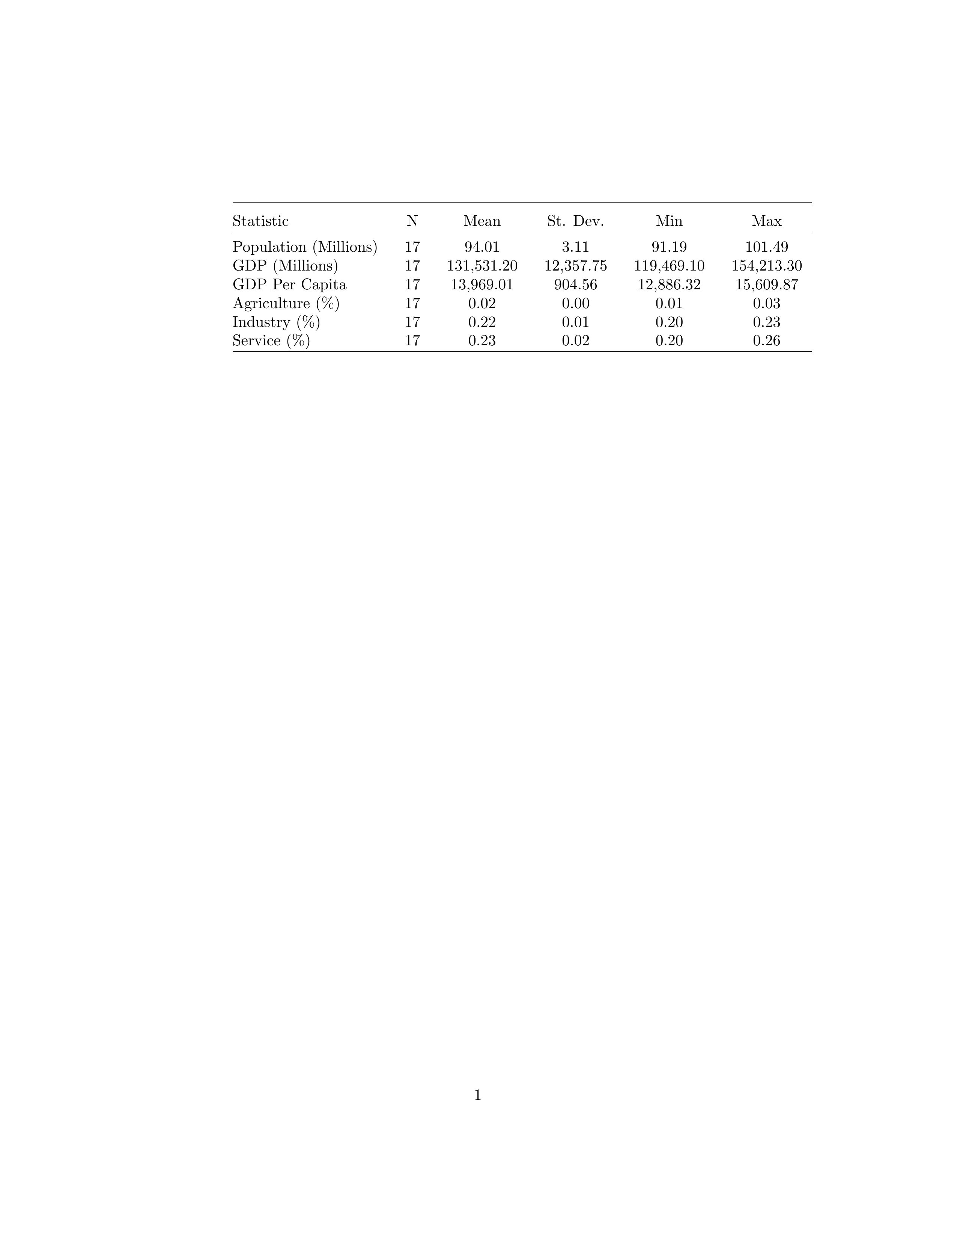
Table 2 Bayern Summary Statistics
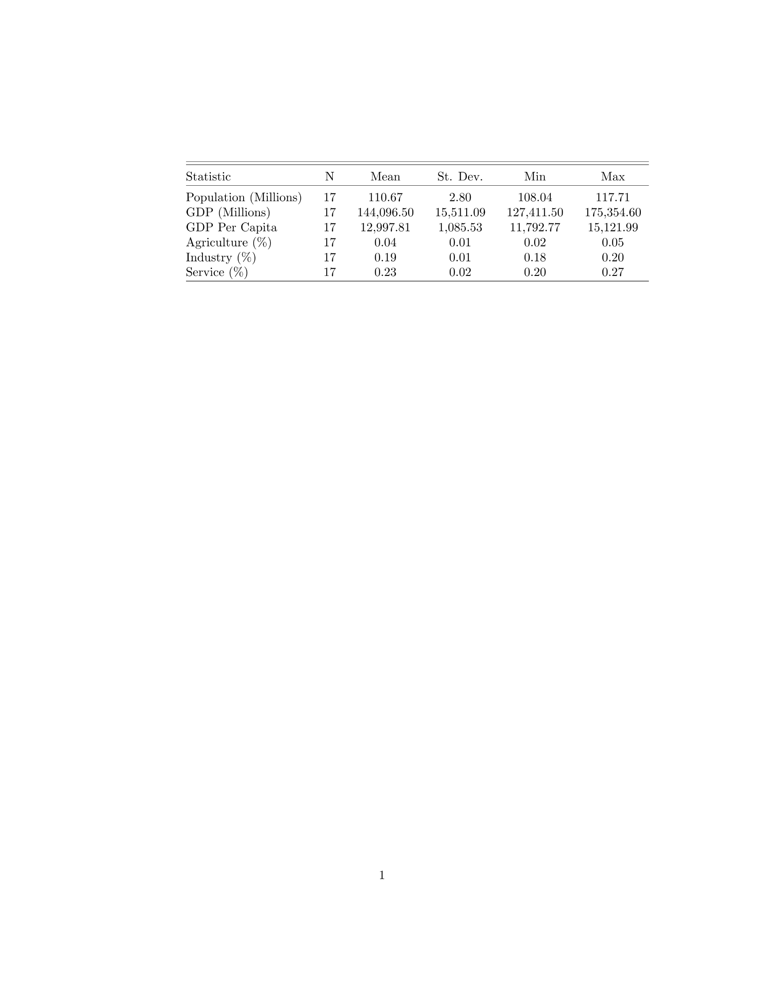
Table 3 Hessen Summary Statistics
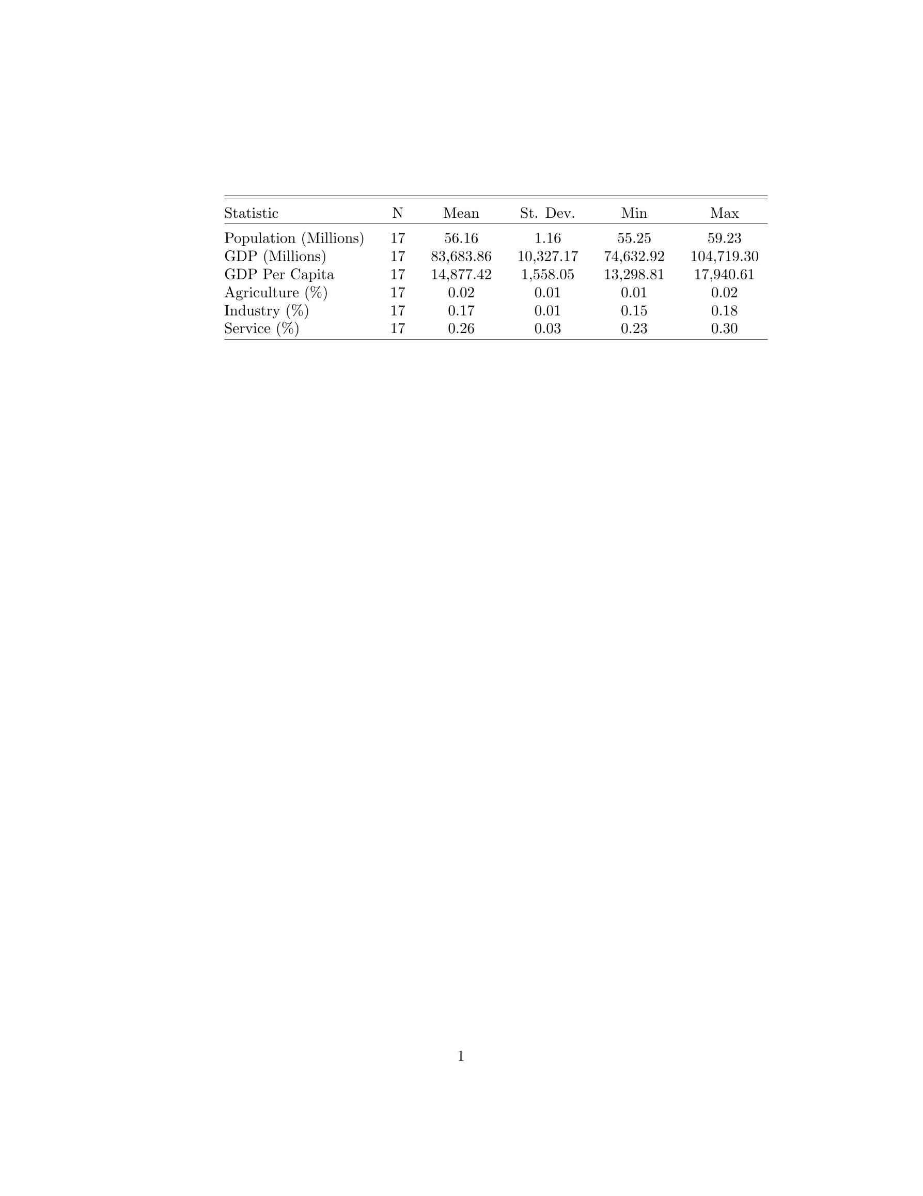
Table 4 Nordrhein-Westfalen Summary Statistics
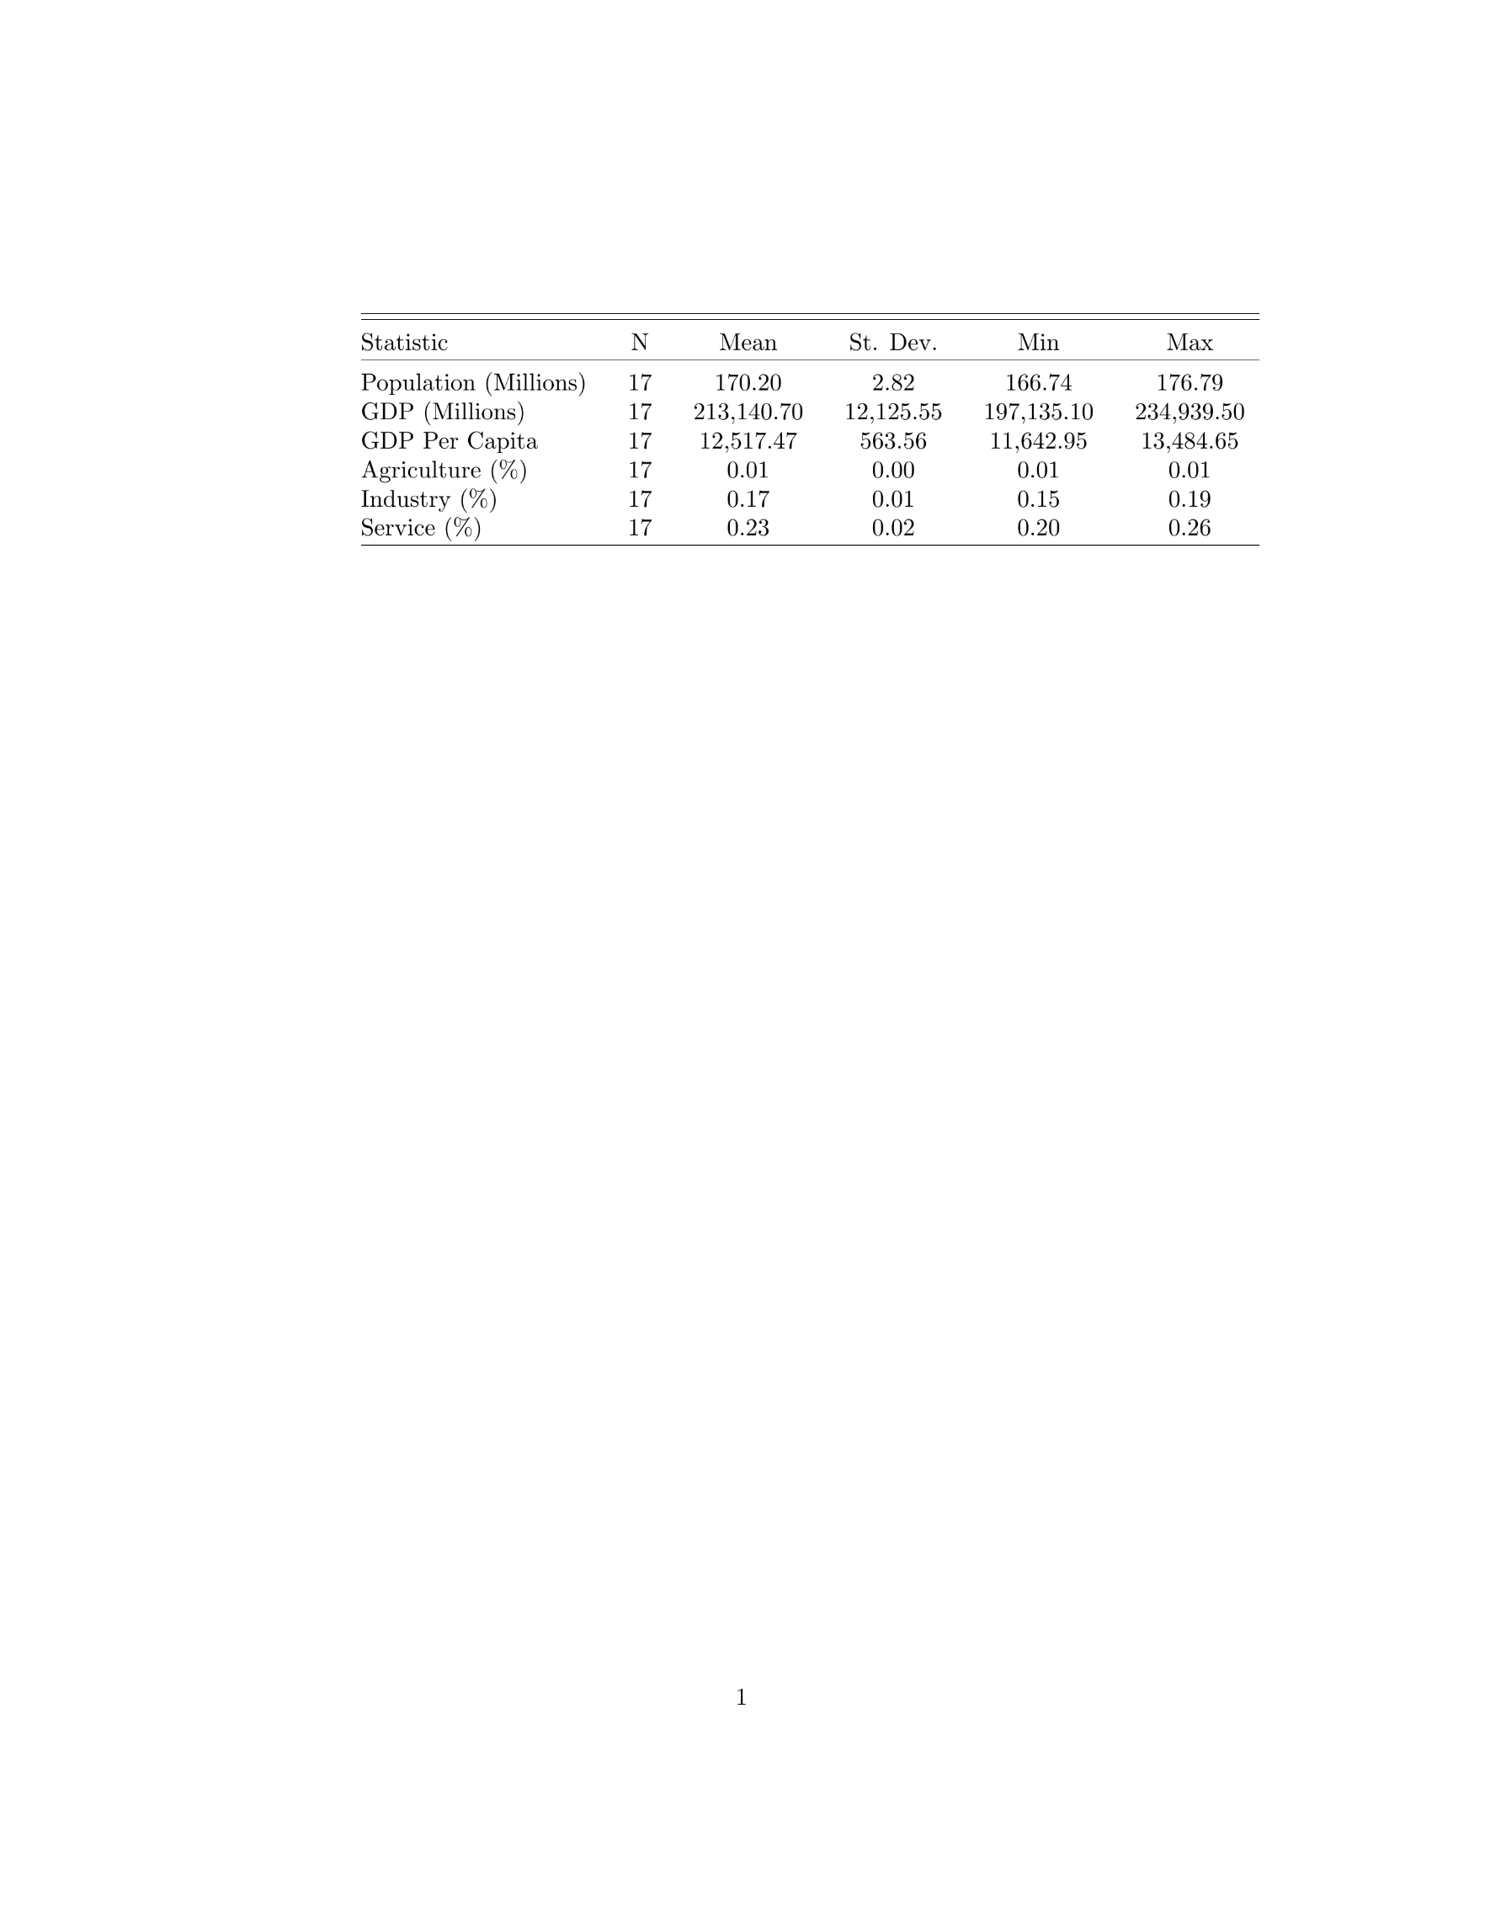
Table 5 Emilia Romagna Summary Statistics
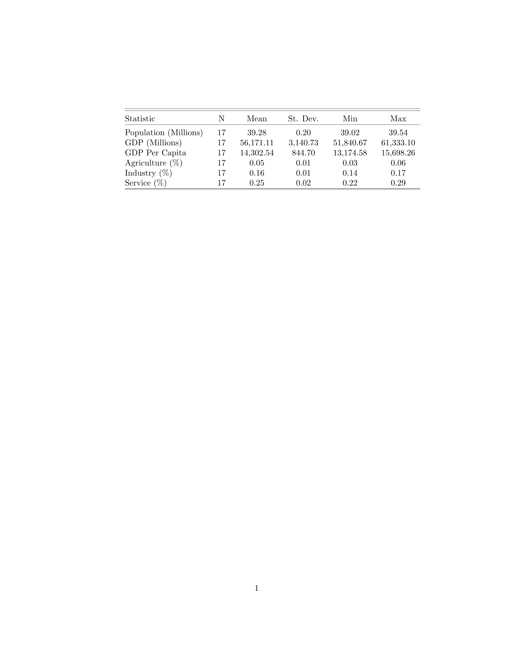
Table 6 Friuli-Venezia Giulia Summary Statistics
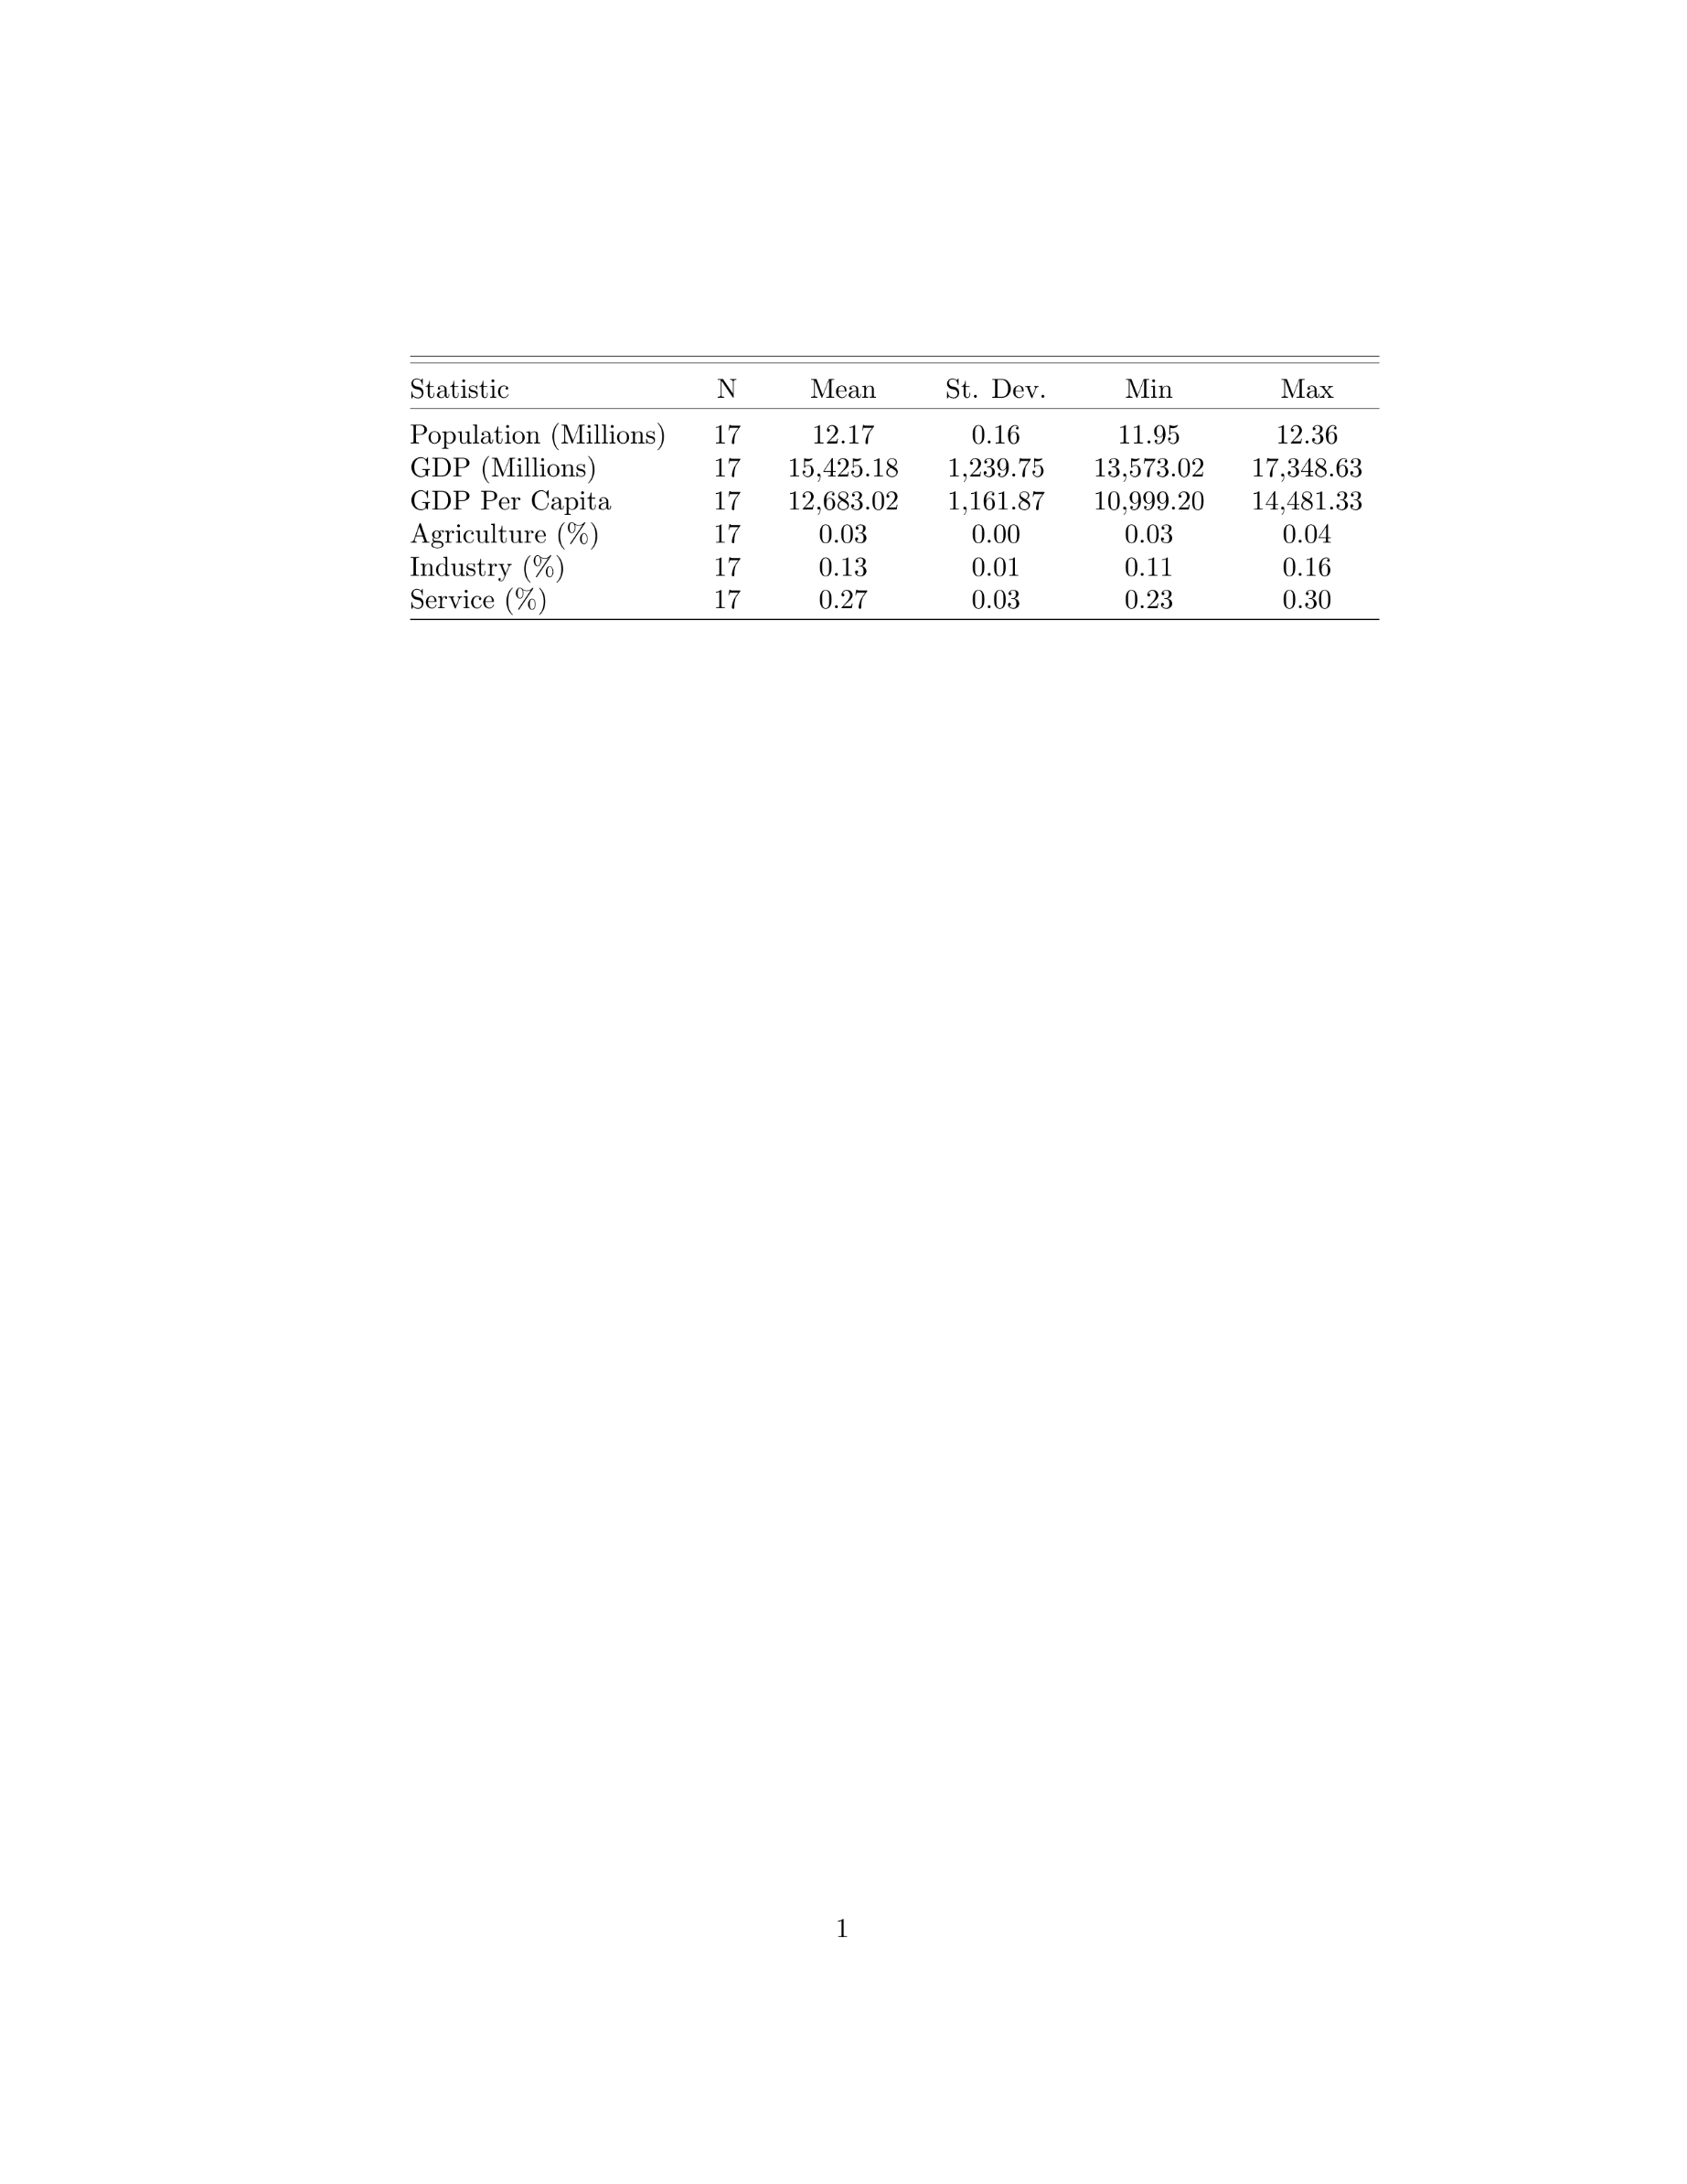
Table 7 Liguria Summary Statistics
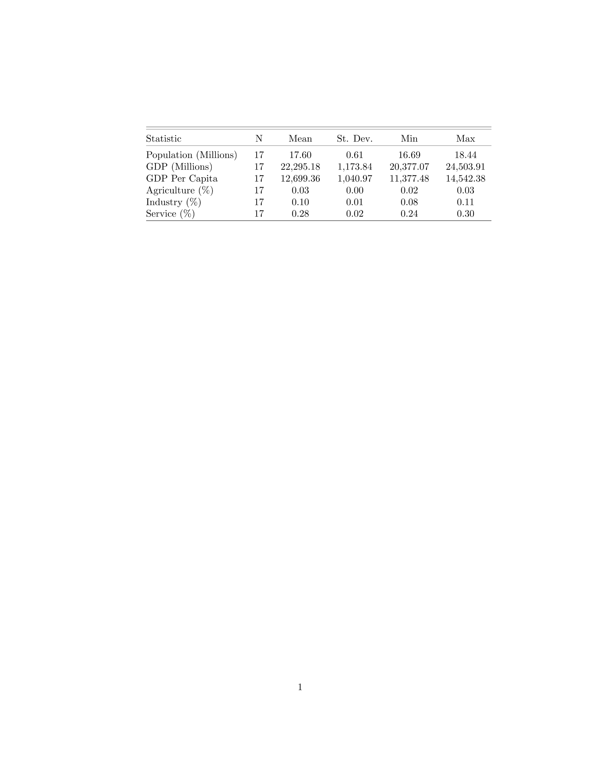
Table 8 Lombardia Summary Statistics
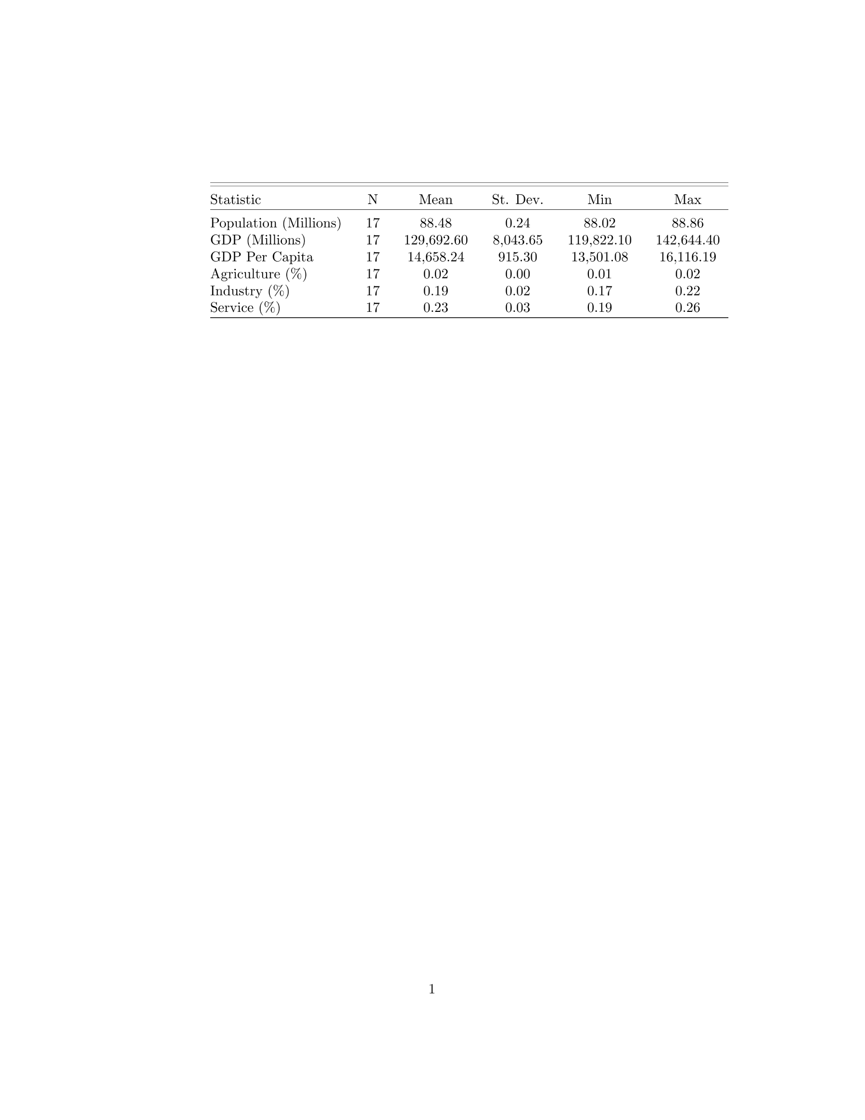
Table 9 Piemonte Summary Statistics
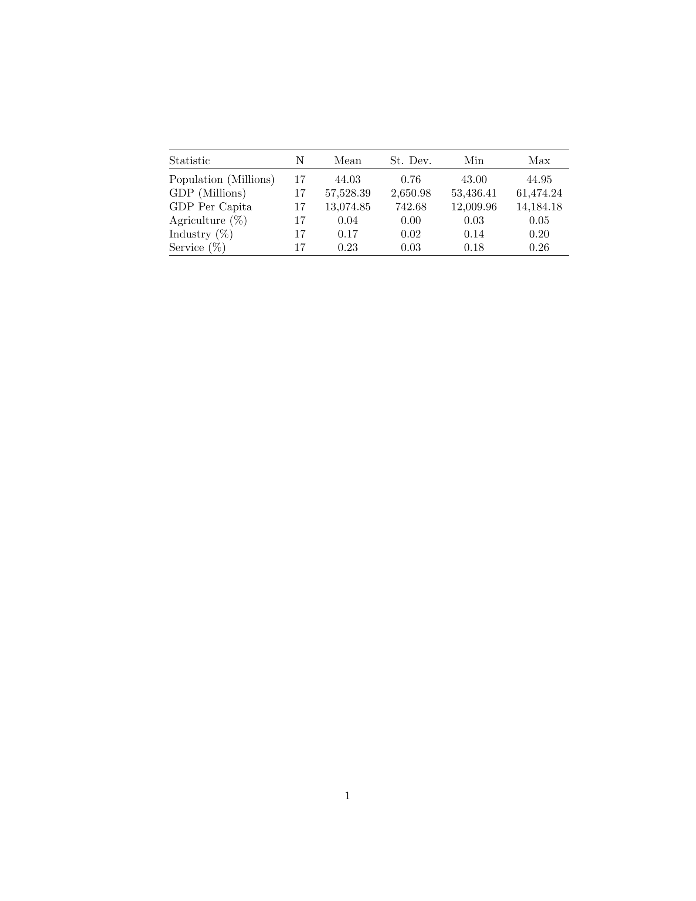
Table 10 Trentino-Alto Adige/Südtirol Summary Statistics
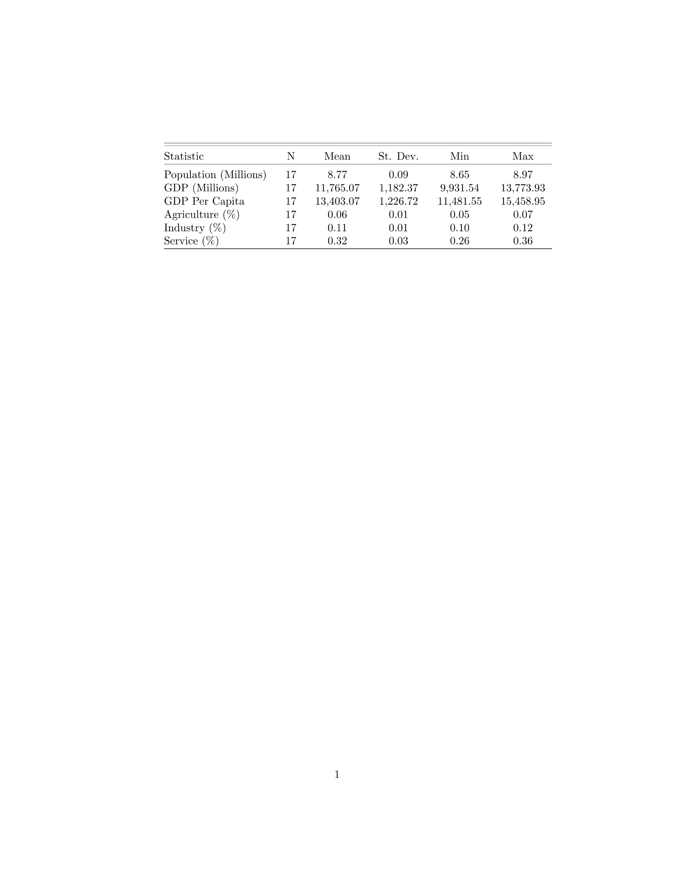
Table 11 Valle d’Aosta Summary Statistics
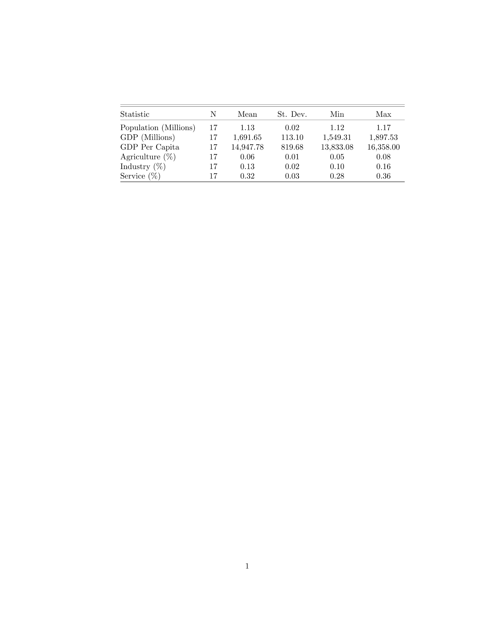
Table 12 Veneto Summary Statistics
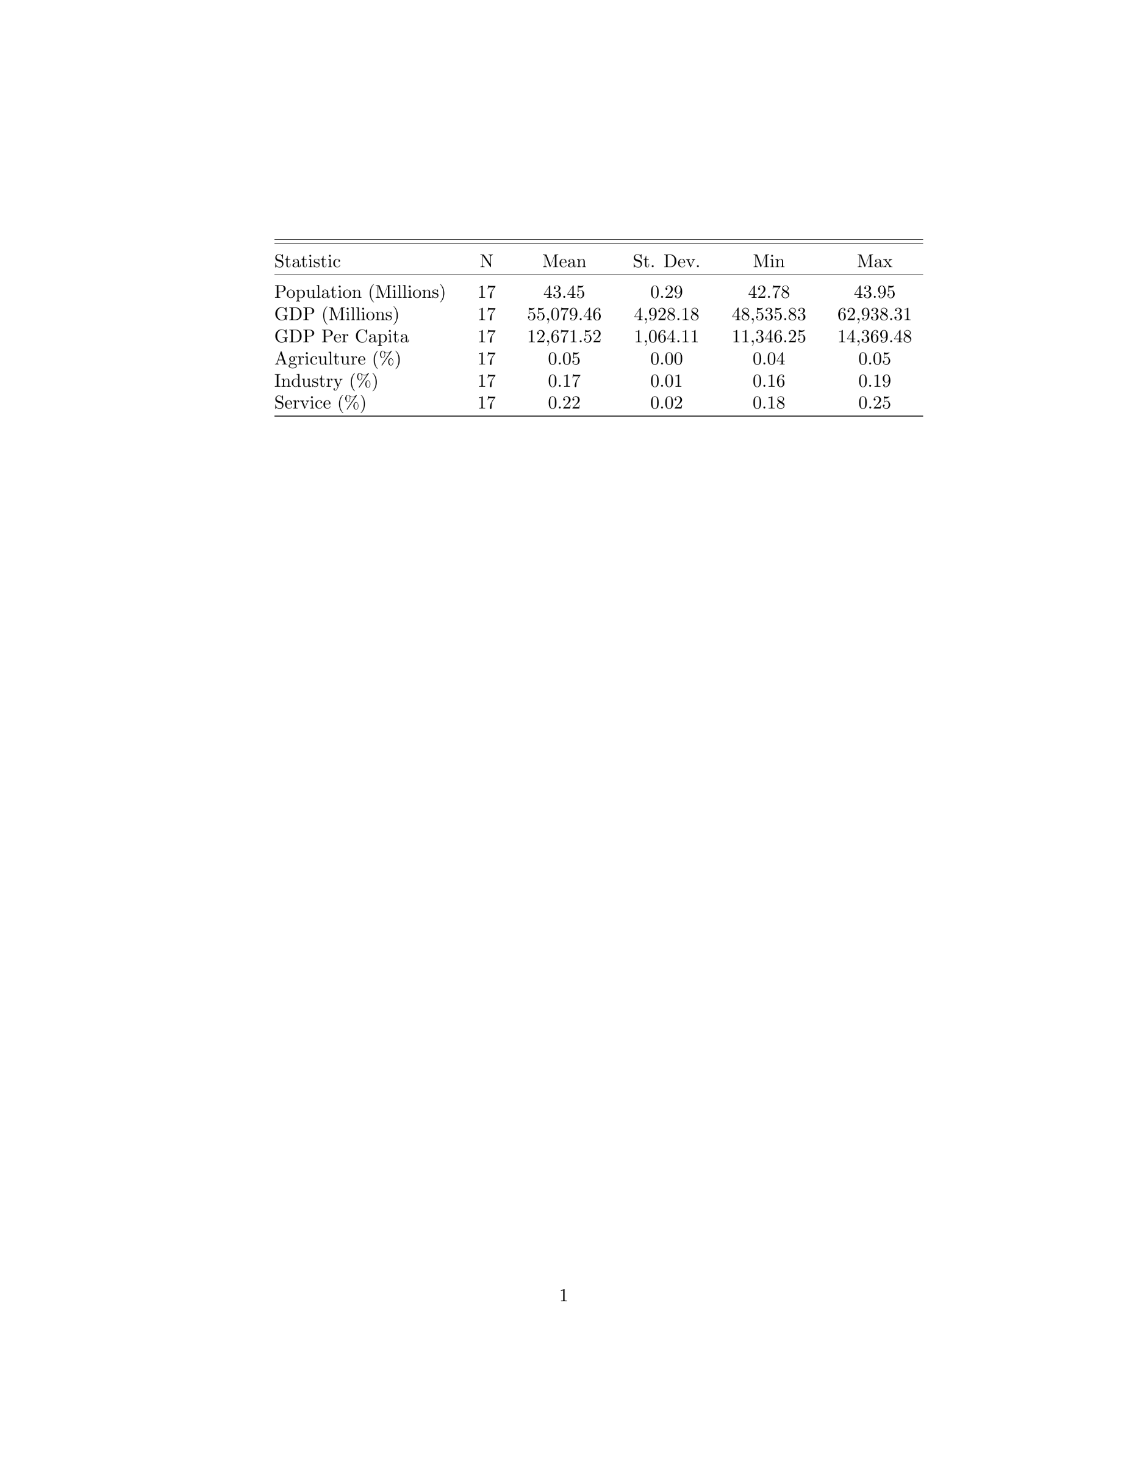

Appendix B: GDP and GDP Per Capita Plots
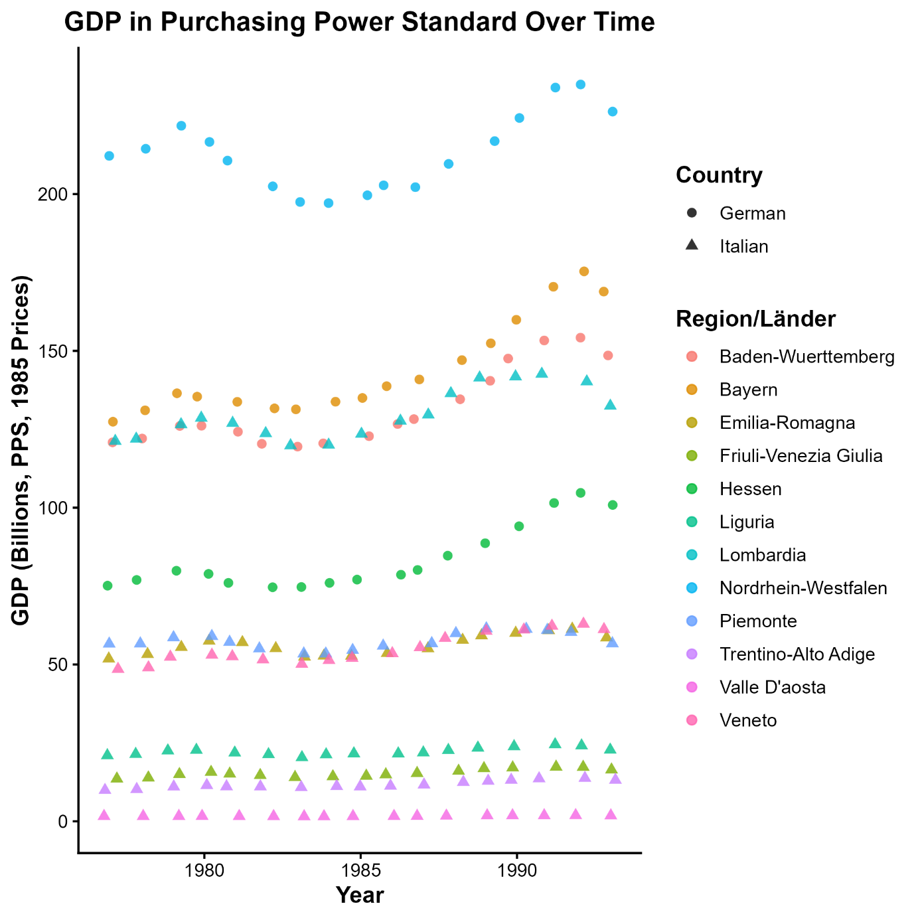
Figure 1: Real GDP 1977-1993 in selected regions using 1985 constant prices. Values in billions of purchasing power standard.
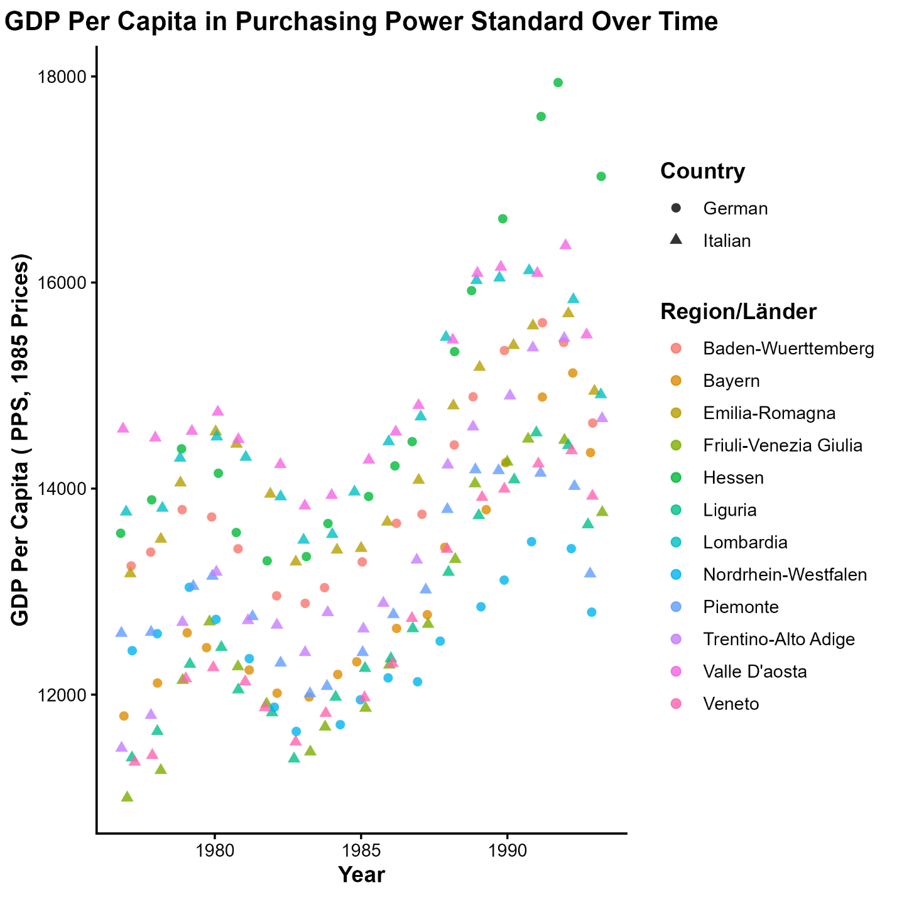
Figure 2: Real GDP Per Capita 1977-1993 in selected regions using constant 1985 prices. Values in purchasing power standard.

Appendix C: Regression Results
Table 13 Panel Regression Results for GDP and GDP Per Capita 1977 – 1993: This table presents the panel-fixed effects estimates for regional GDP and GDP Per Capita. The models evaluate the effects of special statute status, for Italian regions, and federal status, for German Länder, on GDP, GDP Per Capita, and their growth rates. Models (1) – (3) use log(GDP) as the dependent variable, while models (4) – (6) use log(GDP Per Capita) as the dependent variable. Region and year fixed effects are used as indicated, but the standard errors in parentheses are clustered by both region and year, regardless of which fixed effect was used, to be robust to the correlation structure within each region and year. 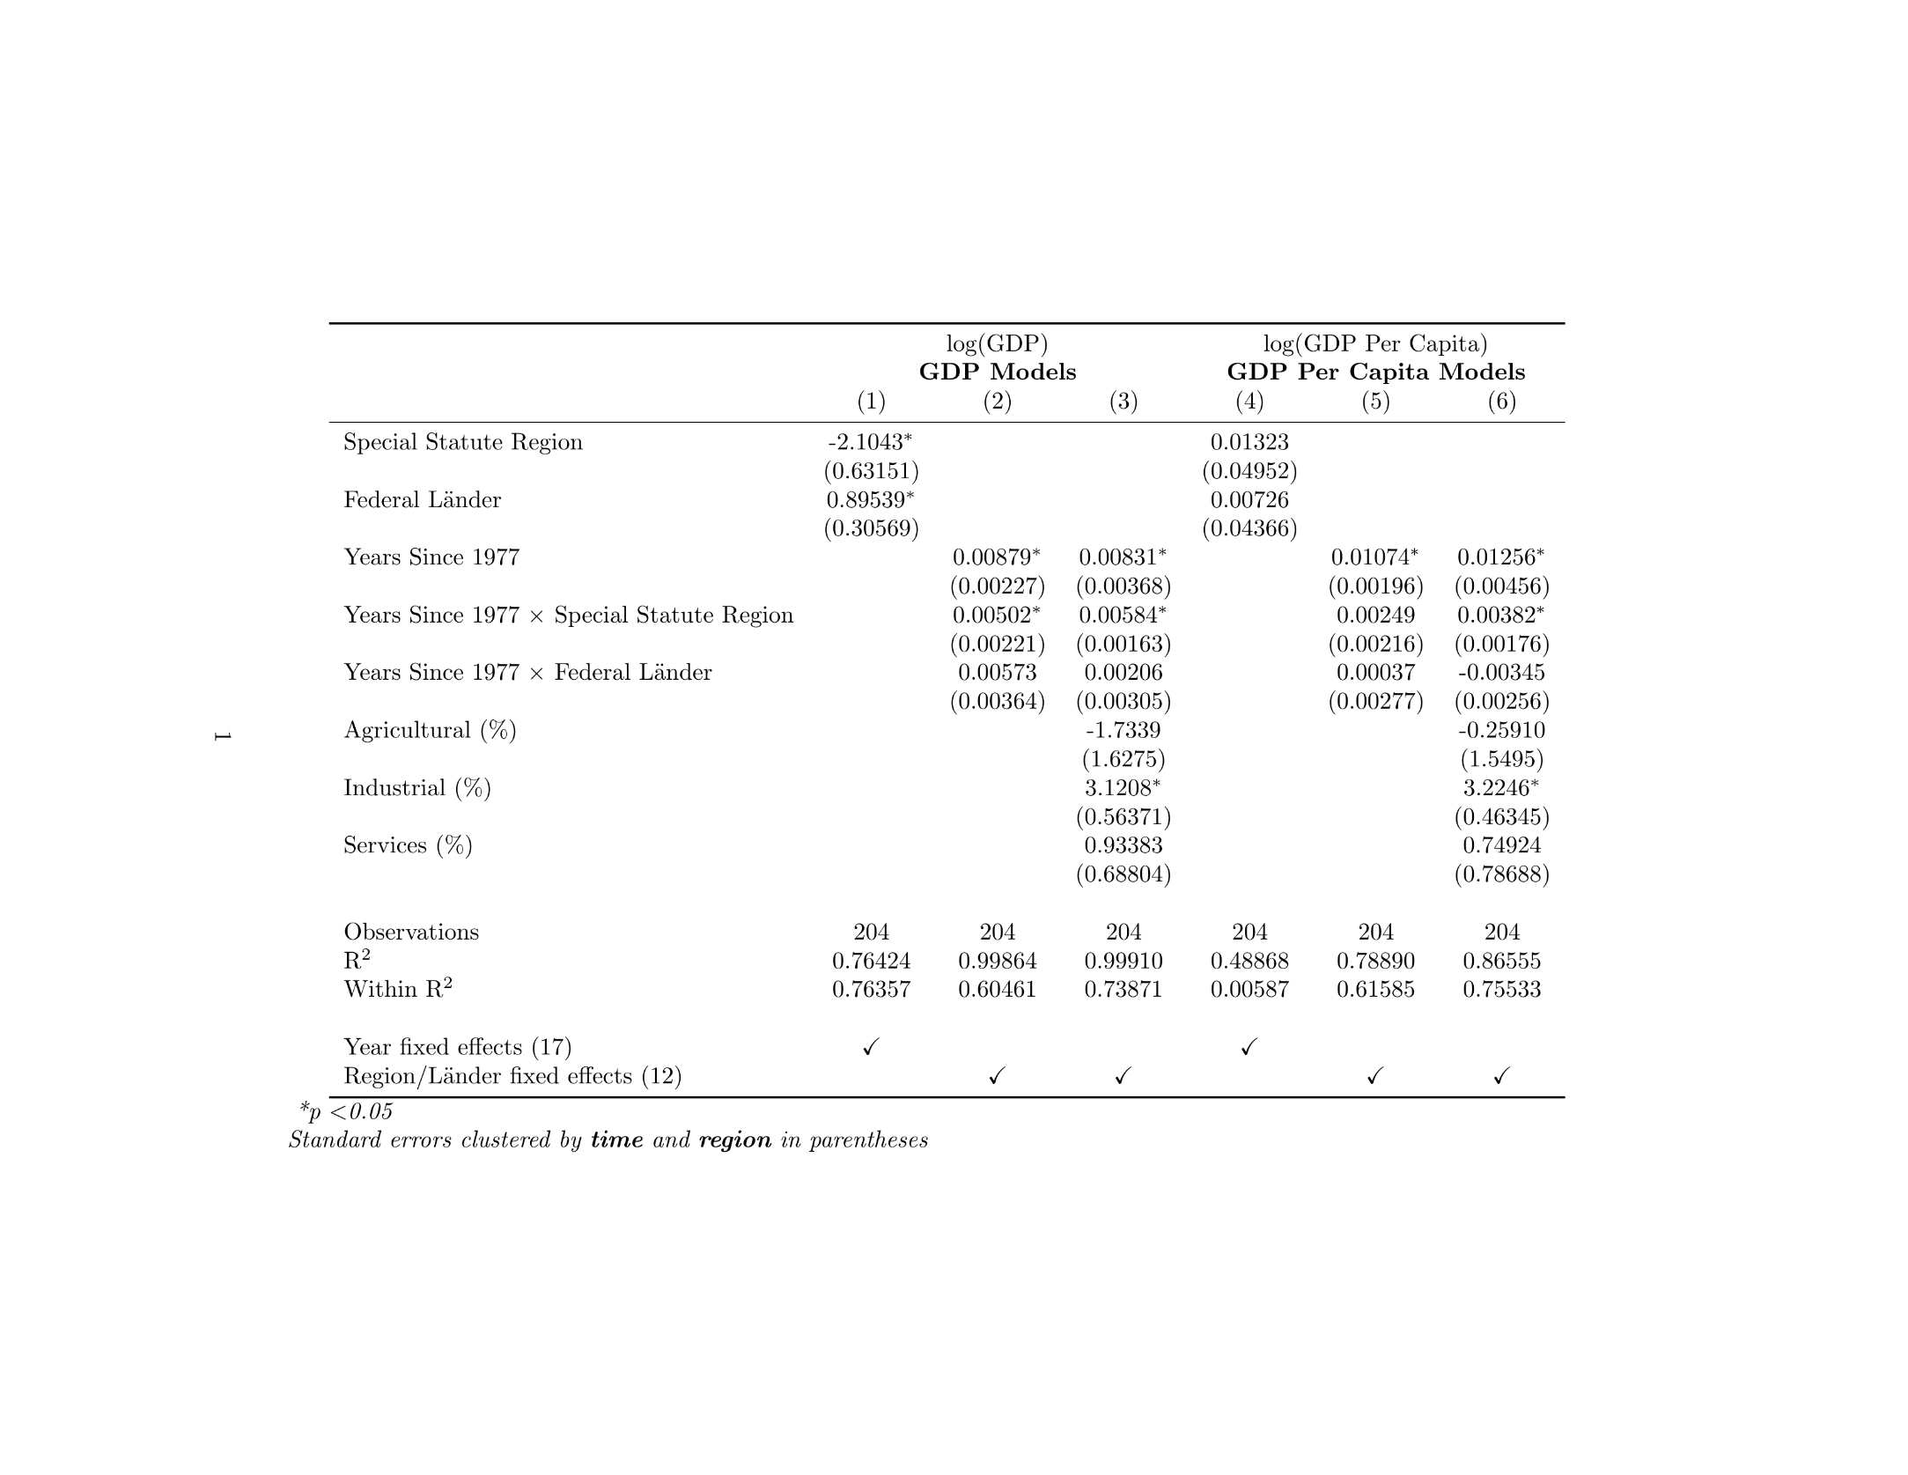

Appendix D: Replication
All of the data and code used are available on GitHub (https://github.com/Noch05/it_de_regional_autonomy_analysis) along with instructions for replication. Note replication requires an R installation with the required packages, and a LaTeX distribution as well.

Giliberto Capano and Andrea Lippi, “Decentralization, Policy Capacities, and Varieties of First Health Response to the COVID-19 Outbreak: Evidence from Three Regions in Italy,” Journal of European Public Policy 28, no. 8 (2021): 1197–218, https://doi.org/10.1080/13501763.2021.1942156; Mattia Casula and Serafín Pazos-Vidal, “Assessing the Multi-Level Government Response to the COVID-19 Crisis: Italy and Spain Compared,” International Journal of Public Administration 44, nos. 11–12 (2021): 994–1005, https://doi.org/10.1080/01900692.2021.1915330; Eugenio Salvati, “Fragmentation and Intergovernmental Conflict during the Covid-19 Crisis. The Complex Relationship between National and Regional Governments in Italy,” Regional & Federal Studies 34, no. 3 (2024): 405–34, https://doi.org/10.1080/13597566.2022.2100769; Erika Arban, Italian Regionalism and the Federal Challenge: Reconciling Economic Regionalism and Solidarity, Federalism and Internal Conflicts (Springer Nature Switzerland, 2023), chap. 2, https://doi.org/10.1007/978-3-031-31543-5.
Charles L. Killinger, The History of Italy (Bloomsbury Publishing USA, 2002), chaps. 3–5, http://ebookcentral.proquest.com/lib/aul/detail.action?docID=3000896.
Arban, Italian Regionalism and the Federal Challenge, chap. 2; Michael Broers, “The Myth and Reality of Italian Regionalism: A Historical Geography of Napoleonic Italy, 1801-1814,” The American Historical Review 108, no. 3 (2003): 688–709, https://doi.org/10.1086/529593.
Rafele Paci and Stefano Usai, “Regio-EU 1977-1996,” 1997, https://crenos.unica.it/crenos/databases/database-regio-eu-1977-1996.
Salvati, “Fragmentation and Intergovernmental Conflict during the Covid-19 Crisis. The Complex Relationship between National and Regional Governments in Italy”; Casula and Pazos-Vidal, “Assessing the Multi-Level Government Response to the COVID-19 Crisis”; Capano and Lippi, “Decentralization, Policy Capacities, and Varieties of First Health Response to the COVID-19 Outbreak.”
Federico Podestà, “The Economic Impact of the Friuli-Venezia Giulia Autonomy: A Synthetic Control Analysis of Asymmetric Italian Federalism,” The Annals of Regional Science 58, no. 1 (2017): 21–37, https://doi.org/10.1007/s00168-016-0779-0; Giuseppe Di Vita, “Institutional Quality and the Growth Rates of the Italian Regions: The Costs of Regulatory Complexity,” Papers in Regional Science 97, no. 4 (2018): 1057–82, https://doi.org/10.1111/pirs.12290.
Killinger, The History of Italy, chap. 3. These former Roman cities today are Italy’s largest metropolitan regions.
Killinger, The History of Italy, chap. 3. Most famously, the northern parts of the Italian peninsula were ruled by the Ostrogoths, Lombards, and then by the Franks under the Carolingian dynasty. These kingdoms were relatively short-lived, lasting only 50 – 150 years on average. These groups relied on the existing structures in place, particularly Roman cities, and the Roman Church (not yet Catholic), to rule giving a strong bias to local institutions, and preventing any significant changes in local administration. Throughout this time, from around 500 to 900 CE, little If any changes to daily life occurred for the average person, they continued working in the fields and speaking their dialect of vulgar Latin. Although later in the Middle Ages (900 – 1300 CE), with the creation of the Holy Roman Empire, these Germanic rulers would be more official, as in they ruled states, not simply tribes or loose kingdoms, they still failed to impose their will or effectively control their Italian territories.
Killinger, The History of Italy, chaps. 3–4.
Killinger, The History of Italy, chaps. 3–5. The southern portion of the Italian peninsula has been ruled by the Eastern Roman Empire, the Arab empires from the Middle East, the Hohenstaufens (a German dynasty), the Angevins (A French dynasty, who ruled England), the Aragonese, the Spanish Habsburgs, and the French Bourbons (A different branch then the bourbons that ruled France, this branch comes from branch that in the early 1700s claimed the thrown of Spain).
Killinger, The History of Italy, chaps. 4–5.
Killinger, The History of Italy, chaps. 4–5; Arban, Italian Regionalism and the Federal Challenge, chaps. 1–2.
Broers, “The Myth and Reality of Italian Regionalism.”
Broers, “The Myth and Reality of Italian Regionalism”; Arban, Italian Regionalism and the Federal Challenge, chap. 2.
Arban, Italian Regionalism and the Federal Challenge, chap. 2. This is partially misleading. The House of Savoy is of French origin, from the Duchy of Savoy inside of the Kingdom of Burgundy, which today is part of France proper. However, they ruled the Piedmont region of Italy for centuries before the Napoleonic invasions, so can effectively be treated as “native” in the sense compared to the other rulers put in place. Additionally, in 1860, on the verge of Italian unification, the House of Savoy ceded its namesake Duchy of Savoy and County of Nice to France, to only bring their Italian territories into the new state. The other states formed by the Congress of Vienna were either under the control of the Austrian Empire, the Pope, the French Bourbon dynasty, or relatives of the Austrian Emperor.
Arban, Italian Regionalism and the Federal Challenge, chap. 2.
Francesco Palermo, “Asymmetries in the Italian Regional System and Their Role Model,” in Federalism and Constitutional Law: The Italian Contribution to Comparative Regionalism, ed. Erika Arban et al. (Routledge, 2021), https://doi.org/10.4324/9781003104469; Brunetta Baldi, “Exploring Autonomism: Asymmetry and New Developments in Italian Regionalism,” Revista d’Estudis Autonòmics i Federals. Journal of Self-Government (REAF-JSG), no. 32 (2020): 15–44, https://doi.org/10.2436/20.8080.01.52.
Arban, Italian Regionalism and the Federal Challenge, chaps. 2–4; Antonia Baraggia and Benedetta Vimercati, “Unity and Diversity: A Turbulent Journey Through Italian Fiscal Federalism,” in Fiscal Federalism and Diversity Accommodation in Multilevel States: A Comparative Outlook, ed. Francisco Javier Romero Caro and Alice Valdesalici (Springer Nature Switzerland, 2024), https://doi.org/10.1007/978-3-031-53759-2_7; Palermo, “Asymmetries in the Italian Regional System and Their Role Model”; Baldi, “Exploring Autonomism”; Gianfranco Baldini and Brunetta Baldi, “Decentralization in Italy and the Troubles of Federalization,” Regional & Federal Studies 24, no. 1 (2014): 87–108, https://doi.org/10.1080/13597566.2013.827116.
Arban, Italian Regionalism and the Federal Challenge, chap. 3; Baraggia and Vimercati, “Unity and Diversity”; Palermo, “Asymmetries in the Italian Regional System and Their Role Model.”
Alice Valdesalici, “Financial Relations in the Italian Regional System,” in Federalism and Constitutional Law: The Italian Contribution to Comparative Regionalism, ed. Erika Arban et al. (Routledge, 2021), https://doi.org/10.4324/9781003104469.
Baraggia and Vimercati, “Unity and Diversity”; Valdesalici, “Financial Relations in the Italian Regional System.”
Baldini and Baldi, “Decentralization in Italy and the Troubles of Federalization”; Baldi, “Exploring Autonomism”; Erika Arban, “An Intellectual History of Italian Regionalism,” in Federalism and Constitutional Law: The Italian Contribution to Comparative Regionalism, ed. Erika Arban et al. (Routledge, 2021), https://doi.org/10.4324/9781003104469.
Arban, Italian Regionalism and the Federal Challenge, 2,4.
Baldi, “Exploring Autonomism.” The five special statute regions are Sicily, Sardinia, Valle d’Aosta, Trentino-Alto Adige/Südtirol, and Friuli-Venezia Giulia. Sicily and Sardinia are both islands that have impacted their development in different ways, as they have not always been integrated with the Italian peninsula. Each speaks their own dialects, which are much more distinct from standard Italian than any other, thus providing the case for autonomy. Valle d’Aosta contains a large French population because it is the remnants of the House of Savoy’s majority French territory that was incorporated into the Kingdom of Italy. Trentino-Alto Adige/Südtirol contains a large ethnic German/Austrian population, because the land was taken from Austria after World War I for political and strategic reasons, not necessarily nationalistic. Lastly, Friuli-Venezia Giulia contains a Slovenian population because most of its land was also given to Italy after World War I, from Austria’s Slavic lands. In fact, special status was only granted in 1963, after the international monitoring phase of the region and the city of Trieste ended.
Baldini and Baldi, “Decentralization in Italy and the Troubles of Federalization”; Baldi, “Exploring Autonomism.”
Podestà, “The Economic Impact of the Friuli-Venezia Giulia Autonomy.”
Podestà, “The Economic Impact of the Friuli-Venezia Giulia Autonomy.” These placebo tests label one of the ordinary regions as autonomous and then run the same quasi-experiment to show whether it is Friuli-Venezia Giulia’s actual autonomy creating its growth or simply the label. The placebo tests in this work are used as a replacement for standard statistical inference
Di Vita, “Institutional Quality and the Growth Rates of the Italian Regions.”
Salvati, “Fragmentation and Intergovernmental Conflict during the Covid-19 Crisis. The Complex Relationship between National and Regional Governments in Italy”; Casula and Pazos-Vidal, “Assessing the Multi-Level Government Response to the COVID-19 Crisis.”
Capano and Lippi, “Decentralization, Policy Capacities, and Varieties of First Health Response to the COVID-19 Outbreak.”
Capano and Lippi, “Decentralization, Policy Capacities, and Varieties of First Health Response to the COVID-19 Outbreak.”
Paci and Usai, “Regio-EU 1977-1996.”
Paci and Usai, “Regio-EU 1977-1996.”
Göran Kauermann and Raymond J Carroll, “A Note on the Efficiency of Sandwich Covariance Matrix Estimation,” Journal of the American Statistical Association 96, no. 456 (2001): 1387–96, https://doi.org/10.1198/016214501753382309; James G MacKinnon and Halbert White, “Some Heteroskedasticity-Consistent Covariance Matrix Estimators with Improved Finite Sample Properties,” Journal of Econometrics 29, no. 3 (1985): 305–25, https://doi.org/10.1016/0304-4076(85)90158-7; J. M. Neuhaus and J. D. Kalbfleisch, “Between- and within-Cluster Covariate Effects in the Analysis of Clustered Data,” Biometrics 54, no. 2 (1998): 638–45; Andrew Bell and Kelvyn Jones, “Explaining Fixed Effects: Random Effects Modeling of Time-Series Cross-Sectional and Panel Data,” Political Science Research and Methods 3, no. 1 (2015): 133–53, https://doi.org/10.1017/psrm.2014.7; Alastair H. Leyland, “No Quick Fix: Understanding the Difference between Fixed and Random Effect Models,” Commentary, Journal of Epidemiology & Community Health 64, no. 12 (2010): 1027–28, https://doi.org/10.1136/jech.2009.102236; A. Colin Cameron et al., “Robust Inference With Multiway Clustering,” Journal of Business & Economic Statistics 29, no. 2 (2011): 238–49, https://doi.org/10.1198/jbes.2010.07136; Guido W. Imbens and Michal Kolesár, “Robust Standard Errors in Small Samples: Some Practical Advice,” The Review of Economics and Statistics 98, no. 4 (2016): 701–12; Giovanni Millo, “Robust Standard Error Estimators for Panel Models: A Unifying Approach,” Journal of Statistical Software 82 (November 2017): 1–27, https://doi.org/10.18637/jss.v082.i03; Yair Mundlak, “Models with Variable Coefficients: Integration and Extension,” Annales de l’inséé, no. 30/31 (1978): 483–509, https://doi.org/10.2307/20075301.
R Core Team, R: A Language and Environment for Statistical Computing, v. 4.5.1, R Foundation for Statistical Computing, released 2025, https://www.r-project.org/; Laurent Berge et al., Fixest: Fast Fixed-Effects Estimations, v. 0.13.2, released September 8, 2025, https://cran.r-project.org/web/packages/fixest/index.html.
Hadley Wickham, “Tidyverse: Easily Install and Load the ‘Tidyverse,’” September 9, 2016, 2.0.0, https://doi.org/10.32614/CRAN.package.tidyverse; Marek Hlavac, Stargazer: Well-Formatted Regression and Summary Statistics Tables, v. 5.2.3, released March 4, 2022, https://cran.r-project.org/web/packages/stargazer/index.html; Jeroen Ooms, Magick: Advanced Graphics and Image-Processing in R, v. 2.9.0, released September 8, 2025, https://cran.r-project.org/web/packages/magick/index.html; Yihui Xie et al., Tinytex: Helper Functions to Install and Maintain TeX Live, and Compile LaTeX Documents, v. 0.58, released November 19, 2025, https://cran.r-project.org/web/packages/tinytex/index.html; Kirill Müller and Jennifer Bryan, Here: A Simpler Way to Find Your Files, v. 1.0.2, released September 15, 2025, https://cran.r-project.org/web/packages/here/index.html.
“CoR - Germany Introduction,” accessed November 5, 2025, https://portal.cor.europa.eu/divisionpowers/Pages/Germany-Introduction.aspx; “CoR - Germany Fiscal Powers,” accessed November 5, 2025, https://portal.cor.europa.eu/divisionpowers/Pages/Germany-Fiscal-Powers.aspx; Yannick Bury and Lars P. Feld, “Fiscal Federalism in Germany,” Freiburg Discussion Papers on Constitutional Economics, Freiburg Discussion Papers on Constitutional Economics, Walter Eucken Institut e.V., 2020, 20/4, https://ideas.repec.org//p/zbw/aluord/2004.html.

