Computer Fundamentals Assignment

PORTFOLIO 2

John Hasznosi

# Table of Content

Table of Content 2

Introduction 3

Entity Relationship Diagram 4

Database Creation and Population 5

DROP Code 5

CREATE Code 5

Insert Values and Population 5

Queries and Results 6

Conclusion 10

Appendix A 10

SQL Code 10

# Introduction

*This task was set in order to introduce concepts or SQL design and implementation while fulfilling the requests of a pretend scenario. Visual Paradigm was also used to create a conceptual diagram. The project started with the DROP items and then Tables were created manually. Manual Inserts were also used to enter data into the tables, followed by SELECT statements to pull the data.*

# Entity Relationship Diagram

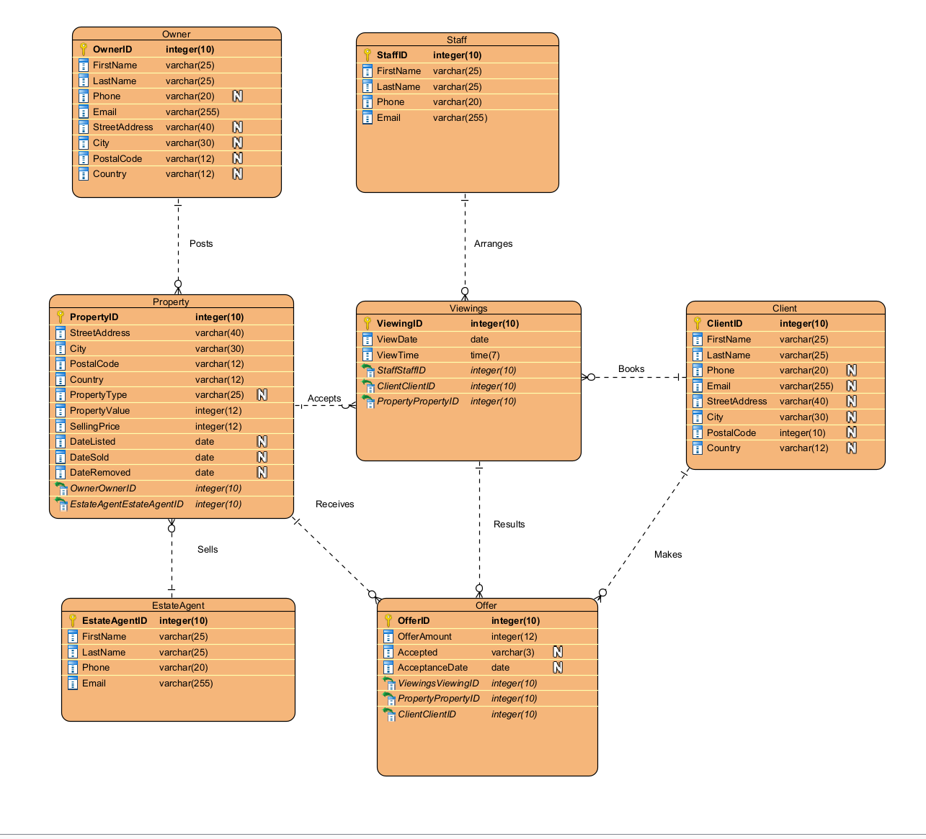

**Commentary**

|  |
| --- |
| The tutorial example was followed. Along with many of the decisions made there, the most important was that there should be a total of seven entities. Other assumptions made included: Some owners might sell multiple properties; owners and clients might reside be overseas; property values are 1 billion or under in price; properties have two types: commercial, house; not all clients or owners will not necessarily have both an email address or phone number, but owners definitely need to have a phone number; not all owners / clients may wish to share their personal address; accepted / acceptance date should be nullable while negotiations are pending. All contact information of staff and estate agents is of course not nullable.  It’s also assumed here that viewings can only take place one at a time. But this would need to be confirmed by speaking to the staff and asking them how they operate. It’s entirely possible that multiple viewings are conducted at the same time for example. |

Clients can make multiple offers on the same properties, and can book multiple viewings.

One staff member can arrange multiple viewings, and one viewing can result in multiple offers.

To the ‘Offer’ an ‘acceptance date’ was added as an attribute. It might be useful information for the company to know how quickly their properties are being sold.

# SQL Code Screenshots

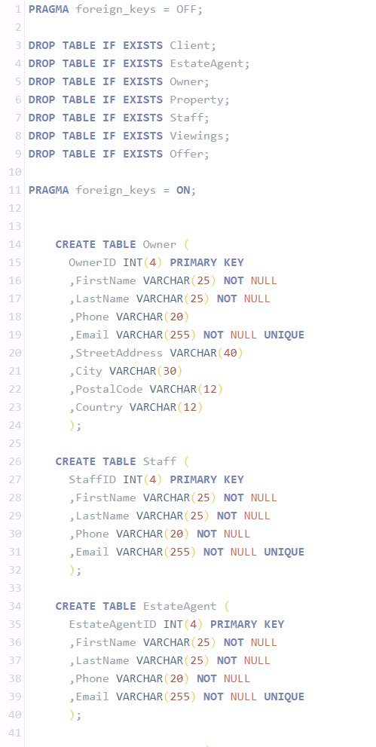

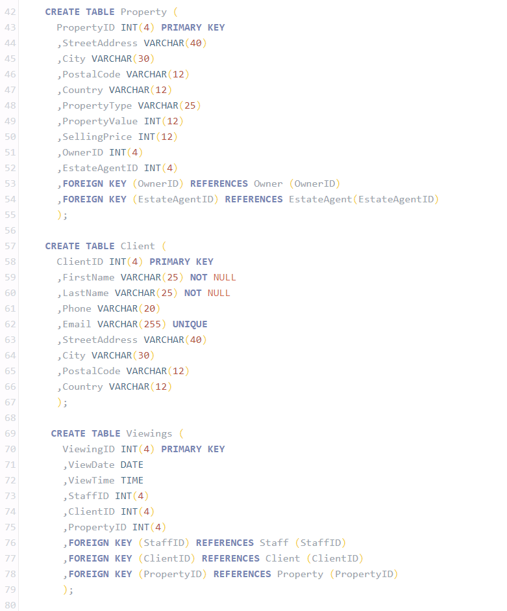

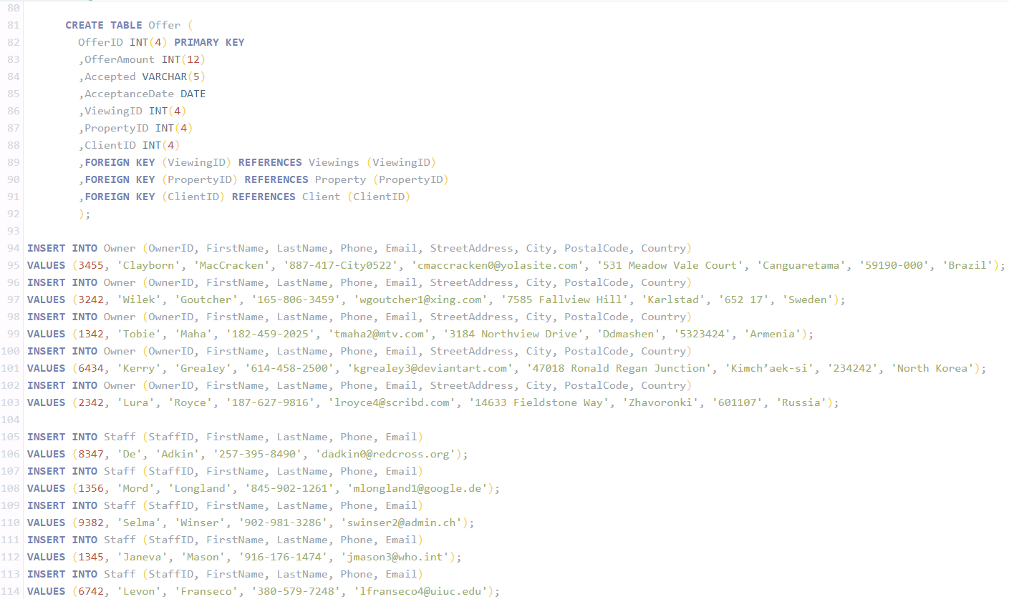

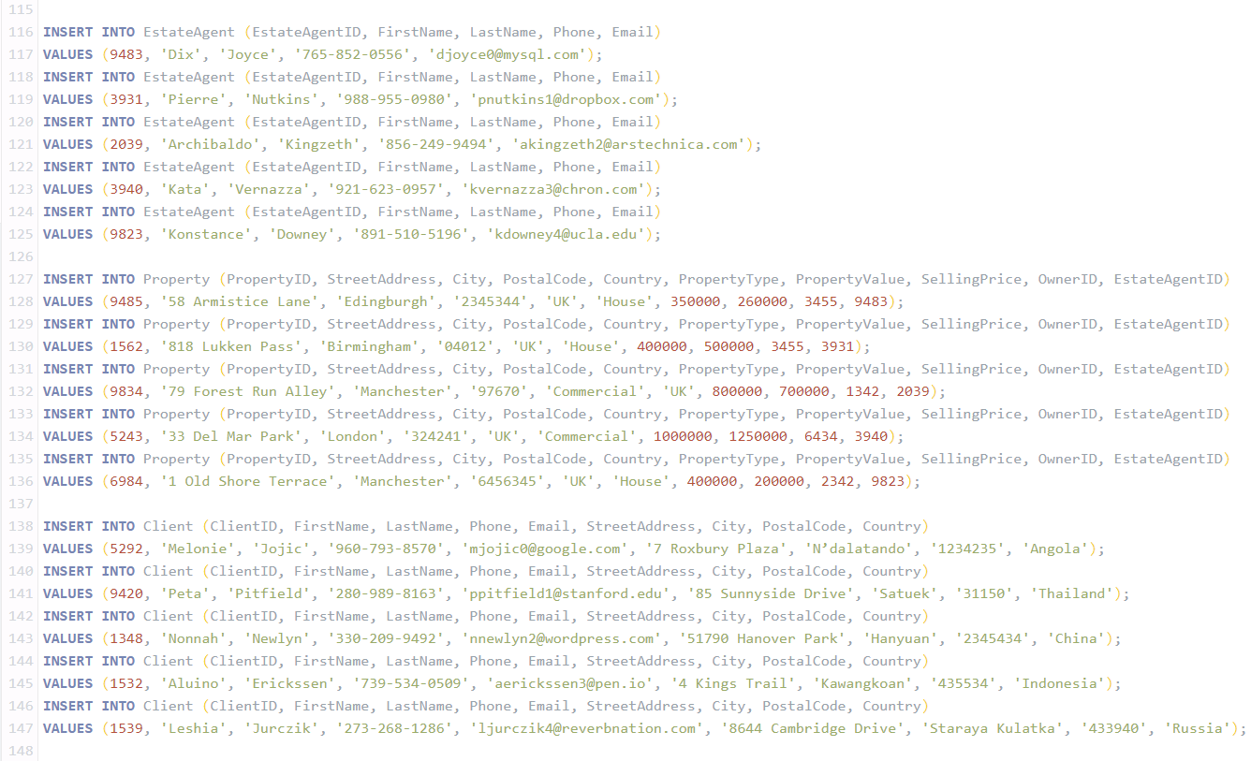

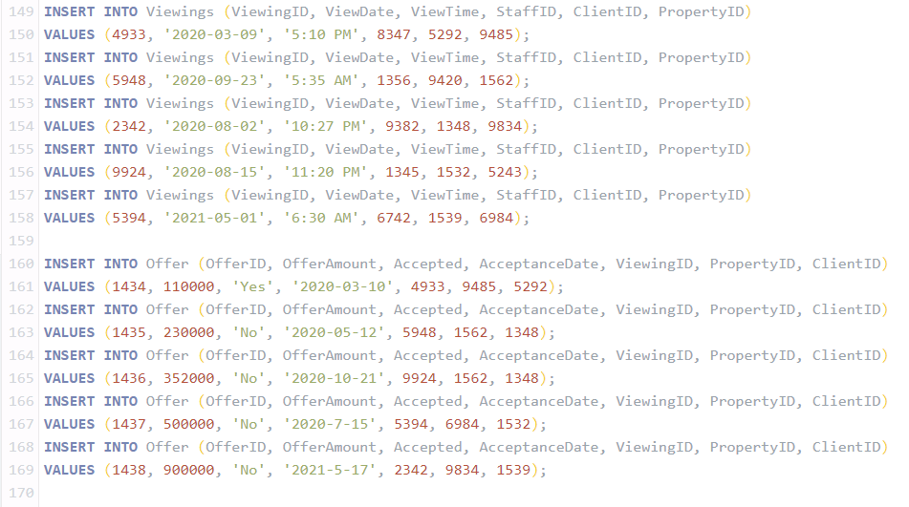

# Queries and Results

1. List all properties located in the city of Manchester with a list price of over £200,000

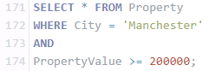



1. List all viewings that took place in August or September 2020 and the clients who requested the viewings

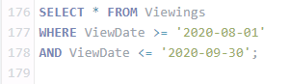

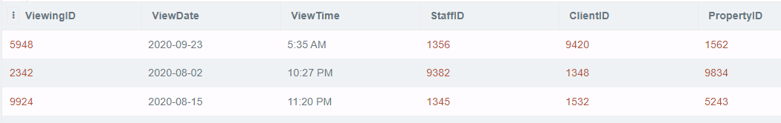

1. For each owner, list their total portfolio value (i.e. the total of all their properties’ prices) but only for properties which are houses

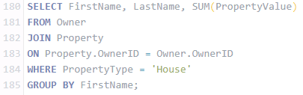

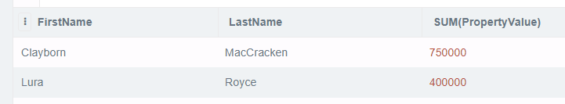

1. For each property, list the smallest offer made by clients and which client made the offer, but only for properties which have not been sold

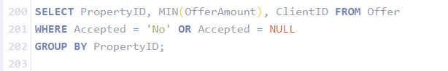

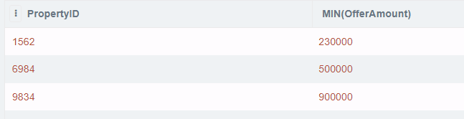

# Conclusion

By using SELECT statements, users should be able to query any of the tables and select the data they need contained there. There was no need for weak elements, as this was avoided in the original portfolio question. It was important to be mindful of the order of the tables created.

# Appendix A

## SQL Code

PRAGMA foreign_keys = OFF;

DROP TABLE IF EXISTS Client;

DROP TABLE IF EXISTS EstateAgent;

DROP TABLE IF EXISTS Owner;

DROP TABLE IF EXISTS Property;

DROP TABLE IF EXISTS Staff;

DROP TABLE IF EXISTS Viewings;

DROP TABLE IF EXISTS Offer;

PRAGMA foreign_keys = ON;

CREATE TABLE Owner (

OwnerID INT(4) PRIMARY KEY

,FirstName VARCHAR(25) NOT NULL

,LastName VARCHAR(25) NOT NULL

,Phone VARCHAR(20)

,Email VARCHAR(255) NOT NULL UNIQUE

,StreetAddress VARCHAR(40)

,City VARCHAR(30)

,PostalCode VARCHAR(12)

,Country VARCHAR(12)

);

CREATE TABLE Staff (

StaffID INT(4) PRIMARY KEY

,FirstName VARCHAR(25) NOT NULL

,LastName VARCHAR(25) NOT NULL

,Phone VARCHAR(20) NOT NULL

,Email VARCHAR(255) NOT NULL UNIQUE

);

CREATE TABLE EstateAgent (

EstateAgentID INT(4) PRIMARY KEY

,FirstName VARCHAR(25) NOT NULL

,LastName VARCHAR(25) NOT NULL

,Phone VARCHAR(20) NOT NULL

,Email VARCHAR(255) NOT NULL UNIQUE

);

CREATE TABLE Property (

PropertyID INT(4) PRIMARY KEY

,StreetAddress VARCHAR(40)

,City VARCHAR(30)

,PostalCode VARCHAR(12)

,Country VARCHAR(12)

,PropertyType VARCHAR(25)

,PropertyValue INT(12)

,SellingPrice int(12)

,OwnerID INT(4)

,EstateAgentID INT(4)

,FOREIGN KEY (OwnerID) REFERENCES Owner (OwnerID)

,FOREIGN KEY (EstateAgentID) REFERENCES EstateAgent(EstateAgentID)

);

CREATE TABLE Client (

ClientID INT(4) PRIMARY KEY

,FirstName VARCHAR(25) NOT NULL

,LastName VARCHAR(25) NOT NULL

,Phone VARCHAR(20)

,Email VARCHAR(255) UNIQUE

,StreetAddress VARCHAR(40)

,City VARCHAR(30)

,PostalCode VARCHAR(12)

,Country VARCHAR(12)

);

CREATE TABLE Viewings (

ViewingID INT(4) PRIMARY KEY

,ViewDate DATE

,ViewTime TIME

,StaffID INT(4)

,ClientID INT(4)

,PropertyID INT(4)

,FOREIGN KEY (StaffID) REFERENCES Staff (StaffID)

,FOREIGN KEY (ClientID) REFERENCES Client (ClientID)

,FOREIGN KEY (PropertyID) REFERENCES Property (PropertyID)

);

Create Table Offer (

OfferID INT(4) PRIMARY KEY

,OfferAmount INT(12)

,Accepted VARCHAR(5)

,AcceptanceDate DATE

,ViewingID INT(4)

,PropertyID INT(4)

,ClientID int(4)

,FOREIGN KEY (ViewingID) REFERENCES Viewings (ViewingID)

,FOREIGN KEY (PropertyID) REFERENCES Property (PropertyID)

,FOREIGN KEY (ClientID) References Client (ClientID)

);

insert into Owner (OwnerID, FirstName, LastName, Phone, Email, StreetAddress, City, PostalCode, Country)

values (3455, 'Clayborn', 'MacCracken', '887-417-City0522', 'cmaccracken0@yolasite.com', '531 Meadow Vale Court', 'Canguaretama', '59190-000', 'Brazil');

insert into Owner (OwnerID, FirstName, LastName, Phone, Email, StreetAddress, City, PostalCode, Country)

values (3242, 'Wilek', 'Goutcher', '165-806-3459', 'wgoutcher1@xing.com', '7585 Fallview Hill', 'Karlstad', '652 17', 'Sweden');

insert into Owner (OwnerID, FirstName, LastName, Phone, Email, StreetAddress, City, PostalCode, Country)

values (1342, 'Tobie', 'Maha', '182-459-2025', 'tmaha2@mtv.com', '3184 Northview Drive', 'Ddmashen', '5323424', 'Armenia');

insert into Owner (OwnerID, FirstName, LastName, Phone, Email, StreetAddress, City, PostalCode, Country)

values (6434, 'Kerry', 'Grealey', '614-458-2500', 'kgrealey3@deviantart.com', '47018 Ronald Regan Junction', 'Kimch’aek-si', '234242', 'North Korea');

insert into Owner (OwnerID, FirstName, LastName, Phone, Email, StreetAddress, City, PostalCode, Country)

values (2342, 'Lura', 'Royce', '187-627-9816', 'lroyce4@scribd.com', '14633 Fieldstone Way', 'Zhavoronki', '601107', 'Russia');

insert into Staff (StaffID, FirstName, LastName, Phone, Email)

values (8347, 'De', 'Adkin', '257-395-8490', 'dadkin0@redcross.org');

insert into Staff (StaffID, FirstName, LastName, Phone, Email)

values (1356, 'Mord', 'Longland', '845-902-1261', 'mlongland1@google.de');

insert into Staff (StaffID, FirstName, LastName, Phone, Email)

values (9382, 'Selma', 'Winser', '902-981-3286', 'swinser2@admin.ch');

insert into Staff (StaffID, FirstName, LastName, Phone, Email)

values (1345, 'Janeva', 'Mason', '916-176-1474', 'jmason3@who.int');

insert into Staff (StaffID, FirstName, LastName, Phone, Email)

values (6742, 'Levon', 'Franseco', '380-579-7248', 'lfranseco4@uiuc.edu');

insert into EstateAgent (EstateAgentID, FirstName, LastName, Phone, Email)

values (9483, 'Dix', 'Joyce', '765-852-0556', 'djoyce0@mysql.com');

insert into EstateAgent (EstateAgentID, FirstName, LastName, Phone, Email)

values (3931, 'Pierre', 'Nutkins', '988-955-0980', 'pnutkins1@dropbox.com');

insert into EstateAgent (EstateAgentID, FirstName, LastName, Phone, Email)

values (2039, 'Archibaldo', 'Kingzeth', '856-249-9494', 'akingzeth2@arstechnica.com');

insert into EstateAgent (EstateAgentID, FirstName, LastName, Phone, Email)

values (3940, 'Kata', 'Vernazza', '921-623-0957', 'kvernazza3@chron.com');

insert into EstateAgent (EstateAgentID, FirstName, LastName, Phone, Email)

values (9823, 'Konstance', 'Downey', '891-510-5196', 'kdowney4@ucla.edu');

insert into Property (PropertyID, StreetAddress, City, PostalCode, Country, PropertyType, PropertyValue, SellingPrice, OwnerID, EstateAgentID)

values (9485, '58 Armistice Lane', 'Edingburgh', '2345344', 'UK', 'House', 350000, 260000, 3455, 9483);

insert into Property (PropertyID, StreetAddress, City, PostalCode, Country, PropertyType, PropertyValue, SellingPrice, OwnerID, EstateAgentID)

values (1562, '818 Lukken Pass', 'Birmingham', '04012', 'UK', 'House', 400000, 500000, 3455, 3931);

insert into Property (PropertyID, StreetAddress, City, PostalCode, Country, PropertyType, PropertyValue, SellingPrice, OwnerID, EstateAgentID)

values (9834, '79 Forest Run Alley', 'Manchester', '97670', 'Commercial', 'UK', 800000, 700000, 1342, 2039);

insert into Property (PropertyID, StreetAddress, City, PostalCode, Country, PropertyType, PropertyValue, SellingPrice, OwnerID, EstateAgentID)

values (5243, '33 Del Mar Park', 'London', '324241', 'UK', 'Commercial', 1000000, 1250000, 6434, 3940);

insert into Property (PropertyID, StreetAddress, City, PostalCode, Country, PropertyType, PropertyValue, SellingPrice, OwnerID, EstateAgentID)

values (6984, '1 Old Shore Terrace', 'Manchester', '6456345', 'UK', 'House', 400000, 200000, 2342, 9823);

insert into Client (ClientID, FirstName, LastName, Phone, Email, StreetAddress, City, PostalCode, Country)

values (5292, 'Melonie', 'Jojic', '960-793-8570', 'mjojic0@google.com', '7 Roxbury Plaza', 'N’dalatando', '1234235', 'Angola');

insert into Client (ClientID, FirstName, LastName, Phone, Email, StreetAddress, City, PostalCode, Country)

values (9420, 'Peta', 'Pitfield', '280-989-8163', 'ppitfield1@stanford.edu', '85 Sunnyside Drive', 'Satuek', '31150', 'Thailand');

insert into Client (ClientID, FirstName, LastName, Phone, Email, StreetAddress, City, PostalCode, Country)

values (1348, 'Nonnah', 'Newlyn', '330-209-9492', 'nnewlyn2@wordpress.com', '51790 Hanover Park', 'Hanyuan', '2345434', 'China');

insert into Client (ClientID, FirstName, LastName, Phone, Email, StreetAddress, City, PostalCode, Country)

values (1532, 'Aluino', 'Erickssen', '739-534-0509', 'aerickssen3@pen.io', '4 Kings Trail', 'Kawangkoan', '435534', 'Indonesia');

insert into Client (ClientID, FirstName, LastName, Phone, Email, StreetAddress, City, PostalCode, Country)

values (1539, 'Leshia', 'Jurczik', '273-268-1286', 'ljurczik4@reverbnation.com', '8644 Cambridge Drive', 'Staraya Kulatka', '433940', 'Russia');

insert into Viewings (ViewingID, ViewDate, ViewTime, StaffID, ClientID, PropertyID)

values (4933, '2020-03-09', '5:10 PM', 8347, 5292, 9485);

insert into Viewings (ViewingID, ViewDate, ViewTime, StaffID, ClientID, PropertyID)

values (5948, '2020-09-23', '5:35 AM', 1356, 9420, 1562);

insert into Viewings (ViewingID, ViewDate, ViewTime, StaffID, ClientID, PropertyID)

values (2342, '2020-08-02', '10:27 PM', 9382, 1348, 9834);

insert into Viewings (ViewingID, ViewDate, ViewTime, StaffID, ClientID, PropertyID)

values (9924, '2020-08-15', '11:20 PM', 1345, 1532, 5243);

insert into Viewings (ViewingID, ViewDate, ViewTime, StaffID, ClientID, PropertyID)

values (5394, '2021-05-01', '6:30 AM', 6742, 1539, 6984);

insert into Offer (OfferID, OfferAmount, Accepted, AcceptanceDate, ViewingID, PropertyID, ClientID)

values (1434, 110000, 'Yes', '2020-03-10', 4933, 9485, 5292);

insert into Offer (OfferID, OfferAmount, Accepted, AcceptanceDate, ViewingID, PropertyID, ClientID)

values (1435, 230000, 'No', '2020-05-12', 5948, 1562, 1348);

insert into Offer (OfferID, OfferAmount, Accepted, AcceptanceDate, ViewingID, PropertyID, ClientID)

values (1436, 352000, 'No', '2020-10-21', 9924, 1562, 1348);

insert into Offer (OfferID, OfferAmount, Accepted, AcceptanceDate, ViewingID, PropertyID, ClientID)

values (1437, 500000, 'No', '2020-7-15', 5394, 6984, 1532);

insert into Offer (OfferID, OfferAmount, Accepted, AcceptanceDate, ViewingID, PropertyID, ClientID)

values (1438, 900000, 'No', '2021-5-17', 2342, 9834, 1539);

/*

1. List all properties located in the city of Manchester with a list price of over £200,000.(5 marks)

2. List all viewings that took place in August or September 2020 and the clients who

requested the viewings. (5 marks)

3. For each owner, list their total portfolio value (i.e. the total of all their properties’

prices) but only for properties which are houses. (10 marks)

4. For each property, list the smallest offer made by clients and which client made the

offer, but only for properties which have not been sold (10 marks

*/

SELECT * from Property

WHERE City = 'Manchester'

AND

PropertyValue >= 200000;

SELECT * FROM Viewings

WHERE ViewDate >= '2020-08-01'

AND ViewDate <= '2020-09-30';

SELECT FirstName, LastName, SUM(PropertyValue)

FROM Owner

JOIN Property

ON Property.OwnerID = Owner.OwnerID

WHERE PropertyType = 'House'

GROUP BY FirstName;

SELECT PropertyID, MIN(OfferAmount), ClientID FROM Offer

WHERE Accepted = 'No' OR Accepted = NULL

GROUP BY PropertyID;