Friday October 15th, 2021

**Portfolio 1 Submission - Python**

John Hasznosi

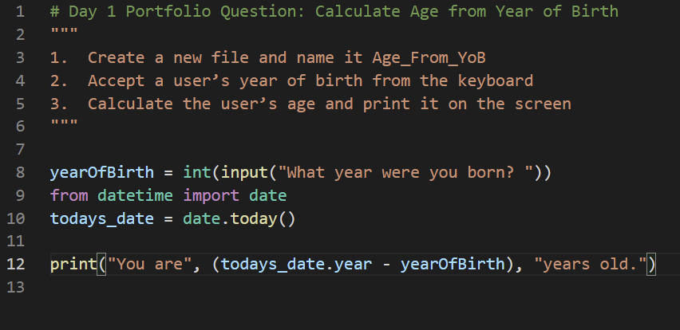

**Summary**

The task was to use the current year to calculate the age of the user after they input their year of birth.

**Self-reflection**

I did notice that python likes to add spaces after variables with the print function, so that was a surprise.

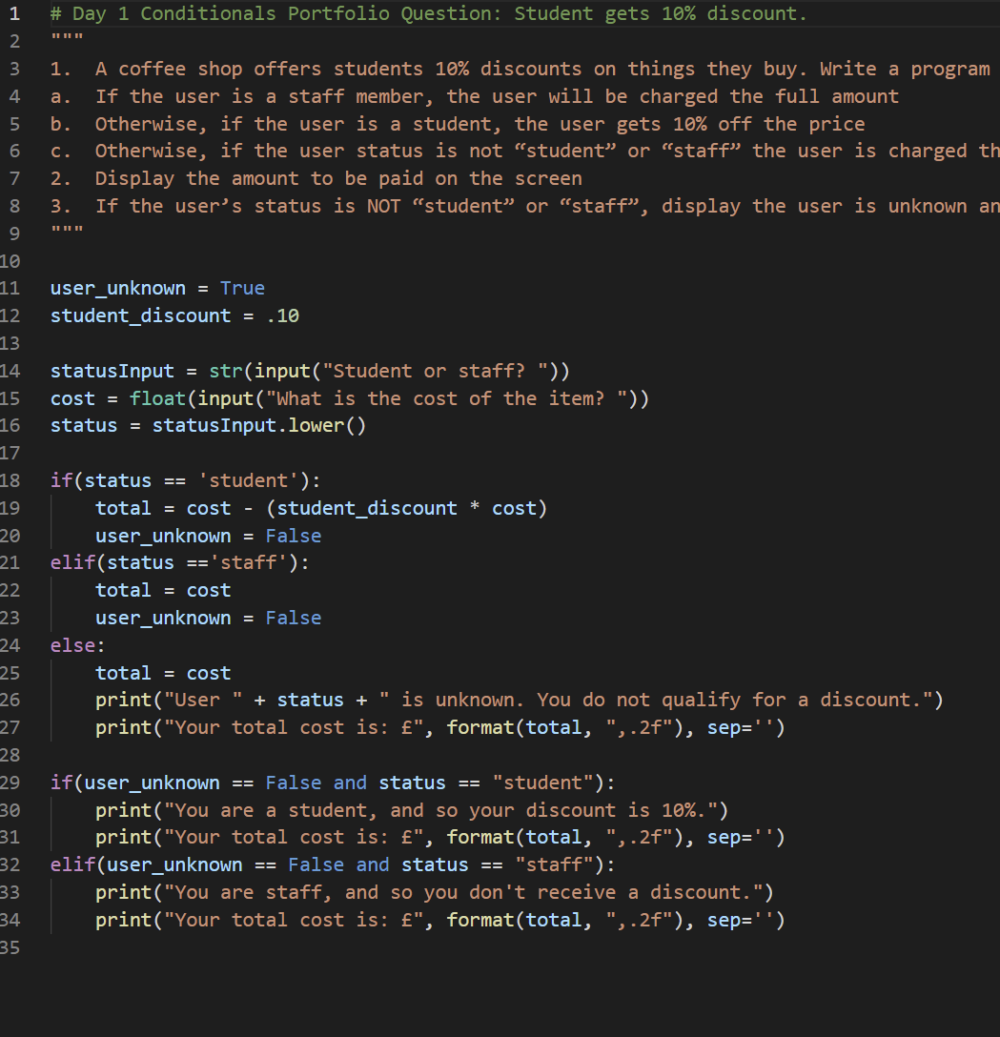

**Summary**

In this task we were asked to prompt the user for: their status; for the cost of an item. If their status is ‘student’ then they get a 10% discount. If it’s ‘staff’ or anything else, there is no discount.

**Self-reflection**

I probably could have gone with another statement like !=’staff’ instead, but I stuck with the Boolean. I wanted the results to print a bit more cleanly, so I looked up how to display the cost to two decimal places. I read conflicting posts online. One said using ‘float’ is not advisable with currency, another said it’s fine. Not sure which is correct.

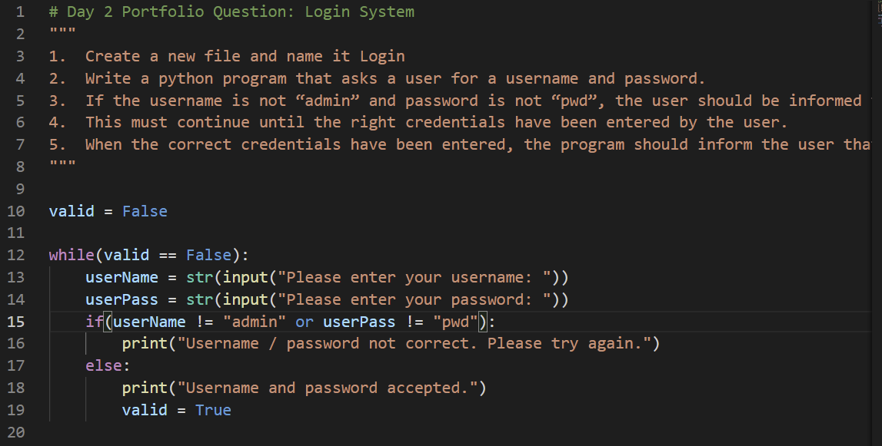

**Summary**

In this task we were asked to create a basic login app.

**Self-reflection**

This time I used a while loop to repeat the prompts and rerun the code if the user failed to input the correct login or pass. Again I used a Boolean as part of the While loop. Not sure if this was a good way of doing it.

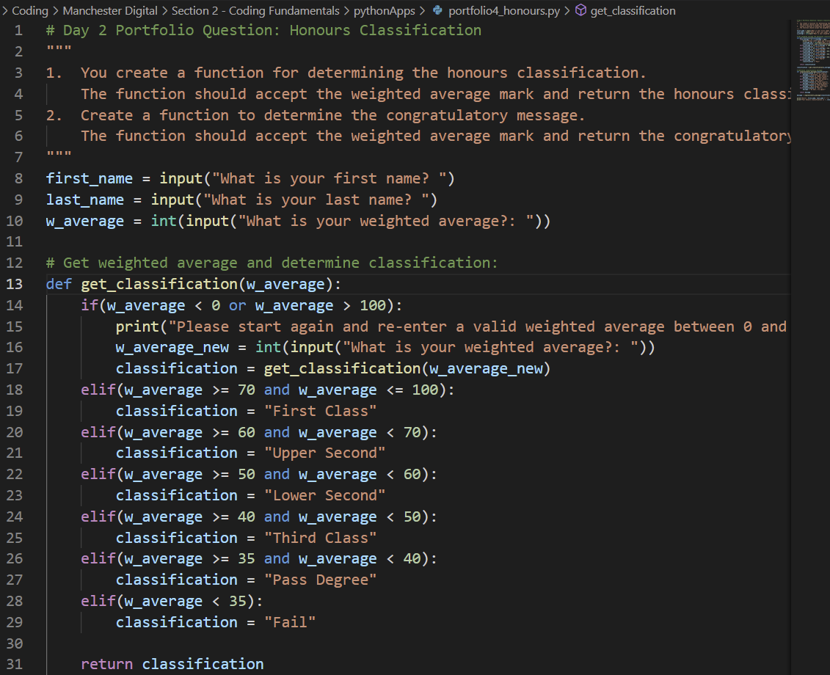

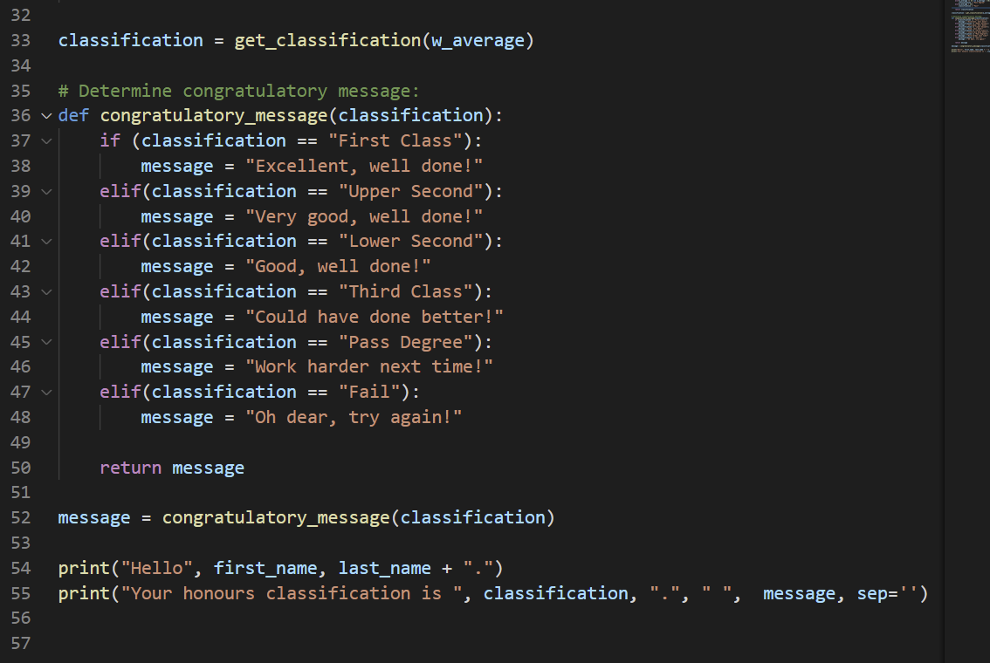

**Summary**

In this task we were asked to create functions and use conditionals. The user inputs: their first and last name; then their weighted average scores. If they input an invalid weighted average, the user should be prompted again. After receiving the correct weighted average then the programme prints out: the user’s name; their honours classification; a congratulatory message.

**Self-reflection**

This was by far the most challenging exercise. I still have several questions:

1. Why must I put parameters in the functions in order to make this particular code work?

2. Why does line 16 and 17 work? Is ‘get_classification(w_average_new)’ restarting the entire function from line 14?

How I understand it:

A new variable is being created called w_average_new. This represents the new input by the user after they’ve made a mistake. So w_average_new (the new input) is being used to run as an argument in the function get_classification(). But why do you need to create a variable (classification) to run this function? And also why call it ‘classification’?

This makes no sense to me. The classification variable below line 17 is meant to represent a text message, not the user’s input. These two lines, 16 and 17, are very confusing.

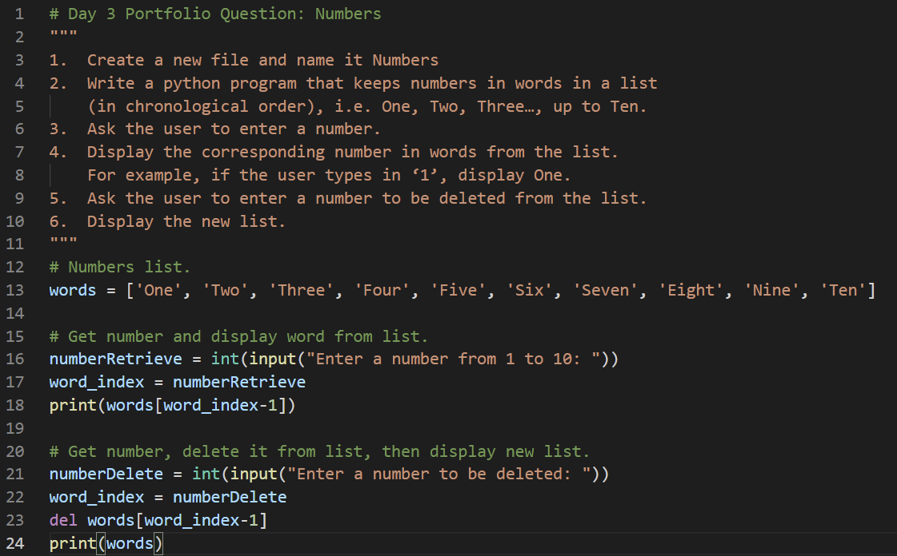

**Summary**

In this task we were asked to create lists and then retrieve specific items from the list. The number typed by the user corresponds to the written word of that number.

Then the programme prompts the user to delete an entry by typing in a number. The number typed matches the word in the list. The full list is then printed out.

**Self-reflection**

This day’s tasks were a lot easier than the previous day. I think it was mainly aimed at understanding how indexes in lists work.

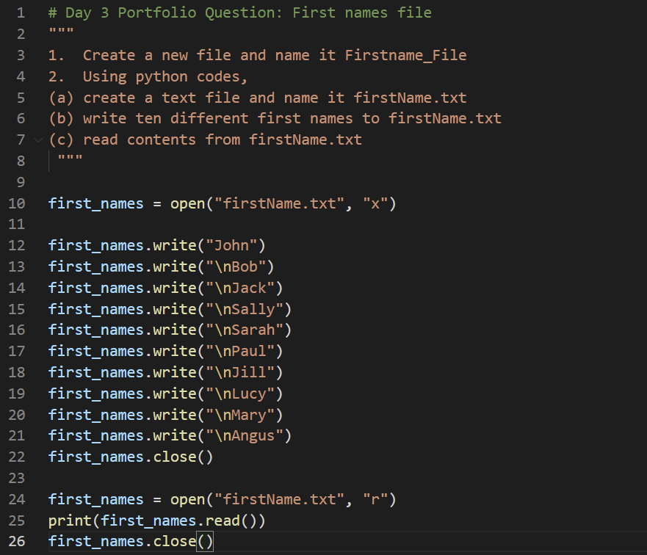

**Summary**

In this task we were asked how to create a file using Python, and how to write to that file. This was interesting for me as it shows how we can make permanent lists / data for future apps we might build.

**Self-reflection**

VS Code gave me a lot of trouble with this exercise. I think I spent more than half an hour trying to figure out where my files were being created (they were not being created in the directory of my python code like they were supposed to). I had to check the Python extension settings.