Imran Rahman

[mdimranrahman121357@gmail.com](mailto:mdimranrahman121357@gmail.com)

+8801981345386

Matuail Medical, Jatrabari, Dhaka, Bangladesh 08-03-2001

Bangladeshi Unmarried Male

https://[www.linkedin.com/in/imran-rahman-1bb747243](http://www.linkedin.com/in/imran-rahman-1bb747243)

# Career Objective

As a Computer Science graduate I am confident that I can bring significant value to any company looking for a driven and knowledgeable professional. My technical skills include programming languages, software development methodologies, databases, network and security technologies and I have applied these skills in several projects. In addition to my technical abilities, I have strong problem-solving skills and the ability to work well in a team environment. I am confident that my technical skills, combined with my passion for technology and commitment to excellence, make me an excellent candidate for any company looking for a talented and dedicated computer science professional.

# Education

12-2019

Dhaka, Bangladesh

2019

Dhaka, Bangladesh

2017

Dhaka, Bangladesh

**Computer Science & Engineering (CSE),** *Daffodil International University*

2019 - 2024 (Ongoing)

**HSC (Science),** *Dania College*

4.42

**SSC (Science),** *Hajee Shariat Ullah Adarsha High School*

4.73

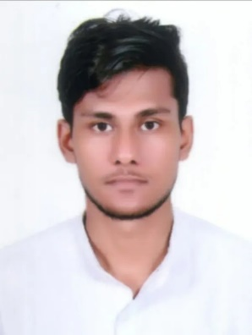

# Professional Experience

2022 **Transport (DIU),** *Student Associate*

I was a student associate at Daffodil International University. I was managing the transport unit in 2022. As an associate of the transportation unit, I was responsible for coordinating the timely delivery of students to various destinations. In the transport unit, my role included optimizing routes to ensure efficient fuel usage and on-time deliveries.

2022 **Volunteer in AUAP,** *Transport Manager*

The Association of the Universities of Asia and the Pacific (AUAP) is a platform and voice of universities in Asia and the Pacific and around the world. AUAP is a Non-Governmental Organization, holding the highest formal consultative status with UNESCO.



**Computer Skills**

## Programming language

C C++

Java Python

**Microsoft** Word Excel

PowerPoint

## Video Editing

Adobe Premiere Pro





**Other Skills**

## Communication Teamwork Leadership Project Planning Attitude



**Languages**

**Bangla**

Native

## Hindi / Urdu

**English**

Fluent



 **Projects**

|  |  |
| --- | --- |
| 2021 | **Student Managment System,** *Java based project* |
| 2020 | **Life Saver,** *Adobe XD App Prototype* |
| 2022 | **Computer Network,** *Networking Solution* |
| 2022 | **Traffic Sign Detection,** *AI Machine Leaning Based Project* |
| 2020 | **Daily Routine,** *Programing and Problem Solving Project* |

 **References**

**Mr. Mayen Uddin Mojumdar**, *Lecturer*, Daffodil International University [mayen.cse@diu.edu.bd,](mailto:mayen.cse@diu.edu.bd) 01402113506

**Nushrat Jahan Ria**, *Lecturer*, Daffodil International University [nushratria.cse@diu.edu.bd,](mailto:nushratria.cse@diu.edu.bd) 01521201557



**Declaration**

I hereby declare that the information provided in this CV is true, complete, and accurate to the best of my knowledge. I understand that any false statements or omissions may result in disqualification from consideration for employment.

