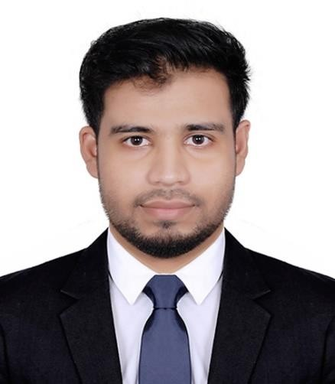Yasin Arafat

**Web Application Developer**

**Present Address:** Mirpur2, Dhaka-1216, Bangladesh

**Contact:** 01993217969

**Email Address:** [yasin.arafat.rwd@gmail.com](mailto:yasin.arafat.rwd@gmail.com)

**LinkedIn Profile:** <https://www.linkedin.com/in/yasin389/>

**GitHub Profile:** <https://github.com/yasin-arafat-389>

## Profile Summary:

Dedicated and detail-oriented web application developer with experience in designing, implementing, testing, and maintaining robust web solutions, having Full Stack Proficiency, Responsive Design and Collaborative approach.

## Career Objectives:

Passionate web application developer seeking to leverage my experience in designing and implementing innovative solutions. Dedicated to delivering high-quality, user-centric applications while staying abreast of emerging technologies. Committed to contributing technical expertise within a collaborative team environment and driving continuous improvement. Eager to tackle new challenges in a dynamic and growth-oriented organization.

## Experience:

**Freelance Web Development | Fiverr Profile:** <https://www.fiverr.com/yaseen_arafat> **Duration: 2021 to 2023**

### Responsibilities:

1. Collaborated with clients to understand their unique requirements, delivering custom web solutions tailored to their needs.
2. Developed and maintained responsive and user-friendly websites, ensuring a seamless user experience.
3. Provided timely communication and updates to clients, fostering strong, ongoing relationships.

### Web Developer | JhornaMart

**Company Address: 60 feet, barek molla more, Mirpur 2 Responsibilities:**

1. Contributed to the design and development of the company's e-commerce platform, enhancing user interface and functionality.
2. Implemented and maintained front-end and back-end features, optimizing website performance and responsiveness.
3. Collaborated with cross-functional teams to troubleshoot and resolve technical issues, ensuring a smooth user experience for online customers.

# EDUCATION:

### Bachelor’s Degree

**Institute Name :** Daffodil International University (DIU), Dhaka Bangladesh

**Subject :** Computer Science and Engineering

**CGPA :** 3.24 (Out of 4)

**Passing Year :** 2020-2024

### Higher Secondary Certificate (HSC)

**Institute Name :** Daffodil International College (DIC), Dhaka Bangladesh

**Subject :** Business

**CGPA :** 3.33 (Out of 5)

**Passing Year** 2019

### Secondary School Certificate (SSC)

**Institute Name :** Daffodil International School (DIS), Dhaka Bangladesh

**Subject :** Business

**CGPA :** 4.23 (Out of 5)

**Passing Year** 2017

# PROJECT/THESIS:

* **DineDash:** A food delivery web application with burger builder functionality by dragging and dropping.

**Tech Stack:** Html, CSS, Java-script, React JS, Tailwind CSS, Node JS, MongoDB

**Environment:** Visual Studio Code.

**GitHub:** <https://github.com/yasin-arafat-389/DineDash-Client>**(Private) Live Website:** <https://dine-dash-client.web.app/>**(Under Development)**

* **WorkVista:** An online job marketplace with job posting, bid placing and other job marketplace functionalities.

**Tech Stack:** Html, CSS, Java-script, React JS, Tailwind CSS, Node JS, MongoDB

**Environment:** Visual Studio Code.

**GitHub:** <https://github.com/yasin-arafat-389/WorkVista-Client>

**Live Website:** <https://workvista-167d6.web.app/>

* **TechTron Hub:** An online electronics tech gadgets marketplace.

**Tech Stack:** Html, CSS, Java-script, React JS, Tailwind CSS, Node JS, MongoDB

**Environment:** Visual Studio Code.

**GitHub:** <https://github.com/yasin-arafat-389/TechtronHub-Client>

**Live Website:** <https://techtron-hub.web.app/>

# CO-CURRICULAR ACTIVITIES:

### Cyber Security Club | Member

**Duration:** 2022 to 2023

Actively participated in club activities, workshops, and events related to cybersecurity awareness and best practices.

# LANGUAGE PROFICIENCY:

Bangla (Native): Excellent Command in reading, writing and speaking. English: Excellent Command in reading, writing and speaking.

# TRAININGS & CERTIFICATIONS:

### Responsive Web Design

From : CodersTrust Bangladesh

Course : Excel: Statistical Process Control From : LinkedIn

# ACHIEVEMENTS:

### Responsive Web Design Certification

* + Awarded a certificate in responsive web design from [Certification Provider].
  + Acquired proficiency in creating web applications that offer optimal user experiences across various devices and screen sizes.

### Fiverr Client Feedback

* + Consistently received positive feedback from clients on Fiverr for delivering high-quality web development solutions.
  + Demonstrated the ability to understand and meet client requirements, resulting in satisfied customers.

# Technical Skills:

* **Programming Languages:** Java-script
* **Markup Languages:** Html, CSS.
* **Frameworks:** React JS, Express JS, Tailwind CSS, Bootstrap.
* **Design Tools:** Figma, Canva.
* **Api Tools:** Postman.
* **Database:** MongoDB
* **Version Controlling Tools:** GitHub.
* **AI Tools:** ChatGPT.
* **IDE:** Visual Studio Code.
* **Computer Literacy:** Adobe Photoshop (Intermediate), MS-Word (Mid-level), MS-Powerpoint (Mid-level),

Browsing and searching (Advanced).

# Soft Skills:

* Analyze and troubleshoot issues efficiently to find innovative solutions.
* Prioritize tasks to meet deadlines and deliver on schedule.
* Stay updated with the latest industry trends and emerging technologies.
* Embrace a continuous learning mindset to stay current with evolving technologies.

# PERSONAL INFORMATION:

**Name :** Yasin Arafat **Fathers Name :** Abdur Rahman **Mothers Name :** Selina Akter **Nationality :** Bangladeshi

**Date of Birth :** 19 October 2000

**Marital Status :** Unmarried

# REFERENCES:

### Md. Ferdous Mahmud

**Designation:** Chief Executive Officer

**Company:** JhornaMart **Contact:** 01730031919 **Email:** [ferdoush@gmail.com](mailto:ferdoush@gmail.com)