**Md Shaklian Mostak Romel**

shaklianmostak5678@gmail.com

+880-1705830610

Birampur, Dinajpur, Bangladesh

ROME

[L](https://sites.google.com/d/1OOaRMfIJ2E5Sq0X6kJQKAiYMjODp81zx/p/102kKrdfTeWNBe1vzfFHzfBUoPBKrYmFi/edit)

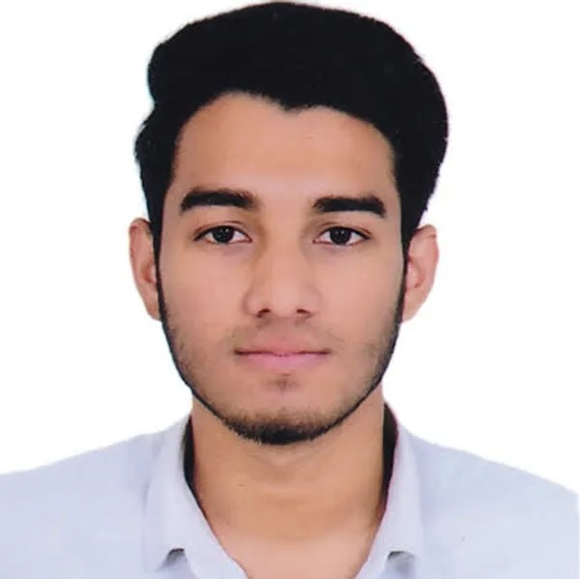

**Profile**

I have a hunger for knowledge and a determination to turn information into action. I can manage my work

very efficiently. Recently I have enhanced my skills in UX/UI designing.

**Career Objective**

•

To obtain a challenging position that fully utilizes my skills and provides me with suitable opportunities

to grow my technical and communication skills which would help me as a fresher to grow while

working towards the organizational goals.

•

Trying to find a challenging position in a reputable company where I can share my ideas, develop new

skills, increase my knowledge, and apply what I've learned.

•

To pursue a job opportunity in a competitive environment that will challenge me to push my

boundaries and expand my knowledge in the field of computer science while allowing me to add value

to the dynamics of the company.

•

To work as a (job role being offered) in your progressive organization that allows me the scope to

update my knowledge to the latest trends and be part of a diverse and dynamic team that adds to both

my personal and professional growth

**Education**

2020

– present

**Bachelor**

**of**

**Computer**

**Science**

**(**

**B.Sc.**

**)**

*Daffodil*

*International*

*University*

Running

Asuliya, Savar,

Dhaka,

Bangladesh

2018

**Higher**

**Secondary**

**Certificate**

**(**

**H.S.C**

**)**

*Dinajpur*

*Holy*

*Land*

*College*

GPA 4.33

Dianjpur,

Bangladesh

2016

**Secondary**

**School**

**Certificate**

**(**

**S.S.C**

**)**

*Birampur*

*Pilot*

*High*

*School*

GPA 5.00

Birampur, Dinajpur,

Bangladesh

Programming Language (Python, Java, C)

**Others Skills**

|  |  |
| --- | --- |
| Project Management  Leadership | Collaboretion  Language (English, Bangla, Hindi, Urdu,) |

**Projects**

2022

**Analysis**

**Of**

**Social**

**Media**

**Marketing**

•

Research paper.

•

Using Machine Learning.

2022

**Cycle**

**Lagbe?**

A Modern Website Prototype for bi-cycle.• Using Figma.•

2022 **Restaurent Management System**

|  |  |
| --- | --- |
| Microso Office  HTML  UI/UX Design | MySQL  Adobe Photoshop  Advance Browsing |

A Bash-Script-Based Project for a restaurant, where we can order food very• fast.

**Computer Skills**

2022 **Car Price Prediction**

An AI-based model to predict used or new car prices.• Using Machine-Learning.•

2021 **Smoke Detector**

A EEE project that triggers the alarm if smoke is detected.•

2020 **Life Saver**

Booking an ambulance and showing• some details about the nearest hospital Mobile App Prototype.

Using Adobe Photoshop.•

**References**

**MD. Abbas Ali Khan**, *Assistance Professor*, Daffodil International University abbas.cse@diu.edu.bd, +8801924196829

**Ms. Aditi Dhali**, *Lecturer*, Daffodil International Univarsity aditidhali.swe@diu.edu.bd, +880-1876044079