**Contact**

**Interest**

01872160995

**Phone**

rifat15-3065@diu.edu.bd

**Email**

Board Bazar, Gazipur, Dhaka.

**Address**

**Rifat Bin Awlad**

C

S

E

U

n

d

e

r

g

r

a

d

As a Computer Science and Engineering undergraduate student, I am passionate about exploring

innovative

solutions

to

complex

problems

in

the

tech

industry.

With

a

solid

foundation

in

programming languages such as C and Python, I am eager to apply my skills to real-world projects

and contribute to the growth of the industry. I am also skilled in data structures and algorithms, and

have experience working with databases and web development technologies. I am always looking

for opportunities to learn and grow, and I am excited to embark on a career in the tech industry.

**Education**

**B.Sc. in Computer Science & Engineering**

**H.S.C.**

**S.S.C.**

**2020 - 2024**

**2017 - 2019**

**2014 - 2017**

Daffodil International University

Milestone College

Tongi Pilot School and Girls College

01776128022

mohosinatoma@gmail.com

**Mohsina Toma**

**Phone:**

**Email :**

SWE,

[d](https://www.facebook.com/Swosti.net)

Swosti Limite

01711092326

salman.soumik@grameenphone.com

**KM Salman Soumik**

**Phone:**

**Email :**

Lead Engineer, Grameenphone

**Reference**

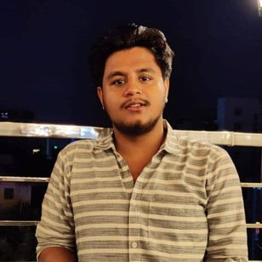

**Reading Book**

Python Programming Language

MS Powerpoint

C Programming Language

MS Excel

MS Word

**English**

**Bangla**

**Expertise**

**Language**

**Watching Football**