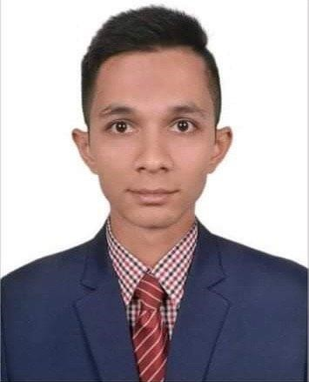**CURRICULUM VITAE**

**Md Shahrul Ahsan**

E-mail : ms.ahsan345@gmail.com

Contract No : 01937843700

# CAREER OBJECTIVE

To develop my career in light of the experience of Textile Engineering sector through working in a well-reputed industry or organization with honesty and dignity where success comes through hard work, sincerity, creativity, teaming and devotion to duty and where there is a scope to gather knowledge and contribute as well .

## ACADEMIC QUALIFICATION

|  |  |  |  |  |
| --- | --- | --- | --- | --- |
| Name  of degree | Subject | Institution | CGPA | Year of passing |
| Bachelor Degree | Apparel  Merchandising  &  Management | BGMEA University of Fashion & Technology | 3.08 | 2023 |
| HSC | B Studies | Gulshan Model College | 4.11 | 2018 |
| SSC | B Studies | Shaheed Ramizuddin Cantonment School | 4.38 | 2016 |

## UNERGRADUTE RESEARCH & PEDEGOGICAL EXPERIENCE

* Visited BEXIMCO Industrial Park and created an assignment for fabric structure analysis.
* Make a research paper about Behavioral Intension to Adopt Online-Based Teaching Learning during the Post-Covid .
* Make Industrial Training report of Ecofab Ltd (Viyellatex Group).

## EXTRA CURICULAM ACTIVITIES

* Join Secretary at BUFT Games & Sports Club (2019 - 2022).
* Executive Member at BUFT Model UN Association (2020 - 2022).

## COMPUTER LITERACY

* MS Word : Document creating & editing.
* MS PowerPoint : To make presentation slide.
* MS Excel : Spreadsheet analysis & calculation.
* Capable to use Internet Browsing & E-mail application.

## LANGUAGE PROFICIENCY

* Excellent communication skill in Bengali .
* Moderate Communication skill in English.

## PROFILE SAMMARY

* About 3 month experience of industrial training in oven garments industry .
* Basic knowledge about PO sheet, BOM and PI sheet.
* Basic idea about product development.
* Minimum knowledge on oven fabric and all kinds of trims and accessories.

## PERSONAL ATTRIBUTES

* Handling situations professionally and organized way.
* Capable of working in a Challenging atmosphere and under extreme strain.
* Effective communication skills.
* Effective negotiation skills.
* Self-Motivated.
* Ability to work in a team.

## PERSONAL INFORMATION

Full Name : Shahrul Ahsan

Father’s Name : Aminul Ahsan

Mother’s Name : Salena Begum

Date of Birth : 29 October 1997

Blood Group : AB+

National ID Number : 690 390 8785

Present Address : 160/A Ekota Bhoban , Vashantak, Dhaka-1206 .

### REFERENCE

Farhana Jannat Wahid Ullah Khan

Assistant Professor Assistant Manager

BGMEA University of Fashion & Technology Ecofab Ltd , Viyellatex Group

Nishatnagar, Tutag, Dhaka 1230 288/1. Jogitola, Gazipur -1701

Contract : 01632183225 Contract : 01713241085



Shahrul Ahsan