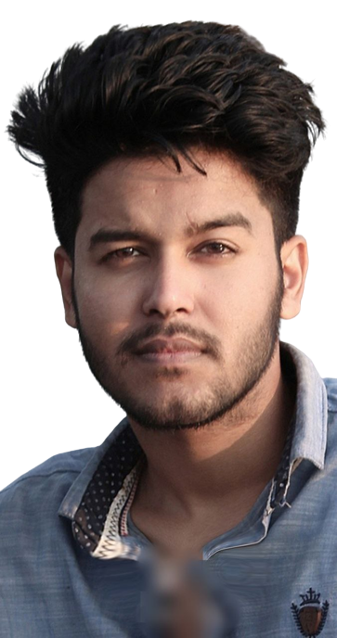

# **Experience:**

I’ve worked as a digital marketer at Fiverr and Upwork. And also I have done some data entry work. Currently I am learning web development .

**Personal Details:**

* Name : Md Riad Hosen.
* Father’s Name : Abdul kaium.
* Mother’s Name : Fatema khatun.
* Address : Muktagacha, Mymensingh.
* Date of Birth : 28/11/2000

**Education:**

BSc in Computer Science and Engineering

**Daffodil International University.**

**Hsc-Rajarbag Policeline College** (2016-2018)

GPA: 4.00 out of 5.00

**SSC-Sristy Residential School,Tangail**

GPA: 5.00 out of 5.00

# **References:**

**Fatematuzzohra**

Assistant Professor

Department of CSE

Daffodil International University

# 

**Phone:**

01601989884

**E-Mail:**

riad15-14199@diu.edu.bd

**Linkedin:**

https://www.linkedin.com/in/alnoor-riyad-448614248/

# **Skill Highlights:**

* Complex problem solver
* Web Developer
* Chess
* English language

# **Languages:**

* Bangla – Native
* English – Advanced

**Project:**

* Wordpress Website
* Various Products landing page(Amazon, Google play, Steam ) & more.

**Academic Project:**

* Currently working on Smart prescription software.

ALNOOR RIYAD

Achieving a dynamic and challenging job to utilize my academic background for the interest of the organization and my career. Working in the environment that involves professional challenges, appreciates hardworking and integrity in carrying out responsibilities. Developing interpersonal skills sharing my knowledge with various professional and buildup myself as an expert professional.