**CURRICULUM VITAE**

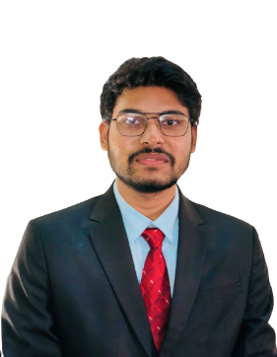Mir Mynul Ahasan

Student of CSE

**Github:** <https://github.com/Mynul-07>

**LinkedIn:** <https://www.linkedin.com/in/mynul-ahsan-7451531a4/>

**E-mail:** mir15-13953[@diu.edu.bd](mailto:bhaskar15-9988@diu.edu.bd)

**Mobile No:** +8801734156344

# CAREER OBJECTIVE

I want to build my career as a Computer Engineer. As a fresher, I want to put to use my creative skills, technologies that I am familiar with, innovative thoughts that will benefit the organization in the long run and also help me in building my professional career. I believe my co-operative attitude, tight concern, consistency and work expertise.

# EDUCATIONAL QUALIFICATION

|  |  |  |  |  |
| --- | --- | --- | --- | --- |
| Degree | Passing Year | Institute | Board | Result |
| B.Sc. in CSE (running) | 2023  (app.) | Daffodil International University |  | CGPA- |
| H.S.C | 2018 | Major General Mahmudul Hasan  College | Dhaka | GPA- |
| S.S.C | 2016 | Bindubashini Govt. Boys’ High School | Dhaka | GPA- |

**SKILLS**

**Programming Language:** C, Python, Java, and JavaScript.

**Operating System:** Windows (XP/ Windows 10), Ubuntu

**Microsoft office package:** MS Word, MS Excel, MS PowerPoint.

**ML Framework & Library:** Sklearn, Pandas, Numpy, Tensorflow.

**Platform:** Code blocks, Anaconda, Jupyter Notebook, Colab, Notepad, Visual Studio.

**Web:** HTML, CSS, Bootstrap.

# EXTRA CURRICULAR ACTIVITIES

* Achieve 1+ Machine Learning, Image processing, Python online courses in Coursera.
* Member of Daffodil International University Programming Club.

# REFERENCE

Mr. Abu Kaisar Mohammad Masum

Lecturer, Department of Computer Science and Engineering Daffodil International University (DIU)

E-mail: [abu.cse@diu.edu.bd](mailto:abu.cse@diu.edu.bd)

Cell-Phone: +8801676882085

## Md. Sanzidul Islam

Lecturer (Senior Scale)

(Study Leave), Department of Computer Science and Engineering

Daffodil International University (DIU)

E-mail: [sanzid.cse@diu.edu.bd](mailto:sanzid.cse@diu.edu.bd)

Cell-Phone: +8801864007005