Exercise 2 Report: Continuous Warehouse RL

Summary Metrics (4D state)
Optimal reference return (oracle policy): -0.532
Discretized Q-learning: episodes_to_80=None, final_avg_last_200=-1.170, params=1600
Tile-coded linear Q-learning: episodes_to_80=None, final_avg_last_200=-1.112, params=800
DQN: episodes_to_80=None, final_avg_last_200=-0.835, params=4740

Ablation finding
Removing experience replay harmed stability more than removing the target network, which matches the deadly triad intuition (function approximation + bootstrapping + off-policy updates).

Bonus 6D finding
6D discretized table size is 4,000,000 Q-values. Only 0.34% of bins were visited in training, while DQN generalized over the full 6D state with far fewer parameters.

Figures
learning_curves_comparison.png
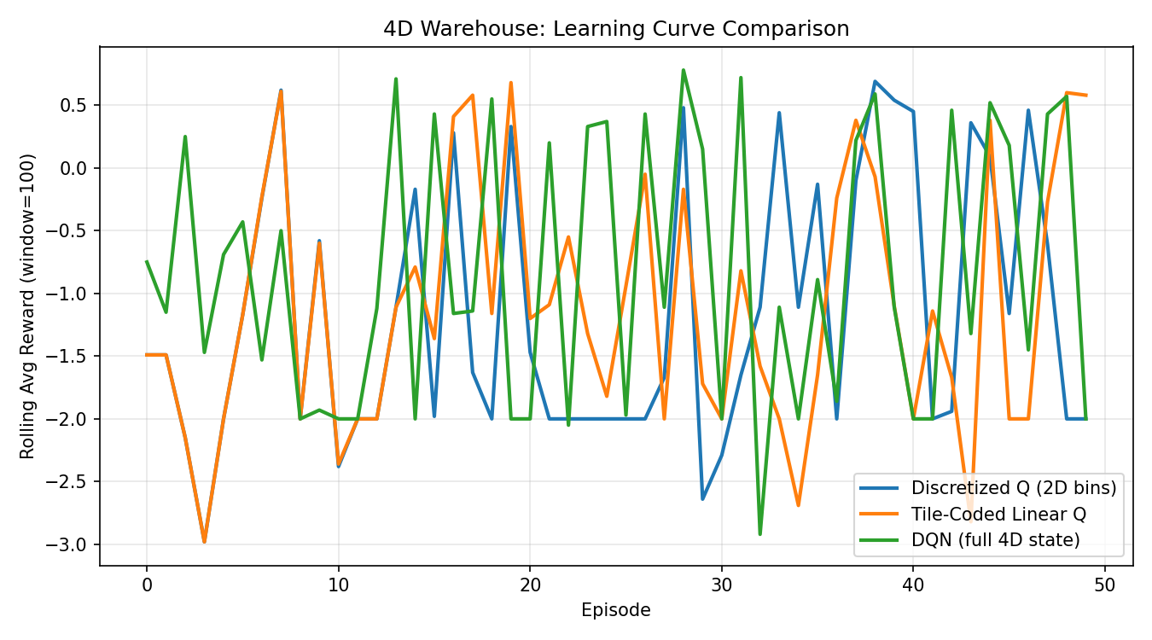
dqn_ablation_curves.png
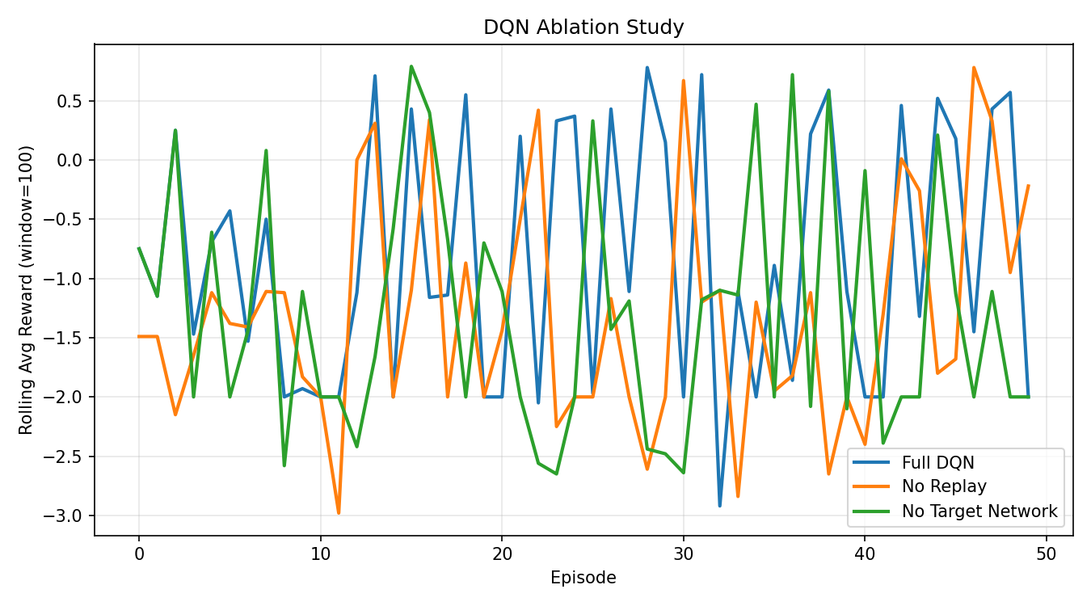
bonus_6d_comparison.png
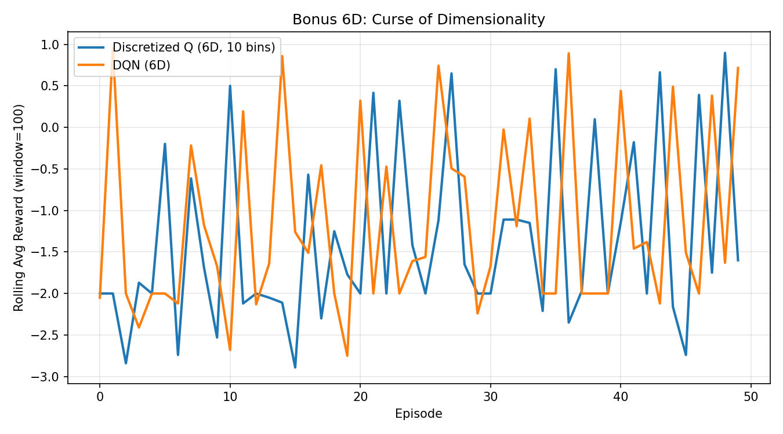
policy_discretized.png
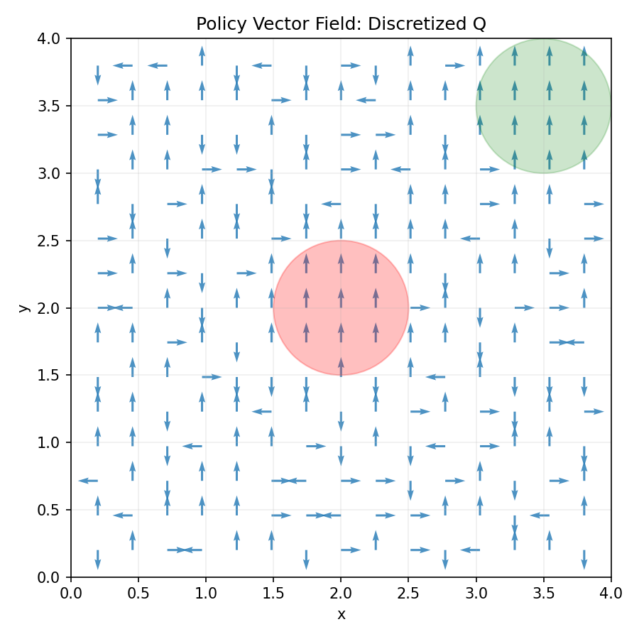
policy_tile.png
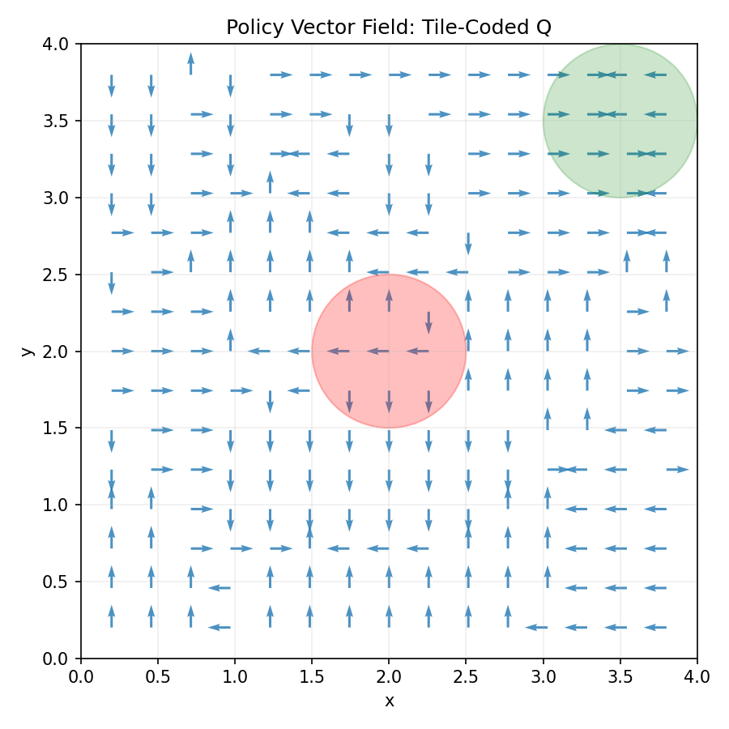
policy_dqn.png
