3.Methods

3.1 Overview

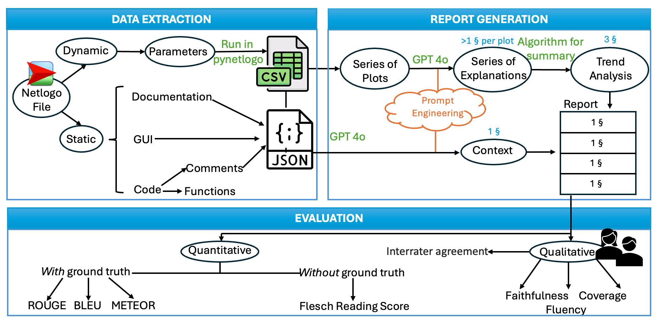

Figure X : Our procedure consists in three main parts. Each part is explained in turn, in a dedicated subsection.

Parts | Use | Python Library
Data Extraction | Running the simulation  Extracting the static data | Pynetlogo (0.5.2)  re (2.2.1), json (2.0.9)
Report Generation | Plotting the data  Generating explanations  Converting image to base64 to pass it to GPT  Combining prompt features  Summarizing | pandas (1.5.3), matplotlib(3.8.3)  openai (1.14.3)  base64 (python 3.10.9)  itertools (python 3.10.9)  transformers (4.41.2)
Evaluation | Scoring | nltk (3.7), rouge_score(0.1.2)

Table 1 : All the libraries involved along with their use in each part of the method.

Our methods are divided into three main parts. First, the Agent-Based Model is specified in NetLogo (subsection 3.2). Given a set of parameters, we run several simulations to obtain results from the model. We also extract data from the NetLogo file: we parse the documentation, the Graphical User Interface (GUI), and the comments from the code. Then we generate a report using this information (subsection 3.3). GPT-4o is used to generate a context and a trend analysis and a summarization algorithm then reduces the number of paragraphs to the length suitable for a report. Finally we evaluate the report (subsection 3.4) by using a qualitative method at the sentence level, and a quantitative method relying on a ground truth for certain metrics.

3.2 Data Extraction
Data extraction involved processing NetLogo simulation files. Our research uses three well documented social agent based models from the website Comses.net. These files were categorized into dynamic and static components.
The dynamic data consisted in parameters we could modify. Thanks to this part of the file, we were able to run the simulations and retrieve the data. Therefore, we have set the initial parameters, the metrics to follow throughout the experiment, the halting condition and ran the experiment. For example a parameter could be “ "number-of-agents": 1000”, a metric could be “mean [incum-quantity] of turtles” and a halting condition could be max_ticks = 73000. This would mean that the experiment starts with 1000 agents, for a maximum of 73000 ticks during which we will measure the mean quantity of whole milk consumed by agents. All the results were then exported into CSV format for further analysis.
From the static data, we extracted the documentation, the GUI (the modifiable elements and their range of values) and the comments from the code using regular expressions. While parsing the documentation, we made sure to not include the default content from Netlogo files that were left unfilled and we also made sure to remove urls. From the GUI, we have made sure to only pick relevant information (i.e the minimum and maximum value as well as the value set for the experiment). This content was saved into JSON files and plays an essential role in giving context to the simulation for the following explanations.

3.3 Report Generation

The report was designed to synthetize the extracted data into meaningful explanations.

The first step was to give context to the simulation. Since the JSON files provide the extracted context (Section 3.2), we appended this information to the prompt given to the LLM. We specified to GPT that the generated paragraph should include the context of the simulation, its goals and the key parameters set for the experiment in a way for the reader to catch the experiment conditions.

The second step was to describe the data from the simulation. To do so, we used the CSV file to plot the different metrics. With the help of GPT-4o's vision capabilities, we then gave these plots to the LLM and generated explanations. We optimized the prompt engineering by using a systematic design of experiments known as 2^{k} factorial design, where k is the number of features considered in the prompt. That is, we automatically generate a series of prompts and record their effect in order to (i) find the best prompt and (ii) assess which parts of a prompt contribute to its effectiveness. Here, we used k=3 features:
- use of a role ( example : “You are an expert in Consumer Behavior”)
- an example of expected style ( for instance : “The total number of earthquakes recorded in the region starts at 5,000 then it declines rapidly over the first 400 time steps. It increases briefly at around 500 steps and ends the simulation near zero. The total seismic activity follows the same pattern, starting at 10,000 events and declining steadily. There is low variance across simulation runs in the first 100 steps, but deviations become noticeable afterward.“)
- “insights” ( “When summarizing trends, provide brief insights about their implications for decision makers.”).

{You are an expert in Consumer Behavior without any statistics background.}

Your goal is to explain an agent-based model. Your explanation must include the context of the model, its goals, and key parameters. For each parameter, include the range of values (if provided) and the value that we have set. Do not write any summary or conclusion.

[We have 16 parameters:
- memory-lifetime, from 1.0 to 10.0. We set it to 5.
- alt-health-mean-initial, from 1.0 to 3.0. We set it to 1.69.
- habit-threshold, from 1.0 to 10.0. We set it to 2.
- p-interact, from 0.0 to 1.0. We set it to 0.3.
- social-susceptibility, from 0.0 to 1.0. We set it to 0.2.
- incumbent-initial-habit, from 0.0 to 10.0. We set it to 10.
- alt-env-mean-initial, from 0.0 to 3.0. We set it to 1.12.
- social-blindness, from 0.0 to 1.0. We set it to 0.51.
- justification, from 0.0 to 1.0. We set it to 0.61.
- cognitive-dissonance-threshold, from 0.0 to 1.0. We set it to 0.15.
- network-parameter, from 2.0 to 10.0. We set it to 8.
- number-of-agents. We set it to 1000.
- habit-on?. We set it to True.
- network-type. We set it to "watts-strogatz".
- norms. We set it to True.
- social-conformity. We set it to 0.28.]

The context and goals of the model are as follows. [documentation]

Prompt 1 : Prompt used to generate the context. {text} is a feature from the design of experiment. [text] is a part of the prompt changing according to the model and the experiment

{ You are an expert in Consumer Behavior with a statistics background}

We have a plot from repeated simulations of an agent based model. Your goal is to describe the trends in details from the plot, mentioning key time steps and values taken by the metric in the plot, and interpreting them based on the context of the model. The report must objectively describe the trends in the data without addressing the quality of the simulation. Do not refer to the plot or any visual in your description. If a plot has very simple dynamics, simply state them without expanding.

{Here is an example of the style of the report: “ The total number of earthquakes recorded in the region starts at 5,000 then it declines rapidly over the first 400 time steps. This initial decline could be attributed to the depletion of immediate stress points within the fault lines, as the most susceptible areas release their pent-up energy early in the simulation. It increases briefly at around 500 steps, likely due to the aftershocks and secondary stress points being triggered as the system seeks a new equilibrium. The simulation ends with the number of earthquakes near zero, indicating that the majority of the stress has been released and the system has stabilized.

The total seismic activity follows the same pattern, starting at 10,000 events and declining steadily. This steady decline reflects a systematic reduction in seismic energy over time, as the energy distribution within the tectonic plates becomes more uniform. There is low variance across simulation runs in the first 100 steps, but deviations become noticeable afterward. This suggests that while the initial reactions to stress are highly predictable, as time progresses, the system's complexity introduces more variability. This variability could be due to differences in secondary stress points and the non-linear nature of seismic energy release over time.”},

{ When summarizing trends, provide brief insights about their implications for decision makers.}

[The attachment is the plot representing the average weekly consumption of whole milk per agent]
Prompt 2 : Prompt used to generate the trend analysis. {text} is a feature from the design of experiment. [text] is a part of the prompt changing according to the plot described

Once the context and the trend analysis were generated, we needed to remove some unnecessary symbols for the report to only contain relevant information. That’s why we deleted all the “#” and “*” symbols found in the API response due to the Markdown format it uses.

In a way to gather all this data into a report, we then used an algorithm to summarize these explanations into 3 paragraphs. For this we distinguished two types of algorithms either extractive or abstractive.

Extractive summarization techniques function by identifying and extracting salient sentences from a source document to generate a concise representation. This approach prioritizes factual content and offers computational efficiency, making it well-suited for summarizing informative texts. In our case we leveraged the BERT (Bidirectional Encoder Representations from Transformers) algorithm (cite Tyler’s paper as a reference).

In contrast to extractive summarization, abstractive summarization techniques aim to capture the essential meaning of a source document and produce a concise representation using novel phrasings and potentially new sentences. As part of this type of algorithms, we chose to leverage BART (Bidirectional and Autoregressive Transformers for Pre-training) (cite Tyler’s paper again).

Both these methods were giving us a summmary for the context and one for every plot from the trend analysis (i.e between 10 and 14 summaries for the trend analysis). To finally get an organized report we had to gather these summaries into paragraphs. This was done by making sure that the context summary would be a paragraph on its own, and that the following summaries would be equally distributed within 3 paragraphs.

Additionally, the summaries from BERT would not always contain a upper case letter at the beginning of each sentence, which then required a post processing algorithm to go through these summaries and replace the lower case letters by upper case ones. Moreover, we found out that some text within the CSV would not be displayed properly on certain devices, which is the reason we ultimately give the CSV as an input to an algorithm removing all the non-unicode characters. Some other post processing modifications were required on the summaries, espcially on the one from BERT concerning punctuation, spaces in parenthesis, hyphens…etc

The final report is the concatenation of the context followed by the data analysis paragraphs, for a total length of 4 paragraphs.

3.4 Evaluation

Our evaluation method is divided into two procedures.

First, human readers perform a qualitative evaluation by ranking each report generated according to three different criteria (faithfulness, coverage and fluency) using the 5-point Likert scale.

The second part of our evaluation is an automated quantitative process, consisting of two parts. A first set of metrics is using a ground truth reference we wrote based on the simulation data, representing a report we would expect in the best case. The metrics using this reference are BLEU, METEOR, ROUGE-1, ROUGE-2, ROUGE-L. The second part of our

quantitative method does not use a reference; rather, it focuses on the readability of the report and thus evaluates it based on the Flesch Readability Score.

X.Discussion

- Order of the plots
- Trying to summarize the given image of a plot / a detailed description of a plot
- Future works associating comments from the code with variables from the parameter

- Faithfulness: The proportion of the content in the output that accurately reflects the content present in the input. High faithfulness means that most or all of the original ideas from the input are correctly represented in the output. - Coverage: The extent to which the output includes all relevant and important information from the input without introducing new, unverified ideas (hallucinations). Good coverage means all critical points from the input are present in the output. - Fluency: The quality of the text in terms of grammar, readability, and naturalness, ensuring that it is grammatically correct and easy to understand.
Automatic evaluation metrics (BLEU, METEOR, ROUGE) are used to assess the quality of machine-generated text summaries by comparing them to human-written references. These metrics focus on n-gram overlap (matching sequences of words) between the generated summary and the reference(s). - BLEU (Bilingual Evaluation Understudy): Focuses on n-gram precision, comparing the generated summary's n-grams (sequences of words) to the reference(s). - METEOR (Metric for Evaluation of Translation with Explicit Ordering): Combines n-gram matching with considering word order and synonyms. - ROUGE (Recall-Oriented Understudy for Gisting Evaluation): A suite of metrics (ROUGE-1, ROUGE-2, ROUGE-L) focusing on recall (how much of the reference content is covered). - ROUGE-N: Measures n-gram overlap (unigrams (single words) for ROUGE-1, bigrams (two-word sequences) for ROUGE-2). - ROUGE-L: Considers Longest Common Subsequence (LCS) between the summary and reference, focusing on sentence-level similarity.

