Noé SAFFAF

Toolbox Project : Image and pattern recognition

Image machine learning & Classification
01/2020

I) Presentation and objectives

1) Presentation

This project is divided into two part. Firstly, the development of a machine learning classifier which uses part of a database of images with their real classes as their training set.
For this part, our database consist of logical images with two categories of object.

This is a binary problem (classes possibles are only 0 or 1) so we use a logistic regression model to create our classifier. To do so, we first extract several features or characteristic values from our image data training set that we call descriptors. Descriptors are chosen when their values differs from one class to another, and hence, permit sorting efficiently samples of the image database.

Then, the classifier is being tested with the second part of the database that is the test set. And the resulting sorting of the testing database is being studied to quantify the efficiency of the classifier.

The second part of the project is an application on a specific case, highlighting the utility of such technology in the engineering field, and in this case, the medical sector.
The project consist of sorting a dataset of images of skin marks taken from subject, associated with a binary image of the mark obtained by an image threshold of the original picture, and an image showing the superpixels cutting of the mark. The problem is to create a classifier and find descriptors in order to sort minor skin injuries from melanoma cancers.

In this part, the difficulty lies in several reasons : Firstly, the quality of the image varies from one to another, and properties like position, size contrast or sharpness aren’t consistent. Secondly, classifying the data with only naked eyes is challenging even for a specialist. The characteristic of a melanoma cancers are visually minors compared to others marks, and it’s tough to intuitively establish a list of descriptors to describe a melanoma from something else. This second part mainly consist of experimenting other descriptors to test our the efficiency of our classifiers.

2) Objectives

For our first part, we have learnt in courses the theory of machine learning of logistic classifiers, and thus, our main goal is to put into practise our knowledge previously acquired to build a functional classifier to sort our data set. The structure of the program is here our main focus, we will use hand-main programs from Matlab to create our classifier to grasp the understanding behind the model used.
We will also look at the result of the classifier to validate our model and our code.

For the second part, the main point the project dwells on the relevance of the chosen descriptors. First, we need to decide on what makes a classifier good. Our dataset is mainly consisted of non-melanoma images, but where our interest lies ? A classifier can have a good accuracy by basically classifying all the dataset test as 0 (non-melanoma).

Predicted\Real | 1 | 0
1 | 0% | 0%
0 | 20% | 80%

However, a good accuracy means nothing here simply because the machine doesn’t sort anything.

Another bad example of classifier is :

Predicted\Real | 1 | 0
1 | 7% | 3%
0 | 20% | 70%

Here, the accuracy is at 77% but nonetheless, the classifier is still bad because it ignores a fundamental objective of our classifier. We first need to question ourselves what, practically speaking, makes a classifier good for this case. Our goal is to detect a possible melanoma, so predicting a case of melanoma rightfully is good,
predicting a case of melanoma for a healthy subject is an “acceptable error”. Meanwhile, claiming a non-melanoma case to someone who actually have melanoma is highly problematic. We would rather class someone healthy as positive by mistake than missing a case melanoma for a patient.
Yet, in this case, our result are the reverse of what we expect, few cases of predicted melanoma (7% TP + 3% FP) compared to (20% FN + 70% TN), showing how inconsistent this classifier is.
Also, there is the constraint of time, flooding our machine classifier with many descriptors that aren’t necessarily relevant to accurately classify our database isn’t a solution. Sorting good from useless descriptors is part of the project, so the machine can calculate descriptors value time-efficiently.

To conclude, our goal here is to establish predictor that gives us satisfying results, with good accuracy (at least 70%), but a good F-score, and trying to maximise the True Positive result and minimise the False Negative result, all while considering the constraint of time.

II) Program structure

Our problem us a logistic regression model with n descriptors, here is the structure of the program
Logical Images
Data Loading
Calculating descriptors
Creating the classifier
Classing test database
Results
Real class affiliation
Area, Perimeter, Circularity…
(regions props function
Calculating Iterative thetas
With gradiant method

Calculating Cost evolution
Sorting the Test database among class 0 and 1
Separating Training/Test set
Displaying confusion Matrix,
Accuracy, F-score

Function: FGetShapefeat(X)

Function:
Ftrain_LogReg(X,Y) FcalculateCostlogReg(…)
Fsigmoid(X,theta)

Function:
ConfusionMatrix
ToolBox

In total, we use 10 descriptors extracted from regionprops methods for this problem, more could be used but add more time processing to the GetShapeFeat function. Those methods can be applied for logical images.
After getting those descriptors values in X variable, we normalize and center out data set so each descriptor have the same weight for our classifier.

Our dataset is composed of a total of 200 images with their associated class. It may sound a lot but in fact is a very limited database. We need to separate those 200 images into two part for both training and testing. The more image we have for training, the better, but we also need to save some untouched images for testing.
A p=0.6 coefficient is a good trade-off (120 training/80 testing) to have a consistent amount of data for both training and testing.

In our case of a logistic regression model, the hypothetical function used is:

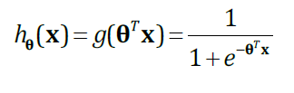

We need to determinate the optimal theta vector, to do so, we introduce a cost function
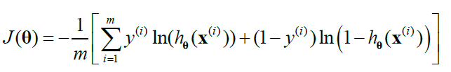

And the optimisation is carried by a descending gradient algorithm, so theta is modified in each loop.

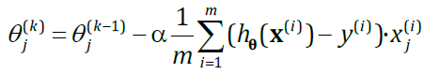

We can do as many loop as we want, but all we need to do is choosing a number sufficiently high so the function J will get time to converge to a minimum. Choosing 50 is in practice a good number.

Also, the variation of theta depends of an alpha coefficient, this coefficient alpha is rather important because it determinate the convergence or divergence of the J function. With a low value, the convergence is slow, meanwhile, with a high value, the function doesn’t converge or does converge while oscillating which is not something that we’re looking for.

Here is an example of a good alpha : (alpha = 0.00001)

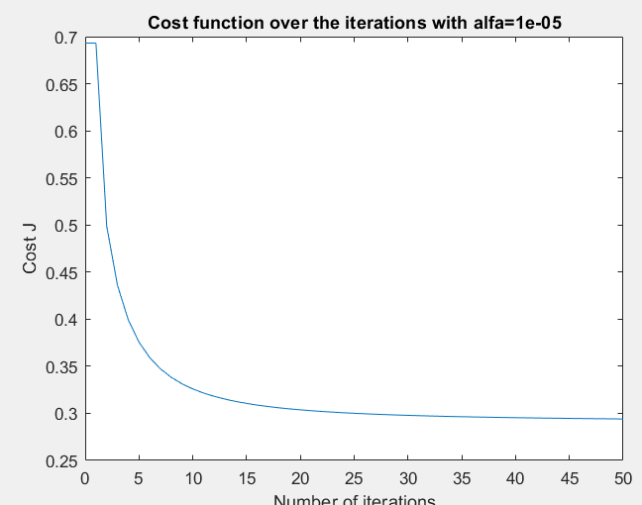

For a too high coefficient alpha : (alpha = 0.0008)

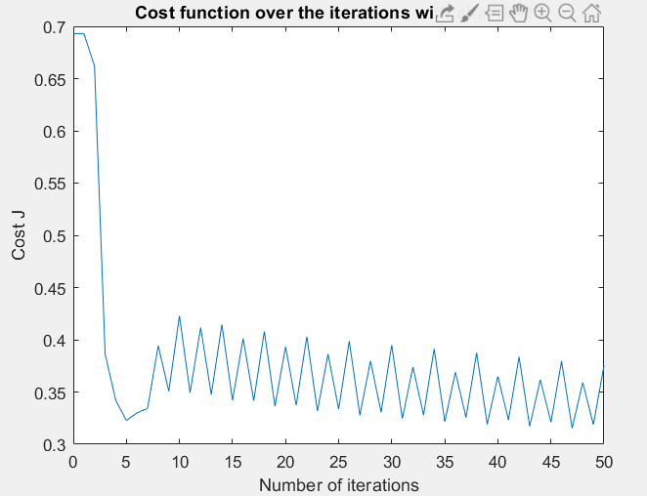

If our coefficient alpha is incoherent, for instance alpha=1, the resulting classifier higly lose in term of efficiency

Now that the classifier is operational, we use the other part of our database to test using the sigmoid function with Fclassify_Logistic reg. Then we extract the results by comparing each element of the Y_hat array with the mean value 0.5.

For each of our datatest element, we have our expected value Y_test, and our predicted value Y_test_asign that are up to the test.

III) Results and interpretation (1st Part)

Having our predicted and expected value of our sample test, we can build a confusion matrix to display the results.

By using 10 descriptors to construct our X matrix, we’re able to get a mean of 85% accuracy, and a similar value for the Fscore. Also because, at each run, the columns of our dataset are shifted randomly so we never use the same samples for both training and testing twice in a row.

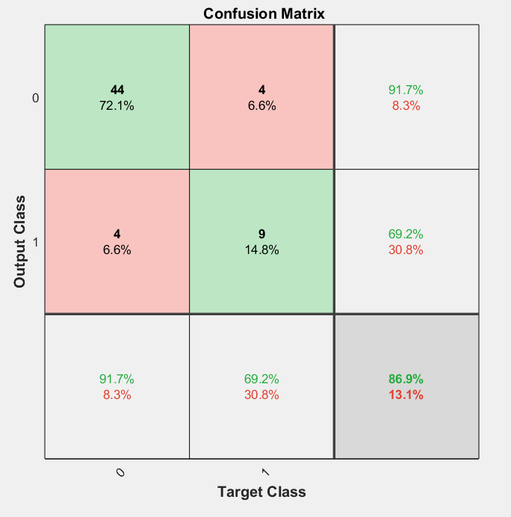

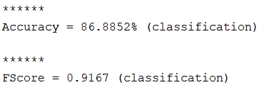

In our case, the average accuracy value of our classifier is 85%, and an even better Fscore (around 90%)

We calculate Fscore with the following formula:

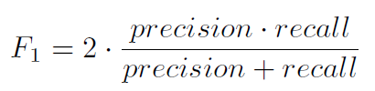

It’s also a value to quantify the effectiveness of our classifier by taking into account the precision and the recall of our classifier.

Also, we can build the ROC (Receiver Operating Characteristic) curve to compare the true positive rate against the false positive rate. The area below the curve represent the success rate.

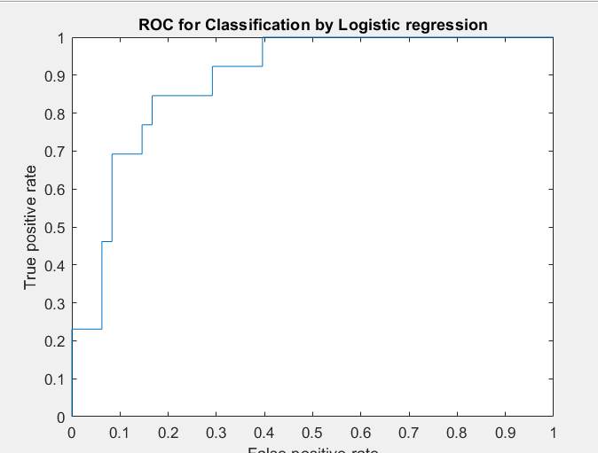

In our example, the lack of dataset test sample gives a non-smooth curve but still the area below is quite high and verify validity of our classifier.

The aim of this part was to create a hand-made classifier and show its performance on a dataset. If we want to improve our classifier. We could possibly upgrade our program by adding more descriptors (which I did with other functions from regionprops and other) or optimising the training session, but this is beyond the reach of our objective here.

IV) Second part: Strategy and implemantation

1) Preparation

Now, to our second part of this project, with our database set of images of melanoma, we need to define a strategy to classify efficiently our samples. First, to optimise our classifier, we will simply use from the Matlab library the function glmfit.
We also modify our importation part of our code to adapt to import all images into Matlab.

The issue of time is dominant in this second part. Loading images and calculating descriptors values are very time-consuming. So, it’s very common to save the result in a data .mat format so we won’t have to repeat the process at each run.

2) Descriptor selection strategy

Before doing any programming, doing some research on the topic to understand how the melanoma is characterised comes handy. I, for instance, had the chance to have a specialist (sort-of) among my family.
There are many symptoms for the melanoma, but only few of them are visually-related.

Here are possible characteristic reusable to program some descriptors:

- Irregular frontier (non-smooth)
- Irregular color density
- Non-spherical
- Presence of a “3D volume effect”, something that have a volume tends to have some light reflects, and hence, can be used to detect this volume aspect.

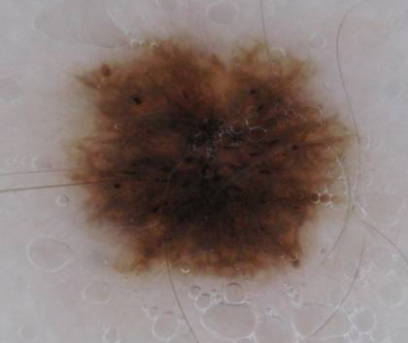
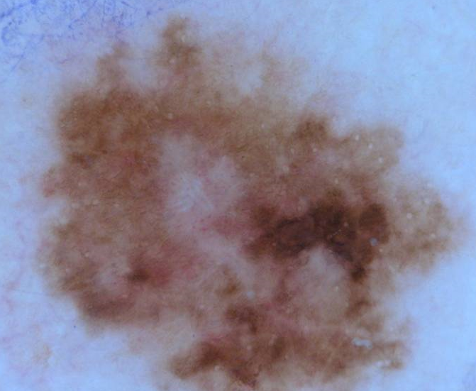
On the right a non-melanoma case, on the left a melanoma

In this example, which is a pertinant comparaison, we can see the frontier irregularity so we can observe the color intensity irregularity. Unfortunately, not all of our images are as easily classable such are those two, which consist of the difficulty of our project.

Also, our data is provided with their logical threshold image and a superpixel representation.
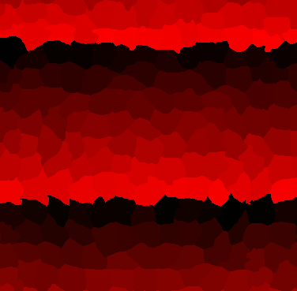
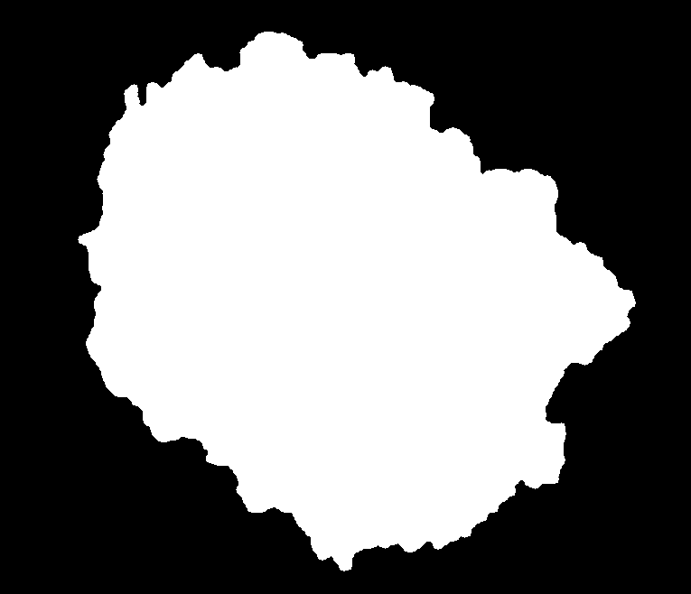
Logical image Superpixel image

Fort the logical image, we can reuse the same descriptors that what used for the first part, adding some other new function of region props, those descriptors alone can give correct results, but nothing outstanding, but nonetheless, is a good start for creating a list of descriptors. We also need to watch out for parameters like area or perimeter that heavily depends of the quality of the image.

For the original (colored) image. There are two possibility to extract features from the image, either using the raw image and extract possible descriptors or filtering the image to normalise it. The problem with normalising the image is that we possibly remove characteristics from the image, and thus, falsifying the results. After making some soft image adjustments (normalising histogram, center zooming), results showed it doesn’t improve the classification.

A simple but effective solution to calculate descriptors for an image is using the LBP (Local Binary Pattern) method. It’s easy to compute, theoretically efficient, and “fairly” rapid to calculate. Because our image is colored, we can reuse this technique for each color vector. This gives us 256*3 values that can be used as descriptors, but many of them are irrelevant and non-characteristic of a specificity to distinct the two classes. To limit the number of values, we only take the values of the highest coefficients for a standard image. I wrote a function determinate the treshold value to class the values that can be used as a descriptor from the others. I conserved in total (8*3) 24 LBP descriptors saved in a data DescripteurLBP3.mat file.

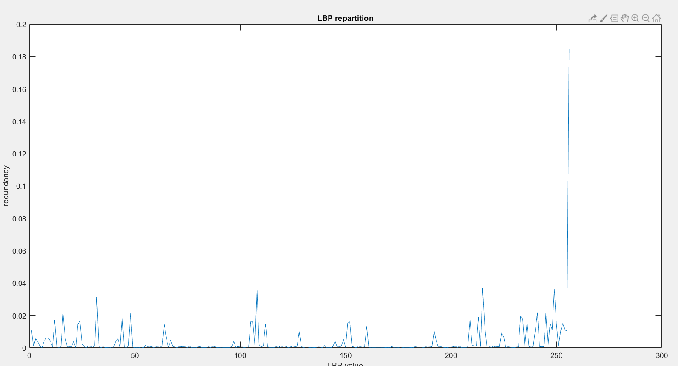
Threshold barrier (LBP value from pics that goes above the line are used as descriptors)
LBP value Repartition

Finally, I tried to make us of the superpixel image data, my first approach was to convert the image in a grey scale, and compute the histogram. But it turned out to have a negative impact on the results. Also, I tried to separate each superpixel by differentiating them them with the function imlabel, then for each superpixel, calculate the perimeter and eventually other descriptors.

The main issue lies on the number of superpixels that isn’t constant, also it takes an excessive amount of time to calculate all those parameter since we study for each image, characteristics for its sub-image.

In the end, none of these methods were satisfying after testing them in practice and thus, were left outside of the main program, but a X database named DescripteurSuperpixelAire.mat was saved .

V) Results and interpretation (2nd Part)

With the following descriptors, I can get a mean accuracy of 70%, and a F score of 78%. Of course, those results can improve by allowing a bigger portion of the dataset for training.
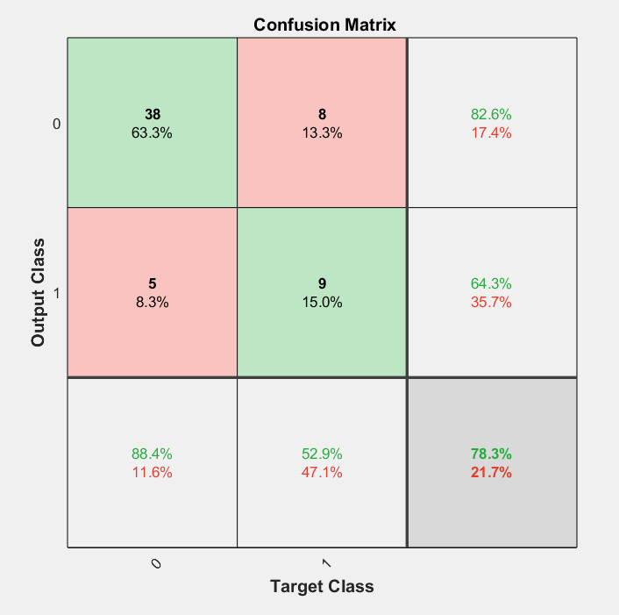

Is is also possible to reduce the threshold to sort an y sample from Y_test so the machine would be more biased to class at is as positive, by saying Y_test_asign=1 if Y_hat>0.45 instead of 0.5.

This permits to class more elements as positives even though it may hurt the accuracy of the system. This way, we may class more TP than in normal case. We also get to have more FP, but in our problematic, it is a bit less of an issue.

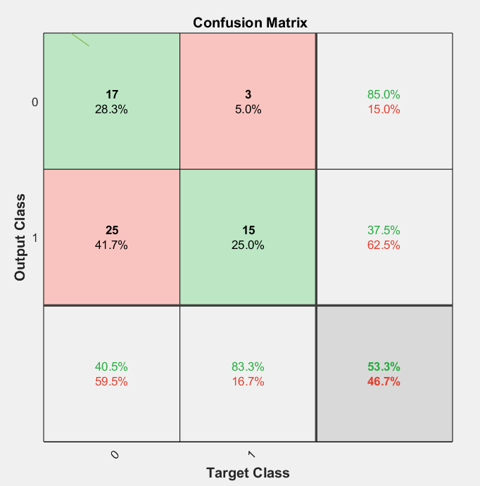

Here is an example where we class with the condition Y_hat>0.05. We considerably dropped in term of accuracy, but we trade this loss with only 3 FN which means only 3 case of melanoma were not detected.

Of course, the threshold value taken here isn’t the smartest decision, but it show how lowering the threshold value can be a possibility if we consider not wanting to miss a positive case of melanoma.

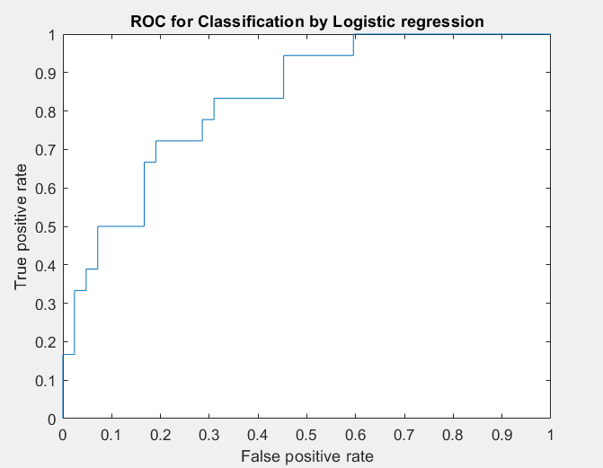
Also if we look at the ROC curve, the type of the curve is atypical of a decent classifier.

The era below the curve is rather important, validating our classifier to some degree.

I personally believe those are rather a poor result for a classifier, the main reason is the lack of “good” descriptor in our case. There is no intuitive descriptors that comes up when we take a look at the dataset images. We can’t flood the classifier with unnecessary features because of time issues and it also conceals the weight of other more useful descriptors.

I also believe this algorithm can be heavily be improved by finding good descriptors, and something that can be a good addition to the program is a function to sort descriptors in term of utility for sorting our test database. We could then conserve good descriptors and get rid off the other that doesn’t bring much to the table.

V) Conclusion

This gave me a quick but full understanding on how is done image classification with machine learning. Each part forced me to study the challenge of building a classifier appropriate to a problem.
On one hand, I learnt more in depth about the algorithm a classifier, the logistic regression model, and h how to make use of descriptors.
On the other hand, the practical application shows every issues that image machine learning can consist of.

Here, we had a very limited image dataset, and even if it comes with some additional treatments (logical image and superpixels). Sorting elements into two different classes looked very challenging at first. The main part lies on finding good descriptors, and those descriptors should have the following specificies:

- Technically possible to implement
- Fast calculation
- Distinguishing classes effectively
- Not being too many if they come in “pack”, so they don’t outweight other descriptors

I took much time experimenting new descriptors, but they usually falls into one of these 4 categories, and thus, is being discarded.

For instance, working on superpixels showed me the limit of machine learning, as the problem of time can represent a real barrier, a barrier that we’re used to turn a blind eye on it normally, but when it comes to use methods for 200 different images, it can take several hours to run the program, to finally observe the little-to-no improvement made by the addition of these new descriptors on the results.

The project overall, represented of a good part of experimenting methods to check if it is possibly implementable to our main program, something that I liked a lot during this project.

Thanks to Víctor González Castro, Johan Debayle and Yann Gavet for presentig us such an interesting project.

