Transcription Delivery Path Analysis
Date: March 23, 2026
Scope: Latency and confidence comparison of four transcription delivery paths.
Target System: ~1,200 agents, ~40,000 calls/day, ~6-minute average call duration (~800,000 utterances/day)
Test Data: 6 live test calls, 61-62 matched utterance pairs per path, independent ground-truth audio timing on a single machine ^{[1]}

Summary
Utterance Latency (end-to-end: speech ended → transcript received) ^{[1]}
Source | p99 | p95 | p50 | >5s rate | >5s/day | STT Conf.
Genesys AudioHook + Deepgram (est. from official docs) | ~3,500 ms | ~2,870 ms | ~1,140 ms | ~0% | ~0 | 98%
Deepgram Direct (measured) | 3,569 ms | 2,945 ms | 1,216 ms | 0.0% | 0 | 98%
Genesys Notifications WS | 7,310 ms | 3,301 ms | 1,369 ms | 3.3% | ~26,400 | 78%
Genesys EventBridge SQS | 7,470 ms | 3,435 ms | 1,570 ms | 3.2% | ~25,600 | 78%

Genesys AudioHook estimates are derived from Deepgram Direct POC measurements adjusted for Genesys infrastructure overhead. Previous analysis showed Genesys reported values to be significantly lower than testing observed ^{[9]}. Validation requires an end-to-end POC with real Genesys call audio.
The EB-Notifications gap remains constant (134-227ms) across all percentiles ^{[1]}. The Deepgram-to-Genesys gap widens at p99, where r2d2 endpointing produces outlier latencies.
Confidence is presented as metric indicating accuracy of transcription.
STT Confidence ^{[1]}
STT Engine | Median (Matched Pairs) | Median (All Transcripts)
Deepgram Nova-3 | 98.3% | 96.9%
Genesys r2d2 | 80.7% | 78.0%

Confidence is independent of delivery path. Notifications and EventBridge carry identical r2d2 confidence (same STT engine, different delivery).

Genesys AudioHook Cost
~$68K-$94K/month for Deepgram STT (enterprise discount likely 40-60% off) plus Genesys AudioHook Monitor licensing (contact Genesys sales). Full implementation research: AudioHook Research ^{[8]}.

Method
Three independent capture paths run simultaneously on the same live Genesys call audio ^{[1] [2]}:
Live Genesys Call
├─→ Genesys → r2d2 STT → Notifications API (WebSocket) → notifications-spike
├─→ Genesys → r2d2 STT → EventBridge → SQS → sqs_consumer
└─→ BlackHole audio loopback → Deepgram Nova-3 STT → poc-deepgram

Path C (Deepgram Direct) provides ground truth. True latency = receivedAt - audio_wall_clock_end, both time.time() on the same machine. No clock synchronization needed.
Utterances matched across systems using fuzzy text similarity (SequenceMatcher ≥ 0.70) within a 15-second temporal window ^{[3]}.
Metric: All latency percentiles in this document are per-utterance unless explicitly labeled per-word.

Self-Reported vs True Latency
Genesys self-reported latency understates true latency by 2.4x-4.4x ^{[1]}. Self-reported misses Stage 1 (audio capture transport) and zeros out the baseline via anchor-event timing.
Pctile | Notif. True | Self-Reported | Ratio | EB True | Self-Reported | Ratio
p99 | 7,310 ms | 2,097 ms | 3.5x | 7,470 ms | 2,781 ms | 2.7x
p95 | 3,301 ms | 1,192 ms | 2.8x | 3,435 ms | 1,236 ms | 2.8x
p50 | 1,369 ms | 346 ms | 4.0x | 1,570 ms | 356 ms | 4.4x

EventBridge Delivery Overhead
The EB delivery pipeline stays under 350ms at p99 ^{[1]}. Tail latency originates in Stages 1-3 (audio capture, r2d2 STT, endpointing).
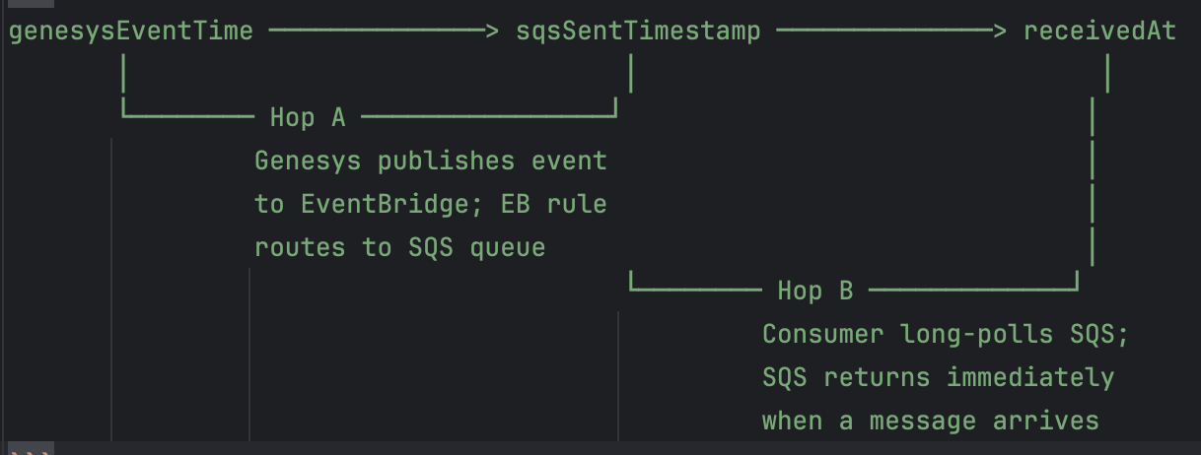

Hop | p99 | p95 | p50
Hop A: Genesys → SQS enqueue | 251 ms | 226 ms | 169 ms
Hop B: SQS → Consumer poll | 165 ms | 142 ms | 56 ms
Total | 343 ms | 325 ms | 238 ms

EB-Notifications delta: +134ms to +227ms across percentiles ^{[1]}.

SLA Exceedance at Production Scale
SLA target: All utterances delivered end-to-end (speech ended → agent sees suggestion) in under 2 seconds. This encompasses Stages 1-6: STT + endpointing + delivery + LLM inference + render.
SLA exceedance rate is the percentage of utterances whose true latency exceeds a given threshold. Rates below are for Stages 1-4 only (speech ended → transcript received, before LLM inference). LLM inference (Stage 5) adds 500-2,000ms on top of these numbers. Rates are measured from the 61-62 matched pairs and projected to 800,000 utterances/day ^{[1]}.
At 800,000 utterances/day:
Source | >2s | >2s/day | >3s | >3s/day | >5s | >5s/day
Deepgram Direct | 27.4% | ~219,200 | 4.8% | ~38,400 | 0.0% | 0
Genesys Notif. WS | 18.0% | ~144,000 | 6.6% | ~52,800 | 3.3% | ~26,400
Genesys EB SQS | 19.4% | ~155,200 | 8.1% | ~64,800 | 3.2% | ~25,600

At a 2s SLA target, Stages 1-4 alone exceed 2 seconds for 18-27% of utterances — before LLM inference begins. With LLM inference added (500-2,000ms), the 2s target is only achievable for utterances where Stages 1-4 complete in under ~1,500ms (approximately p50 and below for all paths).
Tail events appear across multiple conversations. EventBridge tail events track Notifications tail events at the same timestamps with a consistent offset — the tail is caused by r2d2 STT endpointing, not the delivery path ^{[1]}.
All three paths deliver >80% of utterances within 2 seconds (Stages 1-4 only). Deepgram Direct reaches 100% by 3.6s. Genesys paths have tails extending to 7-10s ^{[1]}.

Notifications API Constraints at 1,200 Agents
Hard Limits ^{[10]}
Limit | Value | Source
Topics per WebSocket channel | 1,000 | Genesys docs (400 error if exceeded)
Channels per user/application | 20 | Genesys docs
Channel lifetime | 24 hours | Must recreate and resubscribe after expiry
WebSocket connections per channel | 1 | Second connection disconnects the first
GET /api/v2/conversations | Current user’s conversations only | Empty with client_credentials auth
Capacity Math ^{[5] [10]}
1,200 agent conversation feed topics (static, one per agent)
+ 750-1,000 transcription topics (dynamic, at peak concurrency)
─────────
= 1,950-2,200 topics needed simultaneously → 2x the 1,000 limit
Workarounds Required for Production ^{[5] [10]}
Workaround | What It Requires
Channel sharding (3-4 channels) | Routing logic, per-channel topic tracking, rebalancing when one shard nears 1,000
Dynamic topic management | ~80,000 subscribe/unsubscribe API calls/day (40,000 calls × 2 operations)
24-hour channel rotation | Staggered refresh: create new channel → subscribe all topics → connect new WS → verify events → disconnect old WS. Failure during rotation loses all events for that shard
Analytics-based recovery | Replace GET /api/v2/conversations (broken with client_credentials) with POST /api/v2/analytics/conversations/details/query. Requires 1,200 user ID predicates per query. ~8,640 additional API calls/day at 10s polling
Multi-participant parsing | Iterate ALL agent participants per conversation, not just the first. Required to handle re-routed calls

Issues Found During Testing ^{[6]}
During a 6-call test with 2 agents, the following issues were discovered. Full details: Notifications Testing Learnings ^{[7]}.
# | Issue | Impact | EB Affected?
1 | MAX_CONCURRENT_CONVERSATIONS defaulted to 1 — silently dropped alternating calls | 3 of 6 conversations lost | No
2 | Startup race condition — calls in progress before WebSocket connects are invisible | First conversation lost | No
3 | SQS consumer not started (operator error, but illustrates multi-process dependency) | All EB data missing for that run | N/A (operator)
5 | Status events without transcripts field crash consumer (poison message loop) | Consumer stuck until fix | Fixed (delete non-transcript messages)
6 | _conversation_times() stops at first agent participant — re-routed calls missed | Conversation captured by EB but not Notifications | No
7 | State machine stuck after missed call + agent re-ready (connected=False ended=True loop) | Conversation captured by EB for 10+ min while Notifications shows nothing | No
8 | recover_active_conversations() returns nothing — GET /api/v2/conversations empty with client_credentials auth | Recovery function never worked. Startup recovery was a no-op | No

Issues 6, 7, and 8 are architectural: the reactive subscribe/unsubscribe model requires per-conversation state tracking that breaks under real-world call routing patterns ^{[6]}. EventBridge is unaffected by all of these because it has no per-conversation subscription, no state machine, and delivers all transcription events to a single SQS queue regardless of conversation lifecycle ^{[11]}.
EventBridge Comparison ^{[11]}
Zero per-agent subscriptions. Zero API calls during steady state. Single EB rule captures all events org-wide. SQS retains messages up to 14 days during consumer downtime.

Complexity Comparison ^{[5]}
Dimension | EventBridge | Notifications API | AudioHook + Deepgram
Application code | ~80 lines | ~1,500+ lines | ~500-1,000 lines
Genesys API calls/day | 0 | ~88,640 | 0
WebSocket connections | 0 | 3-4 | ~1,000 (one per call)
Inbound bandwidth | ~5 Mbps | ~5 Mbps | ~256 Mbps
Failure modes | 1 | 7+ | 2+
Recovery from downtime | SQS retains messages | Recreate channels, resubscribe, recover | No recovery for missed audio
Additional cost | $0 | $0 | AudioHook license + Deepgram STT

Latency Budget: Speech Ended → Agent Sees Suggestion ^{[1]}
All three paths share Stages 1-3 (Genesys r2d2 STT + endpointing) and Stages 5-6 (LLM + render). They differ only in Stage 4 (delivery).

Notifications (WebSocket)
p95 p99
Stage 1-3: Genesys STT + endpointing 3,301 ms 7,310 ms
Stage 4: WS delivery ~50-200 ms ~100-250 ms
Stage 5: LLM inference ~500-2,000 ms ~500-2,000 ms
Stage 6: Render in agent UI ~50-100 ms ~50-100 ms
────────────────────────────────────────────────────────────────────
Total: ~3,900-5,600 ms ~7,960-9,660 ms

EventBridge (SQS)
p95 p99
Stage 1-3: Genesys STT + endpointing 3,435 ms 7,470 ms
Stage 4: EB delivery (Hop A + Hop B) 325 ms 343 ms
Stage 5: LLM inference ~500-2,000 ms ~500-2,000 ms
Stage 6: Render in agent UI ~50-100 ms ~50-100 ms
────────────────────────────────────────────────────────────────────
Total: ~4,310-5,860 ms ~8,363-9,913 ms

AudioHook + Deepgram (estimated)
p95 p99
Stage 1-3: Deepgram STT + endpointing 2,945 ms 3,569 ms
Stage 4: In-process (no network hop) ~0 ms ~0 ms
Stage 5: LLM inference ~500-2,000 ms ~500-2,000 ms
Stage 6: Render in agent UI ~50-100 ms ~50-100 ms
────────────────────────────────────────────────────────────────────
Total: ~3,495-5,045 ms ~4,119-5,669 ms

The delivery path (Stage 4) adds 325-343ms for EventBridge and ~50-250ms for Notifications. At p99, the dominant factor is Stage 1-3: Genesys r2d2 reaches 7,310-7,470ms while Deepgram reaches 3,569ms. The AudioHook path eliminates the r2d2 tail entirely.

AudioHook Architecture Reference
The following diagrams illustrate the Genesys AudioHook architecture, session lifecycle, and audio flow patterns.

AudioHook Architecture
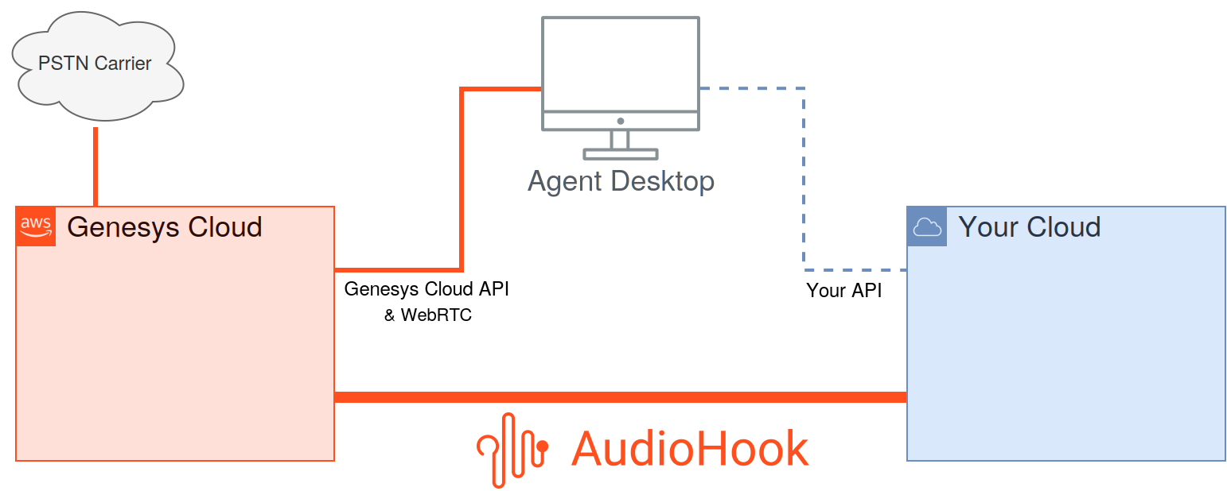

Basic Session Lifetime
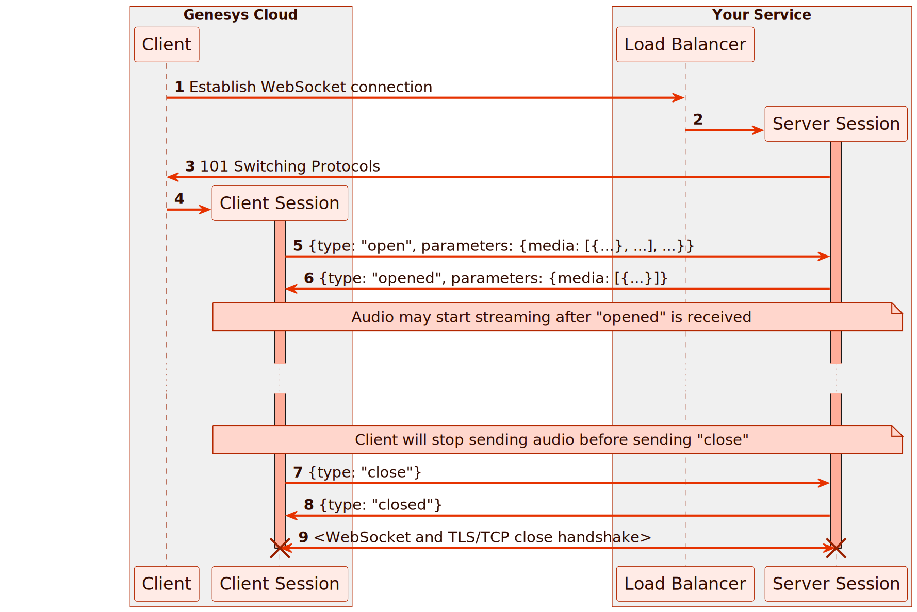

Audio Frame (ulaw stereo)
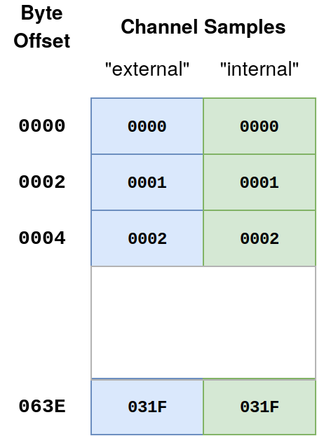

Session Audio Timeline
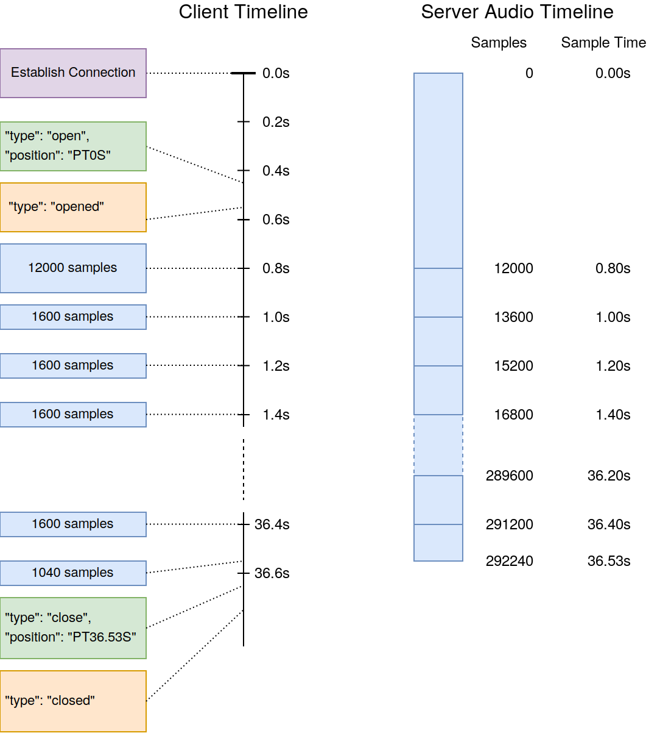

Session Audio Timeline (Discard)
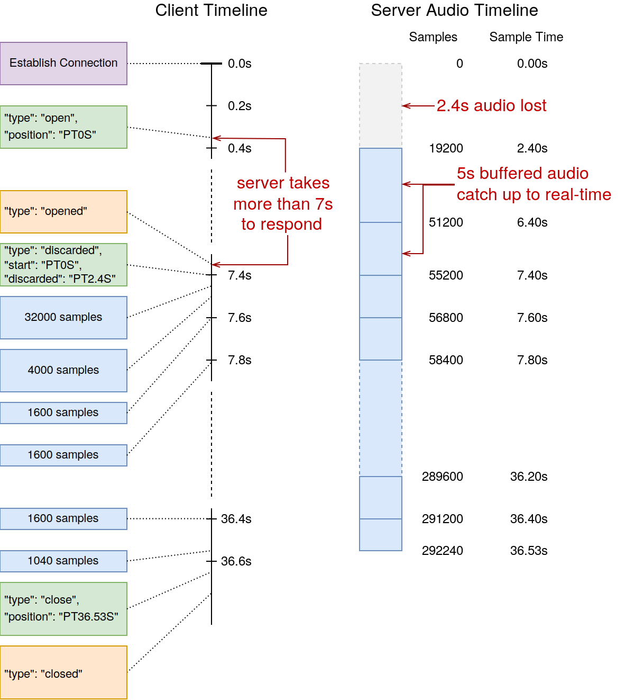

Audio Flow
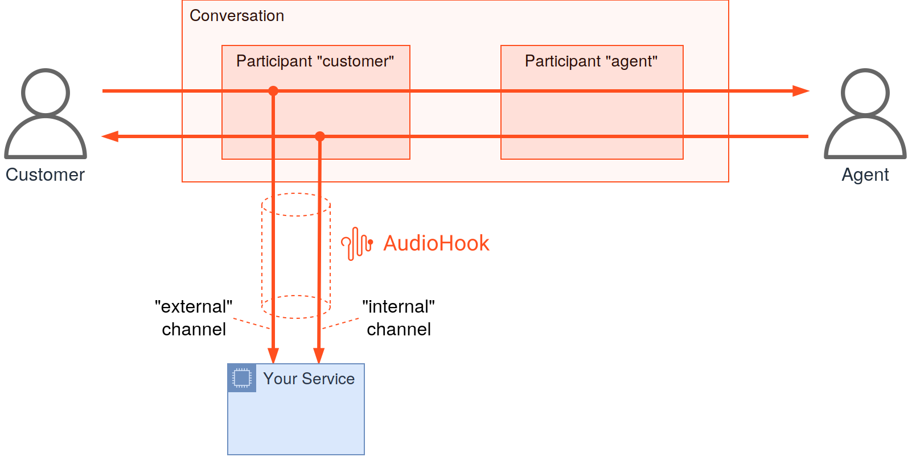

Audio Flow — IVR
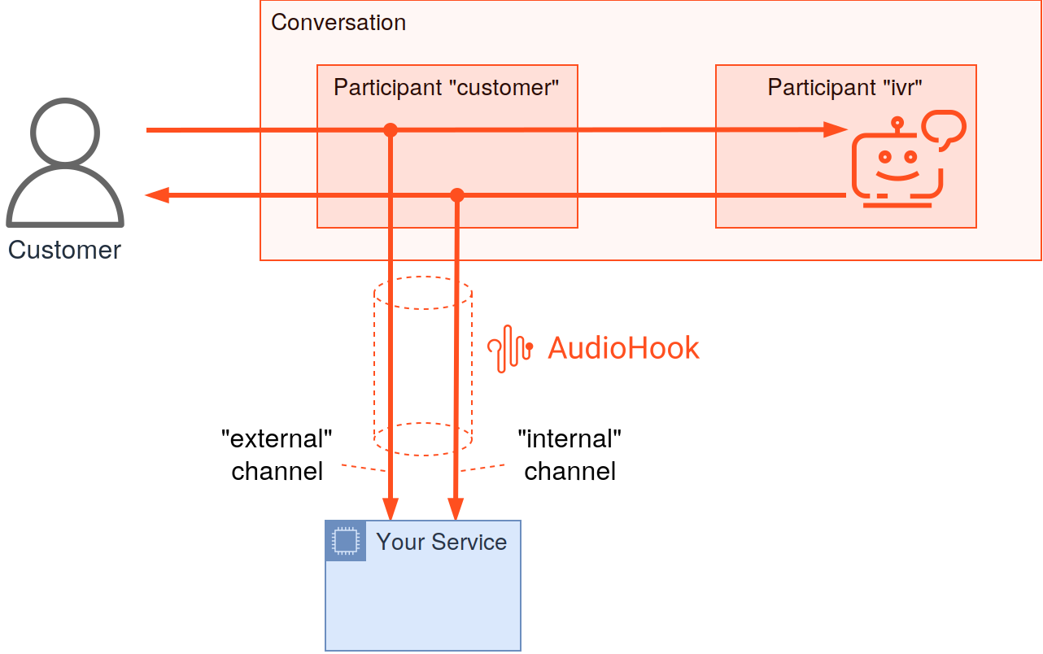

Audio Flow — Follow Agent
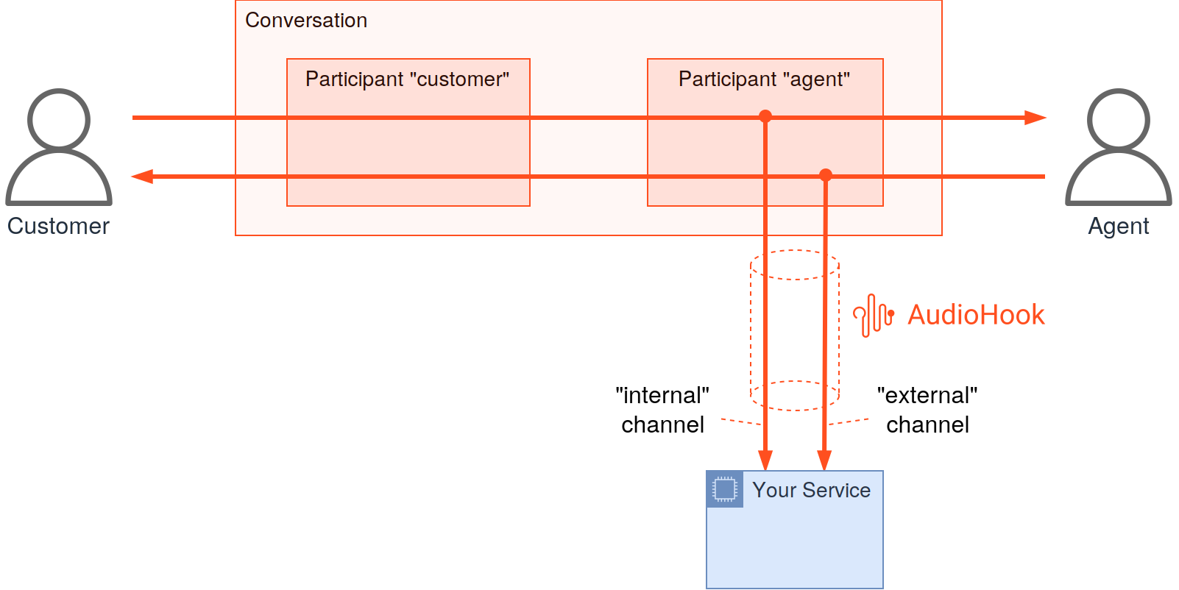

Audio Flow — Follow Both Mono
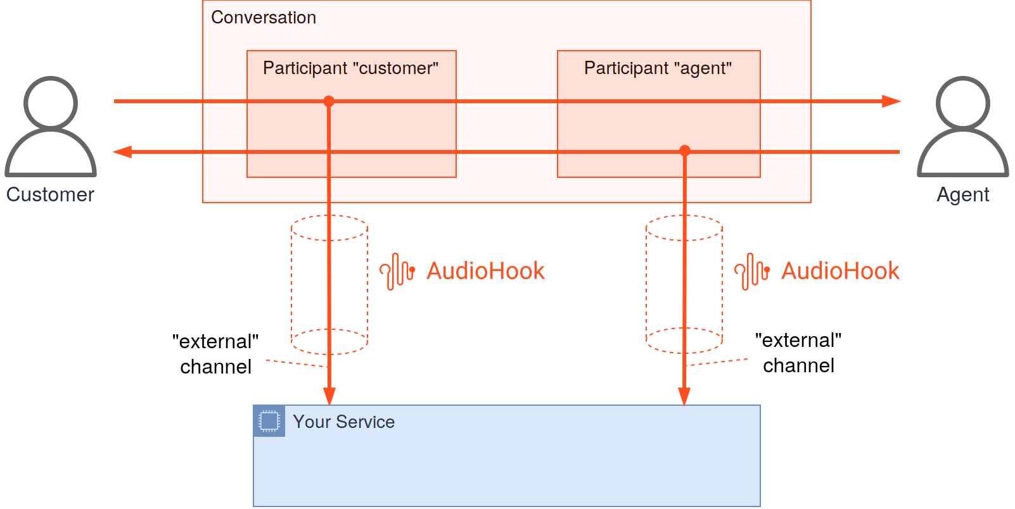

Audio Flow — Conference
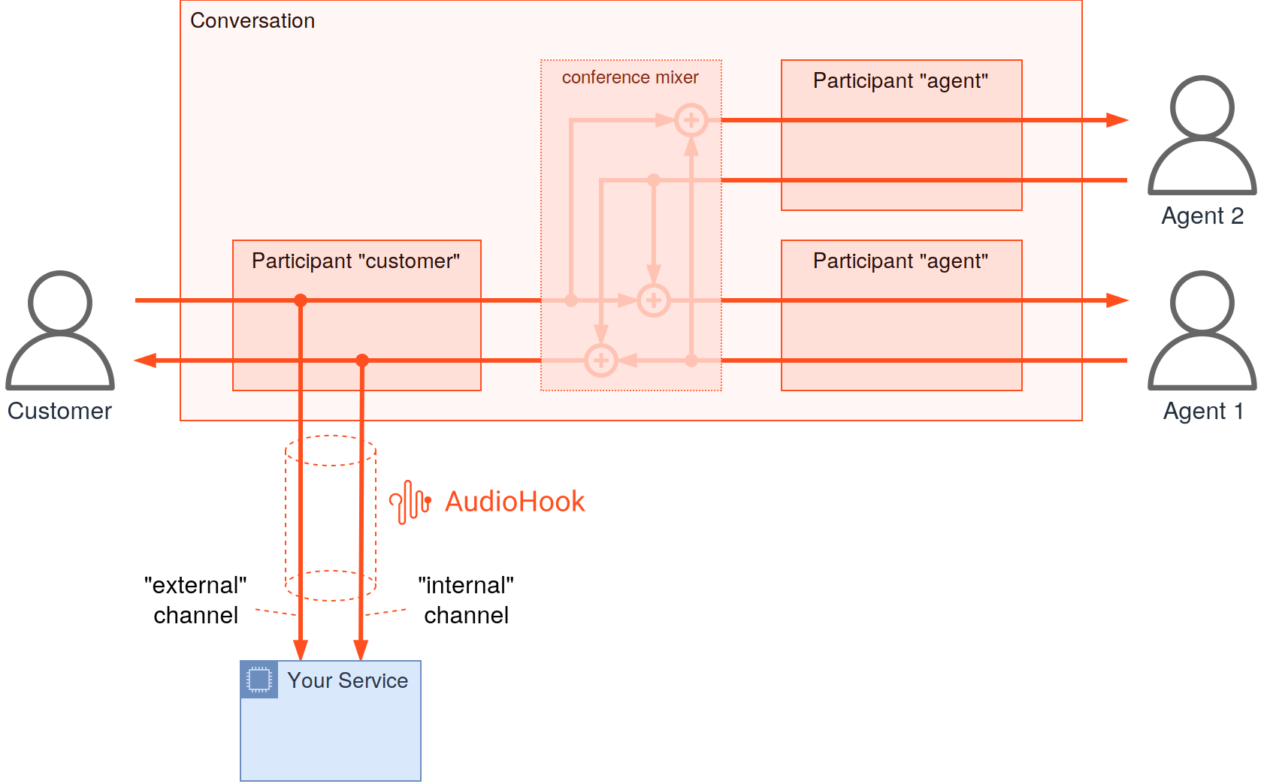

Audio Flow — Follow Both Mono Conference
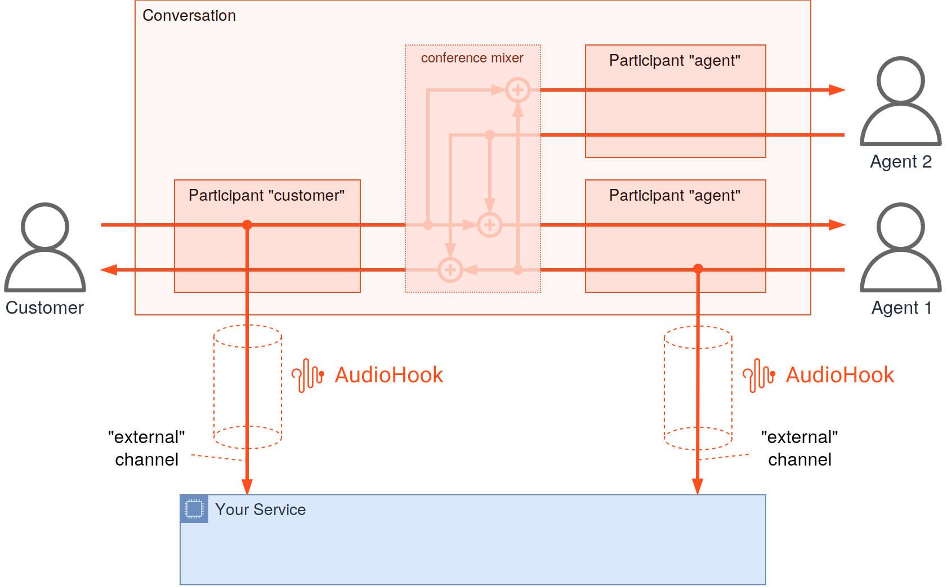

Reconnect — Discarded
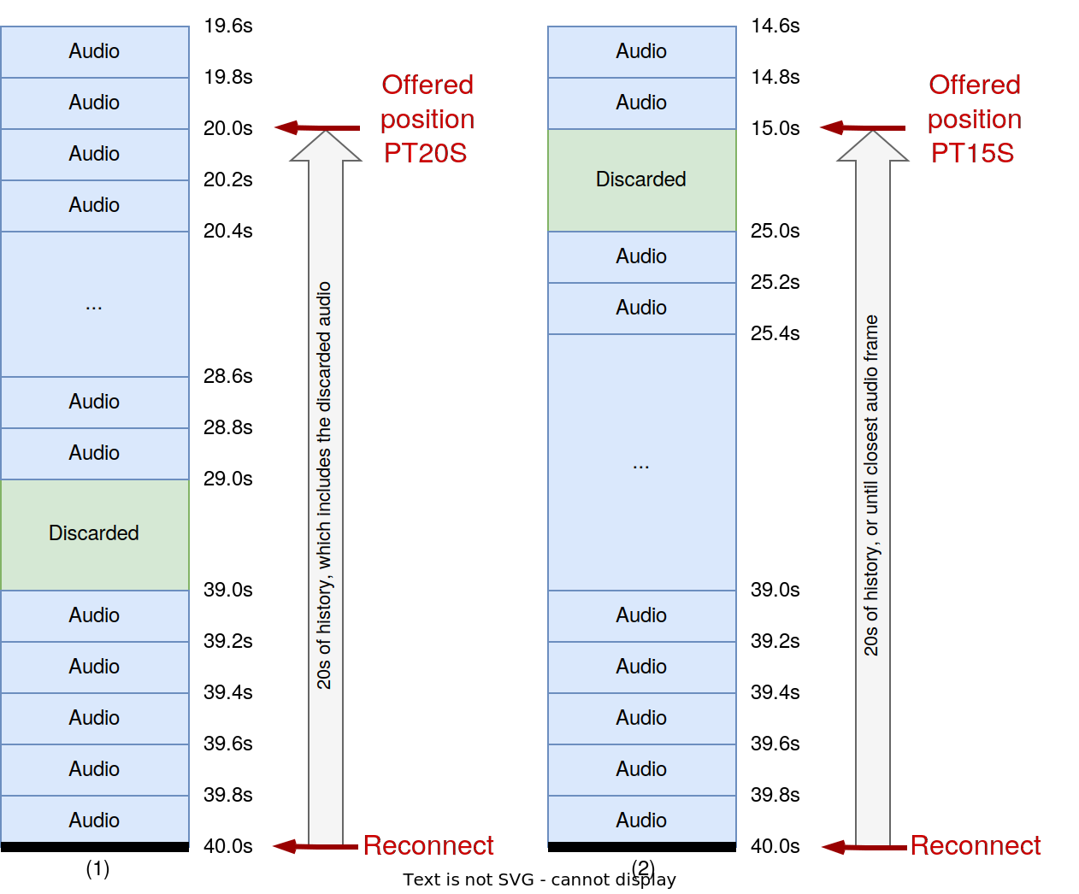

Reconnect — Client Pause
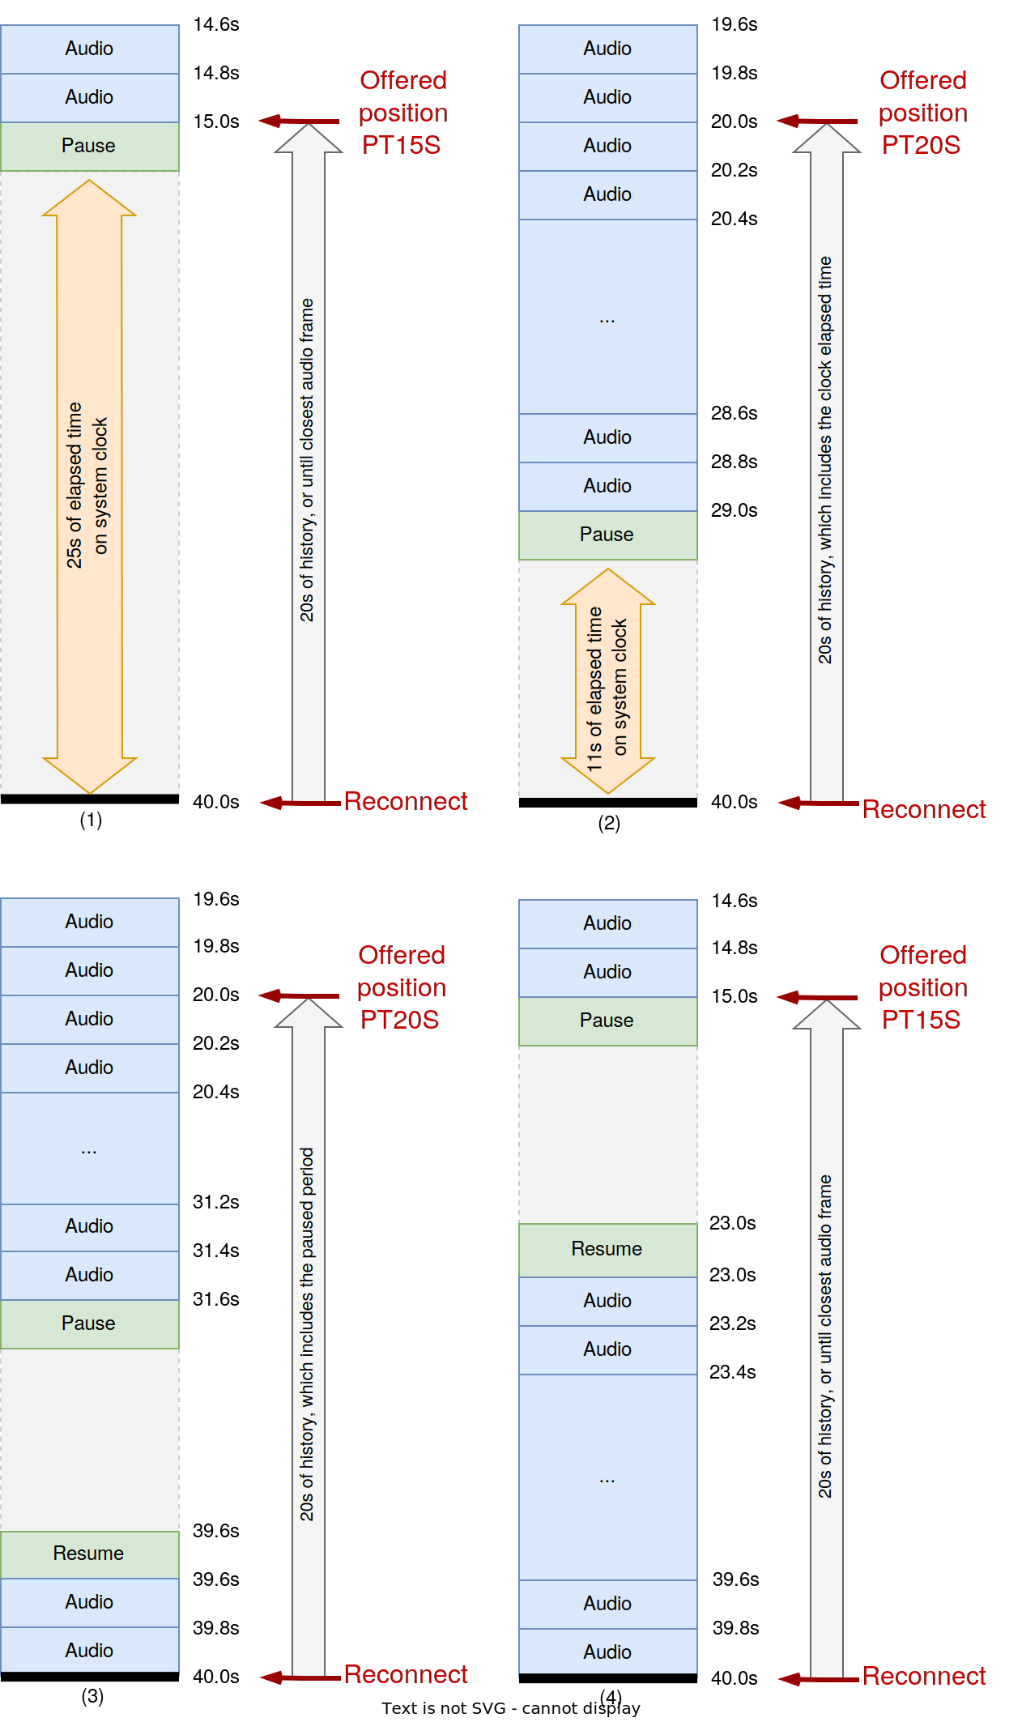

References
# | Source | Description
1 | notebooks/cross_system_latency-03-PERCENTILE-ANALYSIS.ipynb | Primary percentile analysis: latency (p50-p99), SLA exceedance, confidence, EB hop decomposition, self-reported vs true
2 | notebooks/cross_system_latency-02-EB-RESULTS.ipynb | Cross-system median/mean analysis
3 | scripts/correlate_latency.py | Utterance matching engine (fuzzy text similarity, SequenceMatcher ≥ 0.70, 15s window)
4 | analysis_results/cross_system_eb/ and cross_system_eb_p99/ | Exported charts and data (CSV, JSON, PNG)
5 | docs/analysis_key_points.md | Architectural constraints, capacity math, and complexity comparison
6 | docs/notifications_testing_learnings.md | Testing issues discovered during 6-call comparison (8 issues)
7 | Confluence: Notifications Testing Learnings | Notifications Testing Learnings (Confluence)
8 | Confluence: AudioHook Research | AudioHook implementation research (Confluence)
9 | Confluence: Genesys Notifications WS Latency Experiment | Genesys Notifications WebSocket Latency Experiment Results
10 | Genesys Developer Docs: Notifications | Genesys Notifications API documentation (topic limits, channel limits, usage limitations)
11 | Genesys Help: EventBridge Integration | Genesys EventBridge integration documentation

