EXECUTIVE SUMMARY
Genesys Transcription Latency:
Independent Measurement vs. Self-Reported Metrics
Date: March 18, 2026
Basis: 6 controlled test calls (ground-truth measurement); 147 production conversations (self-reported comparison only)
Summary: Independent measurement reveals that Genesys’s self-reported transcription latency understates true end-to-end latency by a factor of 4–6×. Applications designed around the reported ~0.4s median will encounter actual delays of ~1.7s. An AudioHook integration (e.g., Deepgram) reduces median latency by 27% and significantly improves tail-end performance.

Latency Comparison
The following table presents latency measurements from the same 6 test calls, captured through three independent methods.

Time (ms) from caller’s audio being received by Genesys to the transcription text received via the Genesys Notifications API.

Metric | Genesys Self-Reported | Genesys Ground Truth | Deepgram (AudioHook Proxy)
Median | 432 ms | 1,712 ms (4.0×) | 1,248 ms
Mean | 626 ms | 2,775 ms (4.4×) | 1,596 ms
p95 | 1,611 ms | 10,544 ms (6.5×) | 3,469 ms
p99 | 2,751 ms | 16,472 ms (6.0×) | 4,338 ms

The 4.0× discrepancy at the median represents a material gap for latency-sensitive applications. The 6.5× discrepancy at p95 has significant implications for any real-time feature that must account for tail-end latency.

Why Self-Reported Metrics Understate Latency
Three structural factors cause the discrepancy between Genesys’s self-reported latency and independently measured end-to-end latency:

- Audio capture transport is excluded. Genesys measures latency from the point audio arrives at their servers, not from the moment the customer speaks. The network transport stage (~50–100ms) is omitted from self-reported metrics.
- Anchor-event normalization obscures the baseline. Genesys sets the lowest-latency event in each conversation to zero and reports all other values relative to it. This methodology reduces every reported measurement by several hundred milliseconds.
- Endpointing-induced batching is significantly understated. This is the primary contributor: Genesys’s endpointing algorithm waits for silence before emitting a finalized transcript. During continuous speech, it consolidates 2–4 sentences into a single event, introducing 5–15+ seconds of additional delay. While the self-reported metric captures some endpointing effect (the self-reported p95 is 1,611ms), it dramatically understates the true impact — ground-truth p95 is 10,544ms, a 6.5× difference.

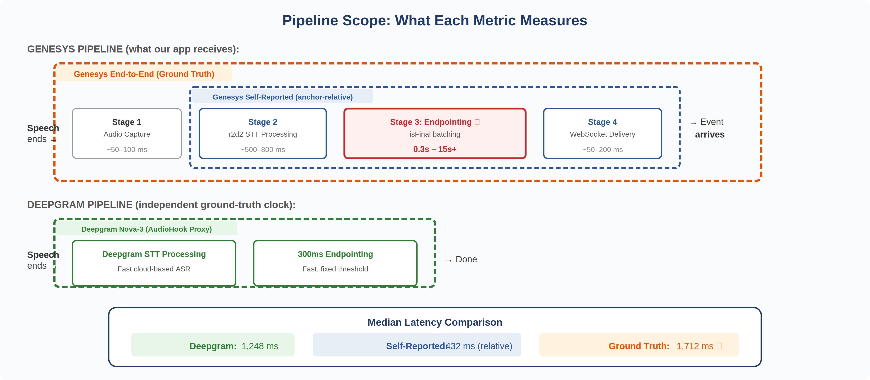
Pipeline coverage by metric — self-reported measurement excludes Stage 1 and understates Stage 3 contribution

Impact on Real-Time Features
The table below illustrates how the latency discrepancy affects planning assumptions for real-time application features:

Feature | Expected (Self-Reported) | Actual (Ground Truth)
Real-time agent assist / prompts | ~0.4s (within tolerance) | ~1.7s (perceptible delay)
Live sentiment dashboard | < 1s (near real-time) | 1.5–2.5s (1–2 turn lag)
Supervisor escalation triggers | ~1.6s at p95 | ~10.5s at p95 (insufficient for real-time)
Post-call summary | Minimal impact | Minimal impact

For post-call workflows (summarization, QA scoring), the latency difference has minimal operational impact. For real-time applications — agent assist, live dashboards, escalation triggers — the true latency profile materially changes feasibility and design requirements.

Supporting Evidence

True Latency Distribution (Ground Truth)
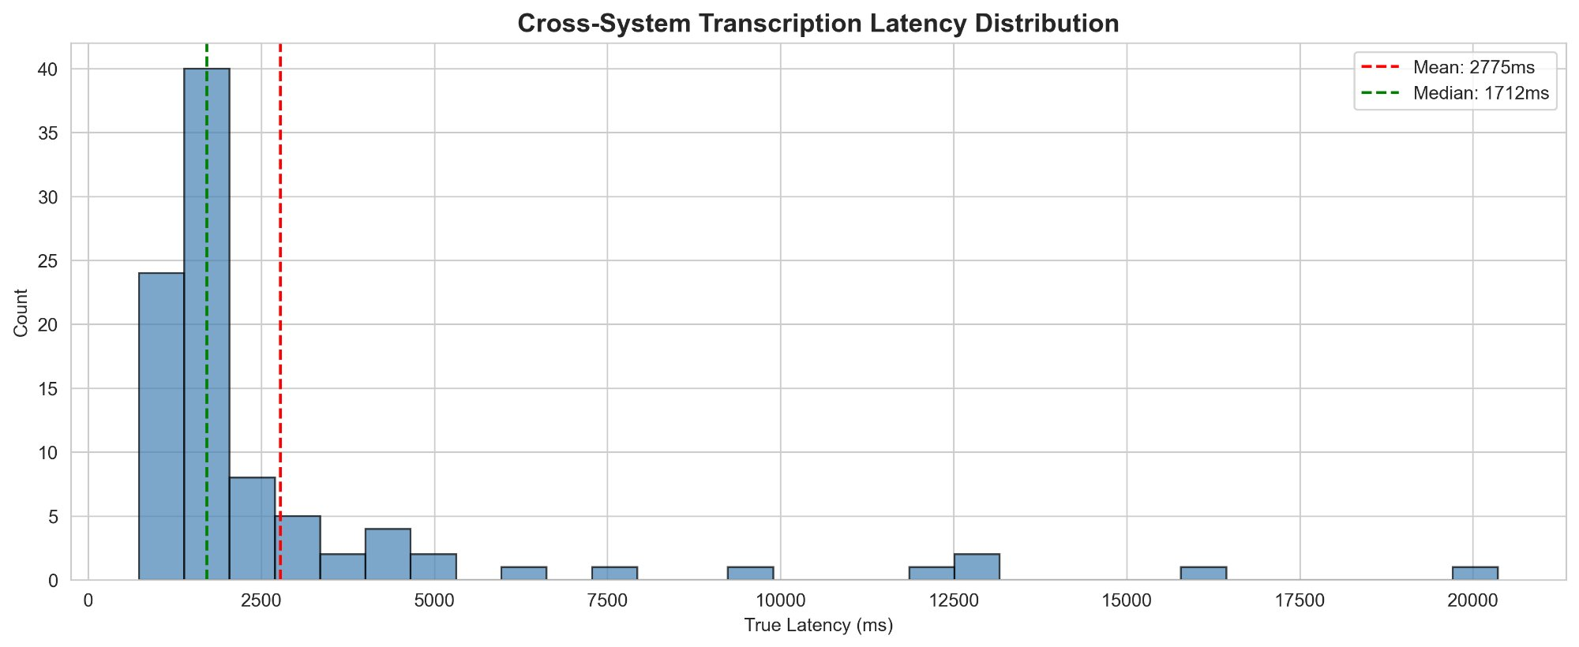
93 matched utterances across 6 test calls — median 1,712ms, long tail past 10s
The distribution is right-skewed, with the majority of utterances arriving in the 1–2 second range. Endpointing batching during continuous speech extends approximately 10% of events beyond 5 seconds.

True Latency Over Time
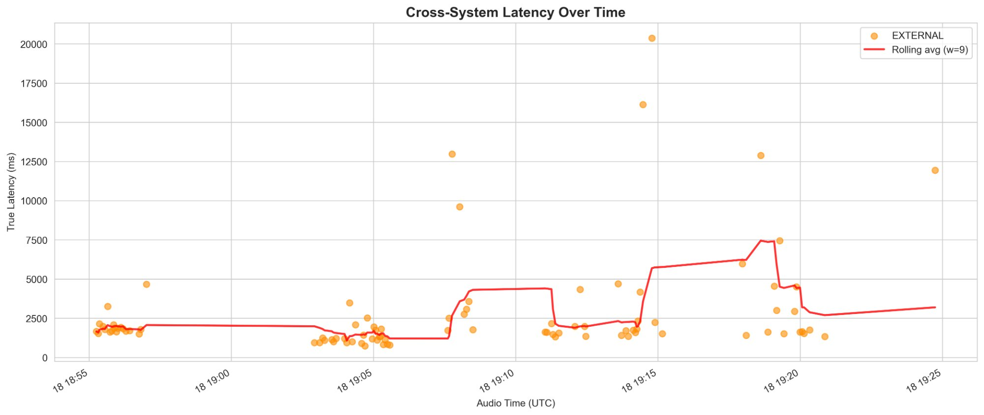
Latency spikes correspond to endpointing batching — not infrastructure issues
Latency spikes above 5 seconds are attributable to Genesys’s endpointing algorithm consolidating multiple sentences into a single event during continuous speech, rather than to infrastructure degradation.

Production Baseline (Self-Reported)
For reference, the charts below present Genesys self-reported latency from 147 production customer service conversations (October 2025). Based on the independent measurement results above, actual end-to-end latency is estimated at 4–6× these reported values.
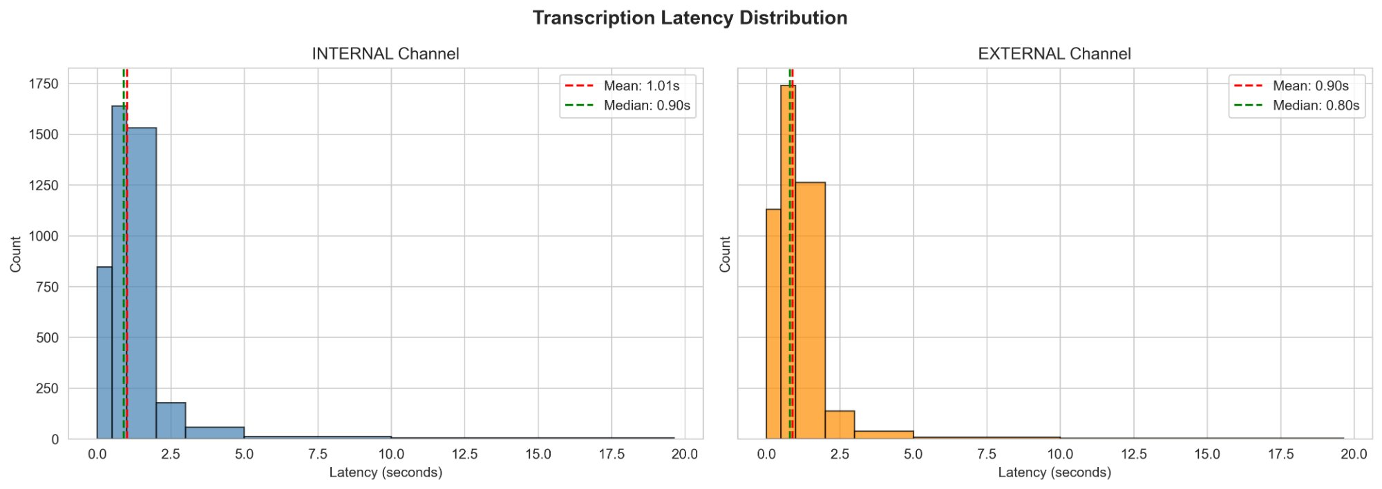
147 production calls, 8,735 utterances — self-reported median ~0.84s
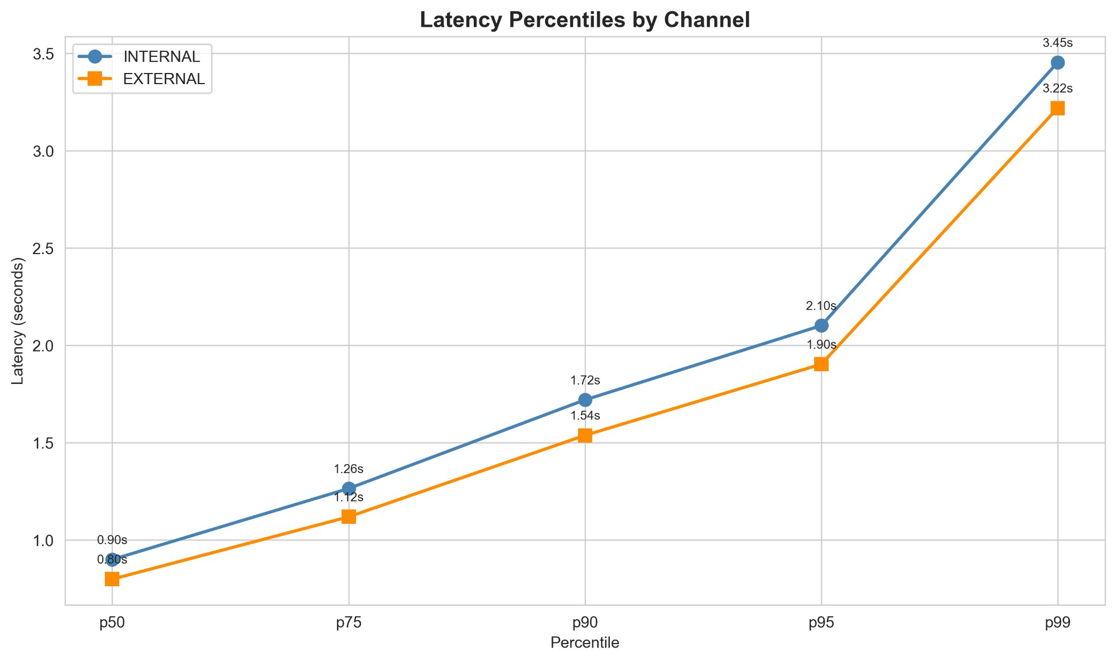
Self-reported percentiles by channel — Internal (agent) consistently ~12% higher than External (customer) at the median

Recommendations
For real-time use cases, an AudioHook integration warrants evaluation. Testing demonstrates that Deepgram via AudioHook delivers 27% lower median latency (1.2s vs 1.7s) and substantially improved tail-end performance (p95 of 3.5s vs 10.5s). The improvement is primarily attributable to faster endpointing rather than faster speech-to-text processing.

- Self-reported latency should not be used for capacity planning or feature design. Independent measurement confirms it understates true end-to-end latency by a factor of 4–6×.
- Real-time features should be designed for ~2s typical latency and 5s+ tail latency. This guidance applies regardless of whether Genesys notifications or AudioHook is selected.
- A production AudioHook pilot is recommended. The current test used movie monologues, which represent a worst case for endpointing. Real conversational speech patterns will produce improved tail latency on both delivery paths. A production pilot will establish operationally representative baselines.
- For post-call workflows, Genesys notifications remain suitable. The latency discrepancy is material only for real-time applications.

Complete methodology, test corpus specifications, and reproduction procedures are documented in the full technical report.

