Genesys Cloud Transcription Latency
Executive Summary
Date: March 18, 2026
Scope: End-to-end latency measurement of the Genesys Cloud real-time transcription pipeline
Method: Cross-system correlation using independent ground-truth audio timestamps

Key Findings
All three columns use data from the same 6 test calls (movie monologues played through live Genesys calls on March 18, 2026).

Metric | Deepgram Nova-3  (AudioHook Proxy) | Genesys r2d2  (Self-Reported) | Genesys End-to-End  (Ground Truth)
Median (p50) | 1,248 ms | 432 ms | 1,712 ms
Mean | 1,596 ms | 626 ms | 2,775 ms
p95 | 3,469 ms | 1,611 ms | 10,544 ms
p99 | 4,338 ms | 2,751 ms | 16,472 ms
Min | 271 ms | 0 ms | 733 ms
Max | 4,833 ms | 8,942 ms | 20,365 ms
Utterances | 225 (6 test calls) | 130 (6 test calls) | 93 matched pairs

What Each Column Measures
- Deepgram Nova-3 (AudioHook Proxy): Time from when speech ended to when Deepgram returned the transcript. poc-deepgram captures the same call audio independently via BlackHole and streams it to Deepgram Nova-3 in real time. This serves as a proxy for the Genesys AudioHook integration — streaming call audio to an external STT engine instead of using the built-in r2d2 engine. Deepgram uses a 300ms endpointing threshold, producing faster but more granular utterances.
- Genesys r2d2 (Self-Reported): Estimated latency derived from Genesys’s own event metadata (offsetMs, durationMs, and receivedAt) using the anchor-event method. This approximates what Genesys reports as their transcription processing time. It captures Stages 2–4 (STT processing + endpointing + delivery) but does not include Stage 1 (audio capture transport). The anchor event (lowest-latency utterance per conversation) is set to 0ms, so all values are relative.
- Genesys End-to-End (Ground Truth): The true end-to-end latency from the moment words are spoken to when the transcribed text arrives at our application via WebSocket. Captures all four pipeline stages (audio capture → r2d2 STT → endpointing → WebSocket delivery). Measured by correlating Deepgram ground-truth audio timestamps with Genesys notification arrival times. The 93 matched pairs are utterances successfully correlated between the two systems.

Key Takeaways
- Genesys self-reported latency significantly understates actual latency — self-reported median is 432ms, but true end-to-end is 1,712ms (4.0x higher). The self-reported metric omits audio capture transport (Stage 1) and uses anchor-relative timing that zeroes out the fastest event.
- The gap widens dramatically at the tail — at p95, self-reported is 1,611ms but true latency is 10,544ms (6.5x higher). At p99, self-reported is 2,751ms but true latency is 16,472ms (6.0x higher). Endpointing batching dominates tail latency during continuous speech.
- Deepgram (AudioHook proxy) is ~27% faster at the median (1,248ms vs 1,712ms) than Genesys end-to-end — Deepgram endpoints more aggressively (300ms silence threshold) and delivers transcripts directly without WebSocket routing overhead.
- Deepgram tail latency stays controlled — p95 of 3,469ms and p99 of 4,338ms vs Genesys’s 10,544ms and 16,472ms. Deepgram’s faster endpointing prevents multi-sentence batching.
- An AudioHook integration would likely deliver similar improvements in a production Genesys environment, assuming comparable audio quality and network conditions.

Footnote: Comparison with Production Data
The self-reported latency from these 6 test calls was compared against 147 production customer service conversations (8,735 utterances, October 2025):

Metric | 6 Test Calls | 147 Production Calls
Median (p50) | 432 ms | 837 ms
Mean | 626 ms | 938 ms
p95 | 1,611 ms | 2,003 ms
p99 | 2,751 ms | 3,304 ms

Test call self-reported latencies are lower than production — expected because movie monologues have fewer speaker turns and simpler endpointing patterns than real conversations. The consistency in order-of-magnitude confirms that the gap between self-reported and ground truth is systemic, not an artifact of the test setup.

Methodology

Architecture
Two independent systems capture the same live call audio simultaneously on a single machine (no clock synchronization needed):
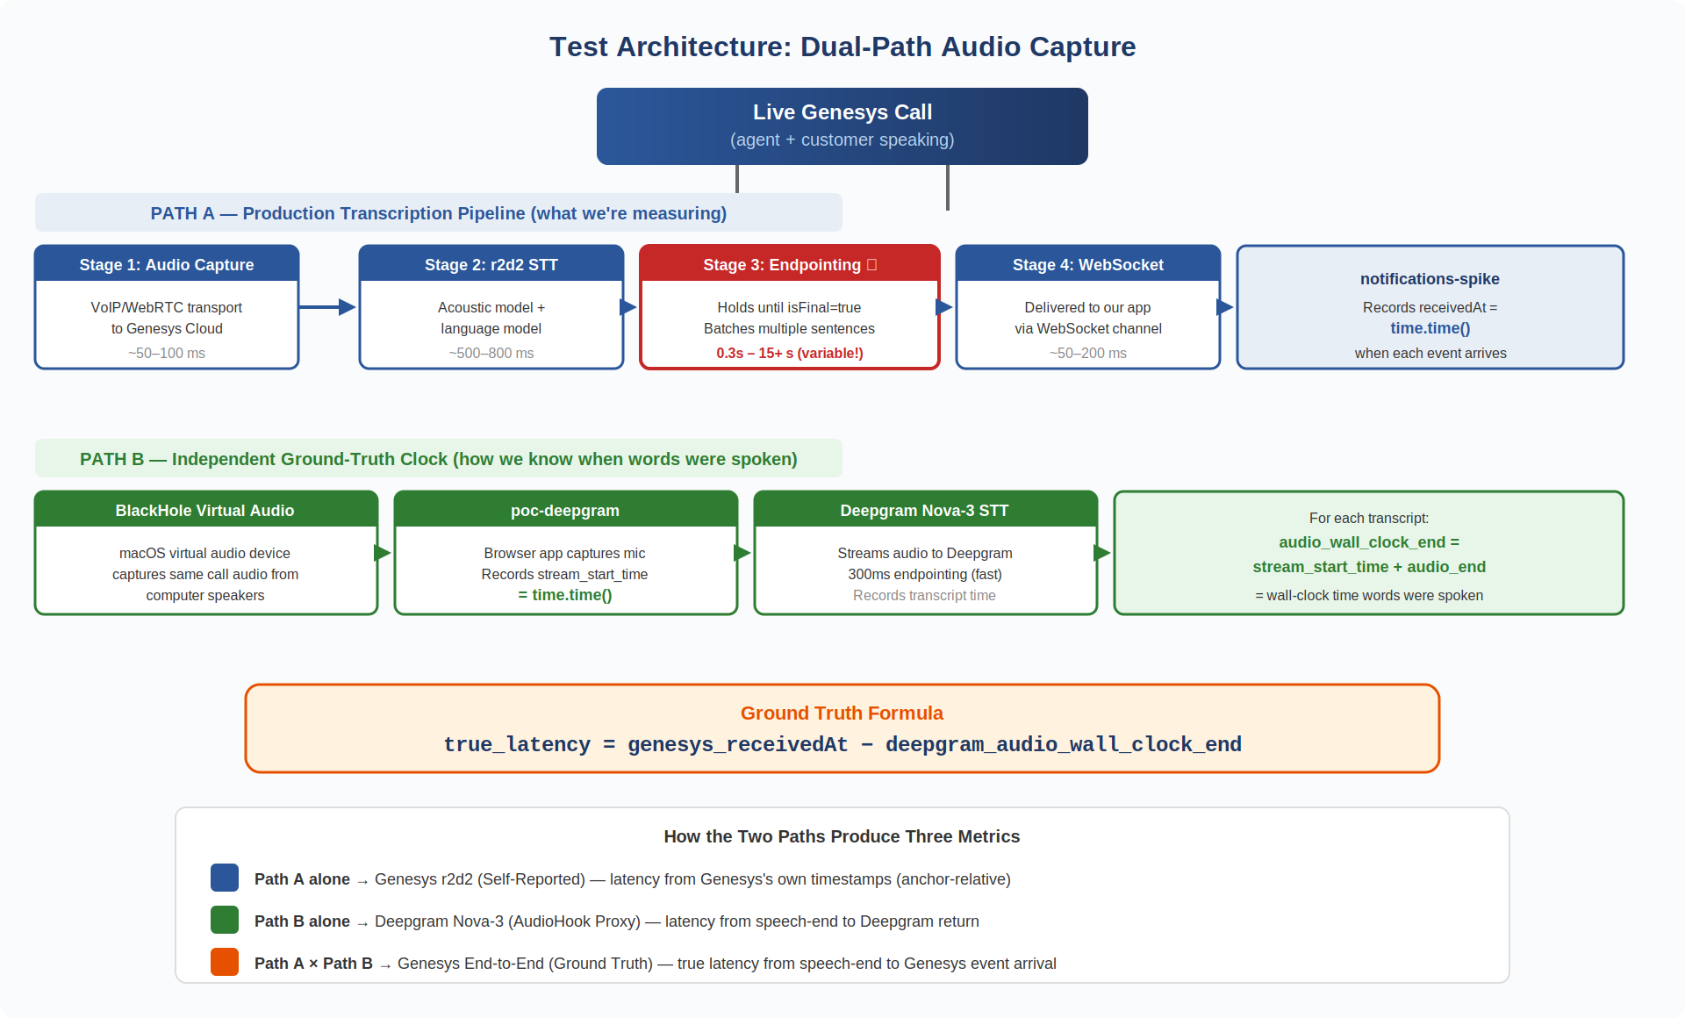
Figure 1: Dual-path test architecture — Path A (Genesys production pipeline) and Path B (Deepgram ground-truth clock)

How the Two Paths Connect to the Three Metrics

Path | Produces | Table Column
Path A alone | receivedAt and event metadata (offsetMs, durationMs) | Genesys r2d2 (Self-Reported) — latency estimated from Genesys’s own timestamps
Path B alone | audio_wall_clock_end and server_receipt_time | Deepgram Nova-3 (AudioHook Proxy) — latency from speech-end to Deepgram return
Path A × Path B | receivedAt minus audio_wall_clock_end, matched by fuzzy text similarity | Genesys End-to-End (Ground Truth) — true latency from speech-end to event arrival

The ground-truth measurement works because Path B tells us exactly when each phrase was spoken (via Deepgram’s audio timestamps), and Path A tells us exactly when Genesys delivered the transcript (via receivedAt). The difference is the true end-to-end latency.

Formula
true_latency = genesys_receivedAt − deepgram_audio_wall_clock_end
Both receivedAt and audio_wall_clock_end are wall-clock timestamps (time.time()) recorded on the same machine, eliminating clock drift.

What True Latency Captures
The measurement spans four pipeline stages:

Stage | Description | Details | Typical Contribution
1 | Audio Capture | VoIP/WebRTC transport from caller to Genesys Cloud | Low (~50–100 ms)
2 | STT Processing | Genesys r2d2 engine: acoustic model, language model, word-level timing | Moderate (~500–800 ms)
3 | Endpointing | Genesys holds partial transcripts until it decides the utterance is final (isFinal=true) | Highly variable (0.3–15+ s)
4 | WebSocket Delivery | Serialization + routing through Genesys infrastructure to our application | Low (~50–200 ms)

What Each Metric Measures (Pipeline Scope)
The three metrics in this report each cover a different slice of the pipeline:
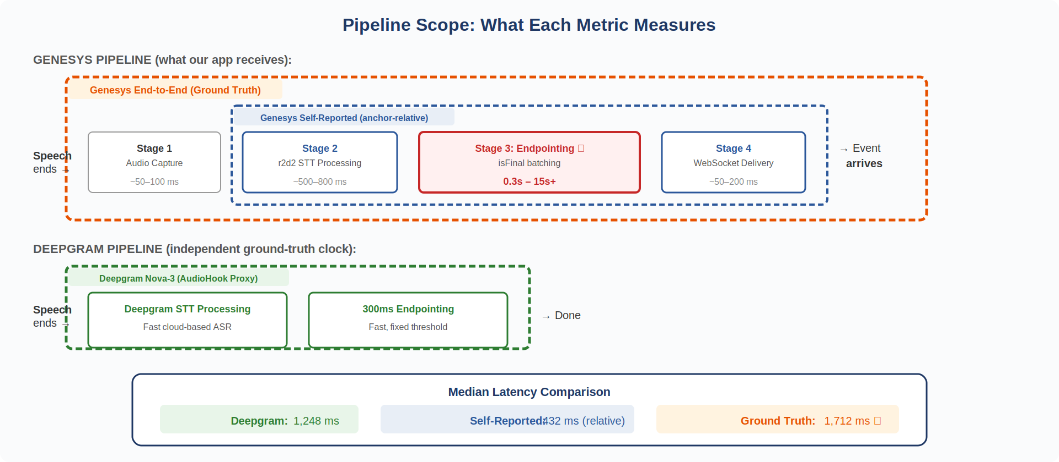
Figure 2: Pipeline scope — showing which stages each metric captures
The self-reported metric (inner bracket) misses Stage 1 entirely and zeros out its fastest event, making it appear that latency is ~432ms at the median. The ground truth (outer bracket) captures everything the user actually experiences — 1,712ms at the median, 4.0x higher.

Why the p95 Is Dramatically Higher Than the Median
The median adds +1.28s over Genesys self-reported latency — this gap reflects Stage 1 (audio capture transport) plus the baseline that the anchor-event method zeros out. But at p95, the gap explodes to +8.9s. This is caused by Stage 3: Endpointing.

The Endpointing Effect
Genesys’s endpointing algorithm determines when a speaker has finished an utterance before emitting isFinal=true. During continuous speech (like the movie monologues in this test), the algorithm:
- Waits for silence — the speaker pauses infrequently during a monologue, so Genesys holds the transcript buffer longer
- Batches multiple sentences into a single final event — where Deepgram (300ms endpointing) would emit 3–4 separate utterances, Genesys emits 1 combined event
- Delays the timestamp — the receivedAt reflects when the batched event finally arrived, long after the first words in that batch were spoken
This means the tail latency is dominated by how long Genesys waited to finalize, not how long STT processing took.

Evidence From the Data

True Latency | What Happened
20,365 ms | Genesys batched multiple sentences from the Glengarry Glen Ross monologue into one event
16,134 ms | Short phrase held until the next natural pause point
12,978 ms | Iron Man press conference — continuous speech, Genesys combined 3 Deepgram utterances
12,883 ms | Cyrano nose monologue — Genesys waited for the full passage to endpoint
11,937 ms | Maleficent curse — entire monologue segment batched

Impact on Real Calls
Movie monologues are a worst-case scenario for endpointing — they are continuous speech with minimal pauses. In real customer service calls, speakers take turns with natural pauses between sentences, Genesys endpoints trigger faster on conversational speech, and the p95 in production would be significantly lower (likely 2–4s rather than 10+s). The test intentionally uses monologues to stress-test the pipeline.

Test Corpus
Six movie monologues were played through live Genesys calls, providing diverse speech patterns and durations:

# | Movie | Duration | Matched  Pairs | Median  Latency | Speech Pattern
1 | Maleficent (Sleeping Beauty curse) | 105.7s | 1 | 11,937 ms | Slow, dramatic, few pauses
2 | Cyrano de Bergerac (nose monologue) | 203.3s | 15 | 1,748 ms | Rapid wit, staccato delivery
3 | Glengarry Glen Ross (ABC speech) | 274.1s | 23 | 1,734 ms | Aggressive, short pauses
4 | Iron Man (press conference) | 95.9s | 8 | 2,920 ms | Mixed: dialogue + monologue
5 | To Kill a Mockingbird (closing argument) | 197.2s | 27 | 1,129 ms | Measured, deliberate, clear pauses
6 | The Shawshank Redemption (Red’s parole hearing) | 173.7s | 19 | 1,785 ms | Reflective, conversational cadence

Total: 93 matched utterance pairs across ~1,050 seconds of call audio.

What Is a “Matched Pair”?
Each of the 93 matched pairs is one utterance — a sentence-level transcript event — from Deepgram matched to one utterance from Genesys by fuzzy text similarity. These are not individual words and not entire conversations; they are turn-level speech segments that each system independently identified as a complete spoken phrase.
Example: Deepgram emits “You wanna work here? Close.” and Genesys emits “you wanna work here close” — these are matched at 1.0 similarity, producing a true latency of 1,812 ms.

Why Only 93 Out of 353 Total Utterances?
Deepgram produced 223 final transcripts across the 6 sessions. Genesys produced 130 final events. The matching algorithm produced 94 candidate pairs, of which 1 was excluded as a false match (negative latency), leaving 93 valid pairs. The low match rate is explained by five factors:
- Endpointing asymmetry (biggest factor) — Deepgram uses a 300ms silence threshold, splitting speech into many short utterances. Genesys batches more aggressively, combining 2–4 Deepgram-sized utterances into a single isFinal=true event.
- Similarity threshold — Matches below 0.55 are rejected. When Genesys batches heavily, its transcript contains extra sentences that drag text similarity below threshold.
- Transcription divergence — Genesys r2d2 and Deepgram Nova-3 produce different text for the same audio. Phone-quality audio through Genesys’s VoIP pipeline degrades differently than BlackHole’s direct capture.
- No double matching — Each utterance on both sides can only participate in one pair.
- Short/ambiguous utterances — Very short transcripts like “oh”, “good”, or “yes” can match multiple candidates.

Per-Movie Observations
- To Kill a Mockingbird had the lowest median (1,129 ms) — Atticus Finch’s deliberate, pause-heavy courtroom delivery aligns well with Genesys endpointing
- Iron Man had the highest median (2,920 ms) — mixed dialogue format caused more endpointing confusion
- Maleficent produced only 1 match — the slow, dramatic delivery resulted in Genesys batching the entire passage
- Glengarry Glen Ross produced the most matches (23) — aggressive, punchy delivery creates frequent natural endpoints

Aggregate Results

Full Distribution

Percentile | Latency
p50 (Median) | 1,712 ms
p75 | 2,300 ms
p90 | 4,627 ms
p95 | 10,544 ms
p99 | 16,472 ms
Max | 20,365 ms
Min | 733 ms

- Standard Deviation: 3,290 ms — reflects the heavy right tail from endpointing batching
- Mean Similarity: 0.801 — indicates strong cross-system utterance matching quality

Latency Bands

Band | Count | % of Total | Description
< 1,000 ms | ~12 | ~13% | Fast — short utterances with quick endpointing
1,000–2,000 ms | ~52 | ~55% | Typical — normal single-utterance processing
2,000–5,000 ms | ~20 | ~21% | Moderate — some endpointing batching
5,000–10,000 ms | ~4 | ~4% | Elevated — multi-sentence batching
> 10,000 ms | ~6 | ~6% | High — heavy batching during continuous speech

The majority of utterances (68%) arrive within 2 seconds. The long tail is driven by a small number of heavily-batched events.

Visualizations: Cross-System (Ground Truth)
The following charts show the ground-truth latency data from the 93 matched utterance pairs across 6 test calls.

Latency Distribution Histogram
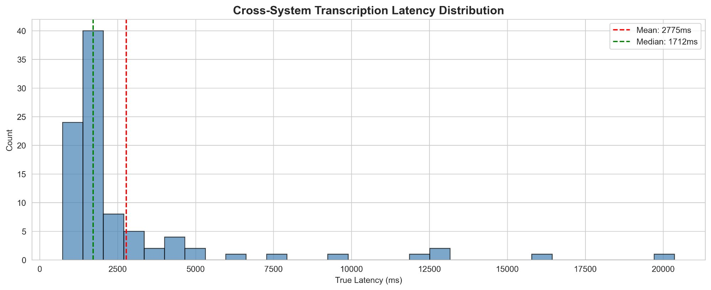
Figure 3: Cross-system true latency distribution — right-skewed with median at 1,712ms
The distribution is right-skewed with a primary peak around 1,500–2,000 ms and a long tail extending past 10,000 ms. The mean (red dashed) is pulled right by tail outliers, while the median (green dashed) sits in the primary cluster.

Latency Timeline (Scatter + Trend)
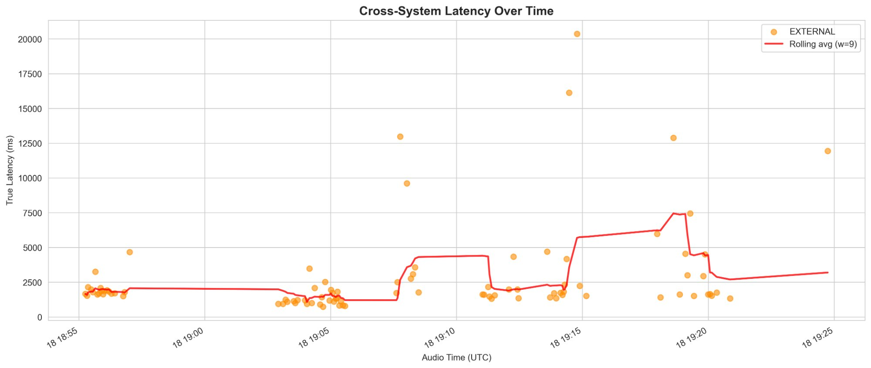
Figure 4: True latency plotted against audio timestamp across all 6 test calls
Most points cluster below 5,000 ms with intermittent spikes corresponding to endpointing batching events. No systematic drift or degradation over time.

Match Quality vs Latency
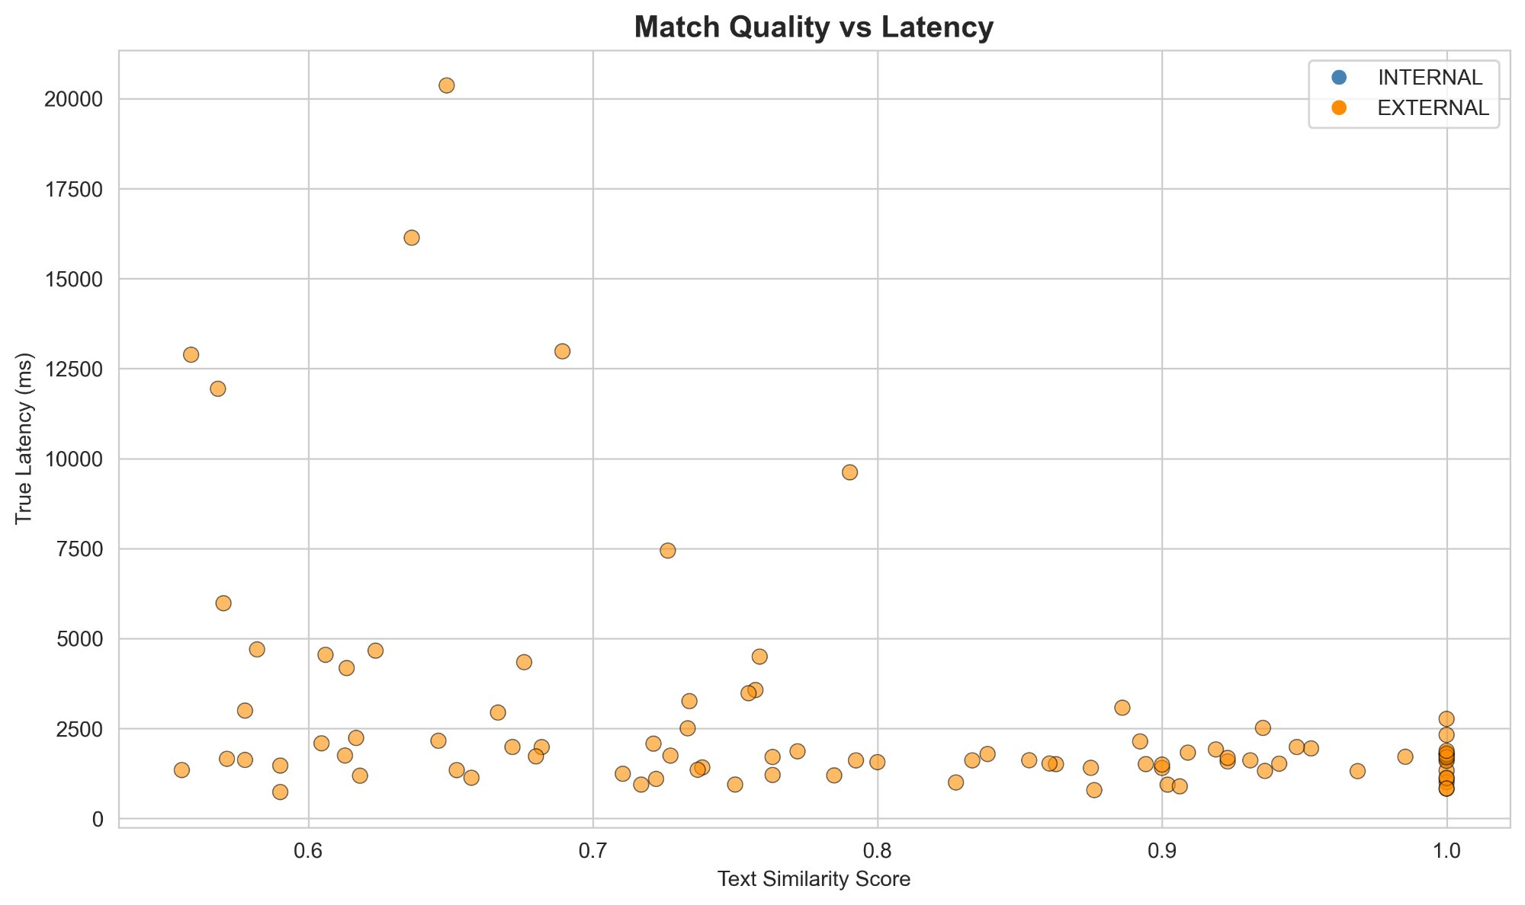
Figure 5: Text similarity score vs true latency — high-latency outliers tend to have lower similarity
High-latency outliers tend to have lower similarity scores (0.55–0.65), consistent with Genesys combining multiple utterances that only partially overlap with the matched Deepgram event.

Visualizations: Self-Reported (Production Data)
The following charts show Genesys self-reported latency data from 147 production customer service conversations (8,735 utterances, October 2025). These illustrate the baseline production behavior for comparison.

Latency Distribution by Channel
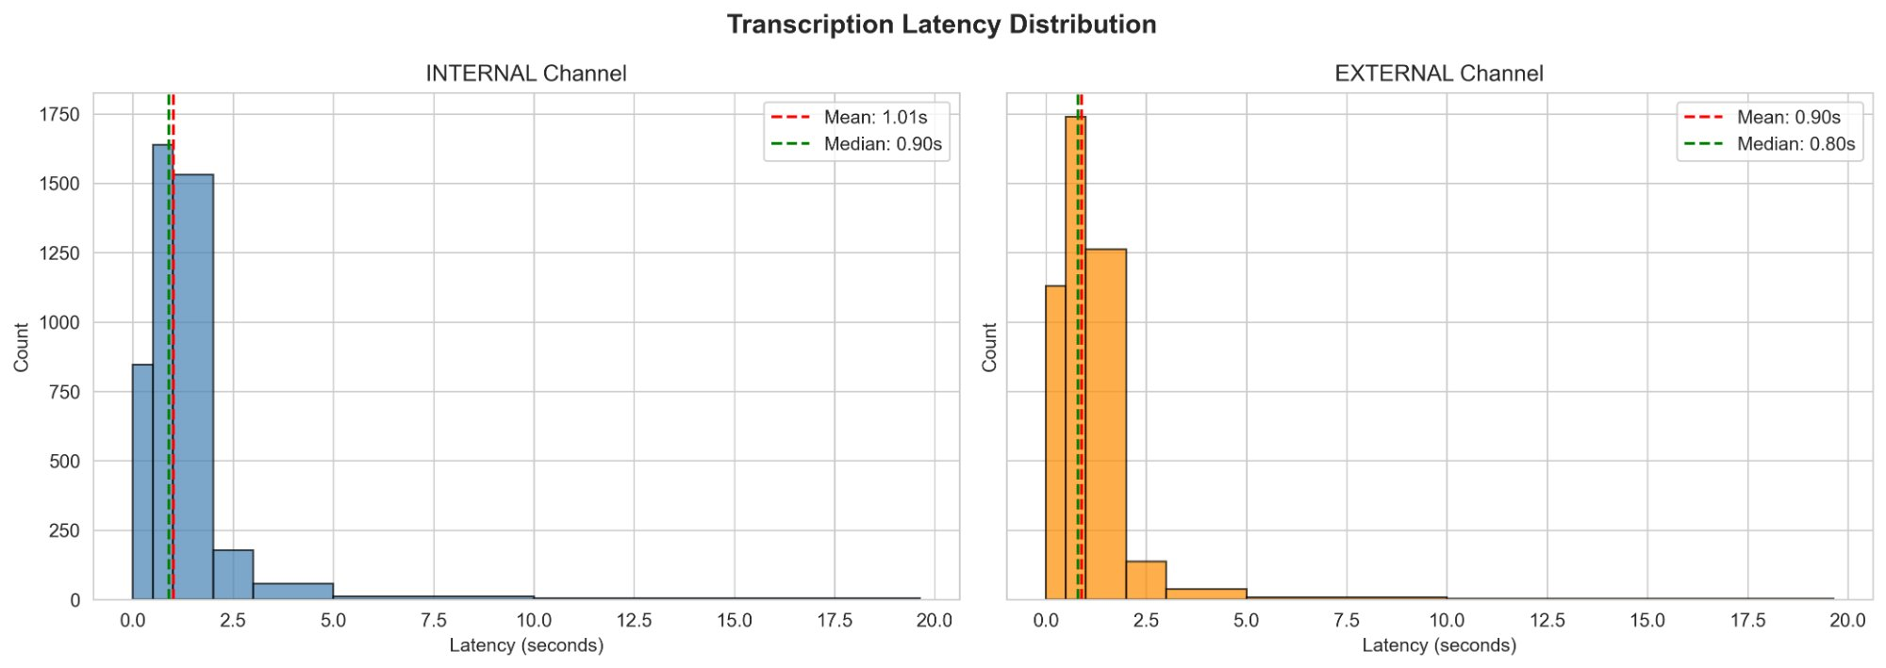
Figure 6: Self-reported latency distribution — Internal (agent) vs External (customer) channels

Latency Box Plot by Channel
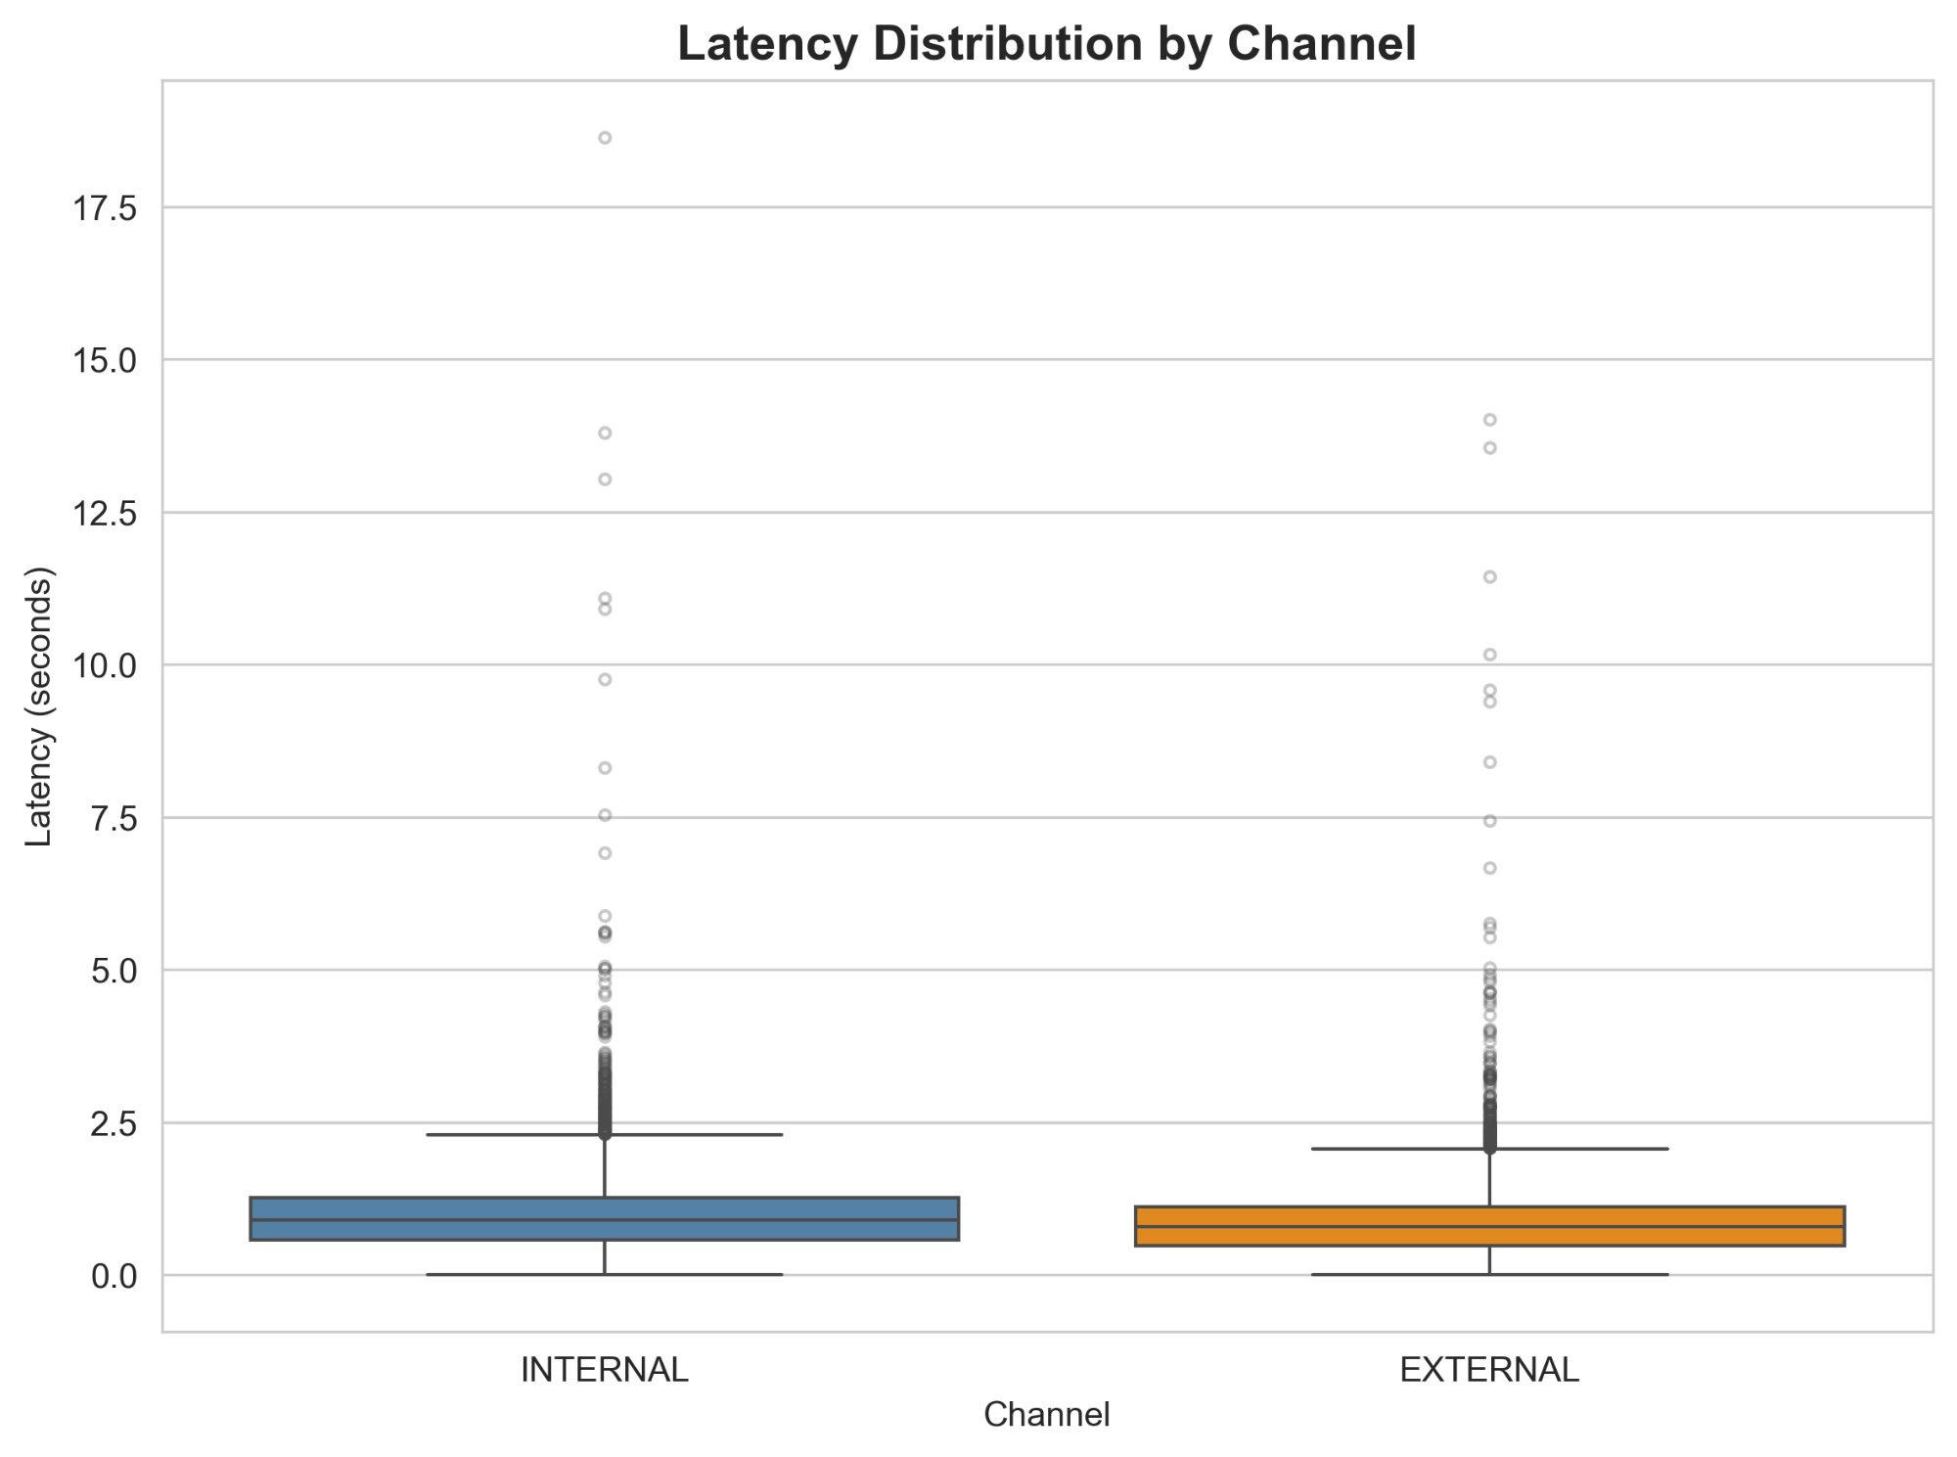
Figure 7: Box plot showing median, quartiles, and outliers by channel

Latency Percentiles by Channel
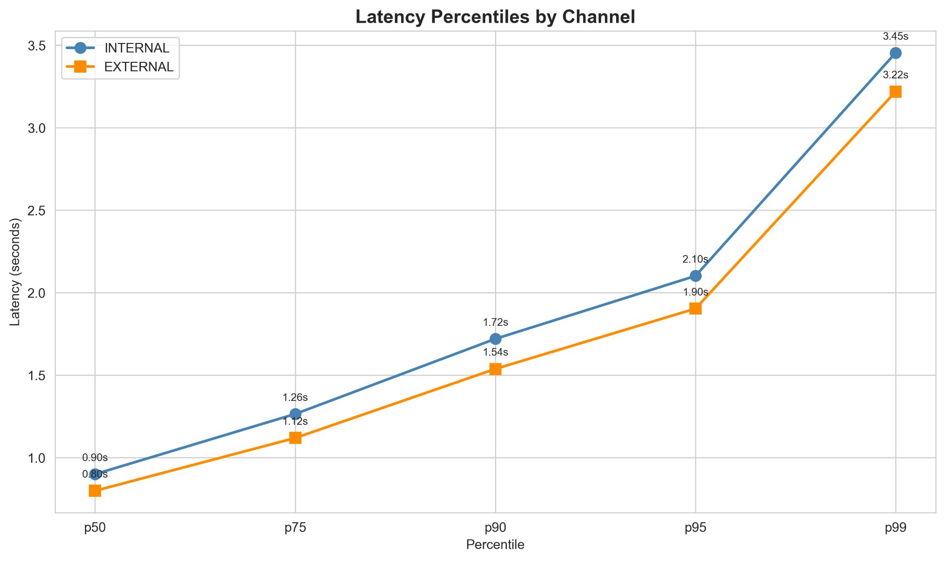
Figure 8: Percentile curves — Internal channel consistently ~10% higher than External

Latency Over Time
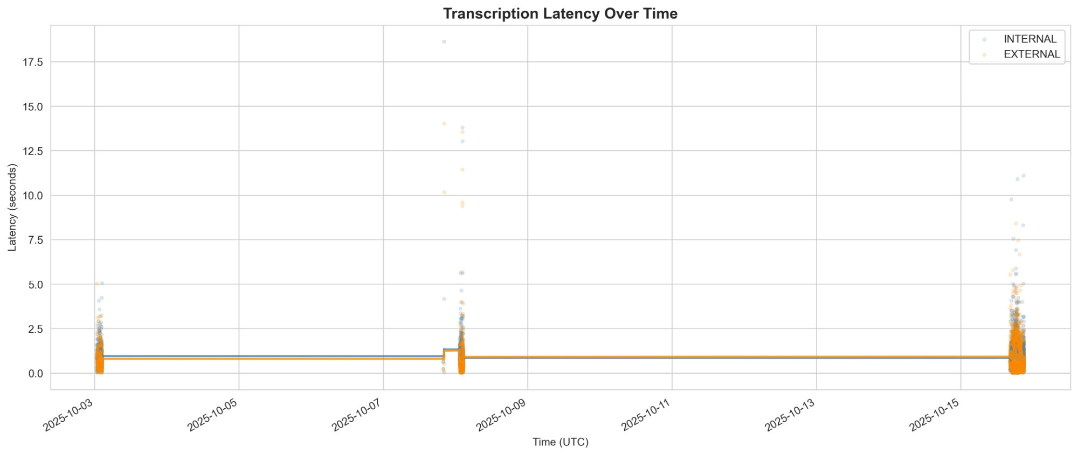
Figure 9: Self-reported latency scatter plot across the October 2025 production period

Average Latency by Date and Hour
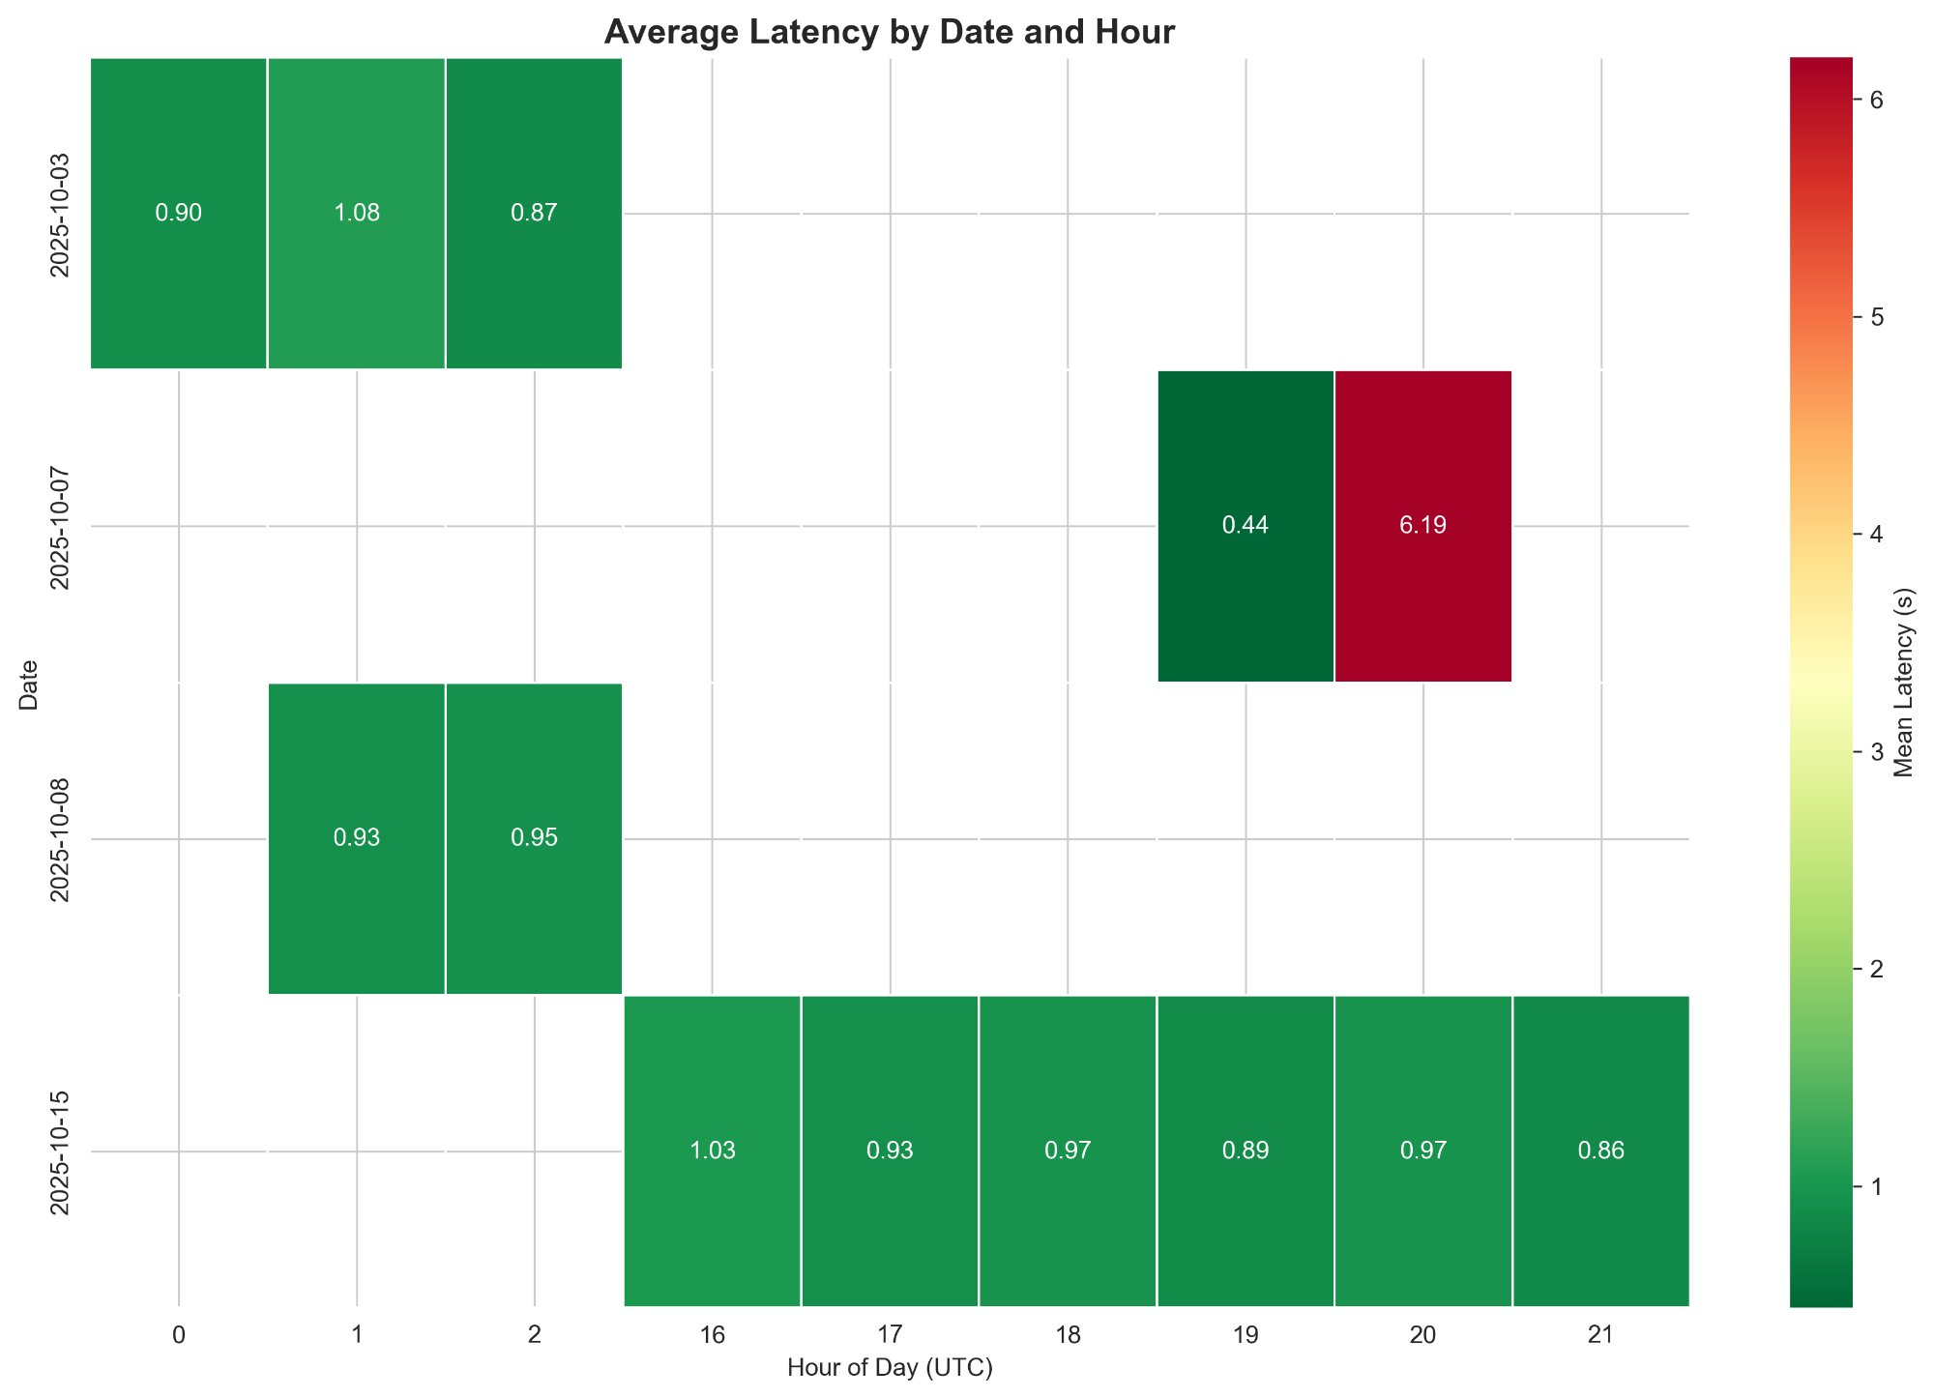
Figure 10: Heatmap showing average latency by date and hour of day (UTC)

Latency vs Audio Duration
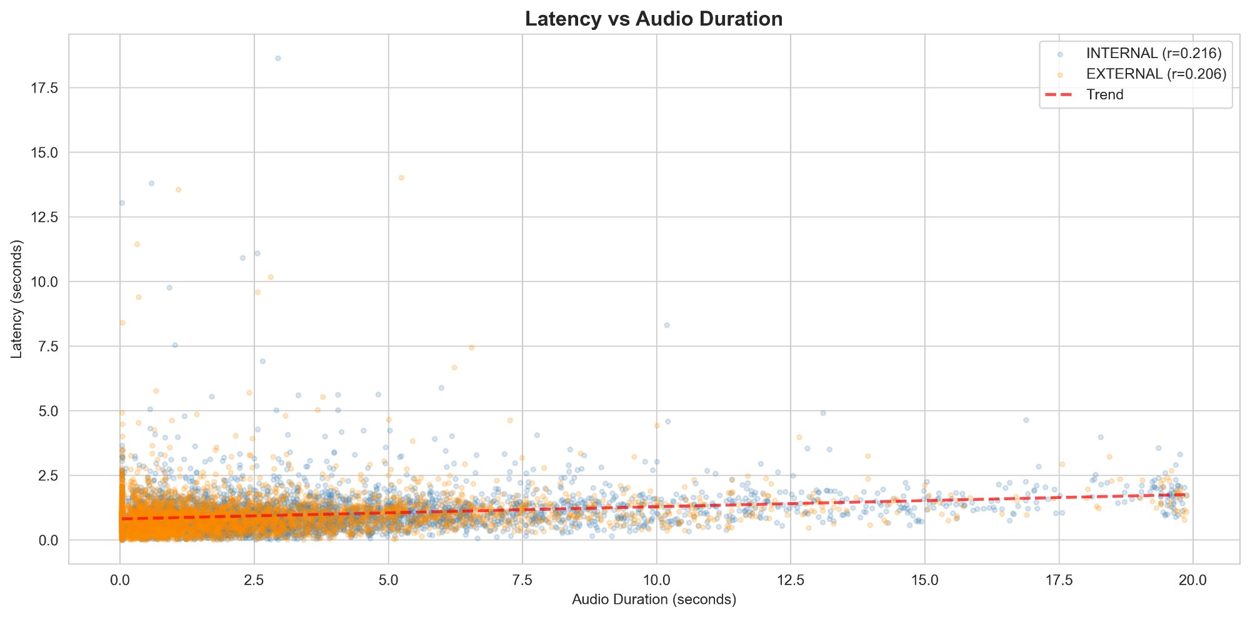
Figure 11: Weak positive correlation (r=0.23) between utterance duration and latency

Data Quality Notes
- 1 false match excluded: In To Kill a Mockingbird, “is.” was matched to “i’m so” with similarity 0.571, producing a latency of -29,618 ms (negative = physically impossible). This false match is filtered out. The remaining 93 valid pairs are used for all analysis.
- Similarity threshold: 0.55 — balances match recall against false positive risk.
- Channel: All matched utterances are EXTERNAL (customer/caller side), since the monologue audio played through the phone system appears as the external participant.

Interpretation Guide

Measured Latency | Likely Cause
700–1,200 ms | Fast path: short utterance, quick endpointing, minimal batching. Stages 1+2+4 only.
1,200–2,500 ms | Normal path: single utterance with standard endpointing pause detection.
2,500–5,000 ms | Moderate batching: Genesys combined 2 short sentences into one final event.
5,000–15,000 ms | Heavy batching: continuous speech, Genesys waited for a clear pause before finalizing 3+ sentences.
> 15,000 ms | Extreme batching: prolonged continuous speech with no detectable pause point. Rare in real conversations.

Recommendations
- Use the median (1.7s) as the primary latency benchmark, not the mean — the right-skewed distribution makes the mean misleading.
- Expect p95 to be lower in production — real customer service calls have natural conversational pauses that trigger faster endpointing than movie monologues.
- Design for ~2s latency in real-time features — any UI or workflow that depends on transcription arrival should assume 1.5–2.5s typical latency.
- Budget 5s+ for worst-case scenarios — long utterances or rapid speech may trigger batching delays.
- Repeat this test with live customer calls to establish production-representative percentile benchmarks. The monologue test establishes the methodology and bounds; real call data will refine the operational expectations.

Reproduction
# Run correlation on a specific pair
uv run python -m scripts.correlate_latency \
--deepgram ../poc-deepgram/results/<SESSION>.json \
--genesys conversation_events/<CONVERSATION>.jsonl
# Run the full analysis notebook
cd notebooks && uv run jupyter notebook cross_system_latency.ipynb
See docs/manual_test_directions.md for the complete setup and test execution guide.

