Q1.Create a simple html page using basic tags.

A. Source code:

<!DOCKTYPE html>

<html>

<body>

<h1>My first heading</h2>

<p1>My first paragraph</p2>

</body>

</html>

Screen Shot of Output:

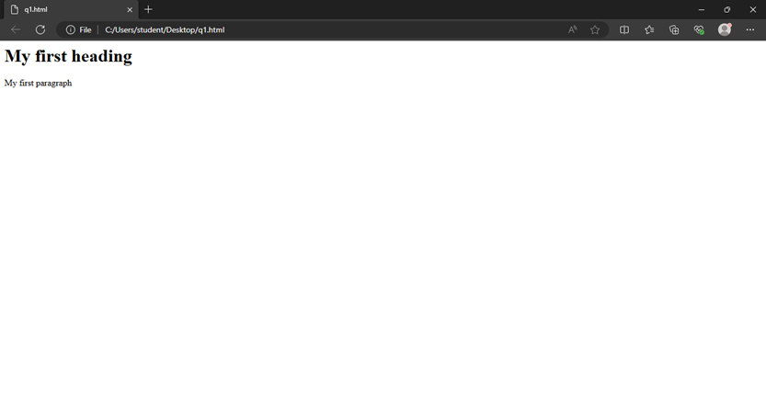

Q2. Create a webpage that displays your name to the screen.

A. Source code:

Source code:

<!DOCKTYPE html>

<html>

<h1>Noel Johnson Jacob</h1>

<body>

</body>

<html/>

Screen Shot of Output:

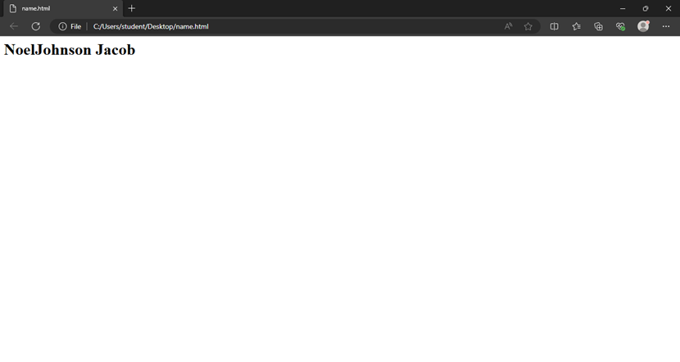

Q3. Create a webpage and show the output 1-10 in different lines.

A. Source code:

<!DOCKTYPE html>

<html>

<body>

<p>1</p>

<p>2</p>

<p>3</p>

<p>4</p>

<p>5</p>

<p>6</p>

<p>7</p>

<p>8</p>

<p>9</p>

<p>10</p>

</body>

</html>

Screen Shot of Output:

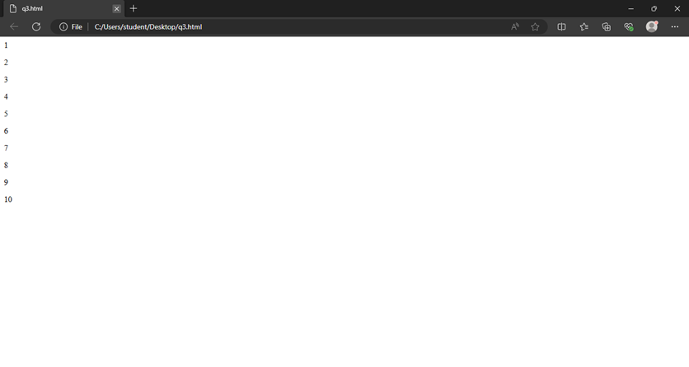

Q4. Create a webpage and show the output 1-10 in different lines, each number being in different colour.

A. Source code:

<!DOCKTYPE html>

<html>

<body>

<p style = "colour:red;">1</p>

<p style = "colour:blue;">2</p>

<p style = "colour:green;">3</p>

<p style = "colour:yellow;">4</p>

<p style = "colour:orange;">5</p>

<p style = "colour:purple;">6</p>

<p style = "colour:pink;">7</p>

<p style = "colour:grey;">8</p>

<p style = "colour:brown;">9</p>

<p style = "colour:violet;">10</p>

</body>

</html>

Screen Shot of Output:

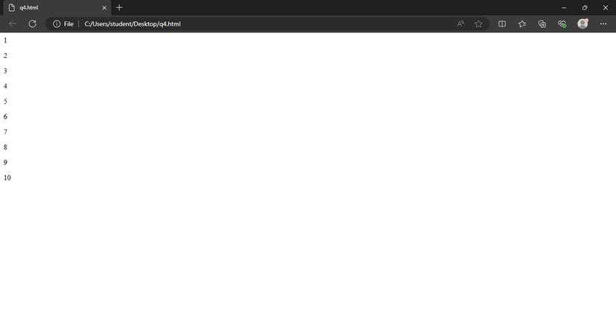

Q5) How do I make a picture as a background in html.

<html>

<head>

<title> Student Information </title>

</head>

<body style="background-color:powderblue;">

<h3 style="color:Tomato;"> Adding picture to background </h3>

<img src="https://encrypted-tbn0.gstatic.com/images?q=tbn:ANd9GcQEc9A_S6BPxCDRp5WjMFEfXrpCu1ya2OO-Lw&s">

</body>

</html>

Screen Shot of Output:

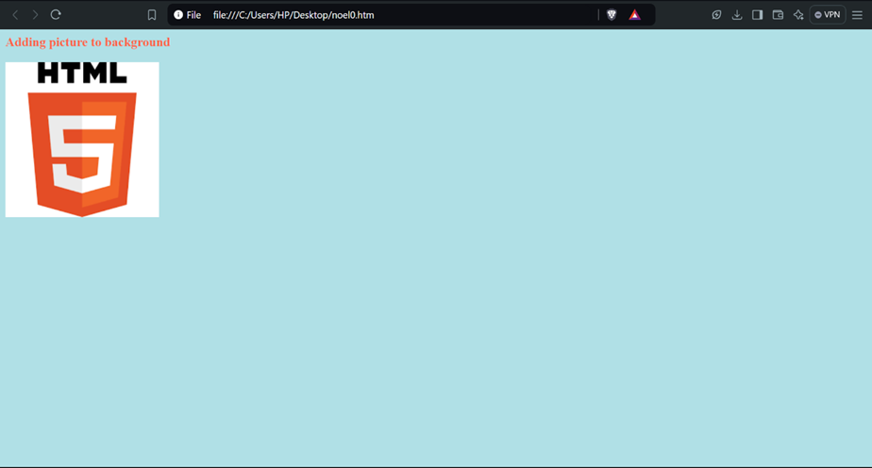

Q6) Create a webpage to display a paragraph of 4 to 5 sentences. Each sentence should have a different font.

A. Source code:

<html>

<head>

<title> Student Information </title>

</head>

<body style="background-color:powderblue;">

<h5 style="Font-Family:Cursive;"> This is Paragraph one </h5>

<h4 style="Font-Family:Fantasy;"> This is Paragraph two </h4>

<h3 style="Font-Family:Helvetica;"> This is Paragraph three </h3>

<h2 style="Font-Family:Courier New;"> This is Paragraph four </h2>

<h1 style="Font-Family:Verdana New;"> This is Paragraph five</h1>

</body>

</html>

Screen Shot of Output:

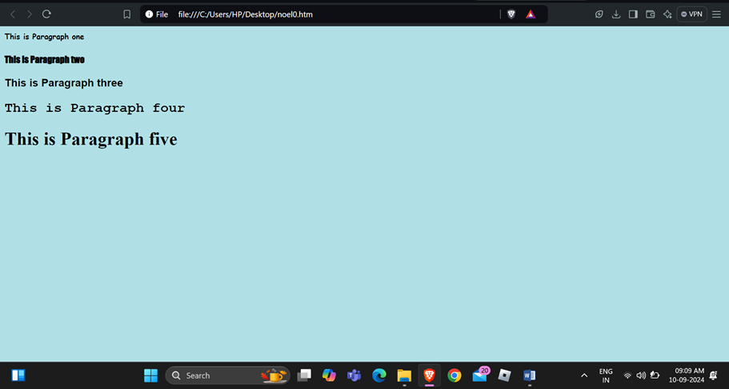

Q7) write html code to print a paragraph that is a description of a book. It includes title of the book and author name. Name and title should be underlined and all adjectives ahould be bold and in italics.

A. Source code:

<html>

<head>

<title> Student Information </title>

</head>

<body style="background-color:powderblue;">

<p>Book name - <b><u><i> Harry Potter and the Philosopher's Stone</b></u></i> Author name - <b><u><i>J. K. Rowling</b></u></i></p>

</body>

</html>

Screenshot of output:

Q8) Write html code to display your name using heading tag. Every letter shall be of different heading size.

A. source code:

<html>

<head>

<title> Heading Tag </title>

</head>

<body style="background-color:powderblue;">

<h1>N</h1>

<h2>O</h2>

<h3>E</h3>

<h4>L</h4>

</body>

</html>

Q9) Write html code to display numbers from 1 – 20. Each number will be in a different line with number 2 next to it as its subscript, an equal sign and the result.

A. Source code:

<html>

<head>

<title> Heading Tag </title>

</head>

<body style="background-color:powderblue;">

<p>1<sub>2</sub> = 2</p>

<p>2<sub>2</sub> = 4</p>

<p>3<sub>2</sub> = 6</p>

<p>4<sub>2</sub> = 8</p>

<p>5<sub>2</sub> = 10</p>

<p>6<sub>2</sub> = 12</p>

<p>7<sub>2</sub> = 14</p>

<p>8<sub>2</sub> = 16</p>

<p>9<sub>2</sub> = 18</p>

<p>10<sub>2</sub> = 20</p>

<p>11<sub>2</sub> = 22</p>

<p>12<sub>2</sub> = 24</p>

<p>13<sub>2</sub> = 26</p>

<p>14<sub>2</sub> = 28</p>

<p>15<sub>2</sub> = 30</p>

<p>16<sub>2</sub> = 32</p>

<p>17<sub>2</sub> = 34</p>

<p>18<sub>2</sub> = 36</p>

<p>19<sub>2</sub> = 38</p>

<p>20<sub>2</sub> = 40</p>

</body>

</html>

Screenshot of output:

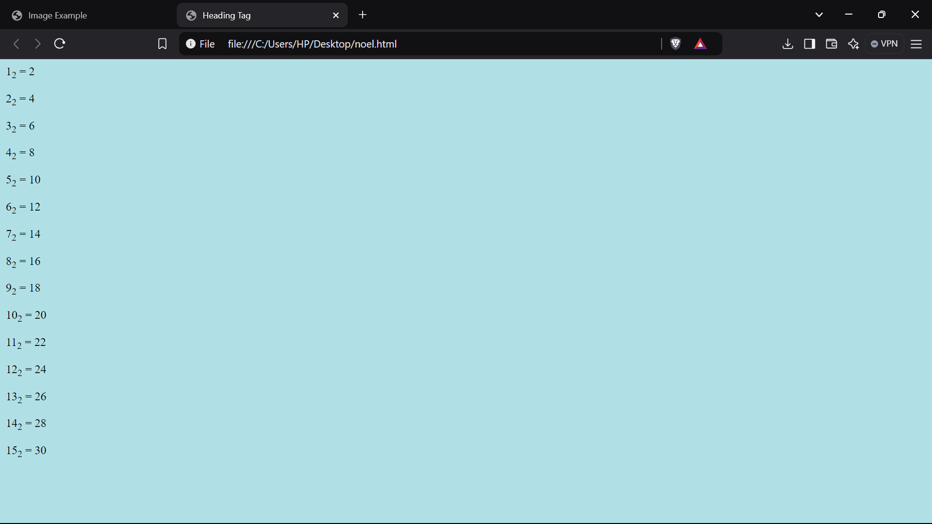

Q10) Write html code to display an image with border of size with width 200 height 200 pixels, leaving h space and v space of your choice with image hanging in the right side on the screen.

A.**INPUT-**

<html>

<head>

<title>Image Example</title>

</head>

<body>

<img src="C:\Users\HP\Desktop\valo.jpg" width="400" height="300" style="border: 5px solid black;" align="right">

</body>

</html>

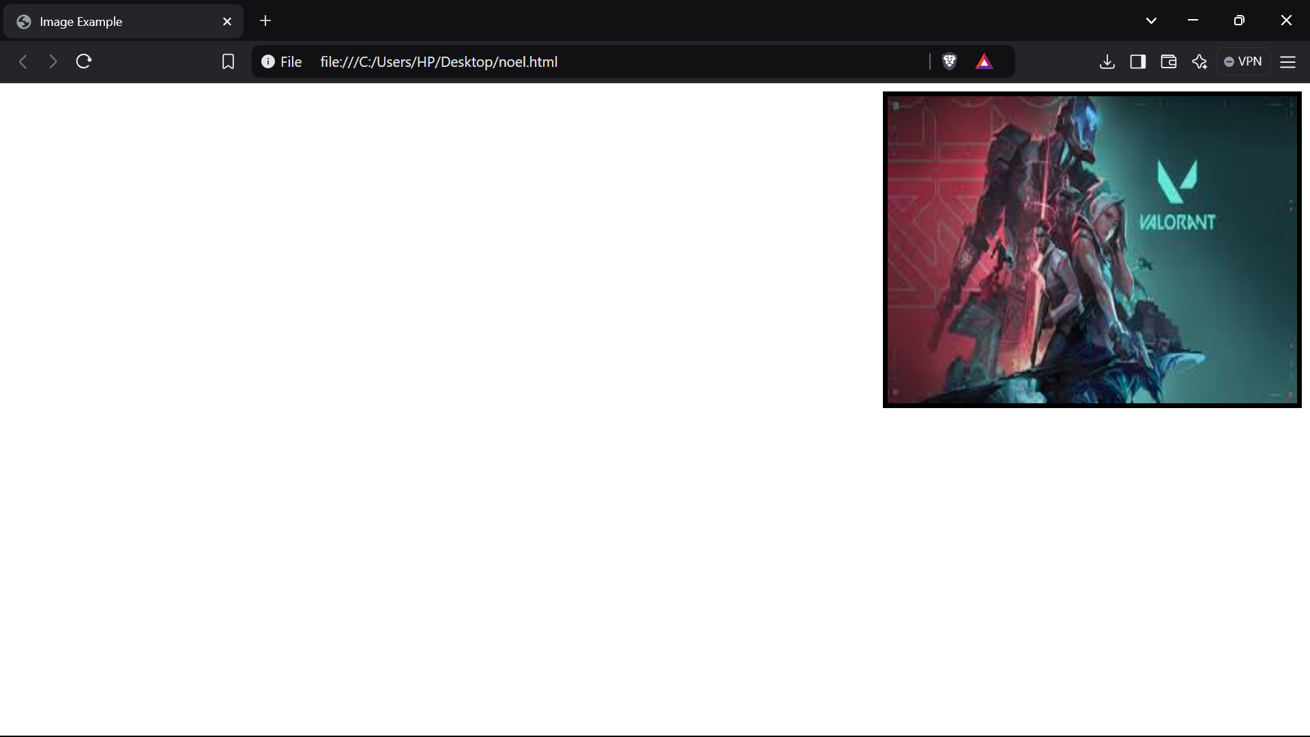

Q11) Write html code to create a webpage with heading. The heading shall be displayed at the top center of the page and the image shall be at the center just below the heading

A.**INPUT-** <html>

<head>

<title>Web Page with Centered Heading and Image</title>

</head>

<body>

<h1 style="text-align: center;">Heading</h1>

<div style="text-align: center;">

<img src="C:\Users\HP\Desktop\valo.jpg"width="200" height="200" alt="Centered Image">

</div>

</body>

</html>

**OUTPUT -**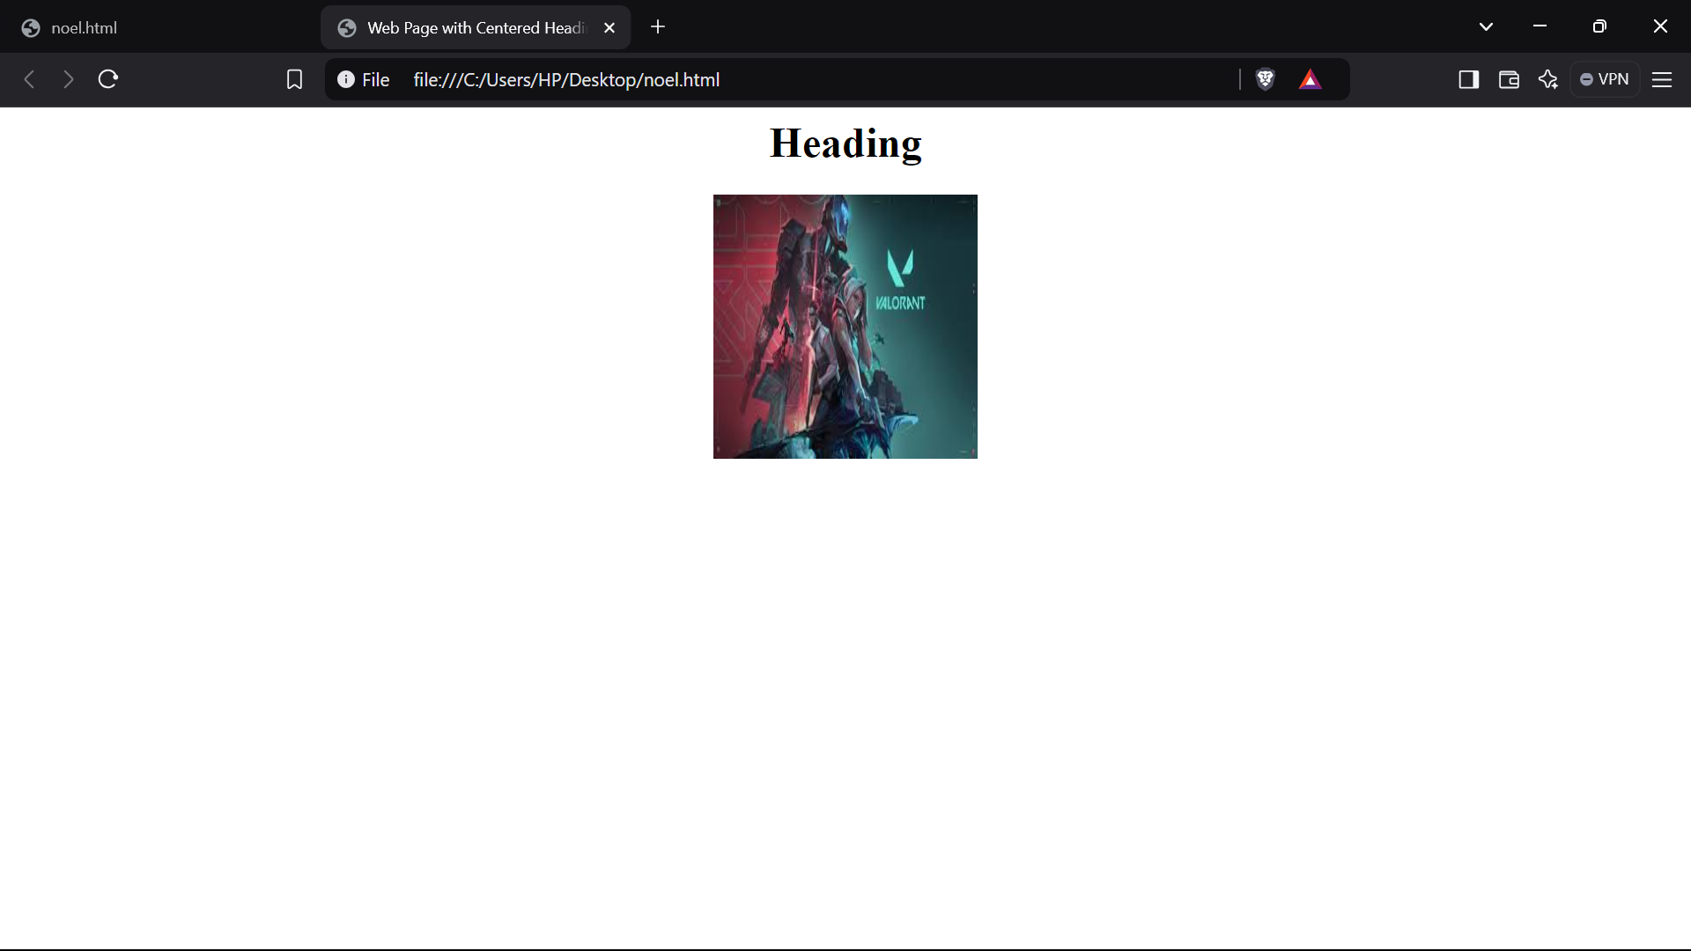

**Question 12) Write HTML code using Multimedia tags.**

**INPUT-** <html>

<head>

<title> multimedia tags</title>

</head>

<body>

<h1> multimedia tags: </h1>

<h1>img</h1>

<center>

<img src=""C:\Users\HP\Desktop\valo.jpg"height="450" , width="450"/>

<h1> audio </h1>

<audio src="C:\Users\Noel\Downloads\wowowowowowowow-103214.mp3" controls/>

</body>

</html>

**OUTPUT -**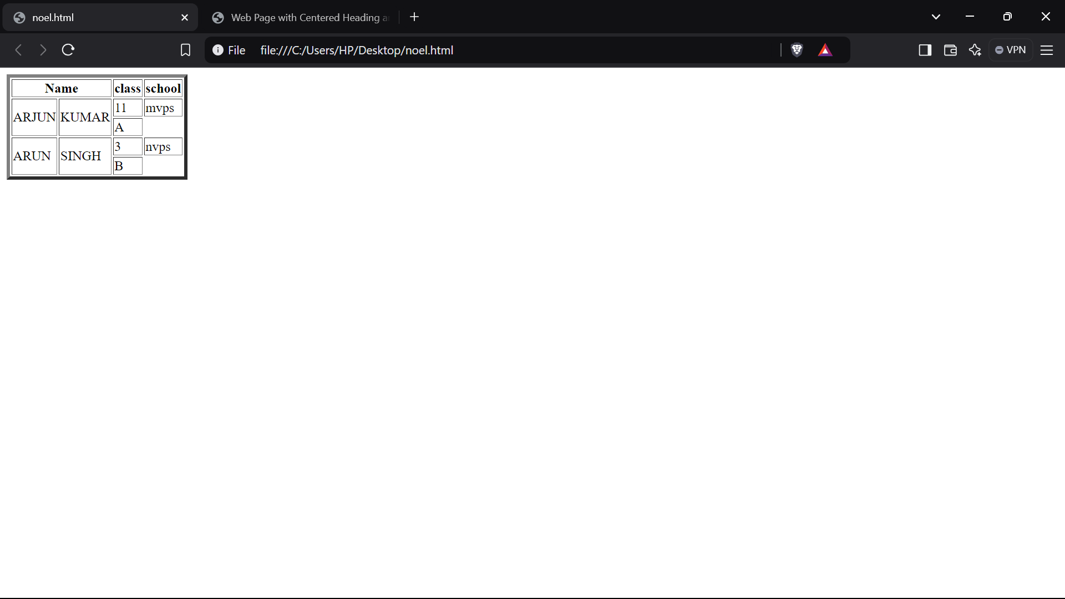

**Question 13) Create a Table using Rowspan and Colspan taking example of student Record .**

**INPUT-** <html>

<head></head>

<body>

<table border='4pt'>

<tr>

<th colspan='2'>Name</th>

<th>class</th>

<th>school</th></tr>

<tr>

<td rowspan='2'>ARJUN</td>

<td rowspan='2'>KUMAR</td>

<td> 11</td>

<td>mvps</td></tr>

<tr>

<td>A</td></tr>

<tr>

<td rowspan='2'>ARUN</td>

<td rowspan='2'>SINGH</td>

<td> 3</td>

<td>nvps</td></tr>

<tr>

<td>B</td></tr>

</body>

</html>

**OUTPUT-**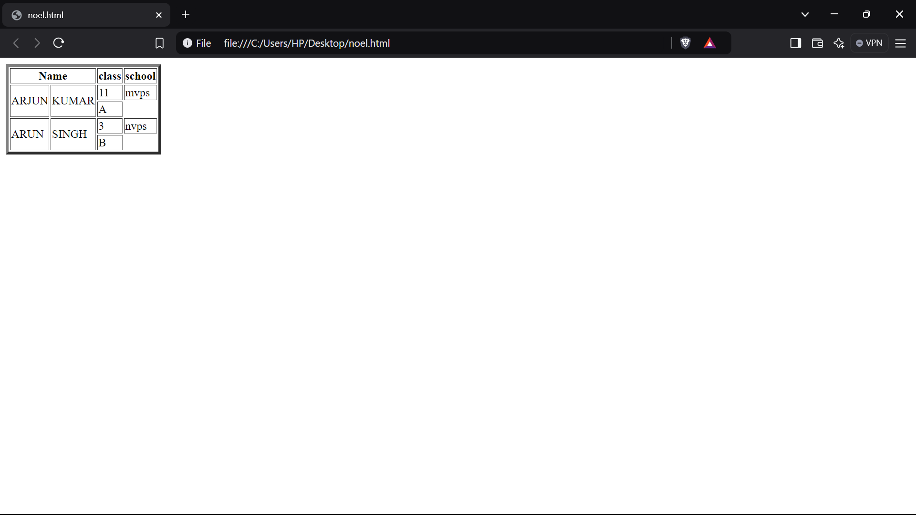

**Question 14) Write HTML code using table tag <table> and cellpadding and cell spacing as its attributes.**

**INPUT-** <html>

<head></head>

<body>

<table border="2pt" cellspacing="5pt" cellpadding="5pt">

<tr>

<th>S.no</th>

<th>Roll no.</th>

<th>Name</th>

<th>Address</th></tr>

<tr>

<td>1</td>

<td>123</td>

<td>ABC</td>

<td>FBD</td></tr>

<tr>

<td>2</td>

<td>456</td>

<td>XYZ</td>

<td>delhi</td></tr>

<tr>

<td>3</td>

<td>789</td>

<td>PQR</td>

<td>gurgaon</td></tr>

</table></body>

</html>

**OUTPUT -**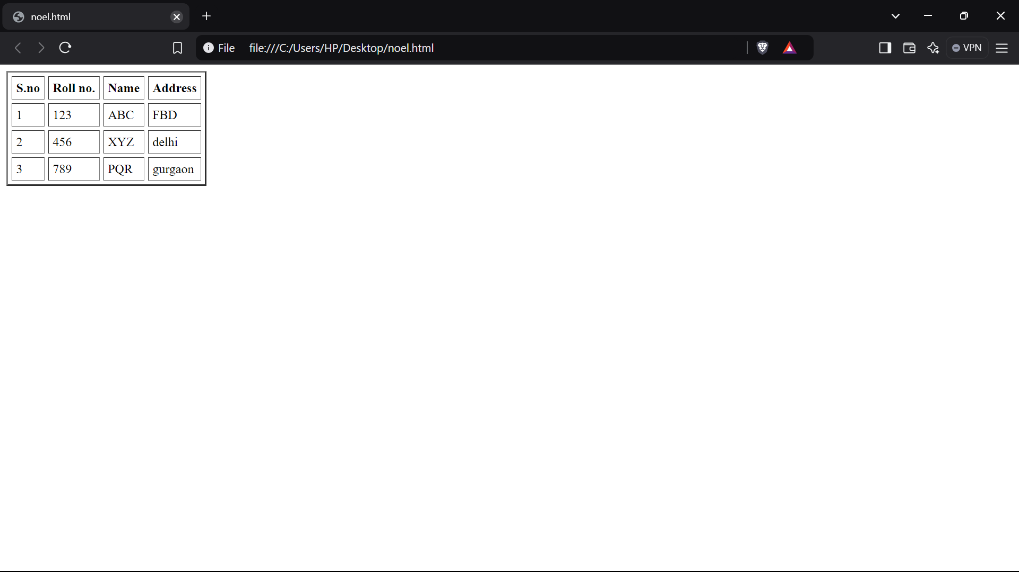

**Question 15) Create unordered, ordered and definition Lists taking example of your subjects in MCA IST, IInd and IIIrd Semester.**

**INPUT-  
 <**html>

<head>

</head>

<body>

<h2> Subjects in BCA sem 1</h3>

<ol>

<li>Web technologies</li>

<li>Introduction to IT & programming in C</li>

<li>Mathematics</li>

<li>DBMS</li>

<li>SDGs</li>

<li>IKS</li>

<li>CDCs</li>

</ol>

<h2> Sunject in BCA sem 2 </h2>

<ul>

<li>COMMUNICATION</li>

<li>DATA STRUCTURE</li>

<li>JAVA</li>

<li>OPERATING SYSTEM</li>

<li>STATICS FOR BCA</li>

</ul>

<h2>Subjects in BCA Sem 3</h2>

<dl>

<dt>C++</dt>

<dt>COMPUTER ARCHITECTURE</dt>

<dt>BUSINESS ECONOMICS</dt>

<dt>ELEMENT OF STATICS</dt>

<dt>DSA OF C++</dt>

</dl>

</body>

</html>

**OUTPUT -**

**Question 16) Write HTML code using <frameset> and <frame> tag with all its attributes .**

**INPUT-** <html>

<head>

<title>Frameset Example</title>

</head>

<frameset rows="50%,50%" frameborder="1" bordercolor="black" framespacing="5">

<frame src="https://www.example.com" name="topFrame" scrolling="yes" noresize="noresize" target="_self" />

<frame src="https://www.example.org" name="bottomFrame" scrolling="auto" noresize="noresize" target="_self" />

</frameset>

<noframes>

<body>

<p>Your browser does not support frames. Please update your browser.</p>

</body>

</noframes>

</html>

**OUTPUT -**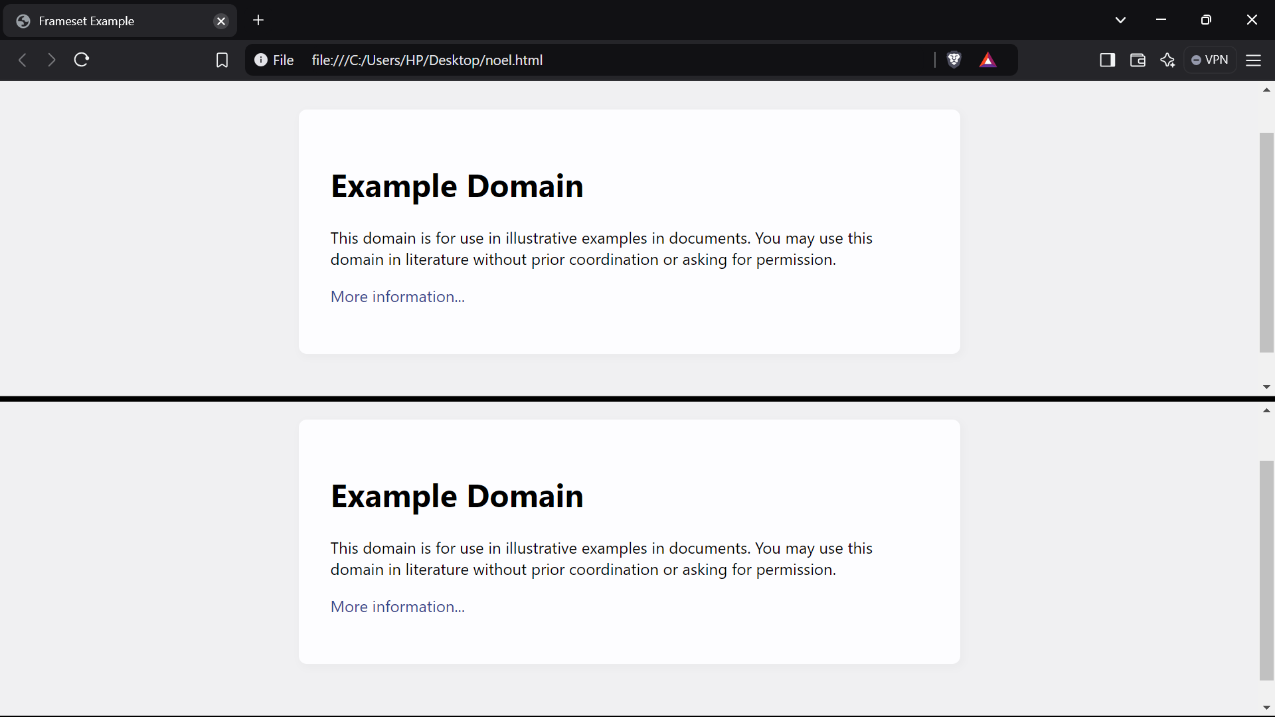

**Question 17 Write HTML code to design a form in HTML using controls and buttons such as Textbox, Textarea, password, submit button, browse button, drop-down menu**

**INPUT-** <html>

<head>

<title>Form with Various Controls</title>

</head>

<body>

<h1>Registration Form</h1>

<form action="submit.php" method="post" enctype="multipart/form-data">

<label for="name">Name:</label>

<input type="text" id="name" name="name" required><br><br>

<label for="email">Email:</label>

<input type="email" id="email" name="email" required><br><br>

<label for="password">Password:</label>

<input type="password" id="password" name="password" required><br><br>

<label for="profile_pic">Profile Picture:</label>

<input type="file" id="profile_pic" name="profile_pic"><br><br>

<label for="country">Country:</label>

<select id="country" name="country">

<option value="india">India</option>

<option value="usa">USA</option>

<option

value="uk">UK</option>

</select><br><br>

<label for="message">Message:</label>

<textarea id="message" name="message" rows="5" cols="30"></textarea><br><br>

<input type="submit" value="Submit">

<input type="reset" value="Reset">

</form>

</body>

</html>

**OUTPUT -**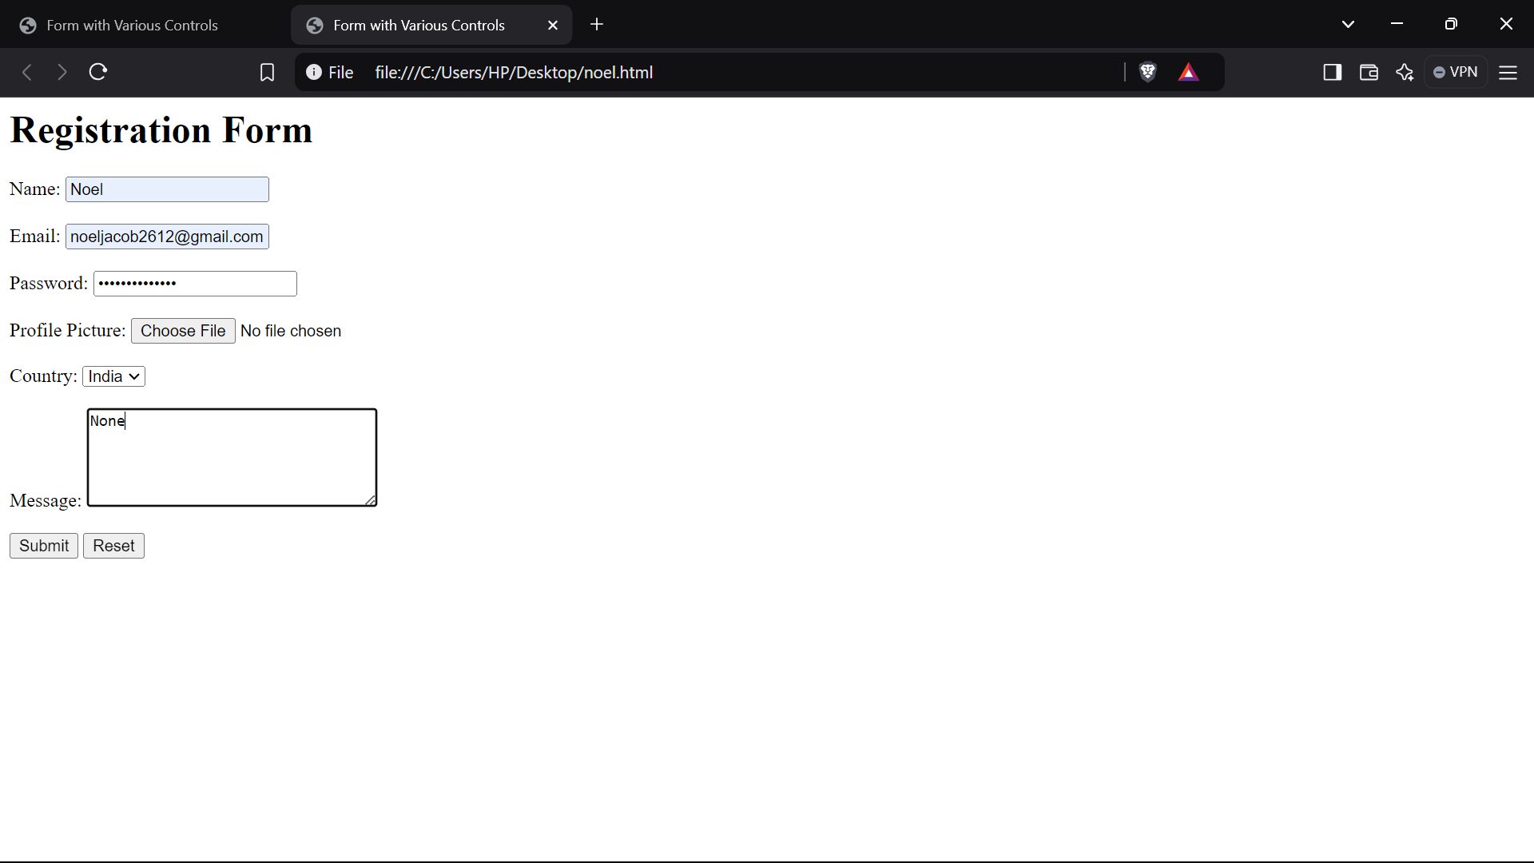

**Question 18. Write HTML code to design a Registration Form in HTML.**

**INPUT-**

<html>

<head>

<title>Grade Volleyball Registration Form</title>

</head>

<body>

<h1>Grade Volleyball Registration Form</h1>

<form action="submit.php" method="post">

<label for="first_name">Participant Name</label><br>

<input type="text" id="first_name" name="first_name" placeholder="First"><br>

<input type="text" name="last_name" placeholder="Last"><br><br>

<label for="age">Age</label><br>

<input type="number" id="age" name="age"><br><br>

<label for="grade">Grade</label><br>

<select id="grade" name="grade">

<option value="">Please select</option>

<option value="1">1</option>

<option value="2">2</option>

</select><br><br>

<label for="school_district">School District</label><br>

<input type="text" id="school_district" name="school_district"><br><br>

<label for="shirt_size">Shirt Size</label><br>

<select id="shirt_size" name="shirt_size">

<option value="">Please select</option>

<option value="s">Small</option>

<option value="m">Medium</option>

<option value="l">Large</option>

<option value="xl">Extra Large</option>

</select><br><br>

<label for="parent_first_name">Parent Name</label><br>

<input type="text" id="parent_first_name" name="parent_first_name" placeholder="First"><br>

<input type="text" name="parent_last_name" placeholder="Last"><br><br>

<label for="emergency_contact">Emergency Contact</label><br>

<input type="text" id="emergency_contact" name="emergency_contact"><br><br>

<input type="submit" value="Submit">

</form>

</body>

</html>

**OUTPUT -**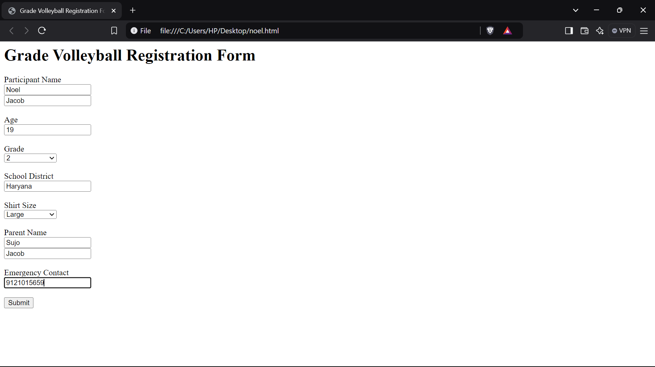

**Question 19) Write HTML code to design a student admission Form in HTML.**

**INPUT-**

<html>

<head>

<title>Student Admission Form</title>

</head>

<body>

<h1>Student Admission Form</h1>

<form action="submit.php" method="post">

<label for="student_name">Student Name</label><br>

<input type="text" id="student_name" name="student_name" required><br><br>

<label for="date_of_birth">Date of Birth</label><br>

<input type="date" id="date_of_birth" name="date_of_birth" required><br><br>

<label

for="gender">Gender</label><br>

<input type="radio" id="male" name="gender" value="male">

<label for="male">Male</label>

<input type="radio" id="female"

name="gender" value="female">

<label for="female">Female</label><br><br>

<label for="address">Address</label><br>

<textarea id="address" name="address"

rows="5" cols="30" required></textarea><br><br>

<label for="phone_number">Phone Number</label><br>

<input type="tel" id="phone_number" name="phone_number" required><br><br>

<label for="email">Email</label><br>

<input type="email" id="email" name="email" required><br><br>

<label for="class">Class</label><br>

<select id="class" name="class" required>

<option value="">Please select</option>

<option value="1">1</option>

<option value="2">2</option>

</select><br><br>

<label for="guardian_name">Guardian Name</label><br>

<input type="text" id="guardian_name" name="guardian_name" required><br><br>

<label for="guardian_contact">Guardian Contact</label><br>

<input type="tel" id="guardian_contact" name="guardian_contact" required><br><br>

<input type="submit" value="Submit">

</form>

</body>

</html>

**OUTPUT -**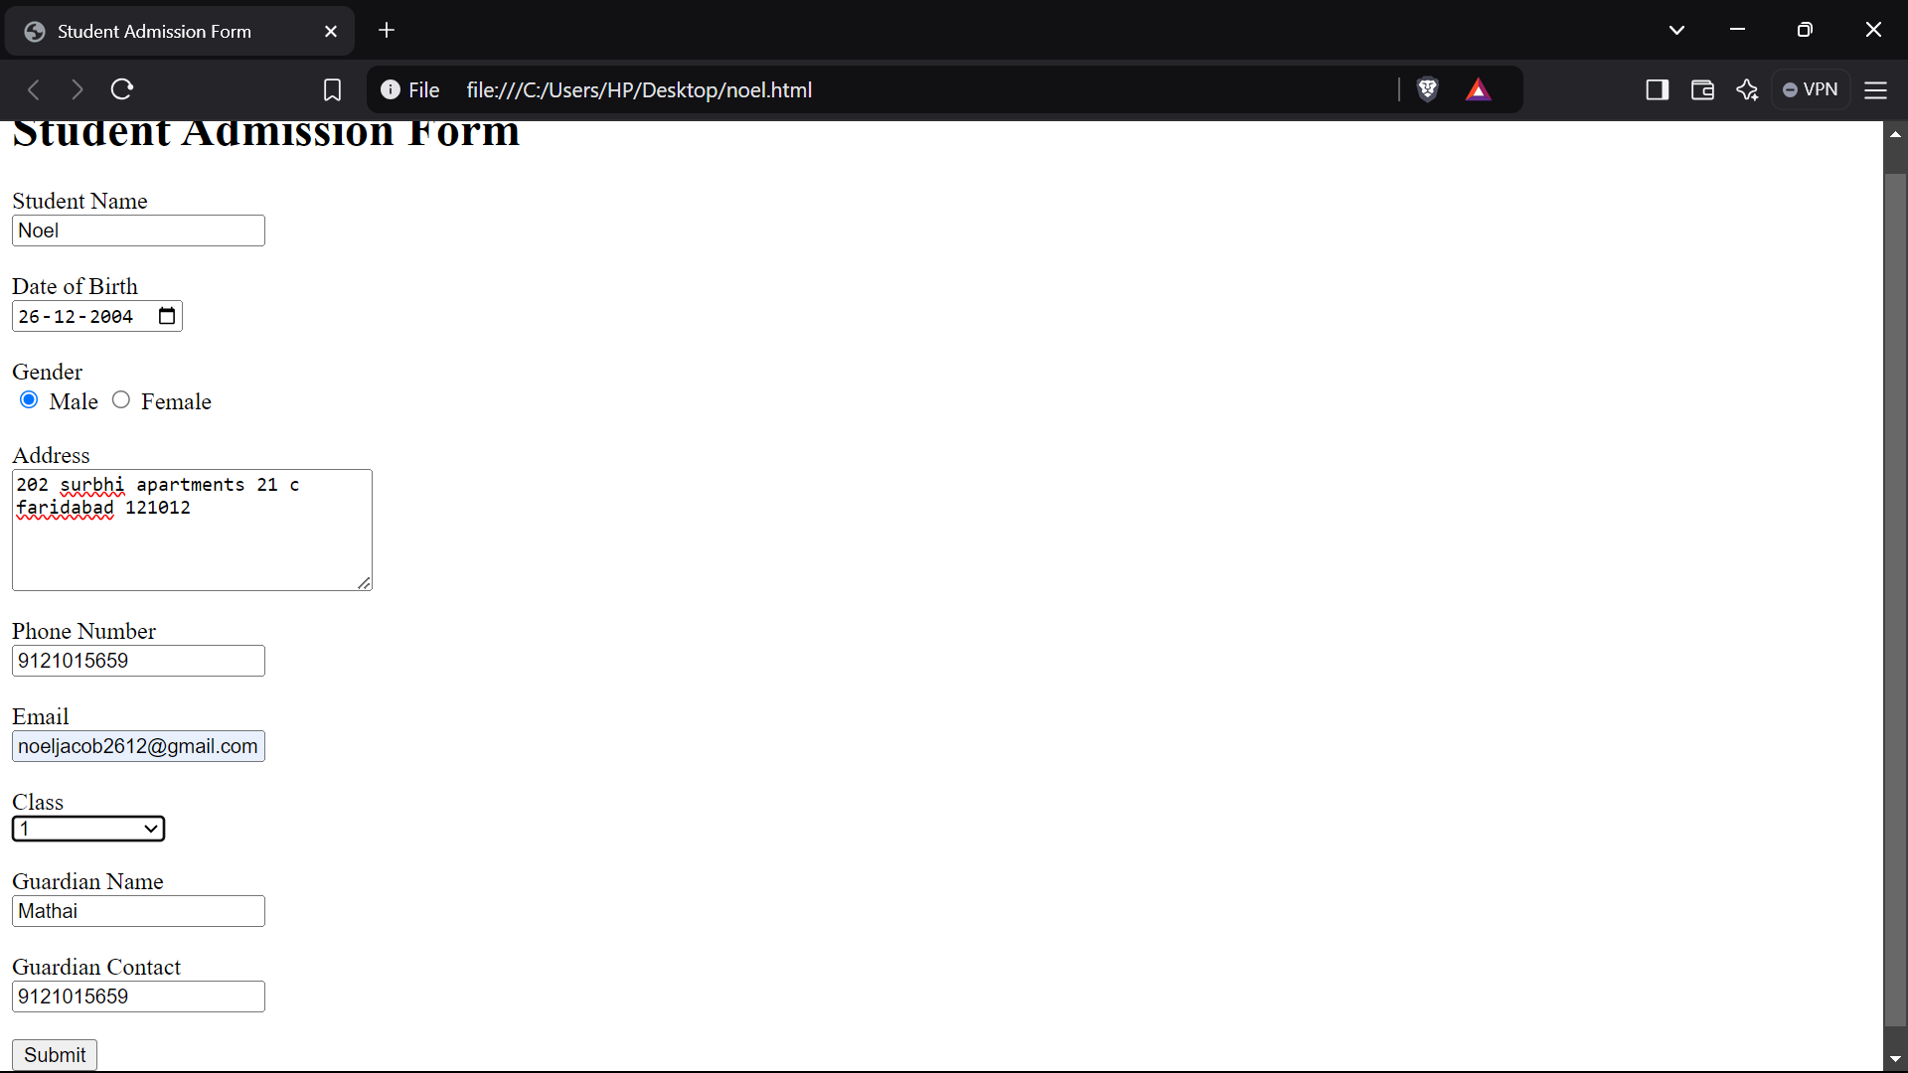

**Question 20) Create a proper home page of your own using any components and styles.**

**INPUT-**

<html>

<head>

<title>My Personal Website</title>

<link rel="stylesheet" href="styles.css">

</head>

<body>

<header>

<h1>My Name</h1>

<nav>

<ul>

<li><a href="index.html">Home</a></li>

<li><a href="about.html">About</a></li>

<li><a href="projects.html">Projects</a></li>

<li><a href="contact.html">Contact</a></li>

</ul>

</nav>

</header>

<main>

<section>

<h2>Welcome to My

Website!</h2>

<p>This is a brief introduction about myself. Feel free to explore my projects and contact me.</p>

<img src="C:\Users\HP\Desktop\valo.jpg">

</section>

</main>

<footer>

<p>&copy; 2023 My Name</p>

</footer>

</body>

</html>

**OUTPUT-**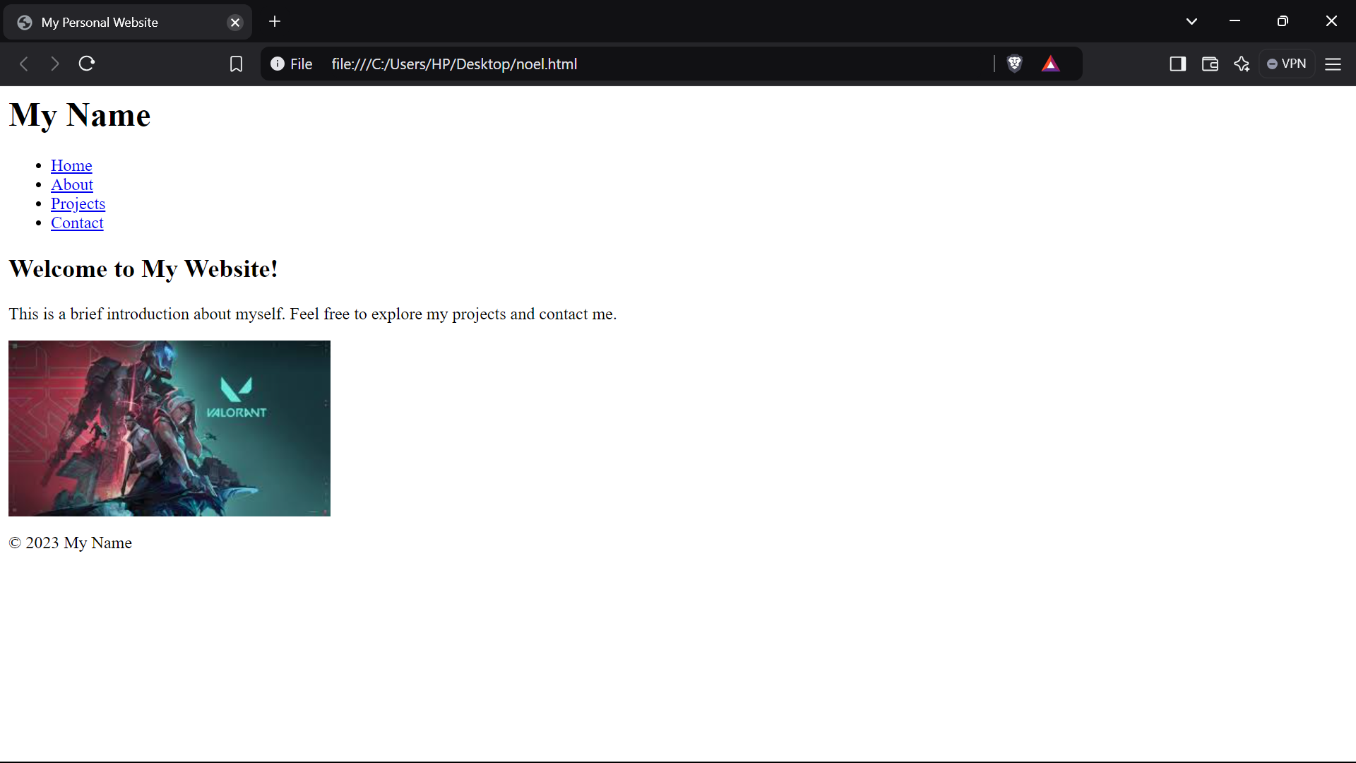

**Question 21) Write HTML code for including Local hyperlinking in a web page.**

**INPUT-**

<html>

<head>

<meta charset="UTF-8">

<meta name="viewport" content="width=device-width, initial-scale=1.0">

<title>Local Hyperlinking Example</title>

</head>

<body>

<h1>Welcome to My Web Page</h1>

<p>Click the links below to jump to different sections of the page:</p>

<ul>

<li><a href="#section1">Go to Section 1</a></li>

<li><a href="#section2">Go to Section 2</a></li>

<li><a href="#section3">Go to Section 3</a></li>

</ul>

<div id="section1">

<h2>Section 1</h2>

<p>This is the first section of the page.</p>

</div>

<div id="section2">

<h2>Section 2</h2>

<p>This is the second section of the page.</p>

</div>

<div id="section3">

<h2>Section 3</h2>

<p>This is the third section of the page.</p>

</div>

</body>

</html>

**OUTPUT-**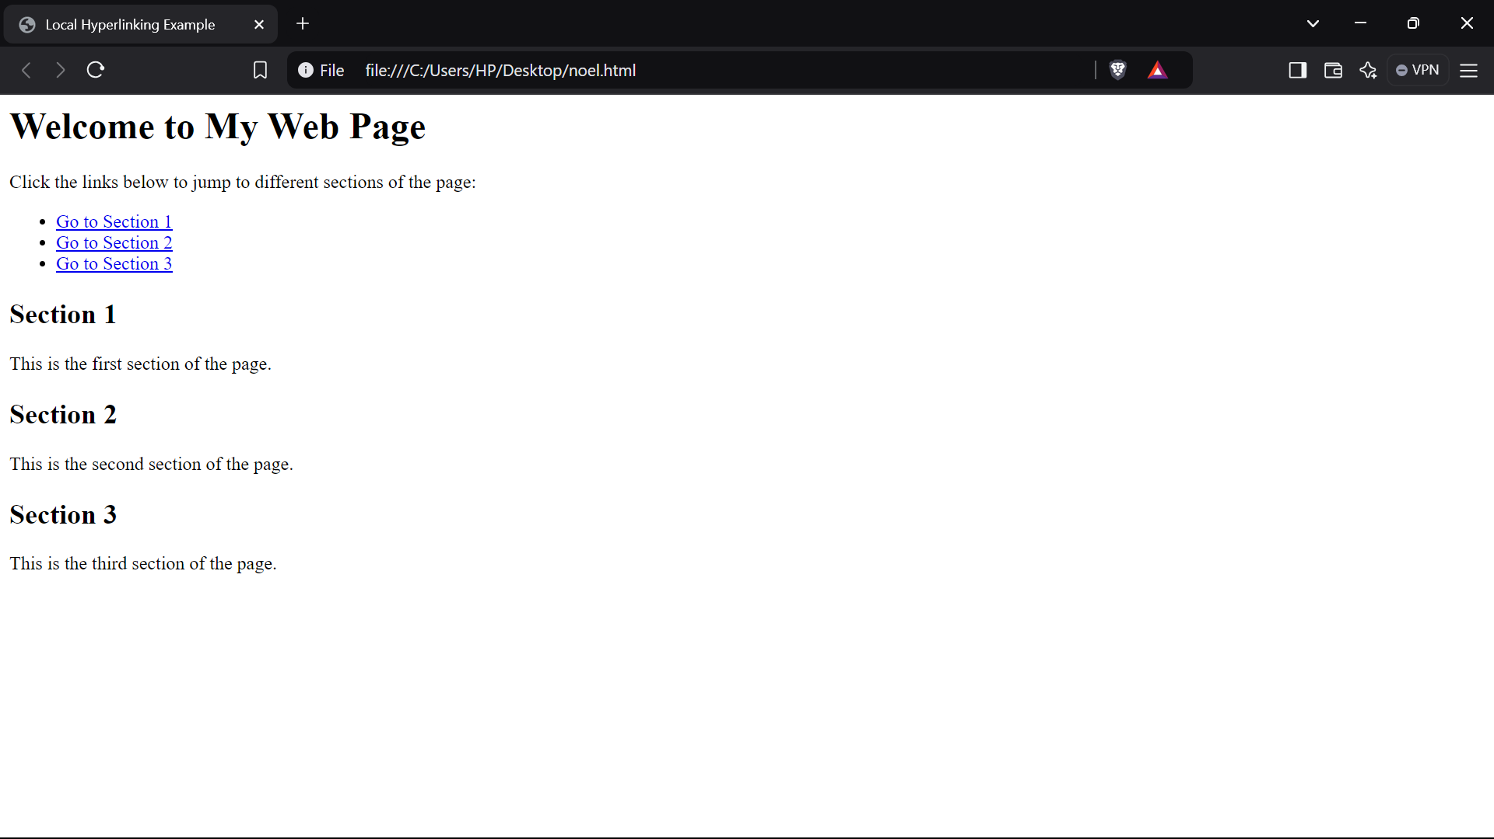

**Question 22) Write HTML code for including Inter hyperlinking in a web page.**

**INPUT-**

<html>

<head>

<meta charset="UTF-8">

<meta name="viewport" content="width=device-width, initial-scale=1.0">

<title>Link to Another Page</title>

</head>

<body>

<h1>Welcome to the Homepage</h1>

<nav>

<ul>

<li><a href="about.html">About Us</a></li>

<li><a href="services.html">Our Services</a></li>

<li><a href="contact.html">Contact Us</a></li>

</ul>

</nav>

</body>

</html>

**OUTPUT-**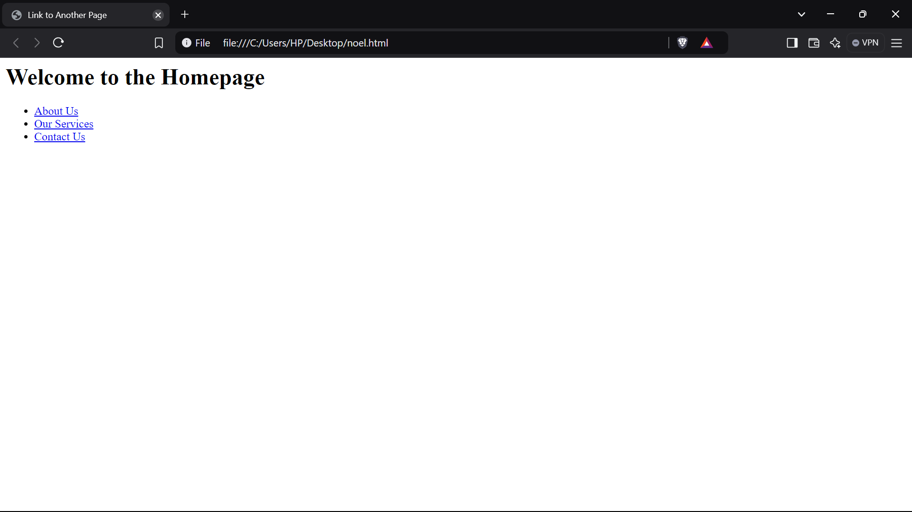

**Question 23) Write HTML code for including External hyperlinking in a web page**

**INPUT-**

<html>

<head>

<meta charset="UTF-8">

<meta name="viewport" content="width=device-width, initial-scale=1.0">

<title>External Link Example</title>

</head>

<body>

<h1>Welcome to My Web Page</h1>

<p>Click the link below to visit an external website:</p>

<a href="https://www.example.com" target="_blank">Visit Example.com</a>

</body>

</html>

**OUTPUT-**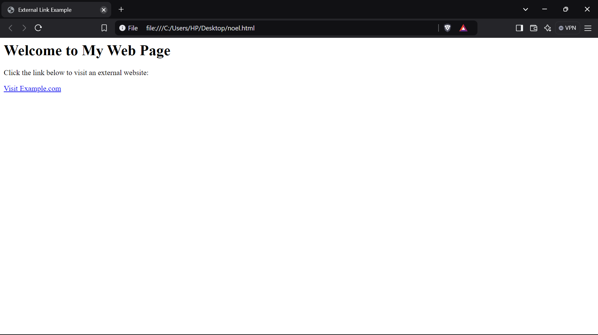

**Question 24) Write code to show External CSS with HTML code**

**INPUT-**

<html>

<head>

<meta charset="UTF-8">

<meta name="viewport" content="width=device-width, initial-scale=1.0">

<title>External CSS Example</title>

<link rel="stylesheet" href="styles.css">

</head>

<body>

<h1>Hello, World!</h1>

<p>This is an example of an HTML document styled with external CSS.</p>

<button>Click Me!</button>

</body>

</html>

**OUTPUT-**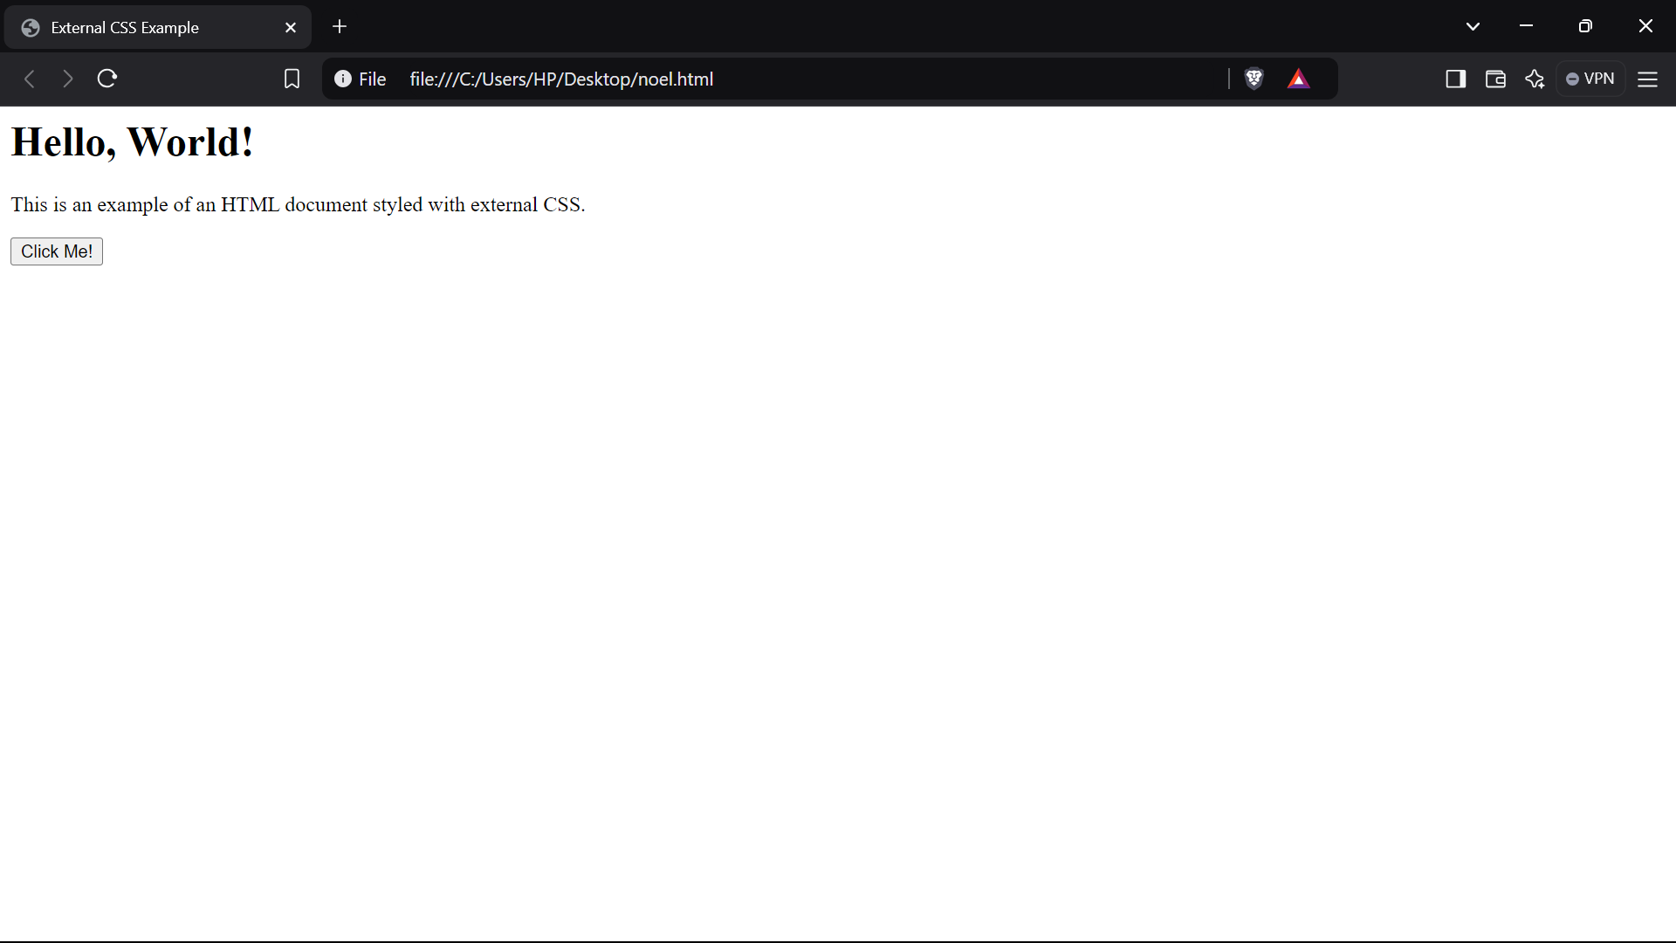

**Question 25) Write code to show Internal CSS with HTML code.**

**INPUT-**

<html>

<head>

<meta charset="UTF-8">

<meta name="viewport" content="width=device-width, initial-scale=1.0">

<title>Internal CSS Example</title>

<style>

body {

font-family: Arial, sans-serif;

background-color: #f4f4f9;

margin: 0;

padding: 0;

}

h1 {

color: #333;

text-align: center;

margin-top: 20px;

}

p {

color: #555;

font-size: 18px;

text-align: center;

line-height: 1.6;

}

.highlight {

background-color: yellow;

font-weight: bold;

}

.container {

width: 80%;

margin: 0 auto;

padding: 20px;

background-color: #fff;

border-radius: 8px;

box-shadow: 0 0 10px rgba(0, 0, 0, 0.1);

}

</style>

</head>

<body>

<div class="container">

<h1>Welcome to My Website</h1>

<p>This is an example of an HTML document with internal CSS.</p>

<p class="highlight">This text is highlighted using a CSS class.</p>

</div>

</body>

</html>

**OUTPUT-**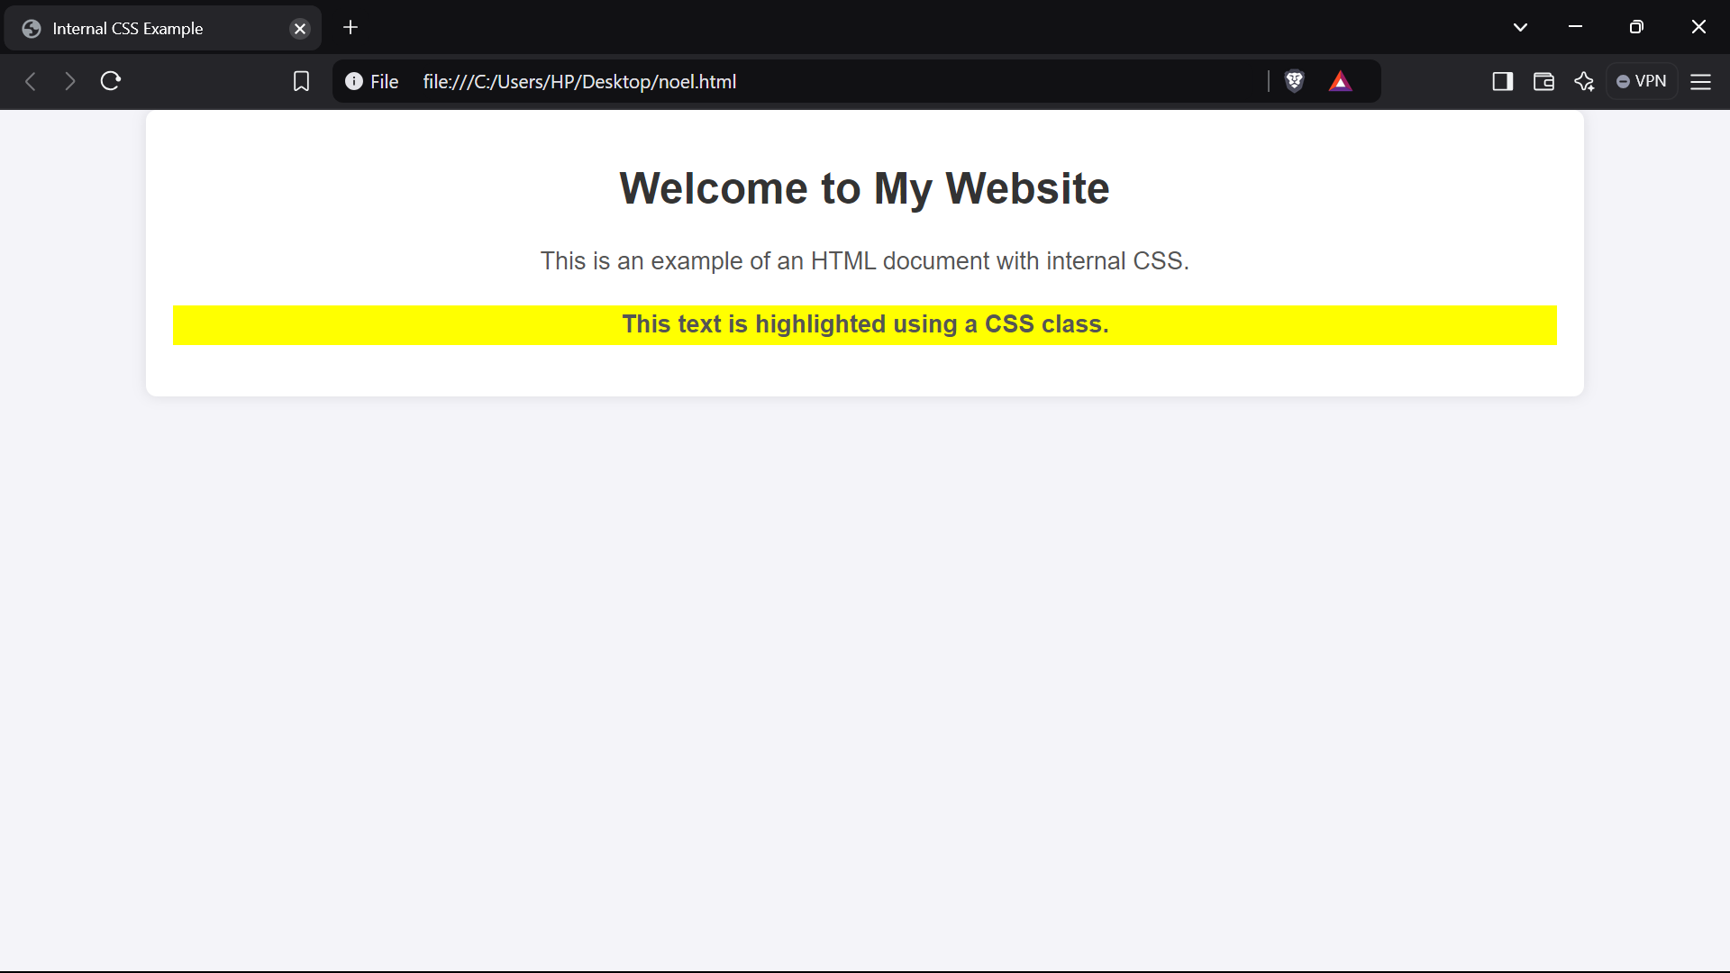

**Question 26) Write code to show Inline CSS with HTML code**

**INPUT-**

<html>

<head>

<meta charset="UTF-8">

<meta name="viewport" content="width=device-width, initial-scale=1.0">

<title>Inline CSS Example</title>

</head>

<body>

<h1 style="color: blue; text-align: center;">Welcome to My Web Page</h1>

<p style="font-size: 18px; color: green; font-family: Arial, sans-serif;">This is a simple paragraph with inline CSS styling. You can apply styles directly within HTML tags using the "style" attribute.</p>

<div style="background-color: lightgray; padding: 10px; border-radius: 5px;">

<p style="color: darkred;">This div has a light gray background, rounded corners, and some padding.</p>

</div>

<button style="background-color: #4CAF50; color: white; padding: 10px 20px; border: none; border-radius: 5px; cursor: pointer;">

Click Me

</button>

</body>

</html>

**OUTPUT-**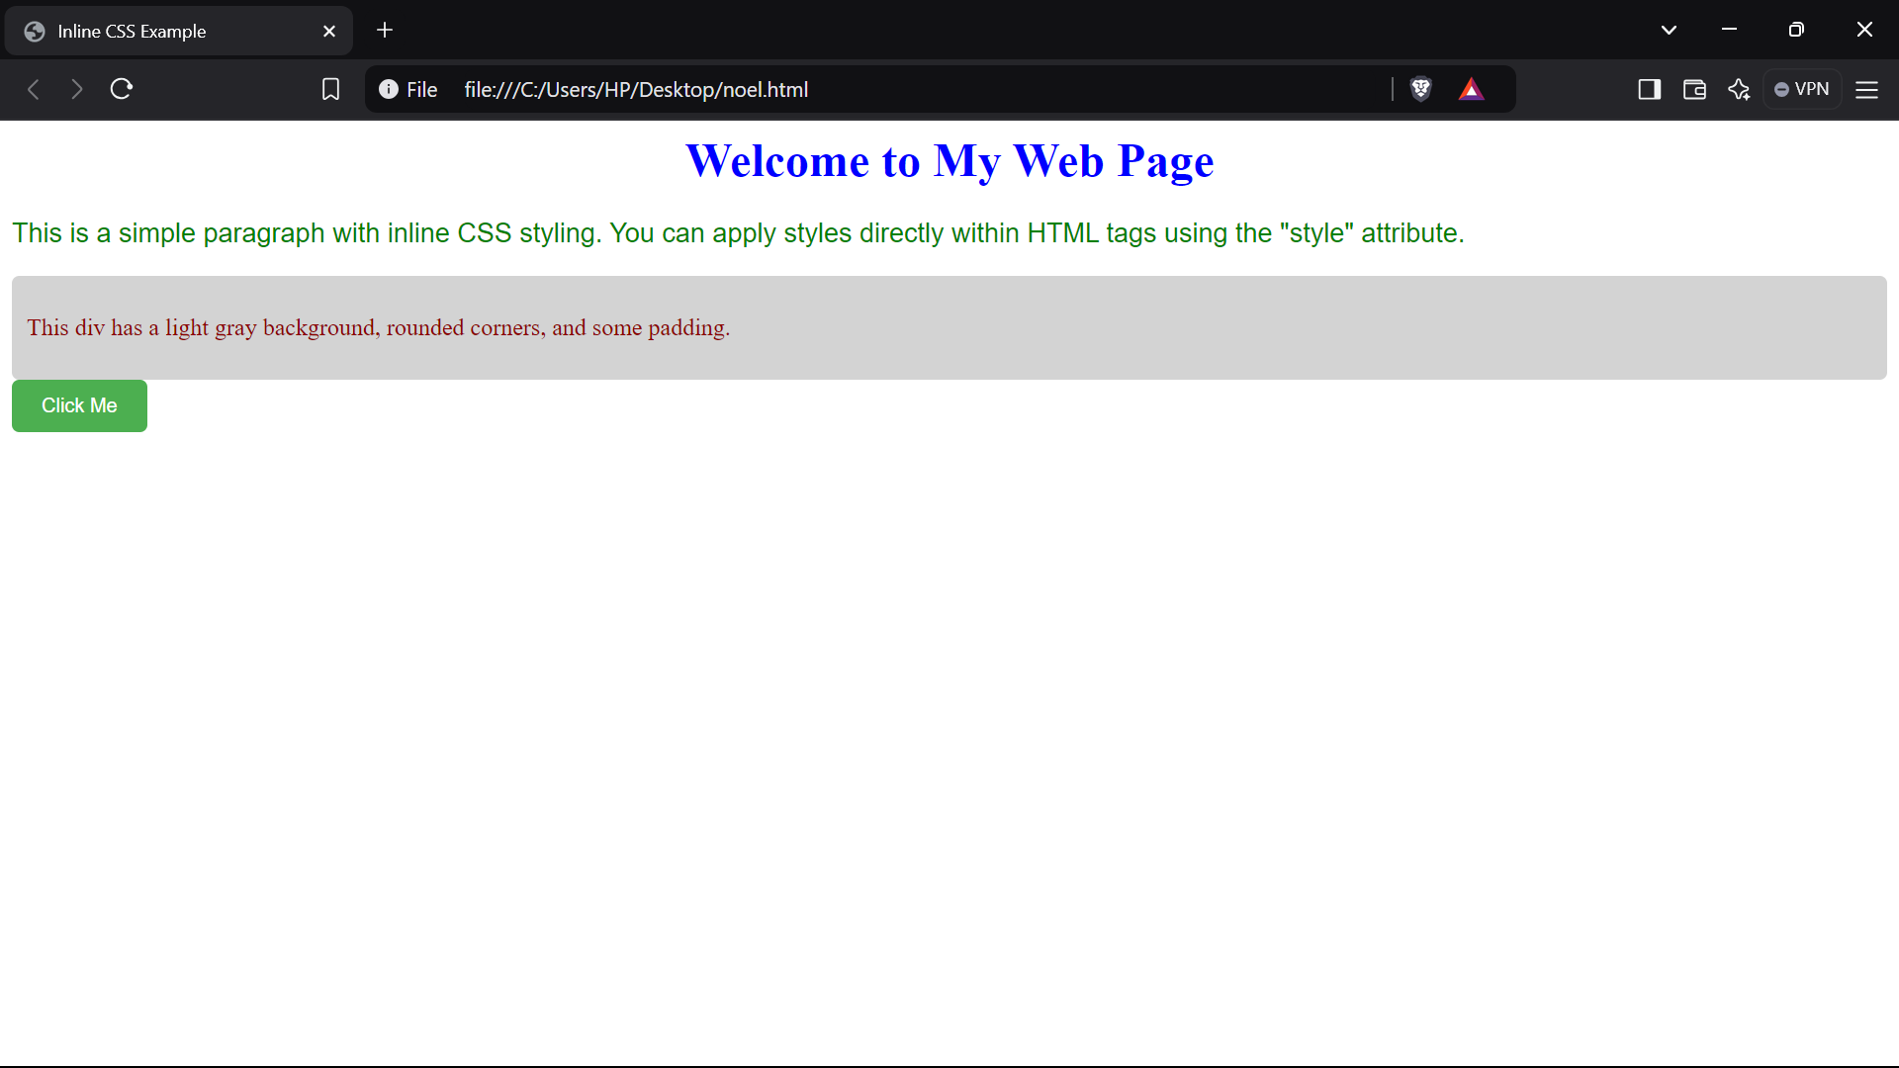

**Question 27) Write a program to add two numbers using form in JavaScript.**

**INPUT-**

<html>

<head>

<meta charset="UTF-8">

<meta name="viewport" content="width=device-width, initial-scale=1.0">

<title>Add Two Numbers</title>

<script>

function addNumbers() {

const num1 = parseFloat(document.getElementById("num1").value);

const num2 = parseFloat(document.getElementById("num2").value);

if (isNaN(num1) || isNaN(num2)) {

document.getElementById("result").innerHTML = "Please enter valid numbers.";

} else {

const sum = num1 + num2;

document.getElementById("result").innerHTML = "Result: " + sum;

}

}

</script>

</head>

<body>

<h2>Add Two Numbers</h2>

<form onsubmit="event.preventDefault(); addNumbers();">

<label for="num1">Number 1: </label>

<input type="number" id="num1" required>

<br><br>

<label for="num2">Number 2: </label>

<input type="number" id="num2" required>

<br><br>

<input type="submit" value="Add">

</form>

<p id="result"></p>

</body>

</html>

**OUTPUT-**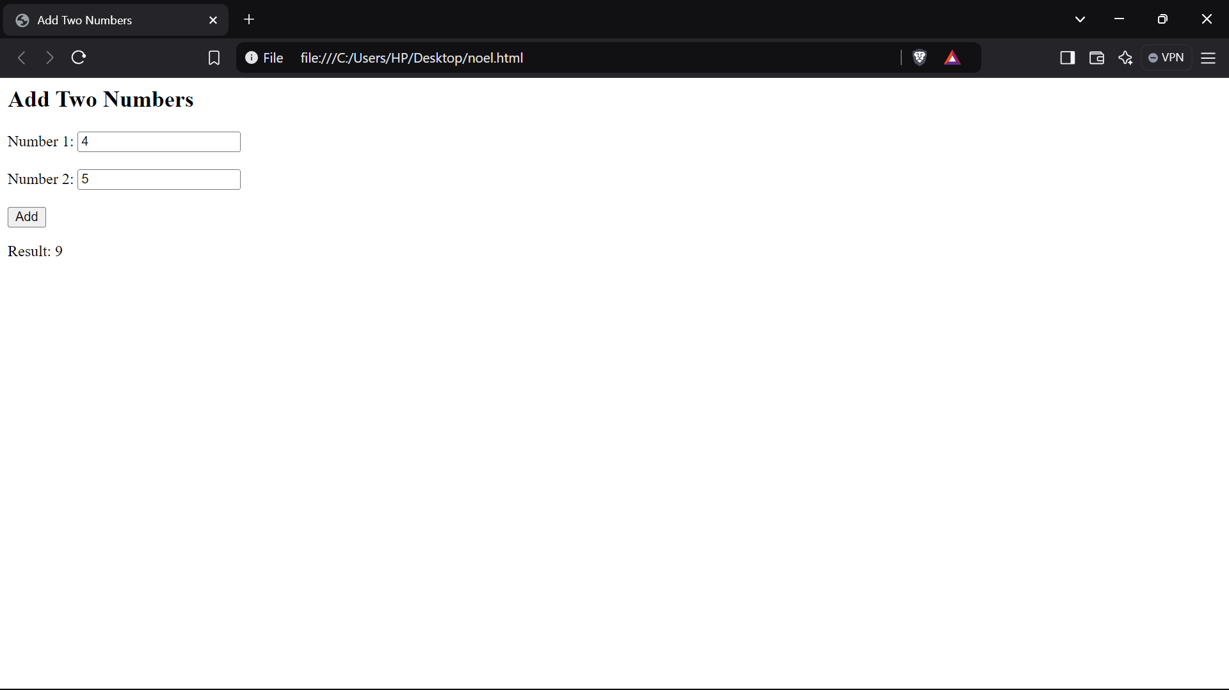

**Question 28) Write a program in JavaScript to swap two images using on mouseover event.**

**INPUT-**

<html>

<head>

<meta charset="UTF-8">

<meta name="viewport" content="width=device-width, initial-scale=1.0">

<title>Swap Images on Mouseover</title>

</head>

<body>

<img id="image1" src="Downloads/OIP (1).jpeg" alt="Image 1" width="500" height="500" onmouseover="swapImages()" onmouseout="resetImages()">

<img id="image2" src="Downloads/OIP.jpeg" alt="Image 2" width="500" height="500" onmouseover="swapImages()" onmouseout="resetImages()">

<script>

function swapImages() {

var image1 = document.getElementById("image1");

var image2 = document.getElementById("image2");

var tempSrc = image1.src;

image1.src = image2.src;

image2.src = tempSrc;

}

function resetImages() {

var image1 = document.getElementById("image1");

var image2 = document.getElementById("image2");

image1.src ="Downloads/OIP (1).jpeg";

image2.src ="Downloads/OIP.jpeg" ;

}

</script>

</body>

</html>

**OUTPUT-**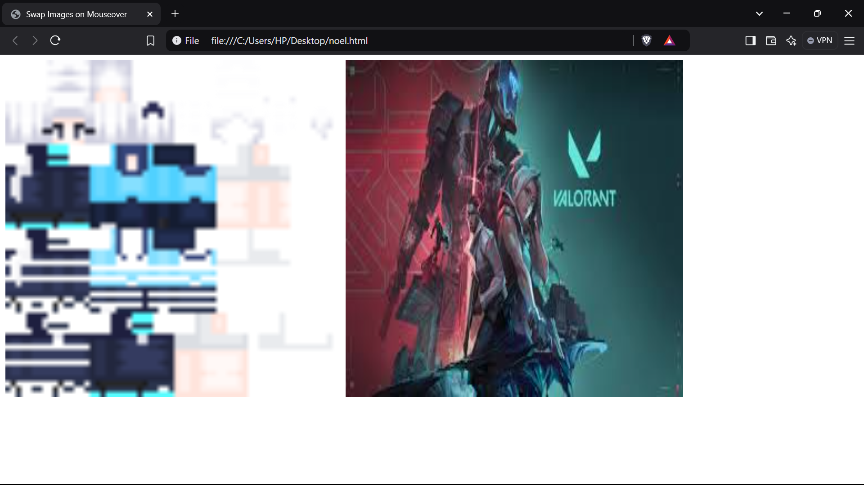

**Question 29) Write a simple JavaScript program to sort an array**

**INPUT-**

let numbers = [5, 3, 8, 1, 2, 7,99,88,543,12,667,7879];

numbers.sort(function(a, b) {

return a - b;

});

console.log("Sorted array:", numbers);

**OUTPUT-**

**Question 30) Write a JavaScript program to take as input three numbers from the user. Find the minimum and maximum of the three numbers. Print the following output in BOLD in the following format: MINIMUM = MAXIMUM =**

**INPUT-**

<html>

<head>

<meta charset="UTF-8">

<meta name="viewport" content="width=device-width, initial-scale=1.0">

<title>Find Minimum and Maximum</title>

</head>

<body>

<h2>Find Minimum and Maximum of Three Numbers</h2>

<label for="num1">Enter first number:</label>

<input type="number" id="num1" required>

<br><br>

<label for="num2">Enter second number:</label>

<input type="number" id="num2" required>

<br><br>

<label for="num3">Enter third number:</label>

<input type="number" id="num3" required>

<br><br>

<button onclick="findMinMax()">Find Minimum and Maximum</button>

<h3 id="output"></h3>

<script>

function findMinMax() {

const num1 = parseFloat(document.getElementById("num1").value);

const num2 = parseFloat(document.getElementById("num2").value);

const num3 = parseFloat(document.getElementById("num3").value);

if (isNaN(num1) || isNaN(num2) || isNaN(num3)) {

alert("Please enter valid numbers in all fields.");

return;

}

const minimum = Math.min(num1, num2, num3);

const maximum = Math.max(num1, num2, num3);

document.getElementById("output").innerHTML = `

<strong>MINIMUM = ${minimum}</strong> &nbsp;&nbsp;&nbsp;&nbsp;

<strong>MAXIMUM = ${maximum}</strong>

`;

}

</script>

</body>

</html>

**OUTPUT-** 