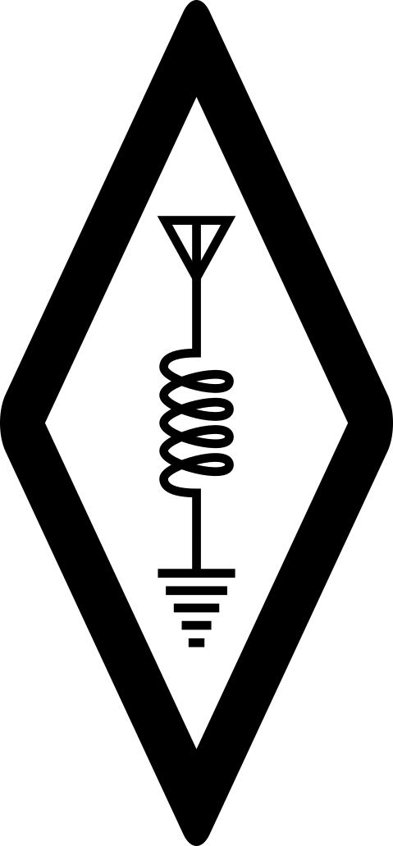
Amateur Radio Booklet
2023 Edition
Noël Martin – F4JJD
Cover Picture
SAQ Grimeton, Sweden, Mårten Sjöbeck, Public Domain
License

Amateur Radio Booklet © 2023 by Noël Martin F4JJD is licensed under CC BY-SA 4.0. To view a copy of this license, visit http://creativecommons.org/licenses/by-sa/4.0/
This license requires that reusers give credit to the creator. It allows reusers to distribute, remix, adapt, and build upon the material in any medium or format, even for commercial purposes. If others remix, adapt, or build upon the material, they must license the modified material under identical terms.
Contributors
Noël Martin – F4JJD – f4jjd@noelmrtn.fr

Table of Contents
1 – Band Plans 7
Summary 7
2200 Meters 9
630 Meters 9
160 Meters 10
80 Meters 11
60 Meters 12
40 Meters 13
30 Meters 14
20 Meters 15
17 Meters 16
15 Meters 17
12 Meters 18
10 Meters 19
6 Meters 21
2 Meters 23
1.25 Meters 25
70 Centimeters 26
2 – International Beacon Project 28
Beacons List 28
Frequencies 29
3 – Digital Modes 30
4 – Morse Code 34
Timings 35
5 – Radio Abbreviations 36
6 – Q Codes 39
7 – Classification of Emissions 43
Modulation of the main Carrier 43
Nature of signals 44
Type of Information 44
8 – Radio Waves 47
Band Definitions 47
Propagation 48
Ionosphere Regions 48
Bands 49
9 – Electricity 50
Kirchhoff’s Law 51
Currents 51
Voltage 51
Operational Amplifiers 51
Non-inverting 51
Inverting 51
Filters & RLC 52
Resistor Colors 53
10 – ITU Prefixes Allocation 55
11 – Units 66
International System 66
Base Units 66
Derived Units 66
Prefixes 67
Conversions 68
Physics Constants 69
Decibels 70
12 – Mathematics 72
Algebra 72
Logarithms 72
Trigonometry 73
Table of Values 73
13 – ITU Regions 75
14 – ITU Alphabet 76
– Document Abbreviations 77
– References 78

Band Plans

Summary
Primary allocations are written in bold, e.g. 14000 — 14350. If the band is exclusive to the amateur service the frequencies are followed by the infinite symbol, e.g. 1800 — 1850 ∞.
Secondary allocations are written in italic, e.g. 135.7 — 137.8.
If the band allows amateur satellite (AMSAT), the frequencies are followed by the lozenge symbol, e.g. 7000 — 7200 ◊.
 | Band | Region 1 | Region 2 | Region 3
LF (kHz) | 2200m | 135.7 — 137.8
MF (kHz) | 630m | 472 — 479
MF (kHz) | 160m | 1810 — 1850 ∞ | 1800 — 1850 ∞ |  | 1800 — 2000
MF (kHz) | 160m | 1810 — 1850 ∞ | 1850 — 2000 |  | 1800 — 2000
HF (kHz) | 80m | 3500 — 3800 | 3500 — 3750 ∞ |  | 3500 — 3900
HF (kHz) | 60m | 5351.5 — 5366.5
HF (kHz) | 40m | 7000 — 7100 ◊
HF (kHz) | 40m | 7100 — 7200 ∞
HF (kHz) | 40m | Forbidden | 7200 — 7300 ∞ |  | Forbidden
HF (kHz) | 30m | 10100 — 10150
HF (kHz) | 20m | 14000 — 14250 ◊
HF (kHz) | 20m | 14250 — 14350 ∞
HF (kHz) | 17m | 18068 — 18168 ◊
HF (kHz) | 15m | 21000 — 21450 ◊
HF (kHz) | 12m | 24890 — 24990 ◊
HF (kHz) | 10m | 28000 — 29700 ◊
VHF (MHz) | 6m | 50 — 52 | 50 — 54
VHF (MHz) | 2m | 144 — 146 ◊
VHF (MHz) | 2m | Forbidden | 146 — 148 ∞ |  | 146 — 148
VHF (MHz) | 1.35m | Forbidden | 220 — 225 |  | Forbidden
UHF (MHz) | 70cm | 430 — 440 | 430 — 440
UHF (MHz) | 33cm | Forbidden | 902 — 928 |  | Forbidden
UHF (MHz) | 23cm | 1240 — 1300
UHF (MHz) | 13cm | 2300 — 2450
SHF (GHz) | 9cm | Forbidden | 3.3 — 3.5
SHF (GHz) | 5cm | 5.65 — 5.83
SHF (GHz) | 5cm | 5.83 — 5.85 ◊
SHF (GHz) | 5cm | Forbidden | 5.85 — 5.925 |  | Forbidden
SHF (GHz) | 3cm | 10 — 10.45
SHF (GHz) | 3cm | 10.45 — 10.5 ◊
SHF (GHz) | 1.2cm | 24 — 24.05 ◊
SHF (GHz) | 1.2cm | 24.05 — 24.25
SHF (GHz) | 6mm | 47 — 47.2 ◊
SHF (GHz) | 4mm | 76 — 77.5 ◊
SHF (GHz) | 4mm | 77.5 — 78 ◊
SHF (GHz) | 4mm | 78 — 81 ◊
SHF (GHz) | 2.4mm | 122.25 — 123
SHF (GHz) | 2.2mm | 134 — 136 ◊
SHF (GHz) | 2.2mm | 136 — 141 ◊
SHF (GHz) | 1.2mm | 241 — 248 ◊
SHF (GHz) | 1.2mm | 248 — 250 ◊

2200 Meters
Region 1 | Region 2 | Region 3
135.7 — 137.8 kHz  BW 200Hz  CW, QRSS, DM | 135.7 — 137.8 kHz  BW 200 Hz  All Modes | 135.7 — 137.8 kHz  BW 500 Hz  CW, QRSS, DM
Max Power: 1W EIRP — Status: Secondary R1, R2, R3 (primary Fixed, Maritime Mobile, R3 Radio-navigation)

630 Meters
Region 1 | Region 2 | Region 3
472 — 475 kHz  BW 200 Hz  CW | 472 — 479 kHz  BW 500 Hz  CW, DM | 472 — 479 kHz  BW 500 Hz  CW, DM
475 — 479 kHz  BW 500 Hz  NBM | 472 — 479 kHz  BW 500 Hz  CW, DM | 472 — 479 kHz  BW 500 Hz  CW, DM
Max Power: 1W EIRP — Status: Secondary R1, R2, R3 (primary Maritime Mobile)

160 Meters
Region 1 | Region 2 | Region 3
1810 — 1838 kHz  BW 200 Hz  CW, 1836 – CW QRP | 1800 — 1810 kHz  BW: 500 Hz  DM | 1800 — 1830 kHz  BW: 200 Hz  CW
1838 — 1840 kHz  BW: 500 Hz  NBM | 1810 — 1840 kHz  BW: 200 Hz  CW, DM  1812 – CW QRP CoA | 1830 — 1840 kHz  BW: 500Hz  CW (DX), NBM  1836 – CW QRP CoA
1840 — 1850 kHz  BW: 2700 Hz  All Modes | 1840 — 1850 kHz  BW: 2700 Hz  CW, DM, SSB (DX) | 1840 — 2000 kHz  BW: 2700 Hz  All Modes
1840 — 1850 kHz  BW: 2700 Hz  All Modes | 1850 — 2000 kHz  BW: 2700 Hz  All Modes  1910 – SSB QRP CoA | 1840 — 2000 kHz  BW: 2700 Hz  All Modes
Status: Primary R1, R2, R3

80 Meters
Region 1 | Region 2 | Region 3
3500 — 3580 kHz  BW: 200 Hz  CW (3505 – DX CoA)  3555 – CW QRS CoA  3560 – CW QRP CoA  > 3570 – NBM | 3500 — 3580 kHz  BW: 200 Hz  CW (3505 – DX CoA)  3555 – CW QRS CoA  3560 – CW QRP CoA  > 3570 – NBM | 3500 — 3535 kHz  BW: 200 Hz  CW (3505 – DX CoA)
3580 — 3600 kHz  BW: 500 Hz  NBM, DM | 3580 — 3600 kHz  BW: 500 Hz  CW, DM | 3535 — 3900 kHz  BW 2700 Hz  CW, SSB, DM  3560 – QRP CoA  3600 – EMCOM CoA  3690 – DV CoA  3690 – SSB QRP CoA  3735 – Image CoA  3795 – DX SSB CoA  3845 – Image CoA
3600 — 3800 kHz  BW: 2700 Hz  All Modes  3690 – SSB QRP CoA  3735 – Image CoA  3760 – EMCOM CoA  3775 – DX CoA | 3600 — 4000 kHz  BW 2700 Hz  All Modes  3690 – SSB QRP CoA  3735 – Image CoA  3750 – EMCOM CoA  3775 – DX CoA  3845 – Image CoA  3885 – AM CoA  3985 – EMCOM CoA
Status: Primary R1, R2, R3

60 Meters
Region 1 | Region 2 | Region 3
5351.5 — 5354 kHz  BW 200 Hz  CW, NBM | 5351.5 — 5354 kHz  BW 500 Hz  CW, DM | 5351.5 — 5354 kHz  BW 500 Hz  CW, NBM, DM
5354 — 5366 kHz  BW 2700 Hz  All Modes, Pref. USB | 5354 — 5366 kHz  BW 2700 Hz  All Modes | 5354 — 5366 kHz  BW 2700 Hz  All Modes, Pref. USB
5366 — 5366.5 kHz  BW 20 Hz  Weak Signal | 5366 — 5366.5 kHz  BW 20 Hz  CW, DM | 5366 — 5366.5 kHz  BW 20 Hz  Weak Signal
Max Power: 15W EIRP — Status: Secondary R1, R2, R3 (primary Fixed, Mobile)
Warning: very small bandwidth between 5366-5366.5 kHz

40 Meters
Region 1 | Region 2 | Region 3
7000 — 7040 kHz  BW 200 Hz  CW  7030 – CW QRP CoA | 7000 — 7040 kHz  BW 200 Hz  CW  < 7025 – DX  7030 – CW QRP CoA | 7000 — 7030 kHz  BW 200 Hz  CW
7040 — 7050 kHz  BW 500 Hz  NBM, DM | 7040 — 7050 kHz  BW 500 Hz  CW, DM | 7030 — 7200 kHz  BW 2700 Hz  CW, SSB, DM  7030 – QRP CoA  7070 – DV CoA  7090 – SSB QRP CoA  7095 – DX Phone CoA  7110 – EMCOM CoA  7165 – Image CoA
7050 — 7200 kHz  BW 2700 Hz  All Modes  < 7060 – DM  7070 – DV CoA  7090 – SSB QRP CoA  7110 – EMCOM CoA  7165 – Image CoA  > 7175 – DX | 7050 — 7300 kHz  BW 2700 Hz  All Modes  7060 – EMCOM CoA  7070 – DV CoA  7090 – SSB QRP CoA  7165 – Image CoA  7240 – EMCOM CoA  7275 – EMCOM CoA  7285 – SSB QRP CoA  7290 – AM CoA
Status: Primary R1, R2, R3; and 7000-7100 kHz AMSAT R1, R2, R3

30 Meters
Region 1 | Region 2 | Region 3
10100 — 10130 kHz
BW 200 Hz

CW
10116 – CW QRP CoA
10130 — 10150 kHz  BW 500 Hz  NBM, DM | 10130 — 10140 kHz  BW 500 Hz  CW, DM | 10130 — 10150 kHz  BW 500 Hz  NBM, DM
10130 — 10150 kHz  BW 500 Hz  NBM, DM | 10140 — 10150 kHz  BW 2700 Hz  CW, DM | 10130 — 10150 kHz  BW 500 Hz  NBM, DM
Status: Secondary R1, R2, R3 (primary Fixed)

20 Meters
Region 1 | Region 2 | Region 3
14000 — 14070 kHz
BW 200 Hz

CW
14055 – CW QRS CoA
14060 – CW QRP CoA
14070 — 14099 kHz
BW 500 Hz

NBM, DM
14099 — 14101 kHz

International
Beacon Project
14101 — 14350 kHz  BW 2700 Hz  All Modes  14130 – DV CoA  14195 – DX  14230 – Image CoA  14285 – SSB QRP  14300 – Glob EMCOM | 14101 — 14350 kHz  BW 2700 Hz  All Modes  14195 – DX  14230 – Image CoA  14285 – SSB QRP  14285 – AM QRG  14300 – Glob EMCOM | 14101 — 14350 kHz  BW 2700 Hz  All Modes  14130 – DV CoA  14195 – DX  14230 – Image CoA  14285 – SSB QRP  14300 – Glob EMCOM
Status: Primary R1, R2, R3; and 14000-14250 kHz AMSAT R1, R2, R3

17 Meters
Region 1 | Region 2 | Region 3
18068 — 18095 kHz
BW 200 Hz

CW
18086 – CW QRP CoA
18095 — 18109 kHz  BW 500 Hz  NBM, DM |  | 18095 — 18109 kHz  BW 2700 Hz  NBM, DM
18109 — 18111 kHz

International
Beacon Project
18111 — 18168 kHz  BW 2700 Hz  All Modes  18130 – SSB QRP  18150 – DV CoA  18160 – EMCOM | 18111 — 18168 kHz  BW 2700 Hz  All Modes  18130 – SSB QRP  18160 – EMCOM | 18111 — 18168 kHz  BW 2700 Hz  All Modes  18130 – SSB QRP  18150 – DV CoA  18160 – EMCOM
Status: Primary and AMSAT R1, R2, R3.

15 Meters
Region 1 | Region 2 | Region 3
21000 — 21070 kHz
BW 200 Hz

CW
21055 – CW QRS CoA
21060 – CW QRP CoA
21070 — 21110 kHz
BW 500 Hz

NBM, DM
21110 — 21120 kHz  BW 2700 Hz  All Modes, except SSB |  | 21110 — 21125 kHz  BW 2700 Hz  CW, NBM, DM
21120 — 21149 kHz  BW 500 Hz  NBM | 21120 — 21149 kHz  BW 500 Hz  All Modes | 21125 — 21149 kHz  BW 2700 Hz  CW, NBM, DM  Satellite Uplink
21149 — 21151 kHz

International
Beacon Project
21151 — 21450 kHz  BW 2700 Hz  All Modes  21180 – DV CoA  21285 – SSB QRP  21340 – Image CoA  21360 – Glob. EMCOM | 18111 — 18168 kHz  BW 2700 Hz  All Modes  21285 – SSB QRP  21340 – Image CoA  21360 – Glob. EMCOM | 18111 — 18168 kHz  BW 2700 Hz  All Modes  21180 – DV CoA  21295 – DX CoA  21340 – Image CoA  21360 – Glob. EMCOM
Status: Primary and AMSAT R1, R2, R3.

12 Meters
Region 1 | Region 2 | Region 3
24890 — 24915 kHz
BW 200 Hz

CW
24906 – CW QRP CoA
24915 — 24929 kHz
BW 500 Hz

CW, NBM, DM
24929 — 24931 kHz

International
Beacon Project
24931 — 24990 kHz  BW 2700 Hz  All Modes  24950 – SSB QRP  24960 – DV CoA | 24931 — 24990 kHz  BW 2700 Hz  All Modes  24950 – SSB QRP | 24931 — 24990 kHz  BW 2700 Hz  All Modes  24950 – SSB QRP  24960 – DV CoA
Status: Primary and AMSAT R1, R2, R3.

10 Meters
Region 1 | Region 2 | Region 3
28000 — 28070 kHz  BW 200 Hz  CW  28055 – CW QRS CoA  28060 – CW QRP CoA |  | 28000 — 28070 kHz  BW 200 Hz  CW  28055 – CW QRS
28070 — 28190 kHz  BW 500 Hz  NBM, DM | 28070 — 28190 kHz  BW 500 Hz  CW, DM | 28070 — 28190 kHz  BW 500 Hz  CW, NBM  > 28050 – DX
28190 — 28225 kHz
BW 200 Hz

Beacons
28200 – International Beacon Project
28225 — 28300 kHz  BW 2700 Hz  Beacons |  | 28225 — 28300 kHz  BW 6000 Hz  All Modes
28300 — 29000 kHz  BW 2700 Hz  All Modes  28330 – DV CoA  28360 – SSB QRP CoA  28680 – Image CoA |  | 28300 — 29510 kHz  BW 6000 Hz  Satellite  Up & Down-Links
29000 — 29510 kHz  BW Unrestricted  All Modes  > 29300 – Satellite |  | 28300 — 29510 kHz  BW 6000 Hz  Satellite  Up & Down-Links
29510 — 29520 kHz

Guard Band
NO TRANSMISSION ALLOWED
29520 — 29590 kHz
BW 6000 Hz

All Modes
Repeater Input (RH1 – RH8)
29590 — 29620 kHz
BW 6000 Hz

All Modes
Repeaters Simplex
29600 – FM QRG
29590 — 29620 kHz
BW 6000 Hz

All Modes
Repeater Output (RH1 – RH8)
Status: Primary and AMSAT R1, R2, R3.

6 Meters
Region 1 | Region 2 | Region 3
50 — 50.1 MHz  BW 500 Hz  CW  < 50.010 Beacons  50.050 – CoA  50.090 – DX CoA | 50 — 50.1 MHz  BW 500 Hz  CW  50.010 – 50.020 Beacons | 50 — 50.1 MHz  BW 200 Hz  CW  50.020 – 50.030 Beacons
50.1 — 50.4 MHz  BW 2700 Hz  CW, SSB, NBM  50.110 – DX CoA  50.305 – PSK CoA  50.315 – EME CoA |  | 50.1 — 50.5 MHz  BW 2700 Hz  CW, SSB, NBM  .110 – DX CoA
50.4 — 50.5 MHz  BW 1000 Hz  Beacons  50.401 – WSPR | 50.4 — 50.5 MHz  BW 2700 Hz  Beacons | 50.1 — 50.5 MHz  BW 2700 Hz  CW, SSB, NBM  .110 – DX CoA
50.5 — 52 MHz  BW 12 kHz  All Modes  50.510 – SSTV  50.530 – FM Internet  50.600 – RTTY  50.630 – DV Calling  51.210 – 51.590 – Repeaters  Wideband  Experiments  BW unlimited  50.9 – 51.2  51.4 – 52 | 50.5 — 50.6 MHz  BW 2700 Hz  All Modes | 50.5 — 54 MHz  BW 25 kHz  All Modes
 | 50.6 — 51 MHz  BW 12 kHz  All Modes | 50.5 — 54 MHz  BW 25 kHz  All Modes
 | 51 — 51.11 MHz  BW 2700  CW, SSB  DX Window | 50.5 — 54 MHz  BW 25 kHz  All Modes
52 — 54 MHz  BW 500 kHz  All Modes | 51.11 — 54 MHz  BW 12 kHz  FM, DV  51.110 – 51.980 – Repeaters
Status: Primary R1, R2, R3.

2 Meters
Region 1 | Region 2 | Region 3
144 — 144.025 MHz
BW 2700 Hz

All Modes
Satellite Down-Links Only
144.025 — 144.150 MHz  BW 500 Hz  CW  144.050 – Telegraphy Calling Freq  144.350 – EME CoA | 144.025 — 144.110 MHz  BW 500 Hz  CW, DM  EME, Weak Signals | 144.025 — 144.035 MHz  BW N/A  CW, EME, Weak Signals
144.150 — 144.400 MHz  BW 2700 Hz  SSB, CW  144.300 – SSB CoA | 144.110 — 144.275 MHz  BW 2700 Hz  CW, DM, SSB  Weak Signals  144.200 – QRG Calling | 144.035 — 145.800 MHz  BW 25 kHz  All Modes  144.1 – DX CoA
 | 144.275 — 144.300 MHz  BW 500 Hz  Beacons | 144.035 — 145.800 MHz  BW 25 kHz  All Modes  144.1 – DX CoA
 | 144.275 — 144.360 MHz  BW 2700 Hz  CW, SSB  144.300 – QRG Calling | 144.035 — 145.800 MHz  BW 25 kHz  All Modes  144.1 – DX CoA
 | 144.360 — 144.400 MHz  BW 12 kHz  DM  144.390 – APRS CoA | 144.035 — 145.800 MHz  BW 25 kHz  All Modes  144.1 – DX CoA
144.400 — 144.500 MHz  BW 500 Hz  Beacons  Weak Signals MGM | 144.400 — 144.500 MHz  BW 500 Hz  CW, DM  Beacons | 144.035 — 145.800 MHz  BW 25 kHz  All Modes  144.1 – DX CoA
144.500 — 144.794 MHz  BW 20 kHz  All Modes  144.5 – SSTV CoA  144.6 – Data CoA  144.75 – ATV | 144.500 — 145.790 MHz  BW 12 kHz  FM, DV  Repeaters Exclusive  144.600 – 144.900  145.200 – 145.500  Local Options  144.500 – 144.600  145.100 – 145.200 | 144.035 — 145.800 MHz  BW 25 kHz  All Modes  144.1 – DX CoA
144.794 — 145.800 MHz  BW 12 kHz  144.800 – APRS  145.375 – DV Calling  145.500 – FM Calling  Repeaters Exclusive  144.975 – 145.194  145.575 – 145.7935  Space  Communications  144.975 – 145.194  145.794 – 145.800 |  | 144.035 — 145.800 MHz  BW 25 kHz  All Modes  144.1 – DX CoA
 | 145.790 — 145.800 MHz  Guard Band | 144.035 — 145.800 MHz  BW 25 kHz  All Modes  144.1 – DX CoA
145.800 — 146.000 MHz
BW 12 kHz

FM, DV
Satellite Exclusive
Forbidden | 146.000 — 148.000 MHz  BW 12 kHz  FM, DV  146.520 – FM Call Freq | 146.000 — 148.000 MHz  BW 25 kHz  All Modes

1.25 Meters
Region 1 | Region 2 | Region 3
Forbidden | 220 — 222 MHz  BW: 12 kHz  ACDS | Forbidden
Forbidden | 222 — 222.05 MHz  BW: 500 Hz  CW, DM  EME, Weak Signals | Forbidden
Forbidden | 222.05 — 222.07 MHz  BW: 500 Hz  CW, DM  Beacons | Forbidden
Forbidden | 222.07 — 222.1 MHz  BW: 500 Hz  CW, DM, SSB  Weak Signal  222.1 – SSB/CW QRG | Forbidden
Forbidden | 222.1 — 222.15 MHz  BW: 2700 Hz  CW, SSB  Weak Signals | Forbidden
Forbidden | 222.15 — 223.85 MHz  BW: 12 kHz  FM, DV  All Modes  Repeaters Exclusive  222.225 – 223.380  Local Options  222.150 – 222.250  223.750 – 223.850 | Forbidden

70 Centimeters
Region 1 | Region 2 | Region 3
Forbidden | 420 — 432 MHz  BW: N/A  ATV | Forbidden
430 — 431.975 MHz  BW: 20 kHz  All Modes | 420 — 432 MHz  BW: N/A  ATV | 430 — 431.9 MHz  BW: 25 kHz  All Modes
432 — 432.1 MHz  BW: 500 Hz  Telegraphy | 432 — 432.1 MHz  BW: 500 Hz  CW, DM  EME, Weak Signals | 431.9 — 432.24 MHz  BW: 2700 Hz  EME, Weak Signals
432.1 — 432.4 MHz  BW: 2700 Hz  Telegraphy, SSB  432.200 – SSB CoA  432.370 – Meteo Scatter | 432.1 — 432.3 MHz  BW: 2700 Hz  CW, SSB  432.1 – SSB/CW Call Freq | 432.24 — 435 MHz  BW: 25 kHz  All Modes
432.4 — 432.5 MHz  BW: 500 Hz  Beacons Exclusive | 432.3 — 432.4 MHz  BW: 500 Hz  CW, Beacons | 432.24 — 435 MHz  BW: 25 kHz  All Modes
432.5 — 433.575 MHz  BW: 12 kHz  All Modes  432.5 – APRS  433.4 – SSTV (FM/AFSK)  433.45 – DV Calling  433.5 – FM Calling | 432.4 — 433 MHz  BW: 2700 Hz  CW, DM, SSB | 432.24 — 435 MHz  BW: 25 kHz  All Modes
 | 433 — 433.1 MHz  BW: 12 kHz  All Modes  ACDS, IVG | 432.24 — 435 MHz  BW: 25 kHz  All Modes
433.6 — 434 MHz  BW: N/A  All Modes | 433.1 — 435 MHz  Local Option | 432.24 — 435 MHz  BW: 25 kHz  All Modes
434 — 435 MHz  BW: 12 kHz  All Modes, ATV | 433.1 — 435 MHz  Local Option | 432.24 — 435 MHz  BW: 25 kHz  All Modes
435 — 438 MHz
BW: N/A

Satellite
438 — 440 MHz  BW: 25 kHz  All Modes | 438 — 450 MHz  BW: N/A  All Modes | 438 — 440 MHz  BW: 25 kHz  All Modes
Forbidden | 438 — 450 MHz  BW: N/A  All Modes | Forbidden

Digital Modes
A summary of the most used calling frequencies. Those frequencies are unofficials, but where most of the traffic is located.
The usage of Digital Modes is not limited to the calling frequencies, but ruled by the Band Plans.
Band | FT4 | FT8 | JS8
160 m |  | 1.840 | 1.842
80 m | 3.575 | 3.573 | 3.578
60 m |  | 5.357
40m | 7.0475 | 7.074 | 7.078
30 m | 10.140 | 10.136 | 10.130
20 m | 14.080 | 14.074 | 14.078
17 m | 18.104 | 18.100 | 18.104
15 m | 21.140 | 21.074 | 21.078
12 m | 24.919 | 24.915 | 24.922
10 m | 28.180 | 28.074 | 28.078
6 m | 50.318 | 50.313  50.323 (DX) | 50.318
2 m | 144.170 | 144.174 | 144.178
1.25 m |  | 222.065
70 cm |  | 432.065
Before use: verify the frequency is allowed in your region.
Band | JT65 | PSK31 | RTTY
160 m | 1.838 | 1.838 | 1.840
80 m | 3.570 | 3.580 | 3.590
60 m | 5.357
40m | 7.076 | 7.040 | 7.040
30 m | 10.138 | 10.141 | 10.140
20 m | 14.076 | 14.070 | 14.080
17 m | 18.102 | 18.103 | 18.100
15 m | 21.076 | 21.070 | 21.080
12 m | 24.917 | 24.920 | 24.925
10 m | 28.076 | 28.070  28.120 | 28.080
6 m | 50.276 | 50.305 | 50.600
2 m | 144.120 | 144.138 | 144.600
1.25 m
70 cm | 432.065 | 432.088 | 432.600
23 cm | 1296.065 | 1296.138 | 1296.600
13 cm | 2301.065 | 2320.138
Before use: verify the frequency is allowed in your region.
Band | WSPR | FST4/W | SSTV
2200 m | 0.136 | 0.136
630 m | 0.4742 | 0.4742
160 m | 1.8366 | 1.839  1.8368
80 m | 3.5686 |  | 3.733
60 m | 5.2872  5.3647
40m | 7.0386 |  | 7.058
30 m | 10.1387
20 m | (13.5539)  14.0956 |  | 14.233  14.230 (Analogue)
17 m | 18.1046
15 m | 21.0946 |  | 21.337
12 m | 24.9246
10 m | 28.1246
6 m | 50.293 |  | 50.510
2 m | 144.489
1.25 m
70 cm | 432.300
23 cm | 1296.500
Before use: verify the frequency is allowed in your region.

APRS
Region 1 | Region 2 | Region 3
144.800 MHz | 144.390 MHz  145.010 MHz  Caribbean zone | 144.800 MHz  144.390 MHz  144.640 MHz
145.825 MHz
International Space Station
432.500 MHz

Morse Code
A | • — | N | — •
B | — • • • | O | — — —
C | — • — • | P | • — — •
D | — • • | Q | — — •
E | • | R | • — •
F | • • — • | S | • • •
G | — — • | T | —
H | • • • • | U | • • —
I | • • | V | • • • —
J | • — — — | W | • — —
K | — • — | X | — • • —
L | • — • • | Y | — • — —
M | — — | Z | — — • •

1 | • — — — — | 6 | — • • • •
2 | • • — — — | 7 | — — • • •
3 | • • • — — | 8 | — — — • •
4 | • • • • — | 9 | — — — — •
5 | • • • • • | 0 | — — — — —

Full Stop [.] | • — • — • — | Understood | • • • — •
Comma [,] | — — • • — — | Error (8•) | • • • • • • • •
Colon [:] | — — — • • • | Cross [+] | • — • — •
Question [?] | • • — — • • | Transmit | — • —
Apostrophe [’] | • — — — — • | Wait | • — • • •
Hyphen [-] | — • • • • — | End | • • • — • —
Slash [/] | — • • — • | Start | — • — • —
LH Bracket [(] | — • — — • | Mult [x] | — • • —
RH Bracket [)] | — • — — • — | At [@] | • — — • — •
Quote [“”] | • — • • — •
Equal [=] | — • • • —

Timings
● (Dot) | Unit of time
— (Dash) | 3 dots (●)
Between — and ● | 1 dot (●)
Between letters | 3 dots (●)
Between words | 7 dots (●)

International Beacon Project
The International Beacon Project (IBP) coordinates HF beacons worldwide. Each beacon transmits once on each band every 3 minutes, 24 hours a day.
The message starts by the station callsign in CW at 22 words-per-minutes. Then followed by a series of dashes sent at:
100 W, 10 W, 1 W and 1 mW.
10 seconds after the end of the transmission, the beacon goes to the band higher and starts to transmit the same message again.

Beacons List
Callsign | Country | QTH | Grid
4U1UN | United Nations | New York City | FN30as
VE8AT | Canada | Inuvik, NT | CP38gh
W6WX | United States | Mt. Umunhum | CM97bd
KH6RS | Hawaii | Maui | BL10ts
ZL6B | New Zealand | Masterton | RE78tw
VK6RBP | Australia | Rolystone | OF87av
JA2IGY | Japan | Mt. Asama | PM84jk
RR9O | Russia | Novosibirsk | NO14kx
VR2B | Hong Kong | Hong Kong | OL72bg
4S7B | Sri Lanka | Colombo | MJ96wv
ZS6DN | South Africa | Pretoria | KG33xi
5Z4B | Kenya | Kariobangi | KI88ks
4X6TU | Israel | Tel Aviv | KM72jb
OH2B | Finland | Lohja | KP20eh
CS3B | Madeira | São Jorge | IM12mt
LU4AA | Argentina | Buenos Aires | GF05tj
OA4B | Peru | Lima | FH17mw
YV5B | Venezuela | Caracas | FJ69cc

Frequencies
Band | Frequency (MHz)
20m | 14.100
17m | 18.110
15m | 21.150
13m | 24.930
10m | 28.200

Radio Abbreviations
The complete list of abbreviations from the ITU Rec. M.1172-0.
Abbreviation  or signal | Definition
AA | All after … (used after a question mark in radiotelegraphy or after RQ in radiotelephony (in case of language difficulties) or after RPT, to request a repetition).
AB | All before … (used after a question mark in radiotelegraphy or after RQ in radiotelephony (in case of language difficulties) or after RPT, to request a repetition).
ADS | Address (used after a question mark in radiotelegraphy or after RQ in radiotelephony (in case of language difficulties) or after RPT, to request a repetition).
AR | End of transmission.
AS | Waiting period.
BK | Signal used to interrupt a transmission in progress.
BN | All between … and … (used after a question mark in radiotelegraphy or after RQ in radiotelephony (in case of language difficulties) or after RPT, to request a repetition).
BQ | A reply to an RQ.
BT | Signal to mark the separation between different parts of the same transmission.
C | Yes or “The significance of the previous group should be read in the affirmative”.
CFM | Confirm (or I confirm).
CL | I am closing my station.
COL | Collate (or I collate).
CORRECTION | Cancel my last word or group. The correct word or group follows (used in radiotelephony, spoken as KOR-REK-SHUN).
CP | General call to two or more specified stations (see Recommendation ITU-R M.1170).
CQ | General call to all stations.
CS | Call sign (used to request a call sign).
DE | “From …” (used to precede the name or other identification of the calling station).
DF | Your bearing at … hours was … degrees, in the doubtful sector of this station, with a possible error of … degrees.
DO | Bearing doubtful. Ask for another bearing later (or at … hours).
DSC | Digital selective calling.
E | East (cardinal point).
ETA | Estimated time of arrival.
INTERCO | International Code of Signals groups follow (used in radiotelephony, spoken as IN-TER-CO).
K | Invitation to transmit.
KA | Starting signal.
KTS | Nautical miles per hour (knots).
MIN | Minute (or Minutes).
MSG | Prefix indicating a message to or from the master of a ship concerning its operation or navigation.
MSI | Maritime safety information.
N | North (cardinal point).
NBDP | Narrow-band direct-printing telegraphy.
NIL | I have nothing to send to you.
NO | No (negative).
NW | Now.
NX | Notice to Mariners (or Notice to Mariners follows).
OK | We agree (or It is correct).
OL | Ocean letter.
P | Prefix indicating a private radiotelegram.
PBL | Preamble (used after a question mark in radiotelegraphy or after RQ in radiotelephony (in case of language difficulties) or after RPT, to request a repetition).
PSE | Please.
R | Received.
RCC | Rescue coordination centre.
REF | Reference to … (or Refer to …).
RPT | Repeat (or I repeat) (or Repeat …).
RQ | Indication of a request.
S | South (cardinal point).
SAR | Search and Rescue.
SIG | Signature (used after a question mark in radiotelegraphy or after RQ in radiotelephony (in case of language difficulties) or after RPT, to request a repetition).
SLT | Radiomaritime Letter.
SVC | Prefix indicating a service telegram.
SYS | Refer to your service telegram.
TFC | Traffic.
TR | Used by a land station to request the position and next port of call of a mobile station; used also as a prefix to the reply.
TU | Thank you.
TXT | Text (used after a question mark in radiotelegraphy or after RQ in radiotelephony (in case of language difficulties) or after RPT, to request a repetition).
VA | End of work.
W | West (cardinal point).
WA | Word after … (used after a question mark in radiotelegraphy or after RQ in radiotelephony (in case of language difficulties) or after RPT, to request a repetition).
WB | Word before … (used after a question mark in radiotelegraphy or after RQ in radiotelephony (in case of language difficulties) or after RPT, to request a repetition).
WD | Word(s) or Group(s).
WX | Weather report (or Weather report follows).
XQ | Prefix used to indicate the transmission of a service note.
YZ | The words which follow are in plain language.

Q Codes
A sample of the most used Q Codes from the ITU Rec. M.1172-0.
Code | Question | Answer or Advice
QRA | What is the name of your vessel (or station)? | The name of my vessel (or station) is …
QRB | How far approximately are you from my station? | The approximate distance between our stations is … nautical miles (or kilometers).
QRE | What is your estimated time of arrival at … (or over …) (place)? | My estimated time of arrival at … (or over …) (place) is … hours.
QRG | Will you tell me my exact frequency (or that of […])? | Your exact frequency (or that of …) is … kHz (or MHz).
QRH | Does my frequency vary? | Your frequency varies.
QRI | How is the tone of my transmission? | The tone of your transmission is:  1. good  2. variable  3. bad.
QRK | What is the intelligibility of my signals (or those of … (name and/or call sign))? | The intelligibility of your signals (or those of … (name and/or call sign)) is:  1. bad  2. poor  3. fair  4. good  5. excellent.
QRL | Are you busy? | I am busy (or I am busy with … (name and/or call sign)). Please do not interfere.
QRM | Is my transmission being interfered with? | Your transmission is being interfered with:  1. nil  2. slightly  3. moderately  4. severely  5. extremely.
QRN | Are you troubled by static? | I am troubled by static:  1. nil  2. slightly  3. moderately  4. severely  5. extremely.
QRO | Shall I increase transmitter power? | Increase transmitter power.
QRP | Shall I decrease transmitter power? | Decrease transmitter power.
QRQ | Shall I send faster? | Send faster (… words per minute).
QRS | Shall I send more slowly? | Send more slowly (… words per minute).
QRT | Shall I stop sending? | Stop sending.
QRU | Have you anything for me? | I have nothing for you.
QRV | Are you ready? | I am ready.
QRW | Shall I inform … that you are calling him on … kHz (or MHz)? | Please inform … that I am calling him on … kHz (or MHz).
QRX | When will you call me again? | I will call you again at … hours on … kHz (or MHz).
QRZ | Who is calling me? | You are being called by … (on … kHz(or MHz)).
QSA | What is the strength of my signals (or those of … (name and/or call sign))? | The strength of your signals (or those of … (name and/or call sign)) is:  1. scarcely perceptible  2. weak  3. fairly good  4. good  5. very good.
QSB | Are my signals fading? | Your signals are fading.
QSG | Shall I send … telegrams at a time? | Send … telegrams at a time.
QSL | Can you acknowledge receipt? | I am acknowledging receipt.
QSM | Shall I repeat the last telegram which I sent you (or some previous telegram)? | Repeat the last telegram which  you sent me (or telegram(s) number(s) …).
QSN | Did you hear me (or … (name and/or call sign)) on … kHz (or MHz)? | I did hear you (or … (name and/or call sign)) on … kHz (or MHz).
QSO | Can you communicate with … (name and/or call sign) direct (or by relay)? | I can communicate with … (name and/or call sign) direct (or by relay through …).
QSP | Will you relay to … (name and/or call sign) free of charge? | I will relay to … (name and/or call sign) free of charge.
QSR | Shall I repeat the call on the calling frequency? | Repeat your call on the calling frequency; did not hear you (or have interference).
QSS | What working frequency will you use? | I will use the working frequency … kHz (or MHz) (in the high frequency bands normally only the last three figures of the frequency need be given).
QSX | Will you listen to … (name and/or call sign(s)) on … kHz (or MHz), or in the bands …/ channels …? | I am listening to … (name and/or call sign(s)) on … kHz (or MHz), or in the bands …/ channels …
QSY | Shall I change to transmission on another frequency? | Change to transmission on another frequency (or on … kHz (or MHz)).
QTH | What is your position in latitude and longitude (or according to any other indication)? | My position is … latitude, … longitude (or according to any other indication).
QTJ | What is your speed? | My speed is … knots (or kilometers per hour or … statute miles per hour).
QTR | What is the correct time? | The correct time is … hours.
QTS | Will you send your call sign (and/or name) for … seconds? | I will send my call sign (and/or name) for … seconds.
QUA | Have you news of … (name and/or call sign)? | Here is news of … (name and/or call sign).
QUD | Have you received the urgency signal sent by … (name and/or call sign)? | I have received the urgency signal sent by … (name and/or call sign) at … hours.
QUE | Can you speak in … (language), with interpreter if necessary; if so, on what frequencies? | I can speak in … (language) on … kHz (or MHz).

Classification of Emissions
The classification of emissions is made of 3 symbols:
- type of modulation of the main carrier;
- nature of signal(s) modulating the main carrier;
- type of information to be transmitted.
For instance, the Morse code is classified as A1A, the audio single-side band J3E, and radio teletype (RTTY) F1B.

Modulation of the main Carrier
Symbol | Definition
N | Emission of an unmodulated carrier
Amplitude Modulation
A | Double-sideband
H | Single-sideband, full carrier
R | Single-sideband, reduced or variable level carrier
J | Single-sideband, suppressed carrier
B | Independent sidebands
C | Vestigial sideband
Angle Modulation
F | Frequency modulation
G | Phase modulation
Amplitude and Angle Modulation
D | Amplitude and Angle Modulation, simultaneously or in a pre-established sequence
Emission of Pulses
P | Unmodulated pulses
K | Modulated in amplitude
L | Modulated in width/duration
M | Modulated in position/phase
Q | Carrier modulated during the angle-period of the pulse
V | Combination of the foregoing or is produced by other means
Other
W | Combination of 2 or more of the previous modes
X | Not covered

Nature of signals
Symbol | Definition
0 | No modulating channel
1 | Single channel with quantized or digital information without a sub-carrier modulation
2 | Single channel with quantized or digital information with a sub-carrier modulation
3 | Single channel with analogue information
7 | Two or more channel with quantized or digital information
8 | Two or more channel with analogue information
9 | Composite (analogue and digital)
X | Not covered

Type of Information
Symbol | Definition
N | No information transmitted
A | Telegraphy, aural reception
B | Telegraphy, automatic reception
C | Facsimile
D | Data transmission, telemetry, telecommand
E | Telephony (includes sound broadcasting)
F | Television (video)
W | Combination of the above
X | Not covered

Radio Waves
The radio waves are periodic waves, so a pattern is generated at a specific frequency, short-handed f. The frequency is associated to the wavelength, which represents the physical length in space of a pattern.
Period | , with f the frequency
Wave Length
Angular Frequency
Angular Wave Vector

Band Definitions
Symbol | Frequency range  (lower limit exclusive, upper limit inclusive) | Corresponding metric subdivision
VLF | 3 to 30 kHz | Myriametric waves
LF | 30 to 300 kHz | Kilometric waves
MF | 300 to 3 000 kHz | Hectometric waves
HF | 3 to 30 MHz | Decametric waves
VHF | 30 to 300 MHz | Metric waves
UHF | 300 to 3 000 MHz | Decimetric waves
SHF | 3 to 30 GHz | Centimetric waves
EHF | 30 to 300 GHz | Millimetric waves
 | 300 to 3 000 GHz | Decimillimetric waves

Propagation
Partially based on the publication: Ionosphere and its Effects on Radiowave Propagation, ITU, 1998.

Ionosphere Regions
The ionosphere is the ionized region of the atmosphere is between 50 km to 2000 km of altitude. The Sun ultra-violets and X-rays ionize the atmosphere gas. The density of electrons per unit of volumes (cube-meter) measures the intensity of the ionization. The collision between electrons and neutral particles, acts as a radiowave absorber. The maximum of collision has been measured between 50-90 km.
This region is split into multiple layers, with specific properties in terms of propagation. The following table summarizes each layer and its properties, only for the sake of information the lower atmosphere layers are detailed in italic.
Alt. (km) | Day | Night | Properties
0 — 20 | Troposphere
20 — 50 | Stratosphere
50 — 90 | D | D | Absorbs: MF, HF  Reflects: VLF, LF  Peak electrons density at noon (10⁸ to 10⁹ electrons/m³), increased during summer, very small density the night.
90 — 130 | E | E | Reflects: HF  Peak electron density near noon and in summer (10¹¹ electrons/m³). Unstable band for reflection, namely the Sporadic Es.
130 — 200 | F1 | F | Reflects: HF  Highly sensitive to solar processes as the E band. The region distinction is not maintained at night (a single F region).
200 — 500 | F2 | F | Reflects: HF, sparsely VHF  Greatest density of electrons, and the only layer, where density of electrons persists at night. The F and F2 are the most reliable layers for reflections.

Bands
Band | Range | Propagation
VLF | 0 – 30 kHz | Waveguide, Groundwave
LF | 30 – 300 kHz | Waveguide, Sky-wave, Groundwave
MF | 300 – 300 kHz | Sky-wave, Groundwave
HF | 3 – 30 MHz | Sky-wave  < 12 MHz, favored the night  12 – 19 MHz, all day band  > 19 MHz, favored the day
VHF | 30 – 300 MHz | Line-of-sight  Sporadically reflected by the F or E layers

Electricity
Ohm’s Law | V = R⋅I
Power | P = V⋅I
N resistors in series | R_{total} = R₁ + ⋅⋅⋅ + R_{N}
N resistors in parallel
N capacitors in series
N capacitors in parallel | C_{total} = C₁ + ⋅⋅⋅ + C_{N}
N inductances in series | L_{total} = L₁ + ⋅⋅⋅ + L_{N}
N inductances in parallel
Inductance of a Solenoid | ,  with N the number of turns, A the cross-section of the solenoid, and l the length

Kirchhoff’s Law

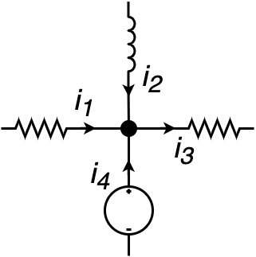
Currents
On a circuit node, the algebraic sum of all currents (positive for incoming and negative for exiting) is equal to zero: .
For instance on the figure, the law reads as: .

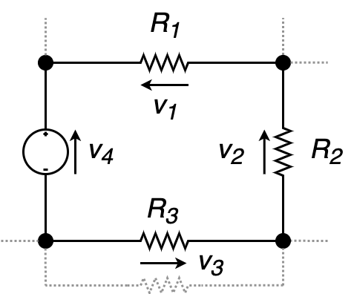
Voltage
The directed sum of all voltage on a closed loop is equal to zero: .
For instance on the figure, the law reads as: .

Operational Amplifiers

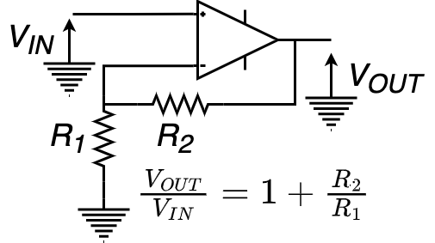
Non-inverting
In a non-inverting amplifier, the output voltage changes in the same direction to the input voltage. The operational amplifier works in a linear mode.

Inverting
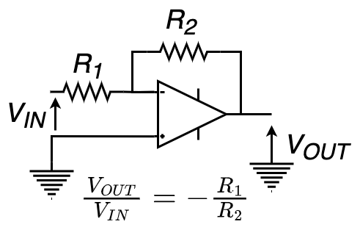
In an inverting amplifier, the output voltage changes in the opposite direction to the input voltage. The operational amplifier works in a non-linear mode, it is in a comparator configuration.

Filters & RLC
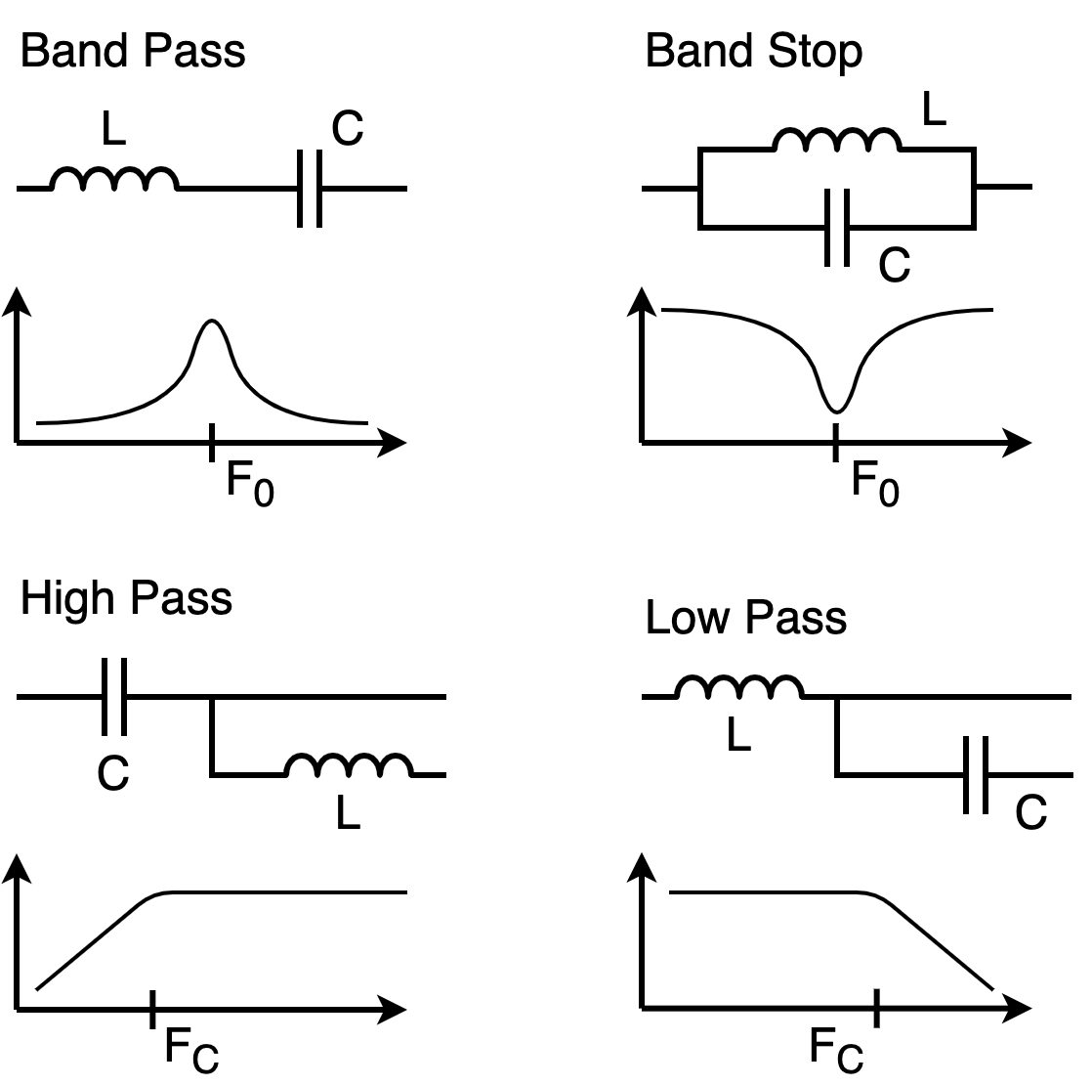
The resonance frequency F₀, and the cutoff frequency F_{C}, are equal to:
.
When the LC circuits are not perfect, because of a resistor, one speaks about RLC. The value of the resistor may affect the selectivity of the filters. The quality of a LC circuit is expressed by the Q factor.
The value of the resistance has a negligible effect for the high and low-pass filters
The higher Q, the thiner bandwidth around the resonance frequency.

Resistor Colors
IEC 60062:2016 Standard
Color | Number | Multiplier | Tolerance
Black | 0 | 10⁰ | N/A
Brown | 1 | 10¹ | ±1 %
Red | 2 | 10² | ±2 %
Orange | 3 | 10³ | ±0.05 %
Yellow | 4 | 10⁴ | ±0.02 %
Green | 5 | 10⁵ | ±0.5 %
Blue | 6 | 10⁶ | ±0.25 %
Violet | 7 | 10⁷ | ±0.1 %
Gray | 8 | 10⁸ | ±0.01%
White | 9 | 10⁹ | N/A
Silver |  | 10⁻² | ±10 %
Gold |  | 10⁻¹ | ±5 %

ITU Prefixes Allocation
With respect to the Appendix 42 of the RR:
The first two characters of a call sign shall be two letters or a letter followed by a digit or a digit followed by a letter. The first two characters or in certain cases the first character of a call sign constitute the nationality identification.
For instance, Monaco has the range 3AA – 3AZ, so the country is identified with 3A. If the allocation is wider, as Spain with EAA – EHZ, the country can be identified with EA, EB, …, EH.
Range | Country or Organization
2—3
2AA – 2ZZ | United Kingdom of Great Britain and Northern Ireland
3AA – 3AZ | Monaco (Principality of)
3BA – 3BZ | Mauritius (Republic of)
3CA – 3CZ | Equatorial Guinea (Republic of)
3DA – 3DM | Eswatini (Kingdom of)
3DN – 3DZ | Fiji (Republic of)
3EA – 3FZ | Panama (Republic of)
3GA – 3UZ | Chile
3VA – 3VZ | Tunisia
3WA – 3WZ | Viet Nam (Socialist Republic of)
3XA – 3XZ | Guinea (Republic of)
3YA – 3YZ | Norway
3ZA – 3ZZ | Poland (Republic of)
4
4AA – 4CZ | Mexico
4DA – 4IZ | Philippines (Republic of the)
4JA – 4KZ | Azerbaijan (Republic of)
4LA – 4LZ | Georgia
4MA – 4MZ | Venezuela (Bolivarian Republic of)
4OA – 4OZ | Montenegro
4PA – 4SZ | Sri Lanka (Democratic Socialist Republic of)
4TA – 4TZ | Peru
4UA – 4UZ | United Nations
4VA – 4VZ | Haiti (Republic of)
4WA – 4WZ | Timor-Leste (Democratic Republic of)
4XA – 4XZ | Israel (State of)
4YA – 4YZ | International Civil Aviation Organization
4ZA – 4ZZ | Israel (State of)
5
5AA – 5AZ | Libya (State of)
5BA – 5BZ | Cyprus (Republic of)
5CA – 5GZ | Morocco (Kingdom of)
5HA – 5IZ | Tanzania (United Republic of)
5JA – 5KZ | Colombia (Republic of)
5LA – 5MZ | Liberia (Republic of)
5NA – 5NZ | Nigeria (Federal Republic of)
5PA – 5QZ | Denmark
5RA – 5SZ | Madagascar (Republic of)
5TA – 5TZ | Mauritania (Islamic Republic of)
5UA – 5UZ | Niger (Republic of the)
5VA – 5VZ | Togolese Republic
5WA – 5WZ | Samoa (Independent State of)
5XA – 5XZ | Uganda (Republic of)
5YA – 5ZZ | Kenya (Republic of)
6
6AA – 6BZ | Egypt (Arab Republic of)
6CA – 6CZ | Syrian Arab Republic
6DA – 6JZ | Mexico
6KA – 6NZ | Korea (Republic of)
6OA – 6OZ | Somalia (Federal Republic of)
6PA – 6SZ | Pakistan (Islamic Republic of)
6TA – 6UZ | Sudan (Republic of the)
6VA – 6WZ | Senegal (Republic of)
6XA – 6XZ | Madagascar (Republic of)
6YA – 6YZ | Jamaica
6ZA – 6ZZ | Liberia (Republic of)
7
7AA – 7IZ | Indonesia (Republic of)
7JA – 7NZ | Japan
7OA – 7OZ | Yemen (Republic of)
7PA – 7PZ | Lesotho (Kingdom of)
7QA – 7QZ | Malawi
7RA – 7RZ | Algeria (People's Democratic Republic of)
7SA – 7SZ | Sweden
7TA – 7YZ | Algeria (People's Democratic Republic of)
7ZA – 7ZZ | Saudi Arabia (Kingdom of)
8
8AA – 8IZ | Indonesia (Republic of)
8JA – 8NZ | Japan
8OA – 8OZ | Botswana (Republic of)
8PA – 8PZ | Barbados
8QA – 8QZ | Maldives (Republic of)
8RA – 8RZ | Guyana
8SA – 8SZ | Sweden
8TA – 8YZ | India (Republic of)
8ZA – 8ZZ | Saudi Arabia (Kingdom of)
9
9AA – 9AZ | Croatia (Republic of)
9BA – 9DZ | Iran (Islamic Republic of)
9EA – 9FZ | Ethiopia (Federal Democratic Republic of)
9GA – 9GZ | Ghana
9HA – 9HZ | Malta
9IA – 9JZ | Zambia (Republic of)
9KA – 9KZ | Kuwait (State of)
9LA – 9LZ | Sierra Leone
9MA – 9MZ | Malaysia
9NA – 9NZ | Nepal (Federal Democratic Republic of)
9OA – 9TZ | Democratic Republic of the Congo
9UA – 9UZ | Burundi (Republic of)
9VA – 9VZ | Singapore (Republic of)
9WA – 9WZ | Malaysia
9XA – 9XZ | Rwanda (Republic of)
9YA – 9ZZ | Trinidad and Tobago
A
A2A – A2Z | Botswana (Republic of)
A3A – A3Z | Tonga (Kingdom of)
A4A – A4Z | Oman (Sultanate of)
A5A – A5Z | Bhutan (Kingdom of)
A6A – A6Z | United Arab Emirates
A7A – A7Z | Qatar (State of)
A8A – A8Z | Liberia (Republic of)
A9A – A9Z | Bahrain (Kingdom of)
AAA – ALZ | United States of America
AMA – AOZ | Spain
APA – ASZ | Pakistan (Islamic Republic of)
ATA – AWZ | India (Republic of)
AXA – AXZ | Australia
AYA – AZZ | Argentine Republic
B — C
BAA – BZZ | China (People's Republic of)
C2A – C2Z | Nauru (Republic of)
C3A – C3Z | Andorra (Principality of)
C4A – C4Z | Cyprus (Republic of)
C5A – C5Z | Gambia (Republic of the)
C6A – C6Z | Bahamas (Commonwealth of the)
C7A – C7Z | World Meteorological Organization
C8A – C9Z | Mozambique (Republic of)
CAA – CEZ | Chile
CFA – CKZ | Canada
CLA – CMZ | Cuba
CNA – CNZ | Morocco (Kingdom of)
COA – COZ | Cuba
CPA – CPZ | Bolivia (Plurinational State of)
CQA – CUZ | Portugal
CVA – CXZ | Uruguay (Eastern Republic of)
CYA – CZZ | Canada
D
D2A – D3Z | Angola (Republic of)
D4A – D4Z | Cabo Verde (Republic of)
D5A – D5Z | Liberia (Republic of)
D6A – D6Z | Comoros (Union of the)
D7A – D9Z | Korea (Republic of)
DAA – DRZ | Germany (Federal Republic of)
DSA – DTZ | Korea (Republic of)
DUA – DZZ | Philippines (Republic of the)
E
E2A – E2Z | Thailand
E3A – E3Z | Eritrea
E4A – E4Z | State of Palestine
E5A – E5Z | New Zealand – Cook Islands
E6A – E6Z | New Zealand – Niue
E7A – E7Z | Bosnia and Herzegovina
EAA – EHZ | Spain
EIA – EJZ | Ireland
EKA – EKZ | Armenia (Republic of)
ELA – ELZ | Liberia (Republic of)
EMA – EOZ | Ukraine
EPA – EQZ | Iran (Islamic Republic of)
ERA – ERZ | Moldova (Republic of)
ESA – ESZ | Estonia (Republic of)
ETA – ETZ | Ethiopia (Federal Democratic Republic of)
EUA – EWZ | Belarus (Republic of)
EXA – EXZ | Kyrgyz Republic
EYA – EYZ | Tajikistan (Republic of)
EZA – EZZ | Turkmenistan
F — G
FAA – FZZ | France
GAA – GZZ | United Kingdom of Great Britain and Northern Ireland
H
H2A – H2Z | Cyprus (Republic of)
H3A – H3Z | Panama (Republic of)
H4A – H4Z | Solomon Islands
H6A – H7Z | Nicaragua
H8A – H9Z | Panama (Republic of)
HAA – HAZ | Hungary
HBA – HBZ | Switzerland (Confederation of)
HCA – HDZ | Ecuador
HEA – HEZ | Switzerland (Confederation of)
HFA – HFZ | Poland (Republic of)
HGA – HGZ | Hungary
HHA – HHZ | Haiti (Republic of)
HIA – HIZ | Dominican Republic
HJA – HKZ | Colombia (Republic of)
HLA – HLZ | Korea (Republic of)
HMA – HMZ | Democratic People's Republic of Korea
HNA – HNZ | Iraq (Republic of)
HOA – HPZ | Panama (Republic of)
HQA – HRZ | Honduras (Republic of)
HSA – HSZ | Thailand
HTA – HTZ | Nicaragua
HUA – HUZ | El Salvador (Republic of)
HVA – HVZ | Vatican City State
HWA – HYZ | France
HZA – HZZ | Saudi Arabia (Kingdom of)
I — J
IAA – IZZ | Italy
J2A – J2Z | Djibouti (Republic of)
J3A – J3Z | Grenada
J4A – J4Z | Greece
J5A – J5Z | Guinea-Bissau (Republic of)
J6A – J6Z | Saint Lucia
J7A – J7Z | Dominica (Commonwealth of)
J8A – J8Z | Saint Vincent and the Grenadines
JAA – JSZ | Japan
JTA – JVZ | Mongolia
JWA – JXZ | Norway
JYA – JYZ | Jordan (Hashemite Kingdom of)
JZA – JZZ | Indonesia (Republic of)
K — L
KAA – KZZ | United States of America
L2A – L9Z | Argentine Republic
LAA – LNZ | Norway
LOA – LWZ | Argentine Republic
LXA – LXZ | Luxembourg
LYA – LYZ | Lithuania (Republic of)
LZA – LZZ | Bulgaria (Republic of)
M — N — O
MAA – MZZ | United Kingdom of Great Britain and Northern Ireland
NAA – NZZ | United States of America
OAA – OCZ | Peru
ODA – ODZ | Lebanon
OEA – OEZ | Austria
OFA – OJZ | Finland
OKA – OLZ | Czech Republic
OMA – OMZ | Slovak Republic
ONA – OTZ | Belgium
OUA – OZZ | Denmark
P
P2A – P2Z | Papua New Guinea
P3A – P3Z | Cyprus (Republic of)
P4A – P4Z | Netherlands (Kingdom of the) - Aruba
P5A – P9Z | Democratic People's Republic of Korea
PAA – PIZ | Netherlands (Kingdom of the)
PJA – PJZ | Netherlands (Kingdom of the) - Bonaire, Sint Eustatius and Saba
PJA – PJZ | Netherlands (Kingdom of the) - Curaçao
PJA – PJZ | Netherlands (Kingdom of the) - Sint Maarten (Dutch part)
PKA – POZ | Indonesia (Republic of)
PPA – PYZ | Brazil (Federative Republic of)
PZA – PZZ | Suriname (Republic of)
R — S
RAA – RZZ | Russian Federation
S2A – S3Z | Bangladesh (People's Republic of)
S5A – S5Z | Slovenia (Republic of)
S6A – S6Z | Singapore (Republic of)
S7A – S7Z | Seychelles (Republic of)
S8A – S8Z | South Africa (Republic of)
S9A – S9Z | Sao Tome and Principe (Democratic Republic of)
SAA – SMZ | Sweden
SNA – SRZ | Poland (Republic of)
SSA – SSM | Egypt (Arab Republic of)
SSN – STZ | Sudan (Republic of the)
SUA – SUZ | Egypt (Arab Republic of)
SVA – SZZ | Greece
T
T2A – T2Z | Tuvalu
T3A – T3Z | Kiribati (Republic of)
T4A – T4Z | Cuba
T5A – T5Z | Somalia (Federal Republic of)
T6A – T6Z | Afghanistan
T7A – T7Z | San Marino (Republic of)
T8A – T8Z | Palau (Republic of)
TAA – TCZ | Republic of Türkiye
TDA – TDZ | Guatemala (Republic of)
TEA – TEZ | Costa Rica
TFA – TFZ | Iceland
TGA – TGZ | Guatemala (Republic of)
THA – THZ | France
TIA – TIZ | Costa Rica
TJA – TJZ | Cameroon (Republic of)
TKA – TKZ | France
TLA – TLZ | Central African Republic
TMA – TMZ | France
TNA – TNZ | Congo (Republic of the)
TOA – TQZ | France
TRA – TRZ | Gabonese Republic
TSA – TSZ | Tunisia
TTA – TTZ | Chad (Republic of)
TUA – TUZ | Côte d'Ivoire (Republic of)
TVA – TXZ | France
TYA – TYZ | Benin (Republic of)
TZA – TZZ | Mali (Republic of)
U
UAA – UIZ | Russian Federation
UJA – UMZ | Uzbekistan (Republic of)
UNA – UQZ | Kazakhstan (Republic of)
URA – UZZ | Ukraine
V
V2A – V2Z | Antigua and Barbuda
V3A – V3Z | Belize
V4A – V4Z | Saint Kitts and Nevis (Federation of)
V5A – V5Z | Namibia (Republic of)
V6A – V6Z | Micronesia (Federated States of)
V7A – V7Z | Marshall Islands (Republic of the)
V8A – V8Z | Brunei Darussalam
VAA – VGZ | Canada
VHA – VNZ | Australia
VOA – VOZ | Canada
VPA – VQZ | United Kingdom of Great Britain and Northern Ireland
VRA – VRZ | China (People's Republic of) - Hong Kong
VSA – VSZ | United Kingdom of Great Britain and Northern Ireland
VTA – VWZ | India (Republic of)
VXA – VYZ | Canada
VZA – VZZ | Australia
W — X
WAA – WZZ | United States of America
XAA – XIZ | Mexico
XJA – XOZ | Canada
XPA – XPZ | Denmark
XQA – XRZ | Chile
XSA – XSZ | China (People's Republic of)
XTA – XTZ | Burkina Faso
XUA – XUZ | Cambodia (Kingdom of)
XVA – XVZ | Viet Nam (Socialist Republic of)
XWA – XWZ | Lao People's Democratic Republic
XXA – XXZ | China (People's Republic of) - Macao
XYA – XZZ | Myanmar (Union of)
Y
Y2A – Y9Z | Germany (Federal Republic of)
YAA – YAZ | Afghanistan
YBA – YHZ | Indonesia (Republic of)
YIA – YIZ | Iraq (Republic of)
YJA – YJZ | Vanuatu (Republic of)
YKA – YKZ | Syrian Arab Republic
YLA – YLZ | Latvia (Republic of)
YMA – YMZ | Republic of Türkiye
YNA – YNZ | Nicaragua
YOA – YRZ | Romania
YSA – YSZ | El Salvador (Republic of)
YTA – YUZ | Serbia (Republic of)
YVA – YYZ | Venezuela (Bolivarian Republic of)
Z
Z2A – Z2Z | Zimbabwe (Republic of)
Z3A – Z3Z | North Macedonia (Republic of)
Z8A – Z8Z | South Sudan (Republic of)
ZAA – ZAZ | Albania (Republic of)
ZBA – ZJZ | United Kingdom of Great Britain and Northern Ireland
ZKA – ZMZ | New Zealand
ZNA – ZOZ | United Kingdom of Great Britain and Northern Ireland
ZPA – ZPZ | Paraguay (Republic of)
ZQA – ZQZ | United Kingdom of Great Britain and Northern Ireland
ZRA – ZUZ | South Africa (Republic of)
ZVA – ZZZ | Brazil (Federative Republic of)

Units

International System
The International System of Units, known under the abbreviation SI, is the modern form of the metric system. The system has been established and is maintained by the General Conference on Weight and Measures (CGPM).

Base Units
Symbol | Name | Quantity
s | Second | Time
m | Meter | Length
kg | Kilogram | Mass
A | Ampere | Electric Current
K | Kelvin | Temperature
mol | Mole | Amount of substance
cd | Candela | Luminous Intensity

Derived Units
A sample of the most common units for Amateur Radio
Symbol | Name | Quantity | Definitions
Hz | Hertz | Frequency | s⁻¹
W | Watt | Power | J⋅s⁻¹  kg⋅m²⋅s⁻³
C | Coulomb | Electric Charge | s⋅A
V | Volt | Electric Potential, Voltage | W⋅A⁻¹  J⋅C⁻¹  kg⋅m²⋅s⁻³⋅A⁻¹
F | Farad | Capacitance | C⋅V⁻¹  kg⁻¹⋅m⁻²⋅s⁴⋅A²
Ω | Ohm | Resistance | V⋅A⁻¹  kg⋅m²⋅s⁻³⋅A⁻²
S | Siemens | Electrical Conductance | Ω⁻¹
Wb | Weber | Magnetic Flux | V⋅s  kg⋅m²⋅s⁻²⋅A⁻¹
T | Tesla | Magnetic Flux Density | Wb⋅m⁻²  kg⋅s⁻²⋅A⁻¹
H | Henry | Inductance | Wb⋅A⁻¹  kg⋅m²⋅s⁻²⋅A⁻²

Prefixes
10^{n} | Symbol | Name
10¹⁵ | P | Peta
10¹² | T | Tera
10⁹ | G | Giga
10⁶ | M | Mega
10³ | k | Kilo
10² | h | Hecto
10¹ | da | Deca
10⁰ | Unit
10⁻¹ | d | Deci
10⁻² | c | Centi
10⁻³ | m | Milli
10⁻⁶ | µ | Micro
10⁻⁹ | n | Nano
10⁻¹² | p | Pico
10⁻¹⁵ | f | Femto

Conversions
Length
1 inch | 25.4 mm
1 feet | 0.3048 m
1 yard | 0.9144 m
1 mile | 1.61 m
Time
1 day | 86400 s
1 hour | 3600 s
1 minute | 60 s
Speed
1 mph | 0.447 m/s (1.61 km/h)
1 knot | 0.5144 m/s (1.852 km/h)
1 km/h | 0.2778 m/s
Surface
1 ha | 10000 m²
1 sq. feet | 0.0929 m²
1 sq. yard | 0.8361 m²
Power
1 Wh | 3600 J
1 cal | 4.184 J
Mass
1 pound | 0.454 kg
1 once | 0.028 kg
1 stone | 6.35 kg

Pressure
1 bar | 10000 Pa
1 psi | 6895 Pa
1 atmosphere | 1013.25 hPa
Temperature
0° Celsius | 273.15 Kelvin  °K = 273.15 + °C
0° Farhenheit | 255.372 Kelvin  °K = (°F – 32)⋅5/9 + 273.15
Data
1 B (byte) | 8 b (bits)
1 kB | 1000 B  10³ B
1 kiB | 1024 B  2¹⁰ B
Angle
30 deg | π/6 rad
45 deg | π/4 rad
60 deg | π/3 rad
90 deg | π/2 rad
180 deg | π rad
360 deg | 2π rad

Physics Constants
Symbol | Quantity | Value
c | Speed of Light | 2.99792458⋅10⁸ m⋅s⁻¹
µ₀ | Vacuum Magnetic Permeability | 1.257⋅10⁻⁷ N⋅A⁻²
Z₀ | Characteristic Impedance of Vacuum | 376.7 Ω
ε₀ = 1/µ₀ c² | Vacuum Electric Permittivity | 8.854⋅10⁻¹² F⋅m⁻¹
k_{e} =  1/4π ε₀ | Coulomb Constant | 8.989⋅10⁹ N⋅m²⋅C⁻²

Decibels
The decibel is defined as ten times the logarithmic between two values . Usually, in the amateur radio community we use decibels for power gains (antenna) and attenuations (feed-lines, medium, reception reports).
dB | 0 | 1 | 2 | 3 | 4 | 5 | 6 | 7 | 10 | 16 | 20 | 30
Ratio | 1 | 1.26 | 1.6 | 2 | 2.5 | 3.2 | 4 | 5 | 10 | 40 | 100 | 1000

Mathematics
A cheat-sheet of the most common rules and remarkable values.

Algebra

Logarithms
The function log_{b} denotes the b-basis logarithm.

Trigonometry
Angle (rad) | Sine | Cosine | Tangent
0 | 0 | 1 | 0
 | 1/2
 |  |  | 1
 |  | 1/2
 | 1 | 0 | N/A
 |  |  | -1
 | 1/2
π | 0 | -1 | 0

Table of Values
N |  |  |  |  | N
0,01 | 0,1000 | -4,6052 | -2,0000 |  | 6 | 2,4495 | 1,7918 | 0,7782
0,1 | 0,3162 | -2,3026 | -1,0000 |  | 7 | 2,6458 | 1,9459 | 0,8451
0,2 | 0,4472 | -1,6094 | -0,6990 |  | 8 | 2,8284 | 2,0794 | 0,9031
0,3 | 0,5477 | -1,2040 | -0,5229 |  | 9 | 3,0000 | 2,1972 | 0,9542
0,4 | 0,6325 | -0,9163 | -0,3979 |  | 10 | 3,1623 | 2,3026 | 1,0000
0,5 | 0,7071 | -0,6931 | -0,3010 |  | 20 | 4,4721 | 2,9957 | 1,3010
0,6 | 0,7746 | -0,5108 | -0,2218 |  | 30 | 5,4772 | 3,4012 | 1,4771
0,7 | 0,8367 | -0,3567 | -0,1549 |  | 40 | 6,3246 | 3,6889 | 1,6021
0,8 | 0,8944 | -0,2231 | -0,0969 |  | 50 | 7,0711 | 3,9120 | 1,6990
0,9 | 0,9487 | -0,1054 | -0,0458 |  | 60 | 7,7460 | 4,0943 | 1,7782
1 | 1,0000 | 0,0000 | 0,0000 |  | 70 | 8,3666 | 4,2485 | 1,8451
2 | 1,4142 | 0,6931 | 0,3010 |  | 80 | 8,9443 | 4,3820 | 1,9031
3 | 1,7321 | 1,0986 | 0,4771 |  | 90 | 9,4868 | 4,4998 | 1,9542
4 | 2,0000 | 1,3863 | 0,6021 |  | 100 | 10,0000 | 4,6052 | 2,0000
5 | 2,2361 | 1,6094 | 0,6990

ITU Regions
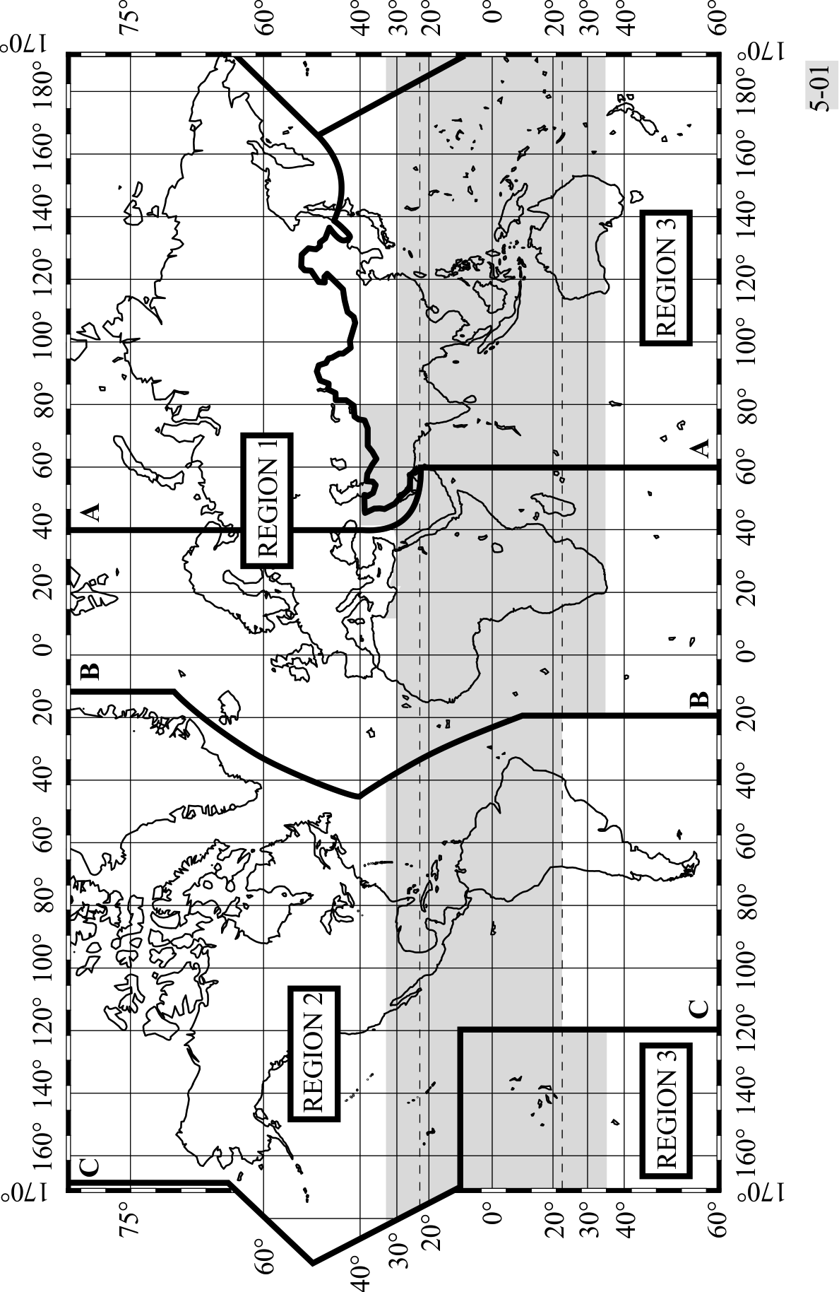

ITU Alphabet
A | Alpha | N | November
B | Bravo | O | Oscar
C | Charlie | P | Papa
D | Delta | Q | Quebec
E | Echo | R | Romeo
F | Fox-Trott | S | Sierra
G | Golf | T | Tango
H | Hotel | U | Uniform
I | India | V | Victor
J | Juliet | W | Whisky
K | Kilo | X | X-Ray
L | Lima | Y | Yankee
M | Mike | Z | Zulu
Widespread usage, occasionally replaced by country names.

1 | Unaone | 6 | Soxisix
2 | Bissotwo | 7 | Setteseven
3 | Terrathree | 8 | Oktoeight
4 | Kartefour | 9 | Novenine
5 | Pantafive | 0 | Nadazero
• | Decimal
Rare usage, only if transmission difficulties. Usually, the numbers are sent in english.

Document Abbreviations
Abbreviation | Description
AM | Amplitude Modulation
AMSAT | Amateur Satellite
BW | Band Width
CoA | Center of Activity
CW | Continuous Waves (Morse code)
DM | Digital Mode
DV | Digital Voice
DX | Distant contact (inter-continental)
EMCOM | Emergency Communication
Glob. | Global
ITU | International Telecommunication Union
NBM | Narrow Band Mode
Pref. | Preferred
RR | Radio Regulations
SSB | Single Side Band

References
ITU Radio Regulation, 2020
https://www.itu.int/pub/R-REG-RR-2020
IARU Region 1 Band Plan, October 2020
https://www.iaru-r1.org/wp-content/uploads/2021/06/hf_r1_bandplan.pdf
IARU Region 2 Band Plan, September 2020
https://www.iaru-r2.org/wp-content/uploads/2020/02/IARU-Region-2-Band-plan.pdf
IARU Region 3 Band Plan, September 2019
https://www.iaru-r2.org/wp-content/uploads/2020/02/IARU-Region-3-Band-plan.pdf
ITU Recommendation M.1772-0, 1995 Edition
https://www.itu.int/rec/R-REC-M.1172-0-199510-I/en

Ask for a repetition if the message is not understood.
For call sign series beginning with B, F, G, I, K, M, N, R, W and 2, only the first character is required for nationality identification. In the cases of half series (i.e. when the first two characters are allocated to more than one Member State), the first three characters are required for nationality identification.
In accordance with Resolution 99 Rev. Dubai, 2018

