*Professional Practice*

*Project – Arduino*

*Simon Says Game*

*By Noel Melia*

*&*

*Eoghan Muldoon*

# Introduction

This module is intended to bring together many of the best practices that the student has learned in the previous semesters. It gives the student an opportunity to design, develop and deploy a project, either individually or in a group environment, delivering a piece of software in a timely and standards driven manner.

We choose to make a game on Arduino because we wanted to use hardware along with software and thought it would be interesting to use it.

# System Requirements

Requirements for the Arduino Kit and IDE would be as follows: -

Windows 10 or less / Mac / Linux etc

Java 8 requires a Pentium 2 266 MHz processor and 128 MB of Ram

600MB of free disk space for the install of the Arduino IDE.

But this is only a guideline for the device to work smoothly and probably.

The project would have to be along the lines of what we are doing in college and technology of our era.

For this reason, we have chosen to design something with Arduino, and it would be interesting in the weeks to come. We both bought an Arduino kit and by the looks of the set and components that came with the kit we would be ready to make something straight away. But over this report we will tell you about how there is two differences in should and will.

# Technology Used and Why

The technology that we choose was based on the product and experiment that we as a group what to design and build together. It would be tricky, but we were prepared to work with whatever we could get our hands on. The design is based on a product that we seen on YouTube and liked what it done. Throughout the process of the design we found a great website stated below which meant that we didn’t have to carry around the Arduino kit in college and that we could just design the finally product online and transfer it on to the kit at the end. So Noel had bought a Arduino kit first but once Eoghan bought one, it would be easier for use to make up and test the product.

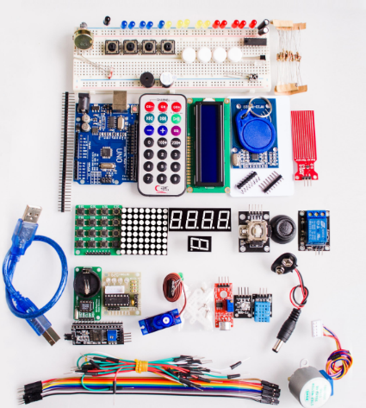Arduino Uno Kit and Components – Bought online and is a hardware component to make the device. On the right diagram

Arduino IDE – To Program what the device will do and make a program for its s it would run probably. On the left Diagram.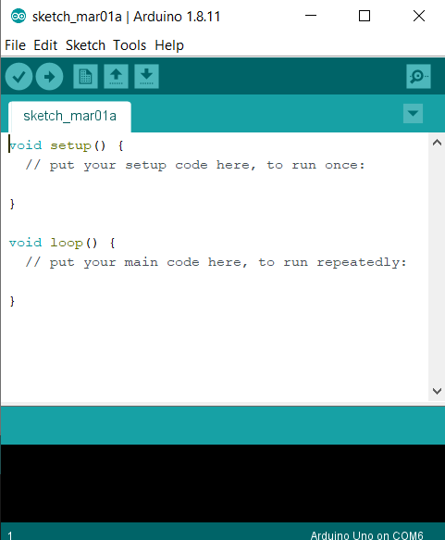 C Language – Arduino Ide uses C Language to run program

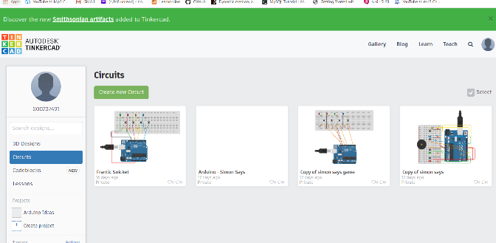<https://www.tinkercad.com/> - Website we used to make the device online and run the program there to. As seen on the left

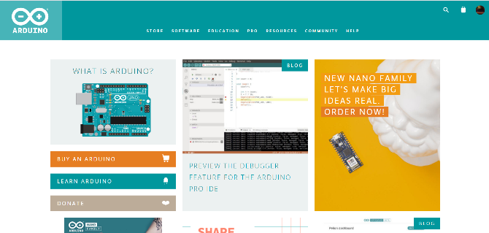

<https://www.arduino.cc/> - Home website of Arduino, as shown on the right

# Architecture of the Solution

From looking at the website of Arduino, I know it was around for a while and there was a lot of designs that would help in the design of the project. Arduino is the world’s leading open source hardware and software ecosystem. The company offers a range of software tools, hardware platforms and documentation enabling almost anybody to be creative with technology.

Arduino is a popular tool for IoT product development and STEM/ STEAM Education. There are many students that can develop or create games, music, smart homes and so many more using Arduino on. Originally started in early 2000’s as a research project by Massimo Banzi, David Cuartielles, Tom Igoe, Gianluca Martino and David Mellis in the Institute of Ivrea in Italy.

The first Arduino board was introduced in 2005 to help design students who had no previous experience in electronics or microcontroller programming and to create working prototypes connecting the physical world to the digital world. Since then it has become the most popular electronic prototyping tool used by engineers and even large corporations.

Arduino is the first widespread Open Source Hardware project and was set up to build a community that could help the use of the tool and benefit from contribution from hundreds of people who helped debug the code, write examples and create tutorials and so much more. Arduino continues to grow and develop to provide open source hardware and source to bring new ideas to everyones life.

# Design Methodology

# Features of the Implementation

# Limitations and Known Bugs

# Testing Plans

# Recommendations for Future Development

Once we got comfortable and familiar with the design and code of the project. We started to investigate more advanced projects, such as: -

Weather Station

Thermal Heat Sensor

These are only a couple of ideas that we researched, and it seemed that with the research that we accomplished would help greatly in the development of any project that we wanted to develop.

There was a problem that we meet, and we eventually got over, but it took time and patience. Some of the problems was thinking that it would be easy to design a game quick and smooth but that was far from the problem. We had to do a lot of research and divide up the project and meet regularly which we did, and it helped.

The hardest part of the project was coming up with a project that we could design and agree to make. Eventually we decided to make a Simon Says game on an Arduino and decided what was going to be on the game.

# Conclusions

Noel Melia

Working on a team with Eoghan was interesting and challenging at the start. But once we set up a plan of action and had regular meetings which we both agreed and concluded that it would help with the progress of the project. From working in an hotel as duty manager, I have worked as part of team before and understand of what had to done.

Eoghan Muldoon