Group 4

Noel Miranda, Christopher Reaney, Kevin Ramirez, Korbyn Mock

October 3, 2024

Module 11

Assignment: Milestone #3

**REPORT 1 - (Noel)**

Business Problem:

Do enough customers buy equipment to keep sales steady?

Description:

This python script will help to retrieve the total number of distinct customers, the total number of equipment bought (including customers who bought equipment multiple times throughout different bookings), and the total number of equipment rented (including customers who rented equipment multiple times throughout different bookings) which all this data is per specified year decided by the user. The data that is retrieved from the database will be integer numbers which can then be put into a graph to make a more visually appealing analysis. Since the data in the database for Outland Adventures currently holds bookings only for the year 2024, the data is limited to be analyzed only for that year. The current data in the database is still enough to see if enough customers are buying equipment to keep sales steady. If you were to input any other year after 2024, the data for each category will be zeroes because we are still not in the year 2025, thus there are no bookings yet for that year. Once bookings are made for the incoming years and they are inputted to the database, this script will be able to retrieve that information efficiently.

After running the script with our current database, we can see that around 33% of the total customers that booked for the year 2024 bought equipment. On the other hand, we can see that 66% of the customers that booked rented out equipment. Based on this information, the owners can decide their threshold on when to pull the plug on continuing to sell their equipment because the customers are not buying enough to keep sales steady. I would say anything less than 50% is not good for the business, therefore I would probably put a high emphasis on just renting equipment since it is making the most profit or I can decide to enhance my advertising for selling my equipment to improve such numbers. The owners have many possibilities of deciding what to do with this information. Although, it is important to emphasize that the python script allows for input from the user to analyze the year they desire, therefore before going public with this database, the owners should know that the input does not have validation. It is up to the discretion of the owners if they would like us to provide validation to the input feature if they want to avoid security breaches or restrict incorrect inputs once the database becomes public.

Result of Query/Report:

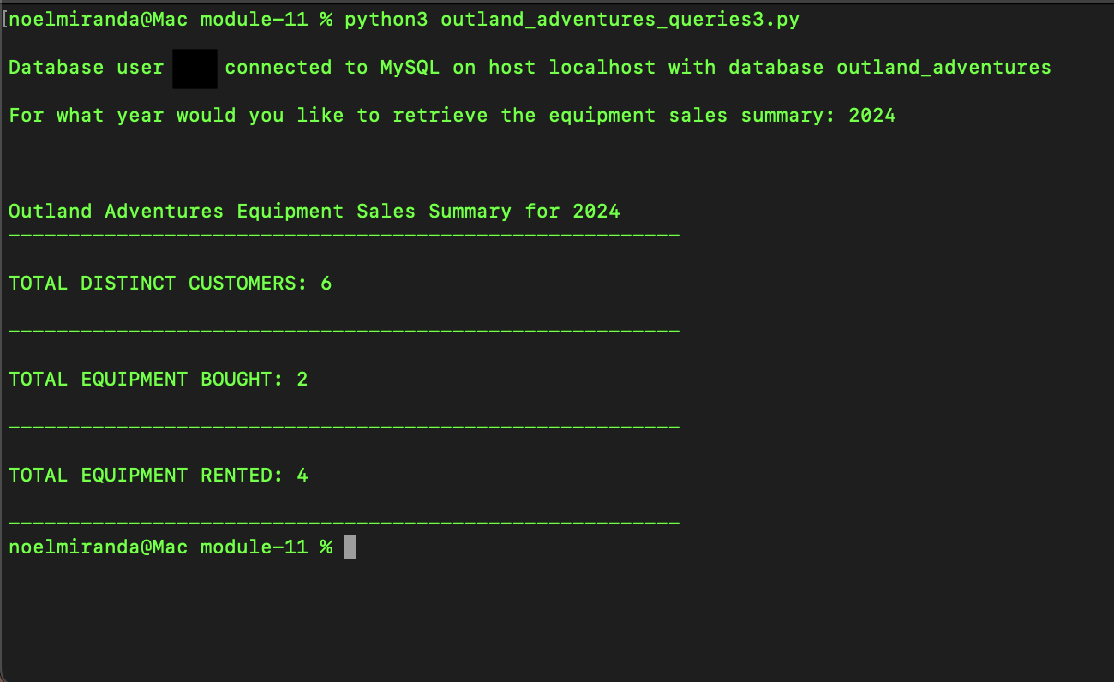

Assumptions:

* The owners want a report to analyze yearly equipment sales made by customers.
* The owners also wanted to analyze the equipment rented by customers yearly.
* The owners want a stored procedure with their database to make this type of report.
* The owners would like to input the year for their analysis of the equipment bought.
* The owners want the report to display zero sales if there are zero sales for that year.
* The database would be private.
* The owners do not want a validation to the input feature since this will be a private database.
* The owners want to keep track of distinct customers instead of tracking the same customers multiple times.
* The owners want to keep track of the equipment sold or rented even if it is by the same customer at a later time (a different booking).

Potential Way of Using Data from Report:

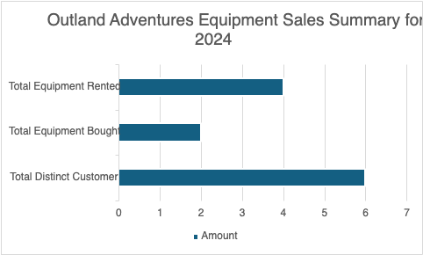

**REPORT 2 - (Noel)**

Business Problem:

Is there a specific location (like treks in Africa, Asia, or Southern Europe) where bookings are trending down?

Description:

This python script will help to retrieve the number of bookings per specified year and per location (specifically continents). The data that is retrieved from the database will be numbers which can then be put into a graph to make a more visually appealing analysis. Since the data in the database for Outland Adventures currently holds bookings only for the year 2024, the data is limited to be analyzed only for the year 2024 which is still helpful to see what locations are trending up or down. After running the script, we can see that Southern Europe for the year 2024 is trending down since there are no bookings compared to the other available locations. After Outland Adventures fills the database with more bookings throughout the years, then they could be able to analyze across different years and see which locations should be removed from their business and which are gaining attraction. The python script allows for input from the user to analyze the year they desire. It is important to know that the input does not have validation, therefore it is up to the discretion of the owners if they would like us to provide validation to the input feature if they want to avoid security breaches or restrict incorrect inputs once the database becomes public.

Result of Query/Report:

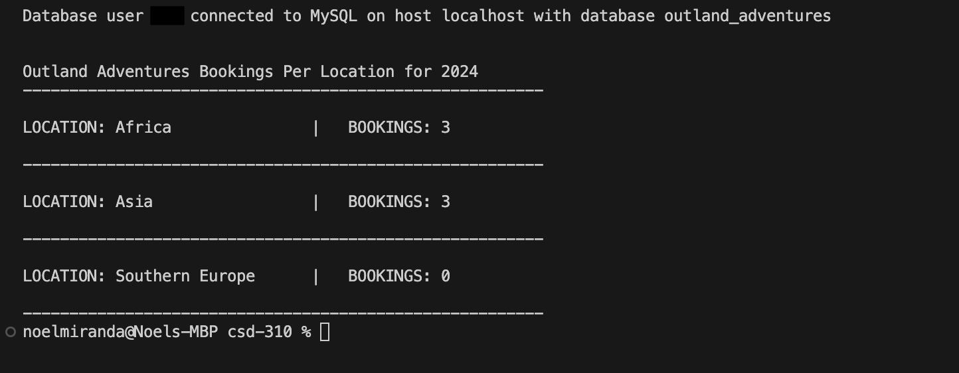

Assumptions:

* The owners want a report to analyze yearly trends.
* The owners want a report to analyze the bookings per continent locations.
* The owners want a stored procedure with their database to make the reports.
* The owners would like to input the year of analyzing bookings, therefore the stored procedure allows an input of the year.
* The owners want the report to display zero bookings if there are zero bookings.
* The database would be private.
* The owners do not want a validation to the input feature since this will be a private database.

Potential Way of Using Data from Report:

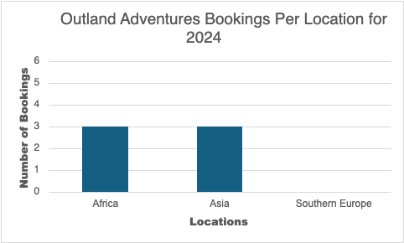

**REPORT 3 - (Kevin)**

Business Challenge

Are there any items in the inventory that have been stored for over five years?

Objective of Script:

The objective of this script is to analyze the SQL database and identify the equipment and inventory Outland Adventure has had on the shelf for more than 5 years. The current script will retrieve the information from item with their matching identifiers and print the results. This script ensures that equipment and inventory within the business is up to industry standards and it will ensure the safety of the customers that buy or rent items from Outland Adventure.

Description:

The report is generated by querying the SQL Database (Outland_Adventures) for the inventory based on the data table “Inventory”. This information will be relative to the current date and for the sake of comparison some data may be subject to change to output proper results. Each item in the table is analyzed for its age and will display the following information:

Item ID: The identification number to be able to distinguish the exact number of each item

Date_On_Shelf: The date the item was placed in inventory

Equipment_Name: The name of the type of item stored

Age: The current age of the item printed in years and days

Business Value:

The information provided by running the python script will help aid the managers and employees make informed decisions on inventory lifecycles. Over time the wear and tear of equipment will cause problems to occur and replacing them will reduce costs, it comes down to an efficiency vs. maintenance trade off. Often times improper tracking of maintenances or equipment replacement will cause downtime for a business causing underperformance in revenue. This script aims to combat this issue by supplying data on equipment subject to replacement; It will also aim to keep inventory turnover at a healthy pace.

Result of Query/Script;

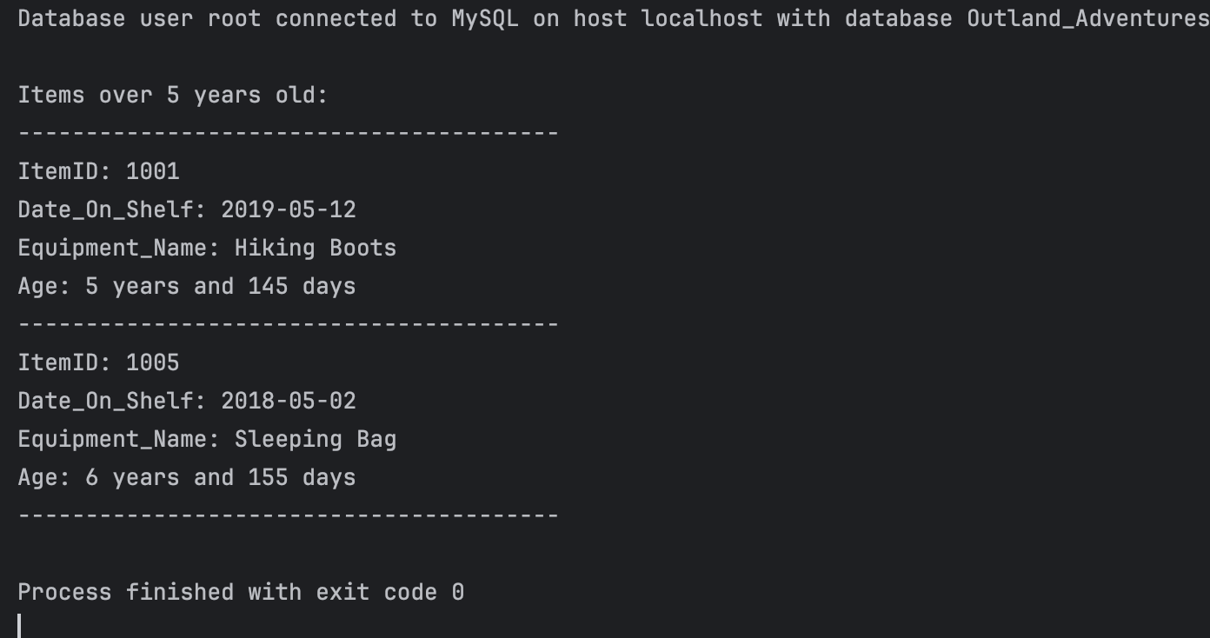

Assumptions

* Items stored over 5 years may no longer meet industry standards
* Owners struggle with balancing costs of maintaining older inventory versus replacing it
* Business aims to prioritize safety and a positive customer experience
* Inventory turnover is a key metric for the growth of the business
* Privatized database

Potential Way of Using Data from Report:

