Noel Miranda

Assignment number: Module 2.3

Data Models

**Business Rules:**

* a USER has many ROLES. (Many-to-Many Relationship)
* a USER has one BIRTHDATE. (One-to-One Relationship)
* a USER can have many DEPENDENTS. (One-to-Many Relationship)

**ERD Diagram:**

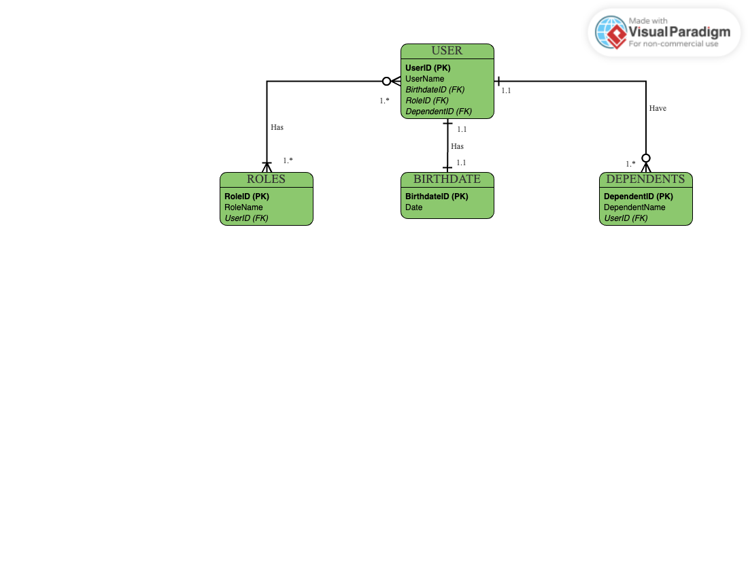

**NoSQL Data Structure (Document Structure such as JSON):**

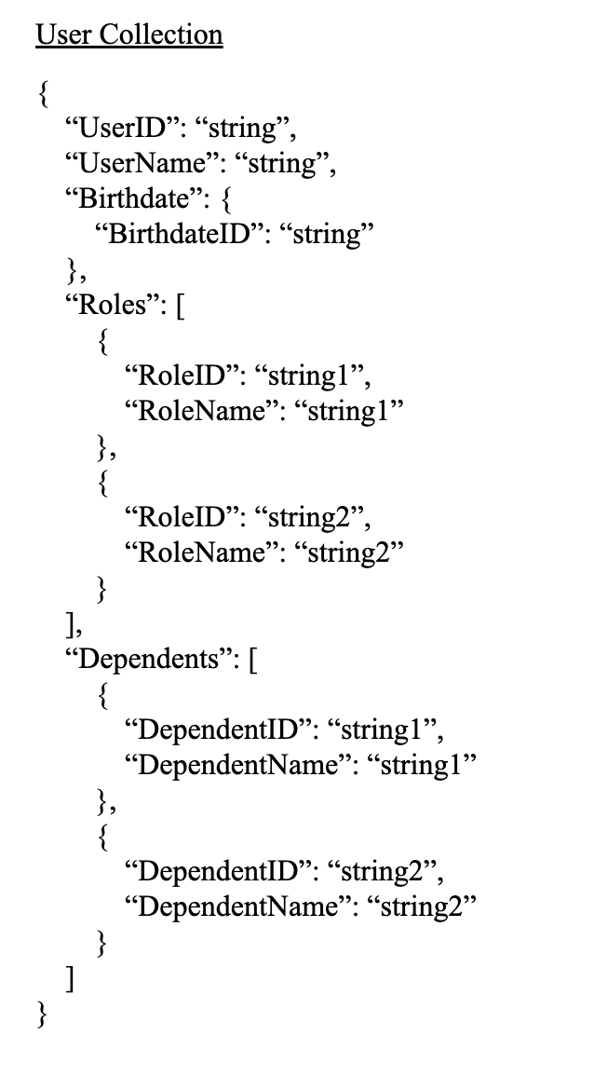

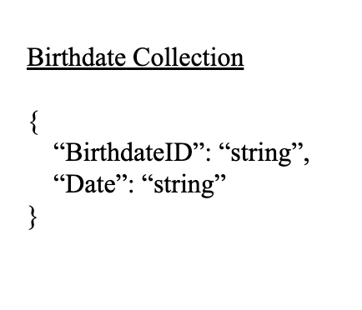

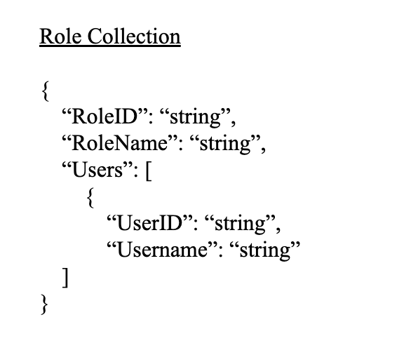

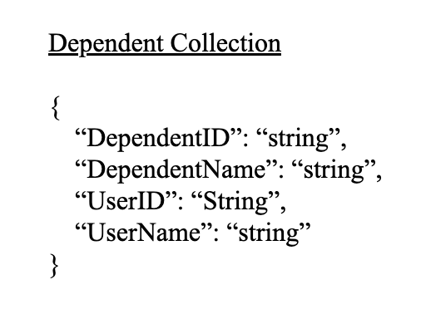

References

Comeau, A. (2017). *MySQL explained : your step-by-step guide to database design*. Ostraining.

*Documents*. (2024). Mongodb.com. https://www.mongodb.com/docs/manual/core/document/documentstructure