Noel Mirada

Module 3.2 Assignment

Normalized Tables

**1NF**

* All rows must be unique (no duplicate rows)
* Each cell must only contain a single value (not a list)
* Each value should be non-divisible (can’t be split down further)



**2NF**

* Database must be in First Normal Form
* Non partial dependency – All non-prime attributes should be fully functionally dependent on the candidate key



**3NF**

* Database must be in First & Second Normal Form
* No transitive dependency – All fields must only be determinable by the primary/composite key, not by other keys

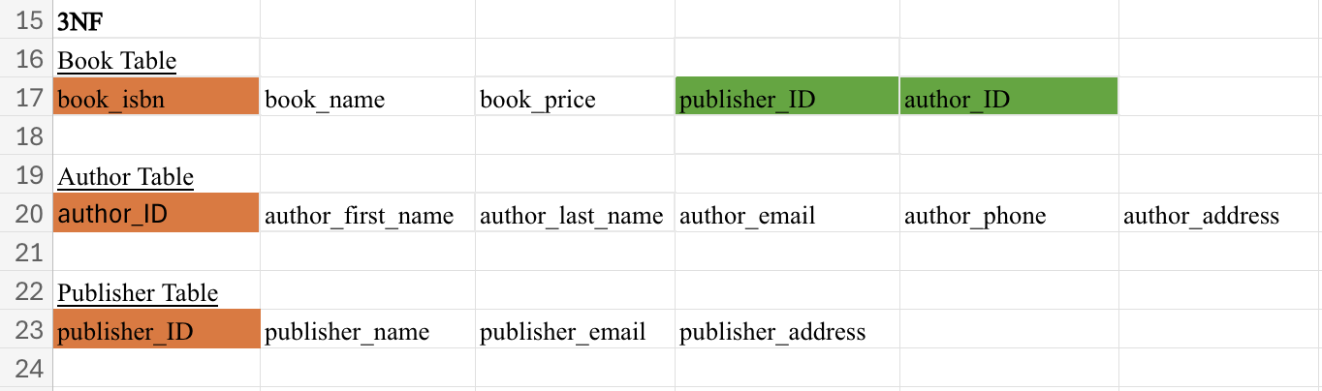

Assumptions made:

* Author contact information should be on its separate table.
* Book names could not be relevant to price because there are other books with the exact same titles.
* Author-ID primary key was required to easily reference author information.
* Composite foreign key was possible, but it would have made it complicated if multiple authors were to be listed per book_isbn.
* Color coded the keys to make it easier for the professor to identify keys. Orange is for the primary keys and green is for the foreign keys.