Noel Miranda

September 05, 2024

Assignment 4.2

MySQL Functions

**Function CONCAT_****WS();**

* Explanation of when it might be used: This function is versatile. It could be applied to many cases when it comes to manipulating data. This function is like the + operator in programming languages and that operator is highly useful. For example, this function could be used to join the data of two columns to put together a full name as I demonstrated in my screenshot. Other case scenarios include making a composite primary key, concatenating a full address from different fields that hold partial address data, constructing a username for a user by concatenating partial data from different fields, etc.
* Alias: The alias for my example is ‘FullName’
* Screenshot Below (SQL statement highlighted in screenshot):

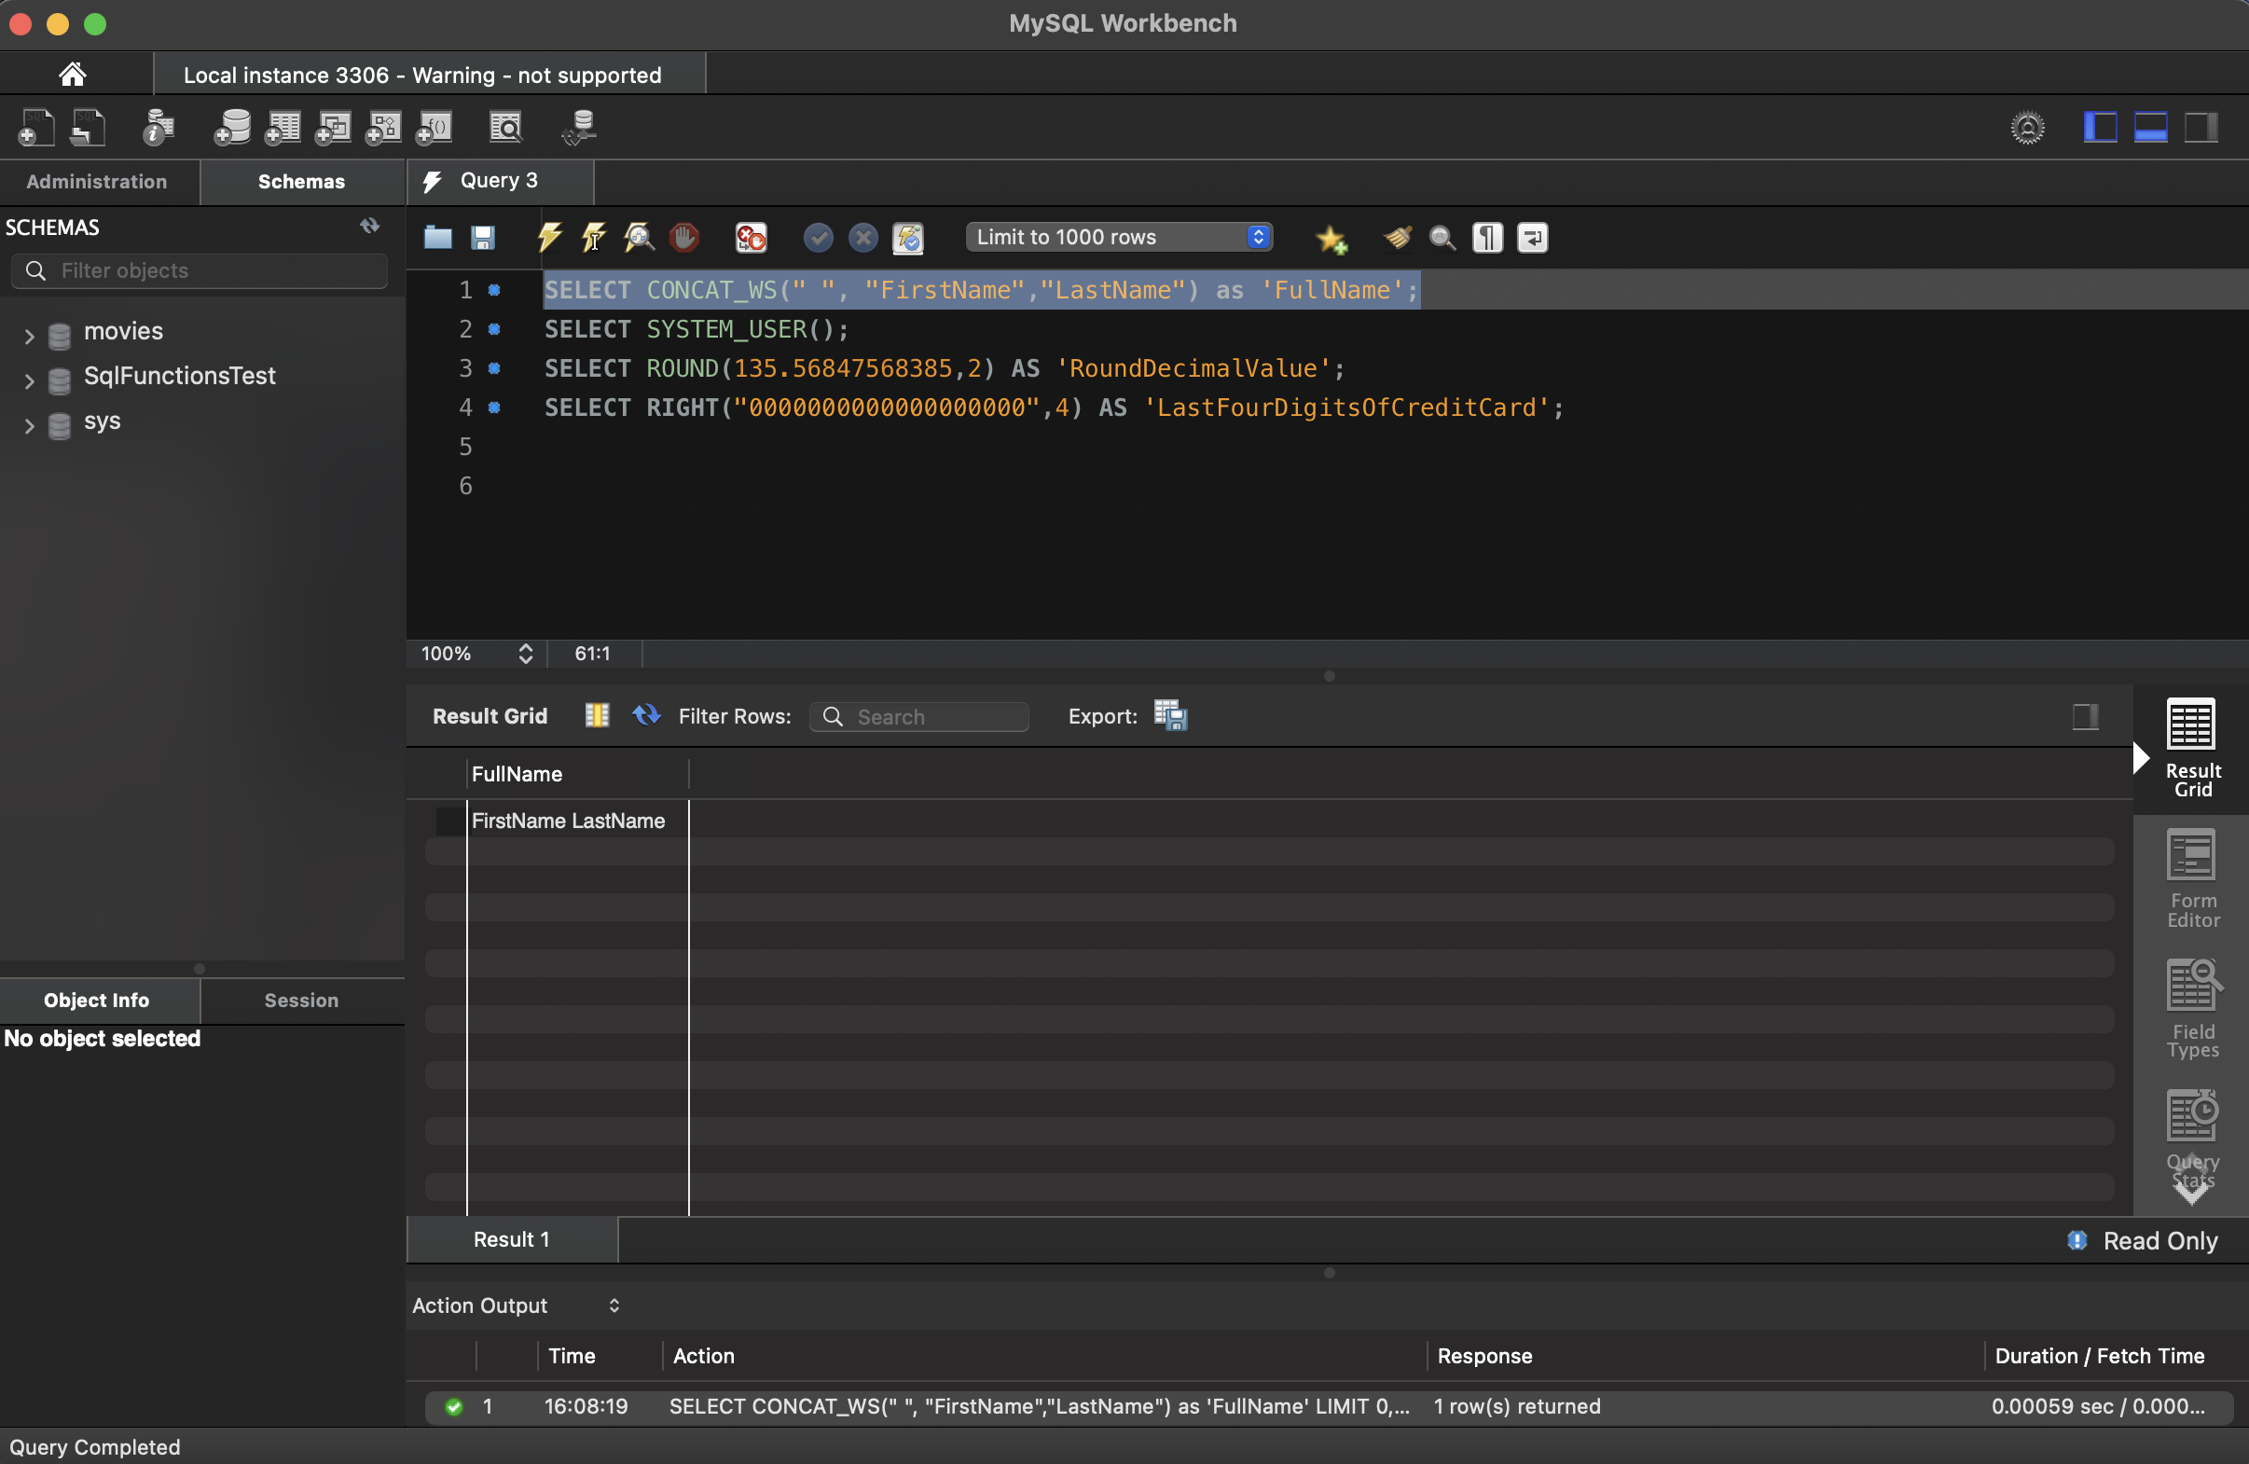

**Function** **ROUND();**

* Explanation of when it might be used: This function could be used for many case scenarios where money needs to be calculated, scientific data needs to be rounded to a certain value, displaying weather temperatures to a certain degree, numeric calculations resulting in a certain specified decimal place, etc. Overall, I can see this function being useful for any scenario where numbers are involved.
* Alias: The alias for my example is ‘RoundDecimalValue’
* Screenshot Below (SQL statement highlighted in screenshot):

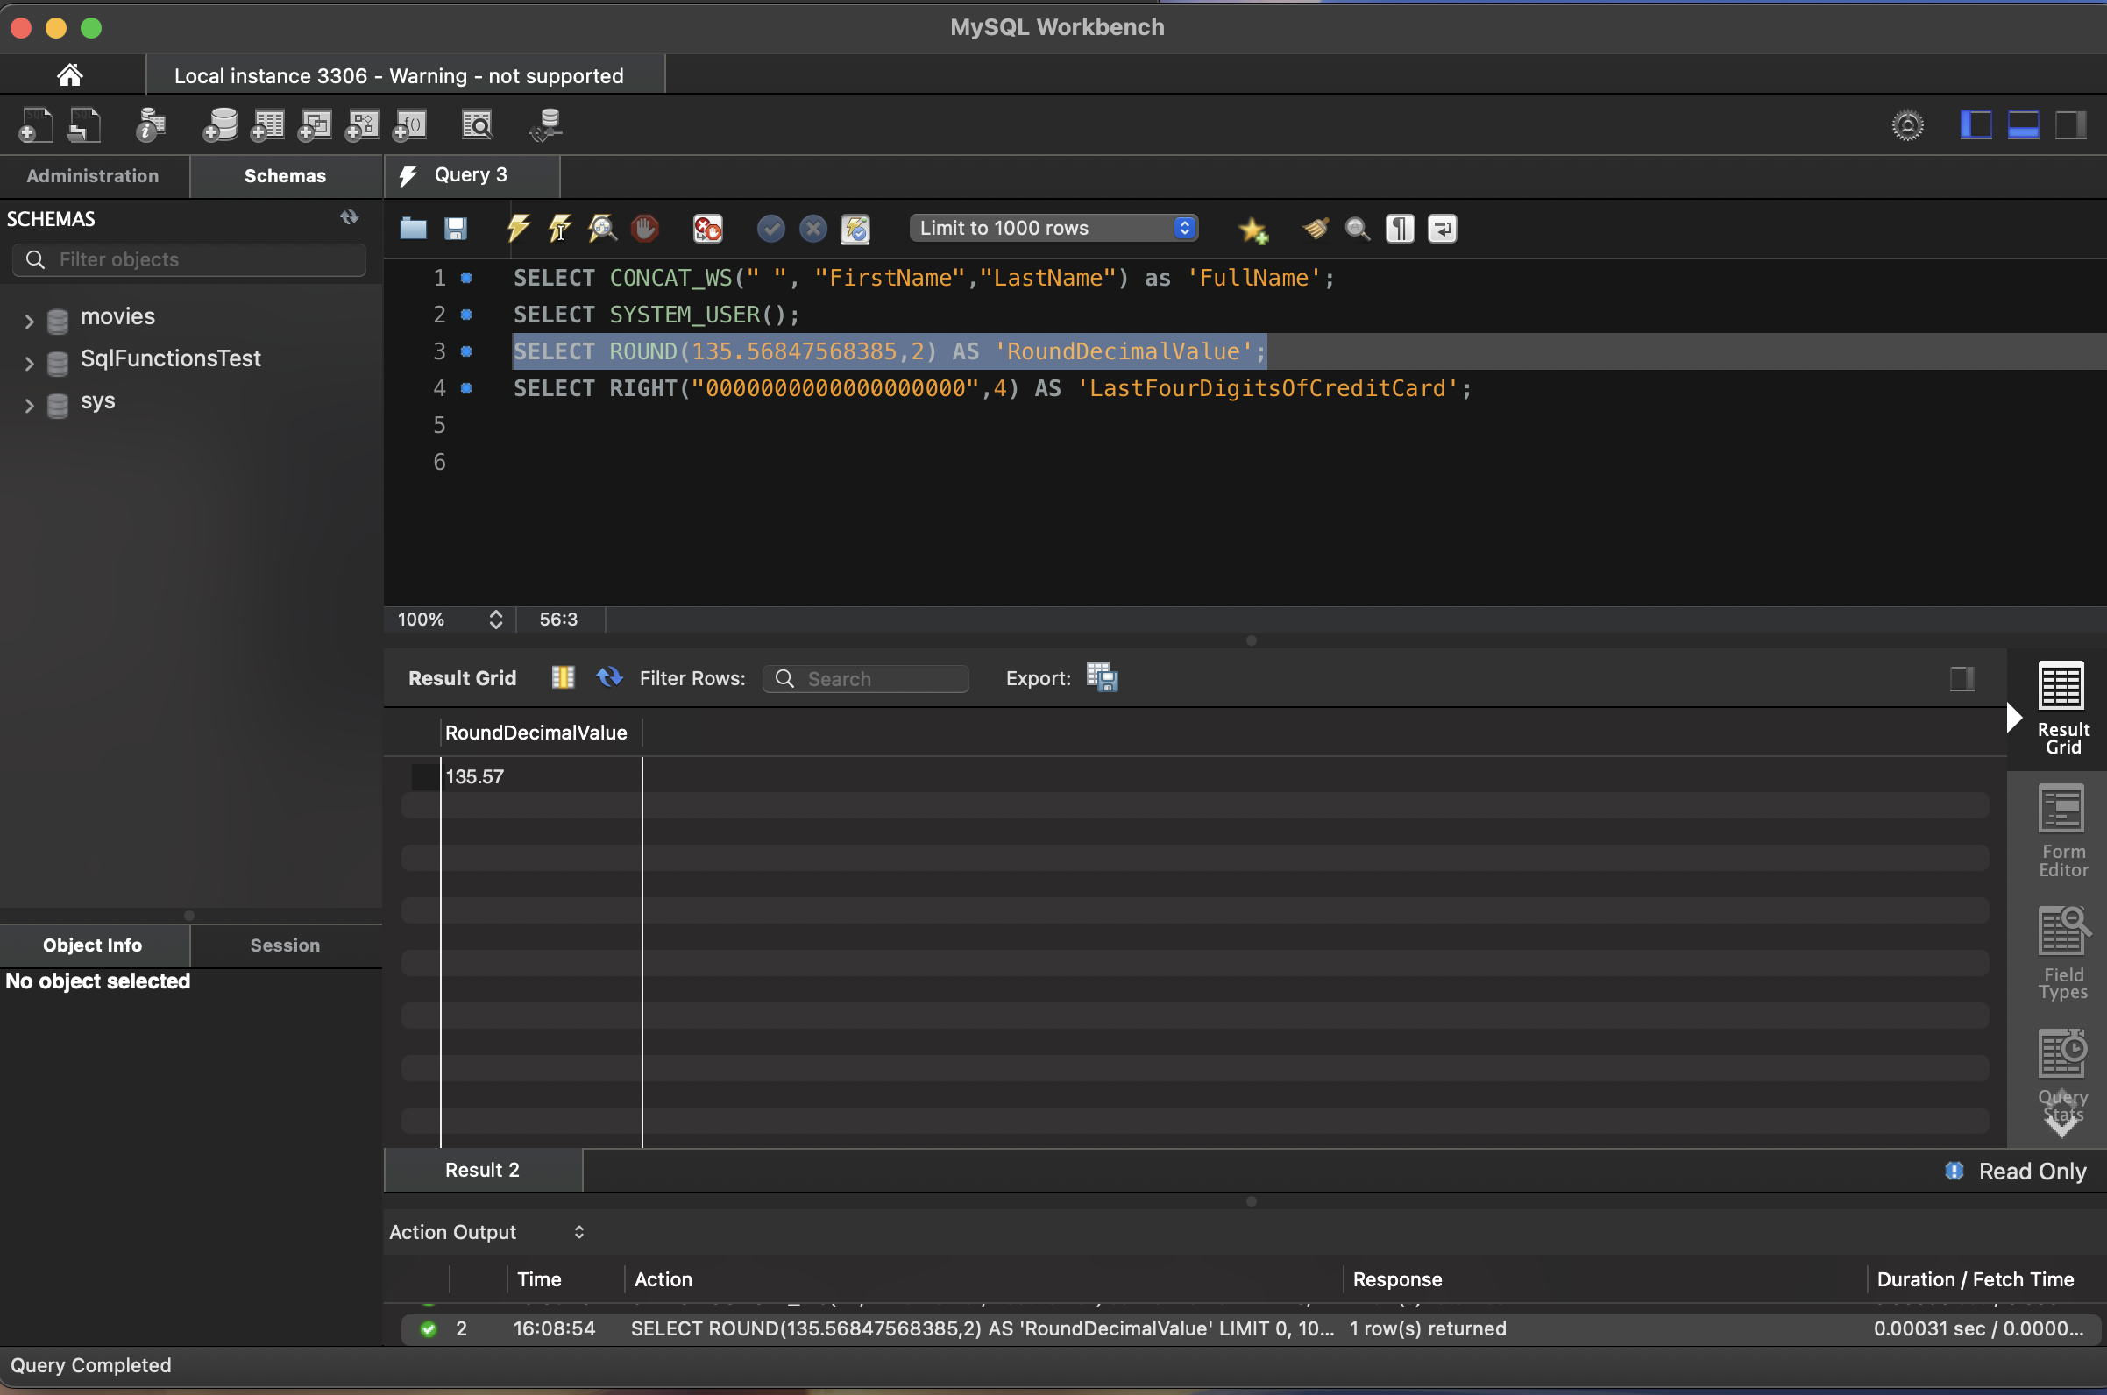

**Function** **RIGHT();**

* Explanation of when it might be used: This function could be useful for case scenarios where one is trying to display partial data to users or save partial data to another table within the same or different database. With that in mind, this function organizes data further or provides privacy and security to specific types of data. For example, in my screenshot I visualized retrieving a credit card number as a string from a database and my task was to display the last four digits of this sensitive data by using the RIGHT() function. The function worked as planned.
* Alias: The alias for my example is ‘LastFourDigitsOfCreditCard’
* Screenshot Below (SQL statement highlighted in screenshot):