Noel Miranda

September 11, 2024

Assignment Module 6.2

Assignment Movies: Setup

**Link to my GitHub:** <https://github.com/NoelMirandaDev/csd-310.git>

**Run the SQL script**: Take a screenshot of the last couple of lines you see once you've run the script. (Utilized the Command Prompt to access the MySQL Command-Line Client to run the script. Result below.

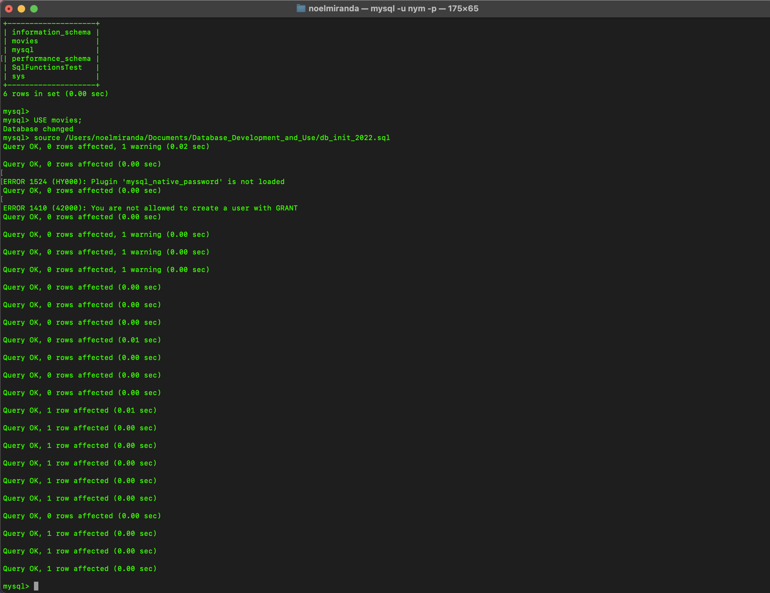

**Take a screenshot of the result of SHOW TABLES**:

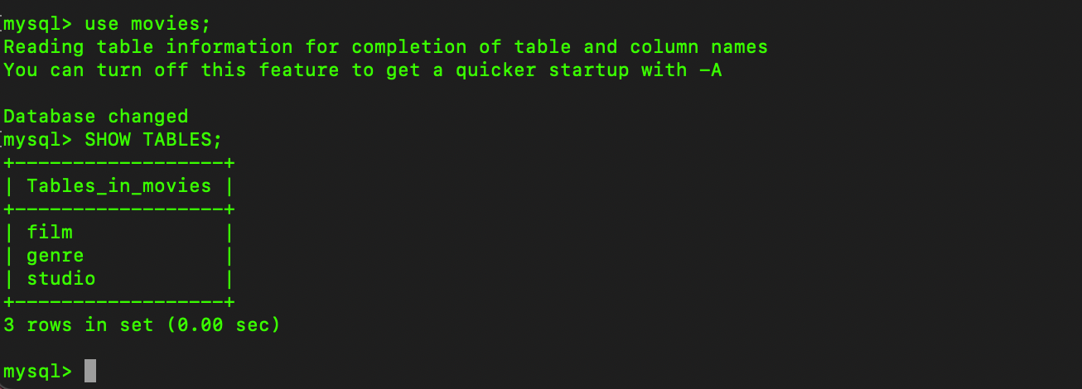

**Run the mysql_test.py script and take a screenshot of the results:**

I uploaded the mysql_test.py file to GitHub and to this assignment with my actual username and password replaced with asterisks for security purposes. Upon needing to utilize the file, I will replace it with my actual username and password. I just do not feel secure uploading that type of information in the file. As you can see below, the script mysql_test.py does work when it has my password and username.

