Noel Miranda

October 24, 2024

Assignment: GitHub Repository Setup

**Deliverable 1**:

Link to personal GitHub repository: <https://github.com/NoelMirandaDev/csd-340>

**Deliverable 2:**

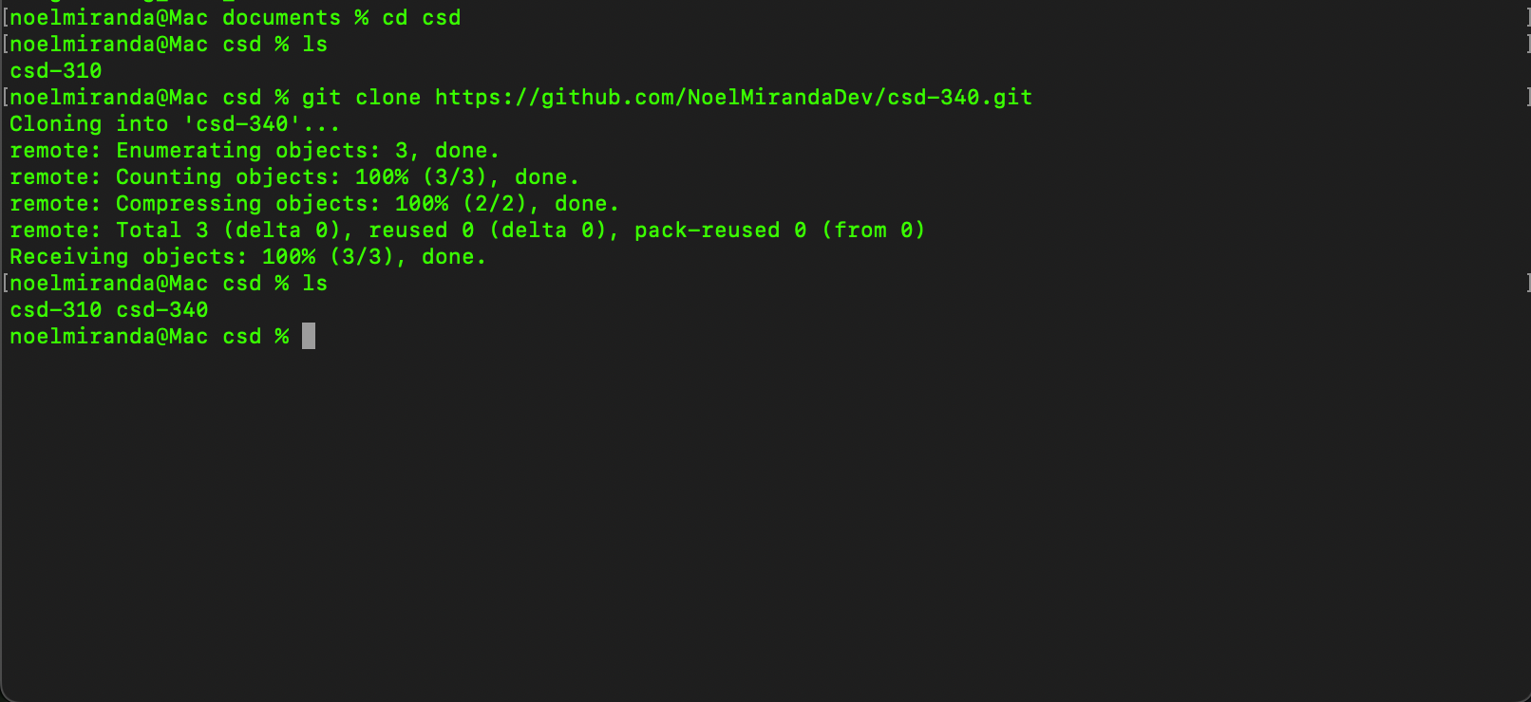

**Deliverable 3:**

