Noel Miranda

October 24, 2024

Building a Web Page Exercise, Part 1

**Deliverable 1:**

Link to personal GitHub repository: <https://github.com/NoelMirandaDev/csd-340>

**First Validation Using W3C Website:**

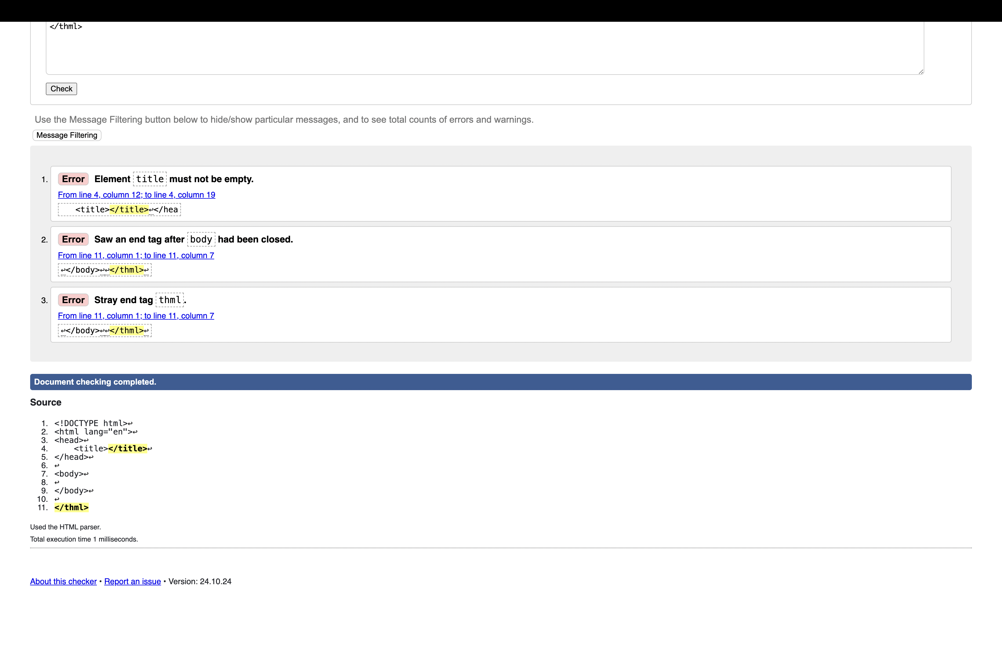

**Second Validation Using W3C Website:**

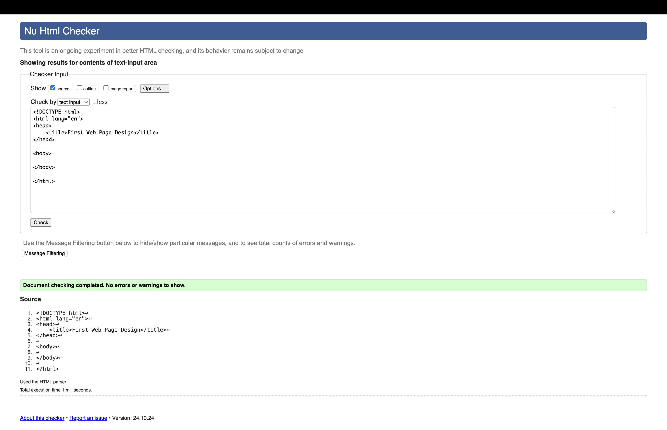**Third Validation Using W3C Website:**

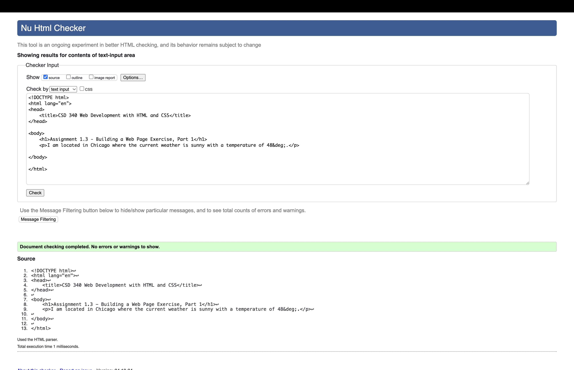

**Web Page Results:**

