Noel Miranda

October 30, 2024

Module 3.2 Assignment

**GitHub Pages**

**Link to GitHub Repository**: <https://github.com/NoelMirandaDev/csd-340>

**URL Link to the GitHub Pages Landing Page**: <https://noelmirandadev.github.io/csd-340/>

**Screenshots Below:**

*Validated HTML:*

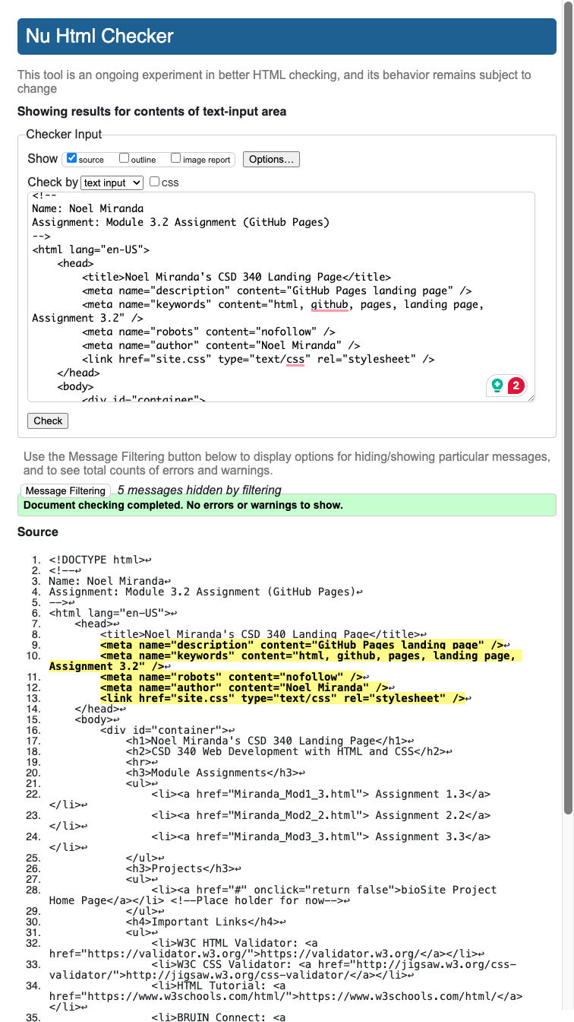

*Validated CSS:*

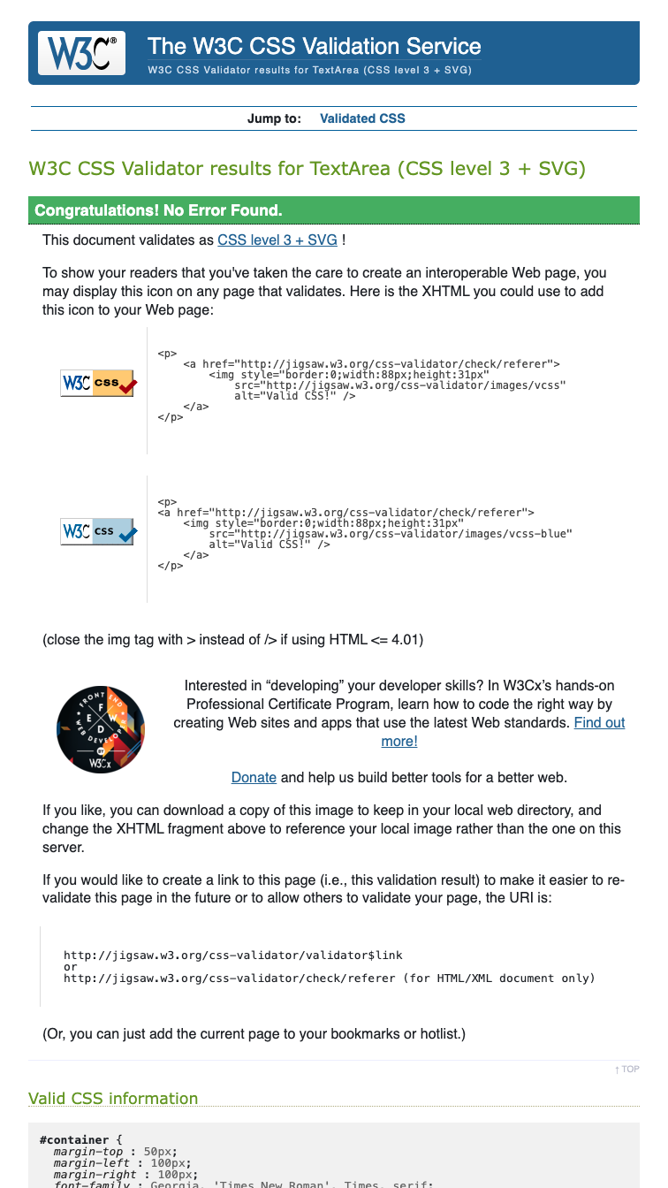

*Landing Page Browser Output:*

