## CHAPTER 1

**INTRODUCTION**

### Background

Considering the volumes of data that needs to be tracked in Nasa, it would be very difficult to manage the accuracy and quality of data manually. It would be almost impossible to get the details required in case of manual maintenance of data. The Nasa Management System simplifies the manual work and allows smooth administration of the operations of an Nasa.

### Problem Definition

This project is aimed to reduce the manual work involved in data maintenance in an Nasa and automates the Nasa Management System. This project is developed mainly to simplify the manual work and allows smooth administration of the operations of an Nasa. The purpose of the project is to computerize the administrative operations of an Nasa and to develop software which is user friendly, simple, fast, and cost – effective. It deals with the collection of Scientists, Missions, Departments, Visitors etc. Traditionally, it was done manually. The main function of the system is to enter and store Admins, Missions, Departments and Visitors information and retrieve these details as and when required and also to manipulate these details meaningfully.

### Motivation

**Manual System:** The system is very time consuming and lazy. This system is more prone to errors and sometimes the approaches to various problems are unstructured.

**Technical System:** With the invent of latest technology, we should update our systems which are very fast, accurate, user-friendly and reliable.

### Objective

Main goal of this project is to simplify the manual operation of an Nasa with the following advantages:

* + 1. Faster System
    2. Accuracy
    3. Reliability
    4. Cost Effective
    5. User Friendly
    6. Immediate access to the data and statistics

### Scope of the project

The project provides a very simple application which simplifies the manual work done by the operations team of an Nasa. This application saves the data of Scientist, Missions, Departments and Visitors in the database. Allows admin to enter the details, update / delete the existing details. Our project allows visitors and scientists to view the data stored in the database and to see the statistics.

## CHAPTER 2

**REQUIREMENTS**

The requirements can be broken down into 2 major categories namely hardware and software requirements. The former specifies the minimal hardware facilities expected in a system in which the project has to be run. The latter specifies the essential software needed to build and run the project.

### Hardware Requirements

* + - Processor : Intel 486/Pentium processor
    - Processor Speed : 500 MHz or above
    - Hard Disk : at least 60 GB
    - RAM : at least 1 GB

### Software Requirements

* + - Technology Implemented : Apache Server
    - Language Used : PHP
    - Database : My SQL
    - User Interface Design : HTML, CSS
    - Web Browser : Google Chrome
    - Software : XAMPP Version: 7.1.32

## CHAPTER 3

### Class Diagram:

**IMPLEMENTATION**

A class diagram in the Unified Modeling Language (UML) is a type of static structure diagram that describes the structure of a system by showing the system's classes, their attributes, operations (or methods), and the relationships among objects.

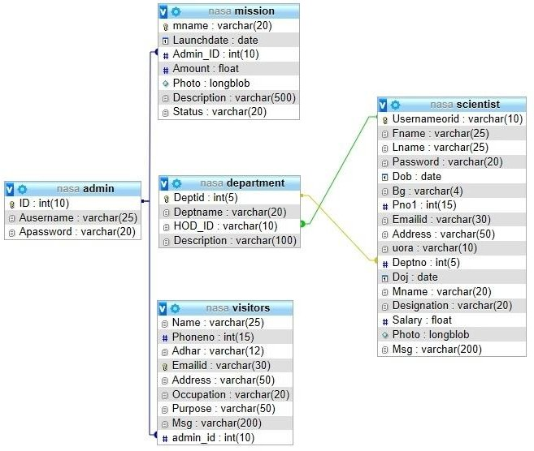

### Activity Diagram:

Activity diagrams are graphical representations of workflows of stepwise activities and actions with support for choice, iteration and concurrency. In the Unified Modeling Language, activity diagrams are intended to model both computational and organizational processes (i.e., workflows), as well as the data flows intersecting with the related activities. Although activity diagrams primarily show the overall flow of control, they can also include elements showing the flow of data between activities through one or more data stores.

### Activity for Admin:

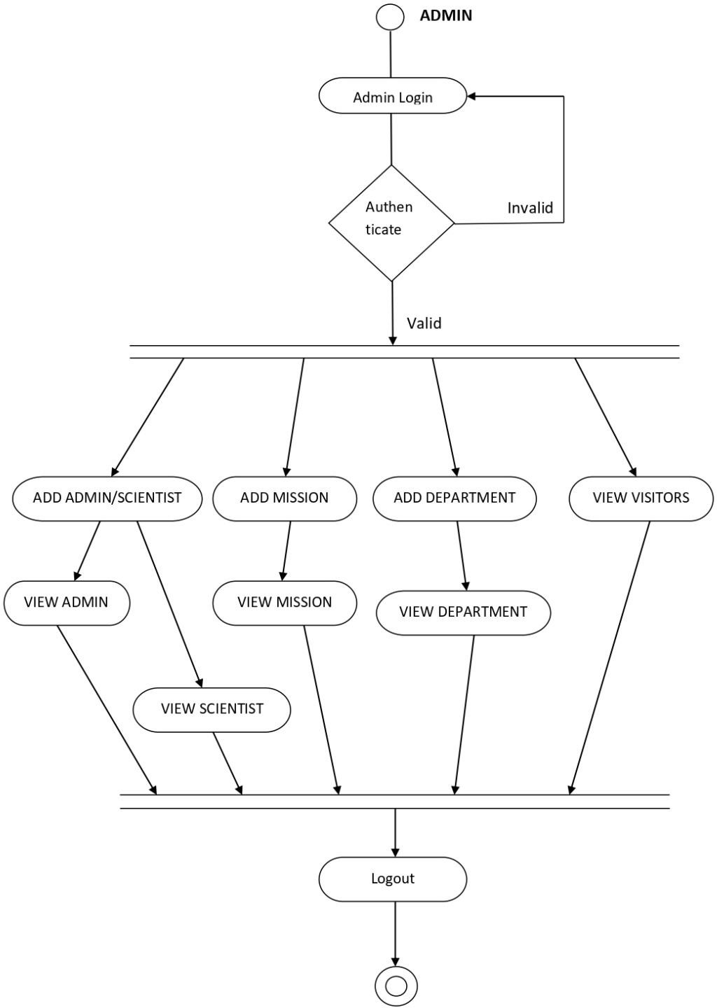

Fig 1: Activity for Admin

* + 1. **Activity for Scientist:**

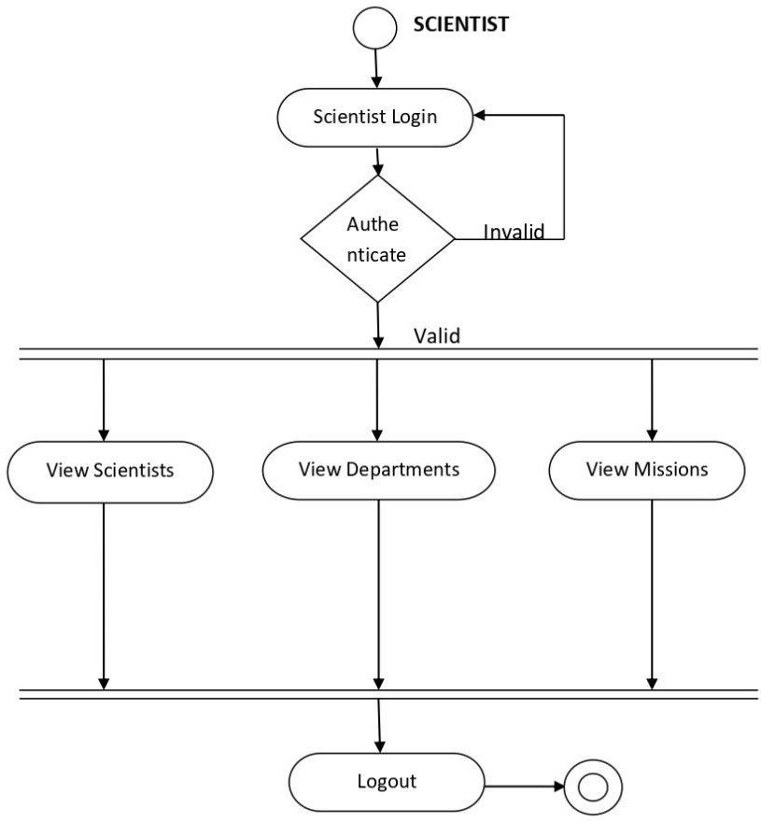

Fig 2: Activity for Scientist

* + 1. **Activity for Visitor:**

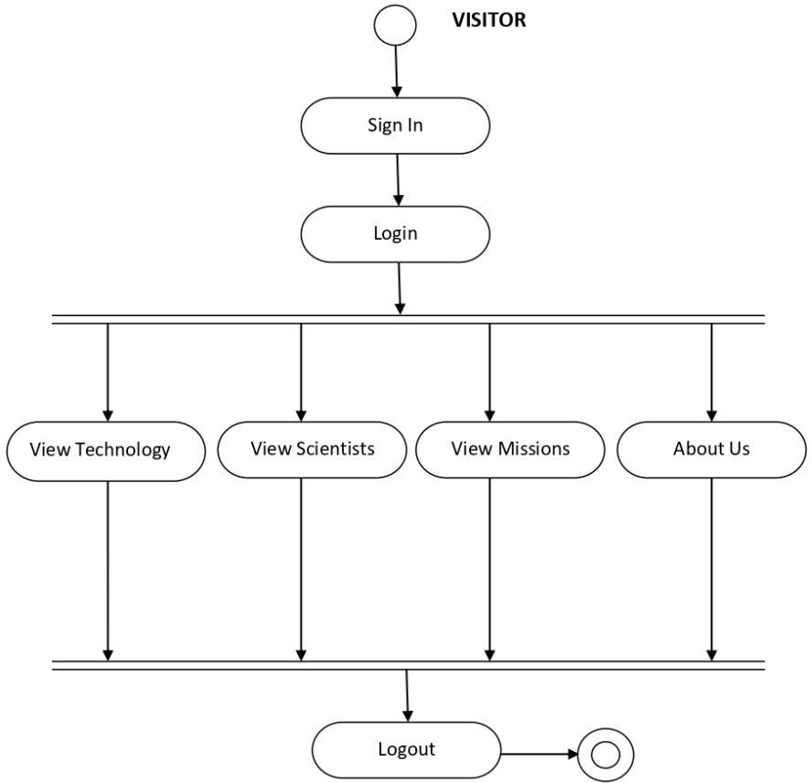

Fig 3: Activity for Visitor

## CHAPTER 4

# SNAPSHOTS

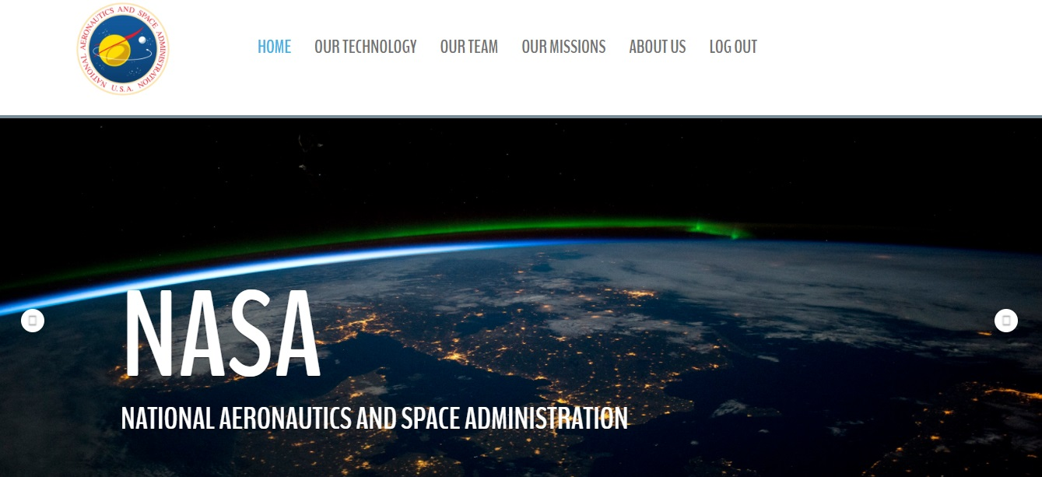Fig 1: Home Page

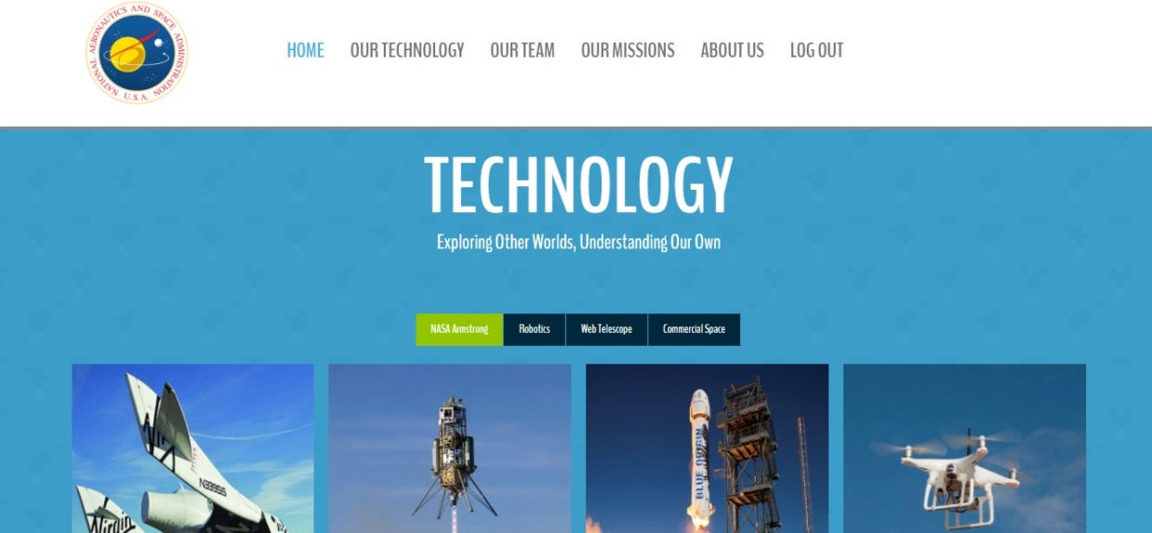

Fig 2: Technology Used

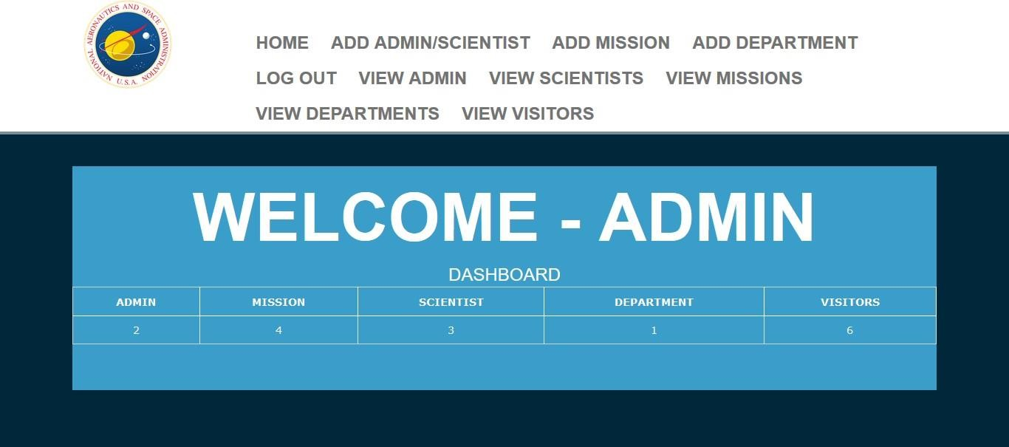

Fig 3: Admin Page

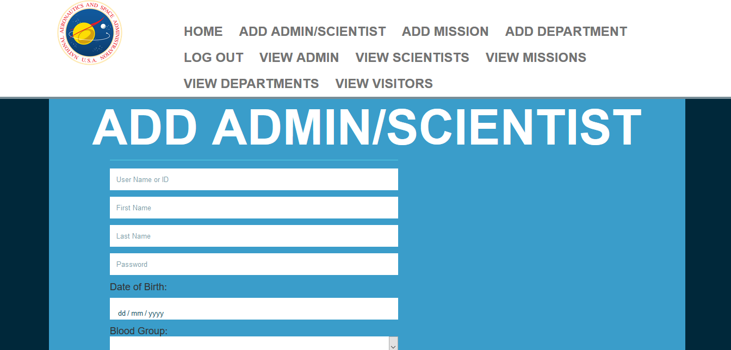

Fig 4: Add Scientist

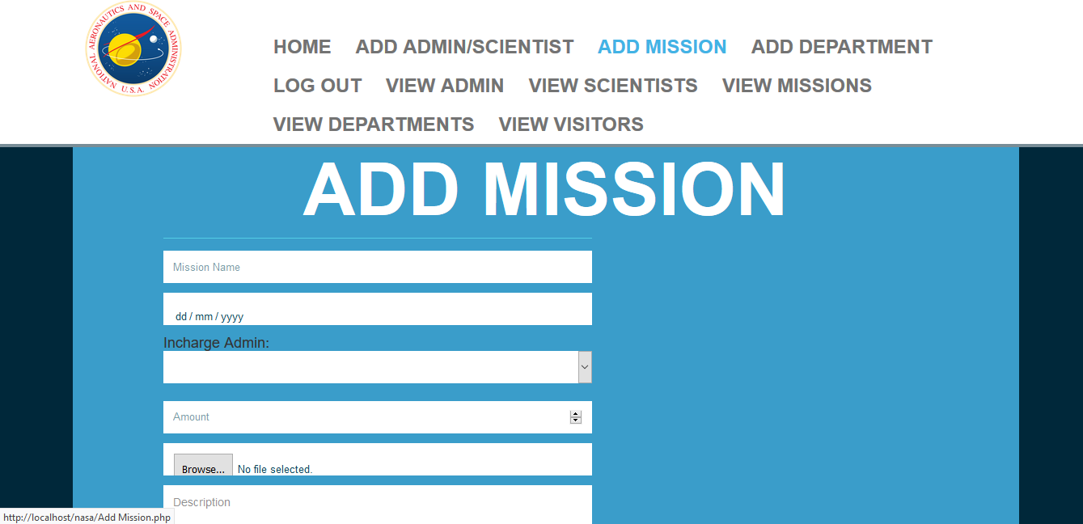

Fig 5: Add Mission

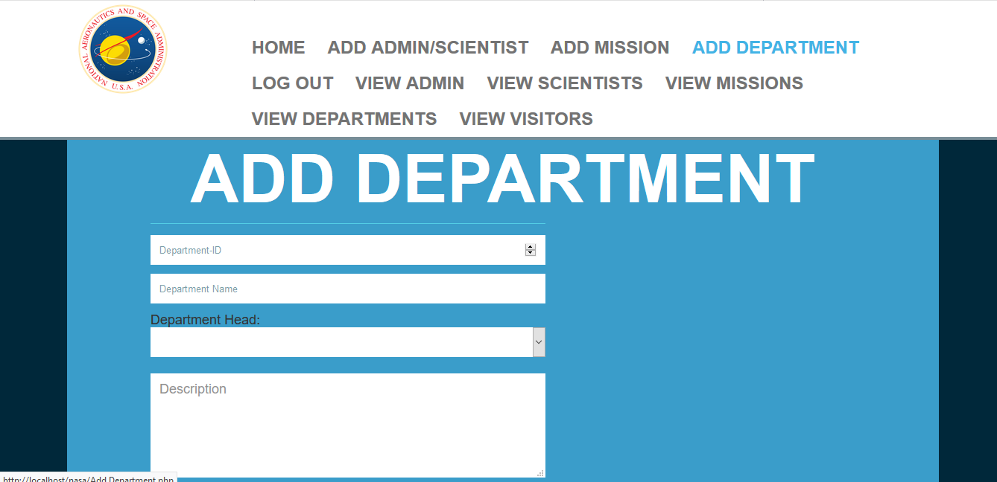

Fig 6: Add Department

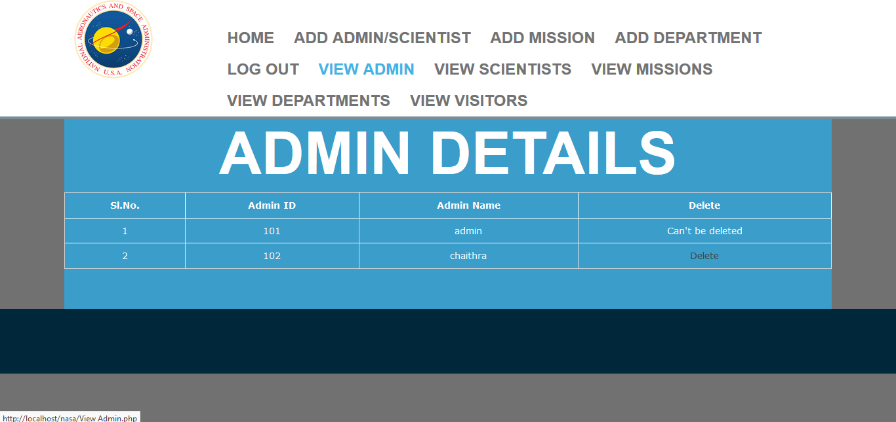

Fig 7: Admin Details

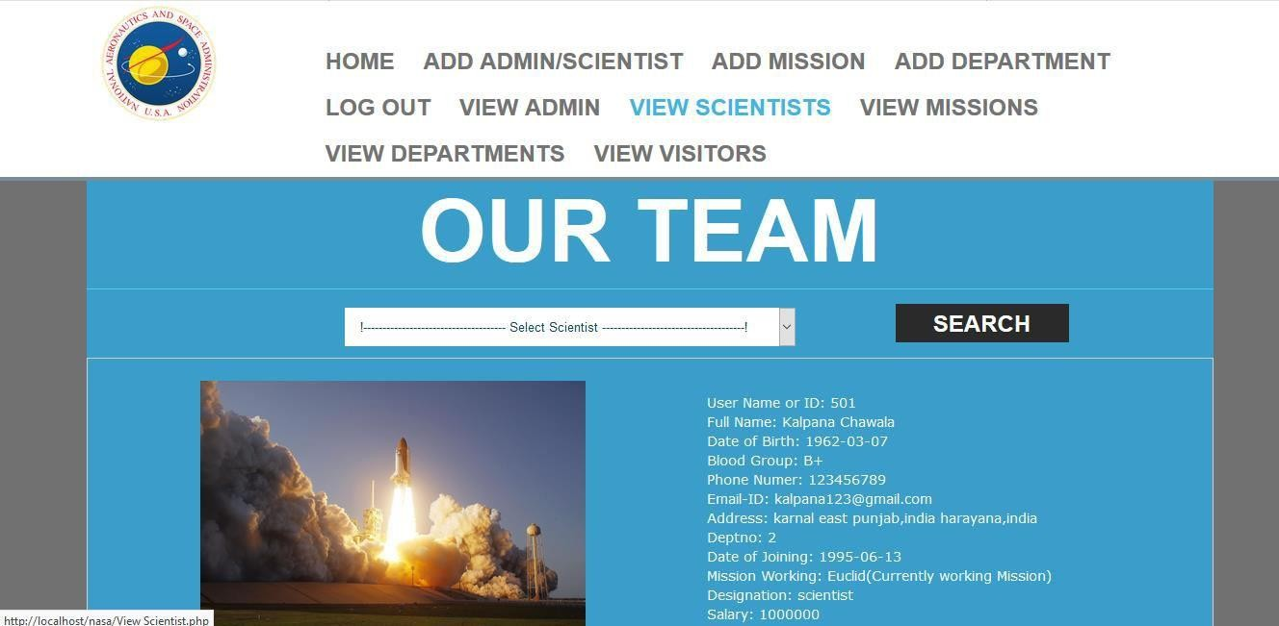

Fig 8: Our Team

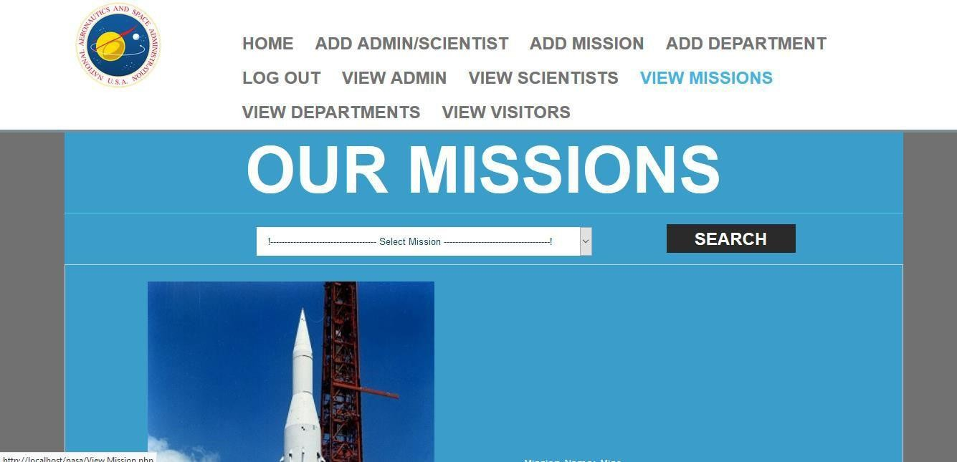

Fig 9: Our Missions

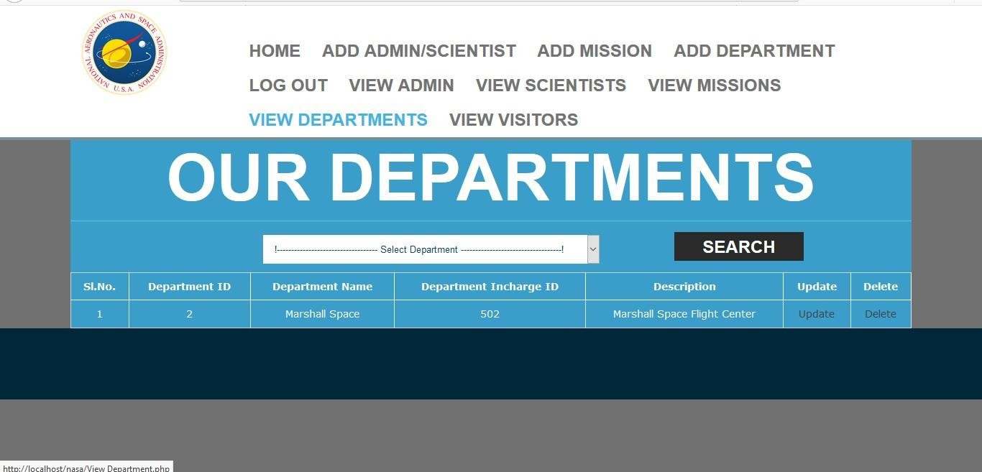

Fig 10: Our Departments

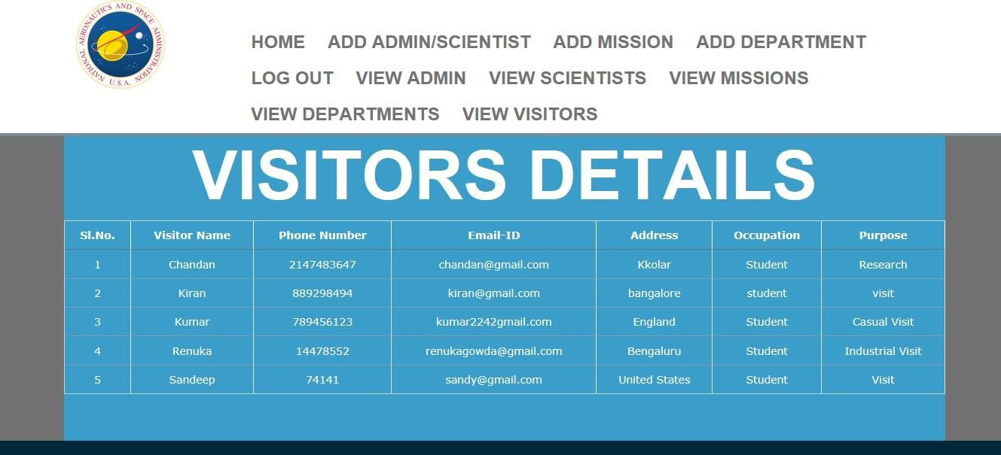

Fig 11: Visitors Details

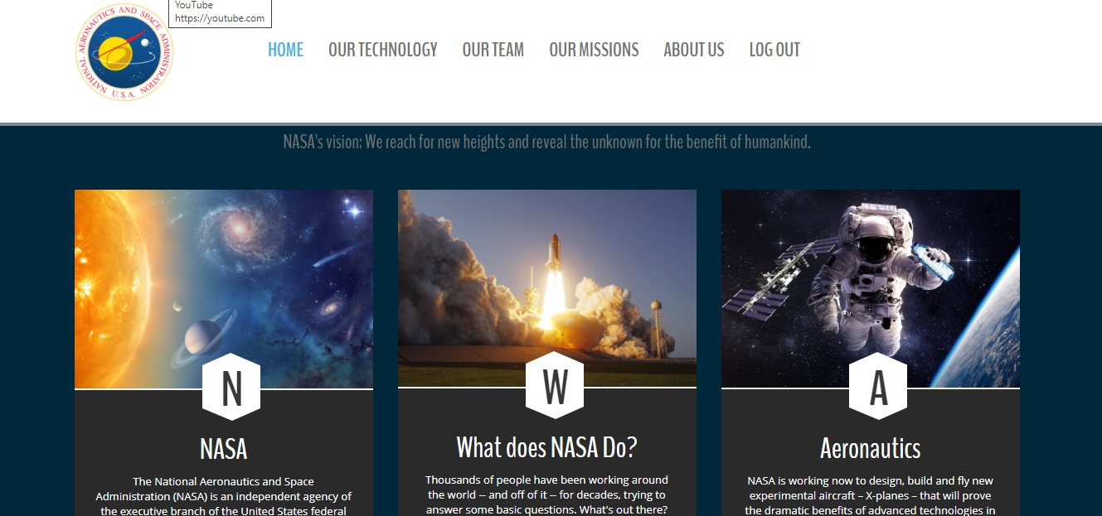

Fig 12: More Information

**CHAPTER 5**

**CONCLUSION AND FUTURE WORK**

The Nasa Management System is a great improvement over the manual system which uses lots of manual work and paper. The computerization of the system speeds up the process. This system was thoroughly checked and tested with dummy data and found to be very reliable.

### Advantages:

* + - * The Nasa Management System is fast, efficient and reliable.
      * Avoids data redundancy and inconsistency
      * Web-based
      * Number of personnel required is considerably less
      * Provides more security and integrity to data

### Future Enhancements:

* + - * In future our software could be further enhanced by Live stream video update and also Individual message can be send.
      * It can be implemented in mobile also.
      * The live stream can further be implemented into mobile and we can use better encryption formats since the data stored which is not available to public is very confidential.

## CHAPTER 6

# BIBLIOGRAPHY

### BOOK REFERENCES:

* + Learn to Code HTML and CSS: Develop and Style Websites (Web Design Courses) 1st, Kindle Edition by Shay Howe
  + *PHP 6 and MySQL 5* - Larry Ullman

### WEBSITE REFERENCES:

#### HTML Learning:

* + <https://www.codecademy.com/>
  + <https://dash.generalassemb.ly/>
  + <https://www.w3schools.com/>

#### PHP Learning:

* + [http://www.tutorialspoint.com/php/](https://www.php.net/)
  + [https://killerphp.com](https://killerphp.com/)
  + <https://www.w3schools.com/>