Noella Dsilva

22112004

3BSc DS

Data Analysis Project

Nutrition Recommendation App

**Project Purpose and Goals**

The Nutrition Recommendation App is designed to assist users in creating personalized meal plans based on their desired intake of calories, proteins, fats, and carbohydrates. The app utilizes a comprehensive dataset containing information about various food ingredients, including grams, calories, protein content, fats, carbs, and more. The primary goals of the project include:

**Personalized Meal Planning:** Enable users to input their nutritional preferences and receive recommendations for food ingredients that match their specified criteria.

**User-Friendly Interface:** Provide an intuitive and easy-to-use interface for users to interact with the app, making it accessible for individuals with varying levels of technical expertise.

**Data-Driven Recommendations:** Leverage data analytics methods to analyze the dataset and generate accurate and relevant recommendations for users based on their nutritional requirements.

**Flexibility and Customization:** Allow users to customize their preferences, including the quantity of calories, proteins, fats, and carbs, to ensure a tailored and flexible meal planning experience.

**About the dataset:**

Data Source

The app utilizes a dataset containing information about various food ingredients, including where the quantity is standardized to 100 grams based on which the nutrients are given:

Ingredients

Grams

Calories

Protein content

Fats

Carbohydrates

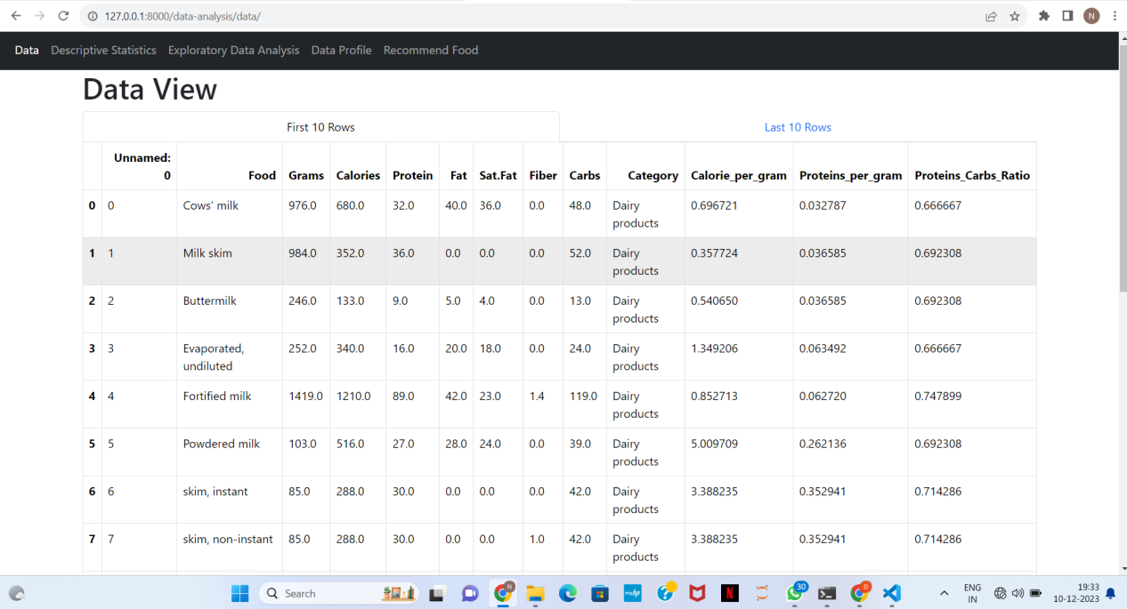Fiber

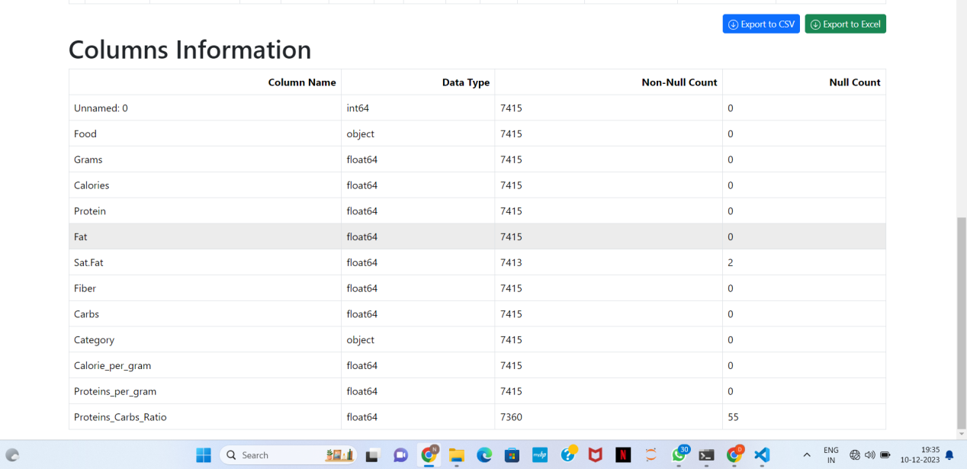

**Descriptive statistics:**

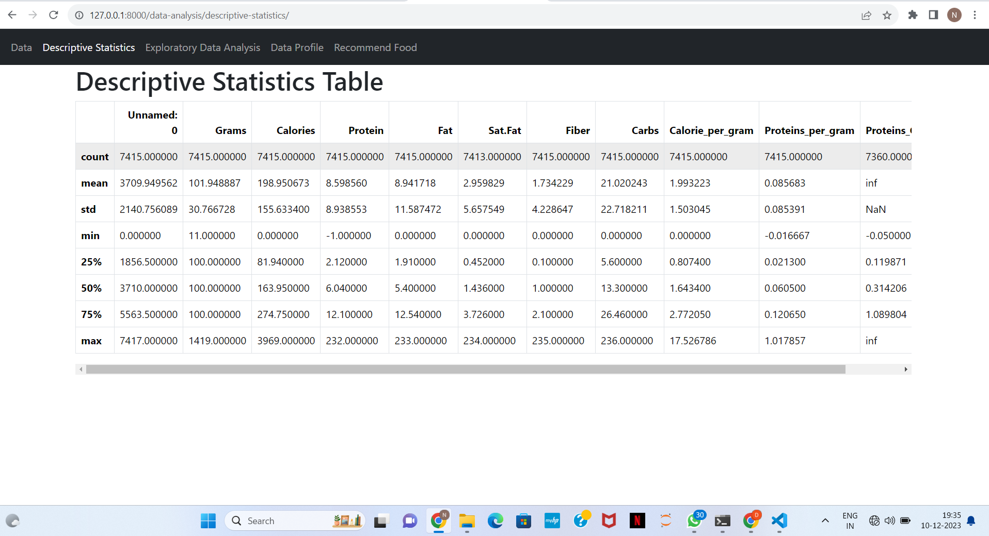

**Exploratory Data Analysis:**

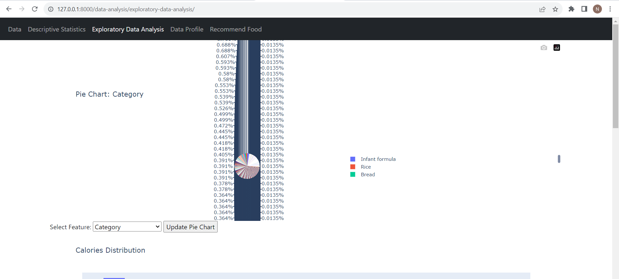

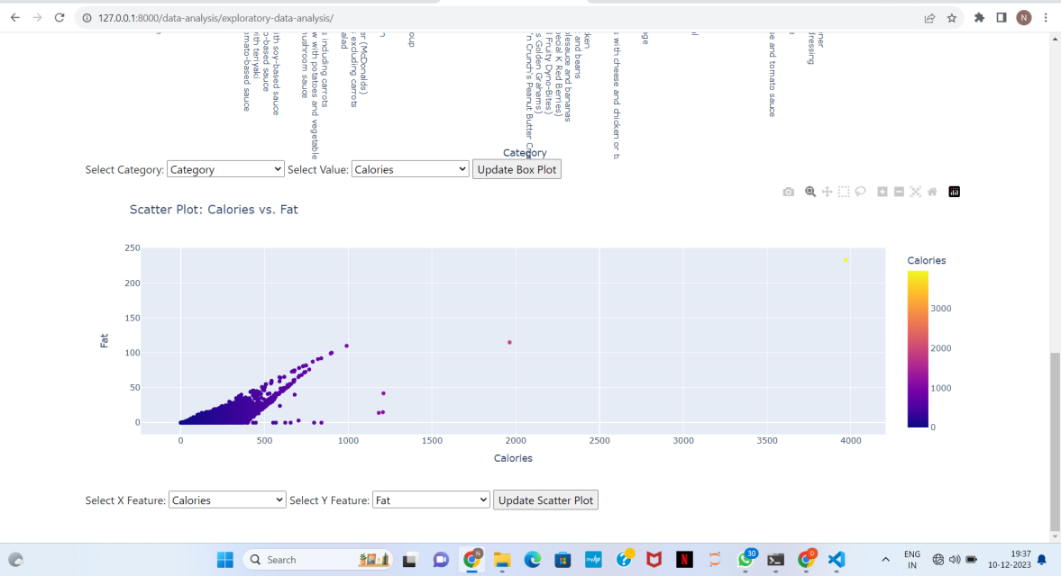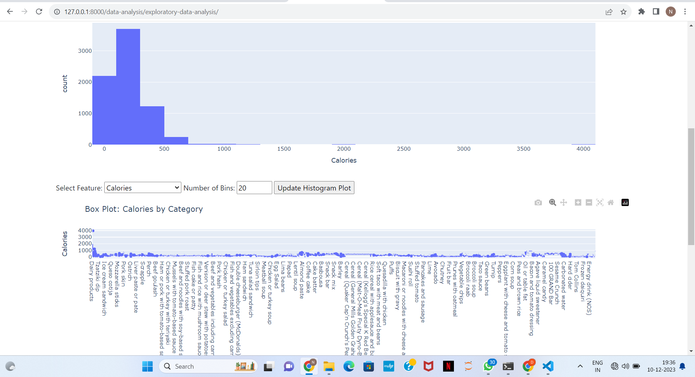**Data Profiling:**

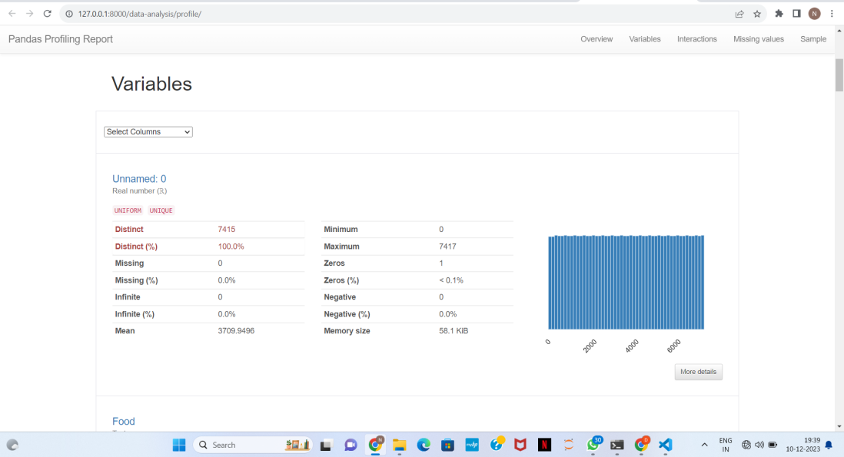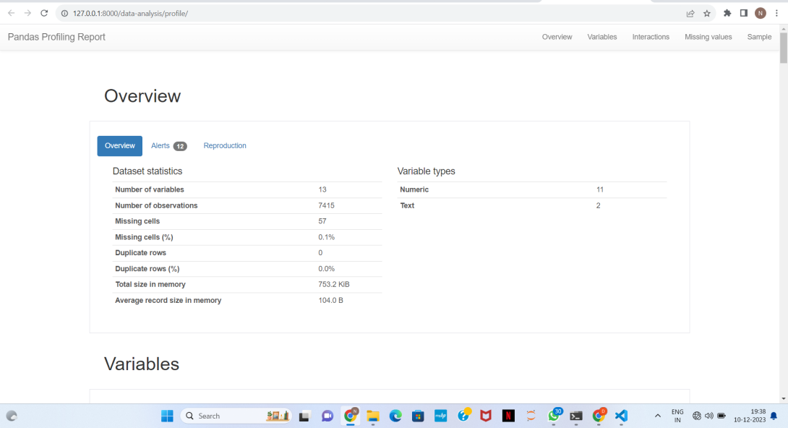

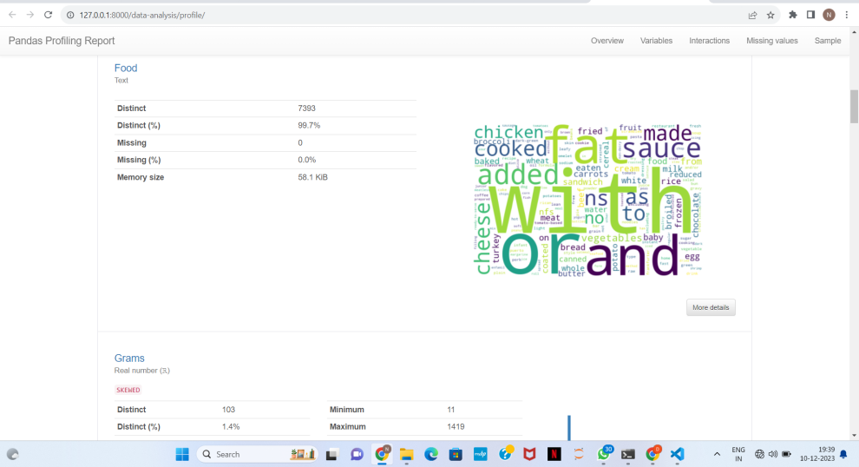

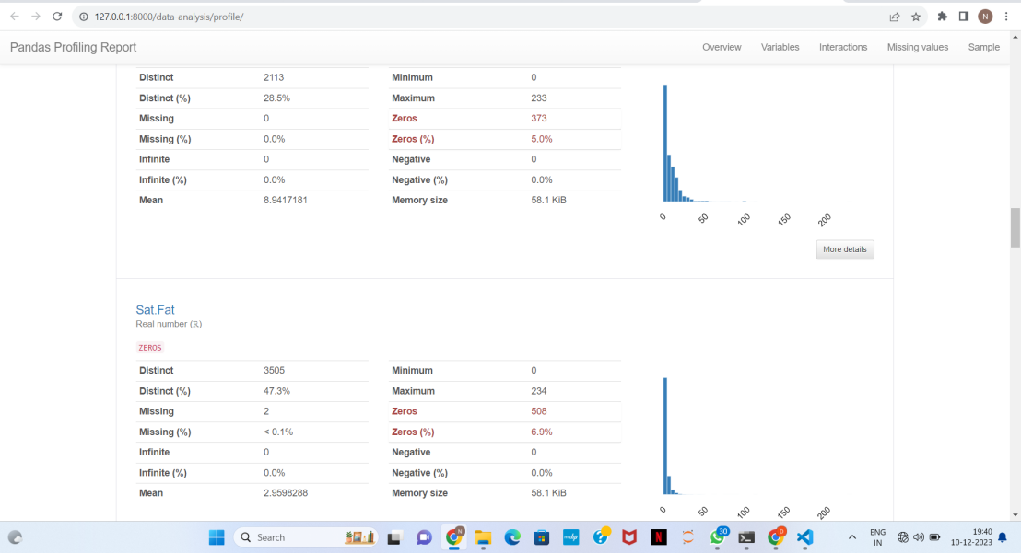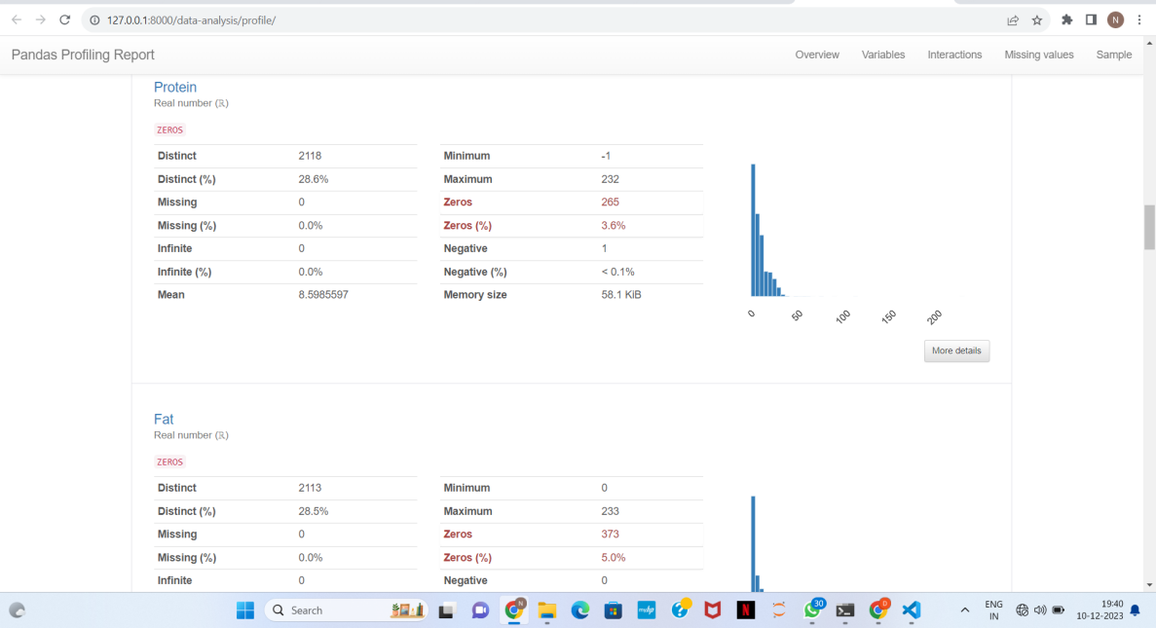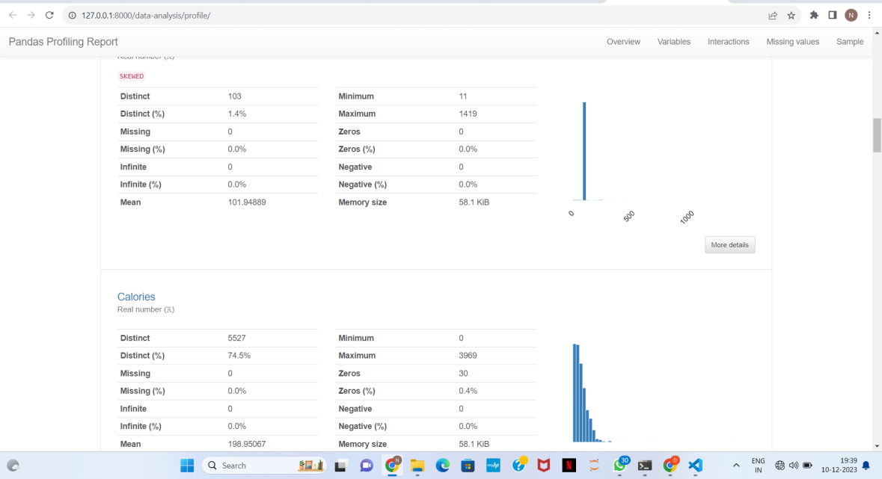

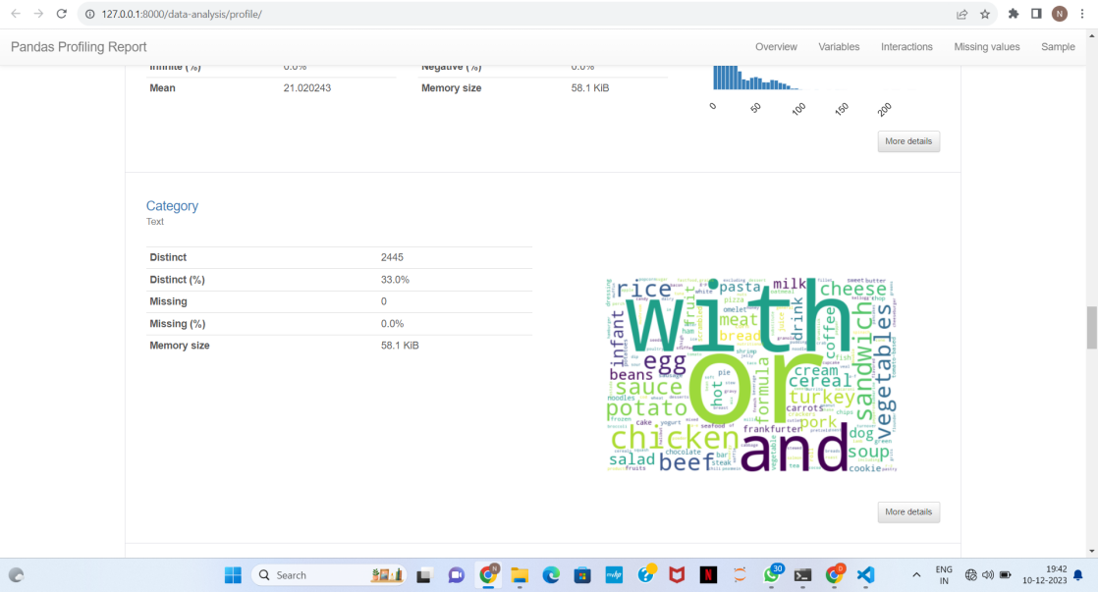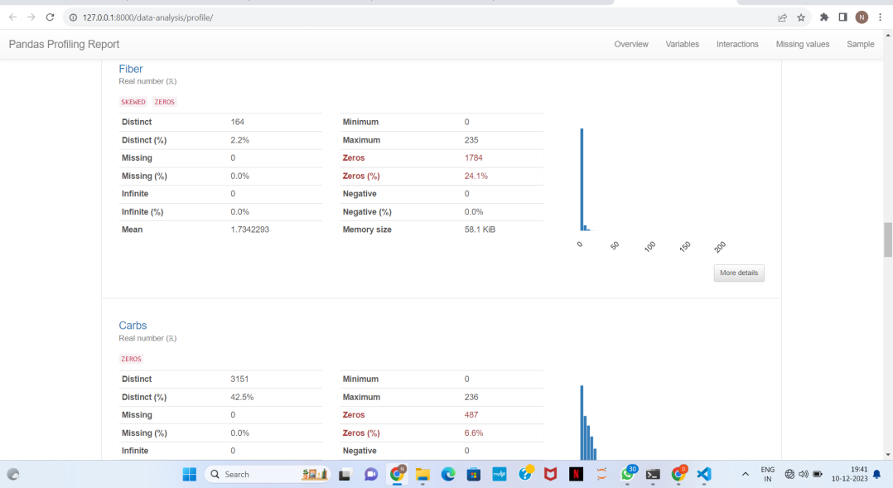

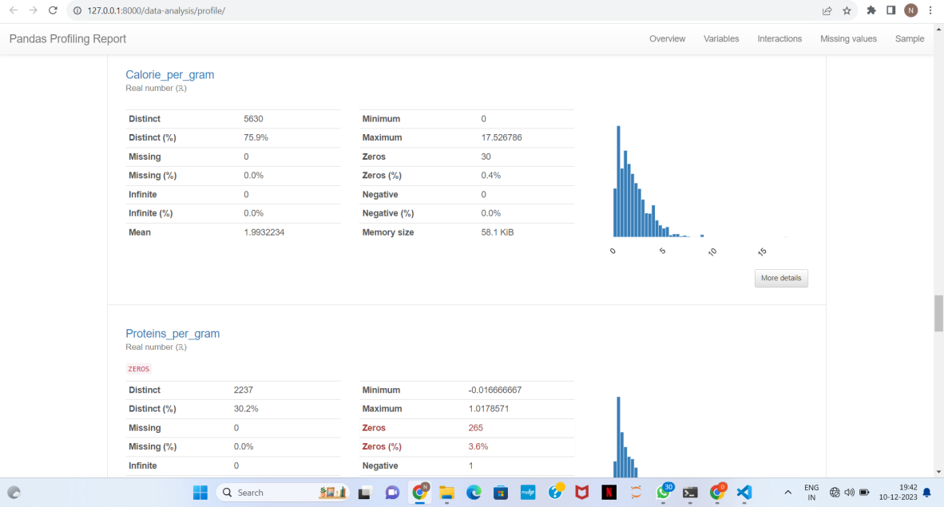

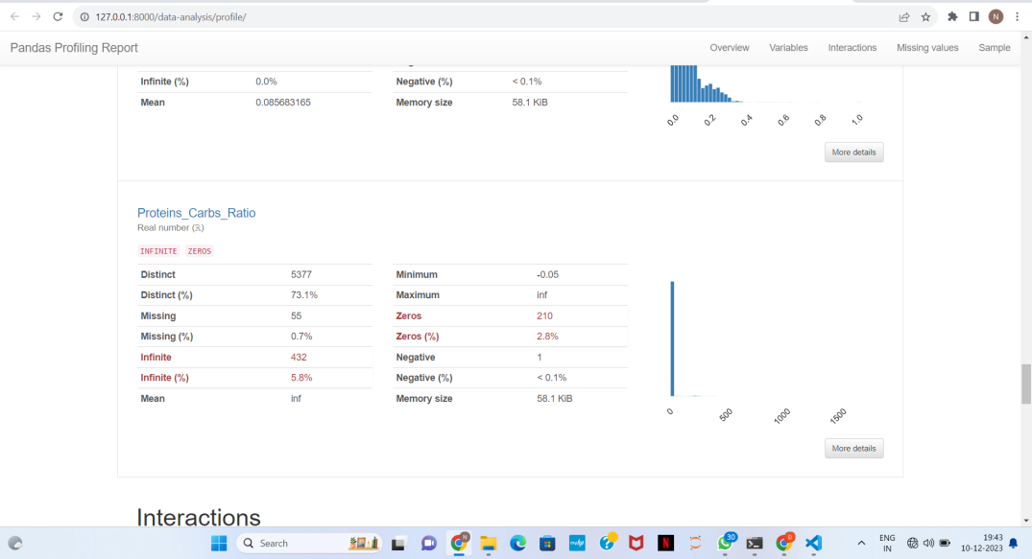

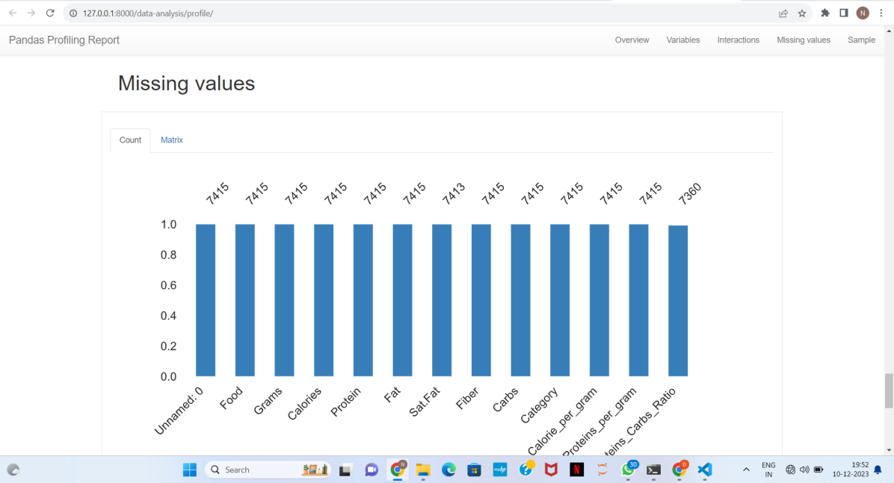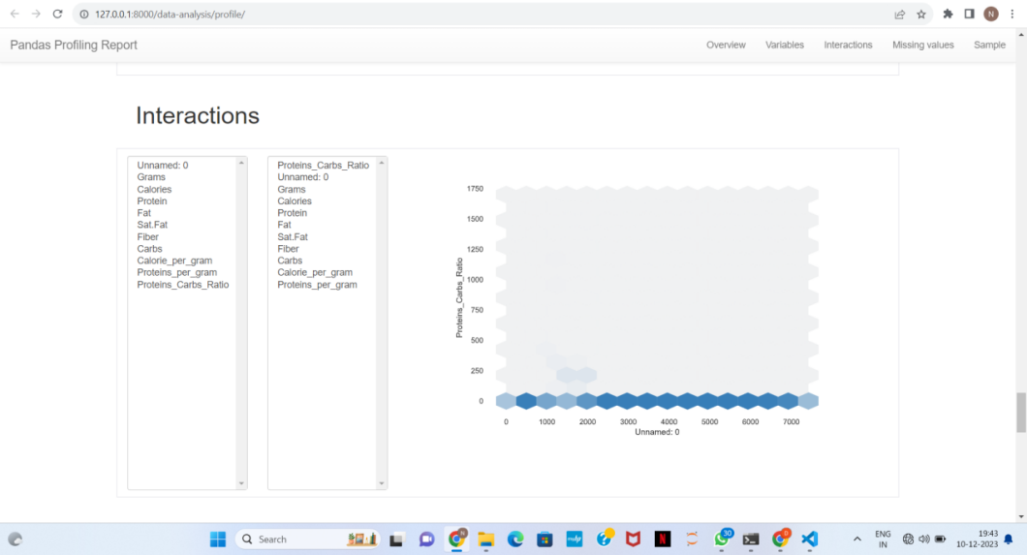

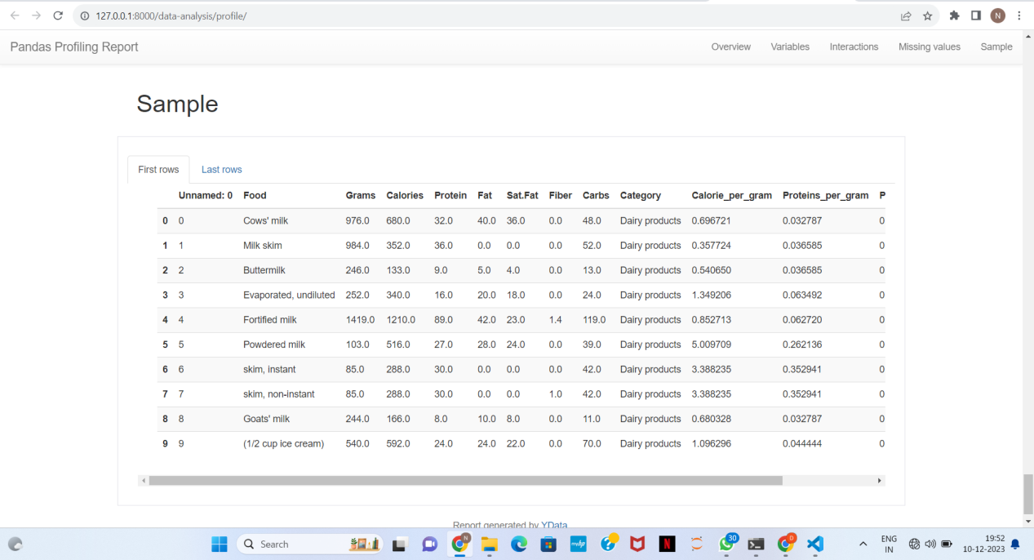

**Food Recommendation:**

**User Input Page:**

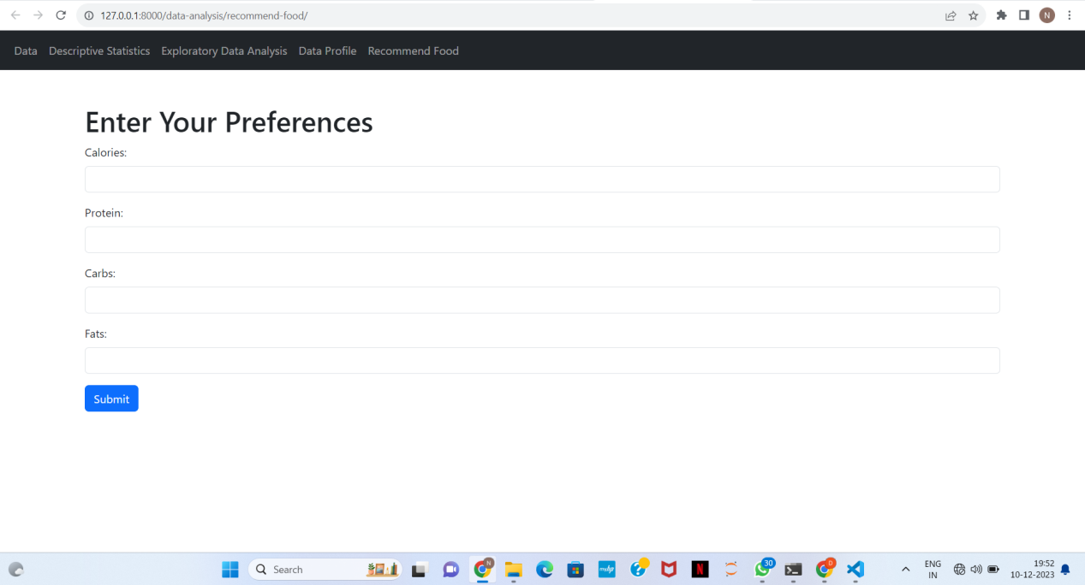

**Input Preferences:**

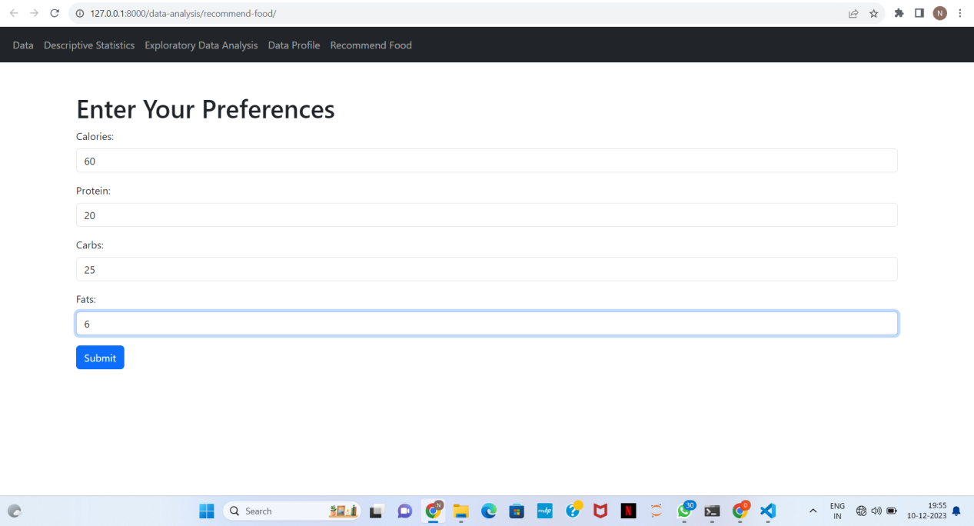

**Recommended Foods:**

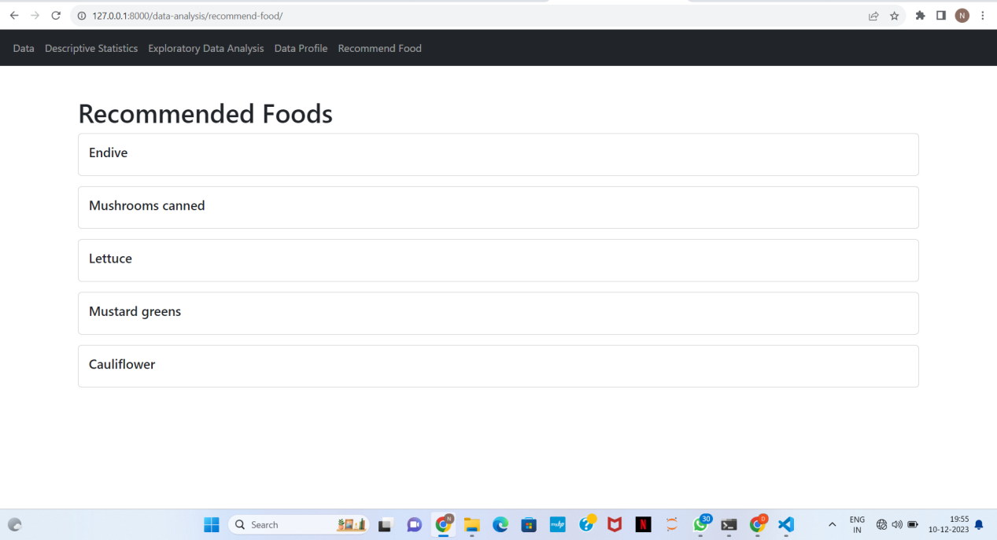

Conclusion:

The Nutrition Recommendation App offers a user-friendly platform for personalized meal planning, backed by robust data analytics methods. Users can easily customize their preferences and receive accurate recommendations for a balanced and tailored diet.